Supplemental Materials For:
Pattern Deviancy Aversion Predicts Prejudice
via a Dislike of Statistical Minorities

Verbatim methodology files as well as the data of each of the eight main-text studies and six supplemental studies can be found on Open Science Framework using the link below. Additionally, elaborations on the methods of the reported studies can be found below. If you have any questions about the materials or data or would like to obtain the utilized methods please contact the corresponding author.
https://osf.io/8z7gf/?view_only=a5108e1de12c46659f75425a62b1a2d3

Studies S1 and S2
In Studies S1 (adults) and S2 (children), we began to examine the proposed mediation model by solely testing Path A. We examined whether nonsocial pattern deviancy aversion, assessed via participants’ evaluation of broken compared to unbroken patterns of geometric shapes, relates to their dislike of statistical minorities, assessed via participants’ evaluation of novel minorities compared to novel majorities (minorities and majorities on alien planets).
Method
Design. The design and materials of Studies S1 and S2 were identical except that Study S1 was conducted with adults and Study S2 was conducted with children. Both studies were correlational.
Introduction. The materials in Study S1 were child-friendly because we planned to run the identical study with children (see Study S2). This was made clear to adult participants who read: “The following study is typically conducted with young children. Even though the questions may be simplistic please respond how you believe not how you think children will respond.”
Participants. A power-analysis based on the relationship between pattern deviancy aversion and prejudice against stigmatized individuals (r = .32; Gollwitzer et al., 2017) revealed that we needed 71 participants to have 80% power (.05 alpha). To account for participants failing attention checks, we recruited 86 adults on Mechanical Turk in Study S1 (MTurk; 44 female; M_{age} = 37.26, SD_{age} = 11.53), and 89 children ranging from 4- to 8-years-old in Study S2 (42 female; M_{age} = 6.37, SD_{age} = 1.12). The children were recruited at a school in downtown New York City (n = 55), and at a museum near a Northeastern university (n = 34). In Study S1, five adults were excluded, three for failing an attention check (see materials below) and two for completing the survey twice (identified via IP address). In Study S2, three children were excluded because they were not paying attention (including these participants did not change the results). A portion of the included children in Study S2 (n = 25) were those reported in Study 7a of Gollwitzer et al. (2017). Of the final participants in Study S1, 8 identified as Asian/Asian American, 8 as Black/African American, 5 as Latino/Hispanic, 58 as White/European American, and 2 as Other. Of the final participants in Study S2, 5 participants were identified as Asian/Asian American, 5 as Black/African American, 2 as Latino/Hispanic, and 71 as White/European American.
Pattern deviancy aversion.
Binary measure. Participants in both studies evaluated two pairs of broken and unbroken patterns comprised of geometric shapes (randomized order; screen-side randomized; Figure S1). “Which picture do you like more?” 0 = Broken pattern to 1 = Unbroken pattern.
Continuous measure. Participants thereafter evaluated whether and how much they liked/disliked the two broken and two unbroken patterns of geometric shapes. Each pattern was evaluated individually. 1 = Like a lot, 2 = Like a little bit, 3 = Like a teeny bit, 4 = Dislike a teeny tiny bit, 5 = Dislike a little bit, 6 = Dislike a lot (Figure S1).
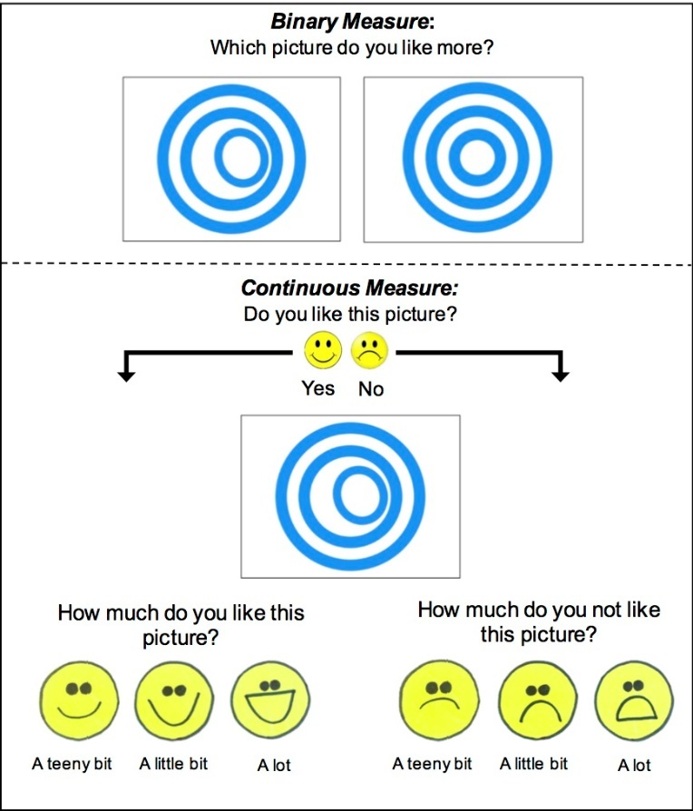
Figure S1. Example item of the binary and continuous measure of pattern deviancy aversion in Study S1 and Study S2.

Disliking statistical minorities.
Binary measure. We described a novel planet and its inhabitants to participants (Figure S2). The inhabitants were 50 red (blue) people, and 7 blue (red) people (statistical minority: 14%; color counter-balanced; screen-side counter-balanced). We then depicted one of the blue people and one of the red people (Figure S2) and assessed participants’ preference, “Who do like more?” and preferred group-identity: “Which group do you want to be in.” 0 = Minority, 1 = Majority.
Continuous measure. Participants thereafter evaluated whether and how much they liked/disliked the minority and majority on a continuous measure (randomized; see Figure S2). 1 = Like a lot, 2 = Like a little bit, 3 = Like a teeny bit, 4 = Dislike a teeny tiny bit, 5 = Dislike a little bit, 6 = Dislike a lot.
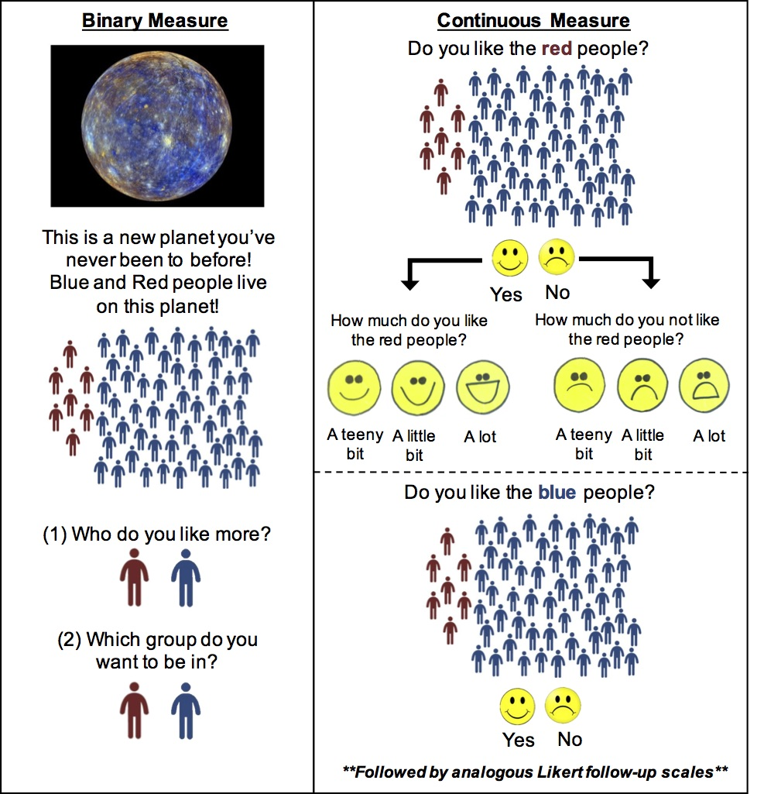
Figure S2. Example binary and continuous measure of participants’ dislike of statistical minorities in Study S1 and Study S2.

Attention Check. Participants in Study S1 (but not S2) completed an ‘indirect’ attention check item (see Study 1.1 below).
Procedure
Both adults (Study S1) and children (Study S2) completed the pattern deviancy aversion and dislike of statistical minorities measures in random order. Thereafter, we assessed demographics and the attention check.
Results
Study S1: Pattern deviancy aversion.
Binary Measure. Participants’ pattern deviancy aversion on the binary measure in Study S1 was calculated by averaging responses to the two binary pattern deviancy items (each item: 0 = preference for broken, 1 = preference for unbroken). Participants could score a 0, .5, or 1. Increased preference for the unbroken images was interpreted as pattern deviancy aversion (see continuous measure for justification of this interpretation). We found that 11.0% participants scored 0, 21.0% scored .5, and 67.9% scored 1 (see Table S1 for means). Replicating the findings of Gollwitzer and colleagues (2017), participants exhibited pattern deviancy aversion – they predominantly preferred the unbroken patterns over the broken patterns (Table S1).
Continuous measure. Participants’ responses on the continuous measure were coded in the following manner (1 = Like a lot, 2 = Like a little bit, 3 = Like a teeny bit, 4 = Dislike a teeny tiny bit, 5 = Dislike a little bit, 6 = Dislike a lot). Pattern deviancy aversion was calculated by subtracting participants’ dislike of the unbroken patterns, M = 2.22, SD = 1.14, from their dislike of the broken patterns, M = 3.94, SD = 1.45 (Table S1). Again, participants exhibited pattern deviancy aversion – they reported greater aversion towards the broken patterns than the unbroken patterns (Table S1).
Study S1: Disliking minorities.
Binary measure. In Study S1, we calculated participants’ dislike of minorities – on the binary measure – by averaging their responses to the preference (“Who do you like more?”) and identity items (“Which group do you want to be in?”; correlation between the two items: r[78] = .83; 0 = preference for minority, 1 = preference for majority). A one-sample t-test indicated that participants did not exhibit a dislike of novel minorities – they did not prefer majorities over minorities (Table S1).
Continuous measure. In Study S1, we calculated participants’ dislike of minorities as we did their pattern deviancy aversion. We subtracted participants’ dislike of the novel majority, M = 2.15, SD = 1.38, from their dislike of the novel minority, M = 2.26, SD = 1.40 (Table S1). Participants evaluated minorities no differently than majorities (Table S1). However, adults did prefer majorities over minorities in Studies 1.1 and S3 when using a more reliable measure.
Study S2: Pattern deviancy aversion. Children exhibited pattern deviancy aversion on the binary measure (Table S1). They also reported higher aversion on the continuous measure towards broken patterns, M = 2.99, SD = 1.59, than unbroken patterns, M = 1.91, SD = 1.08 (Table S1).
Study S2: Disliking minorities. In Study S2, children’s attitudes towards the minority and majority groups on the binary measure did not differ. On the continuous measure, children marginally preferred majorities, M = 2.13, SD = 1.61, over minorities, M = 2.67, SD = 1.74 (Table S1). Notably, children significantly preferred majorities of minorities in Study 1.2 when using a more reliable measure (see main text).
Studies S1 and S2: Relating evaluations of broken and unbroken patterns to disliking minorities. On the binary measures, children’s (Study S2) nonsocial pattern deviancy aversion (their preference for the unbroken compared to broken patterns) related to their dislike of statistical minorities (their preference for the novel majority compared to novel minority), r(84) = .24, p = .026. This was not so for adults, r(79) = .19, p = .096. Unlike on the binary measures, on the continuous measures, adults’ aversion towards broken patterns (compared to unbroken patterns) related to their dislike of the novel minority (compared to the novel majority), but this relationship was not found in children, r(79) = .25, p = .024, and, r(84) = .12, p = .259. This null finding in children on the continuous measures potentially arose due to the small number of trials (e.g., only a single item assessed disliking statistical minorities). Children’s age did not moderate these relationships, p = .924, and p = .250.
To place these results in perspective with the findings reported in the main text: In Studies 1.1 and 1.2 (main text), we found a significant relationship between pattern deviancy aversion and disliking statistical minorities for both adults and children when assessing these constructs using more reliable measures.

Table S1
Studies S1 and S2. Descriptives of Pattern Deviancy Aversion and Disliking Statistical Minorities.
 | M, SD | Significance Test Compared to Chance
Study S1 | N = 81
Pattern Deviancy Aversion
Binary Measure | 0.78, 0.34 | t(80) = 7.84, p < .001, d = 0.83
Continuous Measure | 1.71, 1.90 | t(80) = 8.13, p < .001, d = 1.32
Disliking Statistical Minorities
Binary Measure | 0.51, 0.48 | t(80) = 0.23, p = .818, d = 0.03
Continuous Measure | 0.11, 1.97 | t(80) = 0.51, p = .614, d = 0.08
Study S2 | N = 86
Pattern Deviancy Aversion
Binary Measure | 0.68, 0.36 | t(85) = 4.66, p < .001, d = 0.50
Continuous Measure | 1.09, 2.16 | t(85) = 4.67, p < .001, d = .79
Disliking Statistical Minorities
Binary Measure | 0.57, 0.47 | t(85) = 1.38, p = .170, d = 0.15
Continuous Measure | 0.55, 2.85 | t(85) = 1.78, p = .079, d = 0.32

Note. Means for continuous measures are difference scores. For instance, for the pattern deviancy measure, they are aversion towards unbroken patterns subtracted from aversion towards broken patterns. Significance tests are means compared to chancel: 0 in the case of continuous measures, .5 in the case of binary measures.

Study S3
Method
Design. The design of Study S3 was correlational and largely similar to Study 1.1. We assessed adults’ (1) pattern deviancy aversion, (2) dislike of novel statistical minorities (versus majorities), (3) power judgments regarding these minorities (versus majorities), and (4) racial prejudice against Black individuals.
Participants. A power-analysis based on Study S1 (correlation between pattern deviancy aversion and disliking minorities; r = .25), revealed that we needed 134 participants to have 90% power. We recruited 153 adults on MTurk (72 female; M_{age} = 36.19, SD_{age} = 11.82). Three participants were excluded for failing an attention check. Of the final participants in Study S3, 11 identified as Asian/Asian American, 8 as Black/African American, 9 as Latino/Hispanic, 118 as White/European American, 2 as Other, and 2 as More than one race.
Pattern deviancy aversion. Participants completed the geometric shapes pattern deviancy aversion measure of Study 1.1, except, it included 8 pairs of shapes instead of 5 pairs of shapes. Study S3 did not include the non-visual pattern deviancy measures included in Study 1.1.
Disliking statistical minorities and power judgments. Disliking statistical minorities and power judgments was assessed as in Study 1.1. We made the following changes from Study S1. The disliking minorities measure of Study S1 was altered to (1) increase the reliability of the measure, (2) reduce potential confounds, and (3) make the stimuli more social.
First, to decrease noise and increase statistical power, participants evaluated minority and majority groups on six different planets (instead of just one). Second, in Studies S1 and S2, the minority was presented at the side of the alien population (Figure S2). This presentation may have made the minority seem excluded by the majority group. In Studies 1.1 and S3, we changed the images of the presented populations to better integrate the minority members in the population (Figure 3).
Third, we altered the evaluation items. We depicted images of the entire minority and majority, rather than a single individual from the majority and minority. We did so to extend the generalizability of our findings. Participants answered the following preference and identity question: “How much do you like these people?” (1 = Not at All to 7 = A Lot), and “If you lived on this planet, would you want to be this type of person” (1 = Not at All to 7 = Absolutely; Figure 3).
Fourth, we added items assessing participants’ power judgments. In response to an image depicting the minority and an image depicting the majority (randomized), participants read, “How much do you think these people are in charge on the planet” (1 = Not at All in Charge to 7 = Completely in Charge; Figure 3).
Fifth, we altered the aliens so that instead of simple colored stick figures they were more realistic cartoons. We did so to ensure that the relationship observed in Study S1 is one between nonsocial and social stimuli, that is, between evaluations about patterns of geometric shapes and minority individuals.
The six different alien planets were presented in randomized order. Within each planet, the order of the response items was randomized: the preference, identity, and in charge questions.
Distractor. The distractor was as in Study 1.1.
Racial prejudice. We adapted the continuous prejudice measure of Study 1.1 to be binary. We presented 8-items each depicting a pair of the White and Black individuals included in Study 1.1 (matched for gender, side-of-screen randomized). Participants read: “Which picture do you like more?” 0 = Black individual, 1 = White individual. One may argue that this is a poor measure of racial prejudice; indeed, this is one reason Study S3 is presented in the supplements and not in the main text.
Procedure. The procedure was as in Study 1.1.
Attention Check. The attention check was as in Study 1.1.
Results
Pattern deviancy aversion. Pattern deviancy aversion was calculated by taking participants’ average liking of the unbroken patterns, M = 4.65, SD = 1.25, ω = .91, and subtracting their liking of the broken patterns, M = 2.99, SD = 1.11, ω = .88 (see Table S2). As in Study S1, participants exhibited pattern deviancy aversion (Table S2).
Disliking minorities. We averaged responses to the preference and identity items across the six planets, minority: M = 4.19, SD = 1.28, ω = .92; majority: M = 4.63, SD = 1.26, ω = .92. We then subtracted participants’ responses towards the minority from their responses towards the majority (Table S2). Participants preferred the novel majorities compared to the novel minorities (Table S2).
Power judgments. We averaged participants’ responses to the ‘in charge’ item across the six planets, minority: M = 2.97, SD = 1.62, ω = .90; majority: M = 5.36, SD = 1.48, ω = .89. We then subtracted their minority in charge scores from their majority in charge scores, difference score: M = 2.40, SD = 2.78. Participants judged novel majorities as having greater power than novel minorities, t(149) = 10.56, p < .001, 95% CI [1.95, 2.84], d = 1.54.
Racial prejudice. We averaged participants’ responses to the eight binary prejudice items (Table S2; ω = .89). Participants exhibited prejudice – they preferred the White individuals over the Black individuals (Table S2).
Relating pattern deviancy aversion to disliking minorities. As predicted, pattern deviancy aversion related to disliking novel minorities (path A in the proposed mediation model), r(148) = .39, p < .001. And, importantly, disliking novel minorities related to racial prejudice, r(148) = .29, p < .001 (B path). Finally, unlike Gollwitzer and colleagues (2017), pattern deviancy aversion did not significantly relate to racial prejudice, though, this relationship was in the predicted direction, r(148) = .15, p = .061 (C path; Figure S3; this path was found to be significant in Study 1.1 with a larger sample, however). The relationship between pattern deviancy aversion and disliking statistical minorities remained when controlling for adults’ power judgments, r(148) = .32, p < .001.
Table S2
 | M, SD | Significance Test Compared to Chance
Pattern Deviancy Aversion
Continuous Measure | 1.66, 1.62, ω = .90 | t(149) = 12.56, p < .001, d = 1.40
Disliking Statistical Minorities
Continuous Measure | 0.44, 1.72, ω = .94 | t(149) = 3.12, p = .002, d = 0.35
Racial Prejudice
Binary Measure | 0.59, 0.27, ω = .89 | t(149) = 4.26, p < .001, d = 0.35
Study S3. Descriptives of Pattern Deviancy Aversion, Disliking Statistical Minorities, and Racial Prejudice (Against Black People).

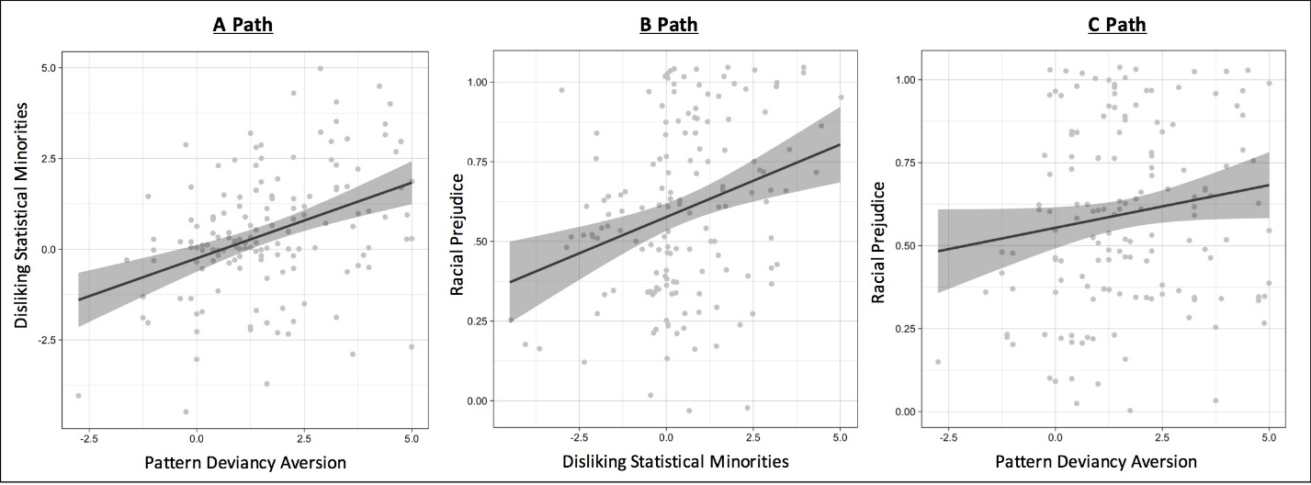
Figure S3. Correlations between key variables – pattern deviancy aversion, disliking statistical minorities, and racial prejudice against Black individuals – in Study S3; Error bars: ± 1 SE.

A significant mediation was found (Table S3). This analysis indicated that approximately 70% of the relationship between pattern deviancy aversion and racial prejudice is accounted for by disliking statistical minorities – disliking people who are uncommon in a population. This indirect relationship remained when controlling for participants’ power judgments (Table S3).

Table S3
Mediation Analyses in Study S3: The Relationship Between Pattern Deviancy Aversion and Racial Prejudice was Mediated by Disliking Statistical Minorities.

 | Predictor Variable | Mediator | Dependent Variable
Study S3 (N = 150) | Pattern Deviancy Aversion | Disliking Statistical Minorities | Racial Prejudice
Total Effect | B = .026, SE = .014, 95% CI: [-0.001, 0.053]  B = .027, SE = .014, 95% CI: [-0.002, 0.55]^{c}
Direct Effect | B = .008, SE = .014, 95% CI: [-0.021, 0.036]  B = .010, SE = .014, 95% CI: [-0.018, 0.039]^{c}
Indirect Effect | B = .018, SE = .007, 95% CI: [0.007, 0.034]  B = .016, SE = .007, 95% CI: [0.005, 0.032]^{c}

Note. ^{c} = controlling for participants’ power judgments. B = unstandardized estimate. SE = Standard Error. CI = Confidence Interval.

Study 1.1
Methods
Attention Check. Participants completed an ‘indirect’ attention check item (included in all studies except Studies 1.2 and S2 – the samples with children): “People vary in the amount they pay attention to these kinds of surveys. Some take them seriously and read each question, whereas others go very quickly and barely read the questions at all. If you have read this question carefully, please write the word yes in the blank box below labeled other. There is no need for you to respond to the scale below.” Participants were then presented with a Likert scale (1 to 7) as well as a blank text box labeled “other.” Only participants who wrote “yes” in the blank text box were included in the analyses. The same attention check was included in all other reported studies (except the studies with children).
Results
Pattern deviancy aversion. Pattern deviancy aversion on the geometric shapes measure was calculated by reverse-coding and averaging participants’ liking of broken patterns, M = 4.92, SD = 1.28, ω = .89. We also reverse-coded and averaged participants’ liking of the unbroken patterns, M = 2.94, SD = 1.12, ω = .86. As in Studies S1 and S3, participants exhibited pattern deviancy aversion – they disliked the unbroken patterns less than the broken ones (see Table S4). Pattern deviancy aversion on the non-visual explicit terms and the mental imagery measures was calculated by reverse-coding and averaging across the three response items to each measure, M = 4.93, SD = 1.60, ω = .86, and M = 4.30, SD = 1.70, ω = .96, respectively.
Disliking minorities. We averaged responses to the liking and identity items across the six planets, minority: M = 4.05, SD = 1.27, ω = .94; majority: M = 4.75, SD = 1.16, ω = .94. We then subtracted participants’ responses towards the minority from their responses towards the majority, M = 0.69, SD = 1.70, ω = .94. Participants preferred the novel majorities compared to the novel minorities (Table S4).
Power judgments. We averaged participants’ responses to the ‘in charge’ item across the six planets, minority: M = 3.13, SD = 1.50, ω = .90; majority: M = 5.32, SD = 1.34, ω = .89. We then subtracted their minority in charge scores from their majority in charge scores, difference score: M = 2.19, SD = 2.46, ω = .93. Participants judged novel majorities as having greater power than novel minorities (see Table S4).
Racial prejudice. We reverse-coded and averaged participants’ responses to the eight images depicting Black individuals, M = 4.13, SD = 1.24, ω = .98, and the eight images depicting White individuals, M = 4.01, SD = 1.11, ω = .98 (3 items per image). Participants exhibited prejudice – they preferred White over Black individuals (see Table S4).

Table S4
Main Effects of Studies 1.1 and 1.2.
Study 1.1 (N = 368) | Paired Samples t-test
Pattern Deviancy Aversion (Geometric Shapes Measure) | t(367) = 20.98, p < .001, d = 1.09
Disliking Statistical Minorities | t(367) = 7.84, p < .001, d = 0.41
Statistical Majorities in Power | t(367) = 17.08, p < .001, d = 0.89
Racial Prejudice | t(367) = 2.83, p = .005, d = 0.15
Study 1.2 (N = 58) | One Sample t-test
Pattern Deviancy Aversion | t(57) = 3.72, p < .001, d = 0.49
Disliking Statistical Minorities | t(57) = 2.35, p = .022, d = 0.31
Statistical Majorities in Power | t(57) = 0.79, p = .433, d = 0.10
Racial Prejudice | t(57) = 3.73, p < .001, d = 0.49

Note. Significance tests in Study 1.1 are paired samples t-tests. Significance tests in Study 1.2 are means compared to chance: .5 given that the relevant variables were assessed in a binary manner.

Study 1.2
Results
Pattern deviancy aversion. We calculated pattern deviancy aversion as in Study S2, M = 0.66, SD = 0.32, ω = .96. Replicating Study S2 and Gollwitzer and colleagues (2017), children exhibited pattern deviancy aversion (see Table S4).
Disliking minorities. We calculated participants’ dislike of novel minorities as in Study S2, M = 0.58, SD = 0.25, ω = .89. In line with past research (e.g., Primi & Agnoli, 2002), children exhibited a dislike of novel minorities – they preferred the novel majorities over the novel minorities (see Table S4).
Power. We calculated power judgments as we calculated participants’ disliking of minorities, M = .54, SD = .36, ω = .96. Unlike adults in Study 1.1, children did not judge the majority as having greater power than the minority (Table S4).
Racial prejudice. We calculated prejudice as in Study S3, M = 0.61, SD = 0.23, α =.50. Replicating past studies documenting explicit prejudice against Black individuals in young children (e.g., Aboud, 1988; Dunham et al., 2008), children exhibited prejudice (Table S4).
Notably, in Study 1.2, unlike in Studies 1.1 and S3, the internal consistency of the prejudice items was low (we could not compare this value to past research on children’s racial prejudice because we could not find these values reported in past studies). This low reliability may have occurred due to children’s responses being noisier than adults’ responses. These results suggest that future studies examining prejudice against Black individuals in children should include measures with a larger number of trials. Either way, though, low internal-consistency does not negate the relationships observed here and, if anything, suggests that the actual effect-sizes of these relationships are larger than documented.
Studies 1.3 and 1.4
Pattern deviancy manipulation. In Studies 1.3 and 1.4, the images presented at the bottom of the manipulation prompt were of two broken geometric patterns (of the measure included in Studies 1.3 and 1.4 and Study 2.1 (see Figure S4). After the first part of the pattern deviancy manipulation prompt (see main text), participants were prompted to imagine and reflect on the negative (positive) aspect of pattern deviancy:
“We would now like you to engage in a thought experiment. This is an exercise where you are supposed to experience your thoughts in vivid detail. Try to truly feel and experience your thoughts. Please relax and we will begin. RELAX: Please close your eyes and relax your muscles. Breath in and out deeply three times. Let your arms and legs become heavy. Feel how your heart rate is decreasing and your body is becoming relaxed. IMAGINE: Think about the negative (positive) attributes of things that break a pattern, are out of line, and create disorder. How do these negative (positive) attributes make you feel? Really think about how negatively (positively) you feel about things that break a pattern, are out of line, and create disorder. Record your feelings below.”
The manipulation was refreshed before participants completed the disliking minorities measure. Studies 1.3 and 1.4: “As you answer the following questions, please keep thinking about how you feel/think about things that break a pattern, are out of line, and create disorder. You said the following about such things: Participants’ response to the manipulation prompt was piped in here.”

Figure S4. The broken pattern images depicted in the pattern deviancy aversion manipulation
Prejudice. In Study 1.4, prejudice was assessed via a race IAT (Greenwald et al., 1998). The labels were African-American and Caucasian. The positive words were Joy, Love, Peace, Wonderful, Pleasure, Good, and Laughter. The negative words were Agony, Terrible, Horrible, Nasty, Bad, Awful, and Failure. Before completing the IAT, participants in the high (low) pattern deviancy aversion condition were asked to write, “I am going to remember the negative (positive) things I said about things that break a pattern, are out of line, and create disorder while I complete the task.” Further, while completing the IAT, participants in the high (low) pattern deviancy aversion condition were presented with the following prompt (presented above the IAT): “As you complete the task please remember and think about the horrible, awful, and bad (pleasurable, wonderful, and good) aspects of things that break a pattern, are out of line, and create disorder.” Participants scores on the IAT were calculated using the updated IAT scoring algorithm (Greenwald, Nosek, & Banaji, 2003).
In both studies, the manipulation was again refreshed before participants completed the prejudice measure. Studies 1.3 and 1.4: “As you answer the following questions, please keep thinking about how you feel/think about things that break a pattern, are out of line, and create disorder. You said the following about such things: Participants’ response to the manipulation prompt was piped in here.”
Criminality stereotype. We also included a stereotype item in Study 1.3 for exploratory reasons: “This person is unlikely to be a criminal” 1 = Not at all agree to 7 = Strongly agree.
Attention check and demographics. Participants completed three attention checks. First, the attention check from Study 1.1. Second, we included an item testing participants on what they had been asked to come up with earlier in the study (“Negative attributes of things/objects that break a pattern, are out of line, and create disorder,” “Positive attributes of things/objects that break a pattern, are out of line, and create disorder,” or “I don’t remember.”). Participants were also asked how someone whose name is Anton would respond to the following question: “What is your name?” (“Anton,” “Ben,” or “Jasmine”). Participants who failed one or more of these attention checks were excluded from the analysis.
Results
In both studies, the mediation model was not moderated by participants’ power judgments, political orientation, age, or sex. All 95% CIs. Power judgments: Study 1.3 (-0.005, 0.024), Study 1.4 (-0.001, 0.024). Political orientation: Study 1.3 (-0.006, 0.029), Study 1.4 (-0.007, 0.020). Age: Study 1.3 (-0.001, 0.004), Study 1.4 (-0.002, 0.003). Sex: Study 1.3 (-0.089, 0.046), Study 1.4 (-0.024, 0.092).
Notably, specifically in Study 1.3, while pattern deviancy aversion did marginally impact racial prejudice, pattern deviancy aversion did not influence judgments of the criminality of Black compared to White individuals, p = .495. This finding potentially aligns with stereotypes and prejudice differing in important ways (e.g., ‘model’ minorities; see Lee, 2015).
Study S4
Methods
Design. Study S4 was identical to Study 1.3, except racial prejudice was assessed in a binary manner. Prejudice was assessed via the binary prejudice measure included in Studies 1.1 and 1.2.
Participants. The power-analysis of Studies 1.3 and 1.4 was applied. We recruited 367 participants (224 female; M_{age} = 37.25, SD_{age} = 12.36). 22 participants were excluded for failing one or more of the attention check items. Of the final participants in Study S4, 23 identified as Asian/Asian American, 17 as Black/African American, 21 as Latino/Hispanic, 270 as White/European American, 4 as Other, and 10 as More than one race.
Results
The pattern deviancy manipulation successfully altered participants’ pattern deviancy aversion. Replicating Studies 1.3 and 1.4, participants in the high (versus low) pattern deviancy aversion condition reported greater dislike of novel statistical minorities as compared to novel statistical majorities (A path). This effect remained when controlling for participants’ power judgments (Table S5). Additionally, disliking novel statistical minorities related to racial prejudice (B path), r(343) = .13, p = .016. As in Studies 1.3 and 1.4, we did not find a total effect of pattern deviancy aversion on racial prejudice.
Replicating Studies 1.3 and 1.4, we did, however, find that the effect of pattern deviancy aversion on racial prejudice was mediated by disliking novel statistical minorities. This mediation analyses remained significant when controlling for participants’ power judgments (Table S6). Finally, the mediation model was not moderated by participants’ power judgments, political orientation, age, or sex. All 95% CIs. Power judgments: -0.0003, 0.009. Political orientation: -0.006, 0.002. Age: -0.0008, 0.0004. Sex: -0.013, 0.019.

Table S5
Studies S4 and S5. Effects of Pattern Deviancy Aversion Manipulation on Disliking Statistical Minorities and Racial Prejudice (Prejudice Against Black Individuals).
 | High Pattern  Deviancy Aversion  (M and SD) | Low Pattern  Deviancy Aversion  (M and SD) | Significance Test
Study S4 | n = 164 | n = 181
Manipulation check
Pattern Deviancy Aversion | 2.58, 1.88 | 0.56, 2.15 | F(1, 343) = 84.97, p < .001, ηp² = .199
Mechanism
Disliking Statistical Minorities | 0.51, 1.79 | -0.29, 1.81 | F(1, 343) = 17.18, p < .001, ηp² = .048
Disliking Statistical Minorities ^{c} | 0.47,1.73 | -0.25, 1.72 | F(1, 342) = 14.78, p < .001, ηp² = .041
Dependent Variable
Racial Prejudice (Binary) | 0.54, 0.24 | 0.53, 0.26 | F(1, 343) = 0.37, p = .545, ηp² = .001
Study S5 | n = 103 | n = 96
Manipulation check
Pattern Deviancy Aversion | 3.47, 1.51 | -0.15, 3.30 | F(1, 197) = 100.99, p < .001, ηp² = .339
Mechanism
Disliking Statistical Minorities | 0.76, 0.37 | 0.51, 0.46 | F(1, 197) = 17.88, p < .001, ηp² = .083
Dependent Variable
Racial Prejudice (Binary) | 0.46, 0.27 | 0.40, 0.29 | F(1, 197) = 2.48, p = .117, ηp² = .012
Note. ^{c} = controlling for participants’ power judgments.

 | Predictor Variable | Mediator | Dependent Variable
Study S4 (n = 345) | Pattern Deviancy Aversion | Disliking Statistical Minorities | Racial Prejudice
Total Effect | B = .017, SE = .027, 95% CI: [-0.037, 0.071]  B = .017, SE = .028, 95% CI: [-0.037, 0.072]^{c}
Direct Effect | B = .002, SE = .028, 95% CI: [-0.053, 0.057]  B = .003, SE = .028, 95% CI: [-0.052, 0.058]^{c}
Indirect Effect | B = .014, SE = .008, 95% CI: [0.002, 0.031]  B = .015, SE = .007, 95% CI: [0.003, 0.030]^{c}
Table S6
Mediation Effects in Studies S4 and S5: Pattern Deviancy Aversion’s Effect on Racial Prejudice was Mediated by Disliking Statistical Minorities.
Study S5 (n = 199) | Pattern Deviancy Aversion | Disliking Statistical Minorities | Racial Prejudice
Total Effect | B = .063, SE = .040, 95% CI: [-0.016, 0.141]
Direct Effect | B = .030, SE = .041, 95% CI: [-0.051, 0.110]
Indirect Effect | B = .033, SE = .015, 95% CI: [0.007, 0.066]

Note. ^{c} = controlling for participants’ power judgments. B = unstandardized estimate. SE = Standard Error. CI = Confidence Interval.

Study S5
Study S5 was largely identical to Study 1.3, except, that we manipulated pattern deviancy aversion in a motivational rather than descriptive manner. We conducted Study S5 so we could compare the results of Studies 2.2 and 2.3 (which applied a motivational manipulation) and assessed prejudice against stigmatized individuals with the racial prejudice results of Studies 1.3 and 1.4.
Methods
Design. Participants were motivationally induced to generate either negative or positive aspects of nonsocial pattern deviancy (between-subjects: high versus low pattern deviancy aversion). We then assessed participants’ dislike of novel statistical minorities compared to majorities (mediator), and thereafter their prejudice against Black people.
Participants. The power-analysis of Studies 1.3 and 1.4 was applied. We recruited 268 participants (168 female, M_{age} = 35.40, SD_{age} = 11.49). 69 participants were excluded for failing one or more of the attention check items. Of the final participants in Study S5, 19 identified as Asian/Asian American, 17 as Black/African American, 17 as Latino/Hispanic, 137 as White/European American, 3 as Other, and 6 as More than one race.
Pattern deviancy manipulation. In Study S5, we manipulated pattern deviancy aversion in a motivational rather than a descriptive manner. Goals generally remain active and intrude on current tasks and judgments until goal-attainment is achieved (e.g., Förster, Liberman, & Friedman, 2007; Förster, Liberman, & Higgins, 2005; Klinger, 1975; Martin & Tesser, 1989; Masicampo & Baumeister, 2011). Thus, we induced the goal to evaluate pattern deviancy as negative (positive) and while this goal was active – goal-attainment had not yet occurred – participants completed the disliking statistical minorities and racial prejudice measures.
To induce the respective goals (depending on condition), participants were told that they would receive a potential reward for coming up with a large amount of either (1) negative attributes of pattern deviancy and positive attributes of unbroken patterns (high pattern deviancy condition), or (2) positive attributes of pattern deviancy and negative attributes of unbroken patterns (low pattern deviancy condition). We added ‘positive attributes of unbroken patterns’ (high pattern deviancy aversion condition) and ‘negative attributes of unbroken patterns’ (low pattern deviancy aversion condition) to the manipulation prompts to account for potential valence differences depending on condition (the condition prompts of Studies 1.3 and 1.4 differed in terms of valence: negative versus positive).
High pattern deviancy aversion. Participants in the high pattern deviancy aversion condition read and responded to the following prompt:
“This survey includes a task or 'game' in which you have to come up with negative attributes about things/objects that break a pattern, are out of line, and create disorder, and positive attributes about things/objects that follow a pattern, are in line, and create order. Later in this survey you will have to report what you have come up with. If you come up with 75% more negative aspects of things that break a pattern, are out of line, and create disorder, and positive aspects of things that follow a pattern, are in line, and create order than the other participants in this survey you will be entered into a raffle to win a prize.”
High pattern deviancy aversion: Attention Check. Participants then answered two attention check items, each with the following prompt: “What is one of the things you will have to come up with later in this survey?” The response options to the first item were: 1 = Positive attributes about things/objects that break a pattern, 2 = Neutral attributes about things/objects that break a pattern, 3 = Negative attributes about things/objects that break a pattern. The response options to the second item were: 1 = Positive attributes about things/objects that follow a pattern, 2 = Neutral attributes about things/objects that follow a pattern, 3 = Negative attributes about things/objects that follow a pattern. Only participants who answered both these items correctly (according to their condition) were included in the analysis.
High pattern deviancy aversion: Motivation. Participants in the high pattern deviancy aversion condition then reported how strongly they agreed with the following statement: “I feel motivated to come up with negative attributes about things that break a pattern, and positive attributes about things that follow a pattern.” Likert-scale: 1 = Not at all agree to 7 = Strongly agree.
High pattern deviancy aversion: Follow-up prompt. Finally, participants in the high pattern deviancy aversion condition read the following prompt:
“Please answer the following 3 sets of questions. Immediately after answering these questions, you will need to report the negative attributes of things that break a pattern, are out of line, and create disorder, and the positive attributes of things that follow a pattern, are in line, and create order that you have come up with. You will only have a limited time to do so, so you should try to come up with these attributes while you answer the following questions.”
High pattern deviancy aversion: Reminder prompts. Before completing each of the dependent variables – the minority group aversion measure, the prejudice measure, and the pattern deviancy aversion measure (manipulation check) – participants read the following prompt to remind them of their active goal: “Questions: Set (1, 2, or 3) of 3. REMEMBER: Try to come up with negative attributes of things that break a pattern and positive attributes of things that follow a pattern while you answer the following questions.”
Low pattern deviancy aversion. Participants in the low pattern deviancy aversion condition read the identical prompts as those in the high pattern deviancy aversion condition except the word ‘positive’ was replaced with the word ‘negative’ and the word ‘negative’ was replaced with the word ‘positive.’
Disliking statistical minorities. In Study S5, we assessed participants’ dislike of statistical minorities in a binary manner. Participants saw three planets and the minority and majority inhabitants on these planets and were asked: “Which people do you consider more negative” 0 = Majority, 1 = Minority. Unlike Study-set 1 and 2, we assessed participants’ negative evaluation to ensure that our findings replicate across valence. Given the results of Studies 1.3, 1.4 and S4, Study S5 did not assess power judgments.
Racial prejudice. Racial prejudice was assessed as in Study S4, but the response items were altered to be negatively valanced “Which person do you consider more negative?” 0 = White individual, 1 = Black individual.
Manipulation check: Pattern deviancy aversion. The pattern deviancy aversion manipulation check was as in Studies 1.3, 1.4, and S4, except the items were altered to assess negative attitude: “How negative is the above image.”
Attention check. The attention check items (4 in total), included the attention check items from Studies 1.3 and 1.4 (adapted appropriately), as well as the attention check assessed directly after the first manipulation prompt noted earlier.
Procedure. The procedure was as in Studies 1.3, 1.4, and S4.
Results
The pattern deviancy manipulation successfully altered participants’ pattern deviancy aversion. Replicating Studies 1.3, 1.4, and S4, participants in the high (versus low) pattern deviancy aversion condition reported greater dislike of novel statistical minorities as compared to novel statistical majorities (A path). This effect remained when controlling for participants’ power judgments (Table S5). Additionally, disliking novel statistical minorities related to racial prejudice (B path), r(197) = .22, p = .002. Again, we did not, however, find a total effect of pattern deviancy aversion on racial prejudice.
Replicating Studies 1.3, 1.4, and S4, we did, however, find that the effect of pattern deviancy aversion on racial prejudice was mediated by disliking novel statistical minorities (Table S6). The mediation model was not moderated by participants’ political orientation, age, or sex. All 95% CIs. Political orientation: -0.009, 0.008. Age: -0.0007, 0.002. Sex: -0.032, 0.036.
Arguing against demand effects, participants’ self-reported motivation to generate positive (negative) aspects of broken patterns and negative (positive) aspects of unbroken patterns neither related to their dislike of statistical minorities nor their level of prejudice, ps > .207. These latter findings align with research indicating that goal pursuit is often guided by nonconscious processes (Bargh, 2007; Bargh, Gollwitzer, Lee-Chai, Barndollar, & Trötschel, 2001; Bargh & Morsella, 2008).
Meta-Analysis of Studies 1.3 and 1.4 and Studies S4 and S5
A meta-analysis of the findings of Studies 1.3, 1.4, S4, and S5 did not demonstrate a convincing total effect of pattern deviancy aversion on racial prejudice, combined z = .171, p = .087. The estimated effect size was very small: weighted: r = .07, unweighted: r = .05.
Study 2.1
Methods
Prejudice. Participants reported how much they like someone transgender, someone who is a highly committed Muslim, someone mentally handicapped, and someone homeless. Specifically, for example, they read, “Imagine someone who is transgender. Really try to picture this person in your mind’s eye” 1 = I do not like this person to 7 = I like this person (reverse-coded; randomized).
Results
Pattern deviancy aversion. We calculated pattern deviancy aversion for each of the three included measures by averaging participants’ responses (reverse-coded when appropriate). Geometric shapes pattern deviancy aversion measure: M = 5.03, SD = 1.22, ω = .87. Explicit terms pattern deviancy aversion measure: M = 5.05, SD = 1.41, ω = .92. Mental imagery pattern deviancy aversion measure: M = 4.57, SD = 1.60, ω = .94. We then averaged participants’ scores on these three measures to create a single pattern deviancy aversion score for each participant, M = 4.88, SD = 1.20. This was deemed appropriate because the three measures strongly loaded on a single factor (Eigenvalue of 2.18; Principle Axis Factor Analysis) and exhibited good reliability, ω = .81.
Disliking statistical minorities. Participants disliking of statistical minorities on the visual measure was calculated by averaging participants’ responses to the liking and identity items across the three planets, minority: M = 4.30, SD = 1.22, ω = .95; majority: M = 4.90, SD = 1.16, ω = .95. We then subtracted participants’ responses towards the minority from their responses towards the majority, M = 0.60, SD = 1.37, ω = .94. Regarding the non-visual measure, we reverse-coded and averaged across the three items to represent disliking minorities, M = 2.87, SD = 1.29, ω = .94. Finally, we averaged across the visual and non-visual measures, M = 1.73, SD = 1.07.
Racial prejudice. We averaged participants’ positive responses to the 10 images depicting deviant individuals, M = 3.79, SD = 1.33, ω = .95, and the 10 images depicting ‘normal’ individuals, M = 5.33, SD = 1.07, ω = .96. We then subtracted participants’ positive evaluation of deviant people from their positive evaluation of ‘normal’ people to represent prejudice, M = 1.54, SD = 1.32. For the non-visual measure, we reverse-coded and averaged across the 4-prejudice items, M = 3.34, SD = 1.32, ω = .89. Finally, we averaged across the two measures, M = 2.44, SD = 1.11.
Studies 2.2 and 2.3
Materials
Pattern deviancy aversion manipulation. The pattern deviancy aversion manipulation of Study 2.2 was almost identical to Study S5, except that we added the following text after the follow-up prompt depending on condition.
High pattern deviancy aversion:
“Start thinking of negative words that are associated with things that break a pattern (e.g., disruptive), and positive words that are associated with things that follow a pattern (e.g., organized).”

Low pattern deviancy aversion:
“Start thinking of positive words that are associated with things that break a pattern (e.g., exciting), and negative words that are associated with things that follow a pattern (e.g., boring).”

Reminder prompts. The reminder prompts included in Studies 1.3 and 1.4 were removed, except for the reminder prompt directly after the manipulation. We did so to reduce potential demand effects, and further, because making the manipulation salient before each of the dependent variables induces pattern deviancy aversion again directly before the final dependent variable (prejudice). Inducing pattern deviancy aversion again before assessing prejudice may be an issue because participants’ prejudice may have been impacted by the refreshed pattern deviancy manipulation rather than by disliking minorities as our proposed mediation model would require.
In Study 2.3, the manipulation was identical to Study 2.2 except for the addition of a third between-subjects condition in which we intervened on the proposed mediator. Specifically, in this new condition, we induced pattern deviancy aversion as in the high pattern deviancy aversion condition and thereafter prompted participants to reflect and report on the positive aspects of minorities (before the disliking minorities measure):
“Important: Before you continue, please imagine the positive aspects of minority groups. That is, please think about the positive attributes of small groups of people that deviate from the majority in a society (e.g., unique, special, exciting). Really try to think of the positive attributes of minority groups and their members and how you feel warmly towards such groups and their members. Record your thoughts below (minimum 3 words; maximum 15 words):”

Results

For visual representations of the results of Studies 2.2 and 2.3 see Figures S5 through S8 below. In Studies 2.2 and 2.3, none of the calculated indirect effects were moderated by participants’ political orientation, 95% CI [-0.114 to -0.043, 0.042 to .094], age 95% CI [-0.028 to -0.018, 0.004 to .016], or sex, 95% CI [-0.396 to -0.213, 0.282 to .430].

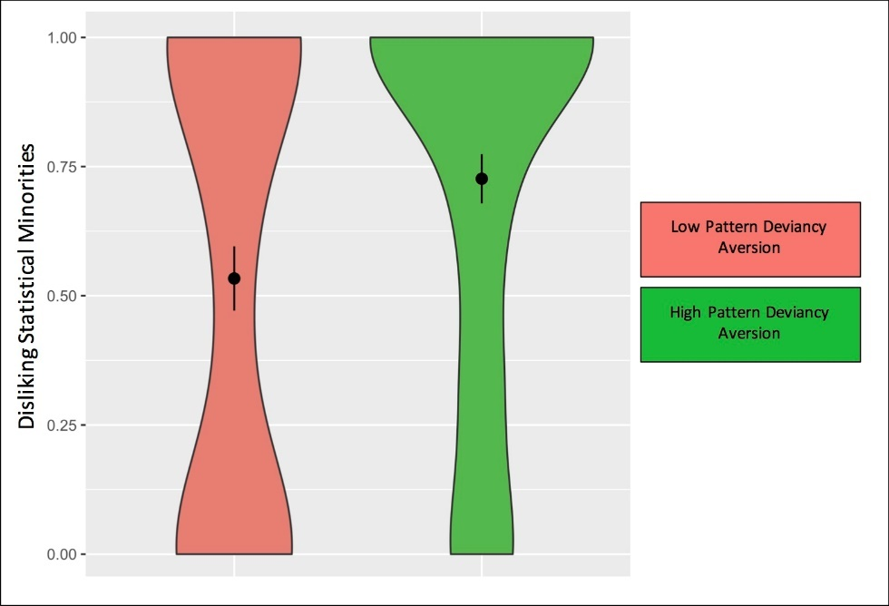

Figure S5. Study 2.2: Violin plots of participants’ dislike of statistical minorities as a function of pattern deviancy aversion manipulation – either low pattern deviancy aversion (salmon) or high pattern deviancy aversion (green); error bars: ± 1 SE.
.

Figure S6. Study 2.2: Violin plots of participants’ prejudice against stigmatized individuals as a function of pattern deviancy aversion manipulation – either low pattern deviancy aversion (salmon) or high pattern deviancy aversion (green); error bars: ± 1 SE.

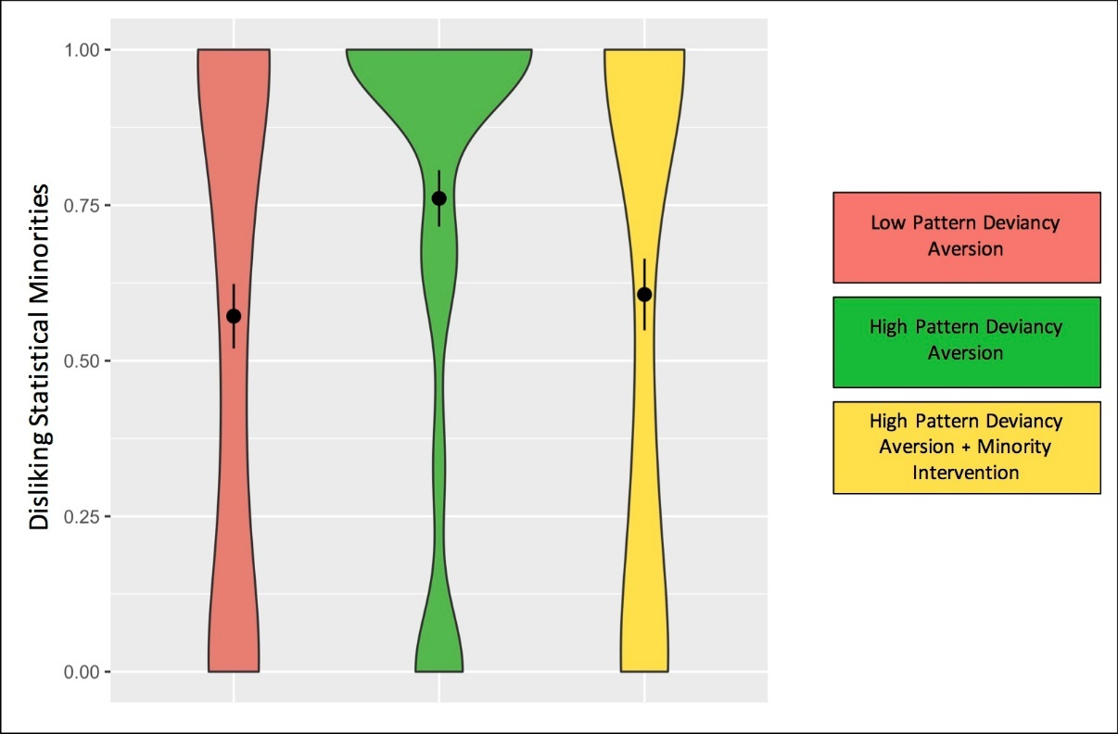
Figure S7. Study 2.3: Violin plots of participants’ dislike of statistical minorities as a function of pattern deviancy aversion manipulation – either low pattern deviancy aversion (salmon), high pattern deviancy aversion (green), or high PDA plus minority intervention (yellow); error bars: ± 1 SE.
Figure S8. Study 2.3: Violin plots of participants’ prejudice against stigmatized individuals as a function of pattern deviancy aversion manipulation – either low pattern deviancy aversion (salmon), high pattern deviancy aversion (green), or high PDA plus minority intervention (yellow); error bars: ± 1 SE.
Specific prejudice images. We conducted a repeated measures GLM to examine whether pattern deviancy aversion differently influenced the prejudice items in Study-set 2. We did not find such effects in either Study 2.2, p = .880, or Study 2.3, p = .274. We did, however, find an interaction for Study 2.1 (perhaps due to the high power of the study), p = .012. Further analyses revealed that pattern deviancy aversion related significantly to all the images of deviant individuals except for one of someone handicapped (in terms of having missing limbs), r = .02, p = .705, and one of someone with a skin condition, r = .05, p = .475. However, pattern deviancy aversion did relate significantly to a different image of an individual with a skin condition, r = .20, p = .002. Given that these analyses were exploratory, were observed in only one of three studies, and that no evident explanation existed for these differing results we recommend that future research examine these potential differences.
Study 3.1
Results
Pattern deviancy aversion. Pattern deviancy aversion was calculated as in Studies 1.1 and 2.1. We calculated pattern deviancy aversion for each of the three included measures by averaging participants’ responses (reverse-coded when appropriate). Geometric shapes pattern deviancy aversion measure: M = 4.89, SD = 1.27, ω = .82. Explicit terms pattern deviancy aversion measure: M = 4.58, SD = 1.41, ω = .79. Mental imagery pattern deviancy aversion measure: M = 4.12, SD = 1.42, ω = .76. We then averaged participants’ scores on these three measures to create a single pattern deviancy aversion score for each participant, M = 4.53, SD = 1.16. This was deemed appropriate because the three measures strongly loaded on a single factor (Eigenvalue of 2.17; Principle Axis Factor Analysis) and exhibited good reliability, ω = .82.
Participants disliking of statistical minorities was calculated by reverse-coding (1 = Liking the Majority/Disliking the Minority, 0 = Liking the Minority/Disliking the Majority) and averaging across all of participants’ responses to the 6 countries, M = 0.62, SD = 0.36, ω = .99 (higher numbers indicate greater disliking of statistical minorities. Group size dependent racial prejudice was calculated by averaging participants’ responses to the 3 countries depicting Black people as the minority, 1 = Disliking the Black people, 0 = Disliking the White people, M = 0.66, SD = 0.40, ω = .99, and averaging participants’ responses to the 3 countries depicting Black people as the majority, 1 = Disliking the Black people, 0 = Disliking the White people, M = 0.41, SD = 0.42, ω = .99.
Study 3.2
Results
Pattern deviancy aversion. As in Study 3.1, we calculated pattern deviancy aversion for each of the three included measures by averaging participants’ responses (reverse-coded when appropriate). Geometric shapes pattern deviancy aversion measure: M = 5.04, SD = 1.21, ω = .87. Explicit terms pattern deviancy aversion measure: M = 4.55, SD = 1.47, ω = .83. Mental imagery pattern deviancy aversion measure: M = 4.13, SD = 1.51, ω = .84. We then averaged participants’ scores on these three measures to create a single pattern deviancy aversion score for each participant, M = 4.57, SD = 1.24. This was deemed appropriate because the three measures strongly loaded on a single factor (Eigenvalue of 2.35; Principle Axis Factor Analysis) and exhibited good reliability, ω = .87.
Participants disliking of statistical minorities was calculated by reverse-coding (1 = Liking the Majority/Disliking the Minority, 0 = Liking the Minority/Disliking the Majority) and averaging across all of participants’ responses to the 2 countries, M = 0.54, SD = 0.24, ω = .96 (higher numbers indicate greater disliking of statistical minorities. Group size dependent prejudice was participants’ averaged responses to the country depicting people wearing Burkas as the minority, 1 = Disliking the people wearing Burkas, 0 = Disliking the people not wearing Burkas, M = 0.84, SD = 0.33, α = .82, and participants’ averaged responses to the country depicting people wearing Burkas as the majority, 1 = Disliking the people wearing Burkas, 0 = Disliking the people not wearing Burkas, M = 0.76, SD = 0.40, α = .87.
Participants’ Racial Identity Across the Reported Studies
It is important to consider that participants’ racial identity may moderate psychological findings, especially in terms of prejudice (Brown, 1995; Henrich, Heine, & Norenzayan, 2010; Nielsen, Haun, Kärtner, & Legare, 2017). Unfortunately, each of our individual studies only included a small number of participants of minority racial identity (e.g., Black, Asian). Therefore, we collapsed across the reported studies, including Studies S3, S4, and S5, but excluding Studies 1.2, 3.1, and 3.2. We then examined whether participants’ minority versus majority identity moderated any of the reported results (Path A, Path B, Path C).
To collapse across the reported studies, we z-scored each of the variables of interest within each study: pattern deviancy aversion, disliking minorities, and prejudice in the correlational studies, and the latter two variables in the experimental studies. We then entered these values into a single data file so that all participants across the studies were represented in the single data file. For the experimental studies we also entered condition (0 = low pattern deviancy aversion, 1 = high pattern deviancy aversion). The high pattern deviancy aversion plus mediator intervention condition of Study 2.3 was not included. To be able to examine the links between pattern deviancy aversion and disliking minorities and prejudice across the correlational and experimental studies we coded participants who exhibited pattern deviancy aversion above the mean in the correlational studies (z-score above zero) as being in the high pattern deviancy aversion condition, and those who exhibited pattern deviancy aversion below the mean (z-score below zero) as being in the low pattern deviancy aversion condition.
Study S6
In a supplemental study we examined whether people judge stigmatized individuals (e.g., someone handicapped) as more pattern deviant in society than Black individuals. Such results may help explain why we found a stronger effect of pattern deviancy aversion on prejudice against stigmatized individuals than on racial prejudice against Black individuals.
Method
Design. We assessed participants’ judgments regarding the pattern deviancy of stigmatized versus ‘normative’ individuals in society, and participants’ judgments regarding the pattern deviancy of Black individuals versus White individuals in society. We then compared these judgments.
Participants. We recruited 99 adults on MTurk (50 female; M_{age} = 35.94, SD_{age} = 10.85). Seven participants were excluded for failing an attention check (the same attention check included in all other conducted studies [with adults]). Of the final participants in Study S6, 9 identified as Asian/Asian American, 10 as Black/African American, 6 as Latino/Hispanic, 62 as White/European American, and 5 as More than one race.
Judging stigmatized individuals as pattern deviant. We assessed participants’ judgment of stigmatized individuals (compared to ‘normative’ individuals) as pattern deviant in society using the 20 images included in Study-set 2. Ten of these images depicted ‘normative’ individuals, and the other 10 depicted individuals commonly stigmatized in society (e.g., someone handicapped, someone with a skin condition, someone dressed as a furry, someone crossdressing, someone wearing a hijab). Unlike Study-set 2, we presented pairs of these images to participants; each pair showed one of the ‘normative’ individuals and one of the stigmatized individuals (side of the screen was counter-balanced). We did so to match the presentation format of Black/White people deviancy measure. In response to each of these 10 pairs, participants responded to the following item: “Regarding the two people above, which person would society say is more likely to break a pattern and be out of line.” 0 = The ‘normative’ person to 1 = The stigmatized person.
Judging Black people as deviant. We assessed participants’ judgment of Black individuals (compared to White individuals) as pattern deviant in society using the 16 images included in Study-set 1. Echoing the prejudice against stigmatized individuals measure, these images were presented in pairs (one White person, one Black person) and participants responded to the following item: “Regarding the two people above, which person would society say is more likely to break a pattern and be out of line.” 0 = The White person to 1 = The Black person.
Results
Participants judged stigmatized individuals as more pattern deviant in society than ‘normative’ individuals, t(91) = 15.77, p < .001, d = 1.64. They also judged Black individuals as more pattern deviant in society than White individuals, t(91) = 4.36, p < .001, d = 0.45. Importantly, the former effect was approximately 3x large than the latter: Participants were more likely to judge stigmatized individuals (compared to ‘normative’ individuals) as pattern deviant in society, M = 0.83, SD = .20, than they were to judge Black individuals (compared to White individuals) as pattern deviant in society, M = 0.65, SD = .34, t(91) = 6.20, p < .001, d = 1.30. These findings may help explain why we found a substantial effect of pattern deviancy aversion on prejudice against stigmatized individuals but not on racial prejudice. That is, Black people are considered less pattern deviant in society than stigmatized individuals and thus, we observed a smaller effect of pattern deviancy aversion on racial prejudice.

References
Greenwald, A. G., Nosek, B. A., & Banaji, M. R. (2003). Understanding and using the implicit association test: I. An improved scoring algorithm. Journal of Personality and Social Psychology, 85, 197-216.
Lee, S. J. (2015). Unraveling the “model minority” stereotype: Listening to Asian American
youth. New York: Teachers College Press.

A portion of the sample (n = 68) was collected at an earlier date than the remaining participants. This occurred because an original, inaccurate power-analysis had been applied. The results did not meaningfully differ before and after the additional participants were collected.
We acknowledge that the binary pattern deviancy aversion measure assessed liking and not disliking of broken patterns versus unbroken patterns. However, we refer to adults’ and children’s preference for the unbroken pattern images as pattern deviancy aversion because on the continuous measure participants exhibited an aversion towards pattern deviancy compared to chance (their responses were higher than the midpoint on a scale on which higher scores indicated aversion).
We also asked participants “Who do others like more?” This item was not included in the analysis and was included for exploratory reasons.

