Supplemental Materials
for
“People believe that others have more voluntary control over their beliefs
than they, themselves do.”

Study 4 Coding Instructions

Introduction:

You are going to read and evaluate a series of statements written by a subject who was tasked with deciding how much voluntary control either they or another person has over a specific belief. Here, and below, “subject” refers to the person who wrote the statement you are coding; “believer” refers to the individual who held the belief (and to whom control is being attributed); this individual (the “believer”) could be the subject themselves, but it could also be another person depending on which condition subjects were assigned to (self vs. other, see above).

There were several different beliefs in the study that believers held. Each subject attributed belief control for one of these beliefs. Attributions of belief control were made in the following way. If the believer believed that, for instance, “Earth’s climate is warming due to human behavior,” then the subject rated how much they agreed with a statement that the believer could voluntarily change this belief. So, if the believer attributed belief control to another person, that means they rated their agreement or disagreement with the statement, “X voluntarily holds this belief. If X wanted to, he/she could choose to believe that Earth’s climate is not warming due to human behavior” (where “X” was substituted with the person’s initials). If the believer attributed belief control to themselves, that means they rated their agreement or disagreement with the statement, “I voluntarily hold this belief. If I wanted to, I could choose to believe that Earth’s climate is not warming due to human behavior.”

KEY TASK: After attributing control, each subject then wrote a statement in their own words reporting what they thought about while judging whether the believer has control over his (or her) belief. Your task is to evaluate what subjects wrote about in these statements.

For each statement, you will separately evaluate (1) whether the subject reported that they considered generic facts about belief control (i.e., general facts that do not pertain to the specific contents of the belief in question) and (2) whether the subject reported that they considered specific evidence held by the believer in favor of the belief. You will be provided with the belief in question but will not have access to any further information about the subject or the believer.

Coding Rules:

Separately evaluate each response in accordance with the following rules, keeping each code (1 or 0) in a separate column clearly marked “Generic Present” and “Evidence Present”, respectively. Each response should be coded either with a “1” or a “0”, and no other codes. Do not leave any columns blank; if you are unsure in any given case, make your best judgment.

GENERIC: Generic conception of belief control:
- If the subject writes something which states or presupposes a general statement about whether (a) beliefs (in general) are controllable, (b) beliefs (in general) are uncontrollable, (c) beliefs (in general) are chosen, or (d) beliefs (in general) are not chosen, indicate “1”. Otherwise indicate “0”. Subjects need not explicitly state that they are making a general statement about beliefs, but this should be implicit in their response.

EVIDENCE: Reasons or evidence supporting the belief:
- If the subject writes something which articulates (or alludes to the existence of) reasons, evidence, or arguments in support of the specific belief in question, indicate “1”. Otherwise indicate “0”. It should be implicit in the subject’s response that the believer is presently consciously aware of the reasons and evidence being described, but this need not be mentioned explicitly.

Notes for resolving potentially ambiguous cases:

- As long as any part of the subject’s response can be coded as either “Generic” or “Evidence” the response gets coded that way. This means that some responses can be coded as both “Generic” and “Evidence”. This also means that some responses can be coded as either “Generic” or “Evidence” (or both) even if other parts of the response would be not be coded as either.

- Regarding “Evidence”, what it means for reasons, evidence, or arguments to “support” the belief is that they suggest that the belief is true. Therefore, statements which cite (or allude to) reasons, arguments, or evidence which suggest the belief is not true should not be counted (i.e., they should instead be coded as “0”). Additionally, statements which suggest that a belief may be useful, morally right, or favorable in some other way that does not pertain to whether the belief is true, should not be counted (unless this information is also clearly intended as evidence for the belief).

- Regarding “Evidence”, a response can still be coded as “1” if it states reasons without also explicitly stating that the believer is aware of them. All that is required is that the context suggest that the reason (or arguments) are known to the believer. For example, this may be because those reasons originally motivated the believer to form the belief or because that information is common knowledge.

- Regarding “Evidence”, statements which cite information that the believer is not currently aware of, such as possible new discoveries, hypothetical arguments, or arguments that the subject is aware of but the believer is not aware of, should not be counted (i.e., they should instead be coded as “0”).

- Regarding “Evidence”, mark “1” any time the subject appears to assess the balance of evidence as supporting their current belief. For instance, if a subject wrote, “this belief is better supported than the other side” or “the other side has no support at all” this would be coded as “1”. (Note that the balance of evidence must be currently known and appreciated by the believer; see note “C” above.)

- Regarding “Evidence”, merely stating that one simply knows something to be true, that the belief simply is right, or objective, should not be counted as evidence. This is because statements must allude to some actual reasons or arguments in favor of the belief in order to count as evidence. In other words, bare statements of knowledge or objectivity that do not allude to reasons should not be counted as evidence (e.g., “X knows this is true.”) However, statements of knowledge or objectivity that do allude to such reasons / evidence should be counted as evidence (e.g., “X knows this is true because X has facts.”).

- Regarding “Generic”, the response may refer to the general controllability of beliefs for all or most people, or for the specific person under consideration (as long as that believer is not marked as any kind of exception, i.e., as having an unusually high or low degree of control over their beliefs). Similarly, a response that seems only to speak of the controllability of the specific belief in question should not be counted (i.e., it should instead be coded as “0”).

- Regarding “Generic”, responses stating that someone can or cannot be blamed for their belief, or that people are permitted or not permitted to hold certain beliefs, should not be counted. Permissibility is independent of control; people may be permitted to hold a given belief without having control over it. Likewise, people may not be permitted to hold a given belief, and yet lack voluntary control over it.

Public debates about belief control and responsibility
In the main text, we referenced a public debate about whether conservatives are properly held responsible for their beliefs. Megan McArdle argued that they are not, and therefore their treatment at the hands of liberals constitutes a form of prejudice. In a reply, Hamilton Nolan argued conservatives are legitimately held responsible for their beliefs because conservativism is a choice, and therefore conservatives could change their ideology at any time. We pointed out that the crux of this disagreement is whether conservatives (or anyone else) has voluntary control over their beliefs. However, McArdle does not explicitly write about belief control in her article. Instead, we attributed this belief to her based on public statements she made about her article upon its publication, available here: https://twitter.com/asymmetricinfo/status/984153783449026560. Below is a screenshot below of the most relevant section (Figure S1).

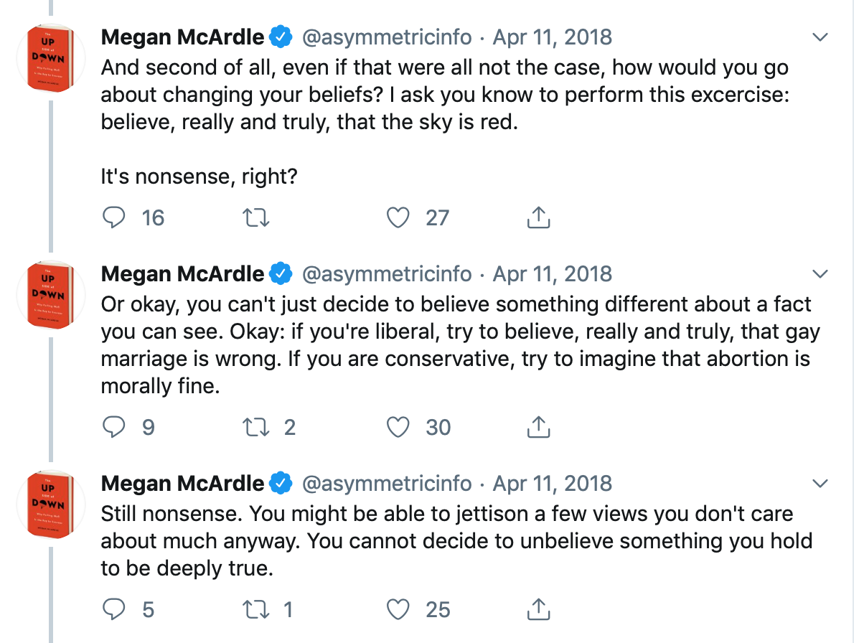
Figure S1. Screen capture of three statements that Megan McArdle posted to twitter accompany the publication of her article “Bias against conservatives works like any other prejudice”.

