Supplemental Materials

Indirect Effects of Positive and Negative Emotions for Flourishing Subscales

Emotional Well-Being.
Post-test. Analyses revealed direct effects of prosocial behavior on positive emotions, b = 0.21 p = .02, and negative emotions, b = -0.18, p = .06. In addition, the direct effects of positive emotions, b = 0.36, p < .0001, and negative emotions, b = -0.19, p < .0001, on emotional well-being at post-test were also significant (b paths). Furthermore, the bias-corrected 95% confidence intervals for the indirect effects of prosocial behavior through positive emotions [.02, .15] and negative emotions [.002, .08] did not contain zero.
Follow-up. Analyses revealed a direct effect of prosocial behavior on positive emotions, b = 0.23, p = .01, and negative emotions, b = -0.20, p = .04 (a paths). The direct effect of positive emotions, b = 0.31, p < .001 on emotional well-being at follow-up was also significant, but the parallel path for negative emotions was not significant, b = -.06, p = .24 (b paths). Furthermore, the bias-corrected 95% confidence interval for positive emotions [0.02, 0.15] did not cross zero.
Social Well-Being.
Post-test. Analyses revealed direct effects of prosocial behavior on positive emotions, b = 0.22 p = .03, and negative emotions, b = -0.19, p = .06. In addition, the direct effects of positive emotions, b = 0.36, p < .0001 on social well-being at post-test was also significant (b paths). However, the direct effect of negative emotions, b = -.08, p = .14, on post-test social well-being was not significant. Furthermore, the bias-corrected 95% confidence intervals for the indirect effect of prosocial behavior through positive emotions [.02, .16] did not contain zero.
Follow-up. Analyses revealed direct effects of prosocial behavior on positive emotions, b = 0.24 p = .02, and negative emotions, b = -0.21, p = .05. In addition, the direct effects of positive emotions, b = 0.39, p < .0001 on social well-being at follow-up was also significant (b paths); however, the direct effect of negative emotions, b = -.08, p = .17, on post-test social well-being was not significant. Furthermore, the bias-corrected 95% confidence intervals for the indirect effect of prosocial behavior through positive emotions [.02, .18] did not contain zero.
Psychological Well-Being.
Post-test. Analyses revealed direct effects of prosocial behavior on positive emotions, b = 0.19, p = .04, and negative emotions, b = -0.16, p = .10. In addition, the direct effects of positive emotions, b = 0.28, p < .0001, and negative emotions, b = -.14, p = .005, on psychological well-being at post-test were also significant (b paths). Furthermore, the bias-corrected 95% confidence intervals for the indirect effect of prosocial behavior through positive emotions [.01, .12] did not contain zero.
Follow-up. Analyses revealed direct effects of prosocial behavior on positive emotions, b = 0.22, p = .02, and negative emotions, b = -0.20, p = .05. In addition, the direct effects of positive emotions, b = 0.29, p < .0001, and negative emotions, b = -0.08, p = .09, on psychological well-being at post-test were also significant (b paths). Furthermore, the bias-corrected 95% confidence intervals for the indirect effect of prosocial behavior through positive emotions [.01, .14] did not contain zero.
Indirect Effects of Positive Emotions, Negative Emotions, and Connectedness on Psychological Flourishing
Connectedness was measured with the 6-item subscale from the Balanced Measure of Psychological Needs (Sheldon & Hilpert, 2012). Participants rated their agreement on each item (e.g., “I felt as ense of contact with people who care for me, and whom I care for”) on a scale ranging from 1 (no agreement) to 5 (much agreement). Reliability in the current sample was high, with αs ranging from .75 to .85 across time points.
Post-Test. Analyses revealed direct effects of prosocial behavior on positive emotions, b = 0.17, p = .03, and negative emotions, b = -0.14, p = .07, but not connectedness, b = 0.04, p = .43. In addition, positive emotions, b = 0.35, p < .0001, negative emotions, b = -0.10, p = .10, and connectedness, b = .25, p = .01, also predicted psychological flourishing at post-test (b paths). Furthermore, the bias-corrected 95% confidence intervals for the indirect effect of prosocial behavior through positive emotions [0.01, 0.13] did not contain zero. However, the indirect effects of negative emotions [-0.001, 0.05] and connectedness [-0.01, 0.04] were not significant.
Follow-Up. Analyses revealed direct effects of prosocial behavior on positive emotions, b = 0.19, p = .02, and negative emotions, b = -0.16, p = .04, but not connectedness, b = 0.04, p = .45. In addition, positive emotions, b = 0.36, p < .0001, and connectedness, b = 0.31, p = .002, but not negative emotions, b = 0.09, p = .15, predicted psychological flourishing at follow-up (b paths). Furthermore, the bias-corrected 95% confidence intervals for the indirect effect of prosocial behavior through positive emotions [0.02, 0.15] did not contain zero. However, the indirect effects of negative emotions [-0.06, 0.003] and connectedness [-0.01, 0.06] were not significant.

Table S1

Activity Instructions

Condition | Instructions
Other-Kindness | In our daily lives, we all perform acts of kindness, generosity, and thoughtfulness—both large and small—for others. Examples include cooking dinner for friends or family, doing a chore for a family member, paying for someone’s coffee in line behind you, visiting an elderly relative, or writing a thank you letter. Tomorrow, you are to perform three nice things for others, all three in one day. These acts of kindness do not need to be for the same person, the person may or may not be aware of the act, and the act may not be similar to the acts listed above. Next week, you will report what nice things you chose to perform. Please do not perform any acts that may place yourself or others in danger.
World-Kindness | In our daily lives, we all perform acts of kindness—both large and small—to make the world a better place. Examples include recycling, picking up roadside litter, donating to charity, or volunteering for a local organization. Tomorrow, you are to perform three nice things to improve the world, all three in one day. These acts of kindness do not necessarily need to involve other people, but they should be efforts to contribute to the world or humanity at large. In addition, the act may or may not be similar to the acts listed above. Next week, you will report what nice things you chose to perform. Please do not perform any kind acts that may place yourself or others in danger.
Self-Kindness | In our daily lives, we all perform acts of kindness for others, but we often neglect to do nice things for ourselves. Tomorrow, you are to perform three acts of kindness for yourself, all three in one day. These nice things that you do for yourself could be large (e.g., enjoying a day trip to your favorite hiking spot or a day at the spa) or they could be small (e.g., taking a 5-minute break when feeling stressed), but they should be something out of the ordinary that you do for yourself with a little extra effort. Examples include having your favorite meal, treating yourself to a massage, or spending time on your favorite hobby. These nice things for yourself do not need to be the same as the examples listed above, and although they may involve other people, they should be things that you do explicitly for yourself, not others.

Table S1 (continued)

Condition | Instructions
Control | Tomorrow, as you go about your day, please keep track of your activities. You do not need to remember who you are with or how you are feeling during that time. Instead, just try to remember factual information about what you are doing. Do not alter your routine in any way; simply keep track of what you do. When you log back in to the study, you will be asked to write an outline of what you did. For example: Morning: ate breakfast, went to work, ate lunch with coworkers. Afternoon: started a new project, held a meeting, went to the gym. Evening: ate dinner, watched TV, went to bed. Only the facts are important.

Table S2
Example Responses for each Condition
World-Kindness | “Picked up litter”  “Rescued a hummingbird the cat had got. Sat with the bird, while my husband found a box for it.”  “Helped an old lady with her groceries”  “Donated clothes to salvation army with husband”  “Picked up trash while on a walk with my husband. He did not pick up any trash.”  “Gave money to a man because his insurance would not cover new prosthetic legs”
Other-Kindness | “Helped elderly person with using their ATM at kiosk”  “Helped sister-in-law plan cost saving trip to take care of family matters”  “I made my girlfriend coffee and breakfast”  “Visited sister-in-law’s mother and stepfather since her stepfather has terminal cancer. Took dinner.”  “Took out trash”  “Walked a stranger with my umbrella to her car because it was raining and she did not have her own umbrella”
Self-Kindness | “Went for an extended run, something I used to do at least a couple times a week but haven’t in some time.”  “Ate at fast food restaurant”  “Went shopping”

Table S2 (Continued)

Self-Kindness (cont.) | “Took a day off from work”  “Went on a hike”  “Had a Breaking Bad marathon”  “Treated myself to a good lunch (I usually pack a lunch)”
Control | “Woke up. Got ready for the day. Made breakfast and lunch for my family and for myself. Drove to work. Conducted an academic advising session for freshman orientation. Attended my toastmasters meeting. Won an evaluation contest at toastmasters. Participated in a registration session for freshman orientation. Attended an end-of-orientation event with colleagues after work. Prepared for an upcoming vacation. Exercised. Got ready for bed. Went to bed.”  “Wake up early and got ready for school. Have breakfast with my ex-in law. Took the bus to school. Check my email at the college library. Read the newspaper. At 1:00 pm I shoed up for a weight lifting class. I talked to two guys there, talk to the instructor. Went back to the library, did my homework. I left to eat dinner. Went home after that. I talked to my father and in-law. Went to sleep after having a light meal.”  “I woke at around 8:10. Watched the news in bed for about 30 minutes. Went to the kitchen to drink water, and celery sticks. Went back to bed and studied for the next hour. Took breaks in between by surfing the internet. Up till around 10:30, I then proceeded to make oatmeal breakfast. I moved from studying on bed to studying on the kitchen table. By 11:25 I prepared to get ready for my day. 11:40 I left the apartment by scooter then took the busy. Attended class at 12:10-1:00. Continued studies at school from 1-3.”  “Morning: Got up and ready for work. Cleaned my room. Got everything ready for school after work. Ate breakfast. Went to work for a couple of hours. Afternoon: Went to school. Went to class. Ate in between class. Walked to my car. Went to the rec center. Evening: Went home. Ate some dinner. Spent time with family. Did some reading. Took a shower. Went to bed.”

Table S3
Attrition Rates by Time Point and Condition
 | Week 2 | Week 3 | Week 4 | Post-Test | Follow-Up
World-Kindness | 11 | 20 | 16 | 21 | 23
Other-Kindness | 8 | 16 | 20 | 20 | 19
Self-Kindness | 17 | 23 | 21 | 28 | 27
Control | 15 | 19 | 29 | 33 | 31
χ² (3) | 4.53 | 1.66 | 5.51 | 6.26 | 4.60
Note. Numbers in the cells represent the number of participants who did not
participate at each time point.

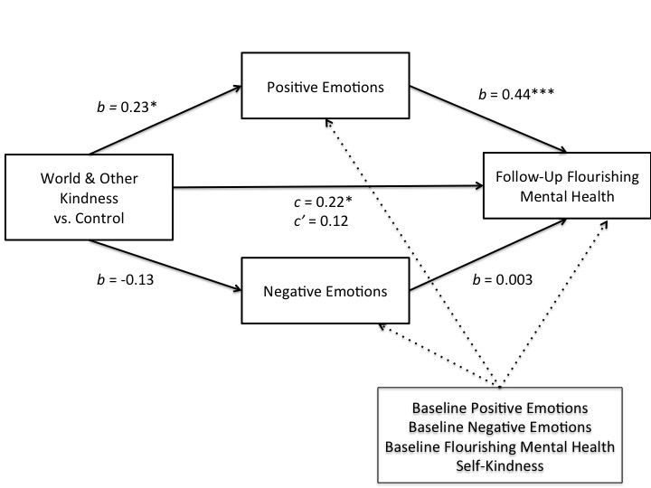

Figure S1. Indirect effects of world-kindness and other-kindness via positive and negative emotions on follow-up psychological flourishing.

