Supplementary Material
Figure S1
Electrode montage of 32 equidistant electrodes
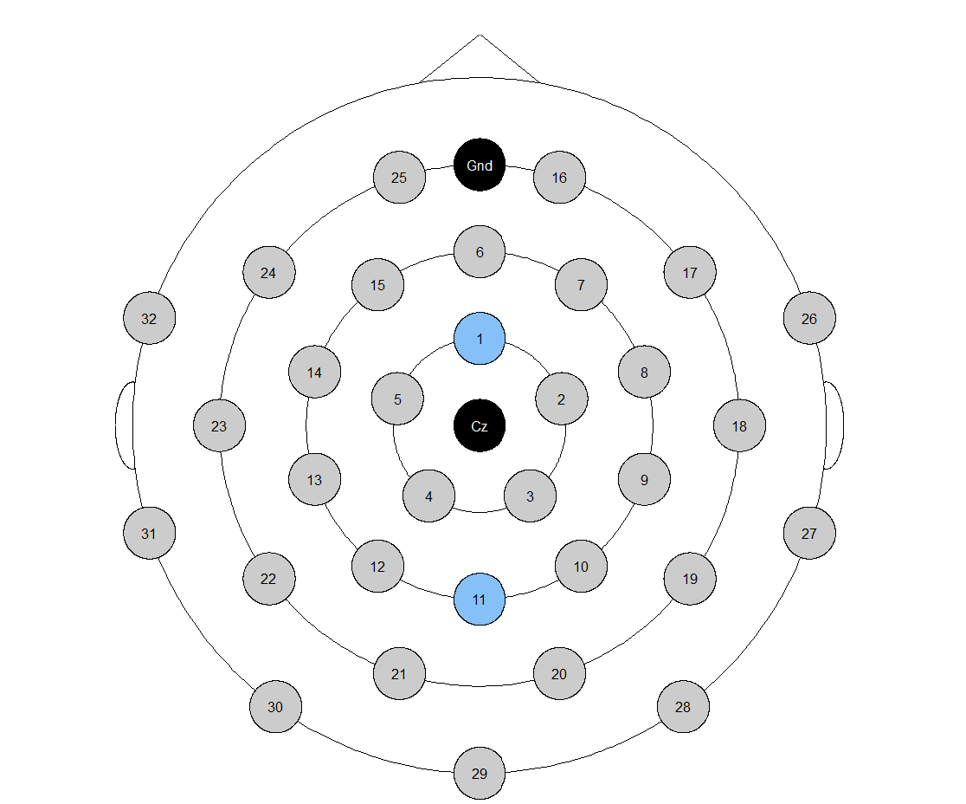
Note. We measured the N2 on the fronto-central electrode 1, and the P3 on parieto-central electrode 11.

Figure S2
The ERP wave forms of the fronto-central N2 and parieto-central P3 in the elementary cognitive tasks (ECTs) 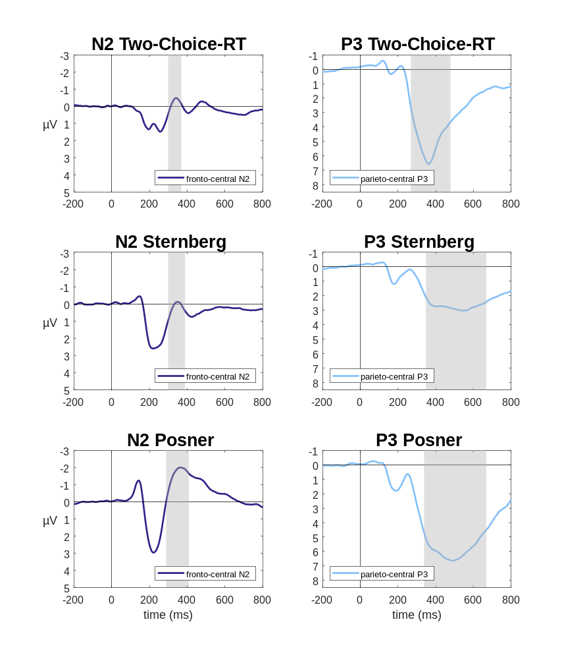 Note. The ERPs are locked to the probe stimuli in the corresponding tasks. The gray shaded areas indicate the time intervals in which the mean amplitudes were measured.

Table S1
The RGB color codes for the colors used in the experminental tasks
Color | R | G | B
black | 0 | 0 | 0
gray | 140 | 140 | 140
green | 0 | 178 | 30
red | 255 | 25 | 32
orange | 255 | 150 | 25
yellow | 255 | 255 | 25
turquoise | 0 | 255 | 255
blue | 25 | 50 | 255
pink | 255 | 25 | 255

Table S2
The experminental effects of the EF tasks on the behavioral level
Task | Dependent variable | Mean value of the condition with lower processing demands | Mean value of the condition with greater processing demands | t-value | df | p | Cohen's d | 95% CI
OE-LM | Mean RT (ms) | 737 | 786 | 9.61 | 141 | <.001 | 0.81 | 0.62 - 1.00
GL | Mean RT (ms) | 1111 | 1194 | 15.51 | 143 | <.001 | 1.29 | 1.07 - 1.52
NL | Mean RT (ms) | 731 | 788 | 10.43 | 133 | <.001 | 0.90 | 0.70 - 1.10
FL | Mean RT (ms) | 488 | 512 | 17.92 | 143 | <.001 | 1.49 | 1.26 - 1.74
NP | Mean RT (ms) | 588 | 606 | 9.07 | 129 | <.001 | 0.80 | 0.60 - 1.00
Stroop | Mean RT (ms) | 727 | 833 | 21.89 | 145 | <.001 | 1.81 | 1.55 - 2.08
NB | A.T. proportion correct | 1.39 | 1.23 | 12.98 | 134 | <.001 | 1.12 | 0.90 - 1.34
KT | A.T. proportion correct | 1.35 | 1.33 | 2.71 | 124 | =.008 | 0.24 | 0.06 - 0.42
RS | A.T. proportion correct | 1.35 | 1.30 | 8.32 | 132 | <.001 | 0.72 | 0.53 - 0.91

Note OE-LM = odd/even-less/more task; GL = Global/Local task; NL = Number/Letter task; FL = Arrow Flanker task; NP = Negative Priming task; Stroop = Stroop task; NB = N-Back task; KT = Keep-Track task; RS = Running-Span task; Mean RT = Mean reaction time; A.T. proportion = Arcsine transformed proportion correct; 95% CI represents the lower and upper boundary of the 95 % confidence interval for Cohen’s d.

Table S3
Correlations between the ERP differences scores between the conditions with greater and lower processing demands

 |  | 1 | 2 | 3 | 4 | 5 | 6 | 7 | 8 | 9 | 10 | 11 | 12 | 13 | 14 | 15 | 16 | 17
1 | Odd/Even-Less/More N2
2 | Global/Local N2 | .15
3 | Number/Letter N2 | .17 | .13
4 | Arrow-Flanker N2 | .03 | .02 | -.06
5 | Negative-Priming N2 | .06 | -.10 | -.10 | .19
6 | Stroop N2 | .10 | .07 | .09 | .10 | .15
7 | N-Back N2 | .00 | .03 | -.01 | -.16 | .23 | .05
8 | Keep-Track N2 | -.10 | .09 | -.07 | -.06 | .00 | -.19 | .16
9 | Runing-Span N2 | .14 | .17 | .03 | -.13 | -.14 | -.17 | -.09 | .06
10 | Odd/Even-Less/More P3 | -.09 | -.02 | -.19 | .05 | -.04 | -.02 | -.04 | .04 | -.04
11 | Global/Local P3 | -.13 | -.28 | -.02 | -.16 | .12 | -.01 | .11 | .03 | -.15 | .13
12 | Number/Letter P3 | -.07 | .09 | -.21 | .17 | -.11 | .10 | -.21 | -.13 | .03 | .34 | -.04
13 | Arrow-Flanker P3 | -.12 | .02 | .11 | -.13 | -.08 | -.04 | .02 | .02 | .13 | -.03 | .15 | -.06
14 | Negative-Priming P3 | -.02 | -.10 | -.03 | -.13 | -.21 | -.11 | -.12 | .08 | .11 | .08 | .15 | -.03 | .11
15 | Stroop P3 | -.09 | -.05 | -.03 | .05 | .09 | -.33 | .01 | .12 | .02 | -.03 | -.14 | .06 | .02 | -.03
16 | N-Back P3 | .12 | .01 | .15 | .05 | .12 | .04 | -.04 | -.06 | .23 | -.14 | -.02 | -.1 | .02 | -.09 | -.03
17 | Keep-Track P3 | .12 | .14 | -.08 | -.07 | -.14 | -.01 | .09 | -.11 | .08 | .16 | -.07 | .13 | .11 | .08 | -.04 | -.04
18 | Runing-Span P3 | -.24 | -.07 | -.11 | -.12 | -.05 | -.19 | .01 | .02 | -.08 | .18 | .09 | .23 | .14 | .00 | .18 | -.27 | .14
Note. Bold printed values represent significant correlation coefficients (p < .05).

Table S4
Relibilities of the ERP difference scores
Task | Reliability N2 | Reliability P3
OE-LM | -.11 | .30
GL | -.04 | .32
NL | .27 | .04
FL | .32 | .12
NP | -.03 | -.08
Stroop | .03 | -.16
NB | .42 | .57
KT | -.01 | .49
RS | .67 | .74
Note OE-LM = odd/even-less/more task; GL = Global/Local task; NL = Number/Letter task; FL = Arrow Flanker task; NP = Negative Priming task; Stroop = Stroop task; NB = N-Back task; KT = Keep-Track task; RS = Running-Span task. Reliability scores were estimated with Spearman-Brown corrected correlations.

Table S5
Interaction effects in a repeated measurement ANOVA between condition and ERP-component
Task | F | df | p | ω²_{partial}​
Arrow Flanker | 3.85 | 140 | .052 | .00
Negative Priming | 0.61 | 126 | .435 | .00
Stroop | 0.06 | 141 | .800 | .00
Odd-Even/Less-More | 70.09 | 136 | < .001 | .04
Number/Letter | 50.10 | 128 | < .001 | .05
Global/Local | 47.76 | 140 | < .001 | .04
N-Back | 54.38 | 130 | < .001 | .05
Keep-Track | 6.84 | 121 | .010 | .01
Running-Span | 0.62 | 130 | .434 | .00
Note. Bold lines indicate a significant interaction between condition (greater or lower processing demands) and ERP-component (N2 or P3) in the repeated measurement ANOVA.

