Supplementary Material

A. Sensitivity power analyses
To estimate the detectable effect size based on our data, we conducted sensitivity power analyses. These analyses assess whether our design had adequate power to identify various effect sizes during the hypothesis testing process (Lakens, 2022). Sensitivity power analyses are deemed more adequate than post hoc power analysis based on the observed effect size, because the latter are directly related to the p-value of the statistical test of the study (Hoenig & Heisey, 2001) and are thus uninformative.

We used the SIMR package (Green & MacLeod, 2016) to simulate the data from our models. Note that because the beta generalized mixed-effects model was unsupported for running the simulations, we refitted our beta-regression models using linear mixed-effects models on confidence (range 0-100%).

We performed four distinct sensitivity power analyses based on our main analyses in our three experiments. We conducted Monte Carlo simulations to estimate the power across a range of plausible effect sizes in our mixed-models (Kumle et al., 2021). For each analysis, we simulated new datasets with various effect sizes and tested each one for statistical significance. Since we used Wald Z-tests throughout our simulations for computational efficiency, we set a significance threshold α = .045 to compensate for the anti-conservative asymptotic approximation. Subsequently, we calculated power as the proportion of significant results across our simulations for each effect size. Importantly, we used our data and estimated models as a starting point for these simulations, directly manipulating the effect sizes for each simulation to establish the true effect sizes from which to compute power. This approach allowed us to consider crucial information in our simulations, such as random structure or excluded trials.

Accuracy (Experiment 1)
We used the data (n = 100) from Experiment 1, along with the binomial generalized mixed-effects model on accuracy as a function of anomaly presence and response stage reported in Table 2. The statistical test from which we computed power, focused on one fixed effect in the model, for which we used a plausible range of effect sizes, ranging from Cohen’s d = 0.20 to 0.5 using steps of 0.05. As showed in Figure S1, our simulations show that we were able to detect a Cohen’s d of 0.35 with 80% power.

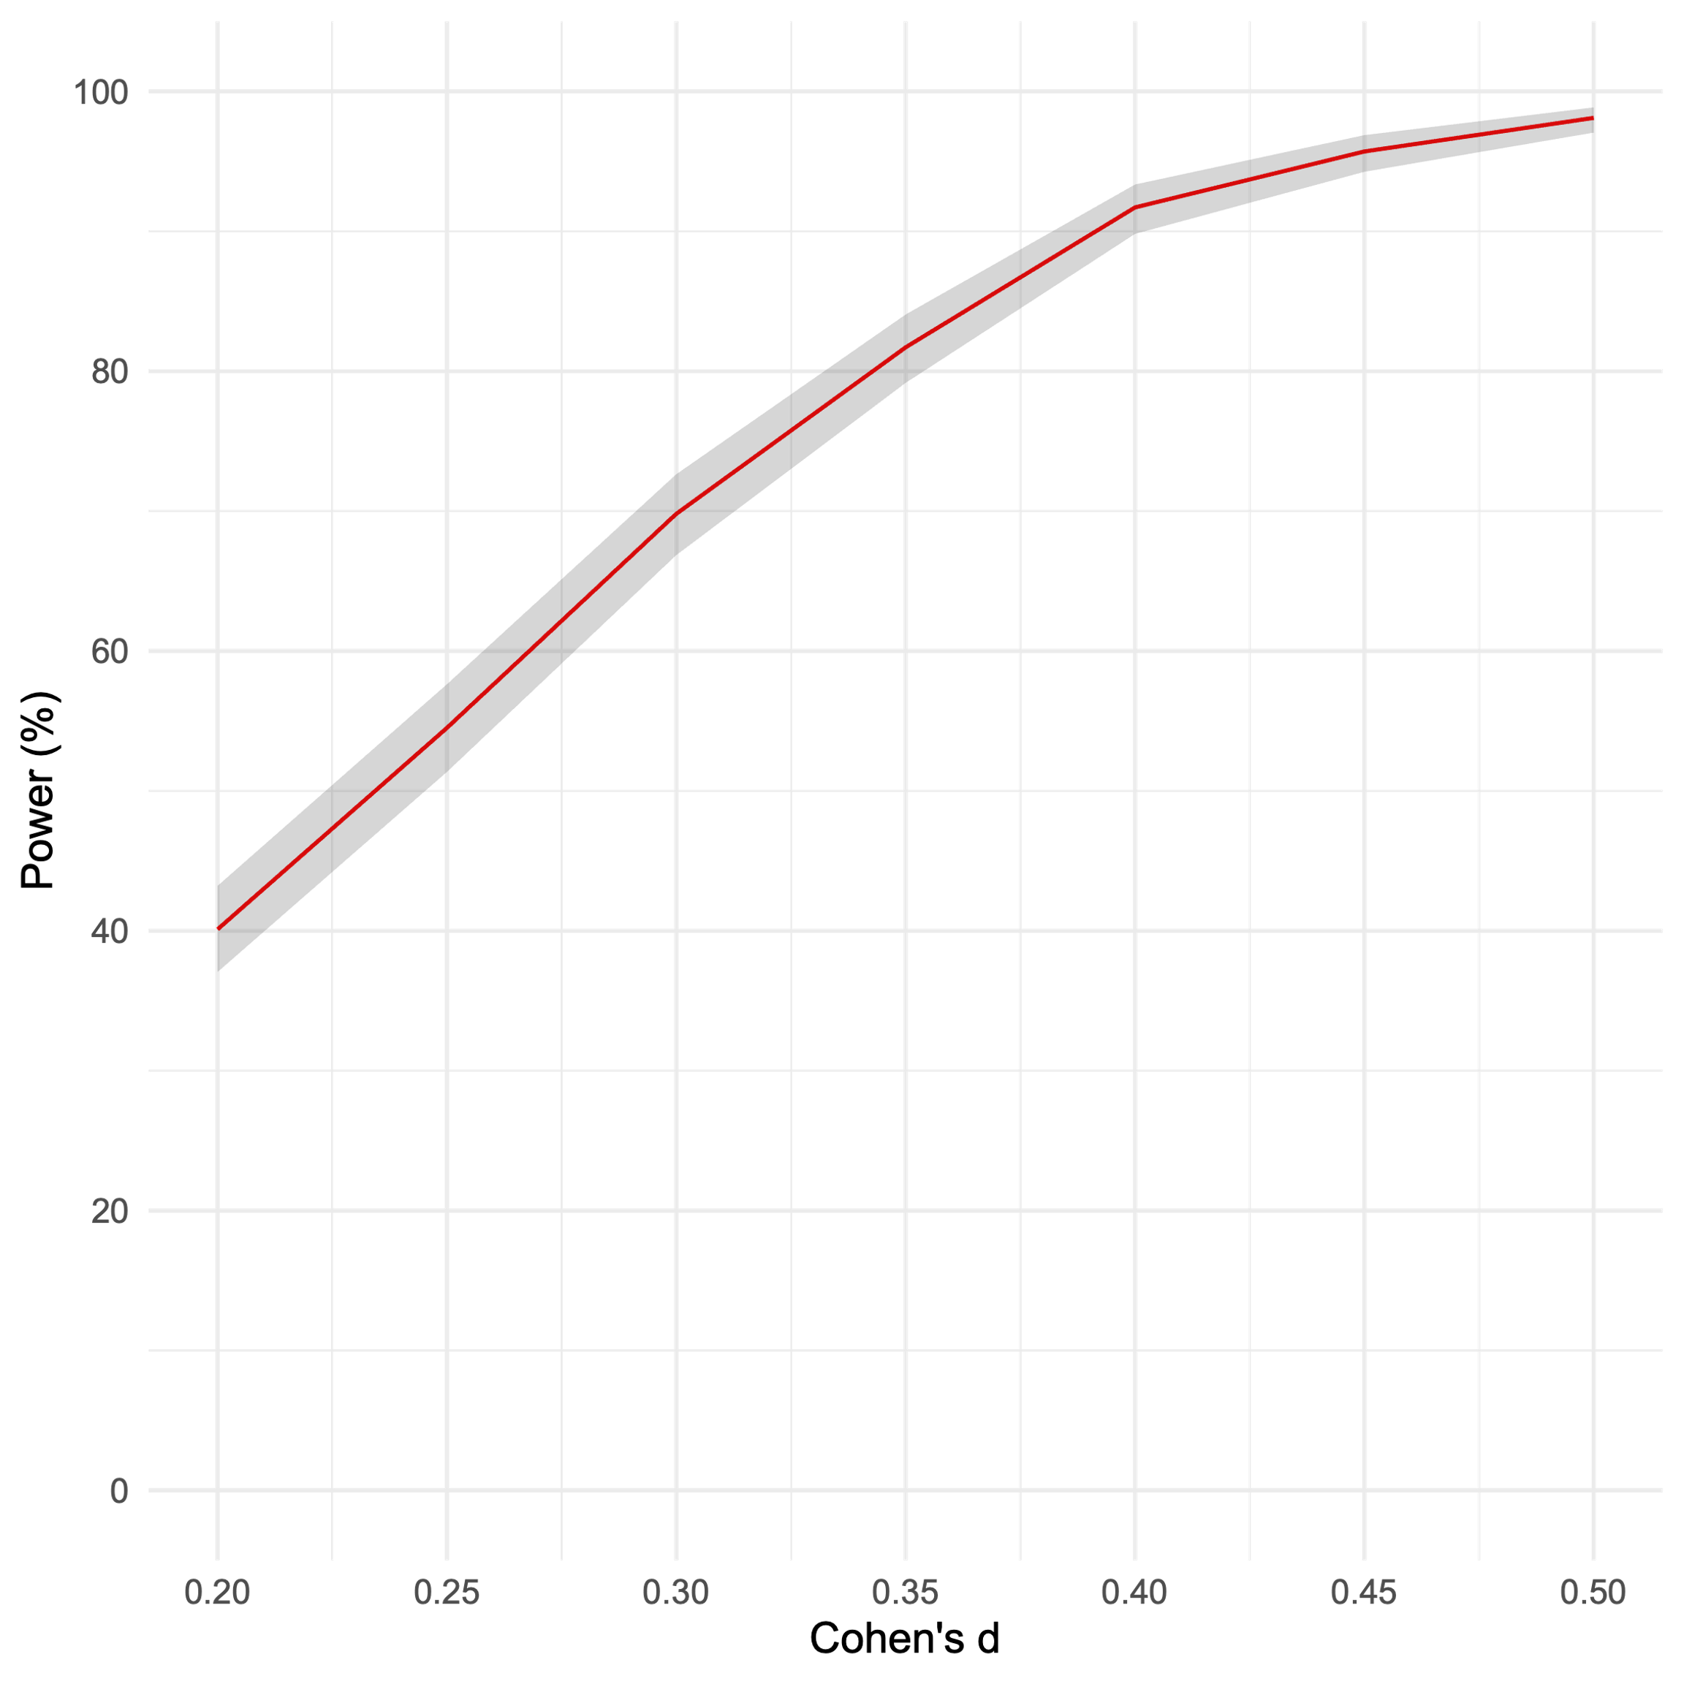

Figure S1. Sensitivity power curve illustrating the achieved power as a function of effect size for n=100 on accuracy in Experiment 1, based on 1000 simulations per effect size.

Accuracy (Experiment 3)
We used the data (n = 200) from Experiment 3, along with the binomial generalized mixed-effects model on accuracy as a function of impostor strength, response block and anomaly presence reported in Table 10. The statistical test from which we computed power focused on one fixed effect in the model, for which we used a plausible range of effect sizes ranging from Cohen’s d = 0.20 to 0.5 using steps of 0.05. As showed in Figure S2, our simulations show that we were able to detect a Cohen’s d of less than 0.10 with 80% power.

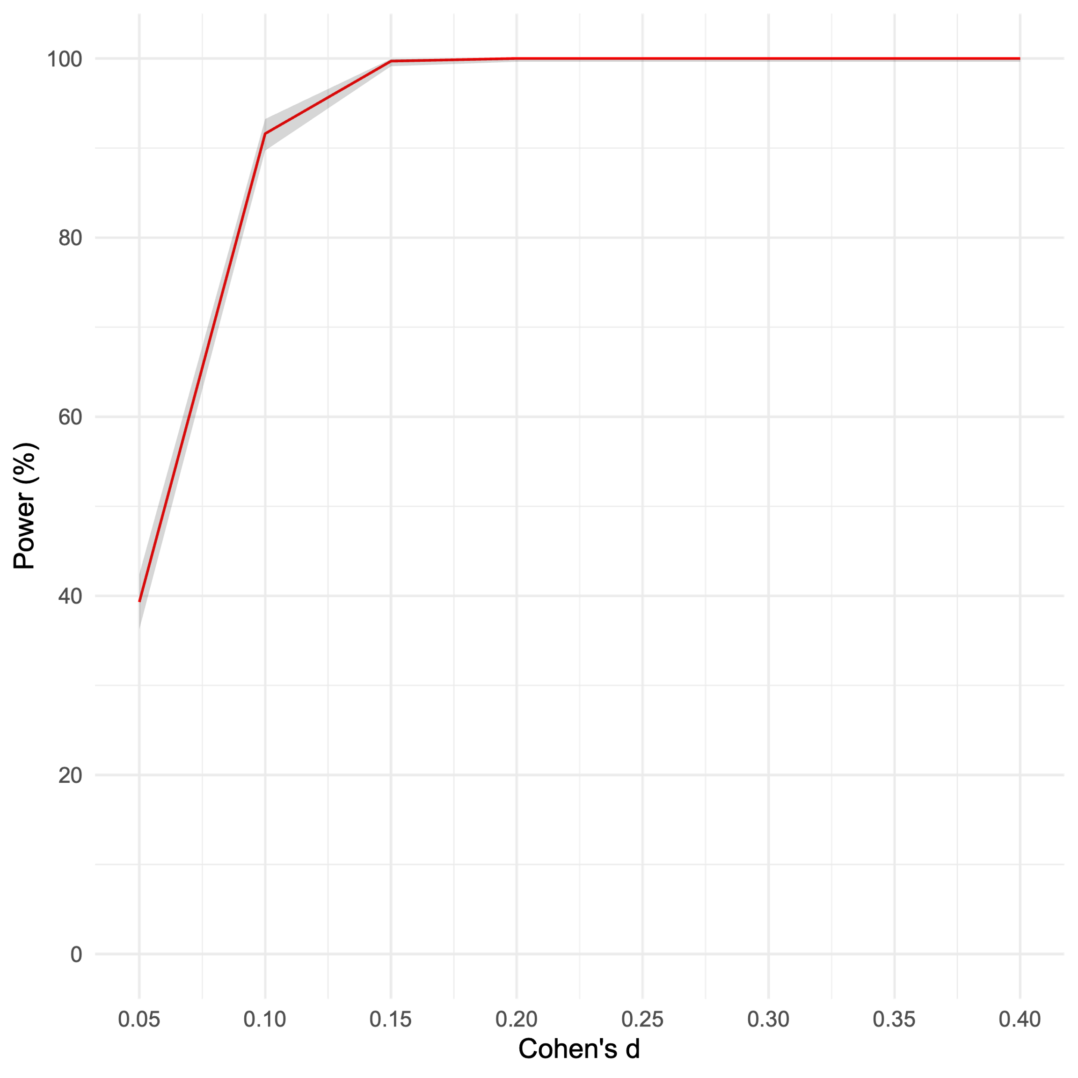

Figure S2. Sensitivity power curve illustrating the achieved power as a function of effect size for n=200 on accuracy in Experiment 3, based on 1000 simulations per effect size.

Confidence (Experiment 1)
We used the data (n=100) from Experiment 1, along with a linear mixed-effects model on confidence using the same formula and random structure as the beta generalized mixed-effects model reported in Table 3. We focused on the fixed effect interaction term contrasting the no-anomaly correct answers to the anomaly incorrect answers. We computed power for a plausible range of effect sizes for this error sensitivity effect, ranging from 1 to 8 percentage points of confidence. As shown in Figure S3, our simulations indicate that we were able to detect a 4.6 percentage point difference in confidence with 80% power.

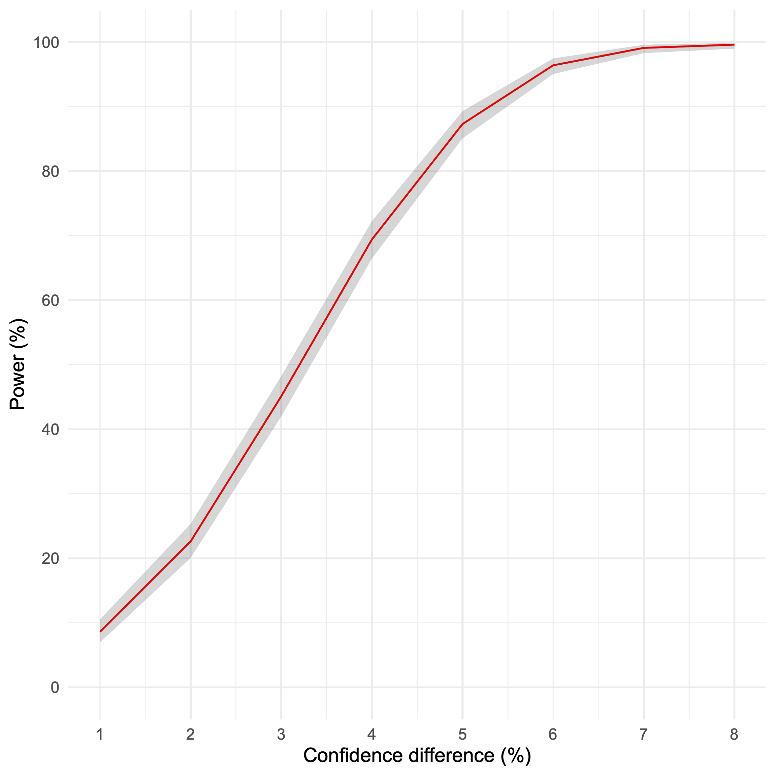

Figure S3. Sensitivity power curve illustrating the achieved power as a function of effect size for n=100 on confidence in Experiment 1, based on 1000 simulations per effect size. Confidence difference denotes the magnitude of the contrast between no-anomaly correct and anomaly incorrect responses in confidence percentage points.

Confidence (Experiment 3)
We used the data (n=200) from Experiment 3, along with a linear mixed-effects model on confidence using the same formula and random structure as the beta generalized mixed-effects model reported in Table 11. We focused on the interaction term between incorrect anomaly responses and impostor strength (testing whether error sensitivity was stronger for weak- compared to strong-impostor questions. We directly manipulated the size of this interaction, selecting a plausible range of values from a 1% to 10% confidence difference between the error sensitivity in the weak- and strong-impostor conditions. As shown in Figure S4, our simulations indicate that we were able to detect an interaction of 8 percentage points in confidence with 80% power.

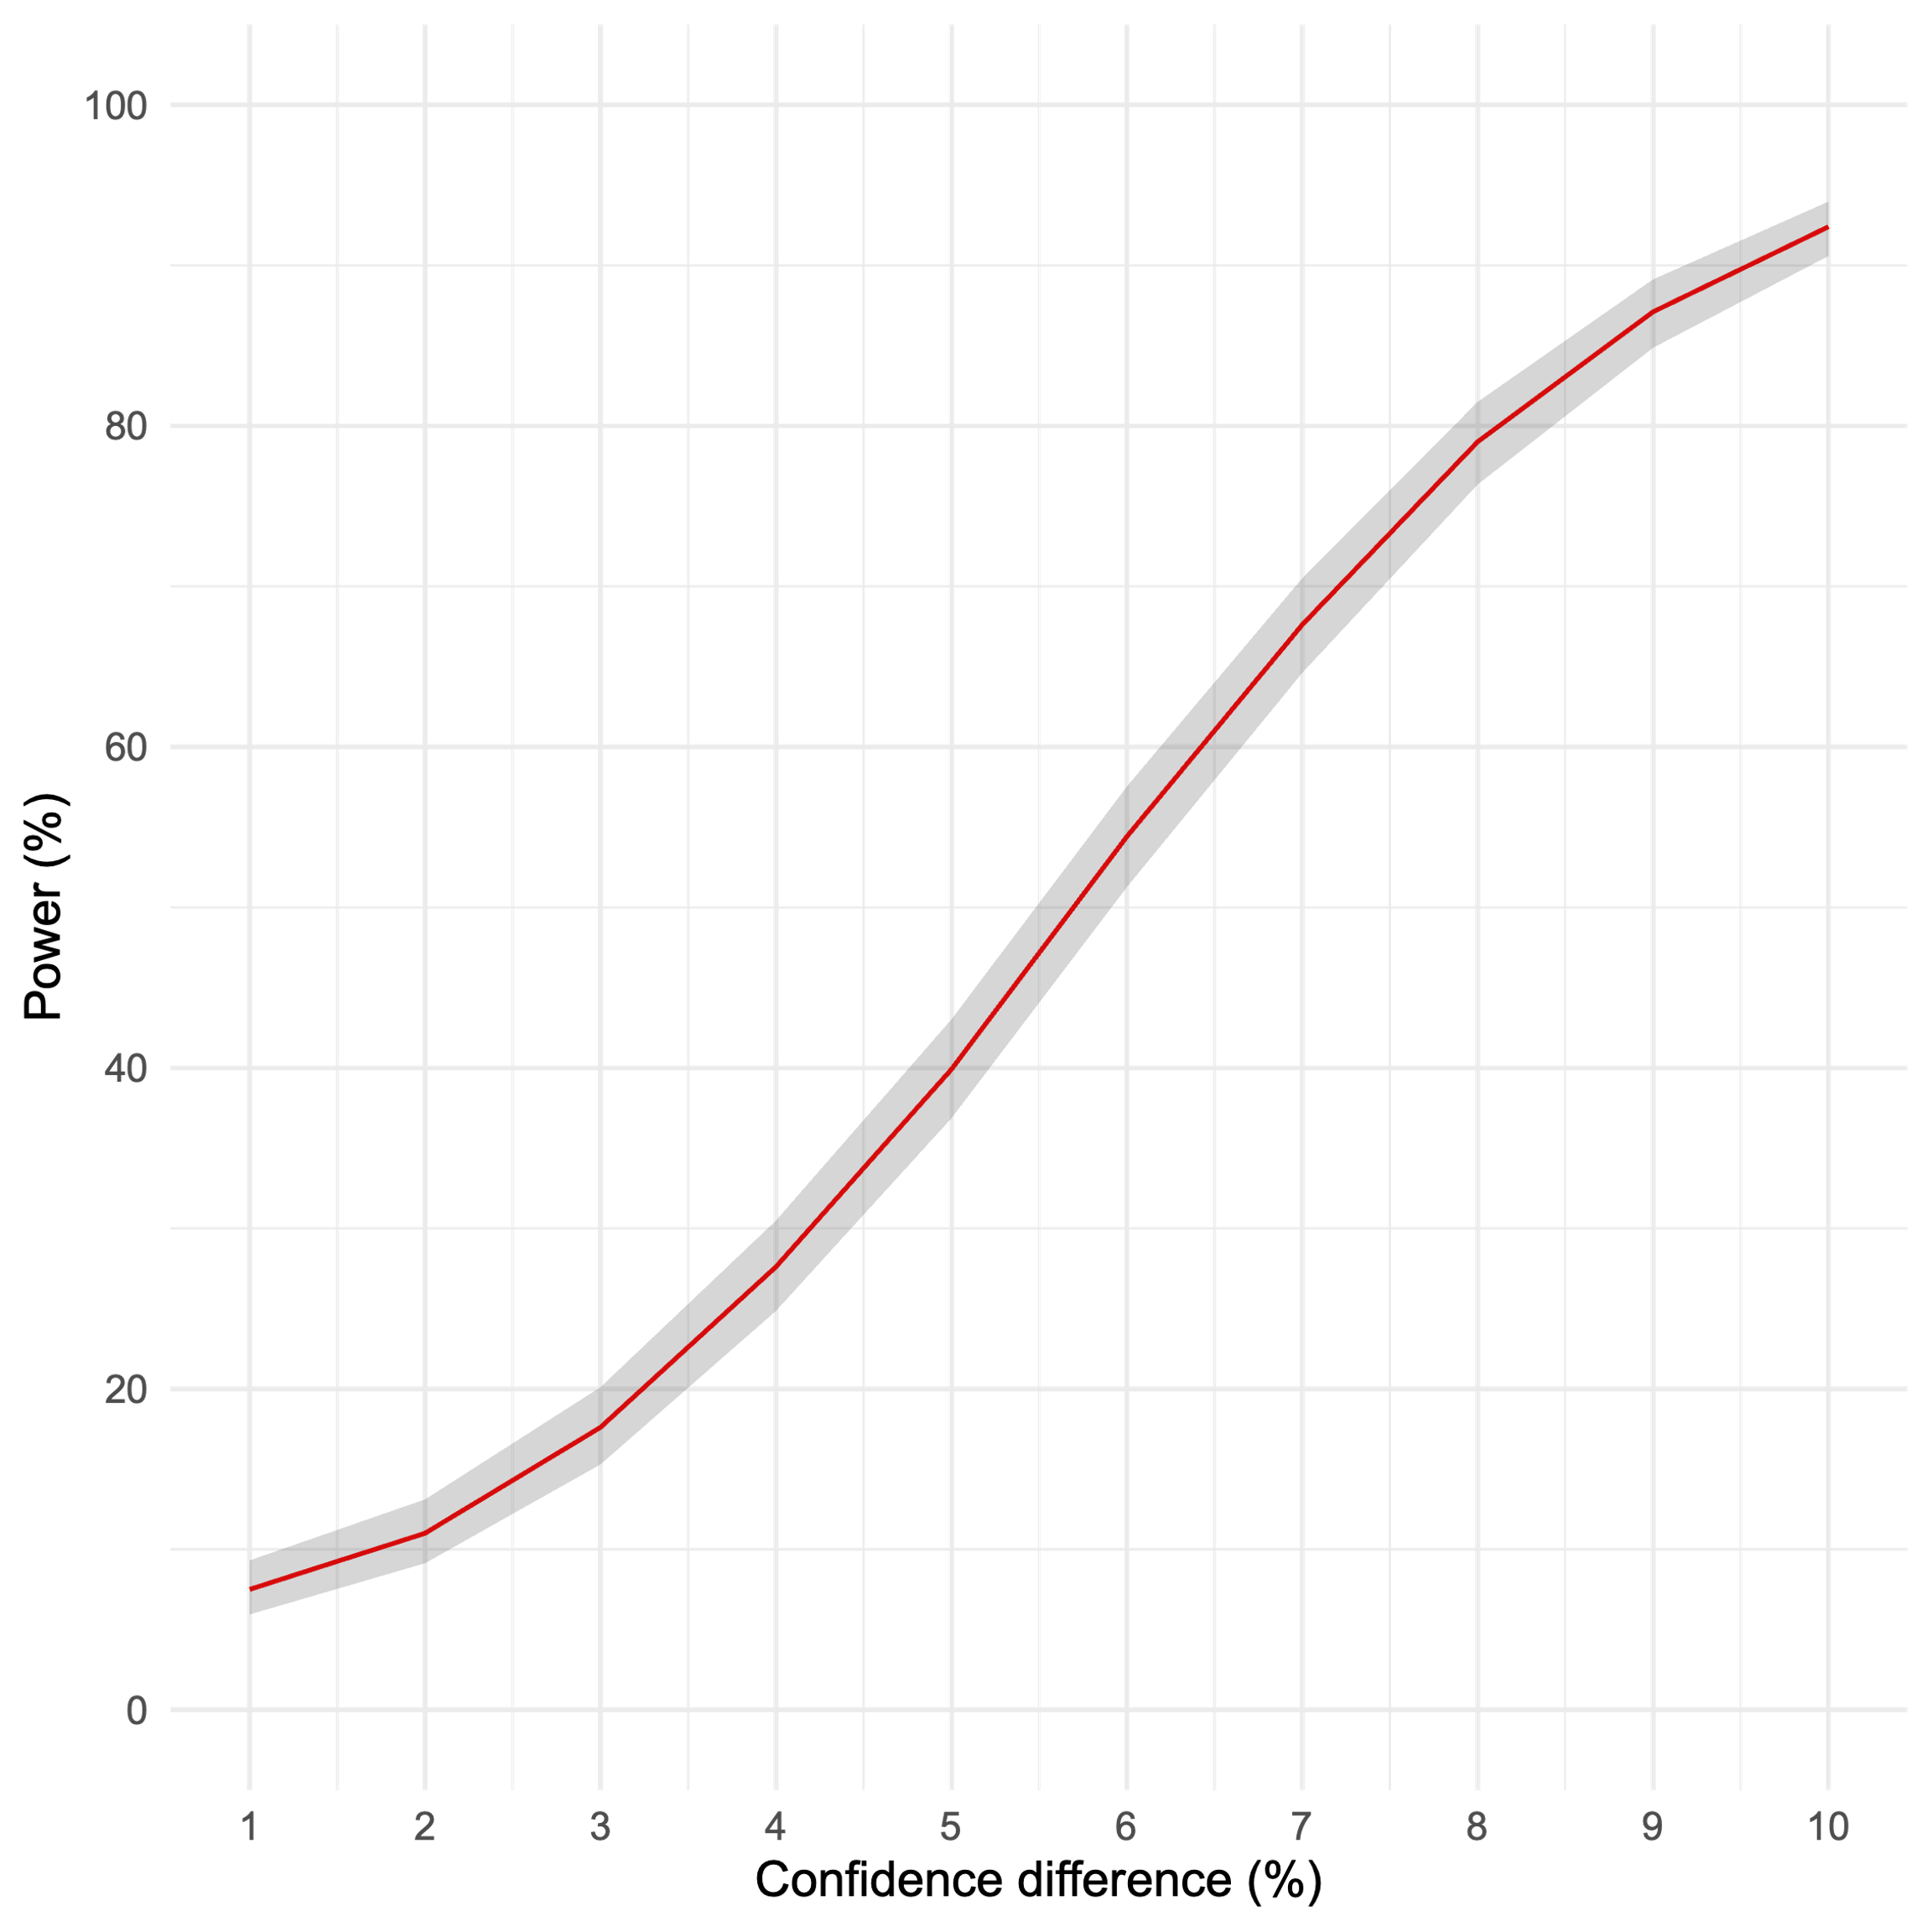

Figure S4. Sensitivity power curve illustrating the achieved power as a function of effect size for n=200 on confidence in Experiment 3, based on 1000 simulations per effect size. Confidence difference denotes the magnitude of the interaction between impostor strength and incorrect anomaly responses in confidence percentage points.

B. Instructions

Experiment 1-2
Please read these instructions carefully!
In this experiment you will have to answer 20 multiple-choice trivia questions and 2 practice questions.

For every multiple choice question you will be presented with four answer options but you can only pick one answer. Please respond as accurately as you can.
Some of the questions are impossible to answer. In that case, select the answer option: ‘This question can’t be answered in this form.’
If you don’t know the answer to a question, select the response option ‘Don’t know’.
To clarify the difference between ‘Don’t know’ and ‘This question can’t be answered in this form.’, take a look at the example questions below:
What is the name of former president’s Obama’s oldest son?
Charles
Jonathan
This question can’t be answered in this form.
Don’t know.
The above question cannot be answered because Obama doesn’t have a son; he only has two daughters. So, the correct answer option to this question is: ‘This question can’t be answered in this form.’
Here is a different example:
What is the name of former president’s Obama’s oldest daughter?
Sasha
Malia
This question can’t be answered in this form.
Don’t know.
In the above example, the question can be answered, since Obama does have an oldest daughter. The correct answer option is ‘Malia’. However, if you do not know the answer to this question, you should select ‘Don’t know’.

Critically, in this study we want to know what your initial, intuitive response to the questions is and how you respond after you have thought about these questions for some more time.
First, we want you to respond with the very first answer that comes to mind. You don’t need to think about it. Just give the first answer that intuitively comes to mind as quickly as possible.
To make sure that you answer as fast as possible, a time limit was set for the first response, which is going to be 5 seconds (Experiment 1)/4 seconds (Experiment 2). When there is 1 second left, the background colour will turn to yellow to let you know that the deadline is approaching. Please make sure to answer before the deadline passes.
Next, the question will be presented again and you can take all the time you want to actively reflect on it. Once you have made up your mind you give your final response.
After you made your choice and clicked on it, you will be automatically taken to the next page.
After you have entered your first and final answer we will also ask you to indicate your confidence in the correctness of your response.
We are going to clarify all of this with a couple of practice questions.

First, a fixation cross will appear. Then, the question and the four answer options will appear. You then enter your first hunch as fast as possible before the deadline. Next, the question will be presented again and you can take all the time to reflect on it and enter your final response.
After you have entered your first and final answer we will also ask you to indicate your confidence in the correctness of your response.
Participants were then given two practice trials, without the concurrent load task. They were then introduced to the load task.
You will also need to memorize a pattern while you respond to the trivia questions.
You will see a grid with crosses and you will have to memorize their location.
You will first practice with 2 patterns without a trivia question.
The pattern will be displayed for 2 seconds and then you will have to select it among 4 different patterns.
Participants were then given two practice trials for the cognitive load task, without the multiple-choice questions. They were then presented with the following instructions:
In the actual study you will need to memorize the pattern while you respond to the trivia question. The pattern is briefly presented before each question.
The difficulty of the pattern might vary. Always try to memorize as many crosses as possible. Each cross counts!
We know that it is not always easy to memorize the pattern while you are also thinking about the trivia question. The most important thing is to correctly memorize the pattern.
First, try to concentrate on the memorization task, and then try to answer the question accurately.
As a next step, you can practice this with two questions.
After those two last practice trials, participants were presented with the following instructions:
Ok, this is the end of practice!
During the experiment, the questions will be presented to you one after the other and you should not pause between them. After the first 10 questions, you can take a short break.
Remember, some of the questions are impossible to answer. In that case, select the answer option: ‘This question can’t be answered in this form.’ If you don’t know the answer to a question, select the response option ‘Don’t know’.

Experiment 3
Please read these instructions carefully!

In this experiment, you will have to respond to 20 multiple-choice trivia questions and 8 practice questions.

We want to know what your intuitive response to these questions is and how you respond if you are taking more time to think about the questions.

We will always instruct you as to whether we want you to answer the question intuitively or whether you can take your time to deliberate on your decision.
Then the trivia task was introduced as in the previous experiments, using the same example (see above). Participants then received the following instructions:
In the intuitive trials, we are interested in your initial, intuitive response. We want you to respond with the very first answer that comes to mind. You don't need to think about it. Just give the first answer that intuitively comes to mind as quickly as possible.

To make sure that you answer as fast as possible, a time limit was set for the intuitive trials response, which is going to be 5 seconds. When there is 1 second left, the background color will turn to yellow to let you know that the deadline is approaching. Please make sure to answer before the deadline passes.

For the deliberative trials, you can take the time to actively reflect on the question before submitting your response. Here we want you to think as deeply as possible before you give your answer.

To better understand the experiment, you are first going to solve some practice questions.

First, a fixation cross will appear. Then, the question and the four answer options will appear.

After you made your choice and clicked on it, you will be automatically taken to the next page.

In both intuitive and deliberative trials, we will also ask you to indicate your confidence in the correctness of your response.

In the next part, you will have to give the first answer that comes to mind, as quickly as possible.
Participants then answered the first practice question without the cognitive load:
That was the first practice question.

We will present you with a second practice question to make sure that the procedure is really clear.

Keep in mind that it is really important to answer the question as fast as possible as you are providing your intuitive response.
After they answered the second practice question, the following instructions were displayed to introduce the load task:
In the intuitive trials, you will also need to memorize a pattern while you respond to the trivia questions.

You will see a grid with crosses, and you will have to memorize their location.

You will first practice with 2 patterns without a trivia question.

The pattern will be displayed for 2 seconds, and then you will have to select it among 4 different patterns.
They then practiced the load task without answering the trivia questions.
In the intuitive trials of the actual study, you will need to memorize the pattern while you respond to the trivia question. The pattern is briefly presented before each question.

The difficulty of the pattern might vary. Always try to memorize as many crosses as possible. Each cross counts!

We know that it is not always easy to memorize the pattern while you are also thinking about the trivia question. The most important thing is to correctly memorize the pattern.

First, try to concentrate on the memorization task, and then try to answer the question accurately.

As a next step, you can practice this with two trivia questions.
After that, they had to complete two intuitive block trials with both the deadline and the load task. Then they saw the following instructions, which introduced the deliberative block:
In the next part, you can take as much time as you need to reflect on the trivia question to give your deliberative answer.

Here you won't have to memorize any pattern while you answer the trivia question.

We'll let you practice with two trivia questions.

After that, they had to answer the first deliberative practice questions before receiving the following instructions:

That was the first practice question.

We will present you with a second practice question to make sure that the procedure is really clear.

Keep in mind that you can take as much time as you need to reflect on the question to give your deliberative answer.
After answering the second deliberative block questions, they received the following instructions:
This is the end of the practice session. You are now ready to start the experiment.

You will be presented with 2 blocks, in which you will need to answer 10 trivia questions each time.

In the intuitive thinking block you will need to give your answer intuitively, as fast as possible. In addition, you'll have to memorize a pattern while you answer the trivia questions.

In the deliberative thinking block, you can take as much time as you need to reflect on the question before giving your answer. Here you won't have to remember any pattern while you answer the trivia questions.

Please make sure to stay maximally focused throughout the study.
Depending on the counterbalancing order, they then saw one of these two prompts:
- You will now start a block of 10 intuitive thinking trials. Give the first answer that comes to mind, as quickly as possible, while memorizing the pattern.
- You will now start a block of 10 deliberative thinking trials. You can take all the time you want to reflect on the trivia question before giving your response.

Experiment 3 Norming Study
Please read these instructions carefully!
In this experiment, you will be presented with 25 items. Each item will include an undistorted, correct trivia question (along with the correct answer between brackets), and two distorted versions of this question. In the distorted versions, one or more words of the original question have been replaced by one or more “impostor” words. We know that people often fail to notice such replacements when the impostor word is very similar to the undistorted word.
Your task is to indicate how similar each distorted sentence is to the original undistorted question on a scale ranging from 0 (Not at all similar) to 100 (Extremely similar).
To clarify, take a look at the following example:
The undistorted question is: “What is the name of Harry Potter’s female best friend, in the famous fantasy NOVEL by J.K. Rowling? (answer: Hermione Granger)”.
How similar is each distorted sentence to the original undistorted question?
Please type a number from 0 (Not at all similar) to 100 (Extremely similar) for each sentence.
What is the name of Harry Potter’s female best friend, in the famous fantasy POEM by J.K. Rowling?
What is the name of Harry Potter’s female best friend, in the famous fantasy SONATA by J.K. Rowling?
In this example, you might think that the first version (“POEM”) is more similar to the original version than the second one (“SONATA”), and that here “POEM” can go unnoticed more easily. In this case, you would have to give a higher similarity rating to the first distorted sentence than to the second one.

C. Estimated models without trial exclusion
In this section, we report the results of the analyses where we do not exclude trials with a missed cognitive load and recode trials with a missed deadline as incorrect. For confidence analyses, note that we still had to exclude trials with a missed deadline (but not with a missed cognitive load) since participants did not provide their confidence on these trials and we do not have a default value to replace them with as we had for accuracy (i.e., incorrect).

Overall, there were few differences in significance in these additional analyses. However, note that the interaction between illusion strength and anomaly-correct responses on confidence was significant in the revised illusion strength analysis of Experiment 2 (p = .04; Table S8). Additionally, in the analysis of confidence as a function of direction of change in Experiment 1, the difference between the reference no-anomaly “11” category and the (very rare) anomaly “10” trials was no longer significant (p = .08; see Table S3).

Table S1

Binomial generalized mixed-effects model on accuracy as a function of anomaly presence and response stage in Experiment 1, using sum coding

accuracy ~ 1 + anomaly + response stage + anomaly:response stage +
(1 + anomaly | subject) + (1 + anomaly | item)

Fixed effects
Predictors | df | χ² | p.value | Cohen’s d
Anomaly | 1 | 42.52 | < .001 | -1.17
Response stage | 1 | 48.17 | < .001 | 0.19
Anomaly:Response stage | 1 | 18.44 | < .001 | 0.12
Random effects
Group |  |  | Parameter | SD
Subject |  |  | (Intercept) | 1.03
Item |  |  | (Intercept) | 0.72
Subject |  |  | Anomaly | 0.81
Item |  |  | Anomaly | 0.73
Subject |  |  | Cor (Intercept x Anomaly) | 0.38
Item |  |  | Cor (Intercept x Anomaly) | -0.49
Model fit
Metric |  |  | R² (Marginal) | R² (Conditional)
 |  |  | 0.49 | 0.66
N |  | Subject | Item | Observations
 |  | 100 | 20 | 4,000

Note. p-values were obtained through bootstrapping on the comparison between a full model and a reduced model without the variable of interest, using type III sum of squares.

Table S2.

Mixed-effects beta-regression on initial confidence ratings as a function of anomaly and accuracy in Experiment 1, using dummy coding
confidence ~ 1 + anomaly + accuracy + anomaly:accuracy + (1 | item)
Fixed effects
Predictors | OR | 95% CI | p.value | Cohen’s d
Intercept (no-anomaly correct) | 3.42 | [3.07, 3.81] | < .001 | 0.68
Anomaly incorrect | 0.64 | [0.56, 0.72] | < .001 | -0.25
Anomaly correct | 1.14 | [0.95, 1.37] | .12 | 0.07
No-anomaly incorrect | 0.20 | [0.16, 0.26] | < .001 | -0.88
Random effects
Group |  |  | Parameter | SD
Item |  |  | (Intercept) | 0.18
Model fit
Metric |  |  | R² (Marginal) | R² (Conditional)
 |  |  | 0.43 | 0.51
N |  | Subject | Item | Observations
 |  | 100 | 20 | 1,865

Note. p-values and confidence intervals were obtained using parametric bootstrap. OR = odds ratio. An OR superior/inferior to 1 indicates the magnitude of the increase/decrease in confidence.

Table S3

Beta-regression results contrasting the initial confidence ratings for “11” control no-anomaly trials with anomaly trials for each direction of change category in Experiment 1, using dummy coding
confidence ~ 1 + response category + (1 | item)
Fixed effects
Predictors | OR | 95% CI | p.value | Cohen’s d
Intercept (no-anomaly "11") | 3.95 | [3.51, 4.45] | < .001 | 0.76
Anomaly "11" | 1.15 | [0.94, 1.39] | .15 | 0.08
Anomaly "00" | 0.77 | [0.68, 0.87] | < .001 | -0.15
Anomaly "01" | 0.20 | [0.16, 0.25] | < .001 | -0.89
Anomaly "10" | 0.51 | [0.23, 1.06] | .08 | -0.37
Random effects
Group |  |  | Parameter | SD
Item |  |  | (Intercept) | 0.16
Model fit
Metric |  |  | R² (Marginal) | R² (Conditional)
 |  |  | 0.55 | 0.62
N |  | Subject | Item | Observations
 |  | 100 | 20 | 1,738

Note. p-values and confidence intervals were obtained using parametric bootstrap. OR = odds ratio. An OR superior/inferior to 1 indicates the magnitude of the increase/decrease in confidence relative to the to the “11” no-anomaly control condition.

To further explore the role of response change on initial confidence, we compared trials in which participants changed their response between the initial and final stages (“01” and “10” categories) to those in which they did not change their response (“00” and “11” categories). Replicating previous findings, a post-hoc contrast showed that initial confidence was significantly lower in change trials than in no-change trials: OR = 2.95, 95% CI [1.99, 4.44], p < .001, Cohen’s d = 0.63.

Table S4

Beta-regression predicting initial confidence ratings in Experiment 1 as a function of standardized illusion strength, response group, and their interaction, using dummy coding
confidence ~ 1 + group + illusion strength + illusion strength:group
Predictors | OR | 95% CI | Z value | p.value | Cohen’s d
Intercept (no-anomaly correct) | 3.58 | [3.49, 3.68] | 26.4 | <.001 | 0.7
Anomaly correct | 1.09 | [1, 1.18] | 1.83 | .07 | 0.05
Anomaly incorrect | 0.61 | [0.51, 0.71] | -9.51 | <.001 | -0.27
Illusion strength | 1.14 | [1.1, 1.17] | 7.08 | <.001 | 0.07
Anomaly correct:Illusion strength | 0.85 | [0.76, 0.95] | -3.36 | <.001 | -0.09
Anomaly incorrect:Illusion strength | 1.17 | [1.08, 1.25] | 3.45 | <.001 | 0.08
Model fit
Metric |  |  |  |  | Pseudo R²
 |  |  |  |  | 0.12
N |  |  | Subject | Item | Observations
 |  |  | 100 | 20 | 1,760

Note. p-values were obtained using Wald Z-tests with clustered standard errors by participants. OR = odds ratio. An OR superior/inferior to 1 indicates the magnitude of the increase/decrease in confidence.

Table S5

Binomial generalized mixed-effects model on accuracy as a function of anomaly presence and response stage in Experiment 2, using sum coding

accuracy ~ 1 + anomaly + response stage + anomaly:response stage +
(1 + anomaly | subject) + (1 + anomaly || item)
Fixed effects
Predictors | df | χ² | p.value | Cohen’s d
Anomaly | 1 | 43.89 | < .001 | -1.03
Response stage | 1 | 104.90 | < .001 | 0.26
Anomaly:Response stage | 1 | 35.48 | < .001 | 0.15
Random effects
Group |  |  | Parameter | SD
Subject |  |  | (Intercept) | 0.94
Item |  |  | (Intercept) | 0.70
Subject |  |  | Anomaly | 0.70
Item |  |  | Anomaly | 0.61
Subject |  |  | Cor (Intercept x Anomaly) | 0.69
Model fit
Metric |  |  | R² (Marginal) | R² (Conditional)
 |  |  | 0.45 | 0.61
N |  | Subject | Item | Observations
 |  | 100 | 20 | 4,000

Note. p-values were obtained through bootstrapping on the comparison between a full model and a reduced model without the variable of interest, using type III sum of squares.

Table S6

Mixed-effects beta-regression on initial confidence ratings as a function of anomaly and accuracy in Experiment 2, using dummy coding
confidence ~ 1 + anomaly + accuracy + anomaly:accuracy + (1 | subject) + (1 | item)
Fixed effects
Predictors | OR | 95% CI | p.value | Cohen’s d
Intercept (no-anomaly correct) | 2.94 | [2.62, 3.31] | < .001 | 0.59
Anomaly incorrect | 0.62 | [0.54, 0.70] | < .001 | -0.26
Anomaly correct | 1.12 | [0.88, 1.42] | .33 | 0.06
No-anomaly incorrect | 0.29 | [0.23, 0.37] | < .001 | -0.68
Random effects
Group |  |  | Parameter | SD
Subject |  |  | (Intercept) | 0.24
Item |  |  | (Intercept) | 0.12
Model fit
Metric |  |  | R² (Marginal) | R² (Conditional)
 |  |  | 0.31 | 0.48
N |  | Subject | Item | Observations
 |  | 100 | 20 | 1,703

Note. p-values and confidence intervals were obtained using parametric bootstrap. OR = odds ratio. An OR superior/inferior to 1 indicates the magnitude of the increase/decrease in confidence.

Table S7

Beta-regression results contrasting the initial confidence ratings for “11” control no-anomaly trials with anomaly trials for each direction of change category in Experiment 2, using dummy coding
confidence ~ 1 + response category + (1 | subject) + (1 | item)
Fixed effects
Predictors | OR | 95% CI | p.value | Cohen’s d
Intercept (no-anomaly "11") | 3.39 | [3.03, 3.81] | < .001 | 0.67
Anomaly "11" | 1.18 | [0.93, 1.50] | .16 | 0.09
Anomaly "00" | 0.75 | [0.65, 0.86] | < .001 | -0.16
Anomaly "01" | 0.23 | [0.18, 0.28] | < .001 | -0.82
Anomaly "10" | 0.34 | [0.16, 0.69] | < .001 | -0.59
Random effects
Group |  |  | Parameter | SD
Subject |  |  | (Intercept) | 0.21
Item |  |  | (Intercep) | 0.11
Model fit
Metric |  |  | R² (Marginal) | R² (Conditional)
 |  |  | 0.49 | 0.59
N |  | Subject | Item | Observations
 |  | 100 | 20 | 1,539

Note. p-values and confidence intervals were obtained using parametric bootstrap. OR = odds ratio. An OR superior/inferior to 1 indicates the magnitude of the increase/decrease in confidence relative to the to the “11” no-anomaly control condition.

To further explore the role of response change on initial confidence, we compared trials in which participants changed their response between the initial and final stages (“01” and “10” categories) to those in which they did not change their response (“00” and “11” categories). Replicating previous findings, a post-hoc contrast showed that initial confidence was significantly lower in change trials than in no-change trials: OR = 3.38, 95% CI [2.28, 5.12], p < .001, Cohen’s d = 0.69.

Table S8

Mixed-effects beta-regression predicting initial confidence ratings in Experiment 2 as a function of standardized illusion strength, response group, and their interaction, using dummy coding
confidence ~ 1 + group + illusion strength + illusion strength:group + (1 | subject)
Predictors | OR | 95% CI | p.value |  | Cohen’s d
Intercept (no-anomaly correct) | 2.99 | [2.67, 3.38] | < .001 |  | 0.60
Anomaly correct | 1.10 | [0.86, 1.42] | .40 |  | 0.05
Anomaly incorrect | 0.61 | [0.53, 0.70] | < .001 |  | -0.27
Illusion strength | 1.17 | [1.06, 1.29] | < .001 |  | 0.09
Anomaly correct:Illusion strength | 0.79 | [0.63, 0.99] | .04 |  | -0.13
Anomaly incorrect:Illusion strength | 1.06 | [0.94, 1.22] | .36 |  | 0.03
 | Random effects
Group |  |  |  | Parameter |  | SD
Subject |  |  |  | (Intercept) |  | 0.22
Model fit
Metric |  |  |  | R² (Marginal) |  | R² (Conditional)
 |  |  |  | 0.28 |  | 0.42
N |  |  | Subject | Item |  | Observations
 |  |  | 100 | 20 |  | 1,567

Note. p-values and confidence intervals were obtained using parametric bootstrap. OR = odds ratio. OR = odds ratio. An OR superior/inferior to 1 indicates the magnitude of the increase/decrease in confidence.

Table S9

Binomial generalized mixed-effects model on accuracy as a function of impostor strength, anomaly presence and response block in Experiment 3, using sum coding
accuracy ~ 1 + impostor + response block + anomaly + impostor:response block + impostor:anomaly + response block:anomaly + impostor:response block:anomaly +
(1 + anomaly | subject) + (1 + anomaly | item)
Fixed effects
Predictors | df | χ² | p.value | Cohen’s d
Impostor | 1 | 9.43 | .003 | -0.16
Response Block | 1 | 116.08 | < .001 | -0.28
Anomaly | 1 | 44.51 | < .001 | 0.97
Impostor:Response Block | 1 | 0.10 | .79 | -0.00
Impostor:Anomaly | 1 | 20.14 | < .001 | 0.15
Response Block:Anomaly | 1 | 19.89 | < .001 | 0.12
Impostor:Response Block:Anomaly | 1 | 0.01 | .93 | 0.01
Random effects
Group |  |  | Parameter | SD
Subject |  |  | (Intercept) | 1.14
Item |  |  | (Intercept) | 0.51
Subject |  |  | Anomaly | 0.48
Item |  |  | Anomaly | 0.58
Subject |  |  | Cor (Intercept x Anomaly) | -0.55
Item |  |  | Cor (Intercept x Anomaly) | 0.15
Model fit
Metric |  |  | R² (Marginal) | R² (Conditional)
 |  |  | 0.43 | 0.61
N |  | Subject | Item | Observations
 |  | 200 | 20 | 4,000
Note. p-values were obtained through bootstrapping on the comparison between a full model and a reduced model without the variable of interest, using type III sum of squares.

Table S10
Mixed-effects beta-regression on confidence as a function of response group and impostor strength in Experiment 3, using dummy coding
confidence ~ 1 + impostor + group + impostor:group + (1 | subject) + (1 | item)
Fixed effects
Predictors | OR | 95% CI | p.value | Cohen’s d
Intercept (no-anomaly correct impostor strong) | 3.96 | [3.32, 4.55] | < .001 | 0.76
Impostor weak | 1.00 | [0.82, 1.23] | .98 | 0.00
Anomaly correct | 0.99 | [0.73, 1.29] | .94 | -0.01
Anomaly incorrect | 0.62 | [0.53, 0.73] | < .001 | -0.26
Anomaly correct:Impostor weak | 1.09 | [0.73, 1.57] | .71 | 0.05
Anomaly incorrect:Impostor weak | 0.91 | [0.72, 1.13] | .40 | -0.05
Random effects
Group |  |  | Parameter | SD
Subject |  |  | (Intercept) | 0.48
Item |  |  | (Intercept) | 0.14
Model fit
Metric |  |  | R² (Marginal) | R² (Conditional)
 |  |  | 0.15 | 0.71
N |  | Subject | Item | Observations
 |  | 200 | 20 | 1,710

Note. p-values and confidence intervals were obtained using parametric bootstrap. OR = odds ratio. An OR superior/inferior to 1 indicates the magnitude of the increase/decrease in confidence.

Table S11
Mixed-effects beta-regression on confidence as a function of response group and standardized illusion strength in Experiment 3, using dummy coding
confidence ~ 1 + group + illusion strength + illusion strength:group + (1 | subject)
Fixed effects
Predictors | OR | 95% CI | p.value | Cohen’s d
Intercept (no-anomaly correct) | 4.02 | [3.62, 4.48] | < .001 | 0.77
Anomaly correct | 0.98 | [0.81, 1.20] | .88 | -0.01
Anomaly incorrect | 0.58 | [0.51, 0.65] | < .001 | -0.30
Illusion strength | 1.11 | [1.02, 1.22] | .01 | 0.06
Anomaly correct:Illusion strength | 0.87 | [0.72, 1.05] | .21 | -0.08
Anomaly incorrect:Illusion strength | 1.15 | [1.02, 1.31] | .017 | 0.08
Random effects
Group |  |  | Parameter | SD
Subject |  |  | (Intercept) | 0.48
Model fit
Metric |  |  | R² (Marginal) | R² (Conditional)
 |  |  | 0.21 | 0.72
N |  | Subject | Item | Observations
 |  | 200 | 40 | 1,710

Note. p-values and confidence intervals were obtained using parametric bootstrap. OR = odds ratio. An OR superior/inferior to 1 indicates the magnitude of the increase/decrease in confidence.

D. Additional Models
Table S12

Log-linear mixed model contrasting the latencies of the one-response pre-test and the initial response stage of Experiment 1 on correct anomaly trials, using dummy coding

log(RT) ~ 1 + experiment + (1 | subject) + (1 | item)
Fixed effects
Predictors | exp(Est) | SE | t val. | df | p.value
Intercept (one-response) | 6.35 | 0.05 | 39.65 | 61.74 | < .001
Experiment 1 | 0.59 | 0.05 | -9.48 | 96.31 | < .001
Random effects
Group |  |  |  | Parameter | SD
Subject |  |  |  | (Intercept) | 0.21
Item |  |  |  | (Intercept) | 0.11
Residuals |  |  |  |  | 0.30
Model fit
Metric |  |  | R² (Marginal) | R² (Conditional)
 |  |  | 0.32 | 0.58
N |  | Subject | Item | Observations
 |  | 107 | 20 | 363

Note. p-values were obtained using Kenward-Roger d.f.

Table S13

Binomial generalized mixed-effects model contrasting the accuracy of the one-response pre-test and the final response stage of Experiment 1, using dummy coding

accuracy ~ 1 + experiment + (1 | subject) + (1 | item)
Fixed effects
Predictors |  |  | OR |  | 95% CI |  | p.value |  | Cohen's d
Intercept (one-response) |  |  | 1.93 |  | [1.41, 2.61] |  | < .001 |  | 0.36
Experiment 1 |  |  | 1.06 |  | [0.79, 1.43] |  | .73 |  | 0.03
Random effects
Group |  | Parameter |  |  |  | SD
Subject |  | (Intercept) |  |  |  | 0.65
Item |  | (Intercept) |  |  |  | 0.44
Model fit
Metric |  |  |  | R² (Marginal) |  |  |  | R² (Conditional)
 |  |  |  | 0.00 |  |  |  | 0.16
N |  |  | Subject |  | Item |  | Observations
 |  |  | 150 |  | 20 |  | 2,636

Note. p-values and confidence intervals were obtained using parametric bootstrap. OR = odds ratio. An OR superior/inferior to 1 indicates the magnitude of the increase/decrease in the odds of giving the correct response.

Table S14

Log-linear mixed model contrasting the latencies of Experiment 1 and Experiment 2 in the initial response stage, using dummy coding

log(RT) ~ 1 + experiment + (1 | subject) + (1 | item)
Fixed effects
Predictors | exp(Est) | SE | t val. | df | p.value
Intercept (Experiment 1) | 3.12 | 0.02 | 53.83 | 55.61 | < .001
Experiment 2 | 0.92 | 0.02 | -4.19 | 197.94 | < .001
Random effects
Group |  |  |  | Parameter | SD
Subject |  |  |  | (Intercept) | 0.14
Item |  |  |  | (Intercept) | 0.07
Residuals |  |  |  |  | 0.20
Model fit
Metric |  |  | R² (Marginal) | R² (Conditional)
 |  |  | 0.03 | 0.39
N |  | Subject | Item | Observations
 |  | 200 | 20 | 3,005

Note. p-values were obtained using Kenward-Roger d.f.

Table S15

Log-linear mixed model contrasting the latencies of the intuitive and the deliberative response blocks in Experiment 3 on correct anomaly trials, using dummy coding

log(RT) ~ 1 + response block + (1 | subject) + (1 | item)
Fixed effects
Predictors | exp(Est) | SE | t val. | df | p.value
Intercept (intuitive block) | 3.87 | 0.05 | 27.62 | 67.06 | < .001
Deliberative block | 1.72 | 0.04 | 15.06 | 474.32 | < .001
Random effects
Group |  |  |  | Parameter | SD
Subject |  |  |  | (Intercept) | 0.26
Item |  |  |  | (Intercept) | 0.14
Residuals |  |  |  |  | 0.34
Model fit
Metric |  |  | R² (Marginal) | R² (Conditional)
 |  |  | 0.23 | 0.56
N |  | Subject | Item | Observations
 |  | 158 | 20 | 546

Note. p-values were obtained using Kenward-Roger d.f.

Statistical Analysis Procedure

Random structure specification
To find the best random structure for each analysis, we identified the maximal model supported by the data (i.e., capable of converging), before performing backward stepwise elimination using the likelihood ratio test. This allowed us to find the optimal model without sacrificing statistical power (Matuschek et al., 2017). When the random structure was unsupported or did not improve model fit, we used clustered standard errors to account for the non-independence of our data (Cameron & Miller, 2015).

Significance evaluation and contrast coding
For generalized mixed models, we used parametric bootstrapping with 1000 iterations per model to evaluate the significance of the fixed effects (Booth, 1995), which does not rely on any traditional statistical distribution (e.g., χ² distribution). In the linear mixed models on reaction times, we used the Kenward-Roger’s F test (Kenward & Roger, 1997) to assess the significance of the fixed effects. In the case of beta regression models with clustered standard errors (i.e., when the random structure was unsupported), we used Wald Z-tests to assess significance.

For each analysis, we specify the contrast coding scheme we used based on the analysis requirements (Brehm & Alday, 2022). When comparing different variable levels to a specific group (e.g., the control no-anomaly group), we applied treatment (i.e., dummy) coding to sidestep the need for post-hoc tests (Schad et al., 2020). Alternatively, when this comparison was not necessary, we used sum coding in conjunction with Type III sum of squares to derive inferences similar to traditional ANOVA models. In this case, bootstrapping was used on the comparison between a full model and a reduced model without the variable of interest (Halekoh & Højsgaard, 2014), to compute a reference distribution of χ² values.

In the event of a significant interaction, we conducted post-hoc tests on the estimated marginal means to explore it further, using the Holm-Bonferroni method to correct for multiple comparisons. For generalized (mixed) models, we report effect sizes by converting the odds ratio to Cohen’s d (Borenstein et al., 2009), reporting both the point estimates and their 95% confidence intervals.

F. Distribution of individual non-correction rates and initial errors sensitivity measures
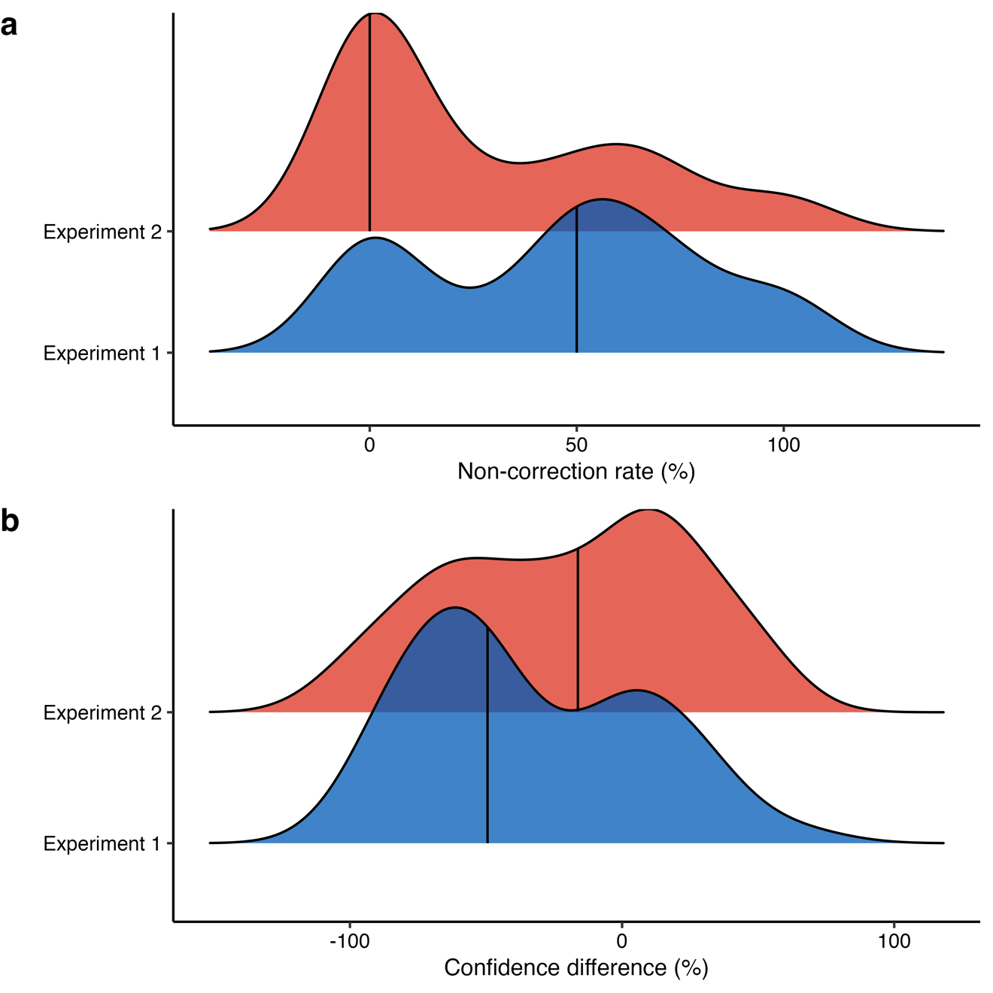

Figure S5. Ridgeline density plots of non-correction rates and initial error sensitivity measures for the two experiments. a) Individual non-correction rates for anomaly problems. b) Initial confidence difference between the correct control no-anomaly trials and the incorrect anomaly trials. Black lines indicate the median.

Table S16

Binomial generalized mixed-effects model on the probability of giving a “11” response (vs. a “01” response) in anomaly trials contrasting Experiment 1 and Experiment 2, using dummy coding

correct int ~ 1 + experiment + (1 | subject) + (1 | item)
Fixed effects
Predictors | OR | 95% CI | p.value
Intercept (Experiment 1) | 0.97 | [0.60, 1.53] | .90
Experiment 2 | 0.41 | [0.25, 0.65] | < .001
Random effects
Group |  | Parameter | SD
Subject |  | (Intercept) | 0.66
Item |  | (Intercept) | 0.85
Model fit
Metric |  | Pseudo-R² (Marginal) | Pseudo-R² (Total)
 |  | 0.04 | 0.29
N | Subject | Item | Observations
 | 154 | 20 | 525

Note. p-values and confidence intervals were obtained using parametric bootstrap. This model is based only on trials with a final correct response (i.e., “11” or “01” responses). OR = odds ratio. An OR superior/inferior to 1 indicates the magnitude of the increase/decrease in the odds of giving a “11” response vs. a “01” response.

We do not report confidence intervals for the effect sizes of these analyses since they do not provide confidence intervals for the regression coefficients.

