Supplementary Materials

Models including SES

SES was not a significant predictor of reading outcomes, did not impact the significance of other predictors, and did not significantly improve model fit (as measured by chi-square comparisons of model fit all p values > , and thus was not included in the models reported in the paper. We attach here the models including SES.
Table 2: Regression results for letter reading, word reading, and nonword reading.
Predictor | Letter Reading |  |  | Word Reading |  |  | Nonword Reading
 | β | SE | p | β | SE | p | β | SE | p
Intercept | -.002 | .077 | .983 | -.006 | .079 | .942 | -.008 | .082 | .928
SES | -.062 | .083 | .460 | -.047 | .085 | .588 | -.026 | .088 | .772
Grade Repetition | -.279 | .088 | .002** | -.177 | .090 | .054 . | -.251 | .094 | .010**
Age at School Start | -.305 | .087 | <.001*** | -.194 | .089 | .033* | -.168 | .092 | .072 .
Phonological Awareness | .484 | .106 | <.001*** | .663 | .110 | <.001*** | .611 | .114 | <.001***
Vocabulary | .065 | .101 | .523 | -.083 | .104 | .429 | -.041 | .107 | .701
Procedural Learning | -.039 | .097 | .689 | .094 | .101 | .350 | .046 | .104 | .662
Declarative Learning | -.250 | .081 | .003** | -.082 | .084 | .332 | -.045 | .086 | .604
Age at School Start*PL | -.098 | .102 | .341 | .155 | .106 | .147 | .024 | .109 | .826
Age at School Start*DL | .172 | .083 | .041* | .093 | .085 | .281 | .077 | .088 | .377
F | 11.38 *** |  |  | 10.33 *** |  |  | 9.573 ***
R² | .59 *** |  |  | .57 *** |  |  | .56 ***
Adjusted R² | .54 |  |  | .52 |  |  | .50
. indicates p<.1 * indicates p < .05. ** indicates p < .01. *** indicates p<.001

Cultural Validity in Measure of Declarative Learning
Assessments of declarative learning can be vulnerable to cultural biases (Kolling et al., 2015; Less, 2012; Vaisey & Lizardo, 2010). We adapted and used a well-established assessment of declarative learning (Children’s Memory Scale; Cohen, 1997) to ascertain if more real-world measures which reduce the reliance on abstract reasoning and more scaffolding from experimenters can provide a context-appropriate means of data collection in contexts like rural Côte d’Ivoire. The Child’s Memory Scale (CMS; Cohen, 1997) evaluates, among other subtests, four tasks tapping verbal and visual declarative learning (Bremner et al., 2004). The original CMS was written in English. We adapted these tasks, including instructions and stimuli, into Ivorian French. For the Faces measure of visual declarative learning (see description below), which originally contained images of primarily white individuals, we created a new set of test items with Black faces from other databases; Face Research Lab (DeBruine & Jones, 2017), Chicago Face Database (Ma et al., 2015), FEI Face Database (do Amaral et al., 2016), American Multiracial Faces Database (Chen et al., 2021), Developmental Emotional Faces Stimulus Set (Meuwissen et al., 2017), Face Database (Minear & Park, 2004), NIMH Child Emotional Faces Picture Set (Egger et al., 2011), and the Face Place Database (Righi et al., 2012; see Supplementary Figure 1 A and B). Each image was selected to match each individual test item from the original stimulus set as closely as possible in terms of age and gender.

Supplementary Figure 1: A) Example of a face from the original Child’s Memory Scale (Cohen, 1997). B) Example of a face from Face Database (Minear & Park, 2004). Used with permission.

- B.
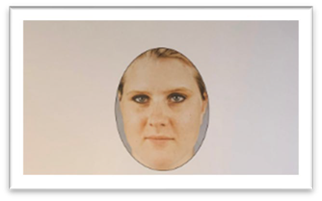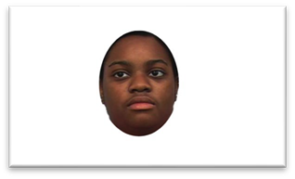

Children’s Memory Scale
Dot Location is a measure of declarative, non-verbal spatial memory. Children are shown a picture of a 4X4 grid with a pattern of 8 dots located in the squares for 5 seconds. The picture is removed and the child is asked to recreate the pattern they just saw on an empty grid, using plastic tokens. The experimenter provides feedback on the correct location of misplaced tokens. Then the experimenter clears the board and asks the child to recreate the pattern again. The child is then shown a distractor pattern of different color dots in different locations on the grid. The child is asked to recreate this distractor pattern. The experimenter provides feedback on misplaced tokens, then clears the board and asks the child to recreate the distractor pattern again. After the second time producing the distractor pattern, without representing the picture of the first pattern, children were then asked to reproduce the initial pattern once again; initial recall. After a delay of about 20 minutes the children are again asked to reproduce the initial pattern; delayed recall. A point is awarded for each dot in the correct location for the initial recall score and the delayed recall score.
Word Pairs. Children passively listen to a list of 14-word pairs such as ‘rice/chair’. After a pause of 5 seconds children are asked to recall half of the list by being prompted by the target word’s pair: “which word goes with rice?” This is repeated twice with the pairs remaining the same but their order in the list changing randomly. Children were given feedback in every trial and, when necessary, provided with the correct answer. The three total repetitions of the list of word pairs was followed by immediate recall during which children were then asked to recall the word pair for each word but were given no feedback.
Faces. Children watched an 8 second video in which they saw 16 young and old faces of individuals. Each face was on the screen for only two seconds. Children were then given an immediate recall task in which they looked at 48 faces in a slide show, including 50% new faces and 50% from the video. The children were asked if they remember seeing each face before.
Word List. Children learn a list of 14 unrelated words over four learning trials. The child’s goal during this task is to recall as many words as possible in any order from a list of 14 unrelated words read out by the experimenter. The experimenter reads the list slowly to the child then asks the child to repeat back all of the words. If the child misses a word the experimenter reminds the child of the missed words. This process repeats four times. The experimenter reads the child a new list of ten unrelated words and has the child repeat that list back. The child hears and then repeats the second list a total of four times. The child is then asked to recall the original list; immediate recall. After a delay of about 20 minutes the child is again asked to remember the first list of words; delayed recall. The number of words remembered across the first five trials are added to the child's learning Score. Additionally, the number of words recalled at the immediate recall and delayed recall provide the child’s immediate and delayed memory scores.
After children completed all of their initial recall tasks they completed the SRTT which meant that the child remained with the experimenter during this delay. Additionally, because the task consistently takes around 20 minutes to complete, it allowed the experimenter to easily ensure that each child had roughly the same delay between the initial and delayed measures of the CMS. Once the SRTT was complete, children completed a delayed recall task for Dot Location, Word Pairs, and Word List. There were also delayed recognition tasks for Word Pairs and Faces during which the children answered whether or not they remember seeing or hearing certain items before (see Supplementary Figure 2).

Supplementary Figure 2: Timeline of CMS subtests
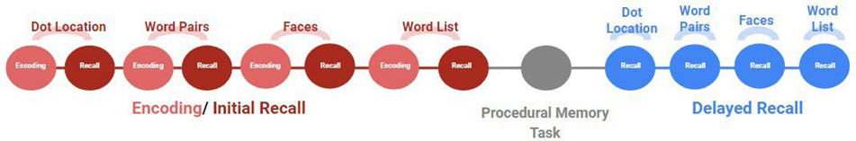

Reliability Results
The means and standard deviations for the testing conditions of each subtest are reported below in Supplementary Table 1. For the Dot Location task, the average child’s accuracy across both training and testing was 58.38% (SD=7.46, range=6.25%-73.44%). For the Word Pair task, the average child’s accuracy across both training and testing was 25.49% (SD=11.03% range=1.45%- 62.32%). For the Faces task the average child’s accuracy across both initial recall and delayed recall was 67.81% (SD=10.51% range=44.79%-91.67%). Finally, For the Word List task the average child’s accuracy across both training and testing was 35.19% (SD=9.67%) the accuracy of this task varied widely (range=15.31%-60.20%). A t-test demonstrated that the combined verbal accuracy scores were significantly different from the combined visual accuracy scores (t(233.8) = -33.07, p < .001).

Supplementary Table 1: Adapted CMS Raw Scores
Task |  | M | SD | Range
Dot Location (0-8) | Initial | 5.06 | 1.12 | 2-7
 | Delayed | 5.39 | 1.42 | 0-8
Word Pair (0-14) | Initial | 3.73 | 1.94 | 0-10
 | Delayed | 2.86 | 1.85 | 0-11
Faces (0-48) | Initial | 32.59 | 5.61 | 1-45
 | Delayed | 32.51 | 5.93 | 18-46
Word List (0-14) | Initial | 5.30 | 2.13 | 0-10
 | Delayed | 4.70 | .24 | 0-11

Comparing Subtests

Construct validity
In the initial phase, the subtests for the two visual measures (Dot Location and Faces) were correlated as were the subtests for the two verbal measures (Word List and Word Pairs; see Supplementary Table 2). In the delayed phase, the subtests for the two verbal measures were correlated but the subtests for the two visual measures were no longer correlated (see Supplementary Table 3). Instead the Dot Location task was correlated with the Word List task. Potentially, as both the Dot Location and Word List were particularly difficult tasks, they are correlated because children with higher scores were more generally skilled in cognitive abilities which support testing and task compliance such as attention, working memory, or task switching.

Supplementary Table 2: Initial Correlations
1 2 3_______
1.Dot Location
2.Word List 0.09
3.Faces .24** 0.13
4.Word Pairs 0.09 .39*** 0.11
Pearson correlations without corrections

Supplementary Table 3: Delayed Correlations
1 2 3_______
1.Dot Location
2.Word List .26**
3.Faces .014 .06
4.Word Pairs 0.10 .31*** 0.17
Pearson correlations without corrections

Subject Sensitivity
D' scores were calculated for each subject to examine their sensitivity in the Faces. For the Faces task the average d' was 1.1 (SD=0.68) above chance sensitivity, the range of d' scores ranged from -0.27 - 2.80. Many children, therefore, were at chance or above chance in their discrimination, reliably indicating that they recognized faces they had seen before and rejected faces they had not seen before (see Supplementary Figure 3A). For the initial recall of the Faces task the average d' was 1.06 (SD=0.72) indicating above chance sensitivity the range of d' scores ranged from -0.44 - 2.84 (see Supplementary Figure 3B). For the delayed recall of the Faces task the average d' was 1.07 (SD=0.67) indicating above chance sensitivity, the range of d' scores ranged from -0.27 - 2.80.

Supplementary Figure 3: A. Histogram of total Faces d'; B. Histogram of initial faces d'; C. Histogram of delayed Faces d'
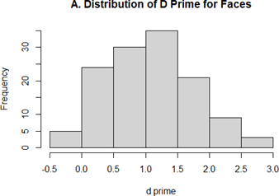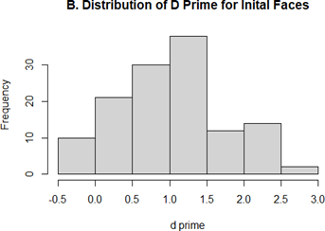
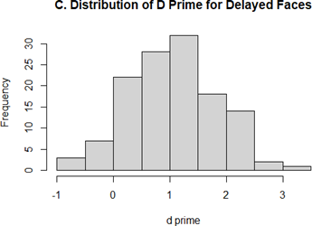

Reliability
One hundred and twenty-seven children took a 327-item adaptation of the Children’s Memory Scale including the four subtests of dot location, word pairs, faces, and word list. Eight children were removed for the internal consistency analysis due to missing data. All of the subtasks together had a Cronbach’s Alpha of α = 0.91 which is considered to be good. The adaptation of the Children’s Memory Scale, therefore, had a good internal consistency. Of the four subtests, Word Pairs (items=69, α = 0.86) and Word List (items=98, α = 0.81) had good internal consistency; Faces had excellent internal consistency (items=96, α = 0.82); and dot location had unacceptable internal consistency (items=64, α =0.40).

Adapted CMS compared to Original CMS
In order to test how our adaption compared to the original version of the CMS the reliability of each subtest was tested with split- half correlations with Spearman-Brown corrections, as originally reported by Cohen (1997). The reliability was measured across training trails for Dot Location, Word Pairs, and Word List, the initial recall for Faces (as this subtest had no training data). The reliability of Dot Location in the adapted CMS was again poor particularly compared to the original CMS (see Supplementary Table 4). The reliability of Word Pairs, Word List, and Faces was good and comparable to the original CMS (see Supplementary Table 4). The reliability of the Faces task was higher than the original CMS.

  - Supplementary Table 4: Spearman-Brown correction of split-half correlations for training data from Dot Location, Word Pairs, and Word List, and initial recall for Faces subtask. Results from the current adaptations are compared to reported reliability in relevant age groups from Cohen (1997).

 | - Subtest | - Current Study  - Age 9-15 | - CMS Age 9 | - CMS  - Age 10 | - CMS  - Age 11 | - CMS  - Age 12 | - CMS  - Age 13-14 |  | - CMS  - Age 15-16
 | - Dot Location | - .34 | - .61 | - .75 | - .65 | - .76 | - .81 | - .68
 | - Word Pairs | - .83 | - .87 | - .92 | - .90 | - .93 | - .94 |  | - .91
 | - Faces | - .83 | - .69 | - .73 | - .72 | - .68 | - .64 |  | - .74
 | - Word List | - .75 | - .86 | - .89 | - .85 | - .82 | - .82 |  | - .84

Overall, the accuracy of the visual tests were higher than the verbal tests. Of the visual tasks, the Dot Location subtest had lower accuracy and very low reliability. Comparatively, the Faces subtest had higher accuracy and high internal consistency. In rural Côte d’Ivoire, the best measure of declarative learning in the CMS task appears to be the recognition of culturally appropriate faces.

References

Egger, H. L., Pine, D. S., Nelson, E., Leibenluft, E., Ernst, M., Towbin, K. E., & Angold, A. (2011). The NIMH Child Emotional Faces Picture Set (NIMH‐ChEFS): a new set of children's facial emotion stimuli. International Journal of Methods in Psychiatric Research, 20(3), 145-156.
Less, A. D. (2012). Cultural Biases in the Weschler Memory Scale iii (WMS-iii).
Long, J. A. (2019). interactions: Comprehensive, User-Friendly Toolkit for Probing Interactions. [R software package]. Version 1.1.0. https://cran.r-project.org/package=interactions.
Ma, D. S., Correll, J., & Wittenbrink, B. (2015). The Chicago face database: A free stimulus set of faces and norming data. Behavior Research Methods, 47(4), 1122-1135.
Meuwissen, A. S., Anderson, J. E., & Zelazo, P. D. (2017). The creation and validation of the developmental emotional faces stimulus set. Behavior Research Methods, 49(3), 960-966.
Minear, M., & Park, D. C. (2004). A lifespan database of adult facial stimuli. Behavior research methods, instruments, & computers. Journal of the Psychonomic Society 36(4), 630–633. https://doi.org/10.3758/bf03206543
Righi, G, Peissig, JJ, & Tarr, MJ (2012) Recognizing disguised faces. Visual Cognition, 20(2), 143-169. doi:10.1080/13506285.2012.654624
Vaisey, S., & Lizardo, O. (2010). Can cultural worldviews influence network composition?. Social Forces, 88(4), 1595-1618.

