Supplemental Materials

Items
For corresponding images, please see the “Stimuli Images” folder in the OSF repository for this study (https://osf.io/9wkmn/?view_only=806d2661bcd54bb3b988fdf2acc37a29). Clarifying descriptions of the naming conventions for the image files (and corresponding columns in the R script) are given in the README file in the OSF repository.
A preview of the study can be viewed on the Qualtrics website (https://ucsd.co1.qualtrics.com/jfe/preview/previewId/b07c2492-e3ef-428d-9b2a-adb593f9106b/SV_3Dw0kprjHhRSAse?Q_CHL=preview&Q_SurveyVersionID=current).

Practice Questions
1. The witches were riding the same broomstick.
2. The woman was holding a guitar.
3. The dogs were chasing the rabbit.
Critical Items
Surface Items.
1. A hiker climbed every hill.
2. A spectator ate every banana.
3. A punk pushed over every chair.
4. A boy painted every turtle.
Inverse Items.
1. A panda bit every apple.
2. A ballerina kissed every man.
3. A woman kicked over every table.
4. A construction worker kicked every rock.
Filler Items
1. The men took the bus.
2. A man drank a hot drink.
3. A horse kicked a fence.
4. The men played a guitar.
5. The boys rode the same elephant.
6. A child stood behind a musician.
7. This man kissed a kitten.
8. The monkeys climbed on a tree.
9. The diver held a bouquet of flowers.
10. The donkeys jumped over a fence.
11. The chefs prepared a salad.
12. A man played the drums.
13. The men played football.
14. The women hugged this man.
15. The vet cared for a cow.
16. This boy poked a cat.
Attention Check Items
Prolific Attention Checks.
The following items were used as Prolific attention checks and were paired with similar images as the other stimuli.
1. Please select 7 (very well)
2. Please select 1 (not well at all)
3. Please select 4.
Regular Attention Checks.
1. There were boys riding on a camel.
2. There were elephants chasing a man.
3. There were shepherds riding a giraffe.

Schema of Randomization of Question Types
Fillers and critical items were assigned to two separate sets of questions. Items enclosed in braces below indicate items randomly drawn from each of these sets. For example, {Filler} denotes that at this point in the study, a filler item was randomly drawn from the set of fillers. The order of attention check items was fixed; therefore, attention check items are not enclosed in braces in the schema below.
{Filler}
{Filler}
{Critical item}
Attention check item 1 (Prolific)
{Filler}
{Filler}
{Filler}
{Critical item}
Attention check item 1 (Regular)
{Filler}
{Critical item}
{Filler}
Attention check item 2 (Prolific)
{Filler}
{Critical item}
{Filler}
Attention check item 2 (Regular)
{Filler}
{Filler}
{Critical item}
{Filler}
Attention check item 3 (Prolific)
{Filler}
{Critical item}
{Filler}
{Critical item}
Attention check item 3 (Regular)
{Critical item}
{Filler}
{Filler}

Print Exposure Measures

Favorite Authors Task Instructions
Please enter the names of your favorite authors. You can enter up to twenty different names.
These should be authors whose work you’ve read for enjoyment, or for your own reasons. Please do not enter authors whose works you’ve read for school or work, or other cases where you had to read it.
Author #1 ___________________
Author #2 ___________________
Author #3 ___________________
…
Author #20 ___________________

ART Author List
Real Authors | Fake Authors
Joanna Gaines | Nancy Frey
John Grisham | Lara J. Handsfield
Pete Souza | Rebecca Silverman
Jonathan Cahn | Anne McGill-Franzen
Grant Blackwood | Robert Tierney
Amor Towles | Anne Cunningham
Bobby Hall | Wan Shun Eva Lam
Sadie Robertson | Kelly Chandler-Olcott
Alex Snodgrass | Amy C. Crosson
Patricia Cornwell | Catherine F. Compton-Lilly
John Bolton | Emily Phillips Galloway
Jan Karon | Rebecca L. Rogers
Karen Kingsbury | Linda Cupples
Ta-Nehisi Coates | Sheila W. Valencia
Rachel Hollis | Heidi Anne Mesmer
Eric Bolling | Jennifer Cromley
Kevin Kwan | Eurydice B. Bauer
Christine Feehan | Emily C. Rainey
Jojo Moyes | Ana Christina da Silva
Brian Kilmeade | David J. Chard
Karen Kilgariff | Amy C. Hutchison
Mitch Albom | James V. Hoffman
Jack Thorne | Patrick H. Smith
Stassi Schroeder | Lesley Mandel Morrow
Sarah Young | Timothy V. Rasinski
Omarosa Manigault Newman | Ivar Bråten
Dan Brown | Bruce McCandliss
Samin Nosrat | James P. Gee
Paul Kalanithi | Shannon M. Daniel
Vince Flynn | Yaacov Petscher
Sylvia Day | Joshua F. Lawrence
David Venable | Daphne Greenberg
Marie Forleo | Shoichi Matsumura
Heather Morris | David Poveda
J R R Tolkien | Joseph Magliano
Michael Crichton | Allison Skerrett
Nelson DeMille | Guofang Li
Brandon Sanderson | Mark Sadoski
Michael Connelly | Kathleen A.J. Mohr
Joy Mangano | Catherine E. Snow
Mark Manson | Patricia Edwards
Philip Rucker | Victoria Risko
Lisa Scottoline | George G. Hruby
Erin Morgenstern | Deborah R. Dillon
Victoria Aveyard | Catherine Prendergast
Delia Owens | Gina Biancarosa
Susan Mallery | Christopher D. Barr
Hoda Kotb | Jacquelynn A. Malloy
Kristin Cavallari | Catherine McBride
Harlan Coben | Susan Sonnenschein

Comparative Reading Habits Items
- Compared to other people your age, how much time do you spend reading all types of materials?
- Compared to other people your age, how complex do you think your reading material is?
- Compared to other people your age, how much do you enjoy reading?
- Compared to other people your age, how fast do you normally read?
- Compared to other people your age, when reading at your normal pace, how well do you understand the reading material?

Results - Reduced Author List Version
For the tables below, results that differ from the original results are displayed in bold. Results are only shown for Tables where values differ from the original results; if all values in the table are the same as in the original results, the table is not shown here.
Table S1 (compare the Table 2)
Descriptive Statistics for Print Exposure Measures
Measure | Possible Range | Observed Range | Mean | SD
ART | -50–50 | -10–23 | 2.84 | 4.53
CRH | 5–35 | 10–35 | 23.86 | 5.60
FA | 0–20 | 0–20 | 4.88 | 3.88
Table S2 (compare to Table 4)
Final model predicting acceptability judgment ratings from the ART
 | β | CI | p
(Intercept) | 5.88 | 5.47 – 6.25 | <0.001 ***
ART Score | -0.02 | -0.05 – 0.00 | 0.06 *
Interpretation - surface | 0.76 | 0.25 – 1.28 | 0.02 *
Note. Bold text indicates significant results
Table S3 (compare to Table 8)
Final model predicting reaction time from the ART
 | β | CI | p
(Intercept) | 6578.57 | 6179.23 – 6977.91 | <0.001 ***
ART Score | 70.89 | 6.26 – 135.53 | 0.03 *
Interpretation - surface | -487.186 | -880.28 – -94.10 | 0.037
ART:interpretation | -60.80 | -105.72 – -15.87 | 0.01 *

Figure S1 (compare to Figure 4)
Acceptability judgment ratings as a function of print exposure tasks
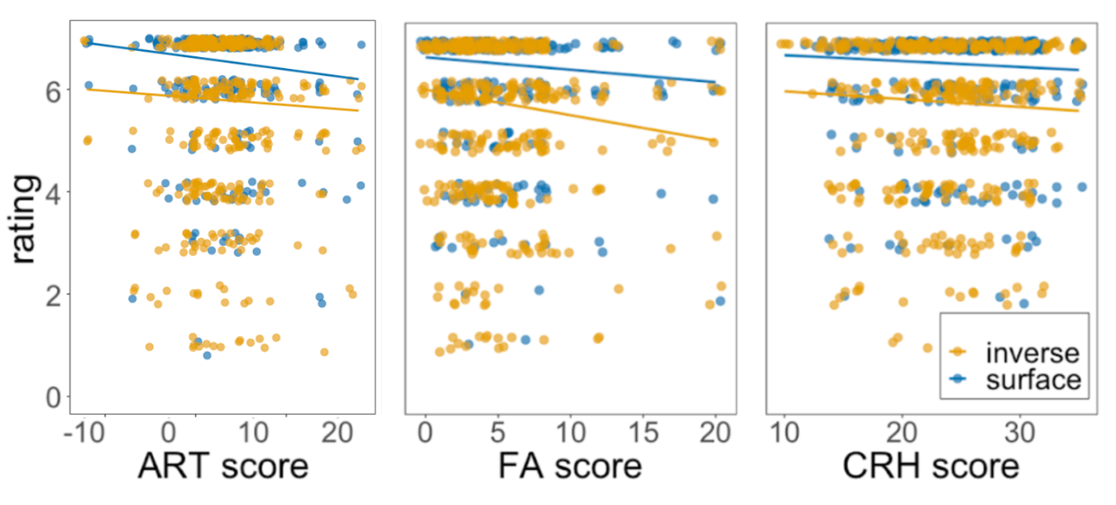
Figure S2 (compare to Figure 5)
Reaction times as a function of print exposure tasks
