Supplementary Materials
Table S1. Speech rate model output.
 | Estimate | Est.Error | Q2.5 | Q97.5
Intercept | 2.36 | 0.1 | 2.16 | 2.56
Focus(contrastive) | -0.09 | 0.02 | -0.14 | -0.05
Focus(narrowsubj) | -0.04 | 0.03 | -0.09 | 0.02
Focus(narrowobj) | 0.08 | 0.02 | 0.03 | 0.12
Interlocutor(voice-AI) | 0.02 | 0.02 | -0.01 | 0.05
Focus(contrastive):Interlocutor(voice-AI) | 0.03 | 0.03 | -0.02 | 0.08
Focus(narrowsubj):Interlocutor(voice-AI) | 0.02 | 0.02 | -0.02 | 0.06
Focus(narrowobj):Interlocutor(voice-AI) | -0.02 | 0.02 | -0.07 | 0.02

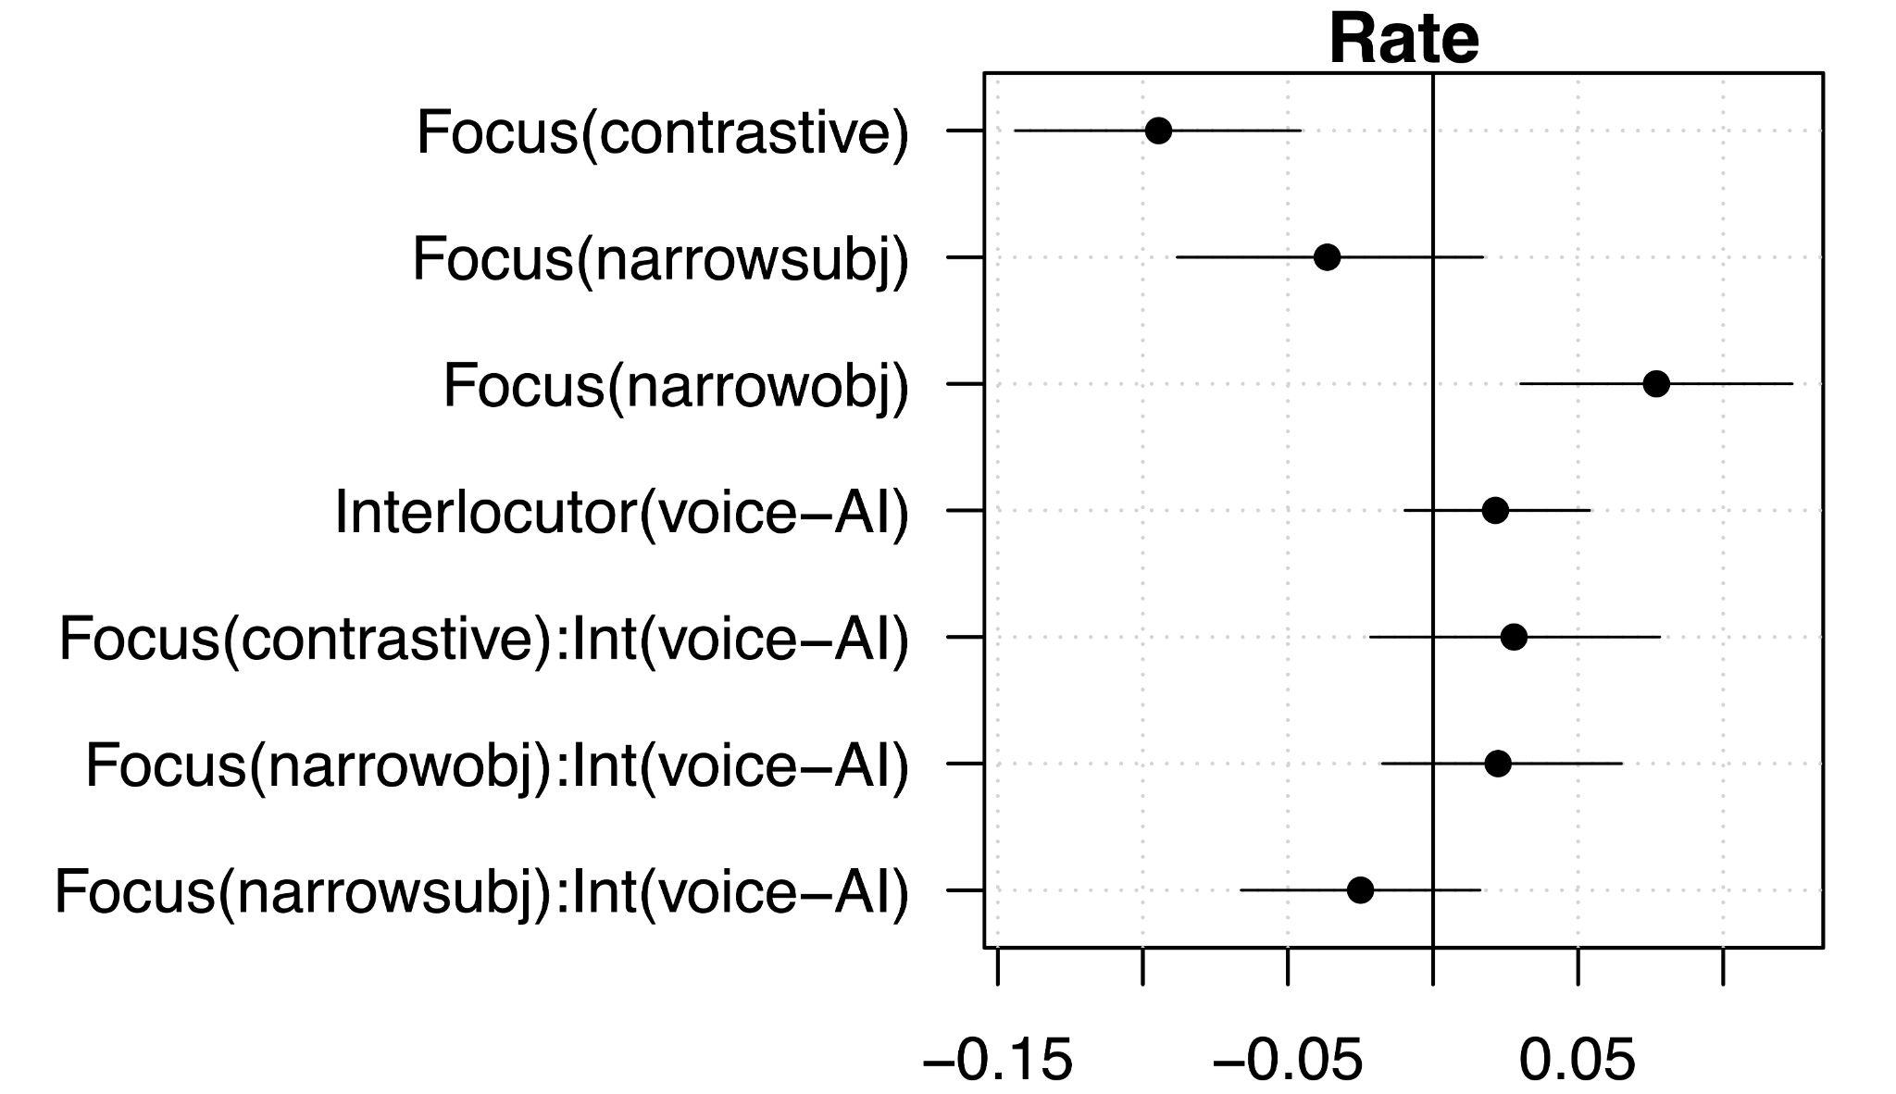
Figure S1. Credible intervals for the speech rate model.

Table S2. Sentence pitch model
 | Estimate | Est.Error | Q2.5 | Q97.5
Intercept | 0.0 | 0.09 | -0.17 | 0.17
Focus(contrastive) | -0.17 | 0.05 | -0.28 | -0.06
Focus(narrowobj) | 0.17 | 0.05 | 0.08 | 0.26
Focus(narrowsubj) | -0.09 | 0.04 | -0.17 | -0.02
Interlocutor(voice-AI) | -0.08 | 0.04 | -0.16 | -3.2e-03
Focus(contrastive):Interlocutor(voice-AI) | 0.03 | 0.02 | 0 | 0.06
Focus(narrowobj):Interlocutor(voice-AI) | -0.01 | 0.03 | -0.07 | 0.05
Focus(narrowsubj):Interlocutor(voice-AI) | 0.04 | 0.03 | -0.01 | 0.09

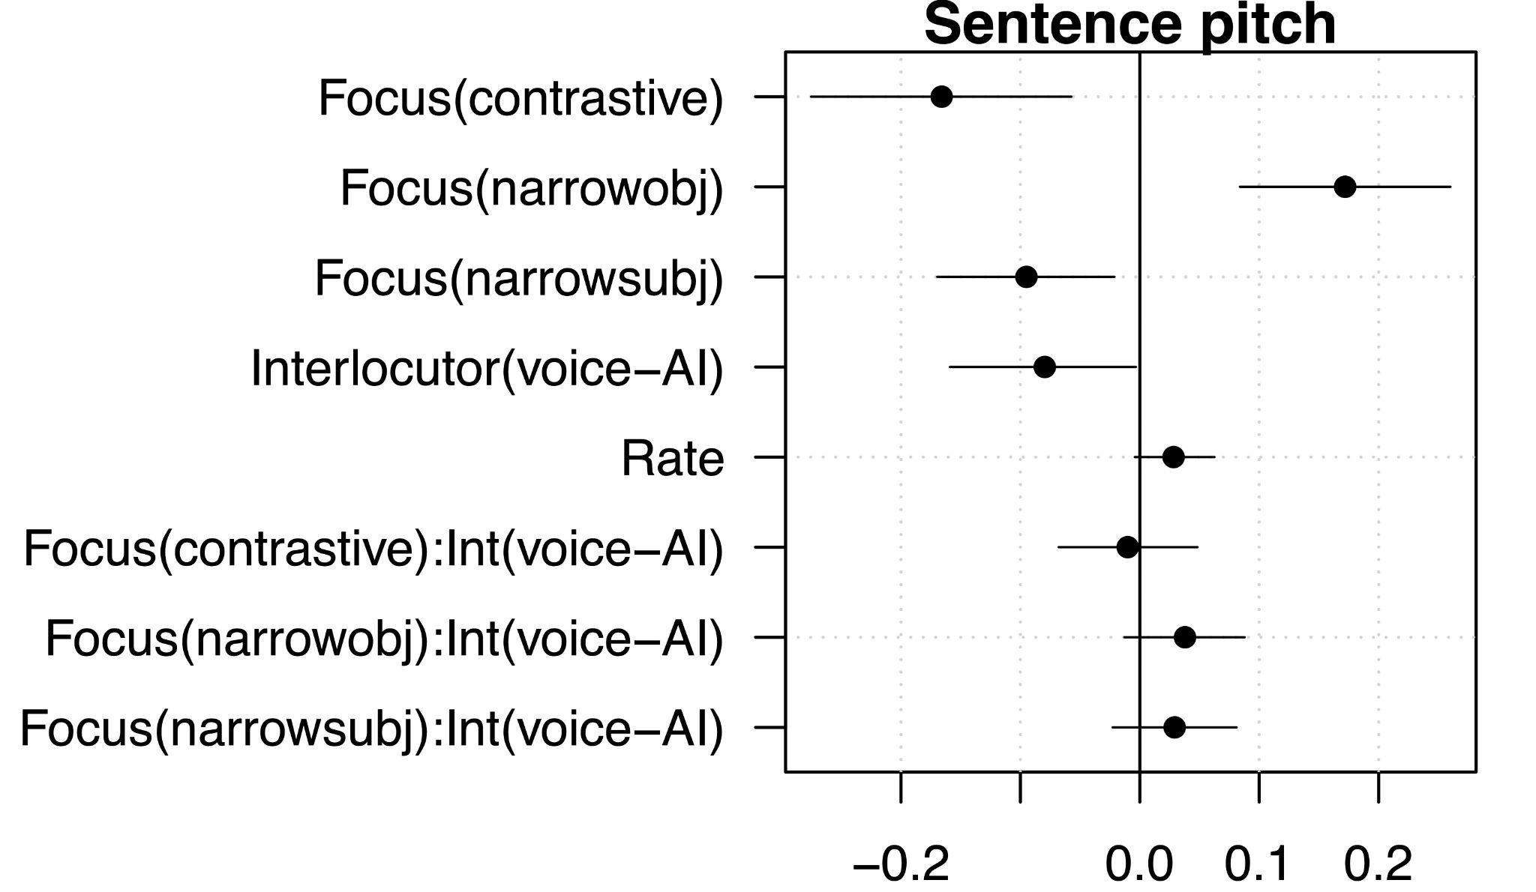
Figure S2. Credible intervals for sentence pitch model.

