Supplemental Materials

Appendix A. Stage 1 test results

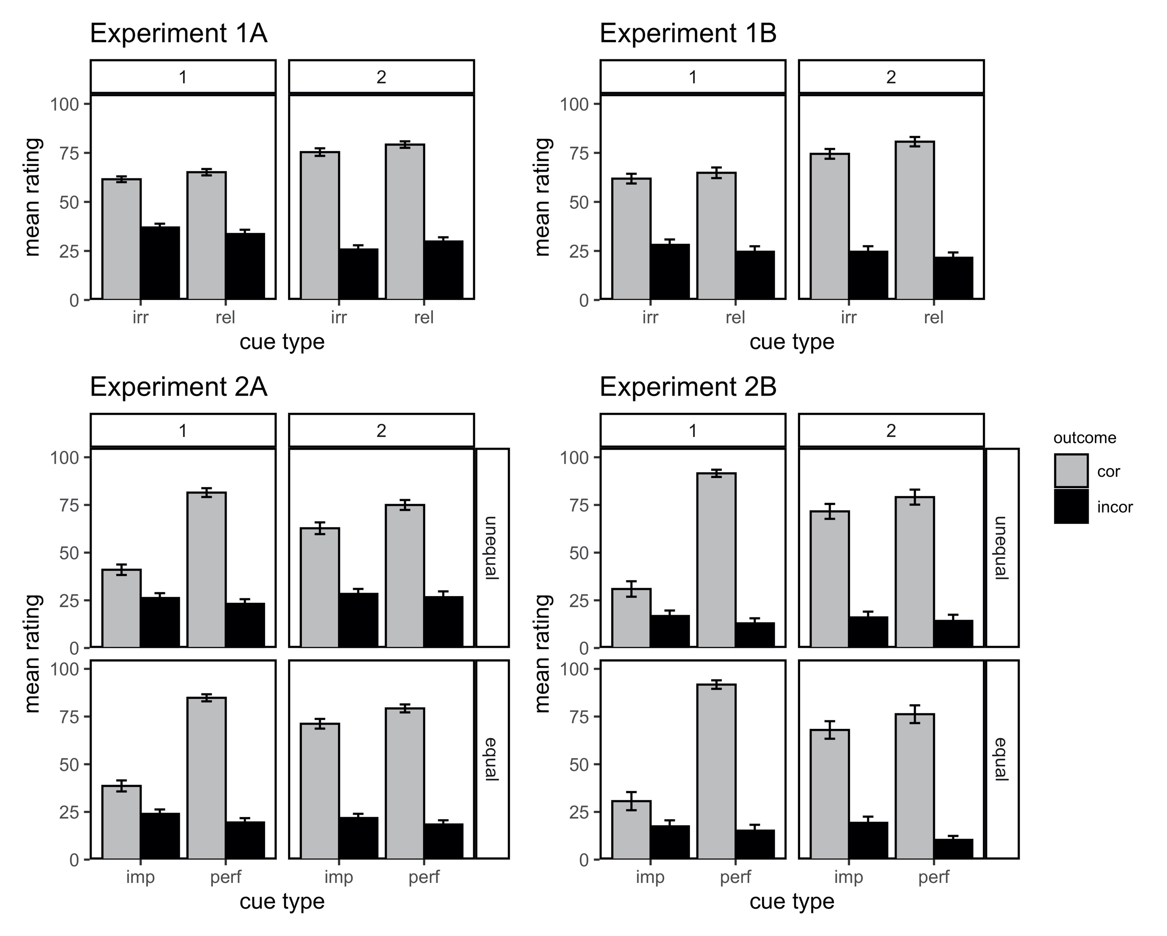
Figure A1. Mean predictive ratings for each cue type (relevant vs. irrelevant in Experiments 1A and 1B, perfect vs. imperfect in Experiments 2A and 2B) averaged for correct (associated with the cue in stage 2 training) and incorrect (not associated with the cue in stage 2 training) outcomes. Error bars represent standard error of the mean.

Appendix B. Eyegaze analyses for Experiment 1B

Table B1 shows the statistical results for the eyegaze data from the training phase in Experiment 1B. We compared relevant to irrelevant cues in a one-way ANOVA and a Bayesian ANOVA. Note that data were missing for two subjects (122, 131) in the feedback period. These participants were excluded from the analyses for this period.

Table B1.
Statistical results for the eyegaze data in the training phases in Experiment 1B.
Stage | Period | Fixations | Dwell
Stage 1 | Decision | F < 1, BF₁₀ = 0.126 | F < 1, BF₁₀ = 0.133
Stage 1 | Feedback | F(1,38) = 2.17, p = .148,  BF₁₀ = 0.238 | F(1,38) = 2.60, p = .115,  BF₁₀ = 0.215
Stage 2 | Decision | F < 1, BF₁₀ = 0.111 | F < 1, BF₁₀ = 0.091
Stage 2 | Feedback | F(1,38) = 4.64, p = .038,  BF₁₀ = 0.465 | F < 1, BF₁₀ = 0.118

Appendix C. Eyegaze analyses for Experiment 2B

Tables C1 and C2 show the statistical results for the eyegaze data from the training phase in Experiment 2B. We ran frequentist and Bayesian versions of a 2 (group unequal vs. equal) x 2 (perfect vs. imperfect cues) ANOVA. Note that data were missing for two subjects (236, 223) in the decision period and for 4 subjects (216, 236, 252, 223) in the feedback period. These participants were excluded from the analyses for the respective time periods.

Table C1.
Statistical results for the fixation eyegaze data in the training phases in Experiment 2B.

Stage | Period | Group Effect | Cue Effect | Interaction
Stage 1 | Decision | F < 1, BF₁₀ = 0.204 | F(1,52) = 26.3, p < .001, BF₁₀ = 19314 | F < 1, BF₁₀ = 0.096
Stage 1 | Feedback | F < 1, BF₁₀ = 0.190 | F(1,50) = 20.7, p < .001, BF₁₀ > 10e14 | F < 1, BF₁₀ = 0.159
Stage 2 | Decision | F < 1, BF₁₀ = 0.627 | F(1,52) = 2.88, p = .096, BF₁₀ = 0.229 | F(1,52) = 5.44, p = .024, BF₁₀ = 0.503
Stage 2 | Feedback | F < 1, BF₁₀ = 0.221 | F < 1, BF₁₀ = 0.109 | F(1,50) = 4.83, p = .033, BF₁₀ = 3.68

Table C2.
Statistical results for the dwell time eyegaze data in the training phases in Experiment 2B.

Stage | Period | Group Effect | Cue Effect | Interaction
Stage 1 | Decision | F < 1, BF₁₀ = 0.072 | F(1,52) = 30.2, p < .001, BF₁₀ = 128957 | F < 1, BF₁₀ = 0.096
Stage 1 | Feedback | F(1,50) = 1.29, p = .261, BF₁₀ = 1.09 | F(1,50) = 22.0, p < .001, BF₁₀ > 10e13 | F < 1, BF₁₀ = 0.482
Stage 2 | Decision | F < 1, BF₁₀ = 0.784 | F(1,52) = 4.08, p = .049, BF₁₀ = 0.269 | F(1,52) = 4.68, p = .035, BF₁₀ = 0.425
Stage 2 | Feedback | F < 1, BF₁₀ = 0.132 | F < 1, BF₁₀ = 0.110 | F(1,50) = 6.33, p = .015, BF₁₀ = 4.59

Appendix D. Learning score x eyegaze scatterplots

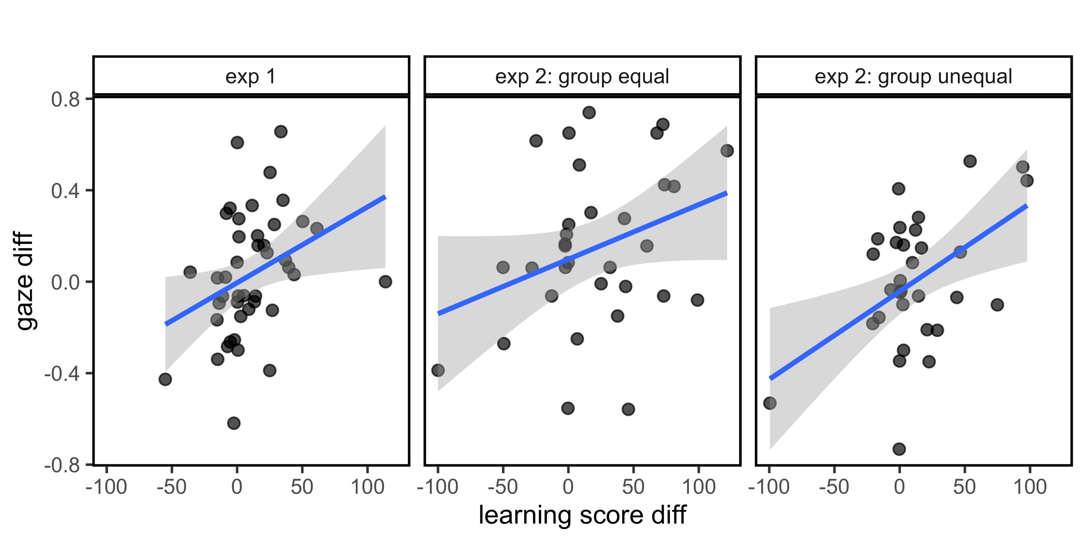

Figure D1. Scatterplot of mean difference scores for eyegaze (number of fixations) and learning scores in Experiment 1 (comparing relevant and irrelevant cues) and experiment 2 (comparing perfect and imperfect cues).

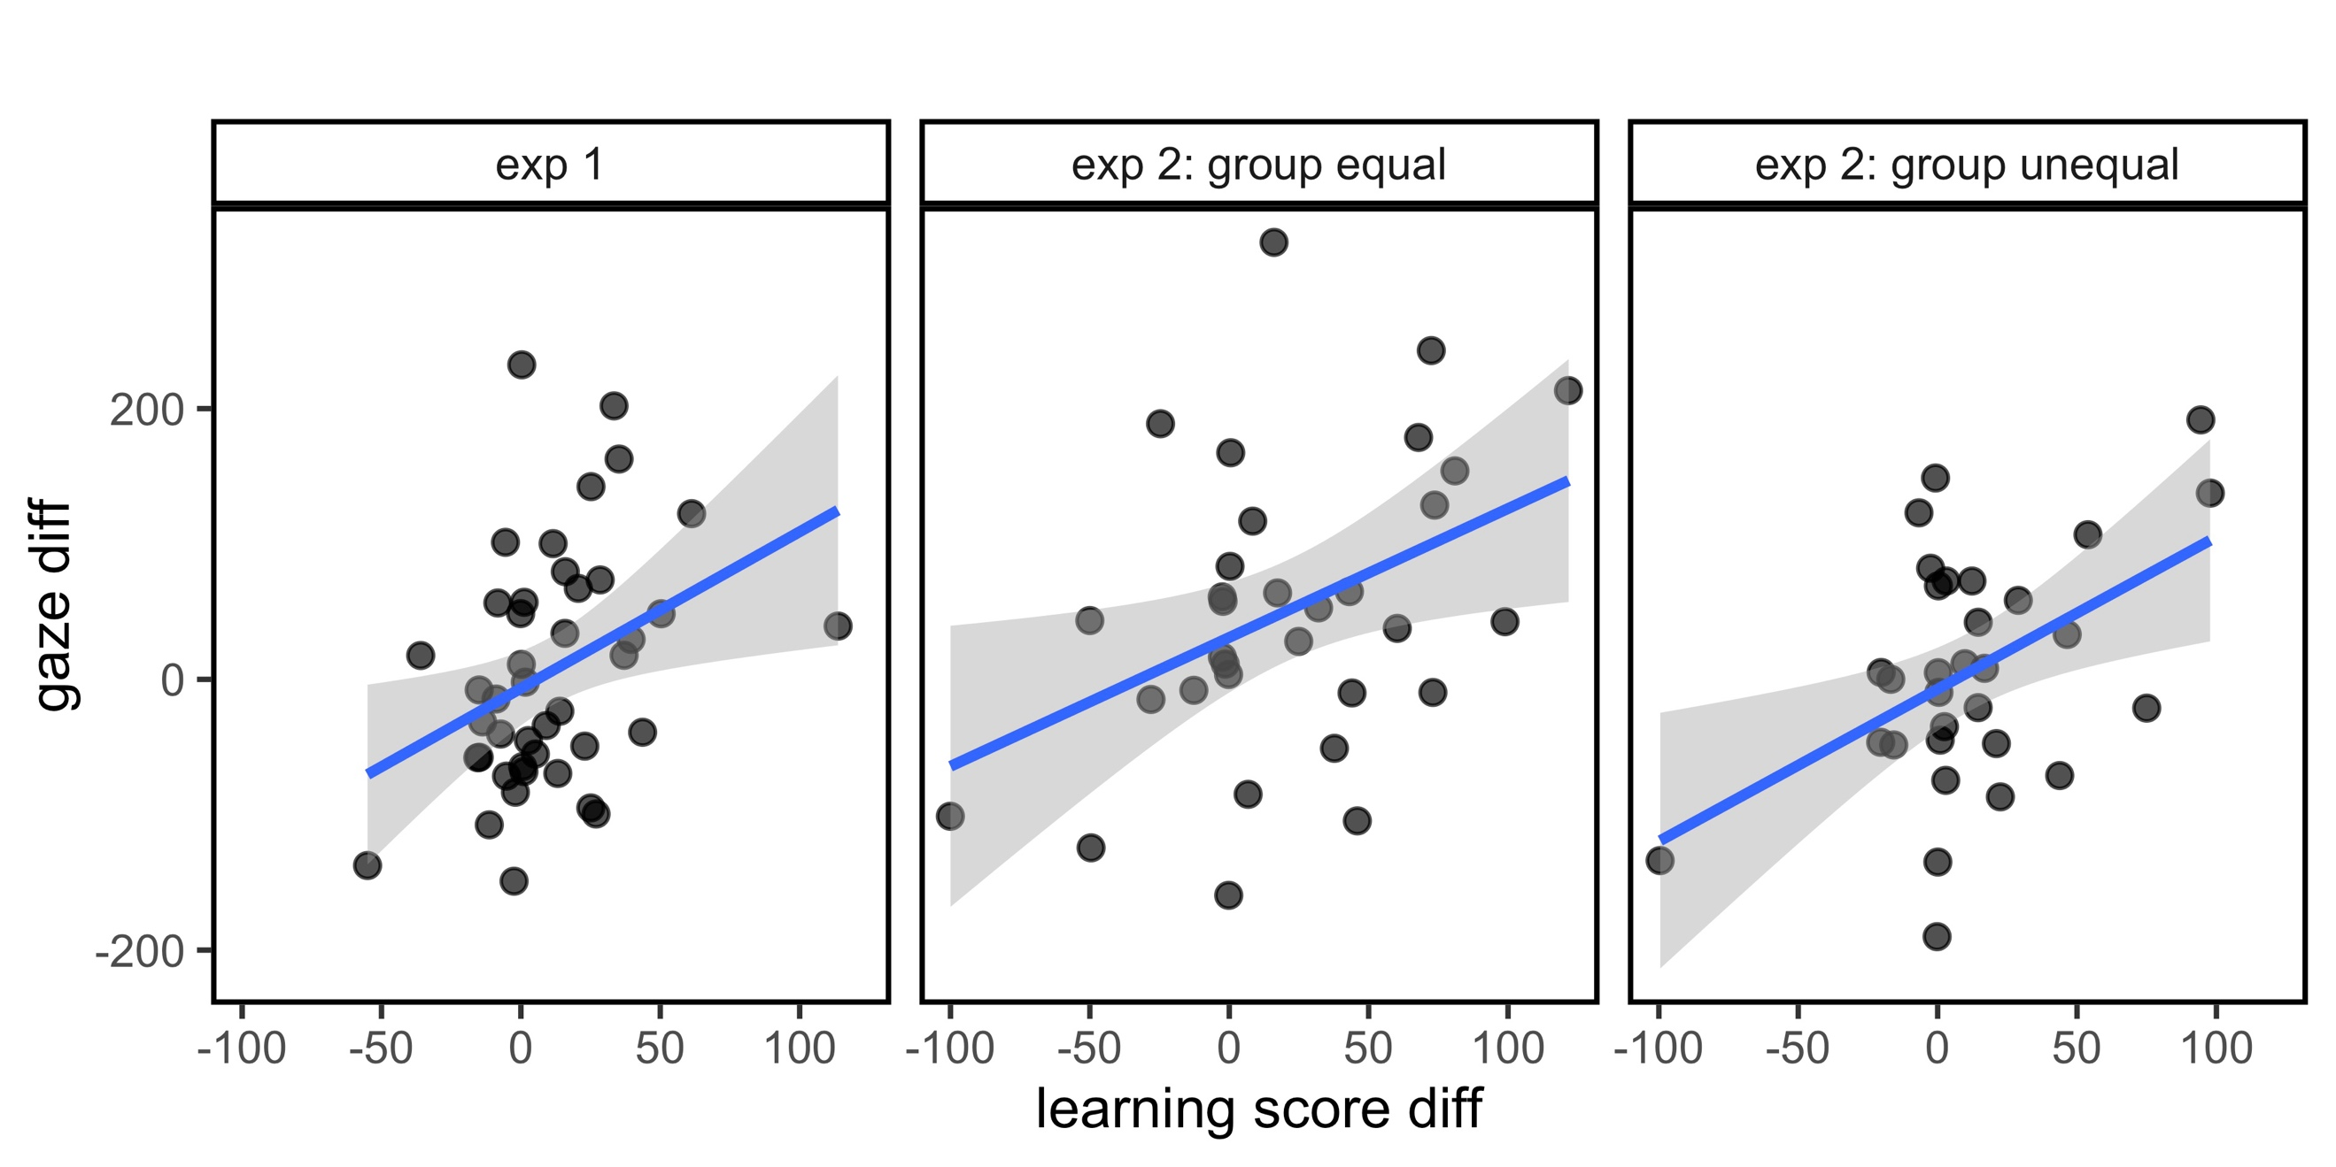

Figure D2. Scatterplot of mean difference scores for eyegaze (dwell time) and learning scores in Experiment 1 (comparing relevant and irrelevant cues) and experiment 2 (comparing perfect and imperfect cues).

