Supplementary Material

Communicative cooperation time ran out scores and individual Theory of Mind
A forward multiple regression analysis was carried out to identify possible predictors of time ran out scores out of the following candidate variables: ToM score of player one, ToM score of player two, Raven score of player one, Raven score of player two, and ToM score difference between player 1 and player 2 within each pair. The regression model revealed that ToM competence (i.e. ToM score of player one or ToM score of player two) was not a significant predictor for time ran out scores.
Table 2. Correlation matrix for outcome (cooperative failure, cooperative success, and time ran out) and predictor variables in the regression analysis. Values in brackets represent the 95% confidence lower and upper intervals.
 | Failed cooperation | Successful cooperation | Time ran out | Player 1 ToM score | Player 1 Raven score | Player 2 ToM score | Player 2 Raven score
Player 1 ToM score | -.177*  (-.32, -.03) | .098  (-.05, .24) | -.015  (-.16, .13) | -
Player 1 Raven’s score | -.139*  (-.28, .01) | .078  (-.07, .22) | -.013  (-.16, .14) | .274***  (.13, .41) | -
Player 2 ToM score | -.162*  (-.30, -.01) | .130*  (-.02, .27) | -.051  (-.20, .10) | .060  (-.09, .21) | .104  (-.04, .25) | -
Player 2 Raven’s score | -.045  (-.19, .10) | .180**  (.03, .32) | -.146*  (-.29, .01) | .102  (-.05, .25) | 0.26  (-.12, .17) | .267***  (.12, .40) | -
*p<.05, **p<.01, ***p<.001
Here, we also report the results from the median split analysis approach, in which we split our sample into low and high ToM groups based on individual MASC scores. A one-way between participants ANCOVA was conducted to assess for quantitative differences between the ToM groups (i.e., low ToM and high ToM) on the time ran out scores whilst adjusting for general ability (i.e., Raven score). The ANCOVA with time ran out score as the dependent variable, using the Raven’s score as the covariate, did not reveal a significant main effect of ToM group upon time ran out scores, F(1, 347) = .053, p = .818, η²_{p} =.056. After adjusting for Raven score, the time ran out adjusted mean % for the low ToM group was 41.415 (SEM = 1.094), and for the high ToM group was 41.33 (SEM = 1.216) (see Figure 1B). This is to be expected as the time ran out scores contain a mixture of ‘almost’ successful and ‘almost’ failed cooperation.
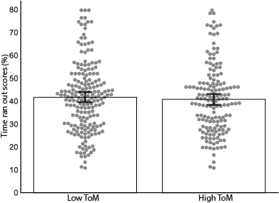
Figure 1. Bar graphs for mean % score for cooperative time ran out scores showing each group performance separately (low and high Theory of Mind groups). Error bars represent 95% confidence intervals. Please note that the outcome variable (i.e., time ran out scores) is duplicated here (if one participant was in the high ToM group and their partner was in the low ToM group, their dyadic time ran out score is plotted twice in the figure, one on each x-axis bar).

Communicative time ran out scores and Theory of Mind of both partners within a pair
A one-way between participants ANOVA did not yield any significant differences between groups on the time ran out scores (F(2,172) = .578, p = .562). Again, this is to be expected as the time ran out responses contain pure noise (i.e., a mixture of ‘almost’ failed and ‘almost’ successful cooperation).
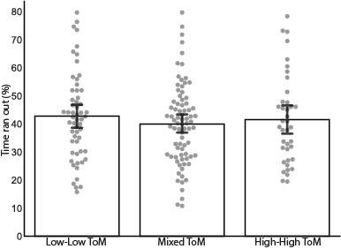
Figure 2. Bar graphs for mean % score for cooperative success (panel A) and cooperative time ran out (panel B) showing each group performance separately (low-low, high-high and mixed Theory of Mind groups). Error bars represent 95% confidence intervals.

