**Supplementary Materials of “Stimulus-triggered task conflict affects task-selection errors in task switching: A Bayesian multinomial processing tree modeling approach”**

**S1 Analyses restricted to fast trials**

**S2 Goodness of fit table of the aggregated data analysis (N=120)**

**S1: Analyses restricted to fast trials**

A vast literature indicates that performance in cognitive control tasks is governed by two routes (Ridderinkhoff, 2002). One is a fast, automatic, and stimulus-driven. The other is slow, controlled, and information is processed in a top-down fashion. Support for such distinction has largely based on findings that interference effects are larger in fast trials compared to slow trials, especially in error rates (Ridderinkhof, 2002; for a formal implementation of this concept, see: Ulrich et al., 2015).

Similarly, we believe that fast responses may be particularly prone to task interference in our paradigm, possibly reflecting attentional capture from the irrelevant task feature. In order to explore such possibility, we run the same analyses as reported in the paper, focusing only on the fastest half of the individuals’ RT distributions, as determined via a median-split. The results are presented for Experiment 1 and 2 separately.

**Experiment 1**

The same models were fit to the data as in the main paper. The only difference was that we only included those trials in which the response was faster than the median response for that participant in that condition. Model fit can be found in Table A1. As in the main analysis, the best fitting model included separate T parameters for each condition of our design, and separate R parameters for repetition and switch trials. The results were even clearer compared to when analyzing the whole sample, in that the model selection procedure gave a clear winner. As for the effects of Distractor Saliency on the R parameter, comparing the winning model with an identical model including separate R parameters for SD and NSD (i.e. the Full model), produced a relatively large decrease in fit (*ΔDIC* = 9).

|  |  |  |  |  |  |
| --- | --- | --- | --- | --- | --- |
| *Model* | *Free parameters for Distractor Saliency* | *Free parameters for Task Transition* | *PPP* | *DIC* | *ΔDIC* |
| Null | None | None | <.001 | 1897 | 89 |
| Saliency_T | T | None | <.001 | 1888 | 80 |
| Transition_T | None | T | <.001 | 1827 | 19 |
| Saliency_R | R | None | <.001 | 1903 | 95 |
| Transition_R | None | R | <.001 | 1837 | 29 |
| Saliency_T&R | T, R | None | <.001 | 1895 | 87 |
| Transition_T&R | None | T, R | .006 | 1816 | 8 |
| Saliency_R_Transition_T | R | T | < .001 | 1835 | 27 |
| Saliency_T_Transition_R | T | R | .002 | 1828 | 20 |
| Saliency_T_Transition_T | T | T | .013 | 1818 | 10 |
| Saliency_R_Transition_R | R | R | < .001 | 1848 | 40 |
| Saliency_T&R_Transition T | T, R | T | .015 | 1824 | 16 |
| Transition_T&R_Saliency_T | T | T, R | .467 | 1808 | 0 |
| Saliency_T&R_Transition_R | T, R | R | < .001 | 1842 | 34 |
| Transition_T&R_Saliency_R | R | T, R | < .001 | 1829 | 21 |
| Full | T, R | T, R | .497 | 1817 | 9 |

***Table A1.*** Experiment 1: analysis restricted to fast responses. Goodness of fit statistics for each of the fitted models. PPP = posterior predictive p-value, DIC = Deviance Information Criterion. ΔDIC represents the distance between the model’s DIC and the best fitting model’s DIC.

Similarly to the main text, we further analyzed possible differences among individuals’ parameters values through means of ANOVA and t-tests. Descriptive statistics for the T parameter are depicted in Figure A1. The ANOVA with Task Transition and Distractor Saliency as independent variables revealed main effects of both Task Transition, *F*(1, 59) = 313.8, p < .001, $η_{p}^{2}$ = .84, $η_{G}^{2}$ = .290, and Distractor Saliency, *F*(1, 59) = 225.9, p < .001, $η_{p}^{2}$ = .79, $η_{G}^{2}$ = .185. Furthermore, an interaction emerged between the two factors *F*(1, 59) = 187.2, p < .001, $η_{p}^{2}$ = .76, $η_{G}^{2}$ = .045. Follow-up t-tests indicated that although task selection accuracy was significantly reduced for SD stimuli in task-repetition trials (.019), *t*(59) = 8.03, *p* < .001, dz = 1.03, this effect was stronger with task switches (.069), *t*(59) = 18.05, *p* < .001, dz = 2.33.

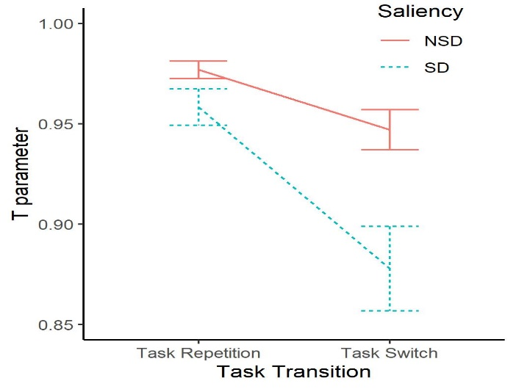

**Figure A1.** Experiment 1. T parameters of the best-fitting model as a function of Distractor Saliency and Task Transition. Error bars represent 95% Confidence Intervals.

As for the R parameter, we found again that response-selection failures were more frequent in task-switch trials compared to task-repetition trials (.022), *t*(59) = 9.71, *p* < .001, dz = 1.25.

**Experiment 2**

The estimated fit for each model is reported in table A2. As evident from the table, a few models had a relatively similar model fit. According to our criteria for model selection, fit is considered to be substantially worse only if *ΔDIC* > 3. In our case, 3 models had a *ΔDIC* < 3: The *Saliency_T&R_Transition T* model, *Transition_T&R* model, and the *Transition_T&R_Saliency_T* model. In order to make sure that such small differences were not due to some random variation in the MCMC process, we fit again these models 30 times each. Such iterative approach confirmed that no substantial differences could be found amongst models (Mean DIC *Saliency_T&R_Transition T* = 1858*,* Mean DIC *Transition_T&R*: 1860, Mean DIC *Transition_T&R_Saliency_T* = 1860). Since only the *Transition_T&R_Saliency_T* model had a PPP > .05, we selected again this model.

|  |  |  |  |  |  |
| --- | --- | --- | --- | --- | --- |
| *Model* | *Free parameters for Distractor Saliency* | *Free parameters for Task Transition* | *PPP* | *DIC* | *ΔDIC* |
| Null | None | None | <.001 | 1941 | 85 |
| Saliency_T | T | None | <.001 | 1945 | 89 |
| Transition_T | None | T | <.001 | 1860 | 4 |
| Saliency_R | R | None | <.001 | 1948 | 92 |
| Transition_R | None | R | <.001 | 1899 | 43 |
| Saliency_T&R | T, R | None | <.001 | 1948 | 92 |
| Transition_T&R | None | T, R | .002 | 1857 | 1 |
| Saliency_R_Transition_T | R | T | < .001 | 1863 | 7 |
| Saliency_T_Transition_R | T | R | < .001 | 1904 | 48 |
| Saliency_T_Transition_T | T | T | .004 | 1860 | 4 |
| Saliency_R_Transition_R | R | R | < .001 | 1902 | 46 |
| Saliency_T&R_Transition T | T, R | T | .039 | 1856 | 0 |
| Transition_T&R_Saliency_T | T | T, R | .065 | 1859 | 3 |
| Saliency_T&R_Transition_R | T, R | R | < .001 | 1905 | 49 |
| Transition_T&R_Saliency_R | R | T, R | .001 | 1865 | 9 |
| Full | T, R | T, R | .484 | 1861 | 5 |

***Table A2.*** Experiment 2: analysis restricted to fast responses. Goodness of fit statistics for each of the fitted models. PPP = posterior predictive p-value, DIC = Deviance Information Criterion. ΔDIC represents the distance between the model’s DIC and the best fitting model’s DIC.

After the best-fitting model was selected, we again proceeded to analyses differences between its parameters. Descriptive statistics for the T parameter are depicted in Figure A2. The ANOVA on T parameters showed a main effect of Task Transition, *F*(1, 59) = 314.4, p < .001, $η_{p}^{2}$ = .84, $η_{G}^{2}$ = .163, indicating higher task-selection failures in switch trials. Contrary to the analysis reported in the main text, also a main effect of Distractor Saliency was present, *F*(1, 59) = 194.0, p < .001, $η_{p}^{2}$ = .77, $η_{G}^{2}$ = .024, showing significantly more task-selection failures with SD stimuli. In addition, an interaction emerged between the two factors *F*(1, 59) = 17.7, p < .001, $η_{p}^{2}$ = .23, $η_{G}^{2}$ = .007. Follow-up t-tests indicated that task selection accuracy was significantly reduced for SD stimuli in both task-repetition trials (.008), *t*(59) = 3.73, *p* < .001, dz = 0.48, and even more so in task switches (.047), *t*(59) = 9.87, *p* < .001, dz = 1.27.

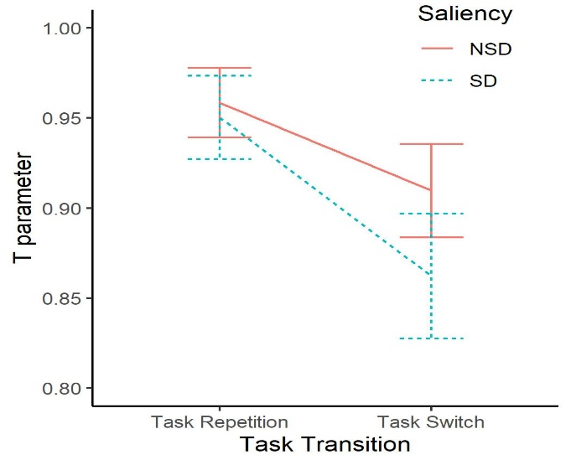

**Figure A2.** Experiment2. T parameters of the best-fitting model as a function of Distractor Saliency and Task Transition. Error bars represent 95% Confidence Intervals.

As for the R parameter, we found again that response-selection failures were more frequent in task-switch trials compared to task-repetition trials (.018), *t*(59) = 5.77, *p* < .001, dz = 0.74.

**Summary**

In conclusion, limiting our analysis to fast trials largely replicated the results reported in the main text. First of all, again, the best-fitting model for both experiment was the *Transition_T&R_Saliency_T* model. Importantly, the T parameters in the SD conditions were always found to be significantly lower than in the NSD conditions. This effect was stronger in switch trials than in repetition trials in both experiments. It is to be noted that in both experiments, and particularly in Experiment 2 the effects were larger when limiting our analysis to fast trials, compared to the analysis reported in the main text. For example, in Experiment 2 a clear main effect of Distractor Saliency was present on the T parameter, which was not present when considering the full set of trials, as reported in the main text.

**S2: Goodness of fit table of the aggregated data analysis (N=120)**

|  |  |  |  |  |  |
| --- | --- | --- | --- | --- | --- |
| *Model* | *Free parameters for Distractor Saliency* | *Free parameters for Task Transition* | *PPP* | *DIC* | *ΔDIC* |
| Null | None | None | <.001 | 5087 | 315 |
| T(Saliency) | T | None | <.001 | 5085 | 313 |
| T(Transition) | None | T | <.001 | 4870 | 98 |
| R(Saliency) | R | None | <.001 | 5099 | 327 |
| R(Transition) | None | R | <.001 | 4829 | 57 |
| T(Saliency)_R(Saliency) | T, R | None | <.001 | 5096 | 324 |
| T(Transition)_R(Transition) | None | T, R | .009 | 4772 | 0 |
| T(Transition)_R(Saliency) | R | T | < .001 | 4880 | 108 |
| T(Saliency)_R(Transition) | T | R | <.001 | 4829 | 57 |
| T(Saliency, Transition) | T | T | <.001 | 4862 | 90 |
| R(Saliency, Transition) | R | R | <.001 | 4838 | 66 |
| T(Saliency, Transition)_R(Saliency) | T, R | T | <.001 | 4871 | 99 |
| T(Saliency, Transition)_R(Transition) | T | T, R | .346 | 4772 | 0 |
| T(Saliency)_R(Saliency, Transition) | T, R | R | <.001 | 4840 | 68 |
| T(Transition)_R(Saliency, Transition) | R | T, R | .011 | 4786 | 14 |
| Full | T, R | T, R | .510 | 4782 | 10 |

***Table S1.*** Aggregated data analysis (N=120). Goodness of fit statistics for each of the fitted models. PPP = posterior predictive p-value, DIC = Deviance Information Criterion. ΔDIC represents the distance between the model’s DIC and the best fitting model’s DIC

**References**

Ridderinkhof, R. K. (2002). Micro-and macro-adjustments of task set: activation and suppression in conflict tasks. *Psychological research*, *66*(4), 312-323.

Ulrich, R., Schröter, H., Leuthold, H., & Birngruber, T. (2015). Automatic and controlled stimulus processing in conflict tasks: Superimposed diffusion processes and delta functions. *Cognitive psychology*, *78*, 148-174.