Supplemental Figures

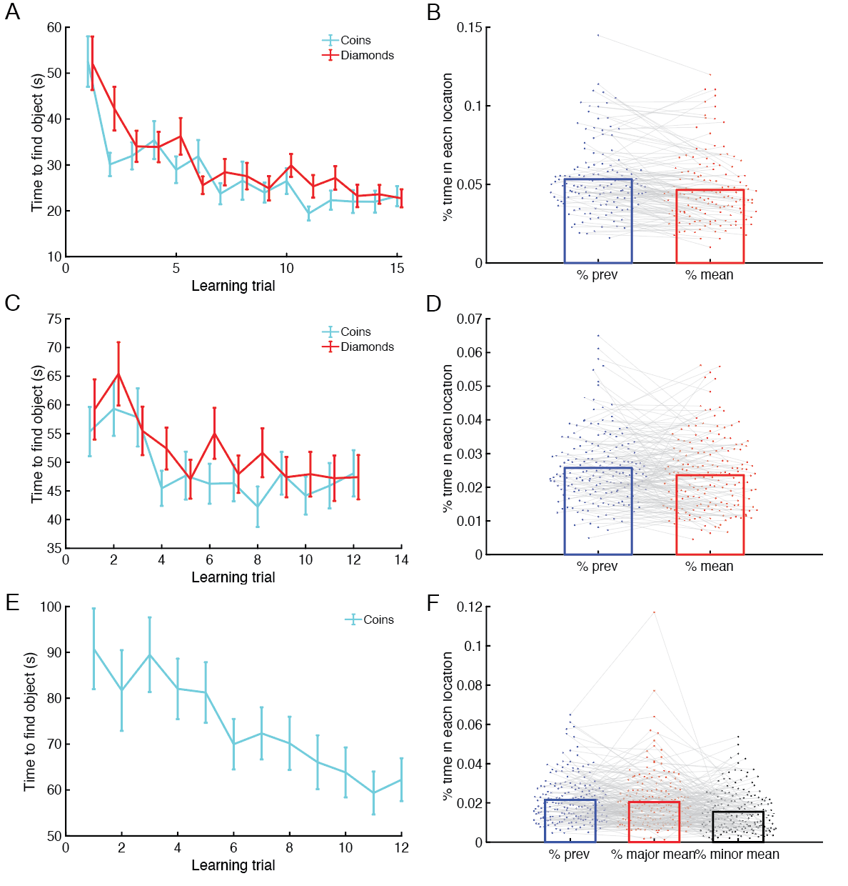
Fig S1. Learning phase. (A, B) refers to Experiment 1, (C, D) refers to Experiment 2, and (E, F) refers to Experiment 3. A, C, E) Subjects in all retention interval conditions demonstrated learning via gradually shorter times to find each object (coins: cyan; diamonds: red). B, D) In Experiments 1 and 2, across both object types and all learning trials, subjects spent more time in the previous location of that object type than the experienced mean of that type. F) In Experiment 3, subjects spent marginally more time in the previous location than the experienced mean of the major mode and more time in these locations than the experienced mean of the minor mode. In (A, C, E), error bars indicate SEM and are staggered for visualization.

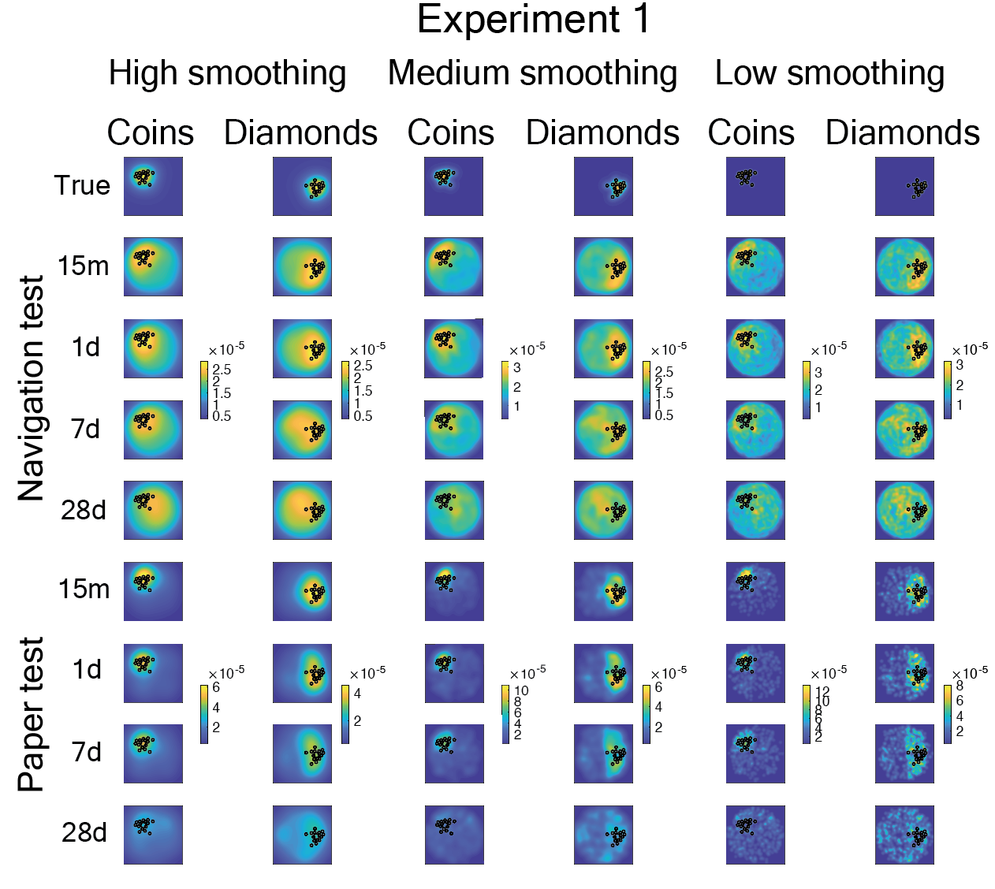
Fig S2. Effects of smoothing on distributed patterns in Experiment 1. Results are shown for three levels of smoothing, from high (left) (used in the main paper) to medium (middle) to low (right). Plotted are the (top row) true representations for both distribution types, (next four rows) average representations across subjects on each retention interval of location during the navigation test, and (last four rows) average representations across subjects on each retention interval of guesses on the paper test. Colorbar scales are set based on each comparison across the retention intervals of the same smoothing, test, and distribution type.

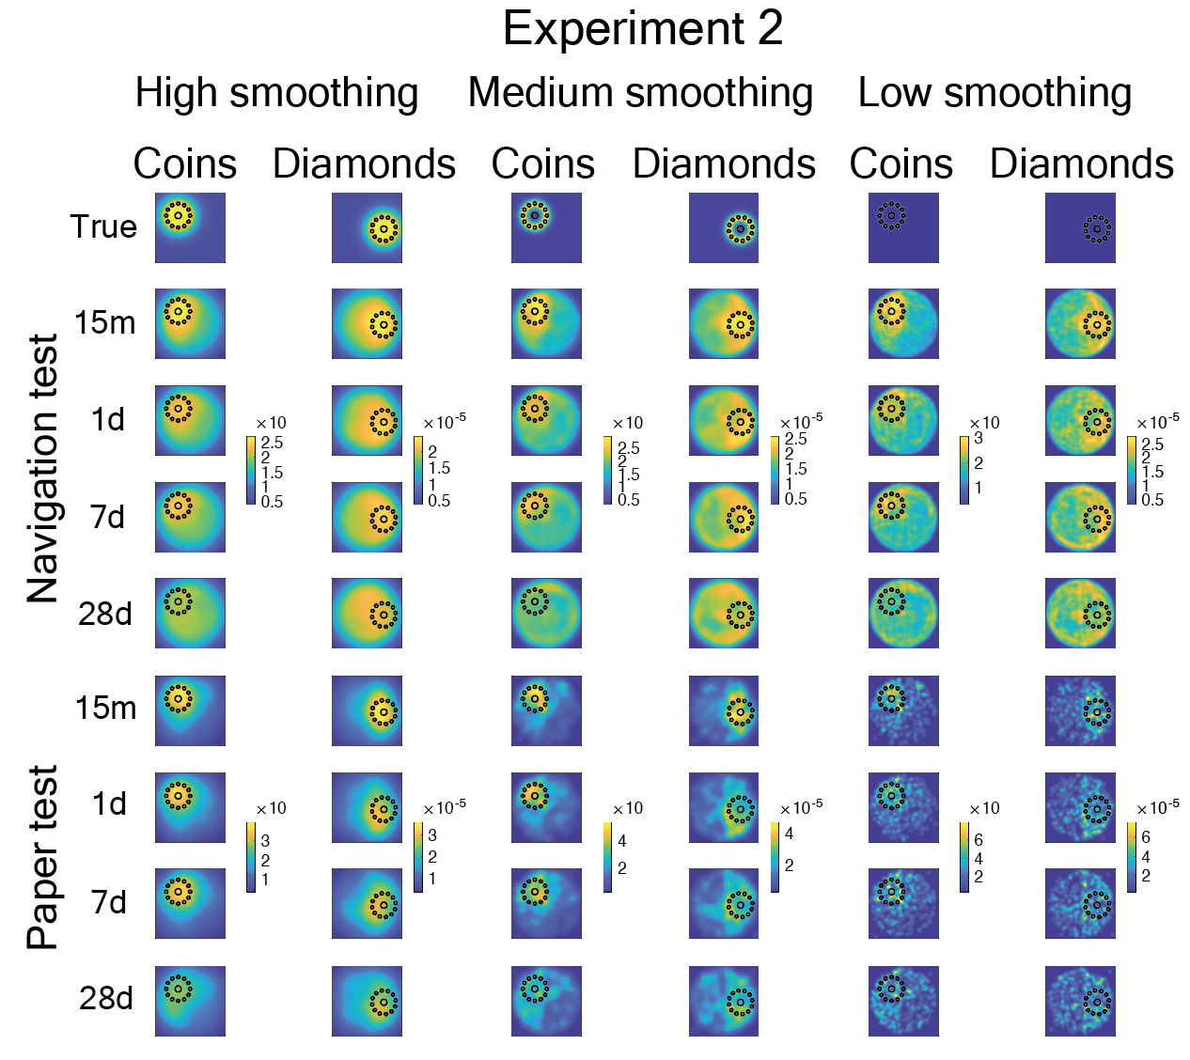
Fig S3. Effects of smoothing on distributed patterns in Experiment 2. Results are shown for three levels of smoothing, from high (left) (used in the main paper) to medium (middle) to low (right). Plotted are the (top row) true representations for both distribution types, (next four rows) average representations across subjects on each retention interval of location during the navigation test, and (last four rows) average representations across subjects on each retention interval of guesses on the paper test. Colorbar scales are set based on each comparison across the retention intervals of the same smoothing, test, and distribution type.

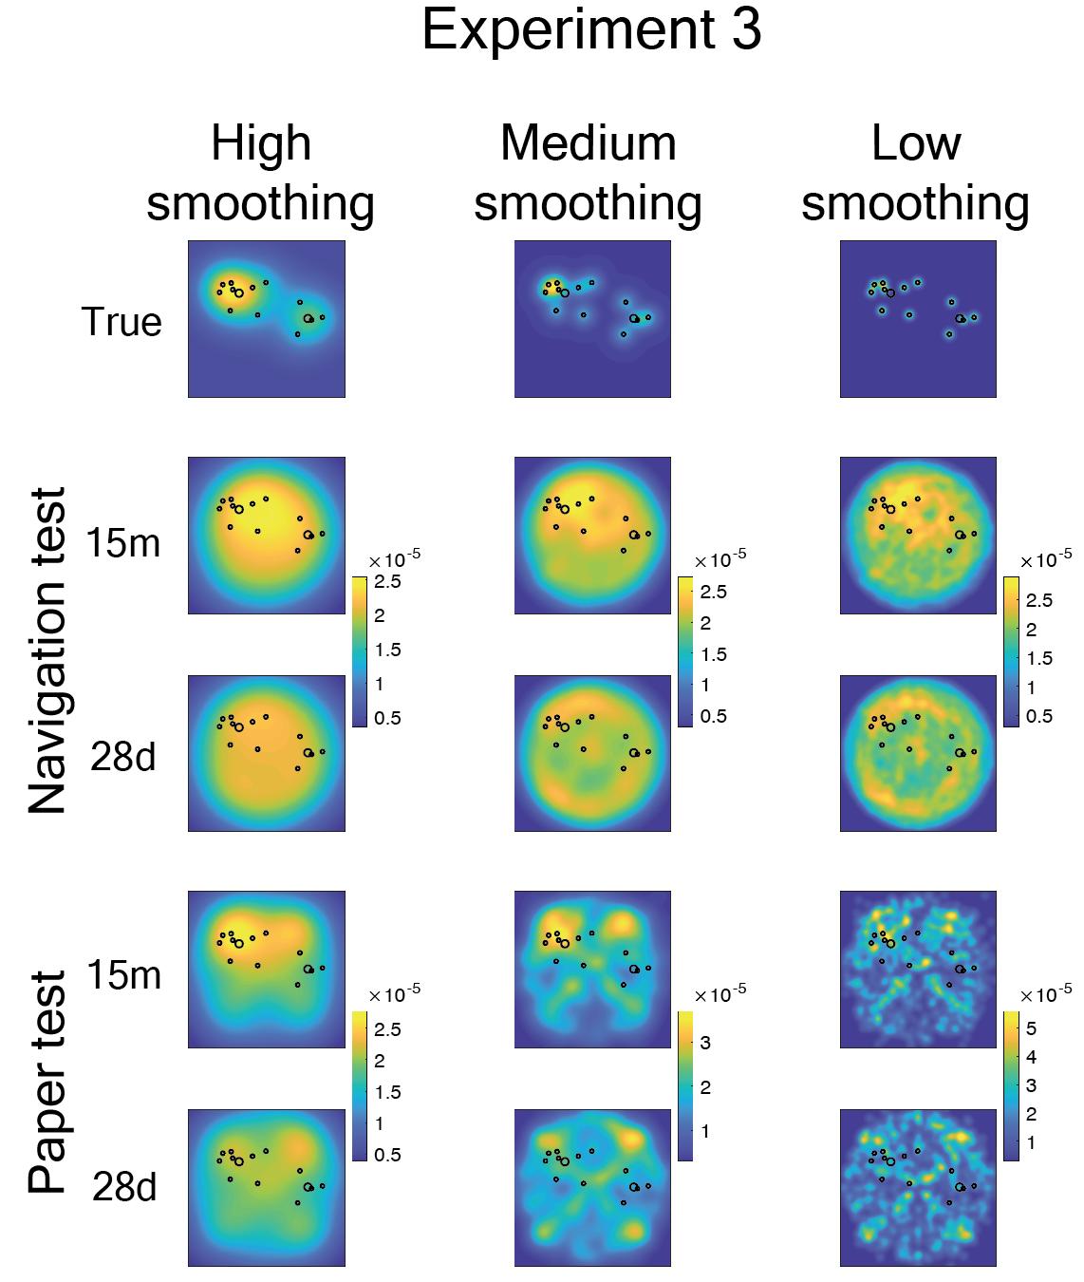
Fig S4. Effects of smoothing on distributed patterns in Experiment 3. Results are shown for three levels of smoothing, from high (left) (used in the main paper) to medium (middle) to low (right). Plotted are the (top row) true representations for the bimodal distribution, (next two rows) average representations across subjects on each retention interval of location during the navigation test, and (last two rows) average representations across subjects on each retention interval of guesses on the paper test. Colorbar scales are set based on each comparison across the retention intervals of the same smoothing, test, and distribution type.

