Supplemental Materials
How Sequential Changes in Reward Magnitude Modulate Cognitive Flexibility: Evidence From Voluntary Task Switching
by K. Fröber & G. Dreisbach, 2015, JEP: Learning, Memory, and Cognition
http://dx.doi.org/10.1037/xlm0000166

Here we will present and discuss results for RT and error data of forced- and free-choice trials from Experiments 1 to 5.
- Experiment 1
    - Design. In forced-choice trials a 2 (Transition: repeat, switch) x 2 (Reward_{N}: low, high) x 2 (Reward_{N-1}: low, high) repeated measures design was used with mean RTs (ms) and error rates (percent) serving as dependent measures. In free-choice trials of Experiment 1 Reward_{N} was always high resulting in a 2 (Transition) x 2 (Reward_{N-1}: low, high) design.
Following reporting by Shen and Chun (2011) statistical analysis in forced-choice trials follow a 2 (Transition: repeat, switch) x 2 (Reward_{N}: low, high) x 2 (Reward_{N-1}: low, high) design, but graphs will show RTs as a function of Transition (repeat, switch) and Reward sequence (reward_{remain_low}, reward_{increase}, reward_{remain_high}, reward_{decrease}). With this procedure we hope to facilitate comparability across studies. The displayed order of reward sequences corresponds to actually occurring transitions of reward expectation: reward expectation can remain low, it increases when a high reward is announced for the first time, it can then remain high, and it decreases again when reward announcement changes back from high to low.
    - Data analysis. The first trial of the test phase was excluded from analysis. For the RT analysis, error trials, trials following an error (19.6 % of data), and RTs exceeding three standard deviations from individual cell means (1.1 %) were removed. Moreover, data from three participants were considered outliers (as identified by boxplots) in mean RTs and/or error rates.
    - Forced-choice trials, RT data. The 2 (Transition) x 2 (Reward_{N}) x 2 (Reward_{N-1}) repeated measures analysis of variance (ANOVA) on mean RTs revealed significant main effects of Transition, F(1, 21) = 35.14, p < .001, η_{p}²= .626, and Reward_{N}, F(1, 21) = 9.83, p < .01, η_{p}² = .319. Participants showed typical switch costs (49 ms) and were generally faster in high (583 ms) as compared to low reward trials (623 ms) irrespective of previous reward. The main effect of Reward_{N-1} and all two-way interactions did not prove reliable (all Fs < 2.09, all ps > .163). Most importantly, we found a significant three-way interaction, F(1, 21) = 7.37, p < .05, η_{p}²= .26. Post hoc analysis showed a significant two-way interaction of Transition x Reward_{N-1} within high reward trials, F(1, 21) = 12.36, p < .01, η_{p}² = .37. In line with previous findings by Shen and Chun (2011), task repetition RTs were fastest in reward_{remain_high} trials (M_{remain_high} = 541 vs. M_{increase} = 569 ms) and switch RTs were fastest in reward_{increase} trials (M_{increase} = 608 vs. M_{remain_high} = 616 ms). No interaction was found within low reward trials (F < 1, p = .557) (see Figure S1).
--- please insert Figure S1 about here ---

    - Forced-choice trials, error data. The same ANOVA revealed a significant main effect of Transition, F(1, 21) = 8.45, p < .01, η_{p}² = .287. No further significant effects were found (Fs < 2.34, ps > .141). Participants made generally more errors in task switch trials (M_{repetition} = 8.67 vs. M_{switch} = 11.51 %) irrespective of reward condition. Mean error rates for each condition are displayed in Table S1.

--- please insert Table S1 about here ---

    - Free-choice trials, RT data. The 2 (Transition) x 2 (Reward_{N-1}) ANOVA showed only a significant main effect of Transition in RTs, F(1, 21) = 14.05, p < .01, η_{p}² = .401, demonstrating typical switch costs (45 ms). All other effects did not prove reliable (Fs < 1, ps > .396). Descriptively, fastest RTs were found on task repetitions in reward_{remain_high} trials (592 vs. 603 ms in reward_{increase} trials) and fastest switch RTs in reward_{increase} trials (639 vs. 644 ms in reward_{remain_high} trials) mirroring the RT pattern found in forced-choice trials. Free-choice RTs and error rates for each condition can be found in Table S2.

--- please insert Table S2 about here ---

    - Free-choice trials, error data. In the same ANOVA with mean error rates the main effect Transition did not reach significance (F = 2.35, p = .140), but descriptively typical switch costs were present (M_{repetition} = 6.51 % vs. M_{switch} = 9.35 %). All other effects did not prove reliable either (Fs < 1, ps > .91).

- Experiment 2
    - Design. Design in forced-choice and free-choice trials was identical to Experiment 1.
    - Data analysis. Data preprocessing was identical to Experiment 1 resulting in exclusion of 22.03% of the data. Boxplots on mean RTs and error rates identified one participant as an outlier in RTs.
    - Forced-choice trials, RT data. The 2 (Transition) x 2 (Reward_{N}) x 2 (Reward_{N-1}) ANOVA revealed significant main effects of Transition, F(1, 24) = 81.88, p < .001, η_{p}² = .773, and Reward_{N}, F(1, 24) = 11.41, p < .01, η_{p}² = .322. Again, participants showed typical switch costs (64 ms) and were generally faster in high (545 ms) as compared to low reward trials (609 ms) irrespective of previous reward. This time, the three-way interaction did not reach significance (F = 2.53, p = .125). Again, the main effect of Reward_{N-1} and all two-way interactions did not prove reliable (all Fs < 2.43, all ps > .132). Descriptively, fastest RTs in task repetitions were again found in reward_{remain_high} trials (509 ms vs. 520 ms in reward_{increase} trials), but this time fastest switch RTs were found in the same condition (573 ms vs. 580 ms in reward_{increase} trials; see Figure S2).
--- please insert Figure S2 about here ---

    - Forced-choice trials, error data. The same ANOVA on error rates revealed significant main effects of Transition, F(1, 24) = 8.36, p< .01, η_{p}² = .258, and Reward_{N}, F(1, 24) = 16.41, p <.001, η_{p}² = .406. Participants made more errors in switch than repeat trials (M_{switch} = 12.77 % vs. M_{repetition} = 10.25 %) and more errors in high reward than low reward trials (M_{high_reward} = 13.76 % vs. M_{low_reward} = 9.26 %). The main effect of Reward_{N-1} and all interactions did not reach significance (all Fs < 1.46, all ps > .238). Mean error rates for each condition are displayed in Table S3.

--- please insert Table S3 about here ---

    - Free-choice trials, RT data. Like in Experiment 1 the 2 (Transition) x 2 (Reward_{N-1}) ANOVA showed only a significant main effect of Transition, F(1, 23) = 17.18, p < .001, η_{p}² = .428, demonstrating typical switch costs (41 ms). All other effects did not prove reliable (Fs < 1, ps > .626). Descriptively, fastest RTs were found on task repetitions in reward_{remain_high} trials (551 vs. 553 ms in reward_{increase} trials) and fastest switch RTs in reward_{increase} trials (590 vs. 595 ms in reward_{remain_high} trials). Free-choice RTs and error rates for each condition can be found in Table S4.
--- please insert Table S4 about here ---

    - Free-choice trials, error data. Like in Experiment 1 the main effect Transition did not reach significance (F = 2.99, p = .097; M_{repetition} = 11.02 % vs. M_{switch} = 15.13 %). All other effects did not prove reliable either (Fs < 1, ps > .535).

- Experiment 3
    - Design. Design in forced-choice and free-choice trials was identical to Experiments 1 and 2.
    - Data analysis. Data preprocessing was identical to Experiments 1 and 2 resulting in exclusion of 22.91 % of the data. No outliers were identified in the sample.
    - Forced-choice trials, RT data. Mean RTs were generally faster (549 ms) as compared to Experiments 1 (603 ms) and 2 (577 ms) indicating that participants indeed adopted the speed instruction for all trials. The 2 (Transition) x 2 (Reward_{N}) x 2 (Reward_{N-1}) ANOVA revealed a significant main effect of Transition, F(1, 25) = 36.78, p < .001, η_{p}² = .595, reflecting typical switch costs (M_{repeat} = 532 ms vs. M_{switch} = 566 ms). Again, the three-way interaction did not reach significance (F = 2.51, p = .126; see Figure S3). The interaction of Reward_{N} x Reward_{N-1} approached significance, F(1, 25) = 4.14, p = .053, η_{p}² = .142. There was a trend for faster RTs when reward remained high as compared to reward_{increase} trials (p = .06), whereas the RT difference between both low reward conditions was far from significant (p = .804). All other main effects and interactions did not prove reliable (all F < 1.68, all p > .206).
--- please insert Figure S3 about here ---

    - Forced-choice trials, error data. The same ANOVA on error rates showed no significant main effects or interactions (all F < 2.37, all p > .136). Descriptively, however, the pattern resembled the RT data found in Experiment 1. Within the high reward condition, error rate in switch trials was lower for reward_{increase} as compared to reward_{remain_high} trials, whereas error rates in repeat trials were lower for reward_{remain_high} trials as compared to reward_{increase} trials (see Table S5).

--- please insert Table S5 about here ---

    - Free-choice trials, RT data. The 2 (Transition) x 2 (Reward_{N-1}) ANOVA showed only a significant main effect of Transition, F(1, 23) = 19.34, p < .001, η_{p}² = .436, demonstrating typical switch costs (61 ms). All other effects did not prove reliable (Fs < 1, ps > .697). Free-choice RTs and error rates for each condition can be found in Table S6.

--- please insert Table S6 about here ---

    - Free-choice trials, error data. The same ANOVA with mean error rates showed no significant main effects (Fs < 1.69, ps > .206), but a significant interaction of Transition x Reward_{N-1}, F(1, 25) = 6.36, p < .05, η_{p}² = .203, confirming the descriptive pattern found in forced-choice trials. In task repetitions error rates were lower when reward remained high (6.66 %) as compared to a reward increase (10.85 %), whereas the opposite pattern was found in task switches (M_{remain_high} = 13.25 % vs. M_{increase} = 8.72 %).

- Experiment 4
    - Design. Design in forced-choice and free-choice trials was the same as in Experiments 1 to 3 except for Reward_{N} being always low in free-choice trials.
    - Data analysis. Data preprocessing was the same as in Experiments 1 to 3 (16.6 % of data excluded). No outliers were identified in the sample.
    - Forced-choice trials, RT data. The 2 (Transition) x 2 (Reward_{N}) x 2 (Reward_{N-1}) ANOVA revealed significant main effects of Transition, F(1, 25) = 36.55, p < .001, η_{p}² = .594, and Reward_{N}, F(1, 25) = 18.35, p < .01, η_{p}² = .423. Participants showed typical switch costs (50 ms) and were generally faster in high (583 ms) as compared to low reward trials (702 ms) irrespective of previous reward. These main effects were further qualified by a significant two-way interaction of Transition x Reward_{N}, F(1, 25) = 4.27, p < .05, η_{p}²= .146, showing smaller switch costs in high reward trials (41 ms) as compared to low reward trials (60 ms). The main effect of Reward_{N-1} and all other two-way interactions did not prove reliable (all Fs < 1, all ps > .531). This time, and consistent with Experiment 1, we again found a significant three-way interaction, F(1, 25) = 7.98, p < .01, η_{p}² = .242. As in Experiment 1, post hoc analysis showed a significant two-way interaction of Transition x Reward_{N-1} within high reward trials, F(1, 25) = 13.99, p < .001, η_{p}² = .359. Again, task repetition RTs were fastest in reward_{remain_high} trials (553 vs. 573 ms in reward_{increase} trials) and switch RTs in reward_{increase} trials (593 vs. 615 ms in reward_{remain_high} trials; see Figure S4). No significant interaction was found within low reward trials (F = 3.5, p = .073).
--- please insert Figure S4 about here ---

    - Forced-choice trials, error data. The same ANOVA revealed significant main effects of Transition, F(1, 25) = 8.66, p < .01, η_{p}² = .257, and Reward_{N}, F(1, 25) = 16.36, p <.001, η_{p}² = .396. Participants made more errors in switch than repeat trials (M_{switch} = 9.67 % vs. M_{repetition} = 7.28 %) and more errors in high reward than low reward trials (10.95 % vs. 6.0 %). The main effect of Reward_{N-1} and all two-way interactions did not reach significance (all Fs < 1.45, all ps > .239), but the three-way interaction was significant, F(1, 25) = 5.2, p < .05, η_{p}²= .172. Post hoc analysis showed a significant two-way interaction of Transition x Reward_{N-1} within high reward trials, F(1, 25) = 4.1, p = .05, η_{p}² = .141. Error rates in task repetitions were lower in reward_{remain_high} (8%) as compared to reward_{increase} trials (11 %), whereas error rates in task switches were lower in reward_{increase} (10.8 % ) as compared to reward_{remain_high} trials (14 %) mirroring the response pattern found in RTs. Within low reward trials the two-way interaction did not reach significance (F = 2.84, p = .104). Mean error rates for each condition are displayed in Table S7.

--- please insert Table S7 about here ---

    - Free-choice trials, RT data. The 2 (Transition) x 2 (Reward_{N-1}) ANOVA showed no significant effects (Fs < 2.25, ps > .146). Free-choice RTs and error rates for each condition can be found in Table S8.

--- please insert Table S8 about here ---

Free-choice trials, error data. The same ANOVA with mean error rates showed a significant main effect of Transition, F(1, 25) = 5.7, p < .05, η_{p}² = .186, demonstrating typical switch costs (M_{repetition} = 4.19 % vs. M_{switch} = 7.71 %). All other effects did not prove reliable (Fs < 1, ps > .579).

- Experiment 5
    - Design. All trials of Experiment 5 were free-choice trials. A 2 (Transition: repeat, switch) x 2 (Reward_{N}: low, high) x 2 (Reward_{N-1}: low, high) repeated measures design was used with mean RT (ms) and mean error rate (percent) serving as dependent measures.
    - Data analysis. Data preprocessing was identical to Experiments 1 to 4 (20.29 % of data excluded). Via boxplots we identified five participants as outliers with a strong bias towards one specific task (the same task was performed in over 80 % of all trials). These participants were excluded from further analyses.
    - RT data. The 2 (Transition: repeat, switch) x 2 (Reward_{N}: low, high) x 2 (Reward_{N-1}: low, high) ANOVA resulted in significant main effects of Transition, F(1, 20) = 15.96, p < 001, η_{p}² = .444, and Reward_{N}, F(1, 20) = 8.58, p < .01, η_{p}² = .3. Participants showed typical switch costs (48 ms) and were generally faster in high (443 ms) as compared to low reward trials (491 ms). These main effects were further qualified by a significant two-way interaction of Transition x Reward_{N-1}, F(1, 20) = 6.87, p < .05, η_{p}² = .256. Switch costs were larger when reward in the previous trial was high (64 ms) as compared to when reward in the previous trial was low (32 ms). The three-way interaction was marginally significant, F(1, 20) = 3.51, p = .076, η_{p}² = .149, indicating that this effect was more pronounced in reward_{remain_low} trials (see Figure S5). The main effect of Reward_{N-1} and all other interactions did not prove reliable (all F < 2.49, all p > .131).
--- please insert Figure S5 about here ---

    - Error data. The same ANOVA on mean error rates revealed a significant main effect of Reward_{N}, F(1, 20) = 10.97, p < .01, η_{p}² = .354, which was further qualified by a two-way interaction of Transition x Reward_{N}, F(1, 20) = 12.22, p < .01, η_{p}² = 379. Participants made generally less errors in low reward as compared to high reward trials, while showing atypical switch costs in low reward trials (M_{repeat} = 10.19 % vs. M_{switch} = 6.2 %) and typical switch costs in high reward trials (M_{repeat} = 11.65 % vs. M_{switch} = 14.19 %). All other main effects and interaction did not prove reliable (all F < 2.65, all p > .119). Mean error rates of each condition are displayed in Table S9.

--- please insert Table S9 about here ---

- Discussion
From previous studies by Shen and Chun (2011) and Kleinsorge and Rinkenauer (2012) we expected to find a three-way interaction of Transition x Reward_{N} x Reward_{N-1.} In particular, such interaction should demonstrate performance enhancement under high reward expectation with greatest benefits in task switches when reward expectation increases and greatest benefits in task repetitions when reward expectation remains high. That is, an increase in reward expectation should especially promote flexible behavior, whereas unchanged high reward expectation should promote stable behavior. We found significant evidence for this response pattern in three out of four experiments including forced-choice trials (Exp. 1, 3, and 4) – in RTs (Exp. 1), in error rates (Exp. 3, free-choice trials), or in both measures (Exp. 4). From all experiments including forced-choice trials only Experiment 2 did not show the typical response pattern, which, however, should not be taken too seriously given the converging evidence from Experiments 1, 3, and 4 and previous findings (Kleinsorge & Rinkenauer, 2012; Shen & Chun, 2011). Furthermore, RTs and error rates of Experiment 5, which used a pure voluntary task switching procedure, were analyzed to see, how these finding would generalize to continuous free-choice conditions. Results did not show the respective interaction. It should be noted, however, that VSRs in this experiment were relatively low, differed considerably between reward sequences and inter-individually (as can be seen in the main text). As a consequence numbers of free-choice trials in some design cells were rather small and consequently high in variance. For further caveats when considering RT and error data from voluntary task switching see Arrington, Reiman, Starla and Weaver (2014).
Interestingly, procedural differences between experiments did not have any impact on the modulatory effect of reward expectation on VSR (see main text). In contrast, RT and error data seemed quite susceptible to procedural influences besides the reward expectation manipulation. All of our experiments except for Experiment 3 adopted the reward manipulation used by Shen and Chun (2011), which stresses accuracy only in the low reward condition and accuracy as well as speed in the high reward condition. This resulted in a corresponding shift in response strategy between low and high reward – that is, slower reactions and reduced error rates in low reward conditions and vice versa in high reward conditions – in most of our experiments (Exp. 2, 4 and 5). Shen and Chun already admitted themselves the risk of promoting different response strategies with this kind of reward manipulation and consequently tested (Shen & Chun, 2011, Exp. 2), whether this might cause the differential influence of reward expectation on flexible vs. stable behavior. But like in our own test (present Experiment 3) the reward expectation effect remained – and the general RT difference between low and high reward disappeared – with a reward manipulation that stressed accuracy and speed in both low and high reward conditions.
Not only low and high reward instructions seemed to modulate different response strategies in our experiment, but also the relative frequency of low and high reward trials. In Experiments 1, 2 and 3 free-choice trials were always high reward trials, whereas in Experiment 4 free-choice trials were always low reward trials. Consequently, those experiments – considering free-choice and forced-choice trials together – were characterized by a disproportion between low and high reward trials. Results showed that the RT difference between low and high reward conditions was less pronounced in Experiments with more high than low reward trials (M_{Difference_Exp.1} = 40 ms, M_{Difference_Exp.2} = 64 ms, M_{Difference_Exp.3} = 2 ms) as compared to Experiment 4 with more low than high reward trials (M_{Difference_Exp.4} = 119 ms). The negligible RT difference in Experiment 3 is a consequence of speed instructions given in both reward conditions, but the rest of the experiments suggest a context effect of the relative frequency of low vs. high reward trials on response strategy: if the frequency of high reward trials exceeds the frequency of low reward trials, participants seem to predominantly adopt a response strategy focused on speed to increase the likelihood of receiving high rewards. However, if the frequency of low reward trials exceeds the frequency of high reward trials, participants seem to put more emphasis on gaining (the relatively more important) low rewards by adopting a more pronounced error avoidance strategy – less errors at the cost of slower responses – in low reward trials.
In sum, response strategies in the present experiments as indicated by RTs and error rates changed together with procedural changes in an adaptive way to maximize rewards. In all experiments (except for Exp. 3 with a constant speed instruction in both reward conditions), participants were significantly faster in high reward trials, that is, participants were motivated to selectively put more effort into high reward trials to beat the speed criterion. In low reward trials, on the other hand, participants put more effort into error avoidance – especially so in Experiment 4, where low reward trials were more important due to their increased frequency. Moreover, most of our experiments found evidence – in RTs and/or error rates – for increased stability when reward expectation remains high and evidence for increased flexibility when reward expectation increases (in line with previous findings by Kleinsorge & Rinkenauer, 2012, and Shen and Chun, 2011). Importantly, the new dependent variable VSR (see main text) revealed that flexibility is likewise increased when reward expectation decreases or remains low. This is in line with influential theories like the adaptive gain theory (Aston-Jones & Cohen, 2005, discussed in more detail in the main text), but it is not apparent from RT and error data. Taken together, the high susceptibility of RT and error data to procedural differences and the resilience of VSR effects to these influences recommend a primary usage of choice behavior as dependent measure in future studies on the influence of changing reward expectations on flexibility versus stability.

- References
Arrington, C. M., Reiman, K. M., & Weaver, S. M. (2014). Voluntary Task Switching. In J. Grange & G. Houghton (Eds.), Task switching and cognitive control (pp. 117–136). Oxford: University Press.
Aston-Jones, G., & Cohen, J. D. (2005). An integrative theory of locus coeruleus-norepinephrine function: Adaptive gain and optimal performance. Annual Review of Neuroscience, 28(1), 403–450. doi:10.1146/annurev.neuro.28.061604.135709
Kleinsorge, T., & Rinkenauer, G. (2012). Effects of monetary incentives on task switching. Experimental Psychology, 59(4), 216–226. doi:10.1027/1618-3169/a000146
Shen, Y. J., & Chun, M. M. (2011). Increases in rewards promote flexible behavior. Attention, Perception, & Psychophysics, 73(3), 938–952. doi:10.3758/s13414-010-0065-7

- Figures
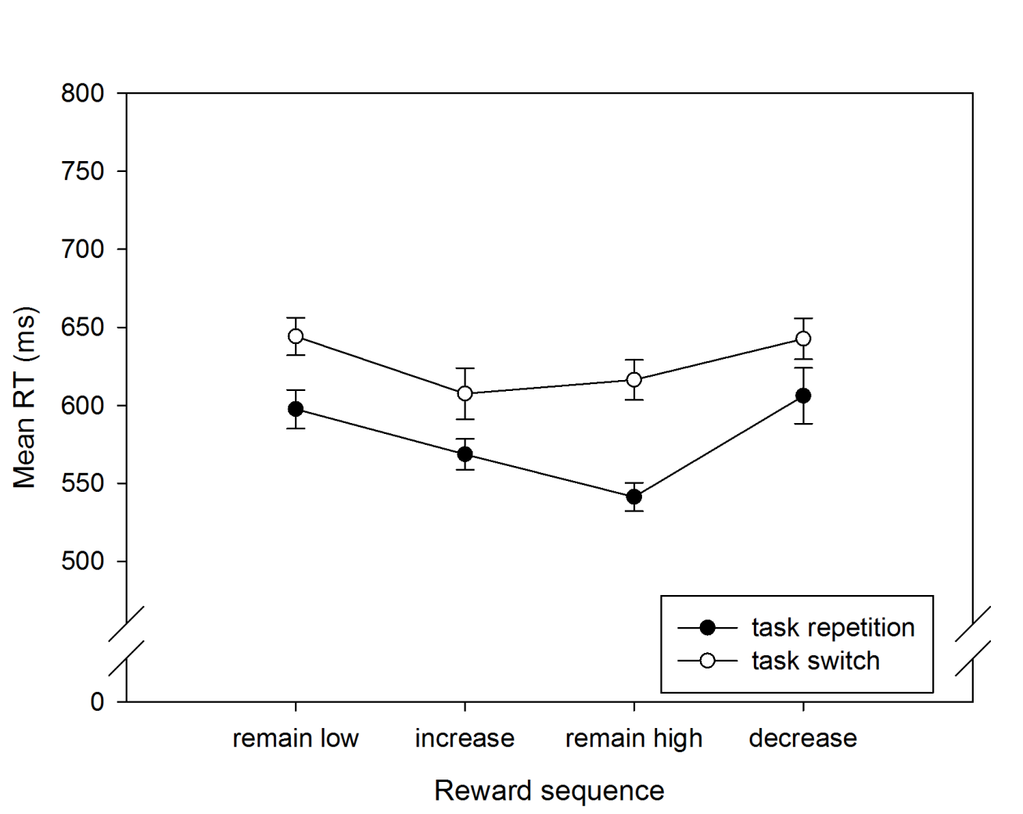
Figure S1. Mean RTs in forced-choice trials of Experiment 1 as a function of Transition (repeat, switch) and Reward sequence (reward_{remain_low}, reward_{increase}, reward_{remain_high}, reward_{decrease}). Error bars represent one standard error of the mean.

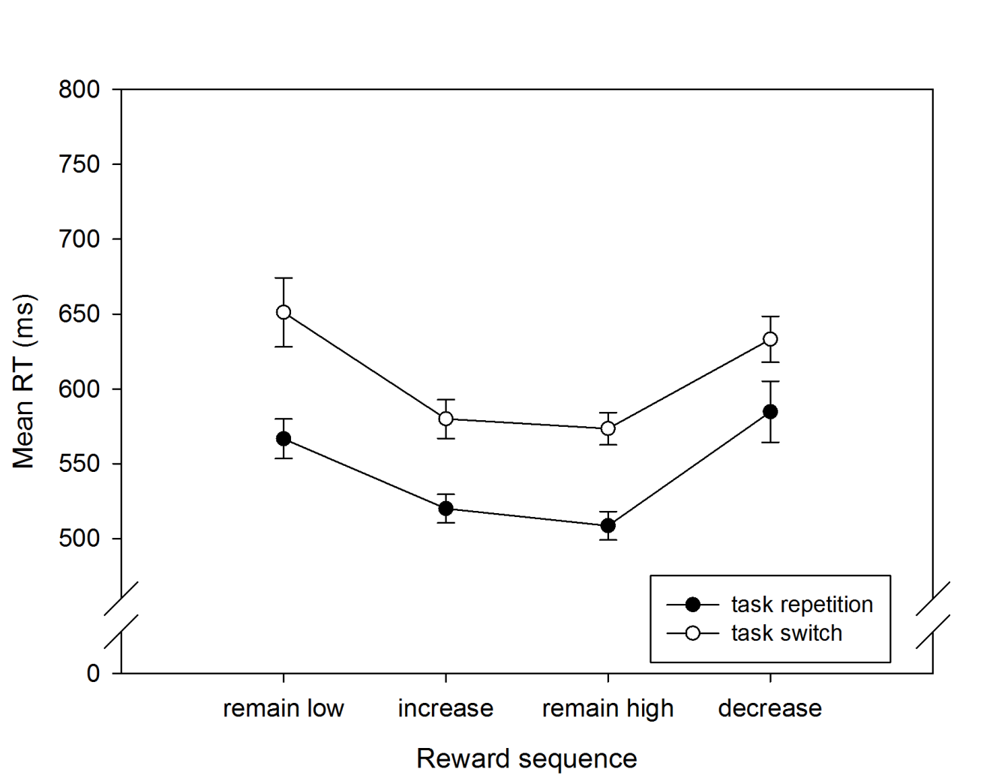 Figure S2. Mean RTs in forced-choice trials of Experiment 2 as a function of Transition (repeat, switch) and Reward sequence (reward_{remain_low}, reward_{increase}, reward_{remain_high}, reward_{decrease}). Error bars represent one standard error of the mean.

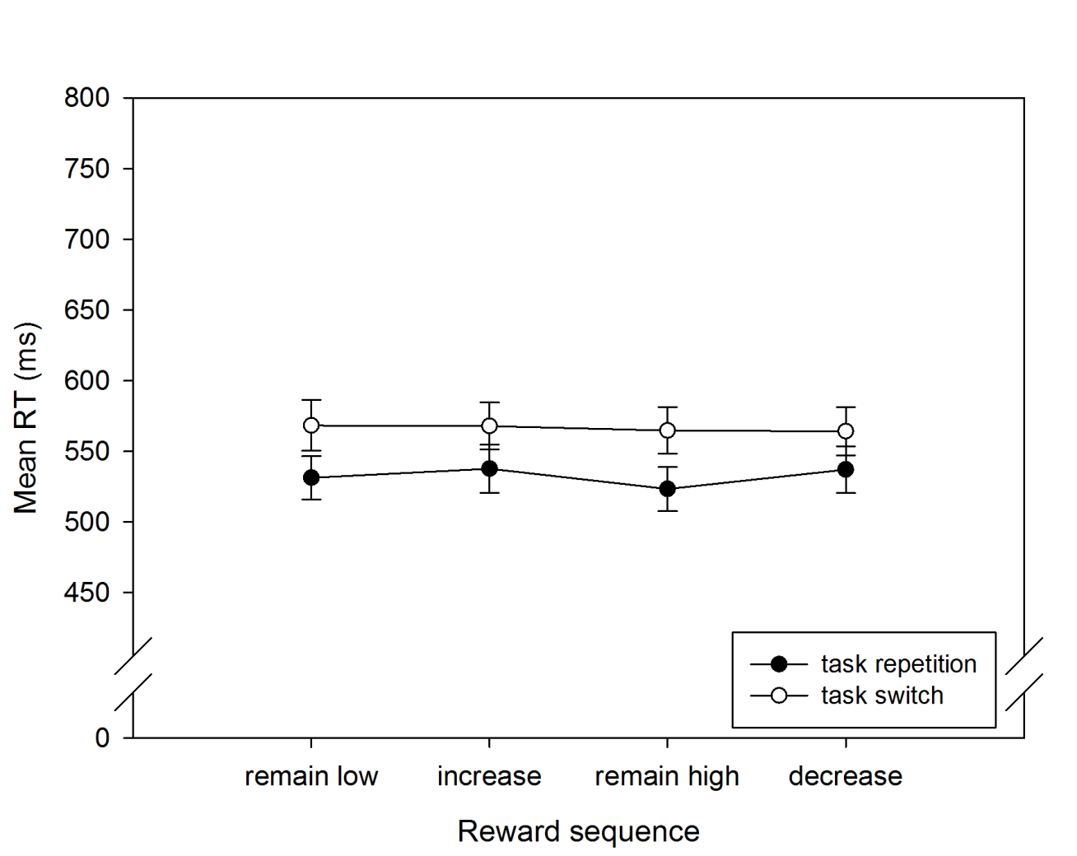 Figure S3. Mean RTs in forced-choice trials of Experiment 3 as a function of Task (repeat, switch) and Reward sequence (reward_{remain_low}, reward_{increase}, reward_{remain_high}, reward_{decrease}). Error bars represent one standard error of the mean.

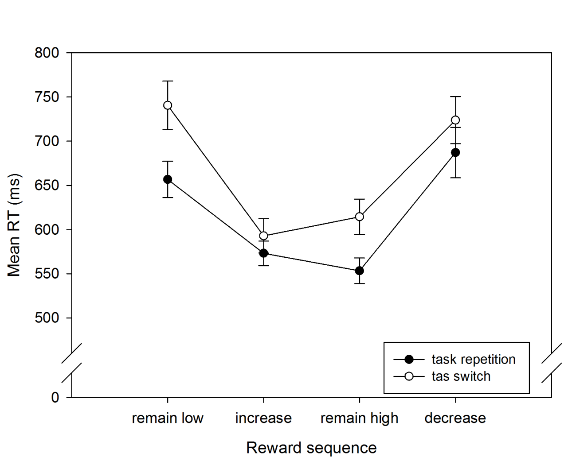
Figure S4. Mean RTs in forced-choice trials of Experiment 4 as a function of Transition (repeat, switch) and Reward sequence (reward_{remain_low}, reward_{increase}, reward_{remain_high}, reward_{decrease}). Error bars represent one standard error of the mean.

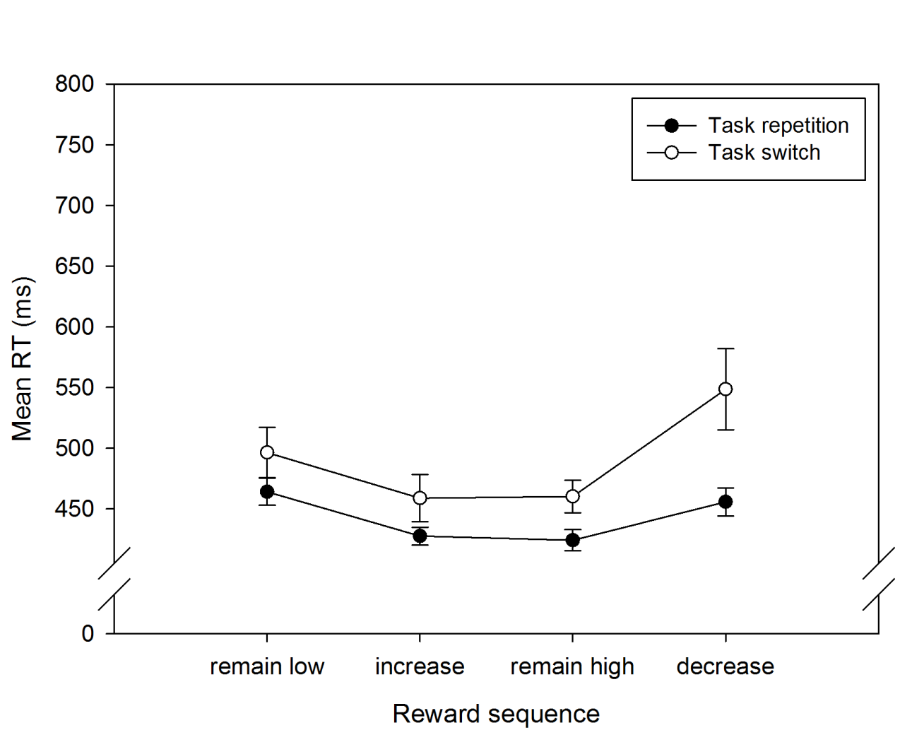
Figure S5. Mean RTs in Experiment 5 as a function of Task (repeat, switch) and Reward sequence (reward_{remain_low}, reward_{increase}, reward_{remain_high}, reward_{decrease}). Error bars represent one standard error of the mean.

- Tables
Table S1. Mean error rates in percent (SD in parenthesis) on forced-choice trials in Experiment 1 as a function of Task (repeat, switch) and Reward sequence (reward_{remain_low}, reward_{increase}, reward_{remain_high}, reward_{decrease}).
 |  | Reward sequence
 |  | remain low | increase | remain high | decrease
Task | repetition | 7.16 (5.72) | 8.09 (6.62) | 9.59 (5.91) | 9.83 (6.34)
Task | switch | 10.59 (7.97) | 12.74 (9.23) | 11.39 (6.57) | 11.34 (7.82)

Table S2. Mean RT in ms and error rates in percent (SD in parenthesis) on free-choice trials in Experiment 1 as a function of Transition (repeat, switch) and Reward sequence (reward_{increase}, reward_{remain_high}).
 |  | Reward sequence
 |  | increase | remain high
 |  | RT
Transition | repetition | 603 (48.71) | 592 (56.61)
Transition | switch | 639 (89.87) | 644 (85.11)
Transition |  | Errors
Transition | repetition | 6.58 (6.21) | 6.44 (6.12)
Transition | switch | 9.47 (6.93) | 9.23 (12.87)

Table S3. Mean error rates in percent (SD in parenthesis) on forced-choice trials in Experiment 2 as a function of Task (repeat, switch) and Reward sequence (reward_{remain_low}, reward_{increase}, reward_{remain_high}, reward_{decrease}).
 |  | Reward sequence
 |  | remain low | increase | remain high | decrease
Task | repetition | 8.24 (5.63) | 13.69 (7.3) | 10.75 (6.56) | 8.32 (7.69)
Task | switch | 10.62 (8.35) | 15.69 (12.51) | 14.91 (7.86) | 9.88 (7.77)

Table S4. Mean RT in ms and error rates in percent (SD in parenthesis) on free-choice trials in Experiment 2 as a function of Transition (repeat, switch) and Reward sequence (reward_{increase}, reward_{remain_high}).
 |  | Reward sequence
 |  | increase | remain high
 |  | RT
Transition | repetition | 553 (62.33) | 548 (58.99)
Transition | switch | 587 (76.59) | 595 (77.28)
Transition |  | Errors
Transition | repetition | 10.87 (8.69) | 11.16 (7.78)
Transition | switch | 14.3 (11.2) | 15.96 (17.29)

Table S5. Mean error rates in percent (SD in parenthesis) on forced-choice trials in Experiment 3 as a function of Transition (repeat, switch) and Reward sequence (reward_{remain_low}, reward_{increase}, reward_{remain_high}, reward_{decrease}).
 |  | Reward sequence
 |  | remain low | increase | remain high | decrease
Transition | repetition | 11.32 (8.37) | 11.99 (8.47) | 11.06 (7.57) | 12.13 (9.23)
Transition | switch | 12.13 (8.55) | 12.87 (9.93) | 13.51 (9.3) | 13.16 (10.06)

Table S6. Mean RT in ms and error rates in percent (SD in parenthesis) on free-choice trials in Experiment 3 as a function of Transition (repeat, switch) and Reward sequence (reward_{increase}, reward_{remain_high}).
 |  | Reward sequence
 |  | increase | remain high
 |  | RT
Transition | repetition | 559 (98.82) | 564 (91.98)
Transition | switch | 624 (154.1) | 621 (117.59)
Transition |  | Errors
Transition | repetition | 10.85 (8.98) | 6.66 (6.48)
Transition | switch | 8.72 (8.45) | 13.25 (13.78)

Table S7. Mean error rates in percent (SD in parenthesis) on forced-choice trials in Experiment 4 as a function of Task (repeat, switch) and Reward sequence (reward_{remain_low}, reward_{increase}, reward_{remain_high}, reward_{decrease}).
 |  | Reward sequence
 |  | remain low | increase | remain high | decrease
Task | repetition | 3.88 (4.48) | 11.01 (8.83) | 8.0 (6.52) | 6.25 (5.03)
Task | switch | 7.09 (5.48) | 10.79 (7.48) | 14.02 (10.84) | 6.79 (7.73)

Table S8. Mean RT in ms and error rates in percent (SD in parenthesis) on free-choice trials in Experiment 4 as a function of Transition (repeat, switch) and Reward sequence (reward_{remain_low}, reward_{decrease}).
 |  | Reward sequence
 |  | remain low | decrease
 |  | RT
Transition | repetition | 774 (197.42) | 822 (401.11)
Transition | switch | 875 (234.83) | 818 (194.08)
Transition |  | Errors
Transition | repetition | 4.28 (6.9) | 4.09 (5.12)
Transition | switch | 6.99 (12.06) | 8.42 (8.73)

Table S9. Mean error rates in percent (SD in parenthesis) in Experiment 5 as a function of Transition (repeat, switch) and Reward sequence (reward_{remain_low}, reward_{increase}, reward_{remain_high}, reward_{decrease}).
 |  | Reward sequence
 |  | remain low | increase | remain high | decrease
Transition | repetition | 9.38 (5.97) | 12.52 (6.52) | 10.78 (5.44) | 10.99 (7.04)
Transition | switch | 5.74 (7.44) | 16.45 (14.56) | 11.93 (12.36) | 6.67 (7.52)

Boxplots were created using the SPSS built-in tool with mean RT and error rates collapsed across all design cells. By default values deviating more than 1.5 inter quartile ranges from the box are marked as outliers.
Exclusion of these participants had no impact on the statistical pattern of results obtained.
Exclusion of this participant had no impact on the statistical pattern of results obtained.
Mean VSR was generally higher in Experiments 1 to 4, which used a mixed forced- and free-choice procedure, as compared to Experiment 5, which used free-choice trials only. Importantly, the relative differences between specific reward sequences remained the same.
Most importantly, no difference in response strategy was found within low or high reward conditions – that is, between reward_{remain_low} and reward_{decrease} or between reward_{increase} and reward_{remain_high} conditions.

