Belief Certainty Guides Exploration Choices During Visual Information Foraging

Supplemental Materials

Sylvie M. Loneragan¹, Dragan Rangelov^{1, 2}, and Jason B. Mattingley^{1, 3}
¹ Queensland Brain Institute, The University of Queensland, St Lucia, QLD 4072
² Department of Psychological Sciences, Swinburne University of Technology, Hawthorn, VIC 3122
³ School of Psychology, The University of Queensland, St Lucia, QLD 4072

Table S1
Posterior Estimates for Comparisons of Response Biases to Zero
Condition | BF₁₀ | Mdn | 95% Credible Interval
Low Rate, Small Magnification | .262 | -.138 | [-.377, .099]
Low Rate, Large Magnification | .156 | .062 | [-.174, .300]
High Rate, Small Magnification | .140 | .030 | [-.207, .267]
High Rate, Large Magnification | .140 | .029 | [-.207, .266]

Note. Table shows Bayes factors, posterior medians and 95% credible interval ranges for one sample t-tests of response biases against zero in all conditions.
Figure S1
Bayes Factor Robustness Checks for Comparisons of Response Biases to Zero
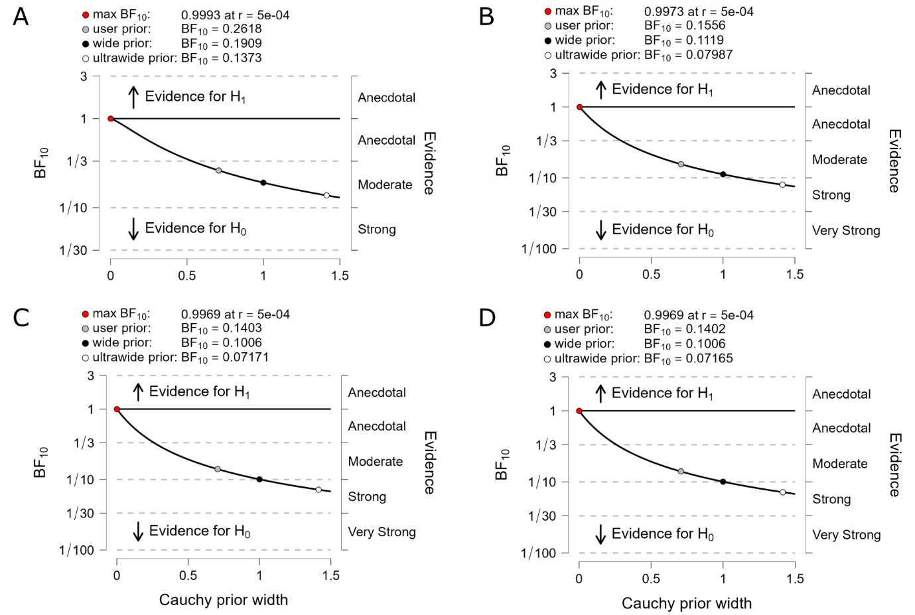
Note. Robustness of Bayes factors for different prior width scale parameters for one sample t-tests of response biases against zero. Tests for (A) low base rate, small magnification, (B) low base rate, large magnification, (C) high base rate, small magnification; and, (D) high base rate, large magnification conditions.

Table S2
Posterior Estimates for Comparisons of Posterior Rates to Generating Rates
Condition | BF₁₀ | Mdn | 95% Credible Interval
Low Rate, Non-Magnified | .247 | .132 | [-.106, .371]
Low Rate, Small Magnification | .997 | -.244 | [-.487, -.003]
Low Rate, Large Magnification | 1.985 x 10⁸ | -.953 | [-1.252, -.658]
High Rate, Non-Magnified | 6.669 x 10¹² | -1.286 | [-1.623, -.955]
High Rate, Small Magnification | 3.286 x 10¹⁹ | -1.825 | [-2.235, -1.426]
High Rate, Large Magnification | 2.076 x 10²¹ | -1.985 | [-2.418, -1.564]

Note. Table shows results of one sample t-tests of the difference between the posterior rate estimate at response time to the generating rate against zero in all conditions.

Figure S2
Bayes Factor Robustness Checks for Comparisons of Posterior Rates to Generating Rates
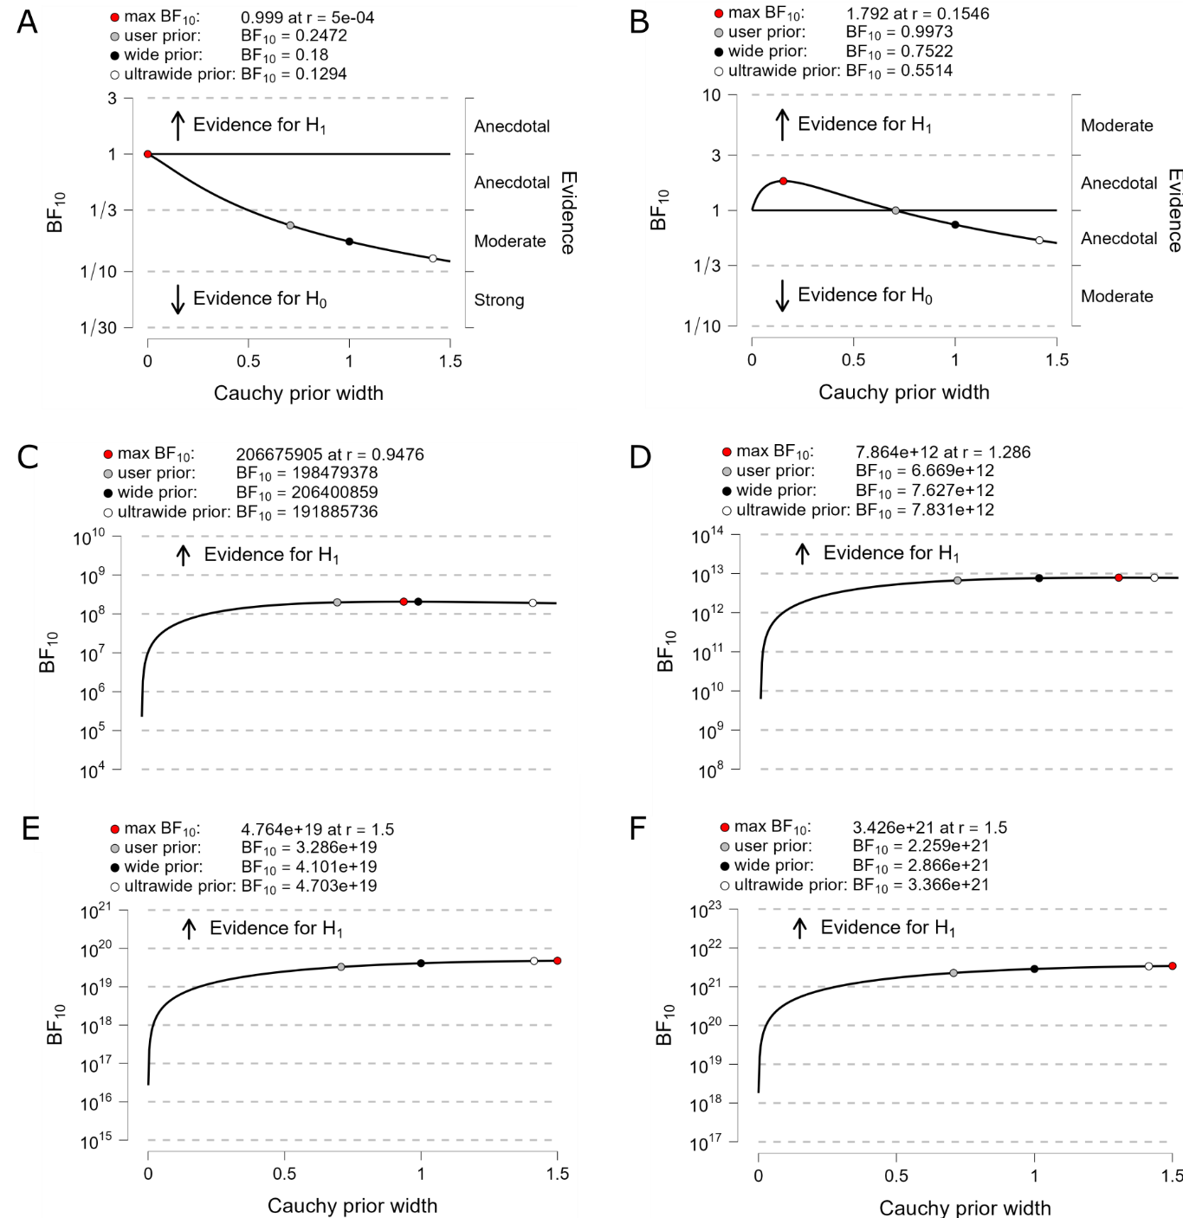
Note. Robustness of Bayes factors for different prior width scale parameters for one sample t-tests of posterior rate estimates at response time against generating rates. Tests for (A) low base rate, non-magnified, (B) low base rate, small magnification, (C) low base rate, large magnification, (D) high base rate, non-magnified, (E) high base rate, small magnification and, (F) high base rate, large magnification conditions.

Table S3
Posterior Estimates for Comparisons of Posterior Relative Rates to True Relative Rates
Condition | BF₋₀ | Mdn | 95% Credible Interval
Low Rate, Small Magnification | .035 | -.026 | [-.125, -.001]
Low Rate, Large Magnification | .050 | -.037 | [-.162, -.001]
High Rate, Small Magnification | .045 | -.033 | [-.151, -.001]
High Rate, Large Magnification | .091 | -.060 | [-.227, -.003]

Note. Table shows results of one-tailed, one sample t-tests that the posterior relative rate estimate at the time of response is less than the true relative rate in all conditions.
Figure S3
Bayes Factor Robustness Checks for Comparisons of Posterior and True Relative Rates
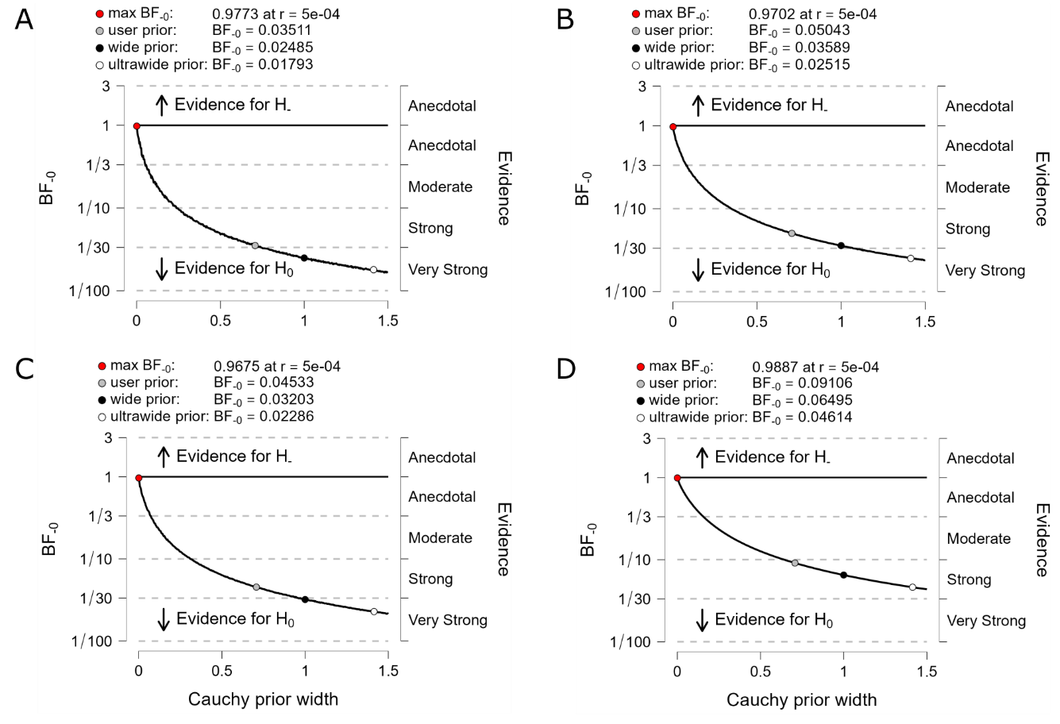
Note. Robustness of Bayes factors for different prior width scale parameters for one-tailed, one sample t-tests that posterior relative rate estimates at response time are less than true relative rates. Tests for (A) low base rate, small magnification, (B) low base rate, large magnification, (C) high base rate, small magnification; and, (D) high base rate, large magnification conditions.
Table S4
Posterior Estimates for Comparisons of Relative Rate Slopes to Zero
Condition | BF₁₀ | Mdn | 95% Credible Interval
Low Rate, Small Magnification, Incorrect | .137 | -.012 | [-.249, .225]
Low Rate, Small Magnification, Correct | .149 | -.051 | [-.288, .185]
Low Rate, Large Magnification, Incorrect | .137 | -.017 | [-.254, .219]
Low Rate, Large Magnification, Correct | .156 | .063 | [-.173, .301]
High Rate, Small Magnification, Incorrect | .143 | .038 | [-.199, .275]
High Rate, Small Magnification, Correct | .185 | .094 | [-.143, .332]
High Rate, Large Magnification, Incorrect | .213 | -.114 | [-.352, .123]
High Rate, Large Magnification, Correct | .228 | .123 | [-.115, .361]

Note. Table shows results of one sample t-tests comparing the slopes of relative rate estimates over the last 500 ms before behavioural responses against zero in all conditions.

Figure S4
Bayes Factor Robustness Checks for Comparisons of Relative Rate Slopes to Zero
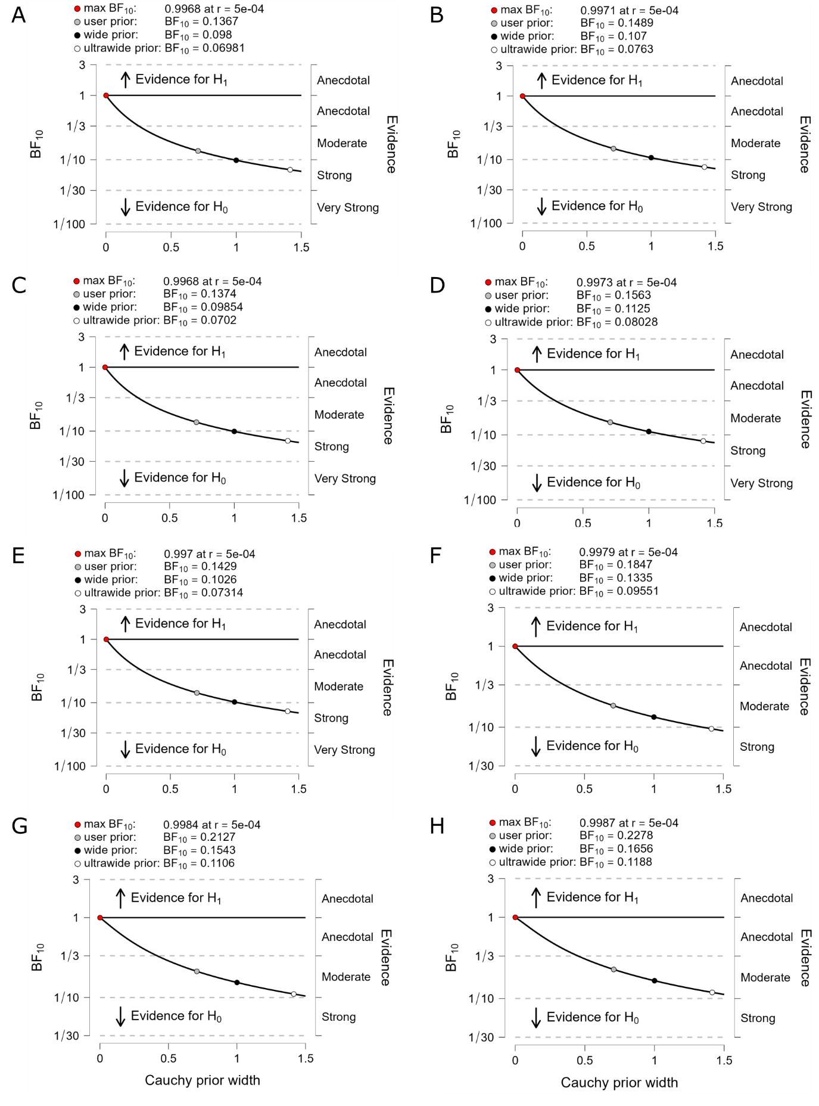
Note. Robustness of Bayes factors for different prior width scale parameters for one sample t-tests of the slopes of relative rate estimates over the last 500 ms before responses against zero. Tests for low rate, small magnification trials with incorrect (A) and correct responses (B), low rate, large magnification trials with incorrect (C) and correct responses (D), high rate, small magnification trials with incorrect (E) and correct responses (F); and, high rate, large magnification trials with incorrect (G) and correct responses (H).
Table S5
Posterior Estimates for Comparisons of TVD Slopes to Zero
Condition | BF₁₀ | Mdn | 95% Credible Interval
Low Rate, Small Magnification, Incorrect | 22.769 | .404 | [.155, .655]
Low Rate, Small Magnification, Correct | 29576.868 | .669 | [.401, .941]
Low Rate, Large Magnification, Incorrect | 6.274 | .345 | [.099, .593]
Low Rate, Large Magnification, Correct | 136.096 | .477 | [.223, .734]
High Rate, Small Magnification, Incorrect | 3937.889 | .600 | [.337, .866]
High Rate, Small Magnification, Correct | 48702.870 | .686 | [.416, .959]
High Rate, Large Magnification, Incorrect | 11.258 | .372 | [.125, .622]
High Rate, Large Magnification, Correct | 4.811 | .332 | [.087, .579]

Note. Table shows results of one sample t-tests comparing the slopes of TVD over the last 500 ms before behavioural responses against zero in all conditions.

Figure S5
Bayes Factor Robustness Checks for Comparisons of TVD Slopes to Zero
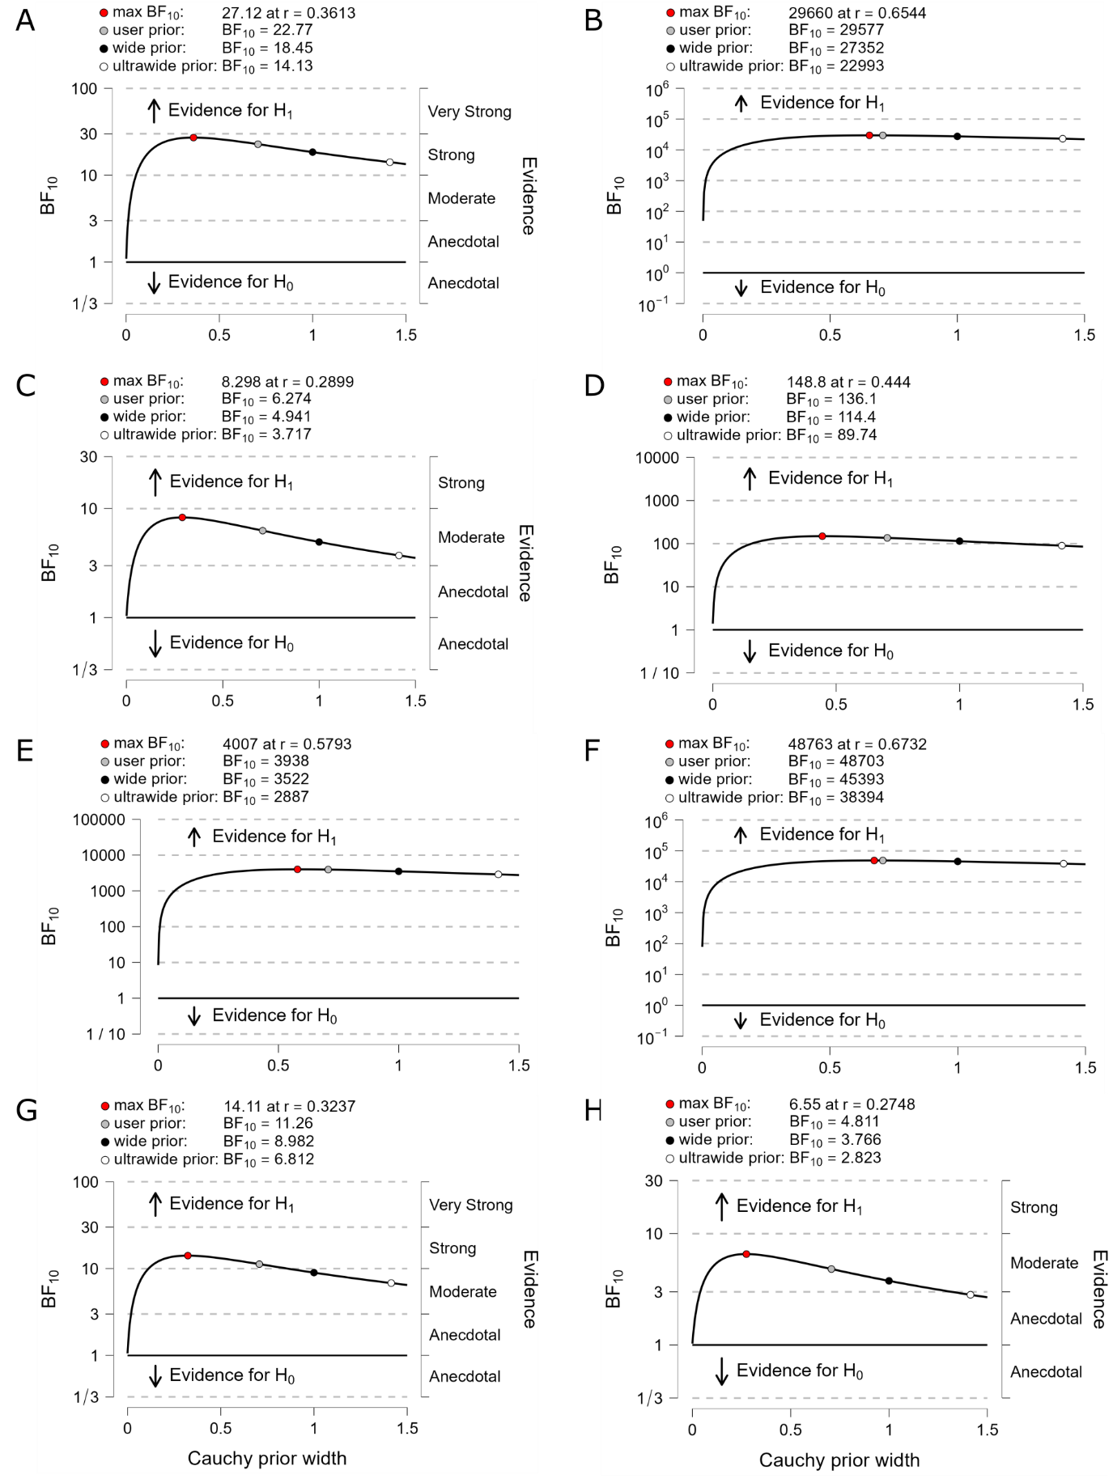
Note. Robustness of Bayes factors for different prior width scale parameters for one sample t-tests of the slopes of TVD over the last 500 ms before responses against zero. Tests for low rate, small magnification trials with incorrect (A) and correct responses (B), low rate, large magnification trials with incorrect (C) and correct responses (D), high rate, small magnification trials with incorrect (E) and correct responses (F); and, high rate, large magnification trials with incorrect (G) and correct responses (H).

Figure S6

Response-Locked Relative Rate Estimates Computed with Prior μ = .1 Hz

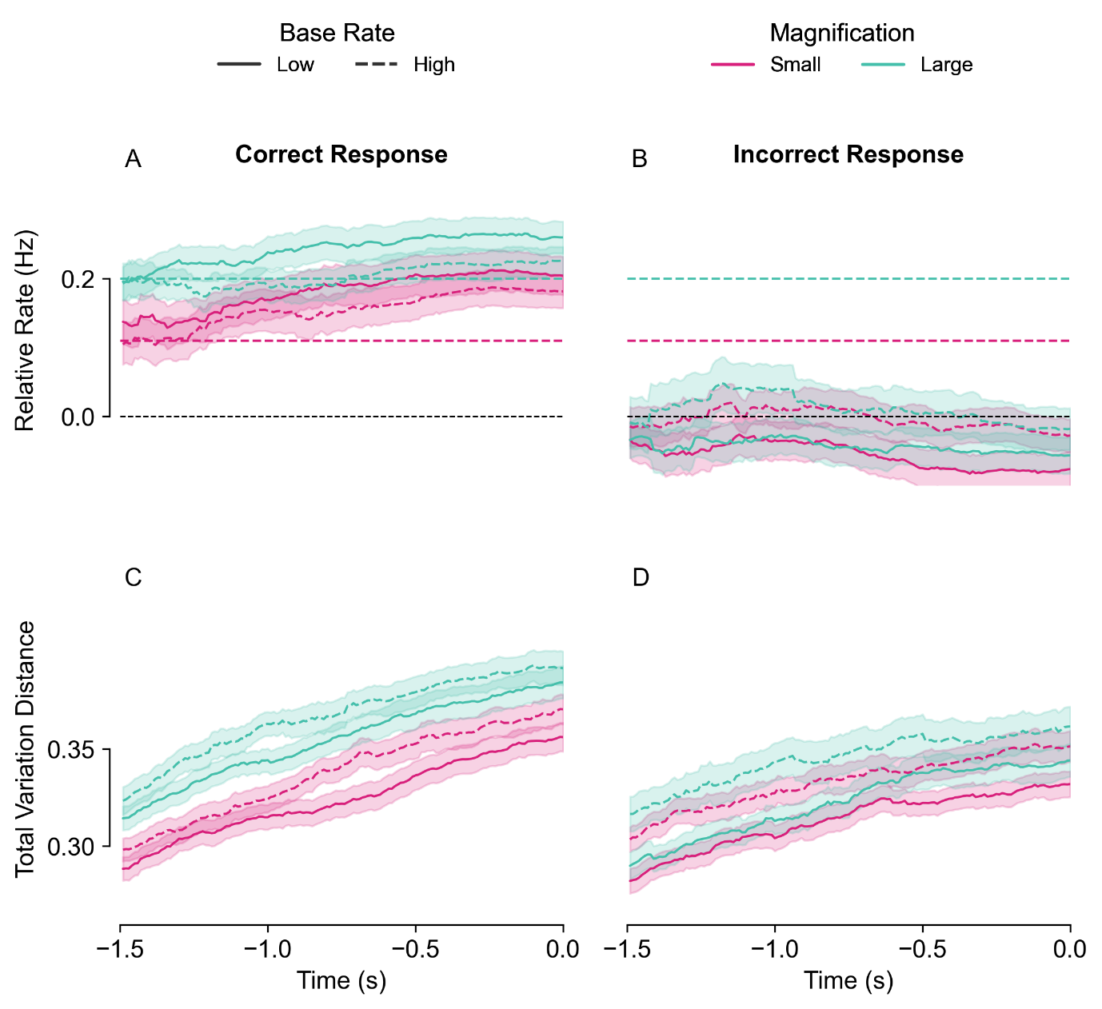

Note. Response-locked relative metrics calculated using a prior mean (μ) value of .1 Hz. Relative rate estimates (A, B) and TVD (C, D) are time-locked to correct (A, C) and incorrect responses (B, D).

Figure S7

Response-Locked Relative Rate Estimates Computed with Prior μ = 7.7 Hz

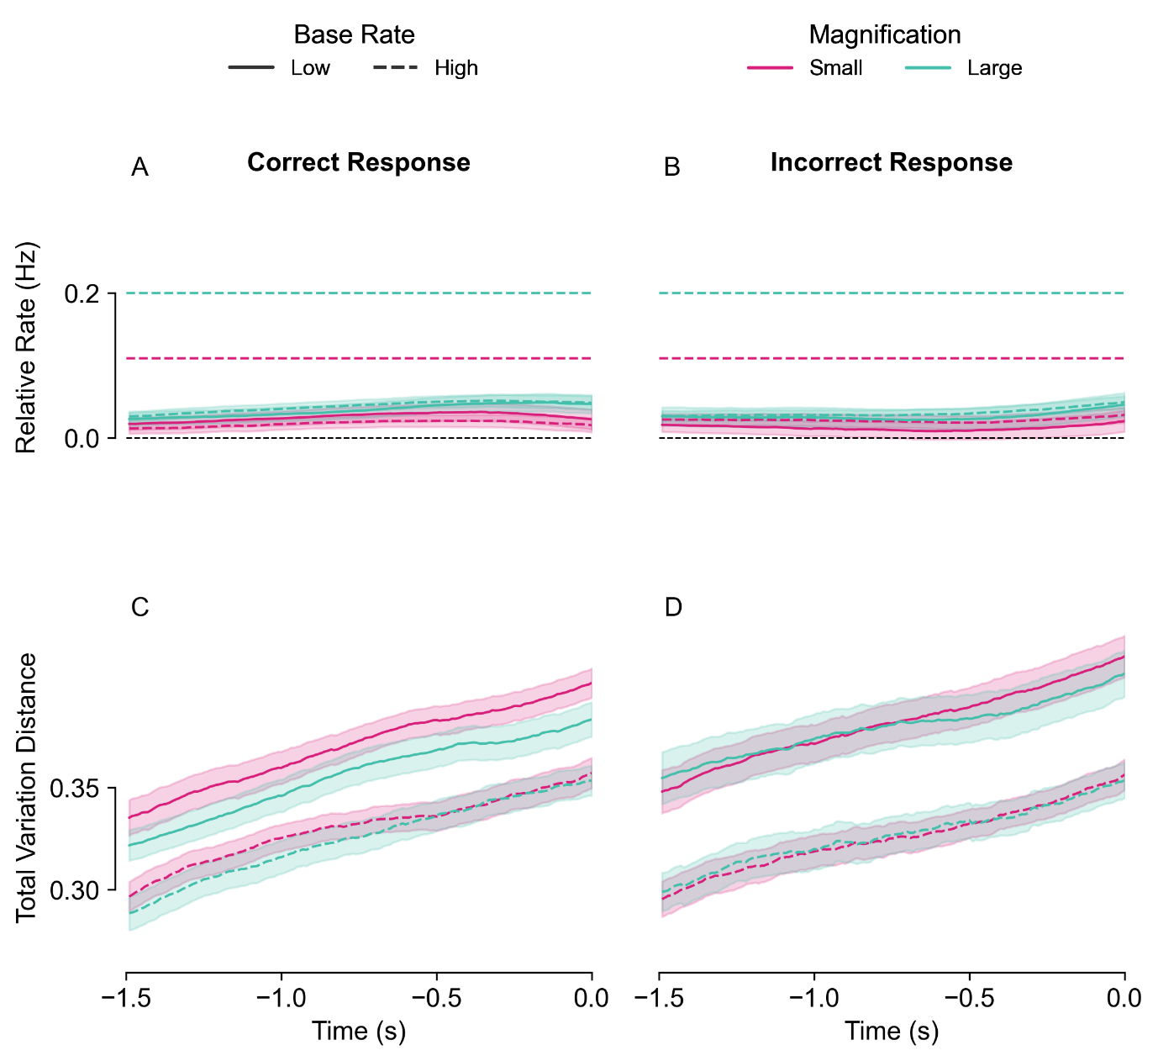

Note. Response-locked relative metrics calculated using a prior mean (μ) value of 7.7 Hz. Relative rate estimates (A, B) and TVD (C, D) are time-locked to correct (A, C) and incorrect responses (B, D).

Figure S8

Relative Patch Metrics Prior to Correct and Incorrect Responses for Simulated Data

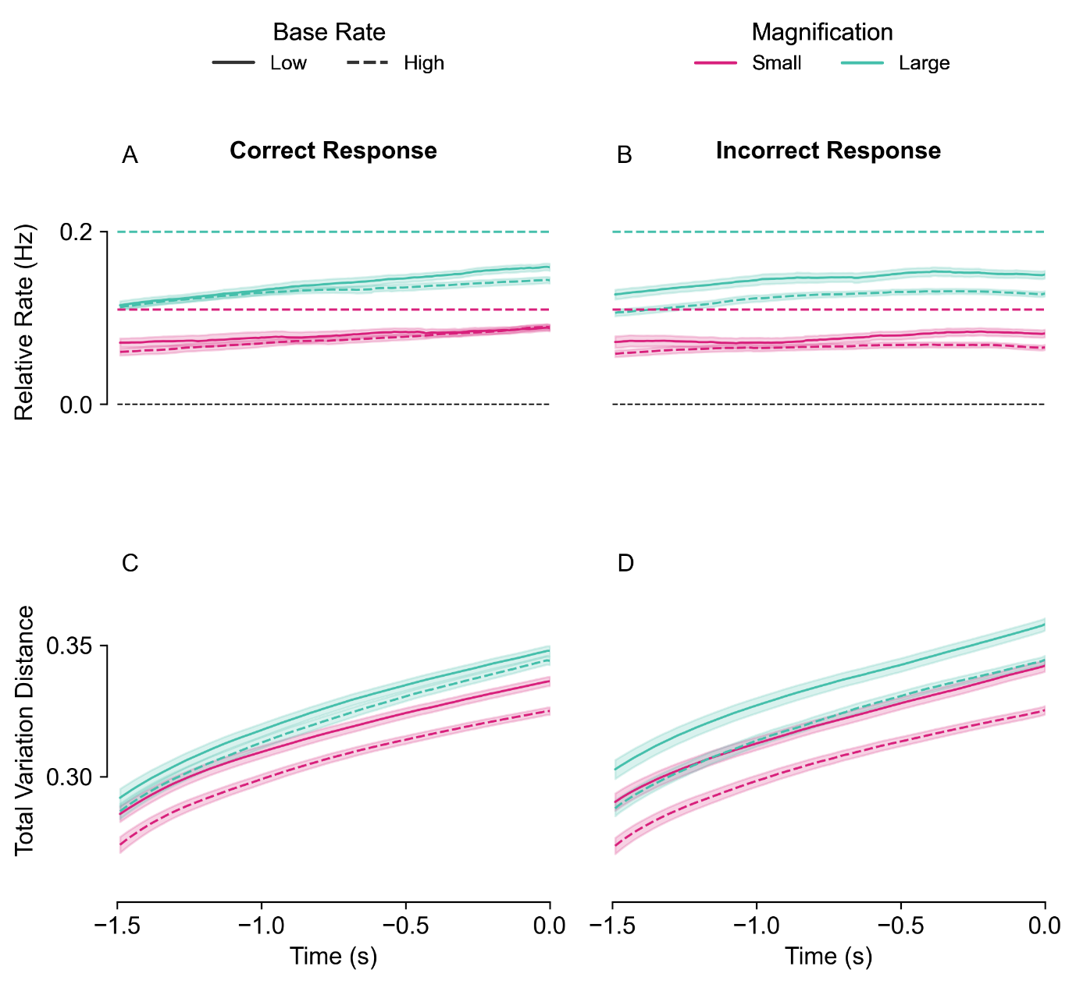
Note. Response-locked relative patch metrics for empirical exploitation and response behaviour and simulated signal inter-arrival times (n = 1000 simulations). (A, B) Simulated relative rate estimates time-locked to correct (A) and incorrect (B) responses, derived over combined exploitations of both patches. (C, D) Simulated response-locked TVD for correct (C) and incorrect responses (D).

Figure S9
Bayes Factor Robustness Checks for Duration of Initial vs Middle Exploitations
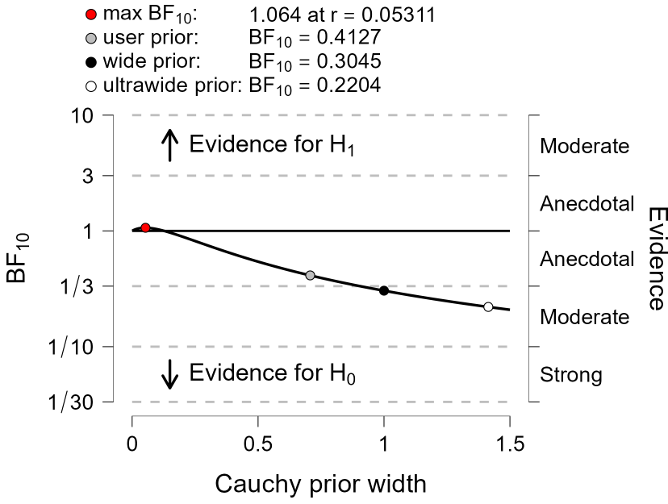
Note. Robustness of Bayes factors for different prior width scale parameters for a paired samples t-test comparing the durations of initial and middle exploitations in a trial.
Figure S10
Bayes Factor Robustness Checks for Changes in Metrics Over Exploitation Periods
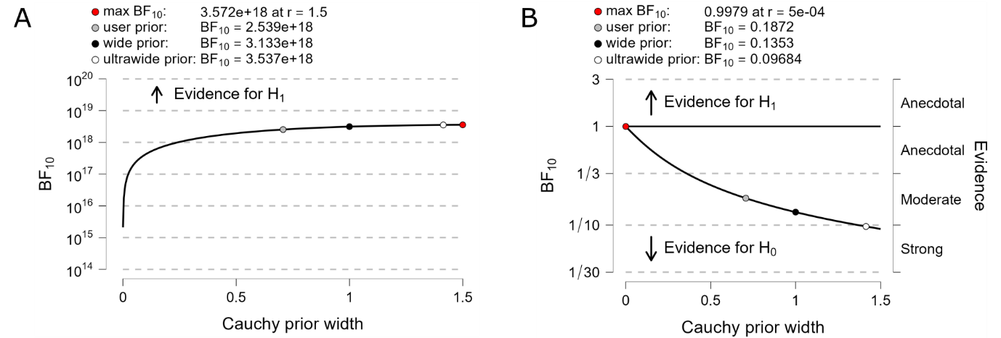
Note. Robustness of Bayes factors for different prior width scale parameters for paired sample t-tests comparing changes in (A) rate and (B) certainty between initial and middle exploitations.

