Supplementary Materials
Primary Instrument(s) | Frequency
Cello | 1
Clarinet | 2
Drums | 1
Guitar | 12
Piano | 5
Trumpet | 1
Viola/Violin | 3

Table S1. Distribution of primary instruments in the musician sample.

(a)
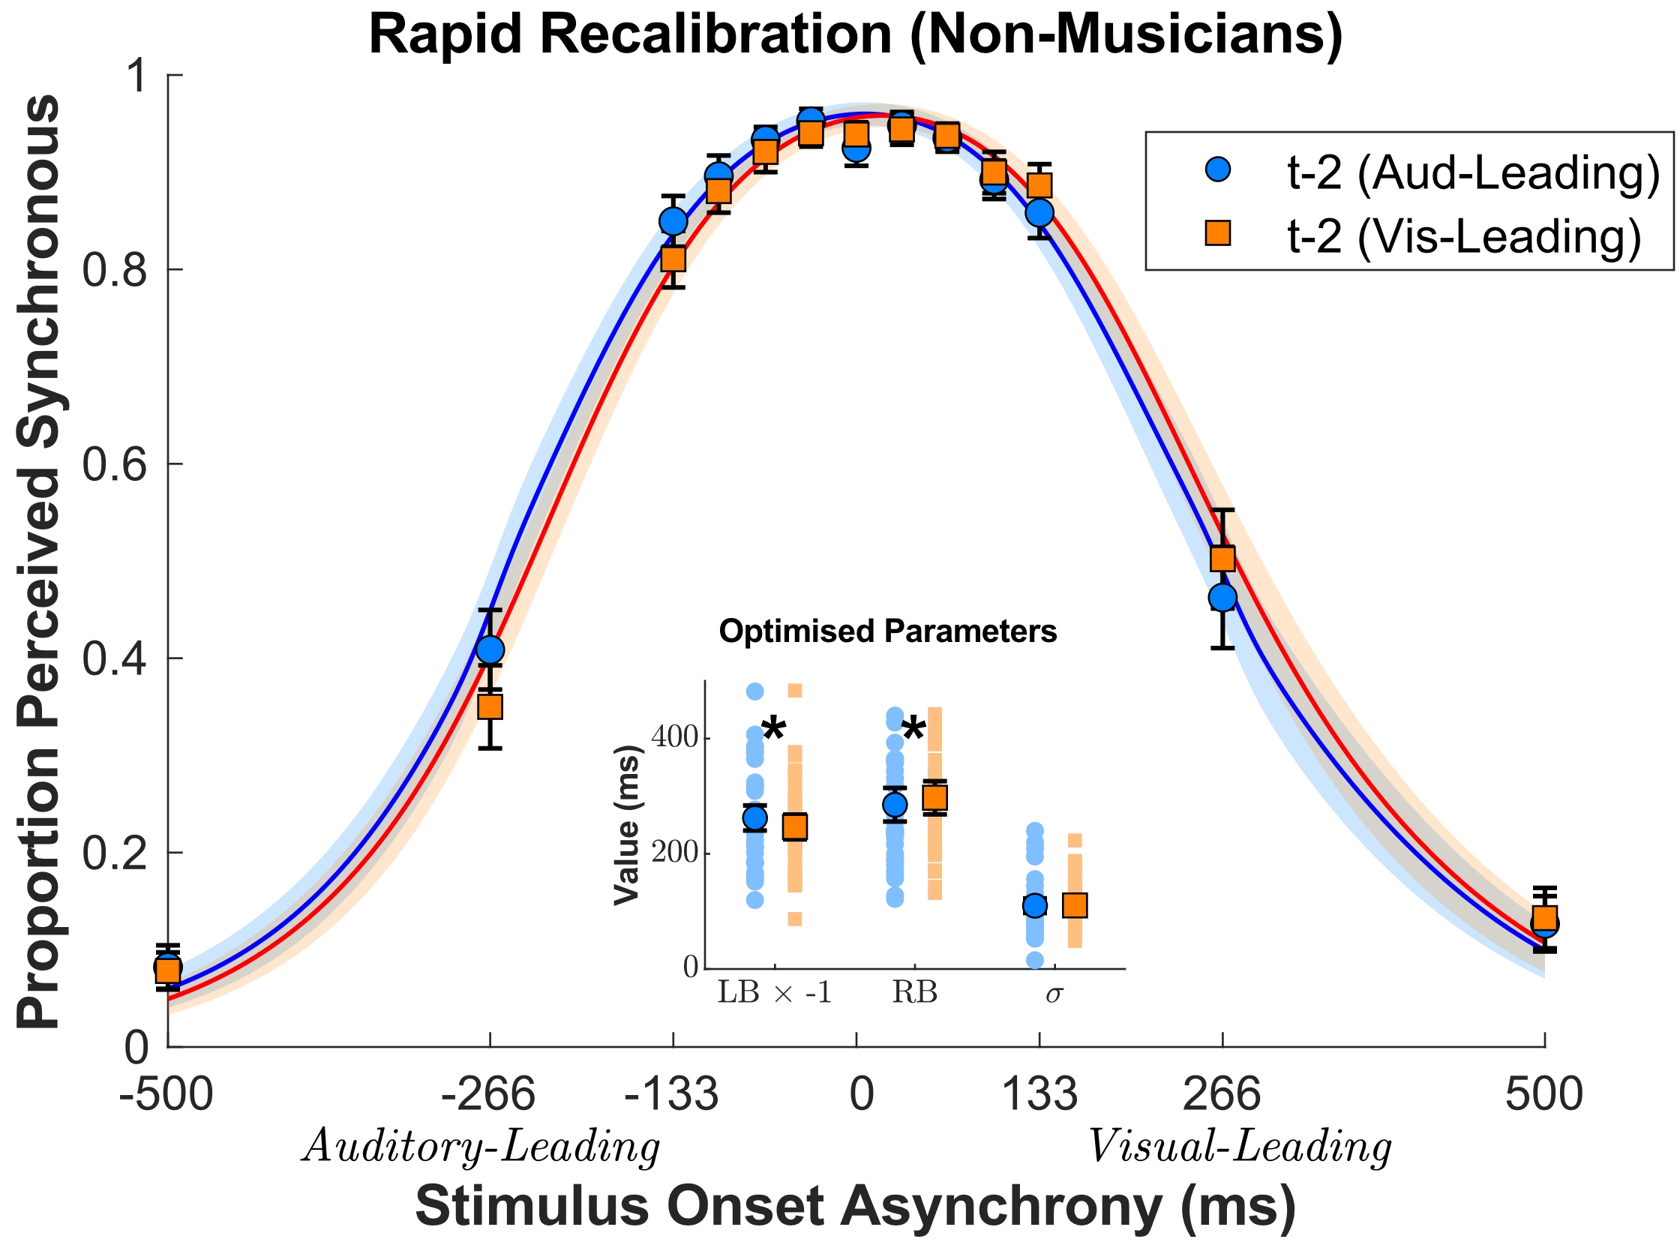
(b)
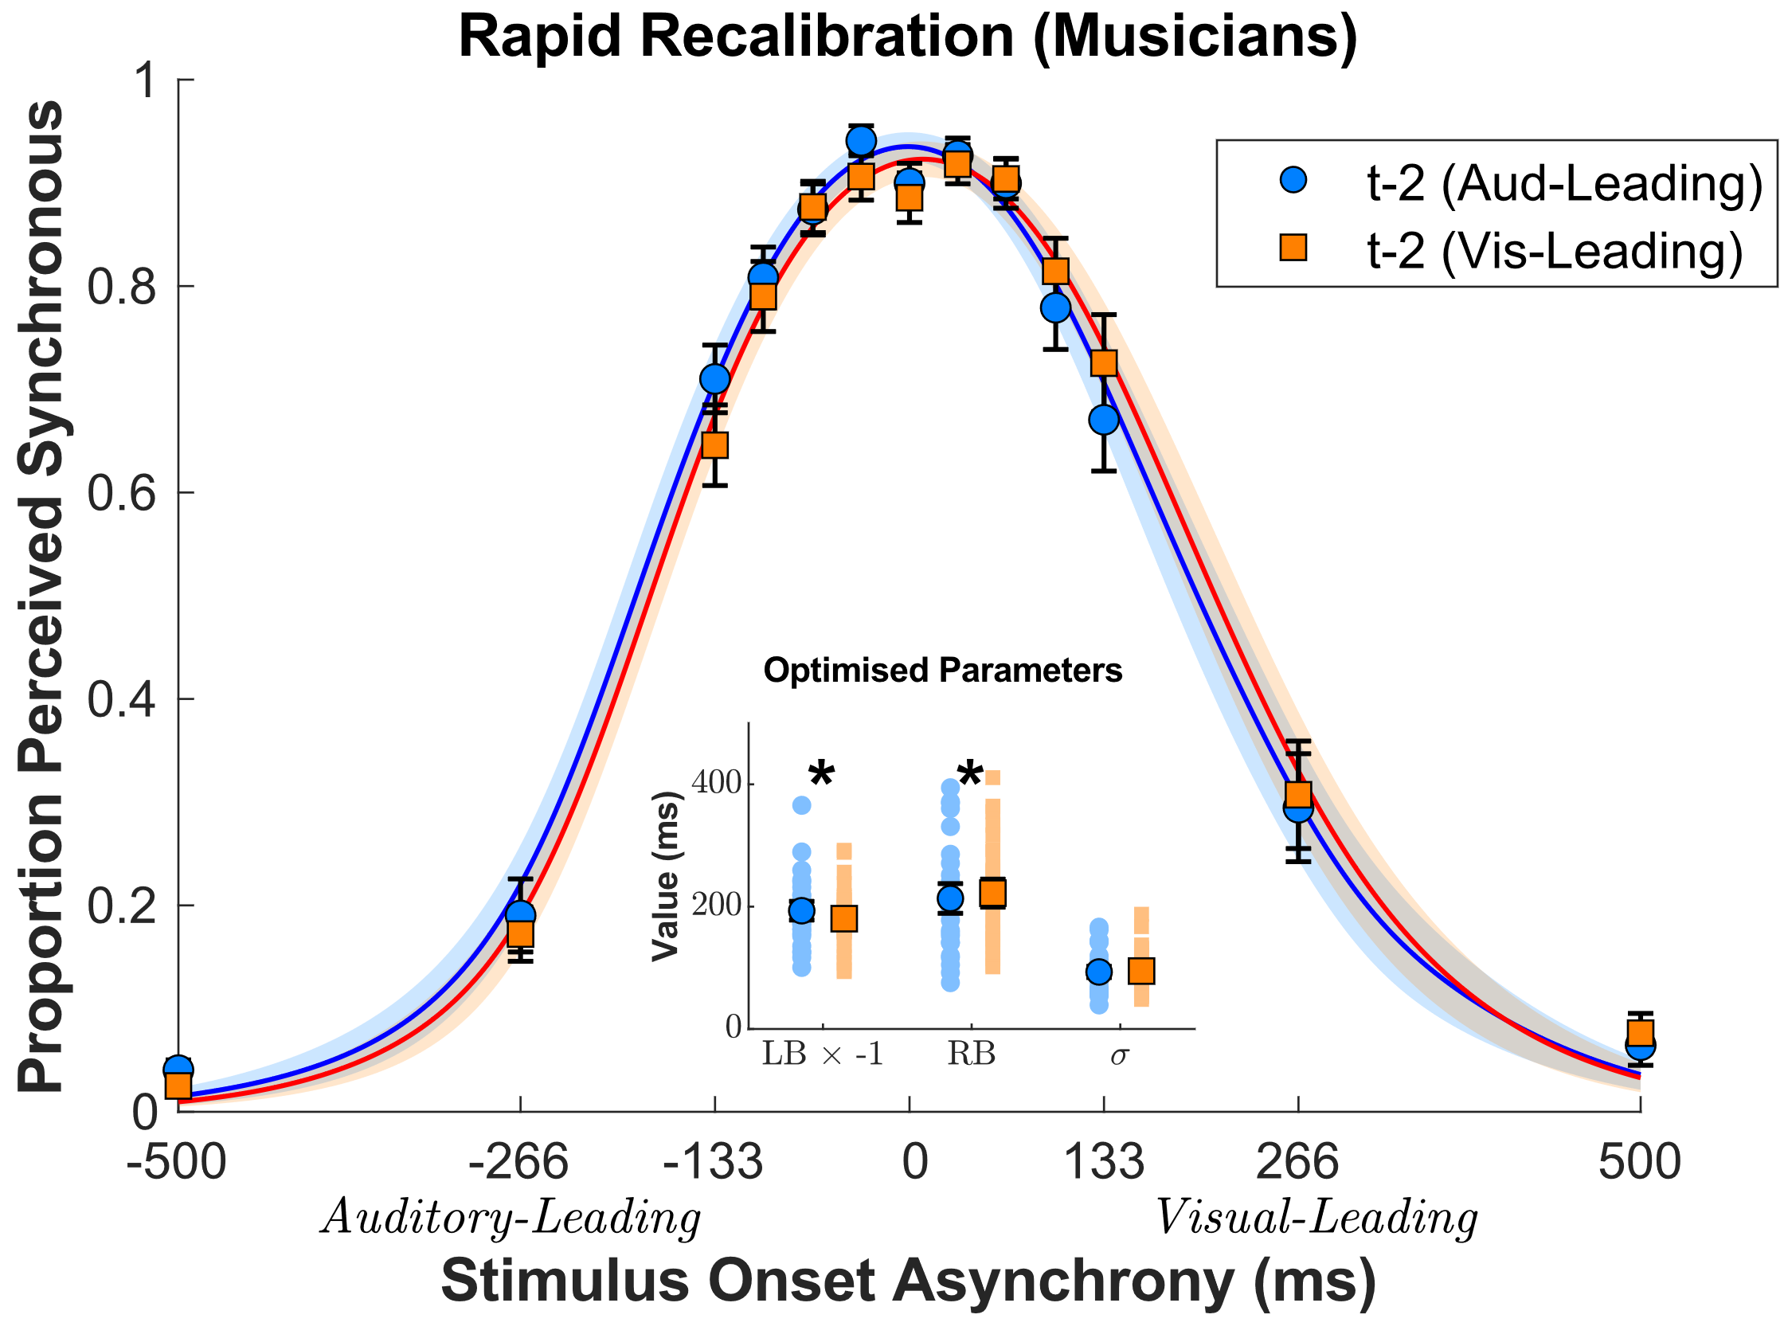

Figure S1. Simultaneity judgements as a function of the modality order of the stimulus two trials in the past (t−2), shown separately for (a) non-musicians and (b) musicians. The curves represent average fits of the AT-A-GLANCE model across participants (in each group), with inset plots showing optimised parameter estimates for the left boundary (LB, multiplied by -1 in the plot), right boundary (RB), and sensory noise ($σ$). Error bars and shaded region in main plots represent ± 1 SEM, error bars in inset plots represent ± 2 SEM, and asterisks denote p < .05. For both musical training groups, the decision boundaries were shifted in the direction of the modality order on t−2, indicative of rapid recalibration that persists across at least two trials. However, there were no significant differences between the musical training groups in terms of the magnitude of these boundary shifts, unlike in the t−1 analysis (see main text).

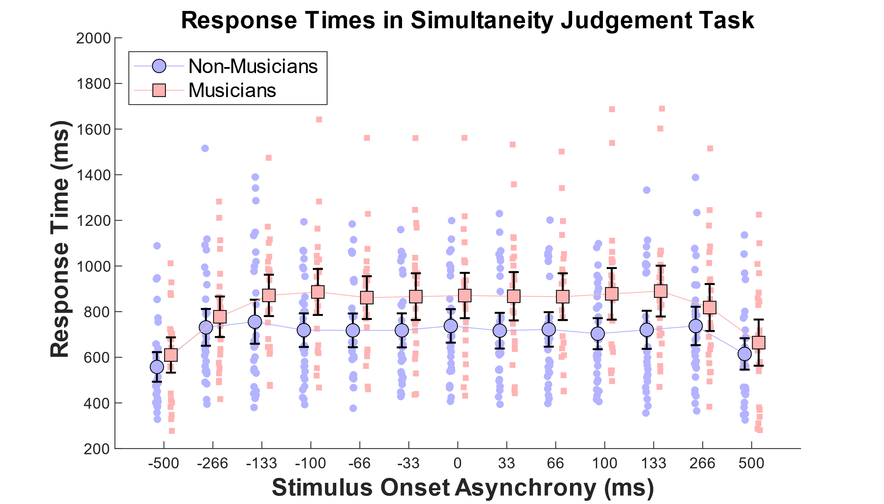
Figure S2. Mean RT in each SOA condition in the simultaneity judgement task. Error bars represent ± 1 SEM. Musicians were significantly slower than non-musicians, possibly reflecting a more conversative strategy. RTs were significantly faster at the two most extreme SOAs, presumably reflecting observers’ increased certainty that stimuli were asynchronous.

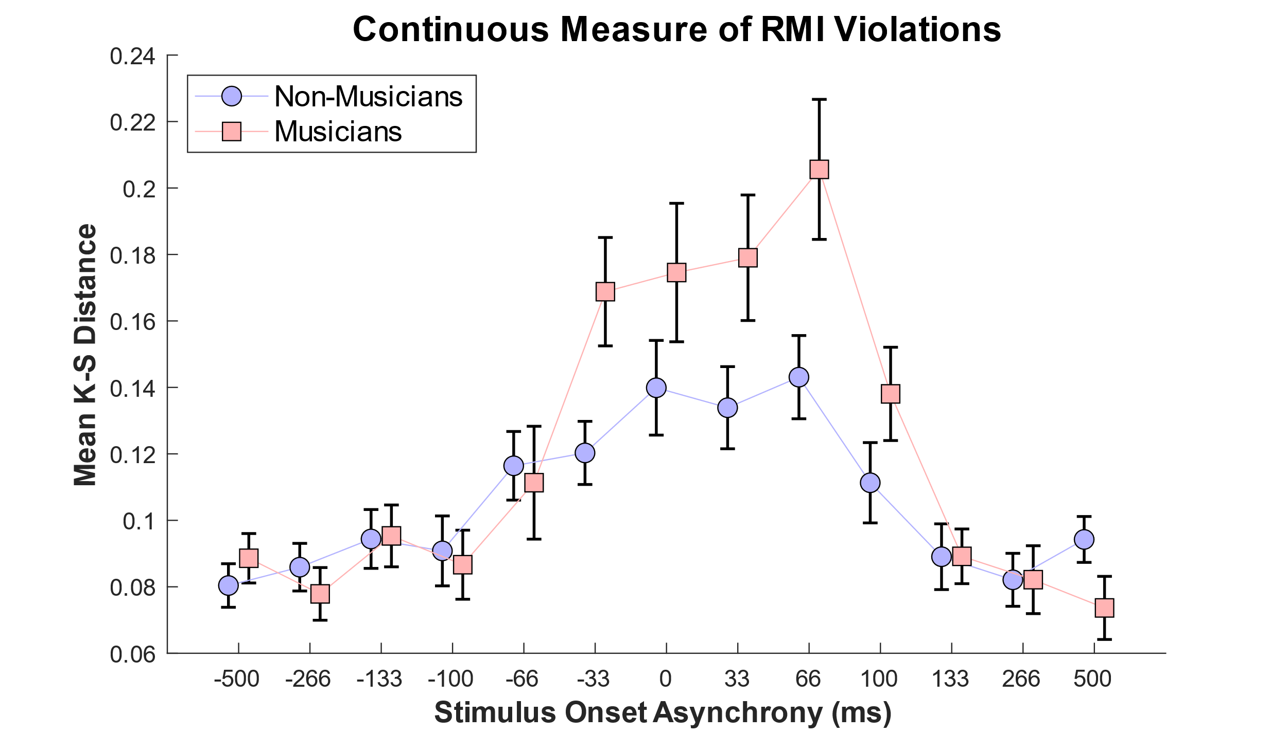

Figure S3. Musicians exhibited stronger effects (relative to non-musicians) on a continuous measure of race model inequality (RMI) violations, defined for each SOA as the maximum distance between the audiovisual CDF and the truncated RMI CDF in the modified Kolmogorov-Smirnov (K-S) test. A mixed ANOVA showed a significant main effect of SOA (p < .001) and a significant interaction between musical training and SOA (p < .001). Error bars represent ± 1 SEM.

