Supplementary Materials for ‘Flexible use of facial features supports face identity processing’
Corresponding Author: James D. Dunn, School of Psychology, Mathews Building, UNSW Sydney, Kensington, NSW 2052, Australia. E: j.d.dunn@unsw.edu.au

Extended methods for Experiment 1
For Experiment 1 we only reported the similarity rating results for the isolated-part feature block because these were used as the foundation for the other experimental studies reported in this paper. This block was part of a larger experiment that is described in full below.
These 90 identity pairs were randomly split into 3 image sets, each with 15 match and 15 nonmatch pairs. This enabled counterbalanced assignment of image sets to the three experimental blocks (no feature rating set, whole-face rating set, and isolated-part rating set).
Participants’ first task was to complete the no feature rating block which measured their baseline face-matching accuracy. They were shown two whole-face images on-screen and asked to decide whether the face stimuli showed the same person or two different people.
After completing the baseline matching test, participants completed 2 separate feature rating blocks. These 2 blocks were the whole-face feature rating block and the isolated-part feature rating block, the order of which was counterbalanced across participants. Each block consisted of 15 match and 15 nonmatch trials presented in a random order. All participants completed both feature rating blocks in a random order.

Percentage of items with each feature as diagnostic
In Experiment 1, we explain the criteria used to select which features are classified as diagnostic for each image pair. We used this criteria for the 90 identity pairs and found 68 of our 90 face pairs (32 match, 36 nonmatch) contained at least one identifying feature that reached the threshold for diagnosticity. Supplementary Table 1 shows the percentage of items where each feature was diagnostic. The most common diagnostic feature was the ears, followed by the eyes, and the least diagnostic feature was the chin, followed by the mouth.
Supplementary Table 1. Percentage of items with each feature classified as identifying, ranked from most to least.
Feature | Overall (%) | Split by Trial Type
Feature | Overall (%) | Match (%) | Nonmatch (%)
Ears | 78 | 81 | 75
Eyes | 34 | 53 | 17
Cheeks | 19 | 28 | 11
Forehead | 19 | 28 | 11
Nose | 18 | 28 | 8
Mouth | 13 | 6 | 19
Chin | 12 | 22 | 3

Ethnicity Analysis
The selected stimuli were predominantly White (83%), so it is possible that the variation and awareness of diagnostic features is due to this largely heterogeneous sample for face.
To address whether the variation and awareness of diagnostic features is explained by differences in the ethnicity of the faces, we conducted additional analysis of Experiments 1 and 2. Supplementary Figure 1 shows the variation in similarity ratings occurs for both Caucasian and Other-race faces, replicating those patterns observed across the whole sample.

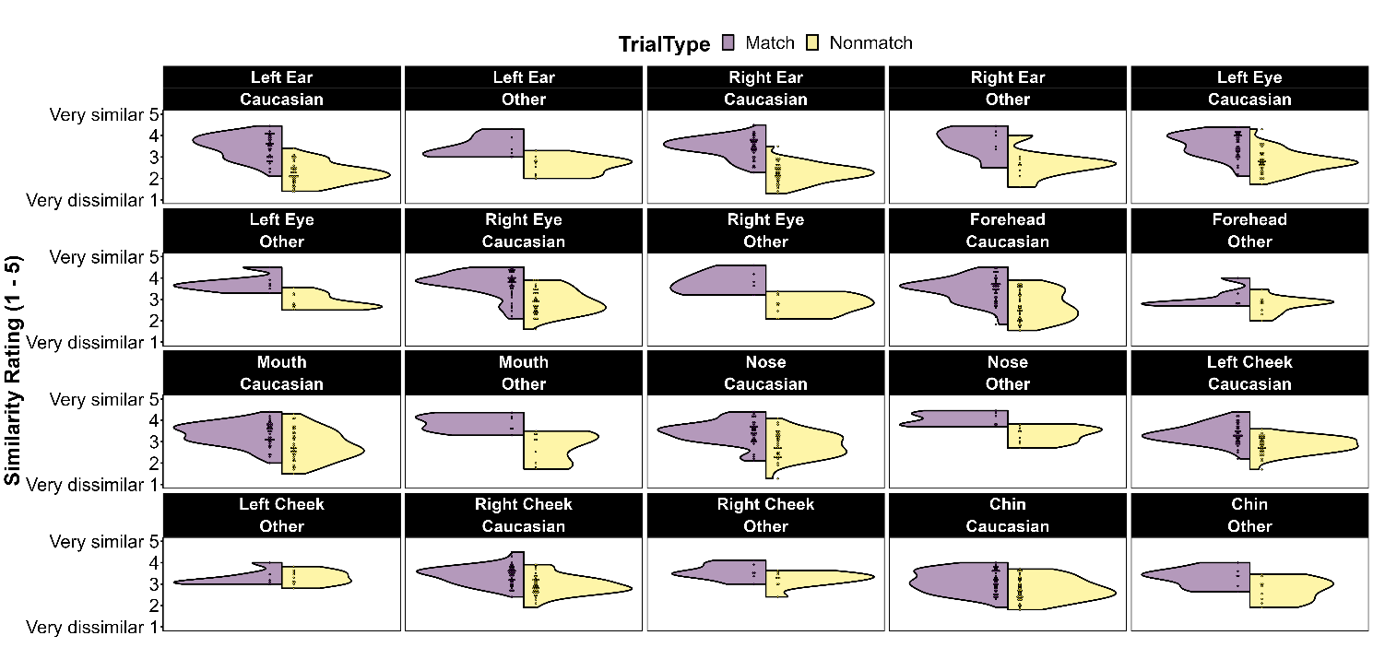
Supplementary Figure 1. The distribution of mean feature similarity ratings ordered from most (top-left) to least (bottom-right) diagnostic of identity for Caucasian and Other-race faces, and split by match (purple) and nonmatch (yellow) face pairs.
For Experiment 2, we conducted a logistic mixed model (JAMOVI’s GAMLj module, 2021) to test whether the race of the face affected the relationship between diagnostic feature awareness accuracy and trial accuracy. We found that the race of the face was not a significant factor (main effect of race: b = 0.16, CI₉₅ = [-0.47, 1.58], z = 0.40, p = .689), nor did it interact with diagnostic feature awareness accuracy (b < 0.01, CI₉₅ = [-0.08, 0.01], z = -0.05, p = .959).

Analysis of Experiment 3 with latency as covariate
We also explored whether the total duration of a trial affects the relationship between dwell time on diagnostic features and accuracy. If accuracy is better when trials are longer but there is less dwell time on diagnostic features, it would support an alternative explanation. We conducted an analysis at the trial level, with trial duration as a covariate. We found that while trial duration predicts accuracy, the relationship is actually negative, with longer trial durations associated with poorer trial accuracy (b = -.003, CI₉₅ = [-0.006, -0.002], z = -2.14, p = .032). However, the relationship between dwell time on diagnostic features remained consistent even when accounting for differences in trial duration, with the same effect size (b = 0.001, CI₉₅ = [0.001, 0.002], z = 6.51, p < .001), and there was no interaction between factors (b < 0.001, CI₉₅ = [-0.002, 0.002], z = 1.52, p = .128). Together, this suggests that accuracy is not improved by sampling non-diagnostic features, but rather only by sampling diagnostic features. We have added this analysis in supplementary materials.

Supplementary Experiment 1
Experiments 2 and 3 show that accurate face matching is supported by sampling and identifying item-specific diagnostic facial features. This points to an important subskill in face matching and identification: the ability to prioritise processing of features that are diagnostic of a specific face. Further, they may also point to a method for improving the accuracy of face identification in applied settings. The most effective training for face matching is instruction to use the most diagnostic features on average (ears and facial marks; Carragher et al., 2022; Towler et al., 2021), but the current studies suggest that a larger benefit may be found if participants are aware of the item-specific diagnostic facial features.
In Supplementary Experiment 1, we examine whether informing participants of the diagnostic facial features for each face pair improves their matching accuracy. To do this, we compare participants’ accuracy when they are told to focus on the diagnostic facial features for a face pair to when they are told to focus on facial features that are not diagnostic of identity and are actually anti-diagnostic, such that they mislead participants towards the incorrect decision.

Method

Participants
The effect size for the relationship between identifying feature accuracy and face matching accuracy was quite large in Experiment 2 (η_{p}² = 0.3). We performed a statistical power analysis for predicting an effect that was half this size (η_{p}² = 0.15) in a paired t-test using the WebPower package in R (Zhang & Yuan, 2018). From this analysis, we estimated that at least 14 participants were needed to have an 80% chance of detecting a similar or larger effect size (α = .05).
Thirty-seven undergraduate psychology students from the University of New South Wales participated in return for course credit. Participants (30 female, 6 male, 1 undisclosed) were aged between 17 and 37 with an average age of 20 (SD = 3.9).

Stimuli & Procedure
Along with the diagnostic features, for this experiment we also identified misleading features in each face pair, i.e., those that suggest the incorrect answer, such as dissimilar mouths for matching pairs or similar eyes for nonmatching pairs. To select the misleading features for each face pair, we selected the number of features that had the lowest similarity Z-score to match the number of diagnostic features selected to be shown to participants, e.g., 3 ‘misleading’ features were selected for face pairs with 3 diagnostic facial features. For two face pairs, 9 of the 10 features were scored as being diagnostic. To avoid using diagnostic features in the misleading features condition, we only used 1 diagnostic and 1 misleading feature for these face pairs.
For the 68 face pairs identified in Experiment 1, half of face pairs were assigned to the diagnostic feature condition and half were assigned to the misleading feature condition for each participant. The face pairs assigned to each condition was counterbalanced between participants.
Participants completed three blocks of a face matching task: pre-condition block, feature information block and post-condition block. For every trial in these three blocks, participants were presented with two side-by-side face images and were asked to decide if the two photos showed the same person or two different people. Participants responded on each trial using a 5-point Likert scale (1= certain different, 3 = unsure, 5 = certain same). Responses on this scale were used to calculate participants’ AUC scores as a measure of their face-matching accuracy.
In the feature information block, participants completed the same diagnostic feature image set from Experiments 1-3. Immediately prior to this block, participants were told there would be a short description detailing the most diagnostic features above each face pair, and that these features would be highlighted by bounding boxes. On half of trials, participants were told the correct diagnostic features for the face pair (Diagnostic feature condition). On the remaining trials, participants were told that misleading features were diagnostic (Misleading feature condition). While the bounding boxes were always visible at the start of every trial, they could be toggled on and off by participants with a button.
The pre-test and post-test blocks had 100 trials each of new face pairs selected from the same passport database as Experiment 1. These two image sets were selected to have equal numbers of match and nonmatch pairs and be of equal difficulty based on previous experimental work (Mean accuracy = 67%). Assignment of the two image sets to pre-test and post-test blocks was counterbalanced across participants and trial order in every block was randomised for each participant.

Results
First, we compared the participants’ accuracy when provided with the diagnostic facial features to when provided with the misleading facial features using a planned t-test. As seen in Supplementary Figure 1, participants had significantly higher AUC when told the diagnostic features for a face pair (M = 0.89, SD = 0.09) than when they were told misleading features (M = 0.77, SD = 0.12), t(36) = 6.68, p < .001, Cohen’s d = 1.09, CI = [0.68, 1.50].
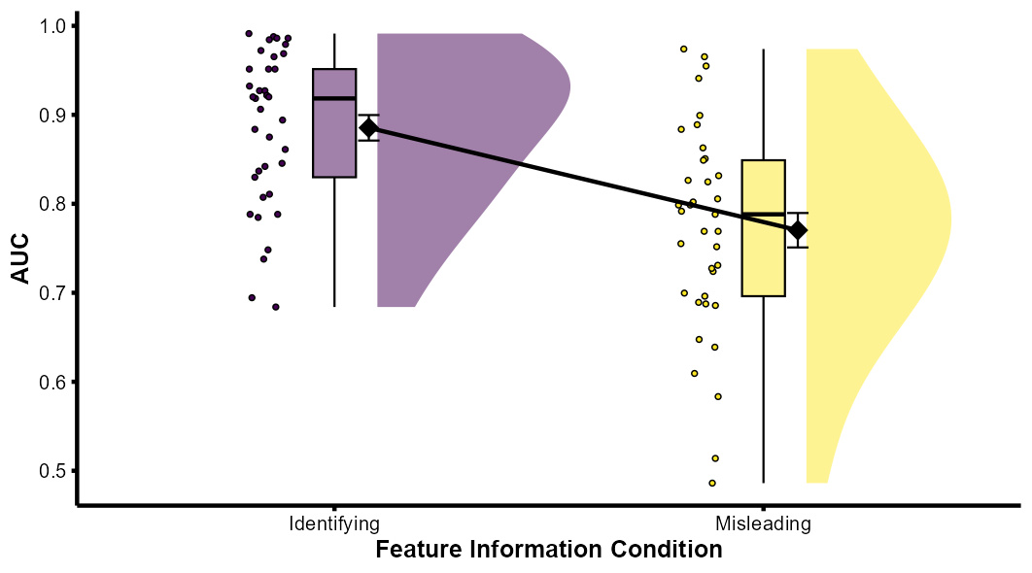
Supplementary Figure 2. AUC comparisons from Supplementary Experiment A show participants are more accurate on trials where participants were given the true identifying feature information than trials where they were given misleading feature information. Diamonds on each boxplot represent the mean AUC score and standard error bars.
Next, we compared participants’ accuracy before and after receiving the feature information block to determine whether being provided with the diagnostic feature information caused an improvement in face matching ability. Planned t-tests show accuracy was better in the pre-condition block (M = 0.79, SD = 0.10) than the post-condition block (M = 0.76, SD = 0.09), t(36) = -2.2, p = .035, Cohen’s d = -0.26, CI = [-0.49, -0.02], providing no evidence of any training effect after being directed to diagnostic features in the feature information block.
Inspection of Supplementary Figure 1 shows there is some variability in the effect of participants being told the diagnostic features compared to the misleading features. To determine whether this variability in the effect of providing diagnostic or misleading features is predicted by individual differences in face matching ability, we correlated the size of the difference between the two feature information conditions with participants’ accuracy on the pre-test block. We found a significant negative correlation, as participants who performed worse on the pre-condition block tended to show larger differences between the diagnostic and misleading feature information conditions, r_{s} (37) = -0.39, p = .016. This suggests that those with better face matching ability were less affected by being shown the diagnostic or misleading information than those who have poorer face matching ability.
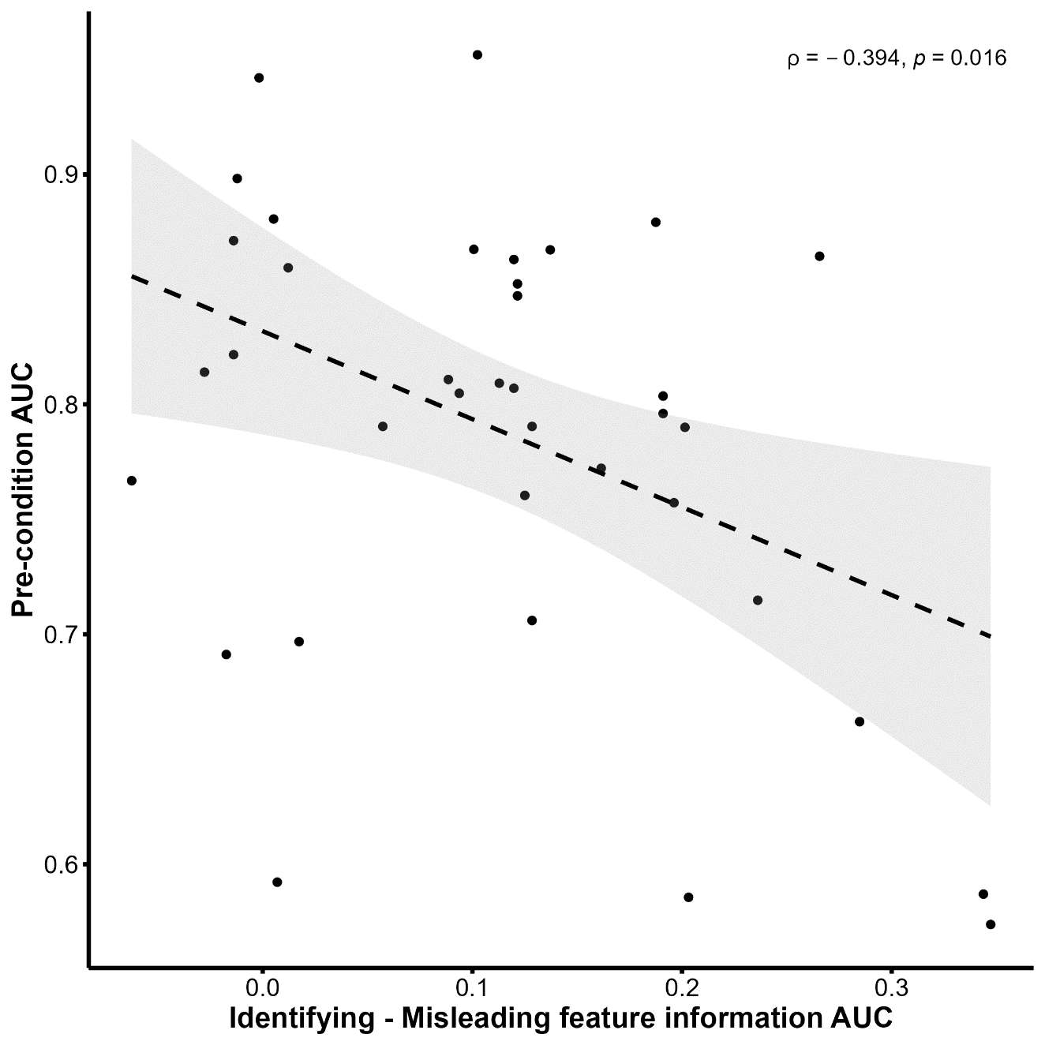
Supplementary Figure 2. Scatterplot showing correlation between baseline face matching accuracy and the difference in accuracy between trials with Identifying feature information and Misleading feature information in Supplementary Experiment A. This relationship suggests face matching ability affects the extent to which diagnostic feature information informs participant’s decisions.

References
Carragher, D. J., Towler, A., Mileva, V. R., White, D., & Hancock, P. J. B. (2022). Masked face identification is improved by diagnostic feature training. Cogn Res Princ Implic, 7(1), 30. https://doi.org/10.1186/s41235-022-00381-x
Towler, A., Keshwa, M., Ton, B., Kemp, R. I., & White, D. (2021). Diagnostic feature training improves face matching accuracy. J Exp Psychol Learn Mem Cogn, 47(8), 1288-1298. https://doi.org/10.1037/xlm0000972

