Supplementary Materials

Duncan, D. H., Theeuwes, J. (2024) Secondary Capture: Salience Information Persistently Drives Attentional Selection.

Experiment 3

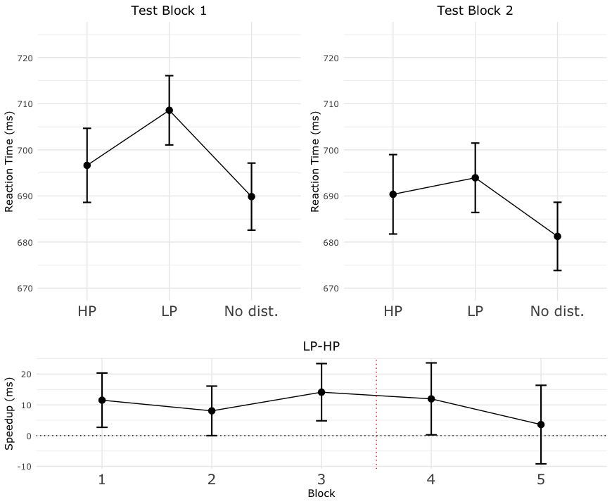
Supplementary Figure 1: Results of the test phase analysis. Top-left: reaction times based on the location of the medium-salience distractor for the first testing block following training. HP indicates distractor was at its previously high-probability location. LP indicates it was at what was previously in training a low-probability location. No dist. indicates reaction times when no distractor was present. Note: the distractor appeared at each location equally frequently during the testing phase. Top-right: reaction times separated for medium-saliency conditions during the second block of testing. Bottom: speedup effect across all five experimental blocks. Speedup was calculated by taking the average reaction time when a distractor was at a low-probability location and subtracting it from average reaction time when the distractor was at a high-probability location. Speedup thus represents how much faster participants were when benefitting form statistical learning. Note that the three blocks to the left of the dotted red line were training blocks, and the two to the right were testing blocks. Black dotted horizontal line represents zero – or no effect of learning. All error bars are within-subject corrected 95% confidence intervals.

The purpose of Experiment 3 was to observe whether learning could occur for a medium-salience distractor that was only ever present in displays which also contained a high-salience distractor – meaning that attention would reliably be captured by the distractor without a regularity. If learning still occurred for this less-salient distractor, then this would be evidence that attention moved from the most salient item to the second most salient item in the display, as attention has recently been shown to be a crucial component of statistical learning. Specifically, Duncan, van Moorselaar and Theeuwes (2024) recently showed that participants could learn the regularity associated with a non-salient visual distractor if it was not easily discriminable from the search target in a serial search task. However, when these non-salient distractors were made clearly distinct from the search target (by changing their color to a different color form the search target) then learning no longer occurred, meaning that attention was an essential component of the process of statistical learning.
We thus sought to leverage the role of attention in learning in a novel manner in Experiment 3. To do this we used a common train/test design which has been used in many statistical learning experiments in the past (Duncan & Theeuwes, 2020; Jiang et al., 2013). In this design, participants are initially exposed to blocks where a regularity is present, and then the regularity is removed and it is observed how long it takes for the learning to disappear. We chose to use this type of design due to precedent. Following completion of the data collection, we realized that the extinction phase of the effect was not of actual interest to the main research question presented in the manuscript – i.e. whether learning of the less-salient distractor would occur. We thus chose to exclude this analysis form the main script as it would only be a distraction from the results of interest, and instead to present these results here.
In short; we found that the learning effect persisted for one block post training, and then effectively disappeared by the second testing block. This is shown in Supplementary Figure 1, which shows block-wise reaction times for the various medium-saliency conditions for the first and second testing blocks (blocks 4 & 5 in the experiment). Of particular interest is the speedup effect – or whether participants were faster when distractors appeared at their previously high-probability locations after the regularity had been removed. The speedup effect separated per-block is shown in the bottom panel of Supplementary Figure 1, including the three training blocks. As can be seem the learning effect was present in all testing blocks, as well as the first block post training, but not the second, indicating rapid extinction of the learning effect. This was further confirmed by paired sample t-tests comparing the reaction times for LP and HP conditions in the two testing blocks. A significant speedup effect was found in the first block of testing (t(120) = 1.988, p = 0.049, d = 0.181) but not the second (t < 1).

References:
Duncan, D. H., Moorselaar, D. van, & Theeuwes, J. (2024). Visual statistical learning requires attention. PsyArXiv. https://doi.org/10.31234/osf.io/6dezr
Duncan, D. H., & Theeuwes, J. (2020). Statistical learning in the absence of explicit top-down attention. Cortex, 131, 54–65.
Jiang, Y. V., Swallow, K. M., Rosenbaum, G. M., & Herzig, C. (2013). Rapid acquisition but slow extinction of an attentional bias in space. Journal of Experimental Psychology: Human Perception and Performance, 39(1), 87.

