Supporting Information-S1: Repetition detection task (selective attention)

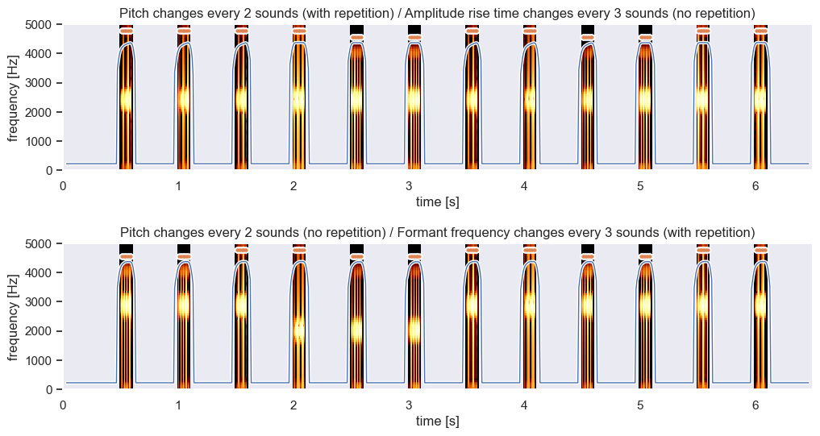
Figure S2. Example sequences from the dimension-selective attention task. Formant frequencies are visible in yellow in the spectrogram, amplitude rise time contour is plotted with a blue line, and pitch is tagged above the spectrogram with orange markers. (Top). Example sequence where pitch changes every two sounds (with repetition), amplitude rise time varies every two sounds (without repetition), and formant frequency is kept stable at its mid-value. The sequence appeared in the "attend to pitch" condition where participants should respond "Yes", indicating the repetition in the attended dimension. If the sequence appeared in the "attend to rise time" condition, participants should ignore the repetition in the ignored varying dimension and respond "No" since there is no repetition in the attended dimension. (Bottom). Example sequence with pitch changing every two sounds (without repetition), formant frequency changing every three sounds (with repetition), and amplitude rise time kept stable. Similarly, the same sequence was used in two conditions, "attend to pitch" and "attend to formant", where participants should respond "No" and "Yes", respectively, to indicate the absence or presence of the repetition within the attended dimension. For peer review, a full version of the repetition detection task is currently available here (https://app.gorilla.sc/openmaterials/497080).

Supporting Information-S2: Repetition detection task (selective attention)

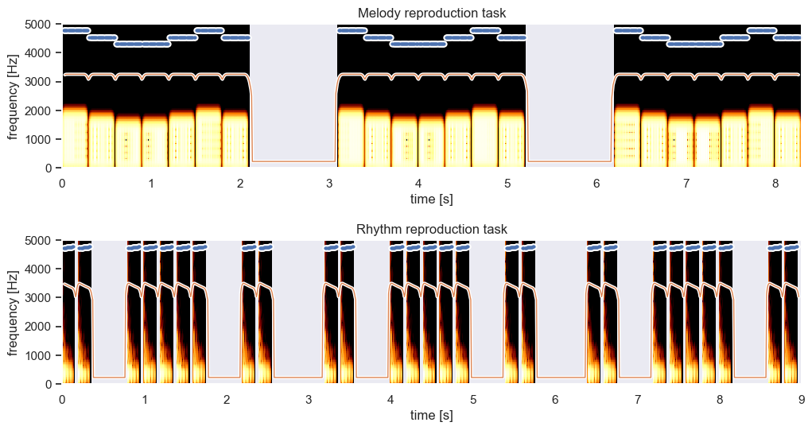
Figure S3. Spectrograms of example sequences from Auditory Motor Integration tasks with intensity contour overlayed with a blue line and pitch height with orange markers above. Participants hear each sequence three times and can only submit their response after the third repetition ends. (Top). Melody reproduction task. Each musical sequence consists of a maximum of 8 tones selected from 5 base stimuli, and it always starts with the note "3". (Bottom). Rhythm reproduction task. All drum sequences consist of the same drum hit sounds. For peer review, a full version of the reproduction task is currently available here (https://app.gorilla.sc/openmaterials/497080).

Supporting Information-S3: Summary of Correlations Between Auditory Processing, Biographical Backgrounds, and Working Memory

Table S3 Biographical and Working Memory Correlates of Attention and Integration
 | Attention |  |  |  | Integration
 | r | p | 95% CI |  | r | p | 95% CI
 | r | p | Lower | Upper | r | p | Lower | Upper
A. Biographical backgrounds
Age | –.128 | .200 | –.316 | .069 | –.152 | .128 | –.338 | .044
Length of residence | –.054 | .595 | –.246 | .143 | .185 | .065 | –.011 | .367
Age of arrival | –.144 | .150 | –.330 | .053 | –.229 | .022 | –.406 | –.035
Current L2 use at home | –.014 | .889 | –.209 | .182 | .121 | .228 | –.076 | .309
Current L2 use at work | .167 | .094 | –.029 | .351 | .012 | .907 | –.184 | .207
Current L2 use at social | –.055 | .587 | –.247 | .142 | .032 | .748 | –.164 | .226
Length of EFL | .030 | .762 | –.166 | .225 | .055 | .583 | –.142 | .248
Music training | .079 | .435 | –.119 | .270 | .299 | .002* | .110 | .467
B. Working memory
Forward span | .349 | < .001* | .165 | .510 | .183 | .067 | –.013 | .365
Backward span | .332 | < .001* | .145 | .495 | .320 | .001* | .133 | .485
* indicates statistical significance (p < .006; Bonferroni corrected)

Table S3 Biographical and Working Memory Correlates of Perceptual Acuity
 | Pitch Acuity |  |  |  | Formant Acuity |  |  |  | Temporal Acuity
 | r | p | 95% CI |  | r | p | 95% CI |  | r | p | 95% CI
 | r | p | Lower | Upper | r | p | Lower | Upper | r | p | Lower | Upper
Age | .023 | .823 | –.174 | .217 | –.068 | .499 | –.260 | .129 | –.042 | .677 | –.235 | .155
Length of residence | .143 | .153 | –.054 | .329 | .020 | .842 | –.176 | .215 | .120 | .230 | –.077 | .309
Age of arrival | –.027 | .786 | –.222 | .169 | –.055 | .585 | –.248 | .142 | –.103 | .304 | –.293 | .094
Current L2 use at home | –.135 | .177 | –.322 | .062 | .098 | .331 | –.100 | .288 | –.042 | .674 | –.236 | .154
Current L2 use at work | –.029 | .771 | –.223 | .167 | –.138 | .169 | –.325 | .059 | .007 | .944 | –.189 | .202
Current L2 use at social | –.020 | .846 | –.214 | .176 | –.094 | .351 | –.284 | .104 | –.100 | .320 | –.290 | .097
Length of EFL | –.120 | .230 | –.309 | .077 | .076 | .447 | –.121 | .268 | –.023 | .822 | –.217 | .174
Music training | –.056 | .580 | –.249 | .141 | –.006 | .956 | –.201 | .190 | –.034 | .732 | –.228 | .162
Forward span | –.049 | .629 | –.242 | .148 | .078 | .436 | –.119 | .270 | –.078 | .439 | –.269 | .119
Backward span | –.072 | .476 | –.263 | .125 | –.072 | .476 | –.263 | .125 | .078 | .440 | –.120 | .269
* indicates statistical significance (p < .006; Bonferroni corrected)

Supporting Information-S4: R codes
Simulation Analyses for Polish Data (Kachlicka et al., 2019)
# Load necessary packages
if (!require("lme4")) install.packages("lme4")
if (!require("simr")) install.packages("simr")
if (!require("readxl")) install.packages("readxl")
if (!require("performance")) install.packages("performance")

library(lme4)
library(simr)
library(readxl)
library(performance)

# Set your file path
file_path <- "data_in_brief_submitted.xlsx"

# Import the data
data <- read_excel(file_path, sheet = "SIMR_Polish")

# Convert 'ID' to a factor if it's not already
data$ID <- as.factor(data$ID)

# Convert 'Test' to a factor if it's not already
data$Test <- as.factor(data$Test)

# Relevel 'Test' with 'a' as the reference level
data$Test <- relevel(data$Test, ref = "a")

#Create MODEL0 (including pitch, formant, and risetime acuity)
MODEL0 <- lmer(DV ~ FA_pitch*Test + FA_formant*Test + FA_risetime*Test + (1|ID), data = data)

# Print the summary of the model
summary(MODEL0)

# Print R squared
performance::r2(MODEL0)

#POWER ANALYSIS
power_sim_pitch <- powerSim(MODEL0, test = fixed("FA_pitch", "z"), nsim = 10)

print(power_sim_pitch)

# Extend the number of levels for 'ID' to n = 200 (*** new n has to be more than simulated dataset)
MODEL0_ID <- extend(MODEL0, along="ID", n=200)

power_sim_pitch_ID <- powerSim(MODEL0_ID, test = fixed("FA_pitch", "z"), nsim = 10)
print(power_sim_pitch_ID)

# Define power curve for 'ID' for each predictor *if* N = 200

pc_ID_pitch <- powerCurve(MODEL0_ID, along = "ID", test = fixed("FA_pitch", "z"), nsim = 10)

#Print power curve for 'ID' for each predictor
print(pc_ID_pitch)
plot(pc_ID_pitch)

Simulation Analyses for Spanish Data (Saito et al., 2022)
# Load necessary packages
if (!require("lme4")) install.packages("lme4")
if (!require("simr")) install.packages("simr")
if (!require("readxl")) install.packages("readxl")
if (!require("performance")) install.packages("performance")

library(lme4)
library(simr)
library(readxl)
library(performance)

# Set your file path
file_path <- "data_in_brief_submitted.xlsx"

# Import the data
data <- read_excel(file_path, sheet = "SIMR_Spanish")

# Convert 'ID' to a factor if it's not already
data$ID <- as.factor(data$ID)

# Convert 'Test' to a factor if it's not already
data$Test <- as.factor(data$Test)

# Relevel 'Test' with 'a' as the reference level
data$Test <- relevel(data$Test, ref = "a")

#Create MODEL0 (including pitch, formant, and risetime acuity)
MODEL0 <- lmer(DV ~ FA_pitch*Test + FA_formant*Test + FA_risetime*Test + (1|ID), data = data)

# Print the summary of the model
summary(MODEL0)

# Print R squared
performance::r2(MODEL0)

#POWER ANALYSIS
power_sim_pitch <- powerSim(MODEL0, test = fixed("FA_pitch", "z"), nsim = 100)

print(power_sim_pitch)

# Extend the number of levels for 'ID' to n = 200 (*** new n has to be more than simulated dataset)
MODEL0_ID <- extend(MODEL0, along="ID", n=200)

power_sim_pitch_ID <- powerSim(MODEL0_ID, test = fixed("FA_pitch", "z"), nsim = 10)
print(power_sim_pitch_ID)

# Define power curve for 'ID' for each predictor *if* N = 200

pc_ID_pitch <- powerCurve(MODEL0_ID, along = "ID", test = fixed("FA_pitch", "z"), nsim = 100)

#Print power curve for 'ID' for each predictor
print(pc_ID_pitch)
plot(pc_ID_pitch)

Main Analyses
# Load necessary packages
if (!require("lme4")) install.packages("lme4")
if (!require("simr")) install.packages("simr")
if (!require("readxl")) install.packages("readxl")
if (!require("multcomp")) install.packages("multcomp")
if (!require("performance")) install.packages("performance")

library(lme4)
library(simr)
library(readxl)
library(multcomp)
library(performance)

# Set your file path
file_path <- "data_in_brief_submitted.xlsx"

# Import the data
data <- read_excel(file_path, sheet = "MAINDATA")

# Convert 'ID' to a factor if it's not already
data$ID <- as.factor(data$ID)

# Convert 'Test' to a factor if it's not already
data$Test <- as.factor(data$Test)

# Relevel 'Test' with 'a' as the reference level
data$Test <- relevel(data$Test, ref = "a")

#Create MODEL0
MODEL0 <- lmer(DV ~ FA_pitch*Test + FA_formant*Test + FA_risetime*Test + (1|ID), data = data)

# Print the summary of the model
summary(MODEL0)

# Print R squared
performance::r2(MODEL0)

#Create MODEL1
MODEL1 <- lmer(DV ~ FA_pitch + FA_formant + FA_risetime + FA_attention + FA_integration + Test + (1|ID), data = data)

# Print the summary of the model
summary(MODEL1)

# Print R squared
performance::r2(MODEL1)

#Create MODEL1_interaction to check any interaction effects

MODEL1_interaction <- lmer(DV ~ FA_pitch*Test + FA_formant*Test + FA_risetime*Test + FA_attention*Test + FA_integration*Test + (1|ID), data = data)

# Print the summary of the model
summary(MODEL1_interaction)

# Print R squared
performance::r2(MODEL1_interaction)

#Create MODEL2
# First, develop a linear model with control variables as predictors
control_model_experience <- lm(DV ~ AOA + LOR + L2useAVE + LengthofEFL + MusicTrainingYN, data = data)

# Create a new dependent variable by subtracting the predicted values from the original dependent variable
data$DV_residuals_experience <- resid(control_model_experience)

# Create a new mixed effects model using the new dependent variable
MODEL2 <- lmer(DV_residuals_experience ~ FA_pitch + FA_formant + FA_risetime + FA_attention + FA_integration + Test + (1|ID), data = data)

# Print the summary of the model
summary(MODEL2)
# Print R squared
performance::r2(MODEL2)

#Create MODEL3
# First, develop a linear model with control variables as predictors
control_model_wm <- lm(DV ~ digit_span_forwards + digit_span_backwards, data = data)

# Create a new dependent variable by subtracting the predicted values from the original dependent variable
data$DV_residuals_wm <- resid(control_model_wm)

# Create a new mixed effects model using the new dependent variable
MODEL3 <- lmer(DV_residuals_wm ~ FA_pitch + FA_formant + FA_risetime + FA_attention + FA_integration + Test + (1|ID), data = data)

# Print the summary of the model
summary(MODEL3)
# Print R squared
performance::r2(MODEL3)

# Compare MODEL0 vs. MODEL1
anova(MODEL0, MODEL1)

# Compare MODEL2 vs. MODEL0

# For the model comparison, MODEL0 was revised using residuals, with experience factors controlled for.

MODEL0_experience <- lmer(DV_residuals_experience ~ FA_pitch*Test + FA_formant*Test + FA_risetime*Test + (1|ID), data = data)

anova(MODEL2, MODEL0_experience)

# Compare MODEL3 with MODEL0

# For the model comparison, MODEL0 was revised using residuals, with working memory factors controlled for.

MODEL0_wm <- lmer(DV_residuals_wm ~ FA_pitch*Test + FA_formant*Test + FA_risetime*Test + (1|ID), data = data)

anova(MODEL3, MODEL0_wm)

