Discrete, pre-decision visual uncertainty impacts visual confidence

Supplementary Materials

Authors: Morgan L. Spence^{1*}, Jason B. Mattingley^{1,2}, & Paul E. Dux¹

Affiliations: ¹ School of Psychology, The University of Queensland, Australia.

² Queensland Brain Institute, The University of Queensland, Australia.

*Corresponding author

Email: morgan.spence@uqconnect.edu.au

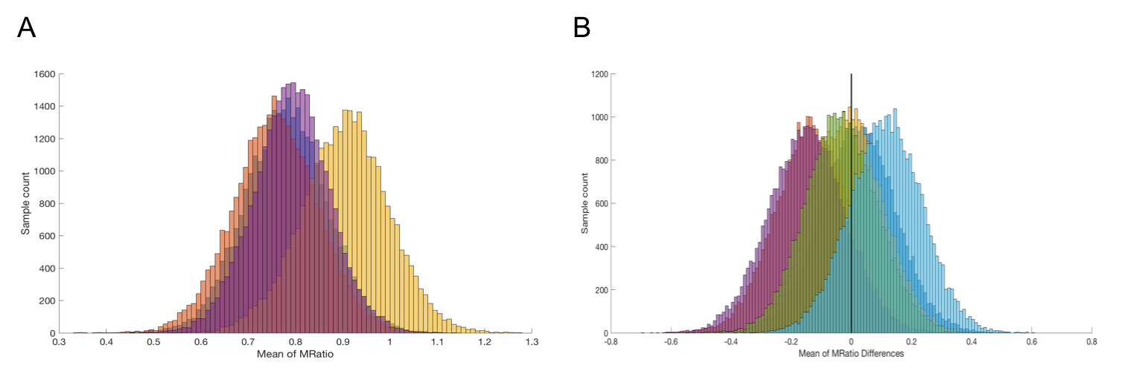
Figure 1. Results from the HMeta-d analysis for direction judgements. (A) Plot showing the distributions of posterior MRatio means obtained using the HMeta-d method for estimating metacognitive efficiency in each of the range distribution conditions for direction (Blue: 30 degrees, Red: 20 degrees, Yellow: 10 degrees, Purple: 5 degrees). (B) Plot showing the distribution of the posterior mean differences between MRatios obtaining using the HMeta-d method for each of the range condition comparisons for brightness judgements (Mid Blue: 30-20, Red: 30-10, Yellow: 30-5, Purple: 20-10, Green: 20-5 and Light Blue: 10-5). All comparisons are nonsignificant as indicated by the 95% HDI, which contains zero in all cases. The vertical black line indicates zero for reference. HDI bounds for each comparison were as follows: 30-20 lower bound = -0.2277, 30-20 upper bound = 0.2702; 30-10 lower bound = -0.3743, 30-10 upper bound = 0.1224; 30-5 lower bound = -0.2483, 30-5 upper bound = 0.2190, 20-10 lower bound = -0.4001; 20-10 upper bound = 0.1045, 20-5 lower bound = -0.2686; 20-5 upper bound = 0.2032, 10-5 lower bound = -0.1254; 10-5 upper bound = 0.3500.

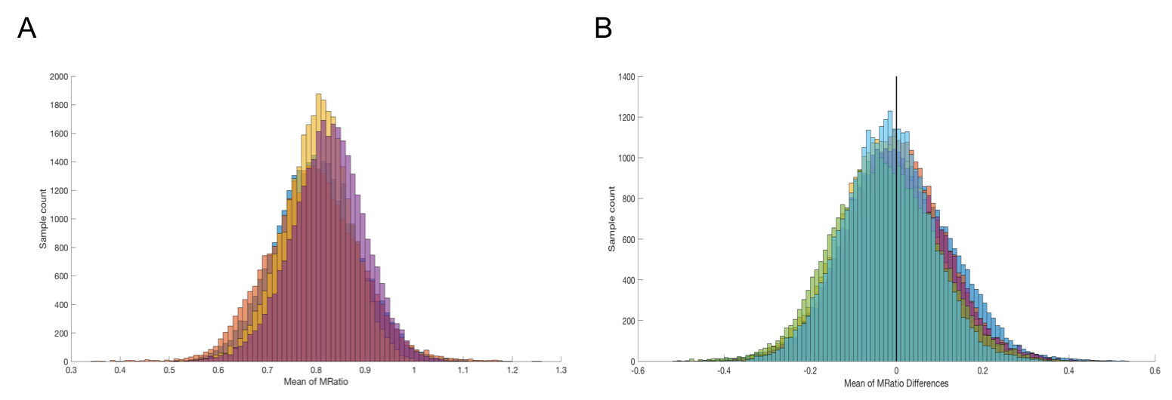
Figure 2. Results from the HMeta-D analysis for brightness judgments. (A) Plot showing the distributions of posterior MRatio means obtaining using the HMeta-d method for estimating metacognitive efficiency in each of the range distribution conditions for direction (Blue: 30 degrees, Red: 20 degrees, Yellow: 10 degrees, Purple: 5 degrees). (B) Plot showing the distribution of the posterior mean differences between MRatios obtaining using the HMeta-d method for each of the range condition comparisons for brightness judgements (Mid Blue: 30-20, Red: 30-10, Yellow: 30-5, Purple: 20-10, Green: 20-5 and Light Blue: 10-5). All comparisons are nonsignificant as indicated by the 95% HDI, which contains zero in all cases. The vertical black line indicates zero for reference. HDI bounds for each comparison were as follows: 30-20 lower bound = -0.2417, 30-20 upper bound = 0.2553; 30-10 lower bound = -0.2204, 30-10 upper bound = 0.2177; 30-5 lower bound = -0.2460, 30-5 upper bound = 0.2013, 20-10 lower bound = -0.2387; 20-10 upper bound = 0.2222, 20-5 lower bound = -0.2629; 20-5 upper bound = 0.2097, 10-5 lower bound = -0.2294; 10-5 upper bound = 0.1745. This indicates that there were no differences in the quality of the participants’ confidence ratings for their brightness judgments under the different range conditions.

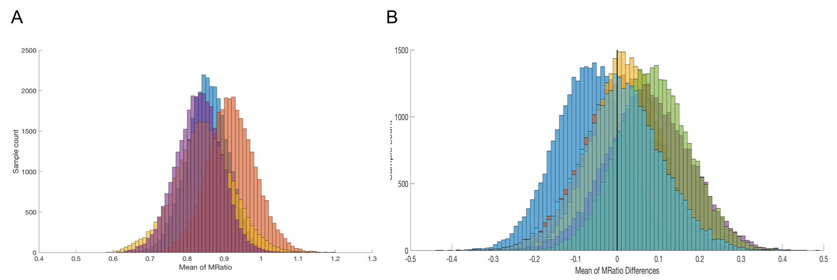
Figure 3. Results from HMeta-d analysis for direction judgments in Experiment 3. (A) Plot showing the distributions of posterior MRatio means obtained using the HMeta-d method for estimating metacognitive efficiency in each of the range distribution conditions for direction (Blue: 30 degrees, Red: 20 degrees, Yellow: 10 degrees, Purple: 5 degrees). (B) Plot showing the distribution of the posterior mean differences between MRatios obtained using the HMeta-d method for each of the range condition comparisons for direction judgements (Mid Blue: 30-20, Red: 30-10, Yellow: 30-5, Purple: 20-10, Green: 20-5 and Light Blue: 10-5). All comparisons are nonsignificant as indicated by the 95% HDI, which contains zero in all cases. The vertical black line indicates zero for reference. HDI bounds for each comparison were as follows: 30-20 lower bound = -0.2357, 30-20 upper bound = 0.1028; 30-10 lower bound = -0.1786, 30-10 upper bound = 0.1917; 30-5 lower bound = -0.1495, 30-5 upper bound = 0.1808, 20-10 lower bound = -0.1219; 20-10 upper bound = 0.2734, 20-5 lower bound = -0.0854; 20-5 upper bound = 0.2615, 10-5 lower bound = -0.1827; 10-5 upper bound = 0.2136. These results suggest that there were no differences in the quality of participants’ confidence ratings for their direction judgments made in the different range conditions.

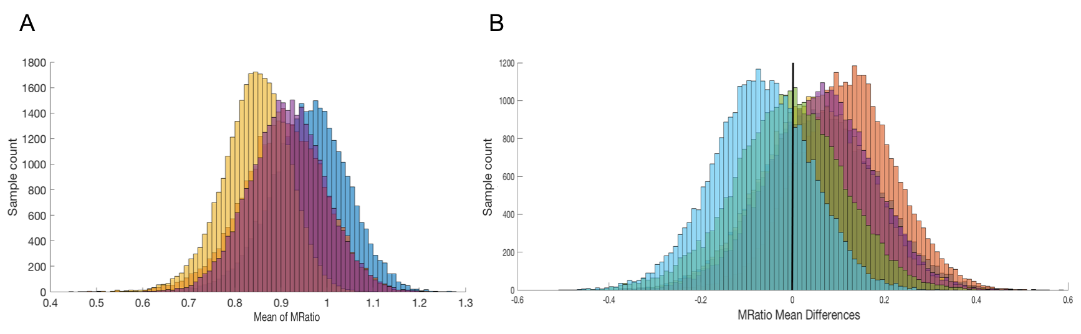
Figure 4. Results from the HMeta-d analysis on brightness judgments in Experiment 3. (A) Plot showing the distributions of posterior MRatio means obtained using the HMeta-d method for estimating metacognitive efficiency in each of the range distribution conditions for brightness (Blue: 30 degrees, Red: 20 degrees, Yellow: 10 degrees, Purple: 5 degrees). (B) Plot showing the distribution of the posterior mean differences between MRatios obtaining using the HMeta-d method for each of the range condition comparisons for brightness judgements (Mid Blue: 30-20, Red: 30-10, Yellow: 30-5, Purple: 20-10, Green: 20-5 and Light Blue: 10-5). All comparisons are nonsignificant as indicated by the 95% HDI, which contains zero in all cases. The vertical black line indicates zero for reference. HDI bounds for each comparison were as follows: 30-20 lower bound = -0.1869, 30-20 upper bound = 0.3032; 30-10 lower bound = -0.0924, 30-10 upper bound = 0.3321; 30-5 lower bound = -0.1849, 30-5 upper bound = 0.2768, 20-10 lower bound = -0.1666; 20-10 upper bound = 0.2871, 20-5 lower bound = -0.2552; 20-5 upper bound = 0.2286, 10-5 lower bound = -0.2815; 10-5 upper bound = 0.1385. This indicates that there were no differences in the quality of participants’ confidence ratings associated with brightness judgments made in the different range conditions.

