Supplementary Materials

How Visual Imagery Representations Are Formed: Through Suppression, Not Activation

Contents
S1. Combination Check……………………..………………………………………..…………………………..…2
S2. Simple Pairwise Comparison……………………………………………………………………..…………3
S3. Counterbalance of the Discrimination Task………………………………………………………….6
S4. Logistic Function Fitting………………………………………………………………………………..……..7
S5. Parameter-Based Simulation of Models……………………………………….……………………10
S6. Predicted Psychometric Curves Overlaid on Experimental Data………………….…….13

S1. Combination Check
For Experiments 1a, 1b, and 1c, before combining the data under 45° clockwise and counterclockwise conditions for further analysis, we ensured proportions of ‘different’ response and subjective vividness ratings (except for Experiment 1c, where the imagery task as well as the vividness rating were removed) were not statistically different under two imagery orientations. We used paired-sample t test if normality assumption was satisfied, or Wilcoxon signed rank test if normality assumption was violated.
For Experiment 1a, neither of these variables showed significant difference. For proportion of ‘different’ response, M_{clockwise} = 0.589, M_{counterclockwise} = 0.575, Z = 0.402, p = 0.701 (or despite of violation of normality, t(18) = 0.814, p = 0.427, cohen’s d = 0.187, 95% CI_{d} = (-0.270, 0.638)). For subjective vividness rating, M_{clockwise} = 2.871, M_{counterclockwise} = 2.839, t(18) = 1.752, p = 0.097, cohen’s d = 0.402, 95% CI_{d} = (-0.071, 0.865).
For Experiment 1b, neither of these variables showed significant difference. For proportion of ‘different’ response, M_{clockwise} = 0.566, M_{counterclockwise} = 0.568, t(18) = 0.097, p = 0.924, cohen’s d = 0.022, 95% CI_{d} = (-0.428, 0.472). For subjective vividness rating, M_{clockwise} = 2.932, M_{counterclockwise} = 2.911, t(18) = 1.450, p = 0.164, cohen’s d = 0.333, 95% CI_{d} = (-0.134, 0.791).
For Experiment 1c, the proportion of ‘different’ response under 45° clockwise and counterclockwise conditions showed nonsignificant difference, M_{clockwise} = 0.575, M_{counterclockwise} = 0.555, t(18) = 1.256, p = 0.225, cohen’s d = 0.288, 95% CI_{d} = (-0.175, 0.744).

S2. Simple Pairwise Comparison
In Experiment 1a, the proportions of ‘different’ response under unilateral and bilateral conditions at each orientation difference level are shown in Table S1. Dissociation of bilateral and unilateral conditions was significant at the orientation difference of 2°, 8°, and 10°.
In Experiment 1b, the proportions of ‘different’ response under unilateral and bilateral conditions at each orientation difference level are shown in Table S2, and no significant difference was found.
In Experiment 1c, the proportions of ‘different’ response under unilateral and bilateral conditions at each orientation difference level are shown in Table S3, and no significant difference was found.
In Experiment 2a, the proportions of ‘different’ response under unilateral and bilateral conditions at each orientation difference level are shown in Table S4. Dissociation of bilateral and unilateral conditions was significant at the orientation difference of 2°, 4°, 6°, 8°, and 10°.
In Experiment 2b, the proportions of ‘different’ response under unilateral and bilateral conditions at each orientation difference level are shown in Table S5. Dissociation between these two conditions was significant at the orientation difference of 2°, 4°, 6°, 8°, and 10°.

Table S1. Simple pairwise comparison in Experiment 1a. At each orientation difference level, the proportions of ‘different’ response under unilateral and bilateral conditions were compared.
Orientation Difference (° ) | Bilateral  (M ± SD) | Unilateral  (M ± SD) | t₍₁₈₎ | p | Cohen’s d
0 | 0.092 ± 0.107 | 0.118 ± 0.115 | 1.714 | 0.104 | 0.393
2 | 0.140 ± 0.119 | 0.196 ± 0.099 | 3.057 | 0.007 | 0.701
4 | 0.308 ± 0.154 | 0.337 ± 0.150 | 1.218 | 0.239 | 0.279
6 | 0.563 ± 0.162 | 0.536 ± 0.180 | 0.954 | 0.353 | 0.219
8 | 0.789 ± 0.116 | 0.696 ± 0.176 | 3.101 | 0.006 | 0.712
10 | 0.911 ± 0.083 | 0.814 ± 0.118 | 5.002 | < 0.001 | 1.148
12 | 0.957 ± 0.054 | 0.928 ± 0.077 | 1.727 | 0.101 | 0.396
14 | 0.965 ± 0.036 | 0.965 ± 0.049 | < 0.001 | 1.000 | < 0.001
Table S2. Simple pairwise comparison in Experiment 1b. At each orientation difference level, the proportions of ‘different’ response under unilateral and bilateral conditions were compared.
Orientation Difference (° ) | Bilateral  (M ± SD) | Unilateral  (M ± SD) | t₍₁₈₎ | p | Cohen’s d
0 | 0.100 ± 0.070 | 0.110 ± 0.080 | 0.972 | 0.344 | 0.223
2 | 0.184 ± 0.133 | 0.174 ± 0.130 | 0.669 | 0.512 | 0.154
4 | 0.322 ± 0.185 | 0.317 ± 0.194 | 0.220 | 0.829 | 0.050
6 | 0.530 ± 0.205 | 0.505 ± 0.216 | 1.256 | 0.225 | 0.288
8 | 0.702 ± 0.187 | 0.692 ± 0.202 | 0.443 | 0.663 | 0.102
10 | 0.845 ± 0.126 | 0.811 ± 0.149 | 1.516 | 0.147 | 0.348
12 | 0.939 ± 0.086 | 0.908 ± 0.090 | 1.635 | 0.120 | 0.375
14 | 0.972 ± 0.034 | 0.959 ± 0.052 | 1.117 | 0.279 | 0.256

Table S3. Simple pairwise comparison in Experiment 1c. At each orientation difference level, the proportions of ‘different’ response under unilateral and bilateral conditions were compared.
Orientation Difference (° ) | Bilateral  (M ± SD) | Unilateral  (M ± SD) | t₍₁₈₎ | p | Cohen’s d
0 | 0.082 ± 0.041 | 0.086 ± 0.064 | 0.261 | 0.797 | 0.060
2 | 0.138 ± 0.061 | 0.161 ± 0.082 | 1.735 | 0.100 | 0.398
4 | 0.299 ± 0.101 | 0.276 ± 0.075 | 1.206 | 0.243 | 0.277
6 | 0.530 ± 0.178 | 0.505 ± 0.124 | 1.035 | 0.315 | 0.237
8 | 0.732 ± 0.175 | 0.714 ± 0.126 | 0.820 | 0.423 | 0.188
10 | 0.857 ± 0.089 | 0.849 ± 0.085 | 0.720 | 0.481 | 0.165
12 | 0.928 ± 0.068 | 0.938 ± 0.063 | 0.697 | 0.494 | 0.160
14 | 0.982 ± 0.032 | 0.969 ± 0.040 | 1.193 | 0.249 | 0.274
Table S4. Simple pairwise comparison in Experiment 2a. At each orientation difference level, the proportions of ‘different’ response under unilateral and bilateral conditions were compared.
Orientation Difference (° ) | Bilateral  (M ± SD) | Unilateral  (M ± SD) | t₍₁₉₎ | p | Cohen’s d
0 | 0.121 ± 0.104 | 0.134 ± 0.118 | 0.709 | 0.487 | 0.159
2 | 0.121 ± 0.108 | 0.164 ± 0.106 | 2.662 | 0.015 | 0.595
4 | 0.218 ± 0.146 | 0.284 ± 0.160 | 3.231 | 0.004 | 0.723
6 | 0.359 ± 0.188 | 0.427 ± 0.187 | 2.362 | 0. 029 | 0.528
8 | 0.516 ± 0.194 | 0.645 ± 0.189 | 4.379 | < 0.001 | 0.979
10 | 0.696 ± 0.206 | 0.761 ± 0.182 | 2.578 | 0.018 | 0.577
12 | 0.850 ± 0.127 | 0.870 ± 0.136 | 1.351 | 0.192 | 0.302
14 | 0.920 ± 0.100 | 0.952 ± 0.074 | 1.964 | 0.064 | 0.439

Table S5. Simple pairwise comparison in Experiment 2b. At each orientation difference level, the proportions of ‘different’ response under unilateral and bilateral conditions were compared
Orientation Difference (° ) | Bilateral  (M ± SD) | Unilateral  (M ± SD) | t₍₁₉₎ | p | Cohen’s d
0 | 0.105 ± 0.080 | 0.120 ± 0.096 | 0.837 | 0.413 | 0.187
2 | 0.166 ± 0.118 | 0.198 ± 0.108 | 2.131 | 0.046 | 0.476
4 | 0.229 ± 0.143 | 0.313 ± 0.148 | 3.661 | 0.002 | 0.819
6 | 0.414 ± 0.139 | 0.504 ± 0.138 | 4.668 | < 0.001 | 1.044
8 | 0.609 ± 0.164 | 0.693 ± 0.182 | 2.954 | 0.008 | 0.660
10 | 0.746 ± 0.174 | 0.821 ± 0.115 | 3.020 | 0.007 | 0.675
12 | 0.870 ± 0.144 | 0.909 ± 0.081 | 1.696 | 0.106 | 0.379
14 | 0.945 ± 0.070 | 0.941 ± 0.051 | 0.326 | 0.748 | 0.073

S3. Counterbalance of the Discrimination Task
As has introduced in the main text, the behavioral discrimination task consists of two differently orientated Gabor patches, whose orientations are manipulated into unilateral and bilateral discrimination-prior conditions. One discriminator locates horizontally on the right of the fixation, and another one locates on the left. For a certain perceptual prior orientation (e.g., 22.5°) and a given orientation difference (e.g., 2°), bilateral condition defines only one type of discriminating pair (e.g., 21.5° and 23.5°) and assigns them to the left and right hemifield, resulting in two types of trial (type A1 and type A2) illustrated in Table S6. In comparison, unilateral condition defines two types of discriminating pair, with both discriminators larger (e.g., 29.5° and 31.5°) or smaller (e.g., 15.5° and 13.5°) than the prior orientation. These two types of discriminating pair will then be assigned to the left and right hemifield, constructing four types of trial (types B1, B2, C1, and C2, Table S6). Considering the balance of experimental design and time cost, for each participant, their experiments would include A1- and A2-type trials in bilateral condition, but only one of B1C1, B1C2, B2C1, or B2C2 combinations in unilateral condition. These four combinations were counterbalanced between participants, and each combination included 5 participants.

Table S6. The counterbalance of the discriminators’ location in Experiment 2a and Experiment 2b. Taking the prior orientation of 22.5° and the orientation difference of 2° as an example.
Condition | Type | Orientation on the left hemifield | Orientation on the right hemifield
Bilateral | A1 | 21.5° | 23.5°
Bilateral | A2 | 23.5° | 21.5°
Unilateral | B1 | 13.5° | 15.5°
Unilateral | B2 | 15.5° | 13.5°
Unilateral | C1 | 29.5° | 31.5°
Unilateral | C2 | 31.5° | 29.5°

S4. Logistic Function Fitting
Fitted curves at individual level for Experiments 1a, 1b, 1c, 2a, and 2b are provided in Figure S1-5, respectively.
Figure S1. In Experiment 1a, the Logistic curve fitting under unilateral and bilateral conditions at individual level. The gray dashed line with arrow represents the fitted threshold.

‘
Figure S2. In Experiment 1b, the Logistic curve fitting under unilateral and bilateral conditions at individual level. The gray dashed line with arrow represents the fitted threshold.
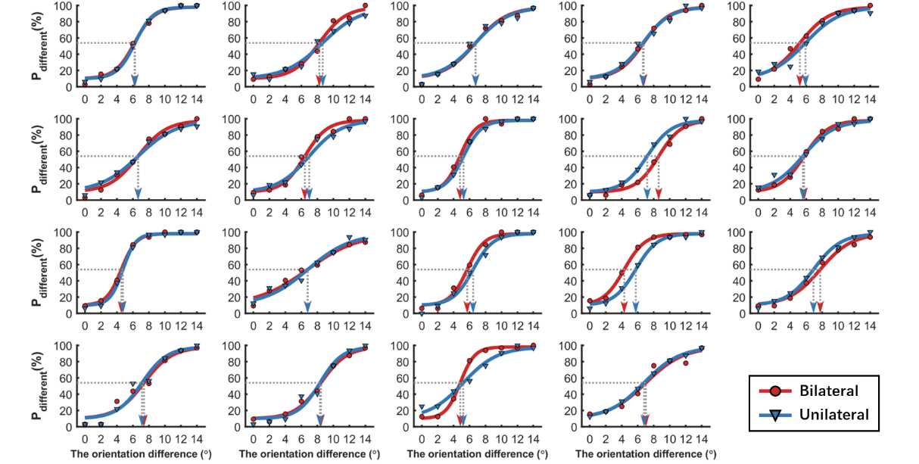
Figure S3. In Experiment 1c, the Logistic curve fitting under unilateral and bilateral conditions at individual level. The gray dashed line with arrow represents the fitted threshold.

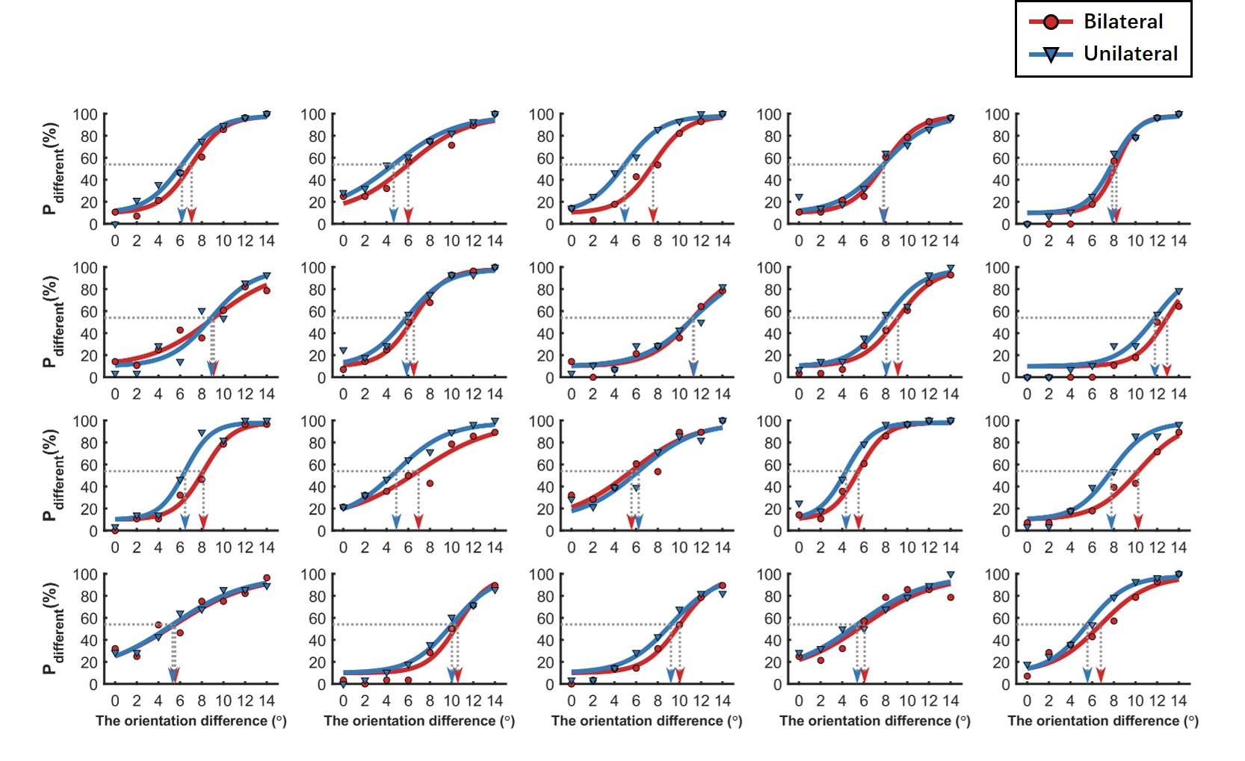
Figure S4. In Experiment 2a, the Logistic curve fitting under unilateral and bilateral conditions at individual level. The gray dashed line with arrow represents the fitted threshold.
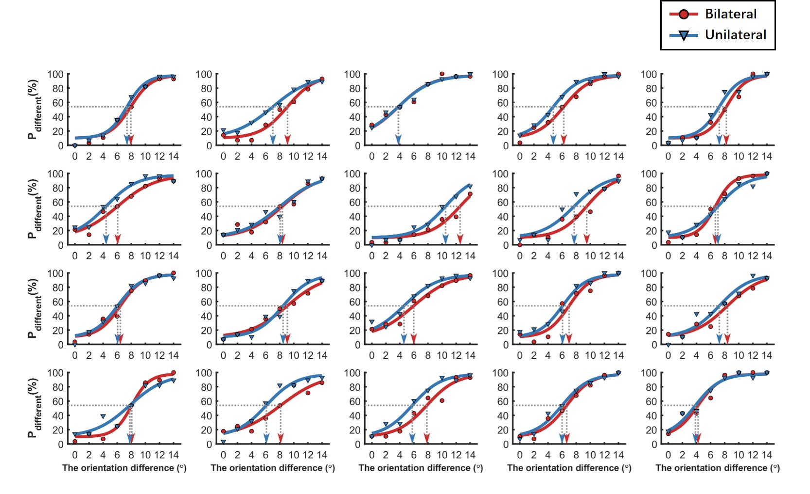
Figure S5. In Experiment 2b, the Logistic curve fitting under unilateral and bilateral conditions at individual level. The gray dashed line with arrow represents the fitted threshold.

S5. Parameter-Based Simulation of Models
We performed supplemental simulations what kind of prior shapes different parameters would lead to for activation and suppression models, respectively. The following figures illustrate how changes in parameters affect stimulus-driven response functions in two models.

- Activation model: We adopted Gaussian-shaped response function defined by R = A⋅normpdf(x, θ_{prior}, σ_{prior}) where the amplitude A and tuning width σ_{prior} are systematically manipulated. Figure S6A demonstrates how increasing A scales the peak response, while Figure S6B shows how smaller σ_{prior} values lead to narrower, more sharply tuned responses.
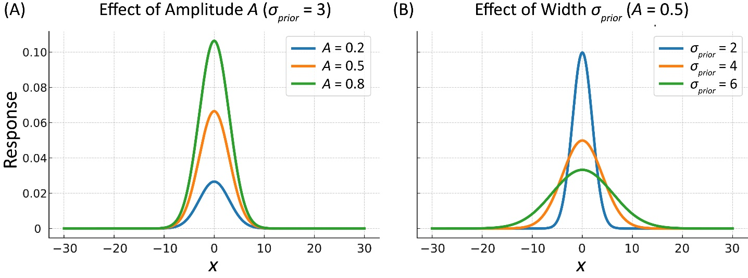
Figure S6. Illustration of activation model (AM) changes with amplitude A (A) and width σ_{prior} (B).

- Suppression model: we adopted suppression-based response function, computed as R′=A⋅normpdf(x, θ_{prior}, σ_{prior1}) − B⋅normpdf(x, θ_{prior}, σ_{prio2}), with B = A/σ_{prior1}⋅σ_{prio2} to preserve relative scaling. This formulation captures a center-surround suppression pattern with negative lobes flanking a central dip or peak.
  - Shown in Figure S7, increasing amplitude A enhances the overall suppression depth. Higher values of A amplify both center excitation and surround suppression, shifting the response from a flat dip to a robust W-profile.
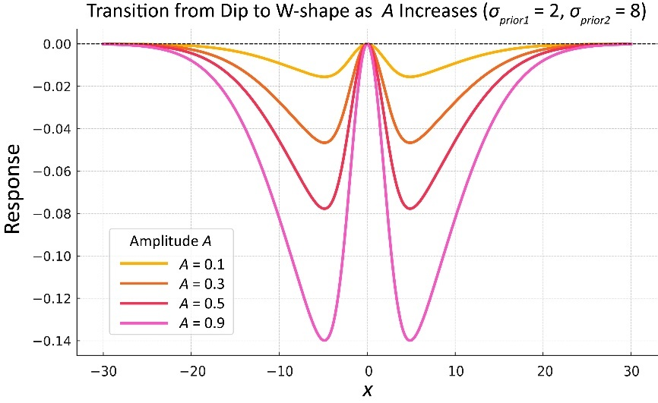
Figure S7. Illustration of suppression model (SM) transits from dip to W-shape as A increases, taking σ_{prior1} = 2 and σ_{prior2} = 8 as an example.

  - The effects of varying σ_{prior1}​ (Figure S8A) and σ_{prior2} (Figure S8B), respectively, on the shape and breadth of the suppression zone. Notably, increasing σ_{prior2}​ broadens the surround inhibition (Figure S8B), while increasing σ_{prior1}​ ​sharpens the center region (Figure S8A), potentially producing a W-shaped profile when the center becomes disinhibited. Note: the value at the center (x = 0) is always zero, due to the constraint B= ​A/σ_{prior1}​⋅σ_{prior2}.

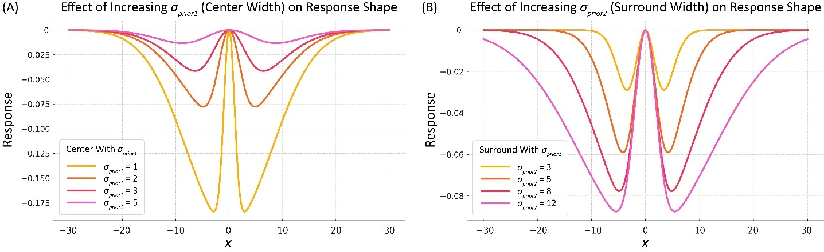
Figure S8. Illustration of suppression model (SM) changes with varied center width σ_{prior1} (A) and surround width σ_{prior2} (B).

  - Shown in Figure S9, the heatmap shows the W-shape strength (measured as the peak value of R′(x), i.e., max R’ – min R’) across combinations of center width σ_{prior1}​ and surround width σ_{prior2}. High W-shape scores (bright yellow) occur when σ_{prior1}​ is small (narrow center) and σ_{prior2} is moderately larger (broader surround). As σ_{prior2} increases too much or σ_{prior1}​​ becomes broader, the W effect diminishes—the function flattens and loses distinct flanking peaks. This confirms that the W-shape arises most strongly when σ_{prior1}​​ is small and σ_{prior2} is large — mimicking a narrow excitation center with broad surround inhibition.
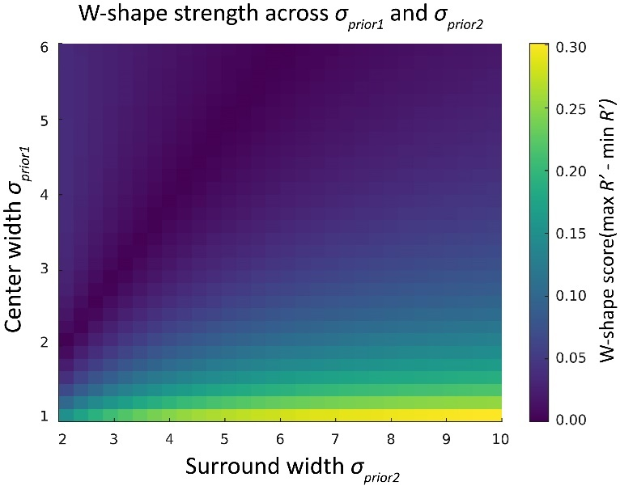
Figure S9. The W-shape strength (max R’ – min R’) of suppression model (SM) across the combinations of varied center width σ_{prior1}​ and surround width σ_{prior2}.

S6. Predicted Psychometric Curves Overlaid on Experimental Data
To visually illustrate how well the fitted models quantitatively predict the observed experimental data. The following Figures S10-13 illustrate the model-predicted neural tuning functions and the corresponding psychometric curve for Experiments 1a and 2a under the Activation Model (AM) and the Suppression Model (SM), using the averaged fitted parameters across participants. Given there were in total 8 levels of orientation difference, we take 4° and 10° as examples for small and larger differences, respectively. The four subplots (Figures S10-13 A-D) on the left show the simulated neural population responses under different conditions of stimulus configuration (bilateral vs. unilateral) and orientation difference (4° vs. 10°). Specifically, each plot displays the tuning functions for stimulus 1 (orange), stimulus 2 (light blue), and their respective post-prior shifts (solid lines), demonstrating how the activation profile changes under different input configurations. The subfigure Figures S10-13E overlays the model-predicted psychometric curve (solid lines) onto the group-averaged behavioral data (dots) for bilateral (red) and unilateral (blue) conditions. The close alignment between predicted curves and observed data supports the model’s validity in capturing the behavioral pattern across conditions.

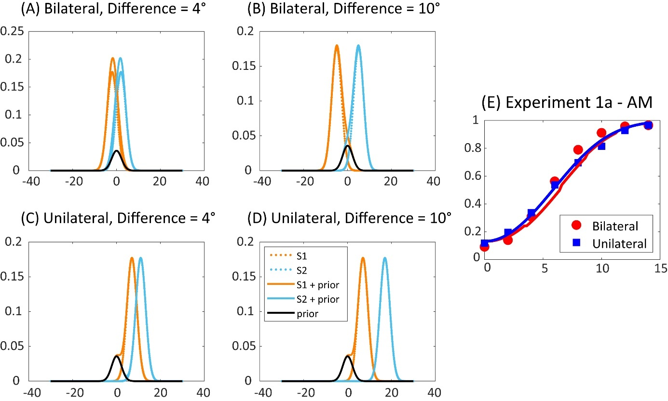
Figure S10. The model-predicted neural tuning functions and the corresponding psychometric curve for Experiment 1a under the Activation Model (AM). (A)-(D) show the simulated neural population responses under different conditions of stimulus configuration (bilateral vs. unilateral) and orientation difference (4° vs. 10°). (E) overlays the model-predicted psychometric curve (solid lines) onto the group-averaged behavioral data (dots) for bilateral (red) and unilateral (blue) conditions.

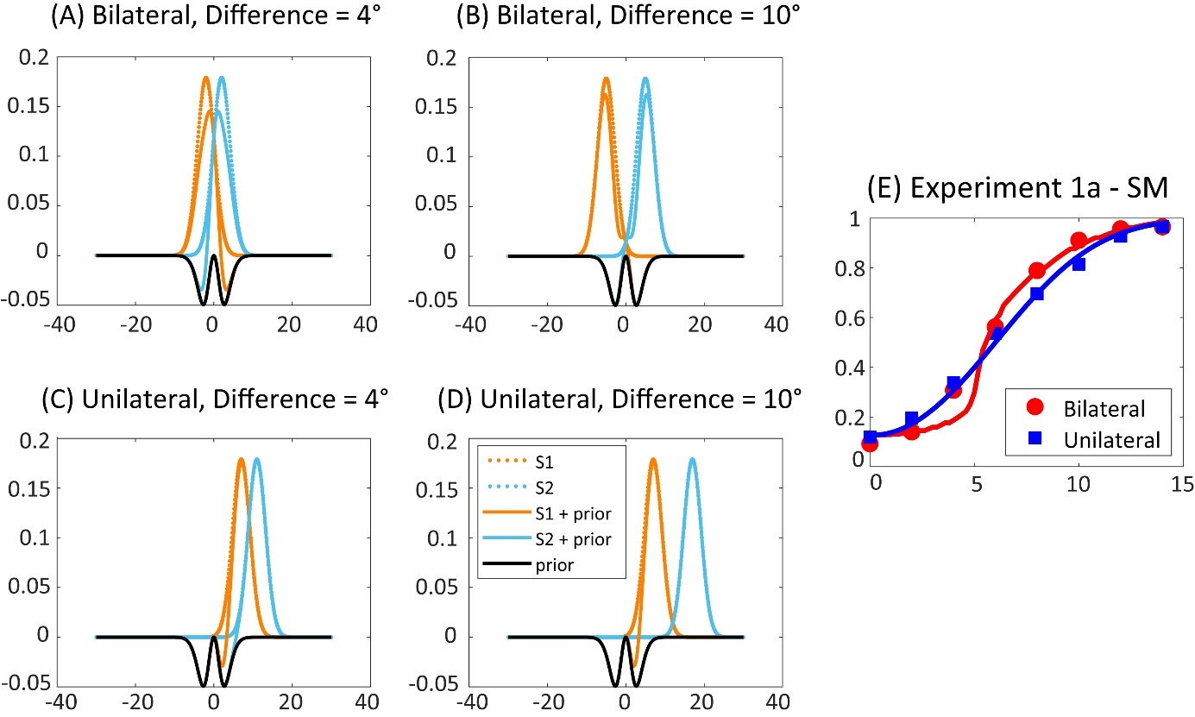
Figure S11. The model-predicted neural tuning functions and the corresponding psychometric curve for Experiment 1a under the Suppression Model (SM). (A)-(D) show the simulated neural population responses under different conditions of stimulus configuration (bilateral vs. unilateral) and orientation difference (4° vs. 10°). (E) overlays the model-predicted psychometric curve (solid lines) onto the group-averaged behavioral data (dots) for bilateral (red) and unilateral (blue) conditions.

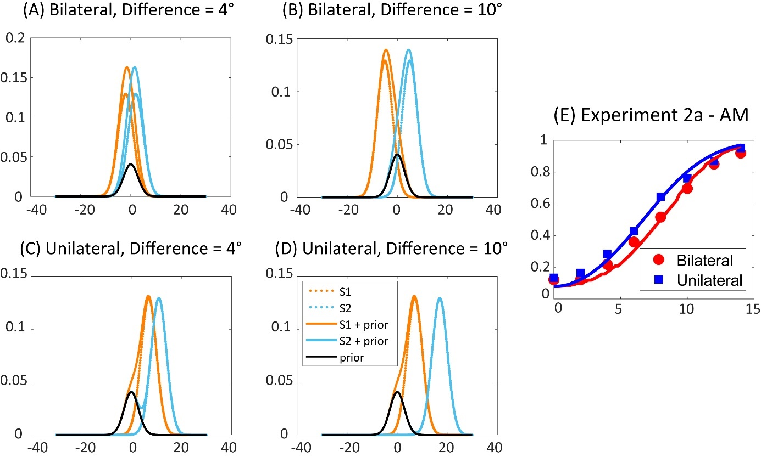
Figure S12. The model-predicted neural tuning functions and the corresponding psychometric curve for Experiment 2a under the Activation Model (AM). (A)-(D) show the simulated neural population responses under different conditions of stimulus configuration (bilateral vs. unilateral) and orientation difference (4° vs. 10°). (E) overlays the model-predicted psychometric curve (solid lines) onto the group-averaged behavioral data (dots) for bilateral (red) and unilateral (blue) conditions.

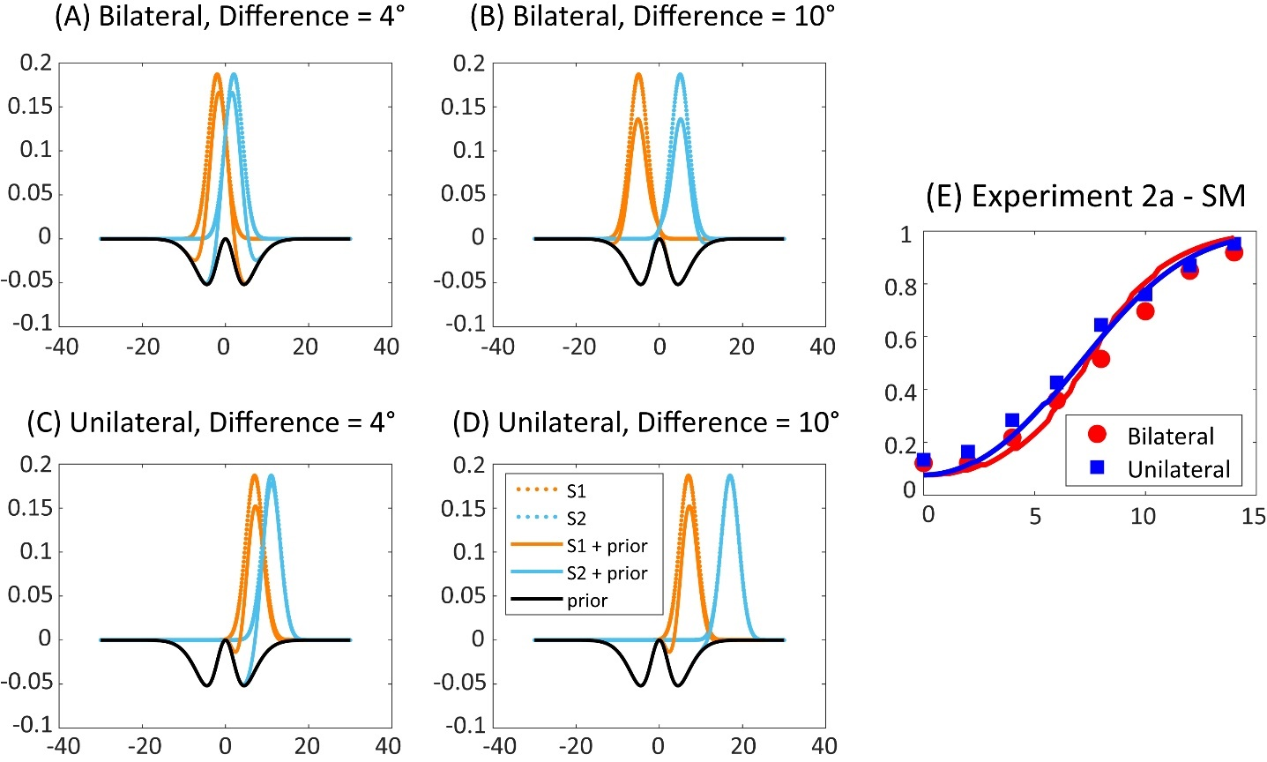
Figure S13. The model-predicted neural tuning functions and the corresponding psychometric curve for Experiment 2a under the Suppression Model (SM). (A)-(D) show the simulated neural population responses under different conditions of stimulus configuration (bilateral vs. unilateral) and orientation difference (4° vs. 10°). (E) overlays the model-predicted psychometric curve (solid lines) onto the group-averaged behavioral data (dots) for bilateral (red) and unilateral (blue) conditions.

