Table of Contents
Relevance of supplemental materials 1
Section 1. Descriptive statistics of adversity measures 1
Section 2. Additional information on cognitive tasks 1
Distributions of response times and error rates 1
Condition manipulation checks 1
Split-half reliability 1
Section 3. Drift Diffusion Modeling 1
Priors and model settings 1
Model convergence 1
Simulation-based model fit assessment 1
Distributions of DDM parameters 1
Section 4. Effects of environmental variables 1
Section 5. Indirect effects of confounders 1
References 1

Relevance of supplemental materials
This file contains the supplementary materials for the article entitled “Adversity is associated with lower general processing speed rather than specific executive functioning abilities”, which was submitted for consideration at Journal of Experimental Psychology: General. The supplemental materials include supporting information relating to more detailed descriptive statistics, model convergence and fit, and details on confounders.

Section 1. Descriptive statistics of adversity measures
Figures S1-S3 present histograms of each separate adversity measure, as well as the composite adversity measures used in the analyses. See the main text for more information on how the composites were calculated.

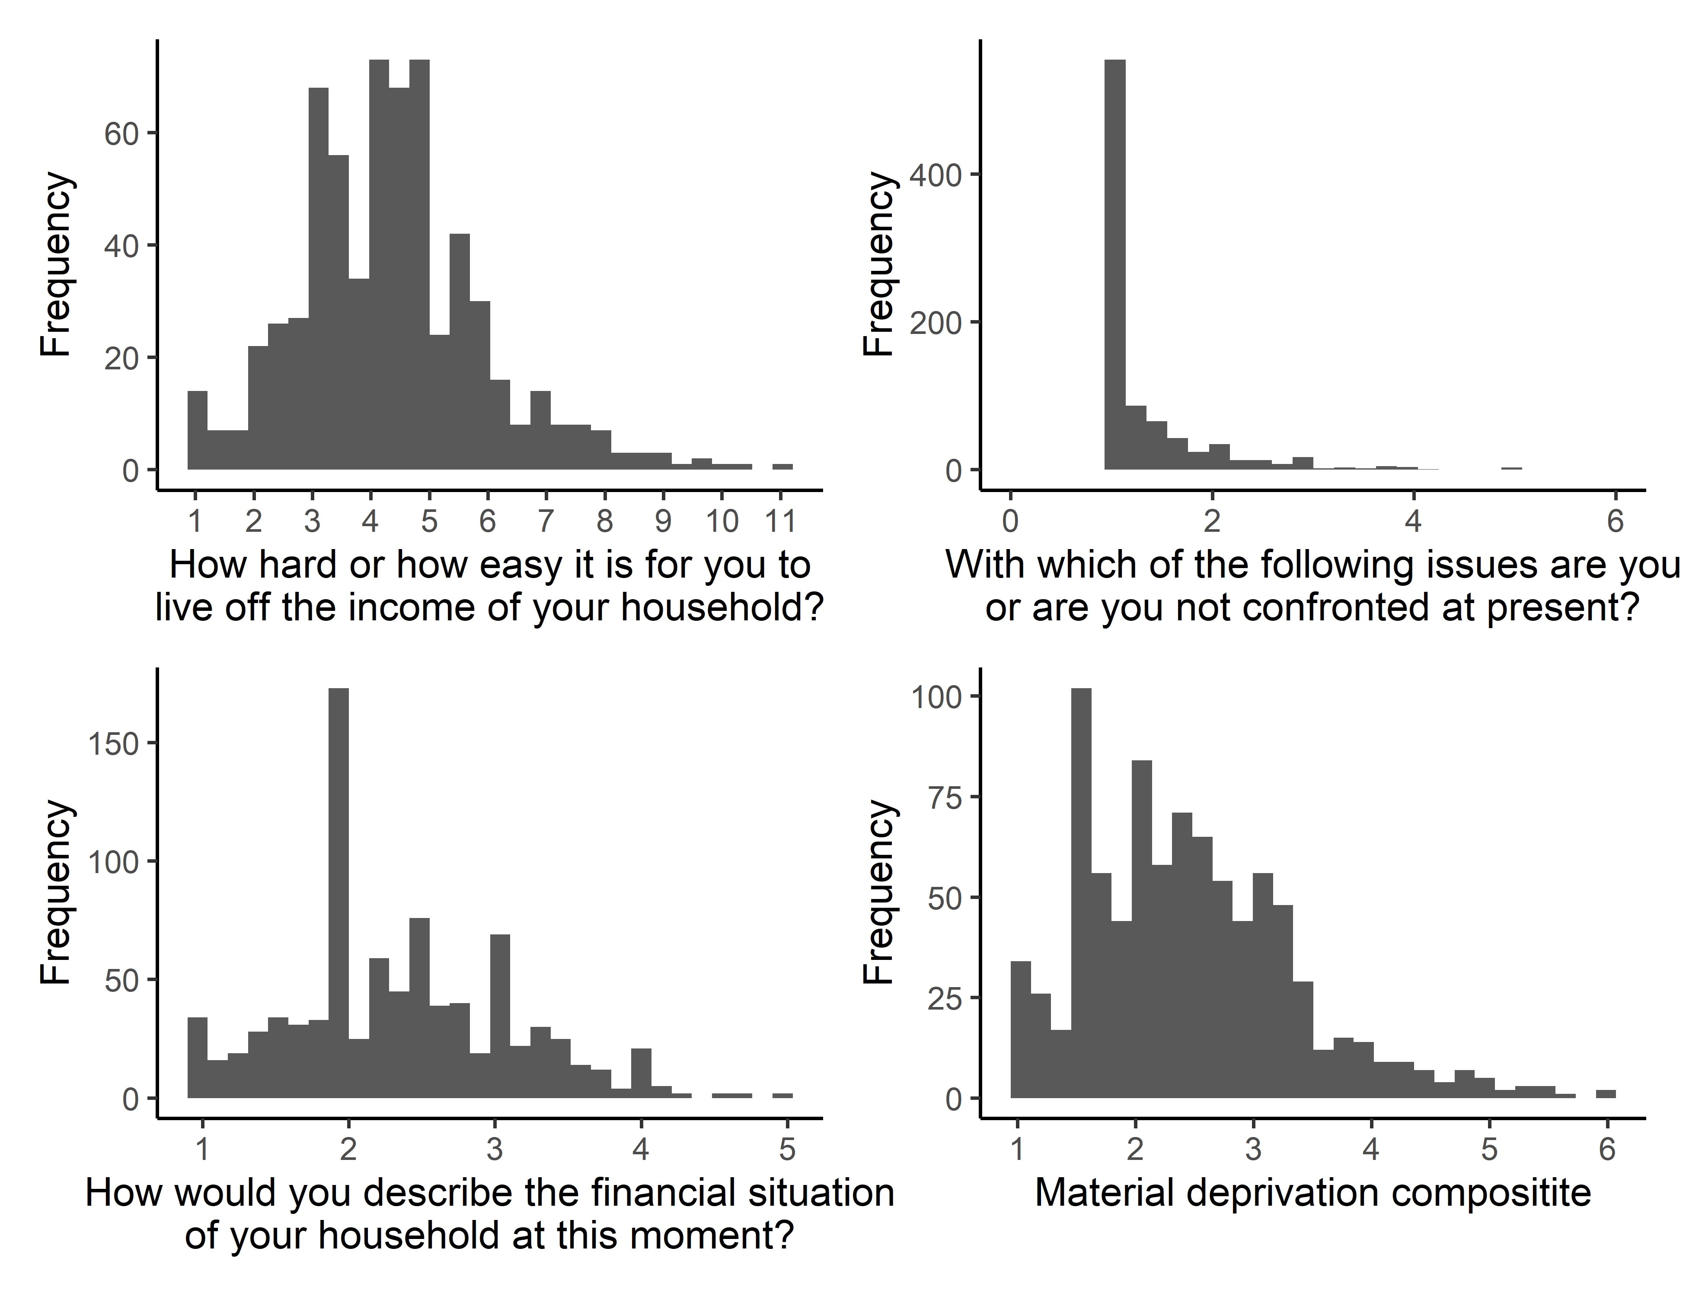
Figure S1. Histograms of material deprivation measures

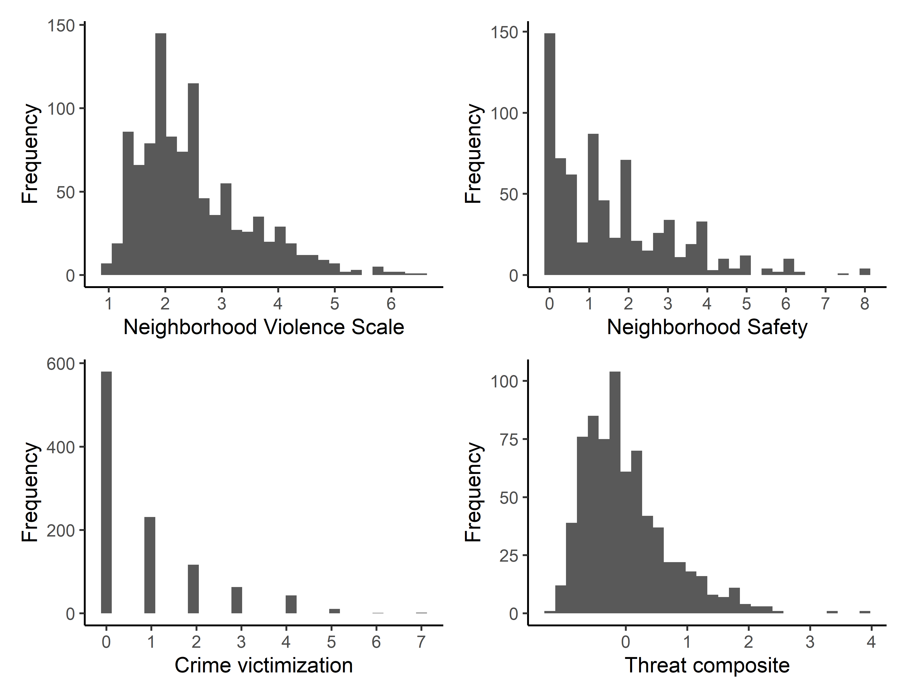
Figure S2. Histograms of threat measures

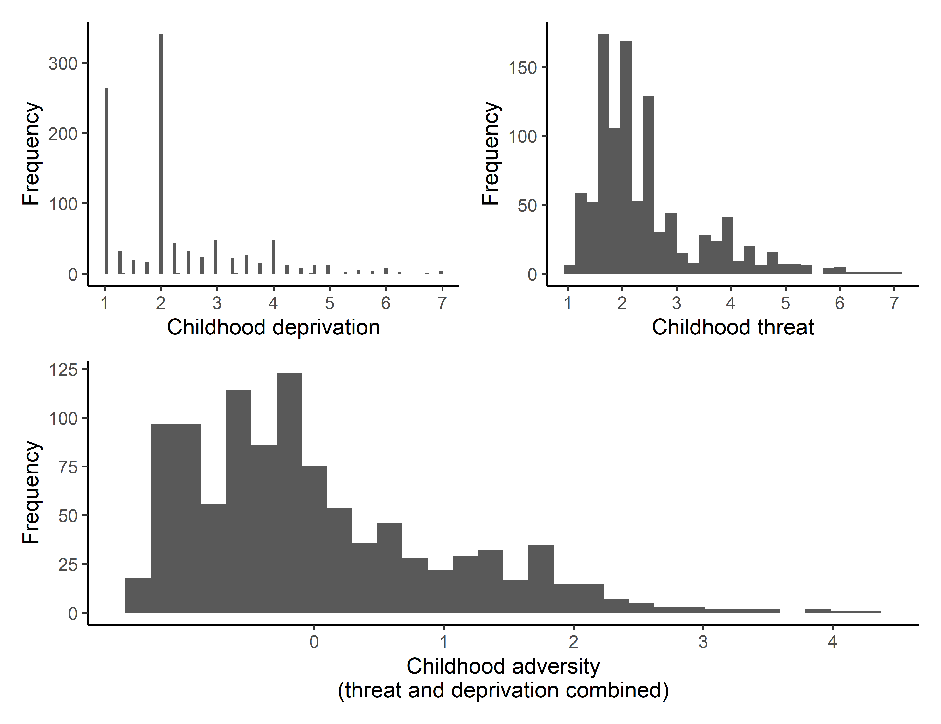
Figure S3. Histograms of threat measures

Section 2. Additional information on cognitive tasks

Distributions of response times and error rates
Figure S4 and S5 show the distributions of mean response times and mean error rate for each cognitive task.

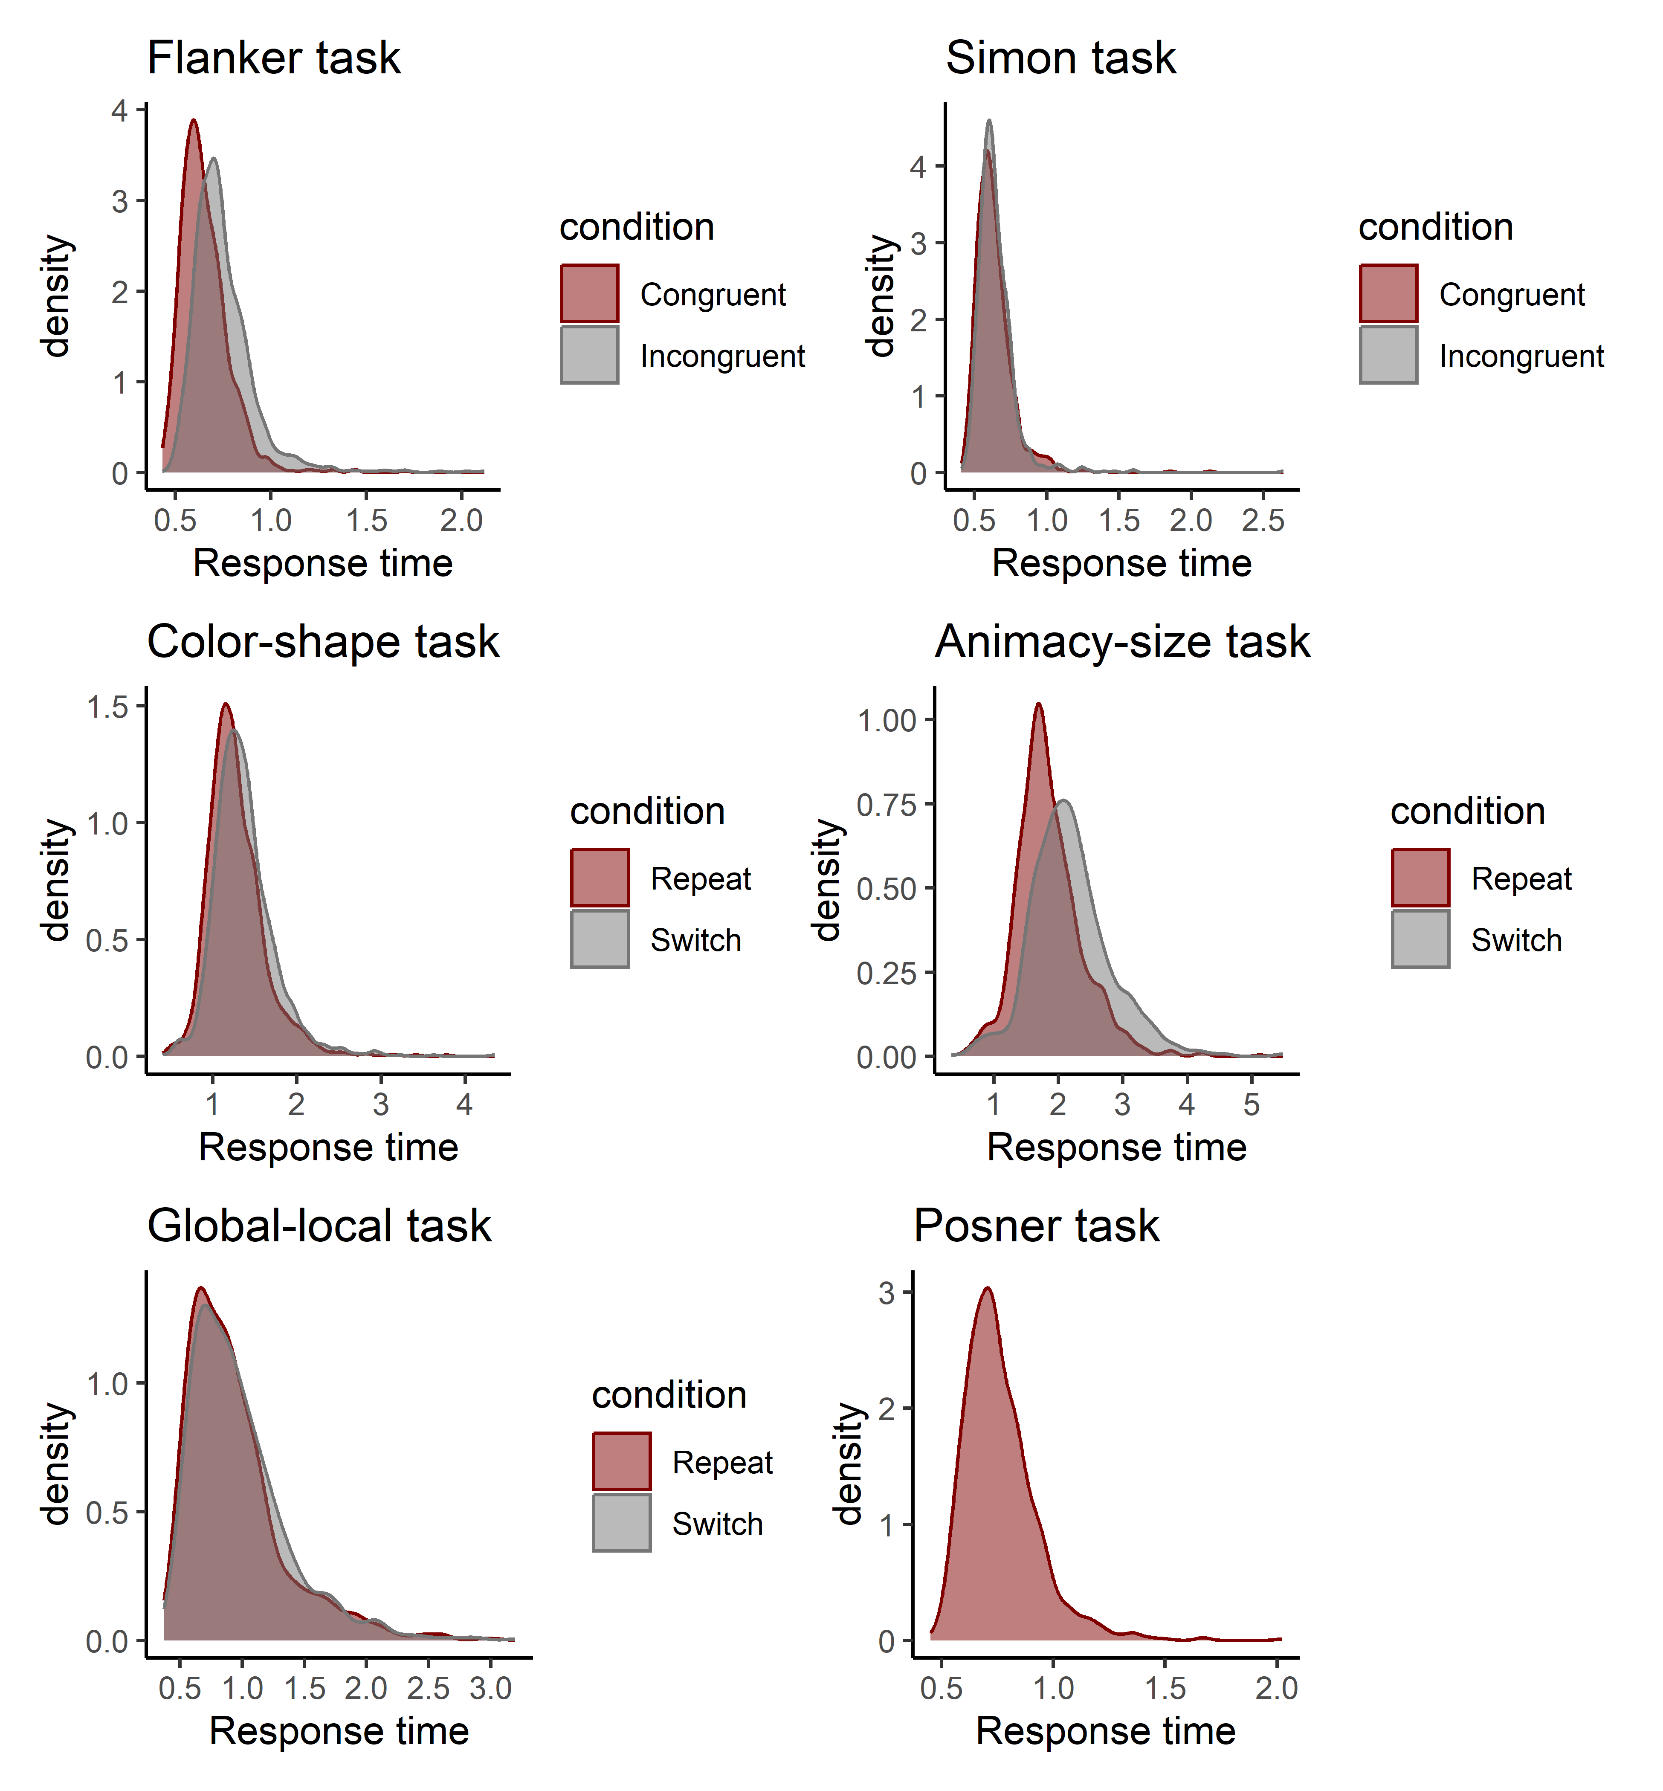
Figure S4. Distributions of response times for all tasks.

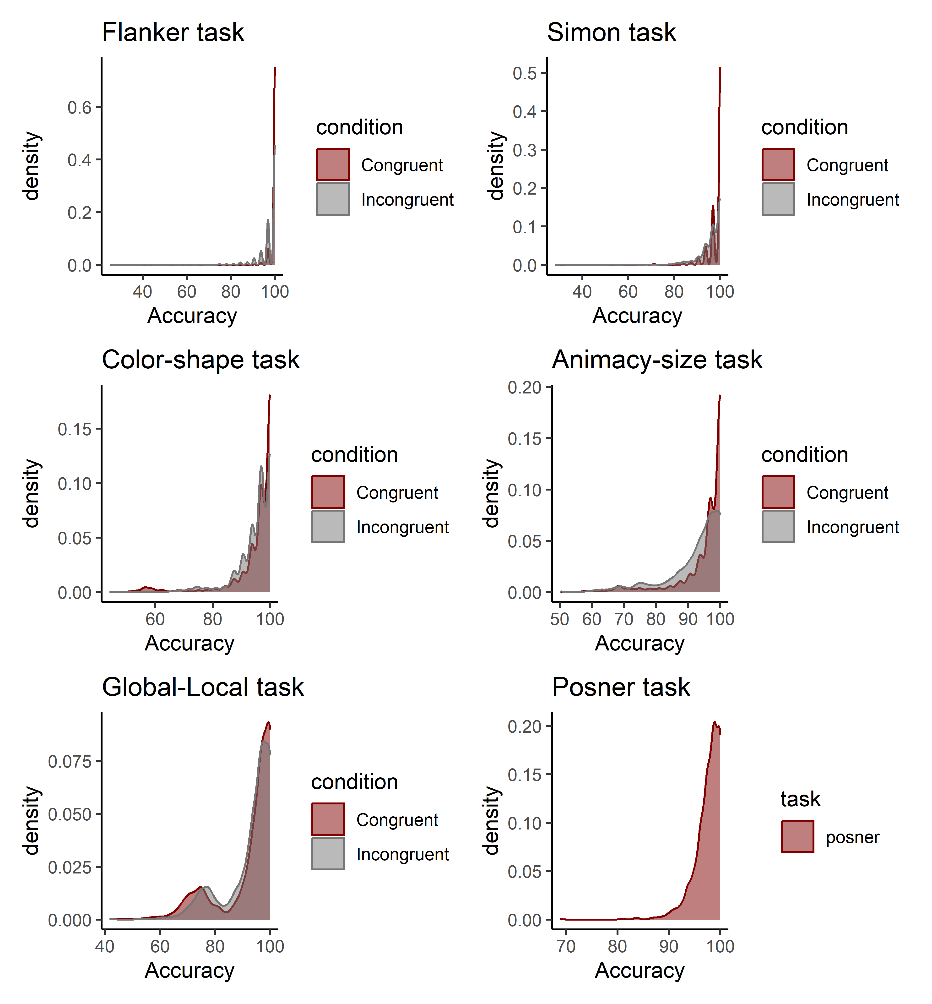
Figure S5. Distributions of error rates for all tasks.

Condition manipulation checks
Table S1 presents manipulation checks for response times for the inhibition and attention-shifting tasks. The manipulation checks were based on mean log-transformed response times using paired-sample t-tests. For each task, we tested whether there was a significant difference in mean log-transformed response time between the congruent (repeat) condition and the incongruent (switch) condition. All tasks showed a significant difference in the expected direction, with participants on average being faster on the congruent (repeat) condition compared to the incongruent (switch) condition (all ps < .001).

Table S1. Log-transformed response time differences across conditions for each task.
Task | Estimate | t | p
Flanker task | 0.14 | 51.96 | < .001
Simon task | 0.02 | 7.27 | < .001
Color-shape task | 0.07 | 19.58 | < .001
Global-local task | 0.04 | 8.86 | < .001
Animacy-size task | 0.16 | 40.65 | < .001

Split-half reliability
For each cognitive task, we calculated split-half reliabilities using the splithalf package (Parsons, 2021). We calculated split-half reliabilities for mean response times and error rates, separately for each condition (see Table S1). The split-half reliability of mean response times was high across all tasks and conditions. For error rates, the reliability estimates were generally lower, which is likely due to ceiling effects (see also Figure S5).

Table S2. Split-half reliabilities of mean response times for all cognitive tasks.
 | Split-half reliability |  |  | Spearman-Brown corrected
Task | Congruent/Repeat | Incongruent/Switch |  | Congruent/Repeat | Incongruent/Switch
Flanker task | 0.91 [0.86, 0.93] | 0.90 [0.87, 0.93] |  | 0.95 [0.93, 0.96] | 0.95 [0.93, 0.96]
Simon task | 0.88 [0.83, 0.92] | 0.89 [0.83, 0.92] |  | 0.94 [0.91, 0.96] | 0.94 [0.90, 0.96]
Color-shape task | 0.83 [0.81, 0.85] | 0.86 [0.84, 0.87] |  | 0.91 [0.89, 0.92] | 0.92 [0.91, 0.93]
Animacy-size task | 0.82 [0.79, 0.84] | 0.86 [0.85, 0.88] |  | 0.90 [0.89, 0.91] | 0.93 [0.92, 0.93]
Global-local task | 0.82 [0.79, 0.85] | 0.82 [0.78, 0.86] |  | 0.90 [0.88, 0.92] | 0.90 [0.88, 0.92]
Posner task | 0.95 [0.94, 0.95] |  |  | 0.97 [0.97, 0.98]

Table S3. Split-half reliabilities of error rates for all cognitive tasks.
 | Split-half reliability |  |  | Spearman-Brown corrected
Task | Congruent/Repeat | Incongruent/Switch |  | Congruent/Repeat | Incongruent/Switch
Flanker task | 0.57 [0.40, 0.65] | 0.64 [0.60, 0.69] |  | 0.72 [0.58, 0.79] | 0.78 [0.75, 0.81]
Simon task | 0.52 [0.46, 0.57] | 0.48 [0.44, 0.53] |  | 0.68 [0.63, 0.72] | 0.65 [0.61, 0.69]
Color-shape task | 0.74 [0.70, 0.77] | 0.46 [0.41, 0.50] |  | 0.85 [0.82, 0.87] | 0.63 [0.58, 0.67]
Animacy-size task | 0.67 [0.62, 0.71] | 0.59 [0.55, 0.63] |  | 0.80 [0.77, 0.83] | 0.74 [0.71, 0.77]
Global-local task | 0.67 [0.63, 0.71] | 0.58 [0.54, 0.62] |  | 0.80 [0.77, 0.83] | 0.73 [0.70, 0.77]
Posner task | 0.42 [0.37, 0.46] |  |  | 0.59 [0.54, 0.63]

Section 3. Drift Diffusion Modeling

Priors and model settings
We drew individual-level DDM parameters from normal distributions, separately for each condition (except for the Posner task, which only contained one condition). The normal distributions were truncated based on reasonable parameter ranges (between -10 and 10 for drift rates, between 0.1 and 5 for boundary separation, and between 0.0001 and 1 for non-decision time). The normal distributions were given uninformative priors.

Model convergence
Figures S6-S11 present the convergence of MCMC chains of the Hierarchical Drift Diffusion Models for all tasks. The figures should resemble a “fat, hairy caterpillar”, which was the case for all tasks.

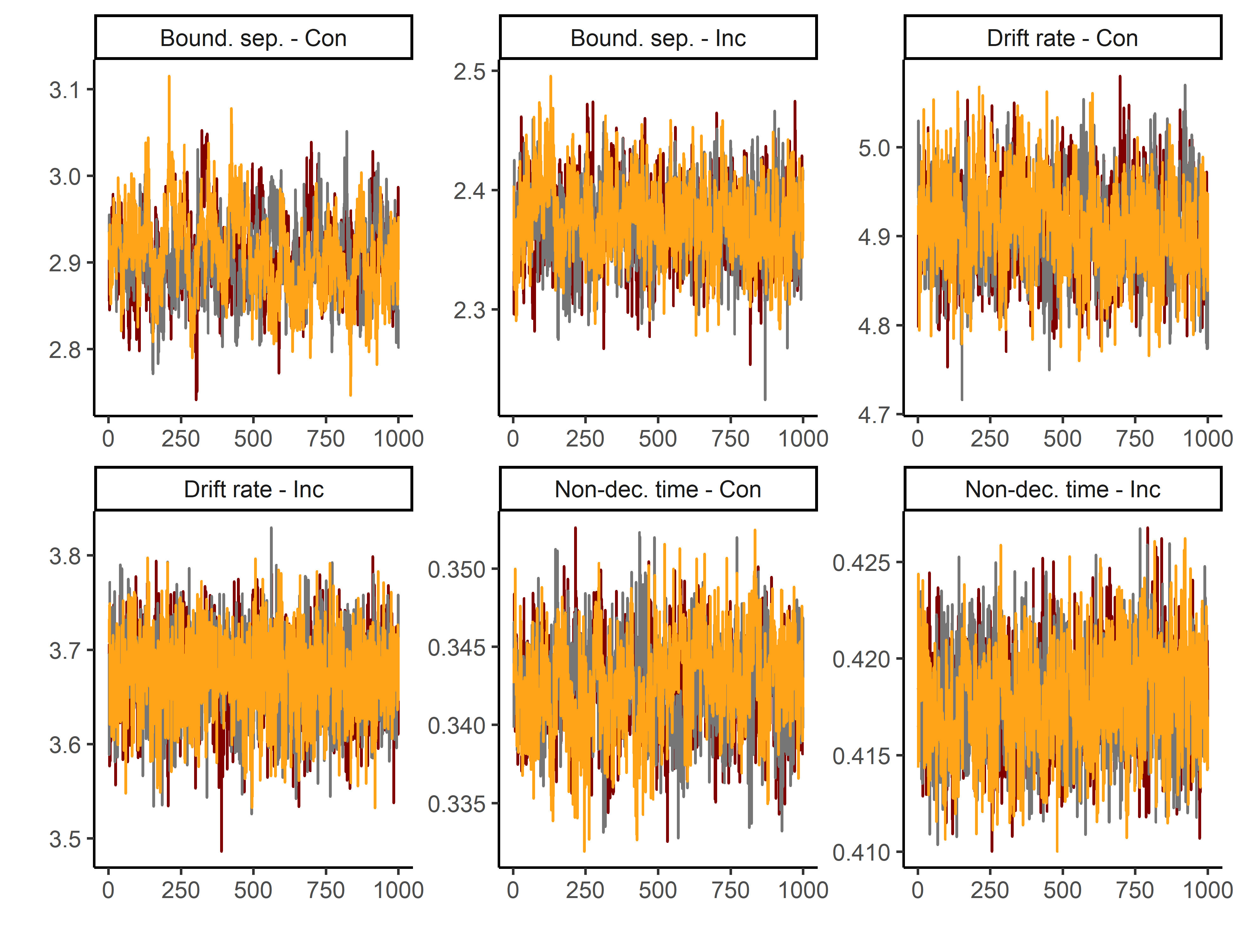
Figure S6. Trace convergence across three chains for the Flanker Task.

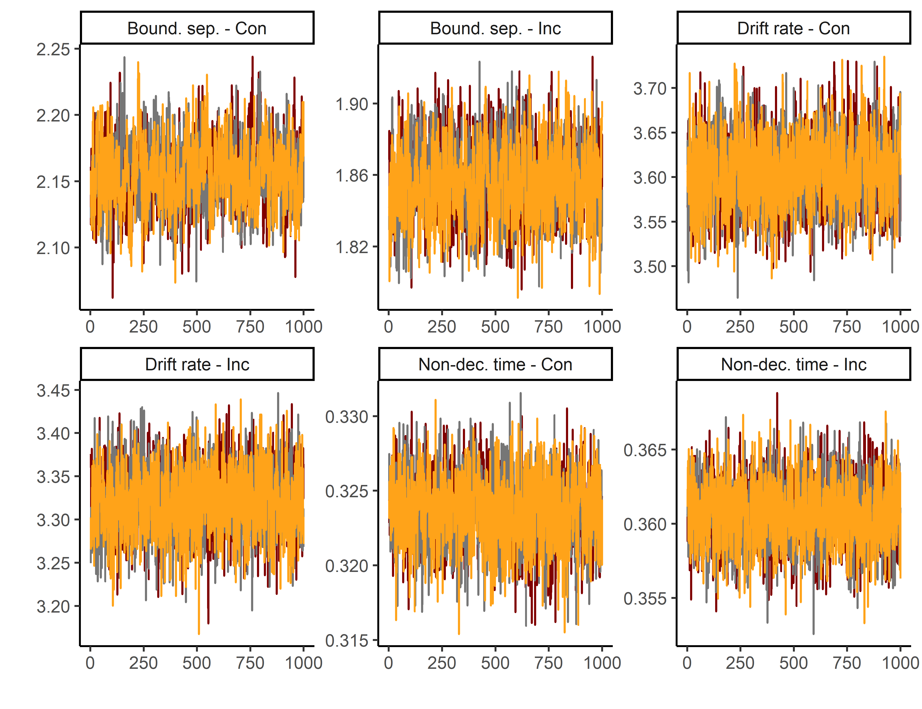
Figure S7. Trace convergence across three chains for the Simon Task.

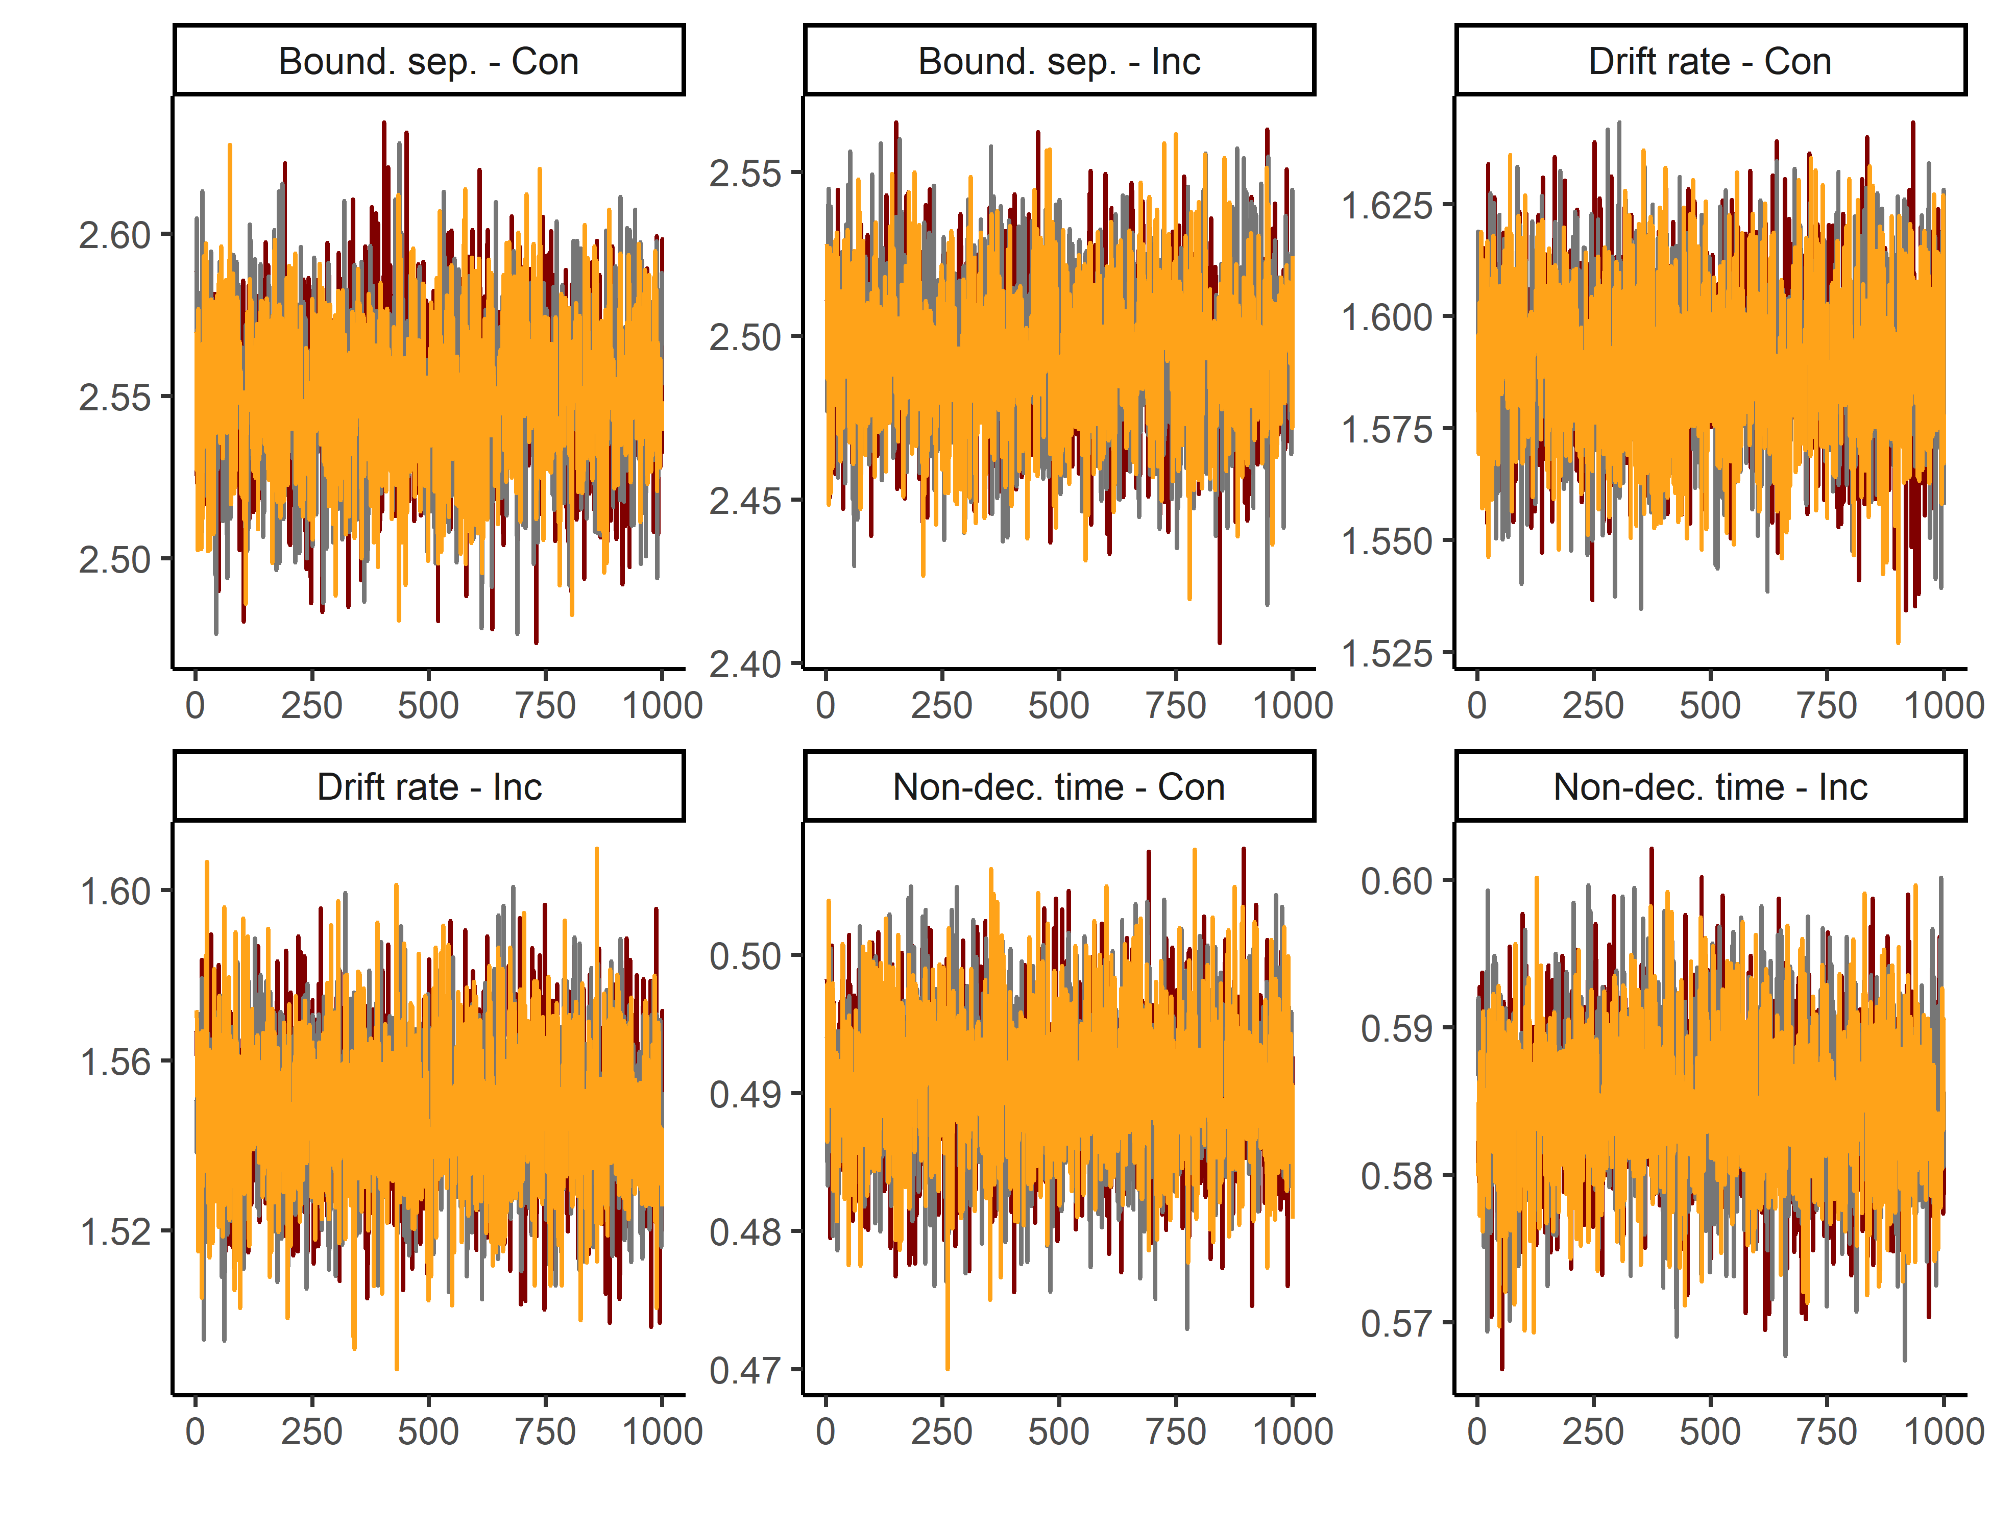
Figure S8. Trace convergence across three chains for the Color-shape Task.

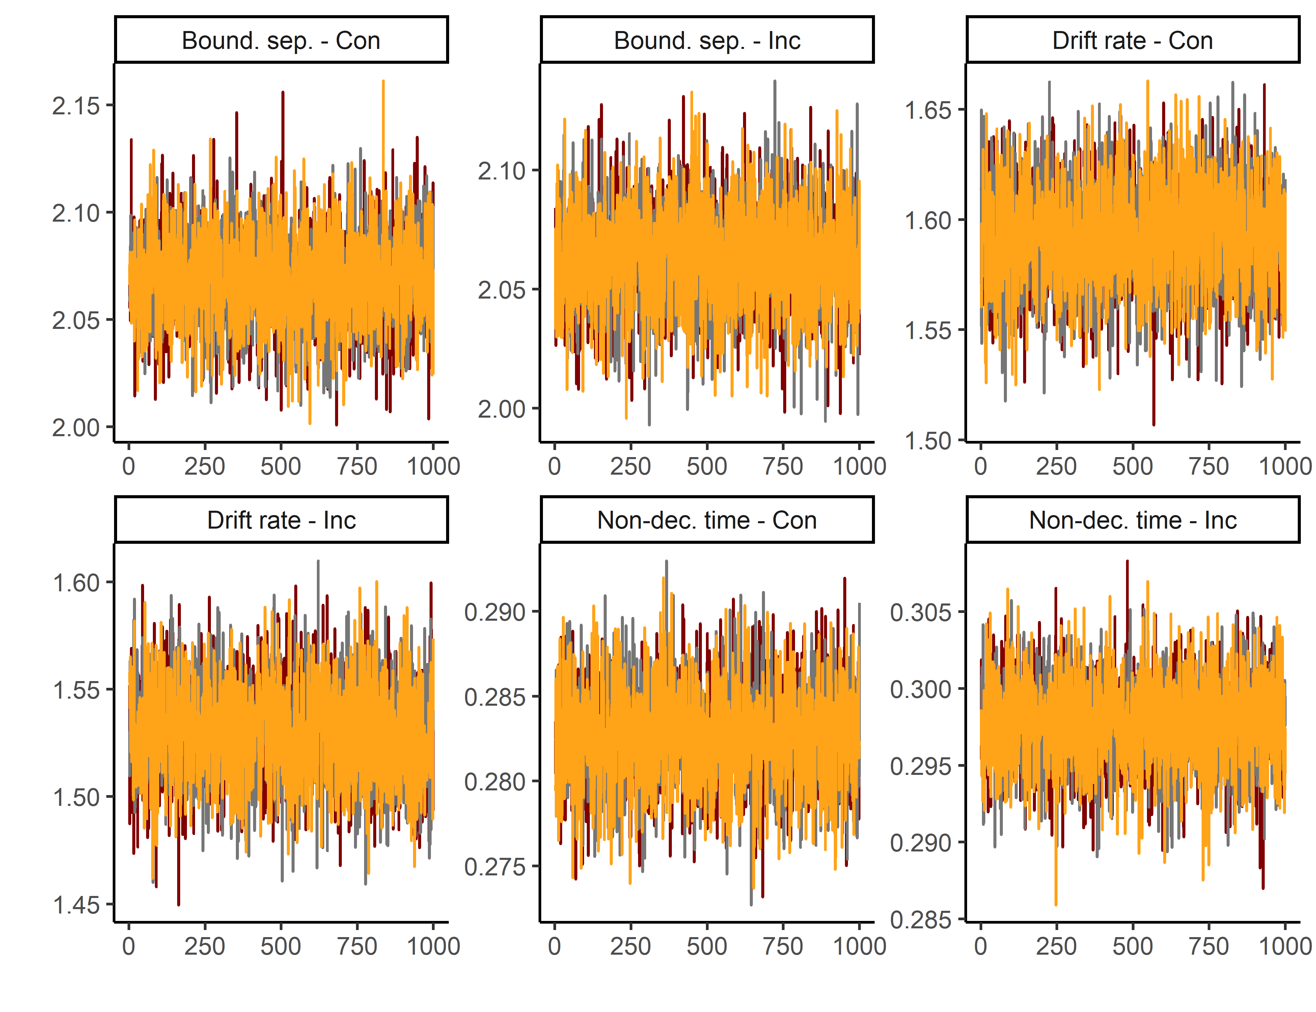
Figure S9. Trace convergence across three chains for the Global-local Task.

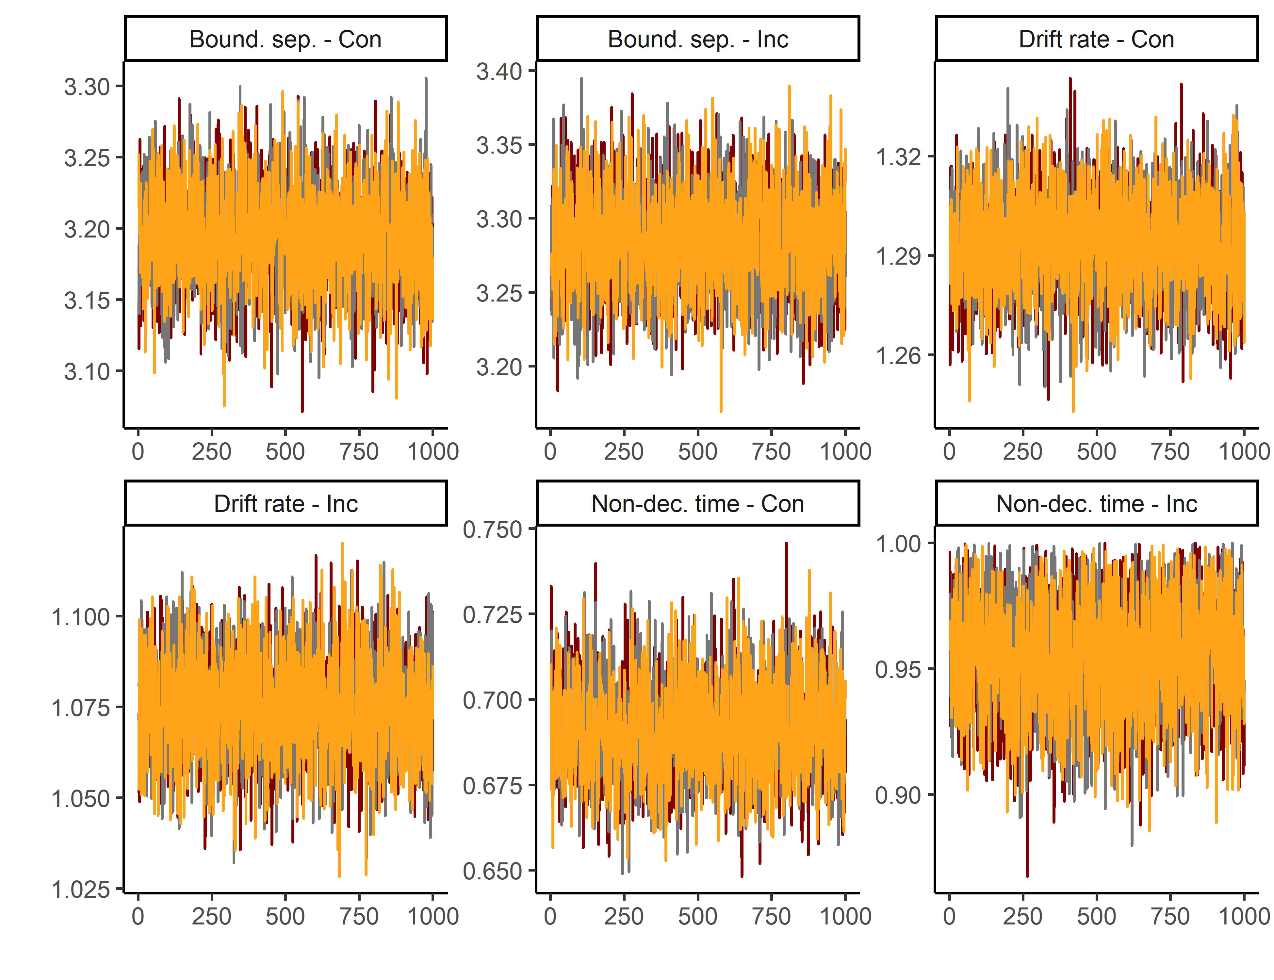
Figure S10. Trace convergence across three chains for the Animacy-size Task.

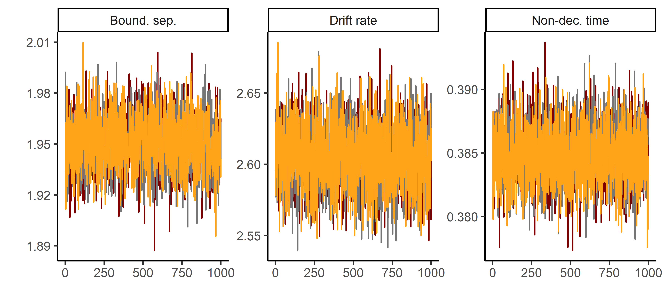
Figure S11. Trace convergence across three chains for the Posner Task.

In addition, we calculated the R^ statistic (also known as the Gelman-Rubin statistic) (Gelman & Rubin, 1992). The R^ calculates the ratio between the variation between MCMC chains and the variation within MCMC chains. A general guideline is that R^ values should be smaller than 1.1. All R^ values are presented in Table S4 below.

Simulation-based model fit assessment
Table S4 presents simulation-based model fit assessments for all tasks. The simulation procedure was as follows. First, we used the DDM parameter estimates for each participant and used them to simulate response times and accuracy data (100 trials per participant). Then, we computed correlations between the simulated and observed response times and accuracies. In the case of response times, we did so separately at the 25th, 50th, and 75th percentile. In the case of accuracy, we looked at mean accuracy. All correlations were > .89, indicating good model fit.

Table S4. Model fit assessment
Task | Condition | RT - 25th Percentile | RT - 50th Percentile | RT - 75th Percentile | Accuracy | R^
Flanker task | Congruent | 0.98 | 0.98 | 0.97 | 0.89 | 1.011
Flanker task | Incongruent | 0.97 | 0.97 | 0.98 | 0.94 | 1.011
Simon task | Congruent | 0.97 | 0.97 | 0.97 | 0.91 | 1.003
Simon task | Incongruent | 0.95 | 0.97 | 0.97 | 0.92 | 1.003
Color-shape task | Repeat | 0.97 | 0.96 | 0.97 | 0.98 | 1.006
Color-shape task | Switch | 0.96 | 0.97 | 0.97 | 0.95 | 1.006
Animacy-size task | Repeat | 0.96 | 0.96 | 0.96 | 0.98 | 1.002
Animacy-size task | Switch | 0.95 | 0.96 | 0.96 | 0.97 | 1.002
Global-local task | Repeat | 0.95 | 0.96 | 0.96 | 0.98 | 1.001
Global-local task | Switch | 0.95 | 0.96 | 0.96 | 0.97 | 1.001
Posner task |  | 0.97 | 0.98 | 0.98 | 0.89 | 1.002
Note: Simulation-based model fit assessment compared observed and predicted data using 100 simulated trials (accuracy, 25th, 50th, 75th percentile). In addition, We calculated R^ values, which should be below 1.1 to indicate adequate chain convergence.

Distributions of DDM parameters
Figures S12-S14 present histograms of individual estimates of the three DDM parameters. With a few exceptions (particularly in non-decision times), the DDM parameters were (approximately) normally distributed.
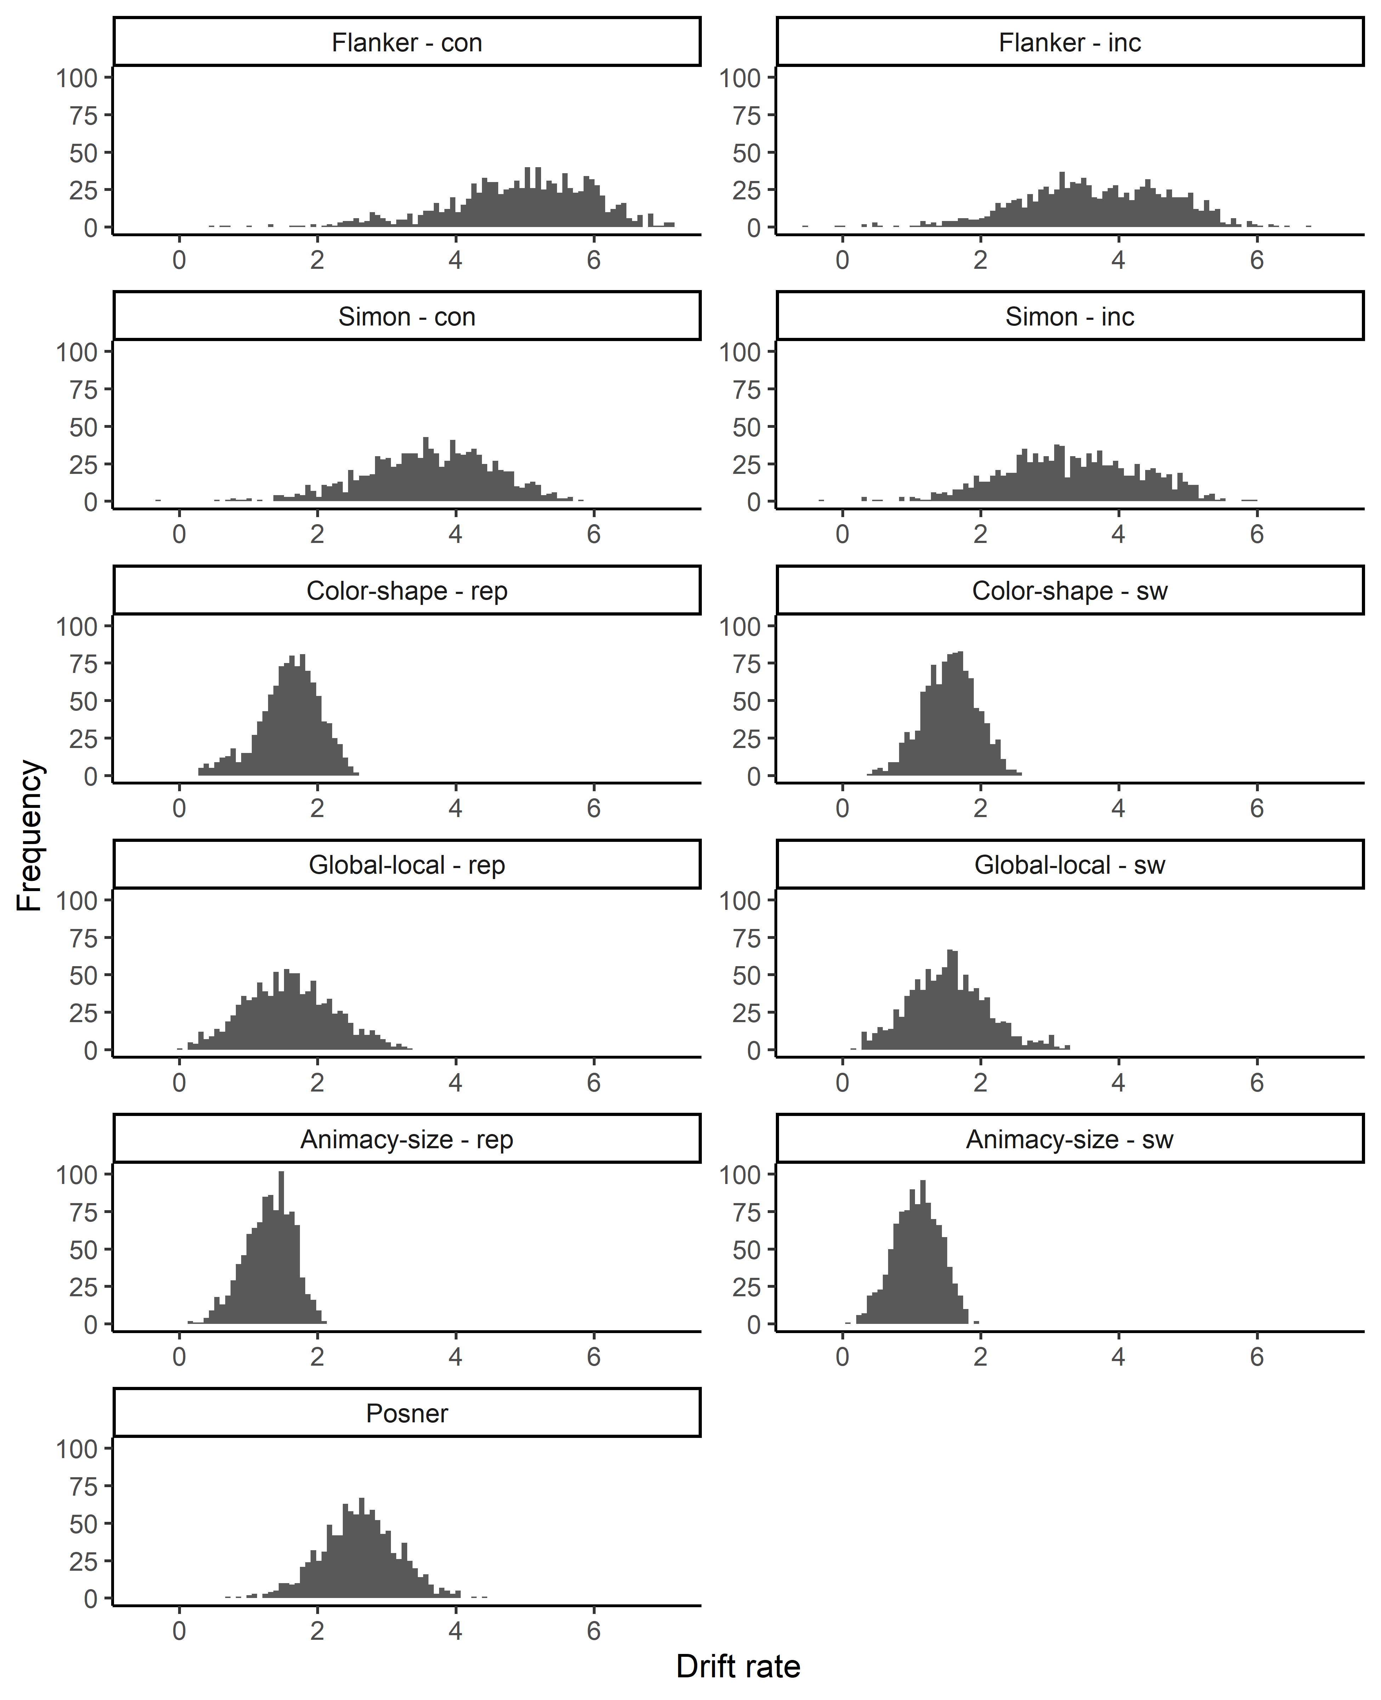
Figure S12. Distribution of drift rates.

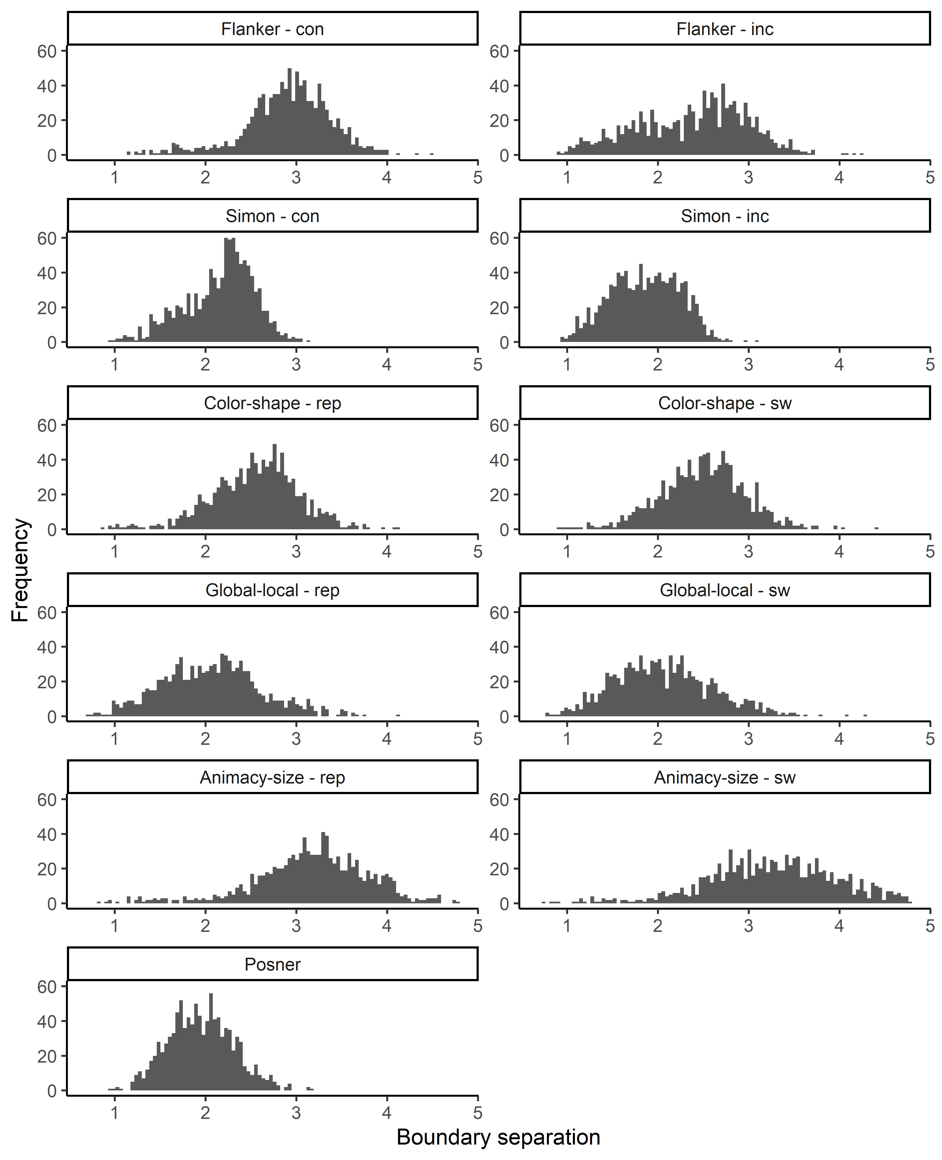
Figure S12. Distribution of boundary separations.

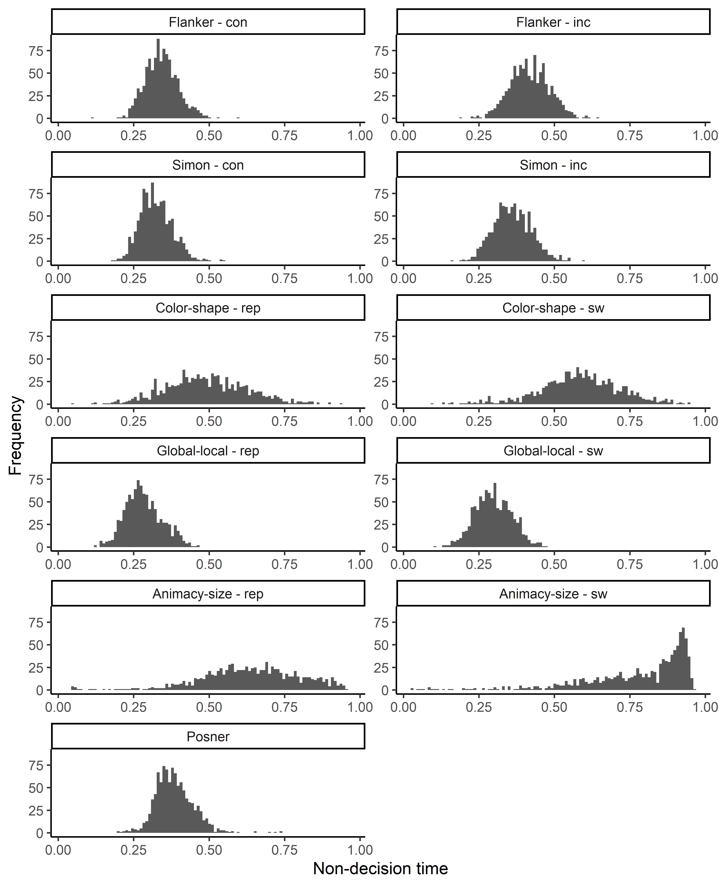
Figure S14. Distribution of non-decision times.

Section 4. Effects of environmental variables

Table S5 presents effects of environmental noise and mean-centered state anxiety on Drift Diffusion parameters. Effects of environmental noise were mostly small non-significant. Mean-centered differences in state anxiety were negatively associated with drift rates across all tasks. In sessions where participants were more anxious than average, their drift rates across all tasks were lower.

Table S5. Effects of noise and anxiety on Drift Diffusion parameters.
 | Intercept |  |  | Noise |  |  | Anxiety
Task | Estimate | p |  | Estimate | p |  | Estimate | p
Animacy-Size (Rep.) - Bound. sep. | 3.23 (0.04) | < .001 |  | -0.03 (0.02) | .093 |  | 0.01 (0.02) | .610
Animacy-Size (Sw.) - Bound. sep. | 3.33 (0.05) | < .001 |  | -0.04 (0.02) | .080 |  | -0.01 (0.02) | .558
Animacy-Size (Rep.) - Drift rate | 1.34 (0.02) | < .001 |  | -0.02 (0.01) | .062 |  | -0.04 (0.01) | < .001
Animacy-Size (Sw.) - Drift rate | 1.11 (0.02) | < .001 |  | -0.02 (0.01) | .155 |  | -0.04 (0.01) | < .001
Animacy-Size (Rep.) - Non-dec. time | 0.67 (0.01) | < .001 |  | -0.02 (0.01) | .001 |  | -0.01 (0.00) | .267
Animacy-Size (Sw.) - Non-dec. time | 0.80 (0.01) | < .001 |  | -0.01 (0.01) | .011 |  | -0.00 (0.01) | .701
Color-Shape (Rep.) - Bound. sep. | 2.57 (0.03) | < .001 |  | -0.01 (0.02) | .578 |  | -0.01 (0.02) | .675
Color-Shape (Sw.) - Bound. sep. | 2.53 (0.03) | < .001 |  | -0.02 (0.02) | .256 |  | -0.00 (0.02) | .839
Color-Shape (Rep.) - Drift rate | 1.65 (0.03) | < .001 |  | -0.03 (0.01) | .034 |  | -0.06 (0.01) | < .001
Color-Shape (Sw.) - Drift rate | 1.59 (0.03) | < .001 |  | -0.02 (0.01) | .153 |  | -0.06 (0.01) | < .001
Color-Shape (Rep.) - Non-dec. time | 0.50 (0.01) | < .001 |  | -0.01 (0.00) | .129 |  | -0.00 (0.00) | .419
Color-Shape (Sw.) - Non-dec. time | 0.59 (0.01) | < .001 |  | -0.00 (0.00) | .387 |  | -0.01 (0.00) | .143
Flanker (Con.) - Bound. sep. | 2.90 (0.03) | < .001 |  | -0.00 (0.02) | .797 |  | -0.01 (0.02) | .380
Flanker (Inc.) - Bound. sep. | 2.42 (0.04) | < .001 |  | -0.03 (0.02) | .121 |  | -0.04 (0.02) | .045
Flanker (Con.) - Drift rate | 4.92 (0.07) | < .001 |  | -0.03 (0.03) | .360 |  | -0.13 (0.03) | < .001
Flanker (Inc.) - Drift rate | 3.77 (0.07) | < .001 |  | -0.08 (0.03) | .029 |  | -0.14 (0.03) | < .001
Flanker (Con.) - Non-dec. time | 0.34 (0.00) | < .001 |  | -0.00 (0.00) | .855 |  | -0.00 (0.00) | .092
Flanker (Inc.) - Non-dec. time | 0.42 (0.00) | < .001 |  | -0.00 (0.00) | .898 |  | 0.00 (0.00) | .767
Global-Local (Rep.) - Bound. sep. | 2.06 (0.04) | < .001 |  | 0.00 (0.02) | .919 |  | 0.03 (0.02) | .093
Global-Local (Sw.) - Bound. sep. | 2.04 (0.04) | < .001 |  | 0.01 (0.02) | .702 |  | 0.03 (0.02) | .030
Global-Local (Rep.) - Drift rate | 1.71 (0.04) | < .001 |  | -0.05 (0.02) | .009 |  | -0.10 (0.02) | < .001
Global-Local (Sw.) - Drift rate | 1.64 (0.04) | < .001 |  | -0.05 (0.02) | .009 |  | -0.10 (0.02) | < .001
Global-Local (Rep.) - Non-dec. time | 0.29 (0.00) | < .001 |  | -0.00 (0.00) | .255 |  | 0.00 (0.00) | .583
Global-Local (Sw.) - Non-dec. time | 0.30 (0.00) | < .001 |  | -0.00 (0.00) | .149 |  | 0.00 (0.00) | .418
Posner - Bound. sep. | 1.98 (0.02) | < .001 |  | -0.01 (0.01) | .215 |  | -0.02 (0.01) | .126
Posner - Drift rate | 2.68 (0.04) | < .001 |  | -0.04 (0.02) | .022 |  | -0.04 (0.02) | .042
Posner - Non-dec. time | 0.38 (0.00) | < .001 |  | 0.00 (0.00) | .703 |  | 0.00 (0.00) | .550
Simon (Con.) - Bound. sep. | 2.15 (0.03) | < .001 |  | 0.00 (0.01) | .806 |  | -0.04 (0.01) | .009
Simon (Inc.) - Bound. sep. | 1.88 (0.03) | < .001 |  | -0.01 (0.01) | .232 |  | -0.04 (0.01) | .005
Simon (Con.) - Drift rate | 3.66 (0.06) | < .001 |  | -0.04 (0.03) | .204 |  | -0.16 (0.03) | < .001
Simon (Inc.) - Drift rate | 3.42 (0.07) | < .001 |  | -0.06 (0.03) | .061 |  | -0.19 (0.04) | < .001
Simon (Con.) - Non-dec. time | 0.33 (0.00) | < .001 |  | -0.00 (0.00) | .087 |  | -0.00 (0.00) | .101
Simon (Inc.) - Non-dec. time | 0.36 (0.00) | < .001 |  | -0.00 (0.00) | .986 |  | -0.00 (0.00) | .044
Note: State anxiety was mean-centered relative to the overall mean across test sessions. Bound. sep. = boundary separation, Con. = congruent condition, Inc. = incongruent condition, Non-dec. time = non-decision time, Rep. = repeat condition, Sw. = switch condition,

Table S6 presents Spearman correlations between preregistered and non-preregistered adversity measures with environmental noise and mean state anxiety. Note that S6 includes mean state anxiety, whereas the analyses (and Table S5) include the difference from the grand mean in specific testing sessions.

Table S6. Bivarate correlations between adversity measures, environmental noise, and mean state anxiety.
Variable | 1 | 2 | 3 | 4 | 5 | 6
1. Deprivation in adulthood | -
2. Threat in aduldhood | 0.27 | -
3. Childhood threat | 0.19 | 0.23 | -
4. Childhood deprivation | 0.08 | 0.32 | 0.48 | -
5. Environmental noise | 0.05 | 0.17 | 0.07 | 0.14 | -
6. State anxiety | 0.09 | 0.21 | 0.14 | 0.13 | 0.08 | -

Section 5. Indirect effects of confounders
Table S7 summarizes the indirect effects of confounders in the confirmatory models: age, education, sex, childhood adversity, and, in the case of threat as dependent variable, material deprivation. As explained in the section on confounders in the main article, we assume that these confounders are common causes of both adversity exposure in adulthood (the independent variable) and cognitive processes (the dependent variable). This means that the regression coefficients in Table S7 and S8 should not be interpreted as direct effects; rather, they should be interpreted as indirect effects (i.e., the effect at mean levels of adversity exposure).
For both threat and deprivation in adulthood, we found a negative indirect effect of age on task-general drift rate, a positive indirect effect of age on task-general boundary separation, and a positive indirect of age on task-general non-decision time. Thus, older adults with average levels of adversity exposure in adulthood processed information more slowly across tasks, were generally more cautious, and were generally slower at encoding stimuli and/or executing responses. In addition, childhood adversity had a negative indirect effect on task-general drift rate. People with more exposure to childhood adversity, at average levels of adversity exposure in adulthood, processed information more slowly across tasks. Finally, we found a negative indirect effect of education on task-general drift rate, but not on task-general boundary separation or non-decision time. People with a higher completed education, at average levels of adversity exposure in adulthood, processed information faster across tasks. None of the other indirect effects were significant.

Table S7. Standardized indirect effects of confounders in the confirmatory models.
 | Threat in adulthood |  |  |  |  | Deprivation in adulthood
Confounder | β | SE | 95% CI | p |  | β | SE | 95% CI | p
Task-general drift rate
Material deprivation | -0.06 | 0.05 | [-0.16, 0.04] | .241
Age | -0.12 | 0.04 | [-0.21, -0.04] | .003 |  | -0.10 | 0.03 | [-0.16, -0.03] | .003
Sex | 0.04 | 0.03 | [-0.01, 0.09] | .130 |  | 0.01 | 0.02 | [-0.03, 0.05] | .623
Childhood adversity | -0.19 | 0.04 | [-0.27, -0.10] | < .001 |  | -0.23 | 0.04 | [-0.31, -0.16] | < .001
Education |  |  |  |  |  | 0.14 | 0.04 | [0.07, 0.21] | < .001
Task-general boundary separation
Material deprivation | 0.07 | 0.04 | [-0.02, 0.15] | .137
Age | 0.37 | 0.04 | [0.29, 0.45] | < .001 |  | 0.42 | 0.03 | [0.36, 0.48] | < .001
Sex | -0.00 | 0.03 | [-0.05, 0.05] | .854 |  | -0.00 | 0.02 | [-0.04, 0.04] | .868
Childhood adversity | -0.00 | 0.05 | [-0.09, 0.09] | .994 |  | -0.03 | 0.04 | [-0.11, 0.04] | .394
Education |  |  |  |  |  | -0.03 | 0.04 | [-0.10, 0.05] | .508
Task-general non-decision time
Material deprivation | 0.01 | 0.04 | [-0.08, 0.10] | .841
Age | 0.37 | 0.04 | [0.29, 0.45] | < .001 |  | 0.39 | 0.03 | [0.32, 0.46] | < .001
Sex | 0.01 | 0.03 | [-0.04, 0.06] | .605 |  | 0.01 | 0.02 | [-0.03, 0.05] | .507
Childhood adversity | -0.04 | 0.05 | [-0.14, 0.05] | .351 |  | -0.05 | 0.04 | [-0.12, 0.03] | .216
Education |  |  |  |  |  | -0.00 | 0.04 | [-0.08, 0.08] | .923

Table S8 summarizes the indirect effects of confounders in the exploratory models: sex, and, in the case of childhood threat as dependent variable, childhood material deprivation. Childhood exposure to deprivation had a negative indirect effect on task-general drift rate and task-general boundary separation. People with more exposure to childhood deprivation, at average levels of childhood threat, processed information more slowly across tasks, and were generally more cautious. Sex did not have an indirect effect on either childhood threat or childhood deprivation.

Table S8. Standardized indirect effects of confounders in the exploratory models of childhood adversity.
 | Childhood threat |  |  |  |  | Childhood deprivation
Confounder | β | SE | 95% CI | p |  | β | SE | 95% CI | p
Task-general drift rate
Childhood deprivation | -0.18 | 0.04 | [-0.26, -0.10] | < .001
Sex | 0.01 | 0.02 | [-0.03, 0.05] | .661 |  | 0.01 | 0.02 | [-0.03, 0.06] | .579
Task-general boundary separation
Childhood deprivation | 0.12 | 0.04 | [0.04, 0.20] | .002
Sex | -0.01 | 0.02 | [-0.05, 0.04] | .725 |  | -0.01 | 0.02 | [-0.05, 0.04] | .770
Task-general non-decision time
Childhood deprivation | 0.06 | 0.04 | [-0.02, 0.14] | .134
Sex | 0.01 | 0.02 | [-0.03, 0.05] | .629 |  | 0.01 | 0.02 | [-0.03, 0.05] | .610

References
Gelman, A., & Rubin, D. B. (1992). Inference from iterative simulation using multiple sequences. Statistical Science, 457–472. https://doi.org/10.1214/ss/1177011136
Parsons, S. (2021). Splithalf: Robust estimates of split half reliability. Journal of Open Source Software, 6(60), 3041. https://doi.org/10.21105/joss.03041

