Preregistered exclusion criteria
- Participants whose choice accuracy in any condition of the dud values is not higher than 0.55 will be excluded.
- Participants whose ω estimate of the relative coding model (see below for details) deviates by more than three standard deviations from the across-participant mean will be excluded.
- Trials with RT less than 250 ms or greater than 3,000 ms will be excluded.
- Participants who violate the above RT criteria in more than 10% of the total trials will be excluded.
- Participants who report the same confidence level in more than 70% of the total trials will be excluded.

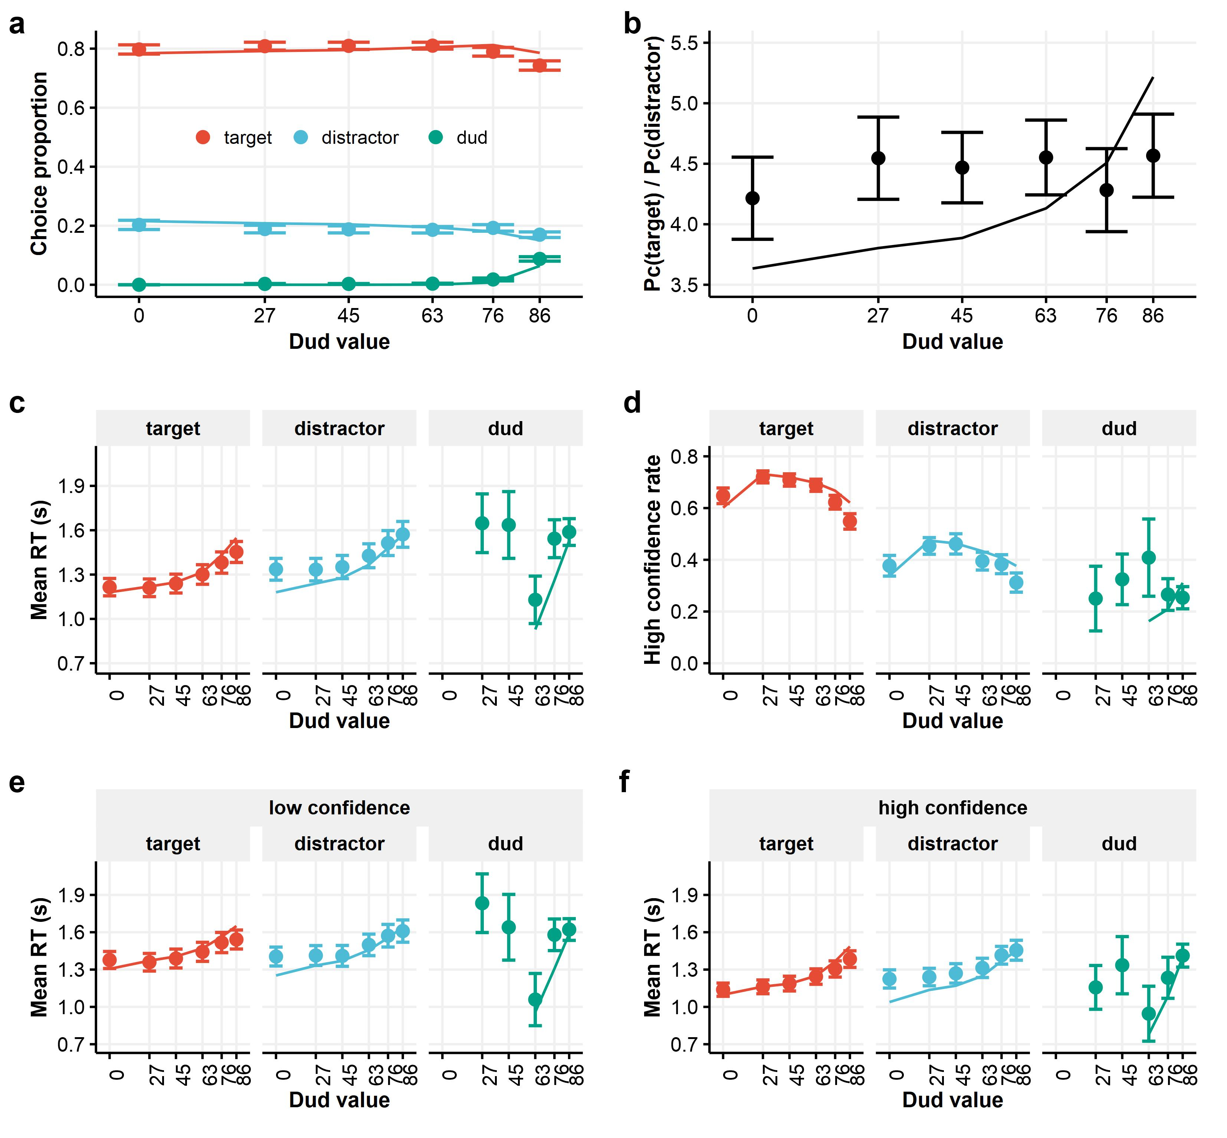
Figure S1. Posterior probability approximation model fitted to the three-choice data. Compared to the MVN model, the PPA model exhibited an overly excessive IIA violation. While this model effectively accounted for the dud-alternative confidence boost, it struggled to capture the nonlinear trend in RT data.

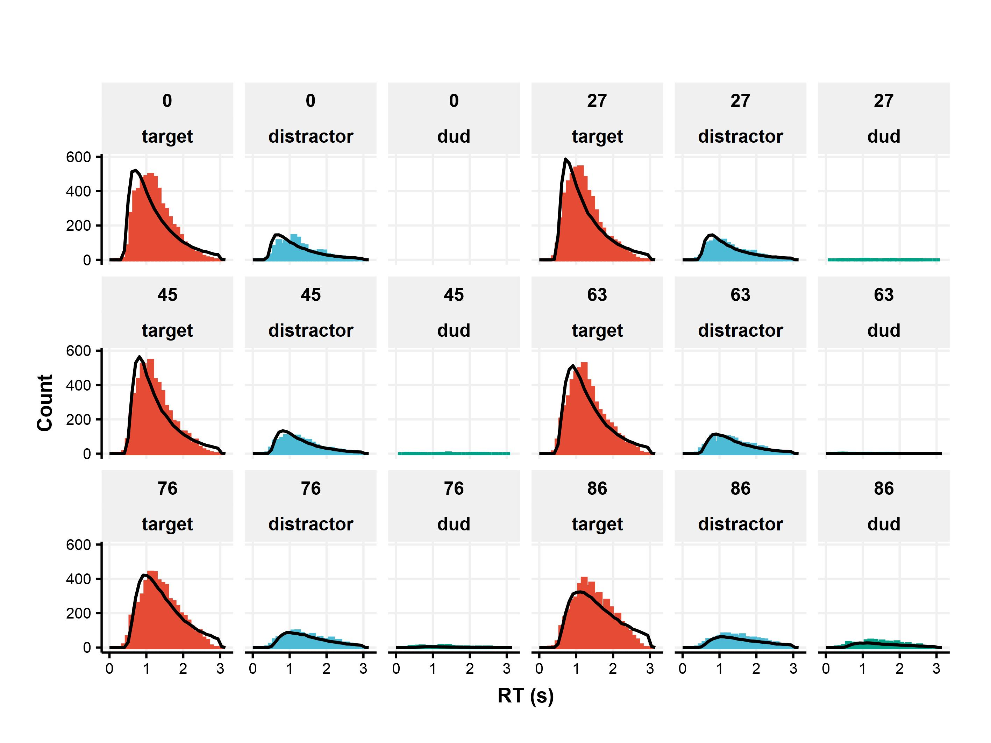
Figure S2. Empirical RT distributions for the three-choice experiment (histograms) alongside PPA model predictions (solid curves). Distinct misfits can be seen in the fastest and slowest RT ranges, especially for target choices. While these misfits are averaged out and thus not conspicuous in Figure S1, they led to severe loss in the model fitting, which considered finer RT quantiles.

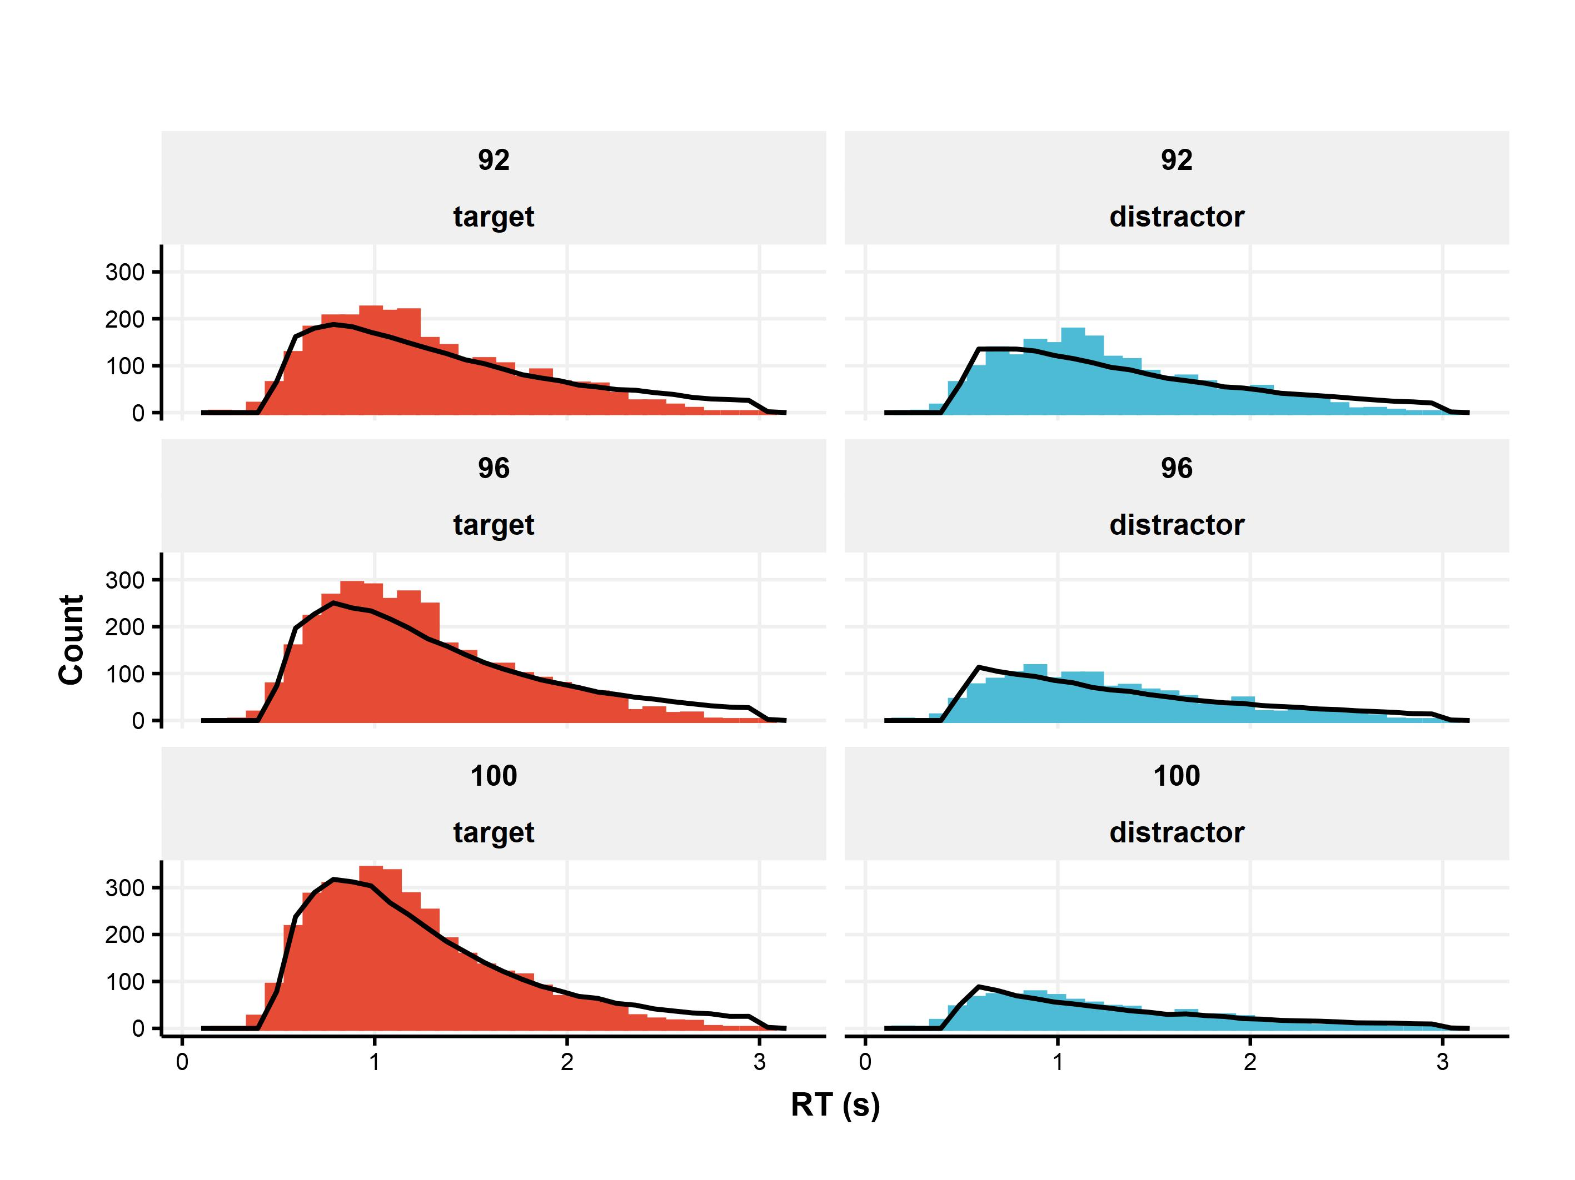
Figure S3. Empirical RT distributions for the two-choice experiment (histograms) alongside MVN model predictions (solid curves). Notable misfits can be seen in the slowest RT range, particularly for target choices.

