Supplemental File
Table S1

Writing Block Themes and Reported Engagement With the Intervention Prompts

 | Average Word Count | Positive Valence |  | Negative Valence
 | Average Word Count | Count | Percentage | Count | Percentage
Math Self-Concept | 120.07 | 73 | 47.71% | 9 | 5.88%
Expressive Writing | 148.08 | 7 | 4.10% | 89 | 52.00%
Active Control | 121.19 | 82 | 47.13% | 4 | 2.30%
Note. Passive control is not included in Table S1 because participants in this group did not complete a writing prompt; they sat in silence for seven minutes. Participants in the active control group completed the same prompt as participants in the math self-concept group, but for reading instead of math.

Table S2

Intervention Check Question Means and Standard Deviations by Experimental Condition

Group | Upcoming Math | Ease to Follow | Effort to Follow
Math Self-Concept | 3.69 (1.91) | 4.63 (1.86) | 5.14 (1.64)
Expressive Writing | 4.66 (1.91) | 4.77 (1.71) | 5.58 (1.38)
Active Control | 3.03 (2.02) | 4.63 (1.96) | 4.89 (1.69)
Passive Control | 3.72 (1.86) | 3.11 (1.81) | 4.87 (1.65)
Note. Upcoming math asked participants the following question: “During the 7 minutes, how often did you think about having to complete the upcoming math problems?” Ease to follow asked participants the following question: “How easy was it to follow the prompt?” Effort to follow asked participants the following question: “How much effort did you make to accurately and fully follow the prompt?” All questions were on a 7-point Likert-type scale with higher numbers representing more thinking, more ease, and more effort, respectively.

Supplementary Math Accuracy Figures

All y-axes are accuracy as a percentage out of 100%. All x-axes are experimental condition with the following acronyms: MSC = math self-concept, EW = expressive writing, AC = active control, and PC = passive control. All error bars are standard error of the mean.
Figure S1

Study 1 Fraction Operation Accuracy

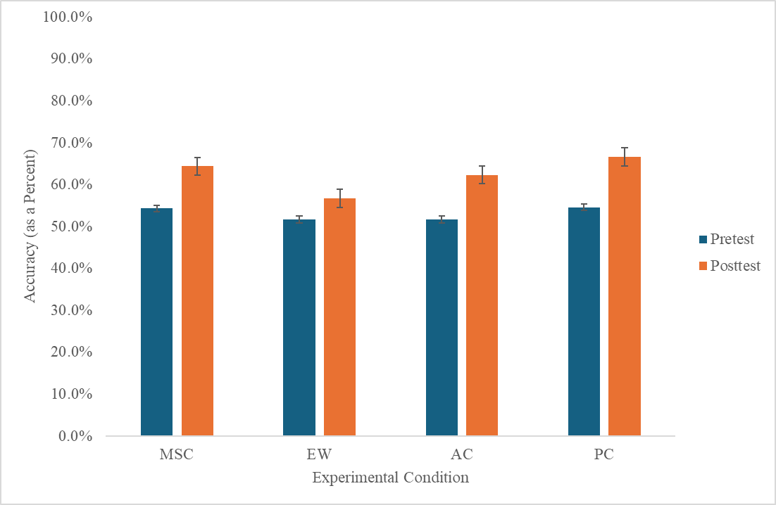
Figure S2

Study 1 Medical Decision Making Accuracy

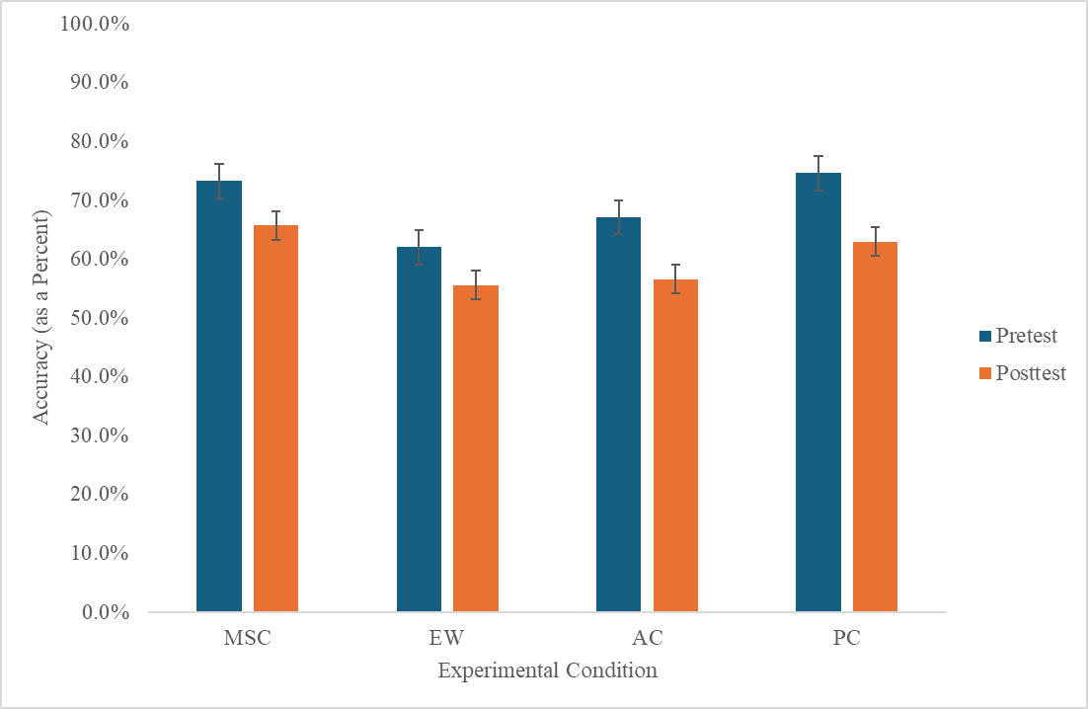
Figure S3

Study 2 Fraction Operation Accuracy

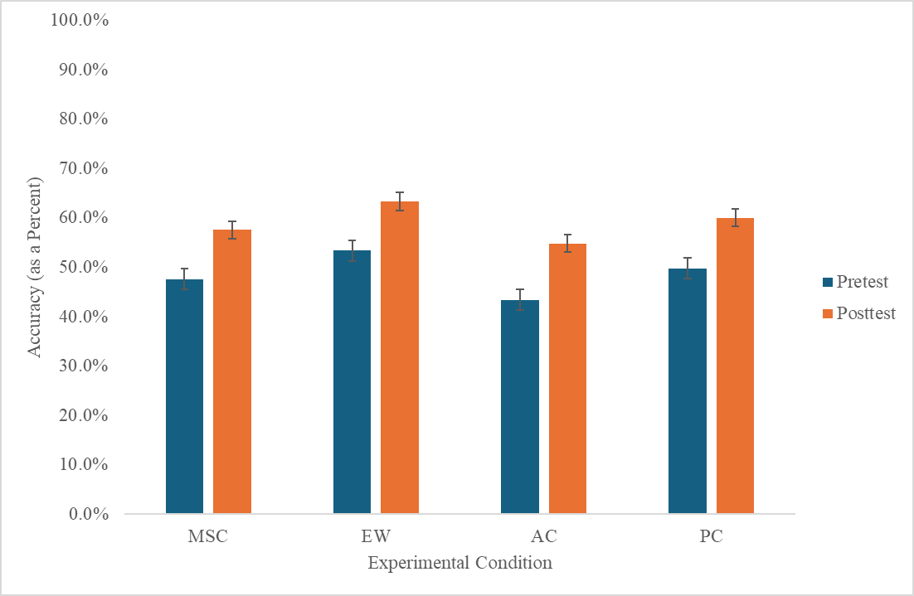
Figure S4

Study 2 Medical Decision Making Accuracy

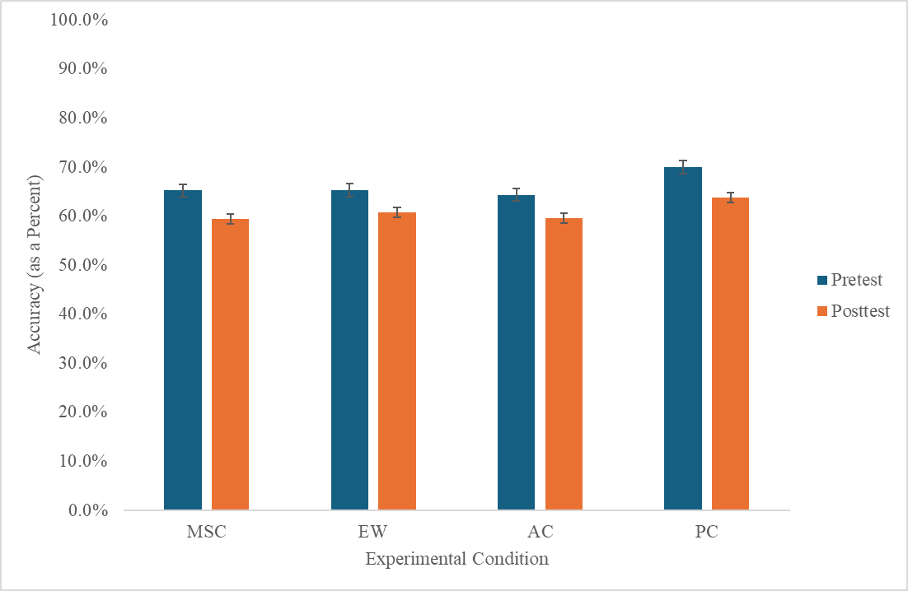

Supplementary Math Anxiety and Math Self-Concept Figures
Figure S5

Reported Math Anxiety by Experimental Condition at Pretest, Post-Intervention, and Posttest

A. Pretest SIMA (Study 1)
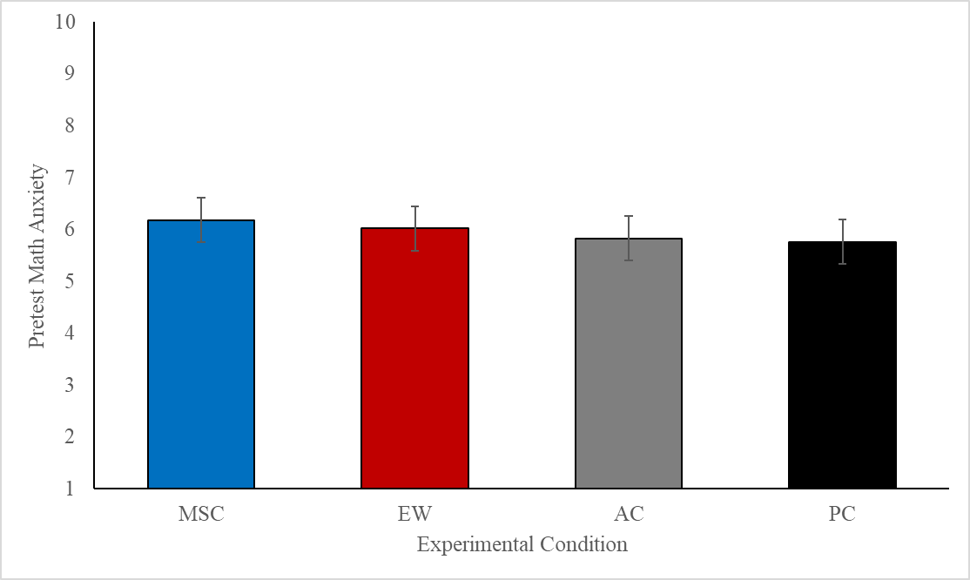
B. Post-Intervention State SIMA (Study 1)
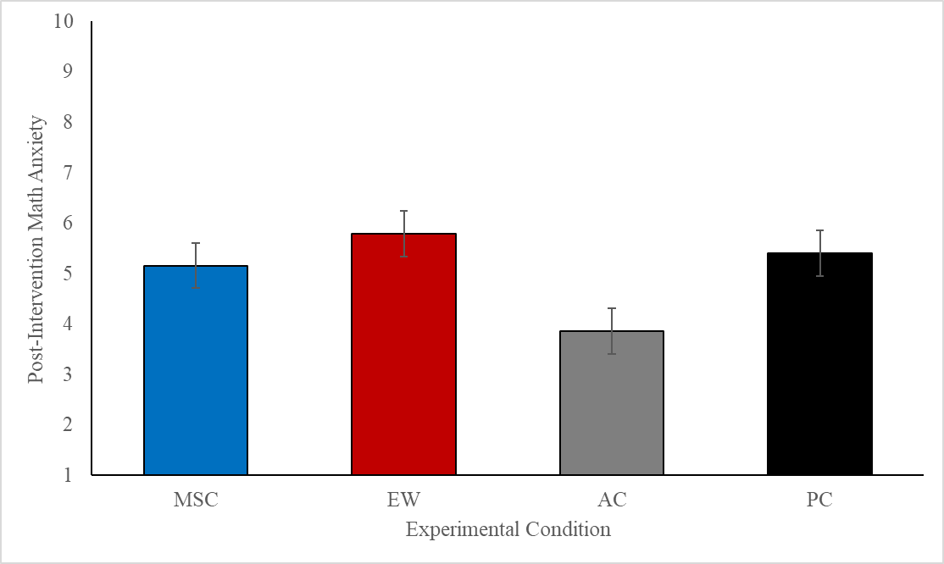
C. Posttest sMARS (Study 1)
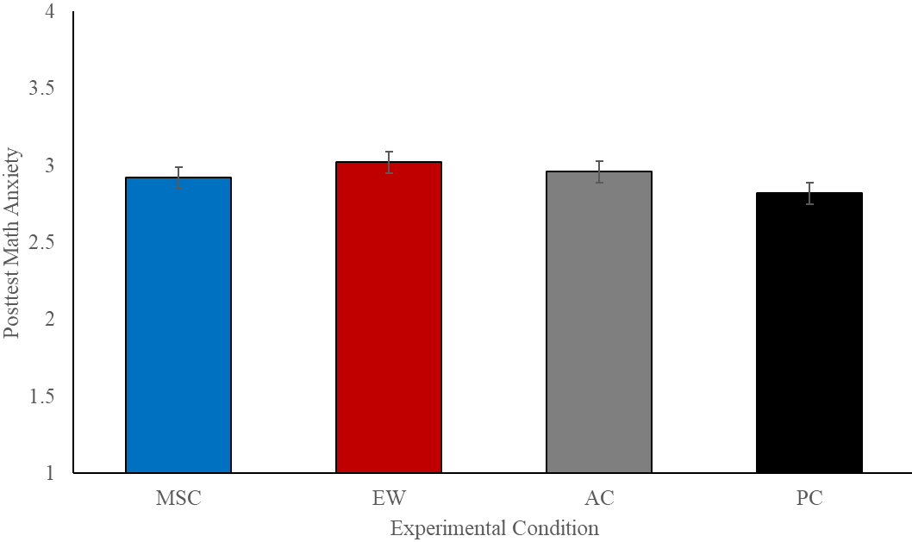
D. Pretest SIMA (Study 2)
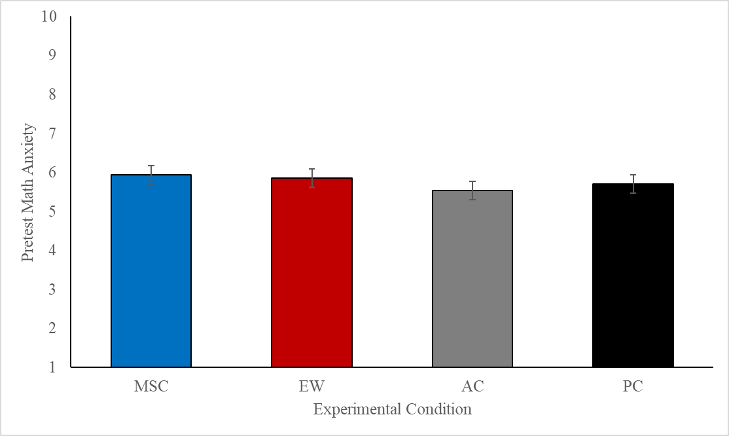
E. Post-Intervention State SIMA (Study 2)
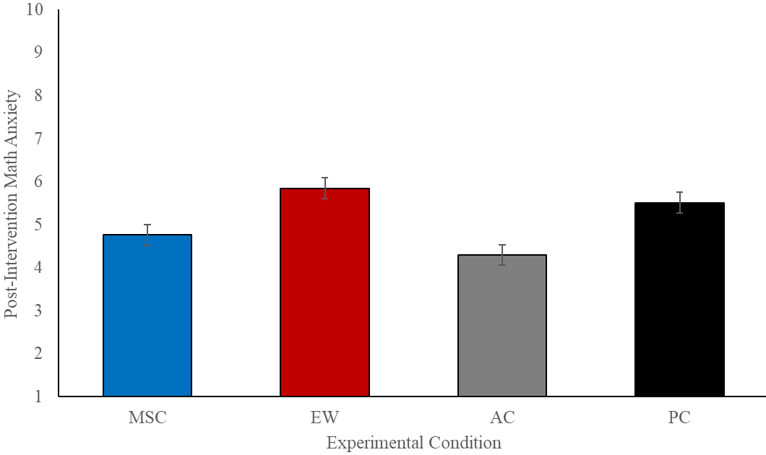
F. Posttest sMARS (Study 2)

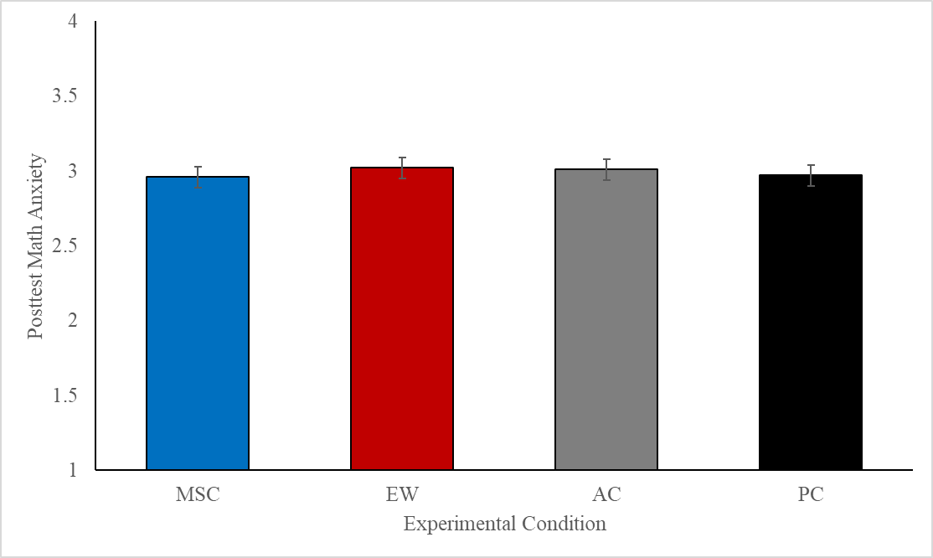
Note. Panels A and D represent participants’ answers on the single-item math anxiety scale (SIMA) on a 1-10 Likert-type scale–prior to completing any other measures. Panels B and E represent participants' responses immediately following the intervention, also on a 1-10 Likert-type scale. Panels C and F represent participants’ average responses on the 25-item posttest shortened math anxiety rating scale (sMARS) on a 1-5 Likert-type scale. Error bars indicate ±1 standard error of the mean.

Figure S6

Reported Math Self-Concept by Experimental Condition in Study 2

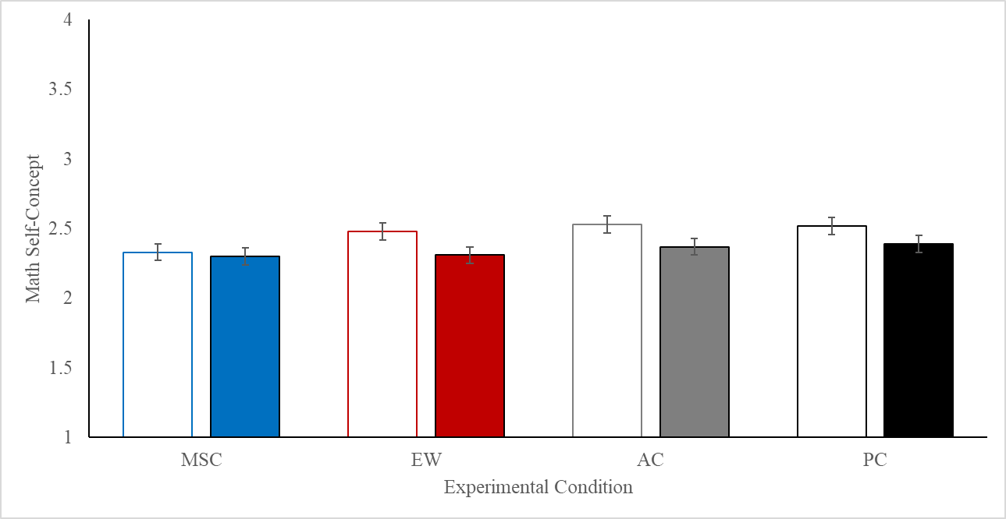

Note. Pretest math self-concept is represented by the white bars and posttest math self-concept is represented by the filled bars. Participants reported math self-concept in the MSC condition was not higher than reported math self-concept in the other three conditions (which would support H1_{b}); however, participants in the MSC did not report the same significant decrease in math self-concept as did participants in the other three experimental conditions (see Table 2 for descriptive statistics). Error bars indicate ±1 standard error of the mean.

Bayesian Statistics to Test Pretest-to-Posttest Change by Experimental Condition
In addition to reporting the pre-registered ANOVA and ANCOVA models in the results, we also conducted exploratory Bayesian analyses to test pretest-to-posttest change for the three primary outcomes (math anxiety, math self-concept, and math task accuracy). Because we largely present null results for our primary hypotheses, we conducted these exploratory Bayesian analyses to help determine the degree of absence (or presence) of evidence for our hypotheses from an alternative statistical perspective. Our original models based on traditional null-hypothesis significance testing are presented in the results section with or without covariates in the models. In this appendix, Bayes factors are presented testing the H1_{a} (differences in posttest math anxiety by experimental condition), H1_{b} (differences in posttest math self-concept by experimental condition), and H1_{c} (differences in posttest fraction operation problem accuracy and medical decision making word problem accuracy) (see Table S3). Even though the Bayesian models presented are exploratory in nature, results are displayed with (ANCOVA models) and without (ANOVA models) the pre-registered covariates included in the models.

Table S3

Bayes Factors for Primary Hypotheses Against the Null Hypothesis (BF₀₁)

Study | Model | Math Anxiety | Math Self-Concept | Fraction Problems Accuracy | MDM Word Problems Accuracy
Study 1 | ANOVA | 16.77 | No posttest data | 10.58 | 0.97
 | ANCOVA | < .0001 | No posttest data | < .0001 | < .0001
Study 2 | ANOVA | 105.94 | 61.88 | 8.00 | 18.06
 | ANCOVA | < .0001 | < .0001 | < .0001 | < .0001
Note. For the ANCOVA models, the included covariates were pretest math anxiety, working memory capacity, and either no additional covariates (for the outcome “math anxiety”), or one of (a) pretest math self-concept, (b) pretest fraction operation problems accuracy, or (c) pretest medical decision making word problems accuracy, depending on the corresponding outcome. As pre-registered and reported in the results, the outcome “math anxiety” is operationalized as scores on the 25-item sMARS scale, completed at posttest.

The Bayes factors displayed in Table S3, a Bayesian approach to analyzing our data, support our original conclusion: The null model is a stronger model than the alternative model for each of our primary outcomes. The Bayes factors displayed in Table S3 represent support for the null model ranging from positive to decisive, with most models suggesting strong or very strong support for the null models (Jarosz & Wiley, 2014; Jeffreys, 1961; Raftery, 1995).

The one exception was for MDM word problems accuracy in Study 1, which yielded a Bayes factor of 0.97 (see Table S3). This suggests inconclusive evidence for either model. However, in the context of the findings for MDM word problems accuracy in Study 2, and the findings from the other models, we interpret these data holistically to say that the null models can be accepted across all primary hypotheses.

