Supplementary Materials
for the Manuscript:

The role of one’s own social network position in learning new networks:
Brokerage is associated with better network learning

Miriam E. Schwyck, Meng Du, Carolyn Parkinson

Sample Characteristics
In Study 1, 250 participants were recruited from the University of California, Los Angeles (UCLA) undergraduate population. Ten participants were excluded due to technical issues or researcher error that prevented complete data collection. As such, our final sample size was 240 (178 women, 61 men, 1 non-binary; ages 18-32 years, M = 20.23, SD = 1.56).
In Study 2, 196 participants were recruited from the UCLA undergraduate population. Fourteen participants were excluded due to technical issues that prevented complete data collection. Five participants were excluded for responding in the same way on all or all-but-one of the trials in the network learning task, suggesting they were not trying to answer correctly. Thus, our final sample size was 177 (126 women, 46 men, 1 non-binary, 4 did not report gender; ages 18-28 years, M = 20.35, SD = 1.59).
In Study 3, 600 online participants were recruited from the UCLA undergraduate population. Twenty-three participants were excluded due to technical issues that prevented complete data collection. Eighty-three participants were excluded for reporting that they paid little or no attention during the task. Twenty-three participants were excluded for taking more than 3 times the estimated length of the study. Thus, our final sample size was 471 (373 women, 91 men, 5 non-binary, 2 did not report gender; ages 18-36 years, M = 20.25, SD = 2.13).
In Study 4, 1,000 online participants were recruited from Prolific (www.prolific.com). Nineteen participants were excluded for reporting that they paid little or no attention during the task. Nine participants were excluded for responding in the same way on all or all-but-one of the trials in the network learning task, suggesting they were not trying to answer correctly. Two participants were excluded pressing the attention check key twice as often as it was needed. Sixteen participants were excluded for taking more than more than three times the estimated length of the study. Thus, our final sample size was 841 (355 women, 456 men, 22 non-binary, 8 did not report gender; ages 18-42 years, M = 29.85, SD = 5.92).
Table S1

Racial/Ethnic Demographics of Participants
Study | Asian | Black | Latinx | Middle Eastern | Native American | White | Multi-Racial | Not Listed | Prefer Not to Answer
Study 1 | 81 | 5 | 53 | 13 | 1 | 59 |  | 23 | 5
Study 2 | 89 | 5 | 33 | 6 | 0 | 28 |  | 11 | 6
Study 3 | 175 | 13 | 96 | 27 | 3 | 95 | 45 | 6 | 11
Study 4 | 82 | 82 | 104 | 2 | 3 | 510 | 43 | 1 | 14

Demographic information was collected at the very end of the study. In Studies 1 and 2, participants were asked about gender (Please select your gender: Female, Male, Other (describe), Prefer not to answer) and race (Please select your race: White, Latino or Hispanic, African, East Asian, South or Southeast Asian, Native Hawaiian or Other Pacific Islander, American Indian or Alaska Native, Middle Eastern or Central Asian, Other or Mixed (describe), Prefer not to answer). In Study 3, participants were asked about gender (How would you describe your gender? Female, Male, Non-Binary, Prefer not to answer; Do you identify as transgender? Yes, No, Prefer not to answer) and race/ethnicity (How would you describe your racial/ethnic background? Latinx/Hispanic, African-American/Black, White/Caucasian, Native American, Asian, Native Hawaiian/Pacific Islander, Middle Eastern, Bi-racial/Multi-racial, Not listed, Other or Mixed (describe), Prefer not to answer). In Study 4, participants were asked about gender (How would you describe your gender? Female, Male, Non-Binary, Prefer not to answer; Do you identify as transgender? Yes, No, Prefer not to answer) and race/ethnicity (How would you describe your racial/ethnic background? Asian, Black, Latinx/Hispanic, Middle Eastern, Native American, White/Caucasian, Bi-racial/Multi-racial, Not listed (please describe), Prefer not to answer).

Study 1 Images
In Study 1, each node in the network was represented by a neutral face from the Chicago Face Database (Ma, Correll, & Wittenbrink, 2015). These images were cropped to a circle and edited such that the gray shirts were colored to aid in distinguishing between people. Across participants, images were semi-randomly assigned to network structures while controlling for gender and race across structures. Each network consisted of one female and one male of each of the four ethnic categories in the Chicago Face Database: Asian, Black, Latinx, White. The ninth node was represented by either a Black man or a Latina woman. This semi-random allocation was used to prevent any potential confounds that inter-image similarity may have on participants’ perceived connections. Within each network, images were randomly assigned to network positions. As such, images were not consistently associated with a given position within a network.

Initials/Airport Codes
There were 28 three-letter codes that were framed as either initials (social condition) or airport codes (non-social condition). These were selected from all possible combinations such that they could realistically represent initials, were dissimilar from any major airports (to prevent the learned information potentially competing with any participants’ prior knowledge in Study 2) and were not common abbreviations for English words or phrases. The full list is: WSG, SBJ, JGC, ENM, DWM, MBF, NWB, RLA, LBK, AFH, LWP, LCF, DBG, RMJ, KJT, TDH, HGP, EBH, EKF, GFT, NFD, NKS, EAG, MLH, RNP, EPJ, ACW, DKP.

Ego Network Relationships
In Studies 3-4, participants listed the people in their ego network and selected one of the following 11 labels (modified from (Cohen, Doyle, Skoner, Rabin, & Gwaltney, 1997) that best reflected their relationship with that person: friend, spouse, child, parent, parent-in-law, other close family member, schoolmate, workmate, close neighbors, member of religious group, member of group without religious affiliations. Example screenshots of the ego network survey are provided below. We used the R package igraph (Csárdi & Nepusz, 2006) to calculate Burt’s constraint (Burt et al., 2004) for each participant. Constraint is an inverse measure of brokerage that increases for people with fewer ties and for those with more redundant ties, thereby varying with ego network size and density. Formally, node i’s constraint measure is calculated as:
Constraint_{i} $=\sum_{j∈V_{i}}{{\left(p_{ij}+\sum_{q∈V_{i}\backslash \{i,j\}}{p_{iq}p_{qj}}\right)}^{2}}$
where V_{i} is i's ego network, p_{ij} is the proportional tie strength of the connection between i and j relative to all of i's connections, and q is socially connected to both i and j (Csárdi & Nepusz, 2006). To get a normalized distribution of participants’ brokerage capacities, we log transformed and multiplied the constraint values by -1.
Two research assistants coded the free responses that were given in Studies 1-2 according to these 11 labels. The two coders were in high agreement (IRR = .97). We then categorized these labels into three categories: friends, family, and other. We then calculated the proportion of each participant’s ties that fell into each of those categories (Fig. S1).
Name generator
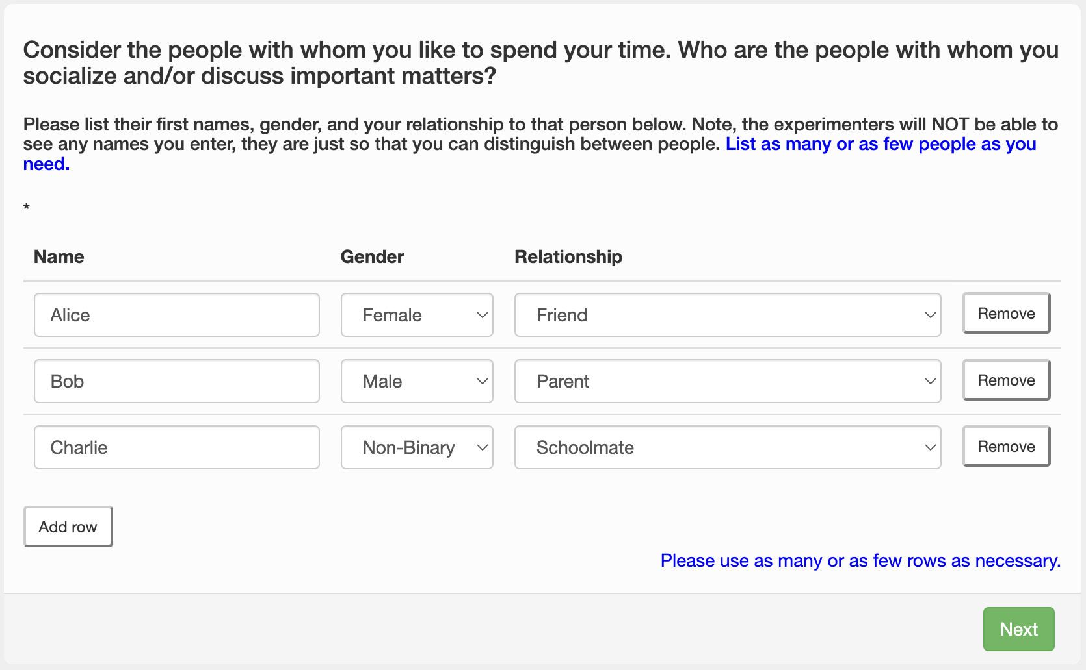
Perceived ties between alters
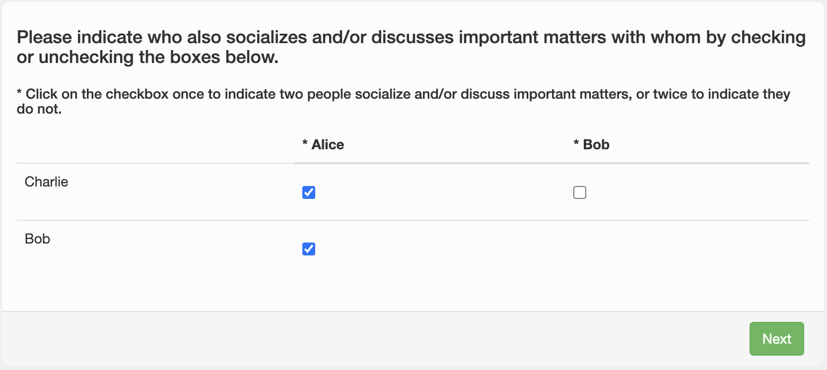

Figure S1

Proportions of Relationships in Ego Network
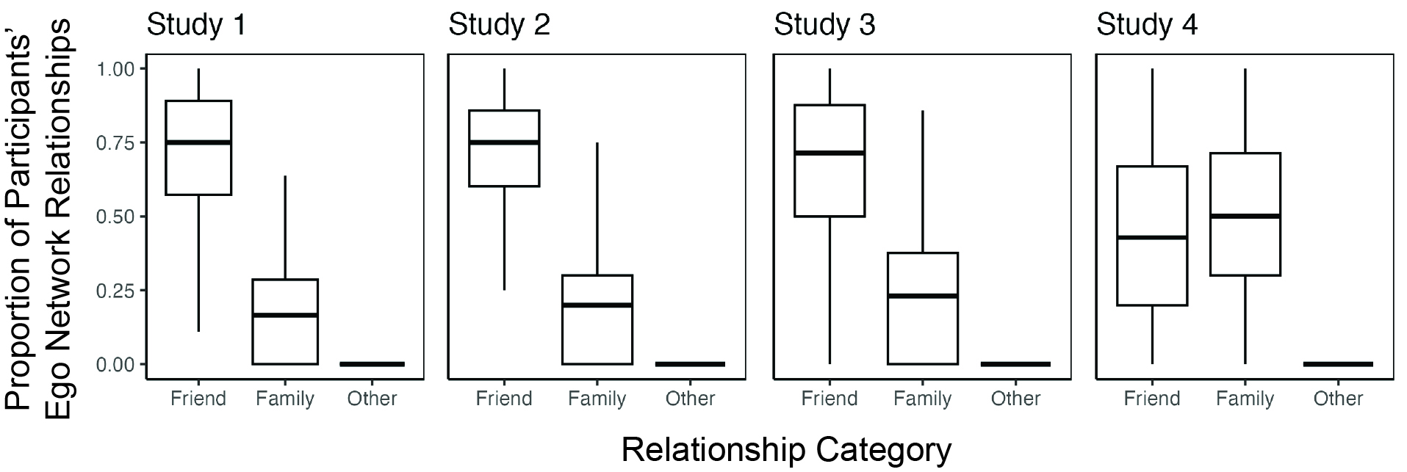
Note. Boxplots illustrating the proportion of each participant’s ties that were friends, family, or other.

The Potential Confound of Self-Monitoring
Table S2

Linear Mixed Model Results Testing Type of Network and Framing Condition Effects Controlling for Self-Monitoring
Effect | df | ß | 95% CI | F | p
Study 3
Brokerage | 1, 466 | 0.03 | [ 0.01, 0.05] | 6.43 | .012 | *
Structure | 1, 467 | 0.01 | [-0.01, 0.02] | 0.66 | .418
Condition | 1, 466 | 0.00 | [-0.02, 0.03] | 0.01 | .915
Self-Monitoring | 1, 466 | 0.00 | [ 0.00, 0.01] | 4.41 | .036 | *
Brokerage x Structure | 1, 467 | 0.02 | [ 0.01, 0.04] | 8.39 | .003 | **
Brokerage x Condition | 1, 466 | 0.00 | [-0.02, 0.03] | 0.09 | .769
Structure x Condition | 1, 467 | 0.00 | [-0.02, 0.02] | 0.03 | .853
Structure x Brokerage x Condition | 1, 467 | 0.00 | [-0.02, 0.01] | 0.24 | .628
Study 4
Brokerage | 1, 831 | 0.02 | [-0.01, 0.04] | 2.10 | .147
Structure | 1, 832 | -0.01 | [-0.02, 0.00] | 2.01 | .157
Condition | 1, 831 | -0.01 | [-0.03, 0.01] | 1.07 | .301
Self-Monitoring | 1, 831 | 0.00 | [ 0.00, 0.00] | 0.02 | .902
Brokerage x Structure | 1, 832 | 0.00 | [-0.01, 0.01] | 0.08 | .781
Brokerage x Condition | 1, 831 | 0.00 | [-0.02, 0.02] | 0.01 | .918
Structure x Condition | 1, 832 | 0.00 | [-0.01, 0.01] | 0.15 | .695
Structure x Brokerage x Condition | 1, 832 | 0.00 | [-0.01, 0.01] | 0.07 | .787
Note. Results from a linear mixed effects model with percent recall accuracy as the dependent variable. Participant brokerage, network structure (typical, atypical), and framing condition (social, non-social) are included as fixed effects with random by-participant intercepts. Self-monitoring was included as a covariate. **p < .01, *p < .05
Figure S2

Brokerage Association With Accuracy When Controlling for Self-Monitoring
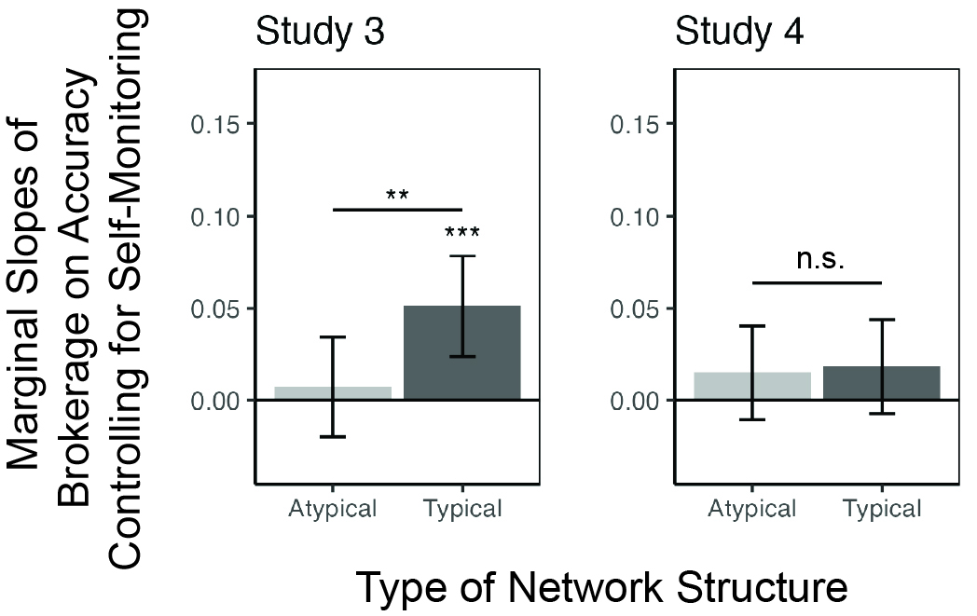
Note. Marginal estimated slopes of brokerage on recall accuracy of networks categorized as Typical and Atypical when controlling for self-monitoring. The pattern of results is the same when controlling for self-monitoring and when it is not included in the model. Error bars reflect 95% CI. ***p < .001, **p < .01, n.s. = not significant

Accounting for the Potential Confound of Effort
It is possible that the association of brokerage with network learning is not due to actual network position, but rather the amount of time and effort participants are willing to put into the study. That is, participants who are more attentive and spend more time filling in the ego network survey may have spent more time learning and recalling the network, and therefore performed better when recalling the network in the drawing task. To test this possibility, we ran the same linear mixed models with the following covariates: average time spent on the viewing trials of the learning task, average time spent on the feedback trials of the learning task, and time spent drawing the network. The results show the same pattern as seen without including these covariates. That is, even when controlling for the amount of time the participant spent on the task at each stage, we still see a strong association between brokerage and ability to learn typically structured social networks, but no other network structure.
Table S3

Linear Mixed Model Results Testing Type of Network and Framing Condition Effects Controlling for Effort
Effect | df | ß | 95% CI | F | p
Study 1
Brokerage | 1, 238 | 0.03 | [ 0.01, 0.05] | 6.87 | .009 | **
Structure | 1, 235 | 0.06 | [ 0.04, 0.09] | 22.43 | < .001 | ***
Time on Viewing Phase | 1, 235 | 0.00 | [ 0.00, 0.01] | 8.83 | .003 | **
Time on Feedback Phase | 1, 235 | 0.00 | [-0.01, 0.01] | 0.00 | .948
Time on Drawing Task | 1, 235 | 0.00 | [ 0.00, 0.00] | 1.99 | .159
Structure x Brokerage | 1, 235 | 0.02 | [ 0.01, 0.04] | 7.31 | .007 | **
Study 2
Brokerage | 1, 173 | 0.05 | [ 0.01, 0.08] | 5.21 | .024 | *
Structure | 1, 170 | -0.06 | [-0.10, -0.03] | 15.02 | < .001 | ***
Condition | 1, 173 | 0.03 | [-0.02, 0.08] | 1.09 | .298
Time on Viewing Phase | 1, 170 | 0.01 | [ 0.00, 0.01] | 8.67 | .004 | **
Time on Feedback Phase | 1, 170 | 0.01 | [ 0.00, 0.02] | 2.40 | .123
Time on Drawing Task | 1, 170 | 0.00 | [ 0.00, 0.00] | 5.19 | .024 | *
Brokerage x Structure | 1, 170 | 0.03 | [ 0.01, 0.06] | 6.68 | .011 | *
Brokerage x Condition | 1, 173 | -0.02 | [-0.06, 0.02] | 0.85 | .359
Structure x Condition | 1, 170 | 0.02 | [-0.01, 0.05] | 1.34 | .249
Structure x Brokerage x Condition | 1, 170 | -0.02 | [-0.04, 0.01] | 1.80 | .181
Study 3
Brokerage | 1, 467 | 0.02 | [ 0.00, 0.04] | 4.71 | .030 | *
Structure | 1, 464 | 0.01 | [-0.01, 0.03] | 1.73 | .190
Condition | 1, 467 | 0.00 | [-0.02, 0.02] | 0.03 | .860
Time on Viewing Phase | 1, 464 | 0.00 | [-0.01, 0.00] | 11.52 | < .001 | ***
Time on Feedback Phase | 1, 464 | 0.02 | [ 0.02, 0.03] | 97.07 | < .001 | ***
Time on Drawing Task | 1, 464 | 0.00 | [ 0.00, 0.00] | 65.63 | < .001 | ***
Brokerage x Structure | 1, 464 | 0.02 | [ 0.00, 0.03] | 5.30 | .022 | *
Brokerage x Condition | 1, 467 | 0.00 | [-0.02, 0.02] | 0.06 | .807
Structure x Condition | 1, 464 | 0.00 | [-0.02, 0.01] | 0.27 | .601
Structure x Brokerage x Condition | 1, 464 | 0.00 | [-0.02, 0.01] | 0.05 | .816
Study 4
Brokerage | 1, 837 | 0.01 | [-0.01, 0.02] | 0.49 | .483
Structure | 1, 826 | -0.01 | [-0.02, 0.00] | 1.68 | .195
Condition | 1, 837 | 0.00 | [-0.02, 0.01] | 0.44 | .509
Time on Viewing Phase | 1, 826 | 0.00 | [ 0.00, 0.00] | 7.84 | .005 | **
Time on Feedback Phase | 1, 826 | 0.02 | [ 0.02, 0.02] | 315.01 | < .001 | ***
Time on Drawing Task | 1, 826 | 0.00 | [ 0.00, 0.00] | 54.65 | < .001 | ***
Brokerage x Structure | 1, 826 | 0.00 | [-0.01, 0.01] | 0.01 | .919
Brokerage x Condition | 1, 837 | 0.00 | [-0.02, 0.01] | 0.10 | .755
Structure x Condition | 1, 826 | 0.00 | [-0.01, 0.01] | 0.17 | .673
Structure x Brokerage x Condition | 1, 826 | 0.00 | [-0.01, 0.02] | 0.27 | .606
Note. Results from a linear mixed effects model with percent recall accuracy as the dependent variable. Participant brokerage, network structure (typical, atypical), and framing condition (social, non-social) are included as fixed effects (when applicable) with random by-participant intercepts. Time spent on the viewing and feedback phases of the learning task and the drawing task were included as covariates. ***p < .001, **p < .01, *p < .05
Figure S3

Brokerage Association With Accuracy When Controlling for Time Spent on Tasks
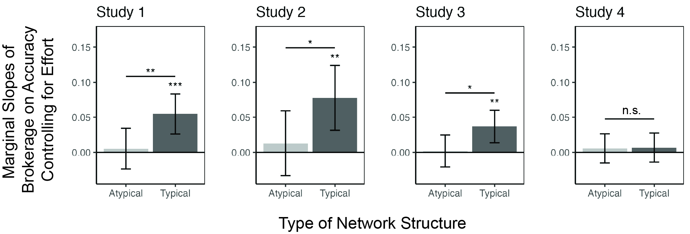
Note. Marginal estimated slopes of brokerage on recall accuracy of networks categorized as Typical and Atypical when controlling for effort. Effort was measured by the time spent on the self-paced portions of the network learning task (viewing phase and feedback phase) and the drawing task. The pattern of results is the same when controlling for effort and when it is not included in the model. Error bars reflect 95% CI. ***p < .001, **p < .01, *p < .05, n.s. = not significant

Controlling for Target Degree
Table S4

Linear Mixed Model Results Testing Target Brokerage Effects Controlling for Target Degree
Effect | df | ß | 95% CI | F | p
Study 1
Participant Brokerage | 1, 238 | 0.03 | [ 0.00, 0.06] | 4.74 | .030 | *
Target Brokerage | 1, 1917 | -0.07 | [-0.10, -0.03] | 13.24 | < .001 | ***
Target Degree | 1, 1917 | -0.08 | [-0.11, -0.06] | 35.29 | < .001 | ***
Participant Brokerage x Target Brokerage | 1, 1917 | 0.05 | [ 0.03, 0.07] | 20.75 | < .001 | ***
Study 2
Participant Brokerage | 1, 175 | 0.07 | [ 0.01, 0.12] | 5.93 | .016 | *
Target Brokerage | 1, 1413 | -0.06 | [-0.12, -0.01] | 4.68 | .031 | *
Target Degree | 1, 1413 | -0.13 | [-0.17, -0.08] | 32.58 | < .001 | ***
Participant Brokerage x Target Brokerage | 1, 1413 | 0.04 | [ 0.00, 0.07] | 4.04 | .045 | *
Study 3
Participant Brokerage | 1, 469 | 0.02 | [-0.01, 0.05] | 2.37 | .124
Target Brokerage | 1, 3765 | -0.07 | [-0.11, -0.04] | 15.87 | < .001 | ***
Target Degree | 1, 3765 | -0.22 | [-0.25, -0.18] | 188.45 | < .001 | ***
Participant Brokerage x Target Brokerage | 1, 3765 | 0.06 | [ 0.04, 0.09] | 27.66 | < .001 | ***
Study 4
Participant Brokerage | 1, 837 | 0.01 | [-0.02, 0.03] | 0.38 | .538
Target Brokerage | 1, 6709 | -0.01 | [-0.04, 0.02] | 0.53 | .466
Target Degree | 1, 6709 | -0.16 | [-0.19, -0.13] | 129.10 | < .001 | ***
Participant Brokerage x Target Brokerage | 1, 6709 | 0.03 | [ 0.01, 0.05] | 8.72 | .003 | **
Note. Results from a linear mixed effects model with percent recall accuracy of each target node’s connections in the typical networks as the dependent variable, participant brokerage, target brokerage, and their interaction as predictors, and random by-participant intercepts. In Study 4, where there were two typically structured networks, target brokerage and target degree were scaled to [0, 1] within each network. Estimated marginal slopes of the interaction terms are illustrated in Fig. S2. ***p < .001, **p < .01, *p < .05
Figure S4

Brokers Are Especially Good at Learning Other Brokers’ Ties Even When Controlling for Degree
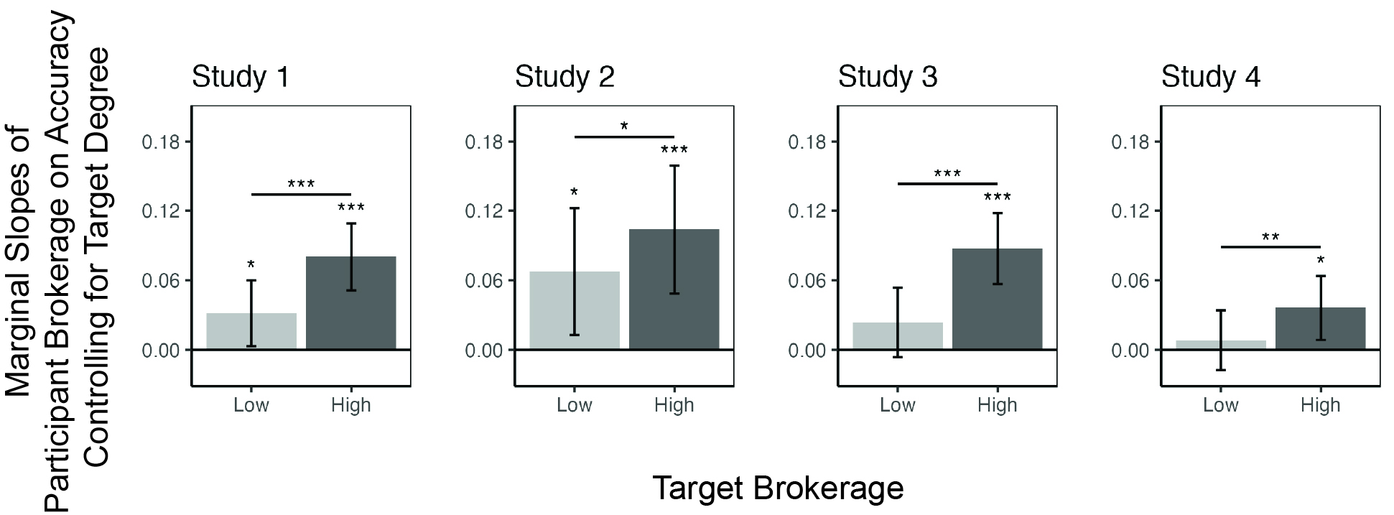
Note. Within the typical networks, the association between participant brokerage and better recall was significantly stronger for targets with higher brokerage capacity compared to targets with lower brokerage capacity when controlling for target’s degree. This was true in all four studies. Error bars reflect 95% CI. ***p < .001, **p < .01, *p < .05
Atypical Network Recall Accuracy
Table S5
Effect | df | ß | 95% CI | F | p
Study 1
Participant Brokerage | 1, 238 | 0.01 | [-0.02, 0.04] | 0.26 | .612
Target Brokerage | 1, 1918 | -0.03 | [-0.07, 0.01] | 1.98 | .160
Participant Brokerage x Target Brokerage | 1, 1918 | 0.01 | [-0.02, 0.03] | 0.12 | .724
Study 2
Participant Brokerage | 1, 175 | 0.02 | [-0.02, 0.06] | 0.89 | .347
Target Brokerage | 1, 1414 | -0.08 | [-0.11, -0.04] | 18.17 | < .001 | ***
Participant Brokerage x Target Brokerage | 1, 1414 | 0.01 | [-0.02, 0.03] | 0.16 | .688
Study 3
Participant Brokerage | 1, 469 | -0.04 | [-0.12, 0.05] | 0.83 | .364
Target Brokerage | 1, 3766 | -0.25 | [-0.33, -0.17] | 40.87 | < .001 | ***
Participant Brokerage x Target Brokerage | 1, 3766 | 0.04 | [-0.03, 0.11] | 1.40 | .237
Study 4
Participant Brokerage | 1, 837 | 0.00 | [-0.02, 0.03] | 0.11 | .739
Target Brokerage | 1, 6710 | -0.13 | [-0.15, -0.12] | 286.44 | < .001 | ***
Participant Brokerage x Target Brokerage | 1, 6710 | 0.01 | [-0.01, 0.03] | 1.34 | .247

Note. Results from a linear mixed effects model with percent recall accuracy of each target node’s connections in the atypical networks as the dependent variable, participant brokerage, target brokerage, and their interaction as predictors, and random by-participant intercepts. In Study 4, where there were two atypically structured networks, target brokerage was scaled to [0, 1] within each network. Estimated marginal slopes of the interaction terms are illustrated in Fig. 6. ***p < .001

Estimated Marginal Slopes by Framing Condition
Figure S5

Broker Accuracy by Framing Condition
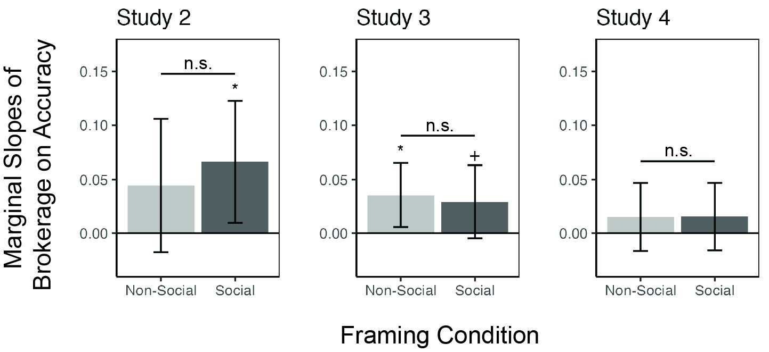
Note. The association between participant brokerage and better recall was not significantly different when the network was framed as a social network of friends or a non-social flight network between airports. Error bars reflect 95% CI. *p < .05, ⁺p < .1, ^{n.s.}p > .1

Alternative Measures of Accuracy
Degree Accuracy
To test if brokers are better at learning node members’ relative degree centralities, we first calculated the correlations between the degrees from each participant’s drawn network and the degrees of the true network structure. We then ran linear mixed effects models with participant brokerage, structure type, and condition predicting the degree correlations with by-participant intercepts.
Table S6

Linear Mixed Model Predicting Degree Accuracy
Effect | df | ß | 95% CI | F | p
Study 1
Brokerage | 1, 238 | 0.06 | [ 0.00, 0.12] | 3.74 | .054 | +
Structure | 1, 237 | 0.23 | [ 0.15, 0.31] | 31.54 | < .001 | ***
Brokerage x Structure | 1, 237 | 0.05 | [ 0.00, 0.11] | 3.31 | .070 | +
Study 2
Brokerage | 1, 173 | 0.12 | [ 0.01, 0.24] | 4.91 | .028 | *
Structure | 1, 173 | -0.04 | [-0.14, 0.06] | 0.69 | .408
Condition | 1, 173 | 0.02 | [-0.12, 0.17] | 0.10 | .754
Brokerage x Structure | 1, 173 | 0.02 | [-0.05, 0.10] | 0.31 | .577
Brokerage x Condition | 1, 173 | 0.00 | [-0.11, 0.11] | 0.00 | .962
Structure x Condition | 1, 173 | 0.08 | [-0.02, 0.18] | 2.46 | .118
Brokerage x Structure x Condition | 1, 173 | -0.07 | [-0.15, 0.01] | 3.34 | .069 | +
Study 3
Brokerage | 1, 467 | 0.08 | [ 0.02, 0.14] | 7.51 | .006 | **
Structure | 1, 465 | 0.03 | [-0.03, 0.08] | 0.86 | .355
Condition | 1, 467 | 0.01 | [-0.06, 0.08] | 0.07 | .791
Brokerage x Structure | 1, 465 | 0.06 | [ 0.01, 0.11] | 5.88 | .016 | *
Brokerage x Condition | 1, 467 | 0.01 | [-0.05, 0.07] | 0.04 | .852
Structure x Condition | 1, 465 | 0.03 | [-0.03, 0.09] | 0.97 | .325
Brokerage x Structure x Condition | 1, 465 | -0.03 | [-0.09, 0.02] | 1.84 | .176
Study 4
Brokerage | 1, 836 | 0.05 | [-0.01, 0.11] | 2.99 | .084 | +
Structure | 1, 829 | -0.01 | [-0.04, 0.02] | 0.29 | .591
Condition | 1, 836 | -0.04 | [-0.09, 0.01] | 2.57 | .109
Brokerage x Structure | 1, 829 | 0.01 | [-0.03, 0.05] | 0.10 | .747
Brokerage x Condition | 1, 836 | 0.01 | [-0.04, 0.07] | 0.23 | .635
Structure x Condition | 1, 829 | 0.02 | [-0.01, 0.06] | 2.13 | .145
Brokerage x Structure x Condition | 1, 829 | -0.01 | [-0.05, 0.03] | 0.14 | .707
Note. Results from a linear mixed effects model with degree accuracy as the dependent variable. Participant brokerage, network structure (typical, atypical), and framing condition (social, non-social) are included as fixed effects (when applicable) with random by-participant intercepts. ***p < .001, **p < .01, *p < .05, +p < .1
Density Accuracy
To test if brokers are better at learning the network-level feature of density (i.e., the number of possible ties that exist in the network), we calculated density accuracy as the difference between a participant’s drawn density and the true density in the network. We then ran linear mixed effects models with participant brokerage, structure type, and condition predicting density accuracy with by-participant intercepts.
Table S7

Linear Mixed Model Predicting Density Accuracy
Effect | df | ß | 95% CI | F | p
Study 1
Brokerage | 1, 238 | 0.03 | [ 0.02, 0.05] | 15.54 | < .001 | ***
Structure | 1, 238 | 0.02 | [ 0.00, 0.03] | 3.35 | .068 | +
Brokerage x Structure | 1, 238 | 0.00 | [-0.02, 0.01] | 0.208 | .649
Study 2
Brokerage | 1, 173 | 0.02 | [ 0.00, 0.04] | 3.25 | .073 | +
Structure | 1, 173 | -0.05 | [-0.07, -0.02] | 18.04 | < .001 | ***
Condition | 1, 173 | 0.00 | [-0.02, 0.03] | 0.02 | .878
Brokerage x Structure | 1, 173 | 0.02 | [ 0.00, 0.03] | 3.28 | .072 | +
Brokerage x Condition | 1, 173 | 0.00 | [-0.02, 0.02] | 0.07 | .795
Structure x Condition | 1, 173 | 0.00 | [-0.02, 0.02] | 0.10 | .751
Brokerage x Structure x Condition | 1, 173 | 0.00 | [-0.02, 0.02] | 0.00 | .989
Study 3
Brokerage | 1, 467 | 0.06 | [ 0.04, 0.08] | 44.21 | < .000 | ***
Structure | 1, 467 | 0.00 | [ 0.00, 0.01] | 0.78 | .377
Condition | 1, 467 | 0.01 | [-0.01, 0.03] | 0.42 | .516
Brokerage x Structure | 1, 467 | 0.00 | [-0.01, 0.01] | 0.00 | .954
Brokerage x Condition | 1, 467 | -0.01 | [-0.03, 0.01] | 0.91 | .342
Structure x Condition | 1, 467 | 0.00 | [-0.01, 0.01] | 0.61 | .435
Brokerage x Structure x Condition | 1, 467 | 0.00 | [-0.01, 0.00] | 0.91 | .339
Study 4
Brokerage | 1, 837 | 0.02 | [ 0.01, 0.03] | 9.86 | .002 | **
Structure | 1, 833 | -0.01 | [-0.02, 0.00] | 9.19 | .003 | **
Condition | 1, 837 | -0.01 | [-0.02, 0.00] | 3.14 | .077 | +
Brokerage x Structure | 1, 833 | 0.00 | [-0.01, 0.01] | 0.35 | .552
Brokerage x Condition | 1, 837 | 0.01 | [-0.01, 0.02] | 1.36 | .244
Structure x Condition | 1, 833 | 0.00 | [-0.01, 0.01] | 0.08 | .780
Brokerage x Structure x Condition | 1, 833 | 0.00 | [-0.01, 0.01] | 0.33 | .565
Note. Results from a linear mixed effects model with density accuracy as the dependent variable. Participant brokerage, network structure (typical, atypical), and framing condition (social, non-social) are included as fixed effects (when applicable) with random by-participant intercepts. ***p < .001, **p < .01, +p < .1
Figure S6

Association of Brokers with Alternative Measures of Accuracy
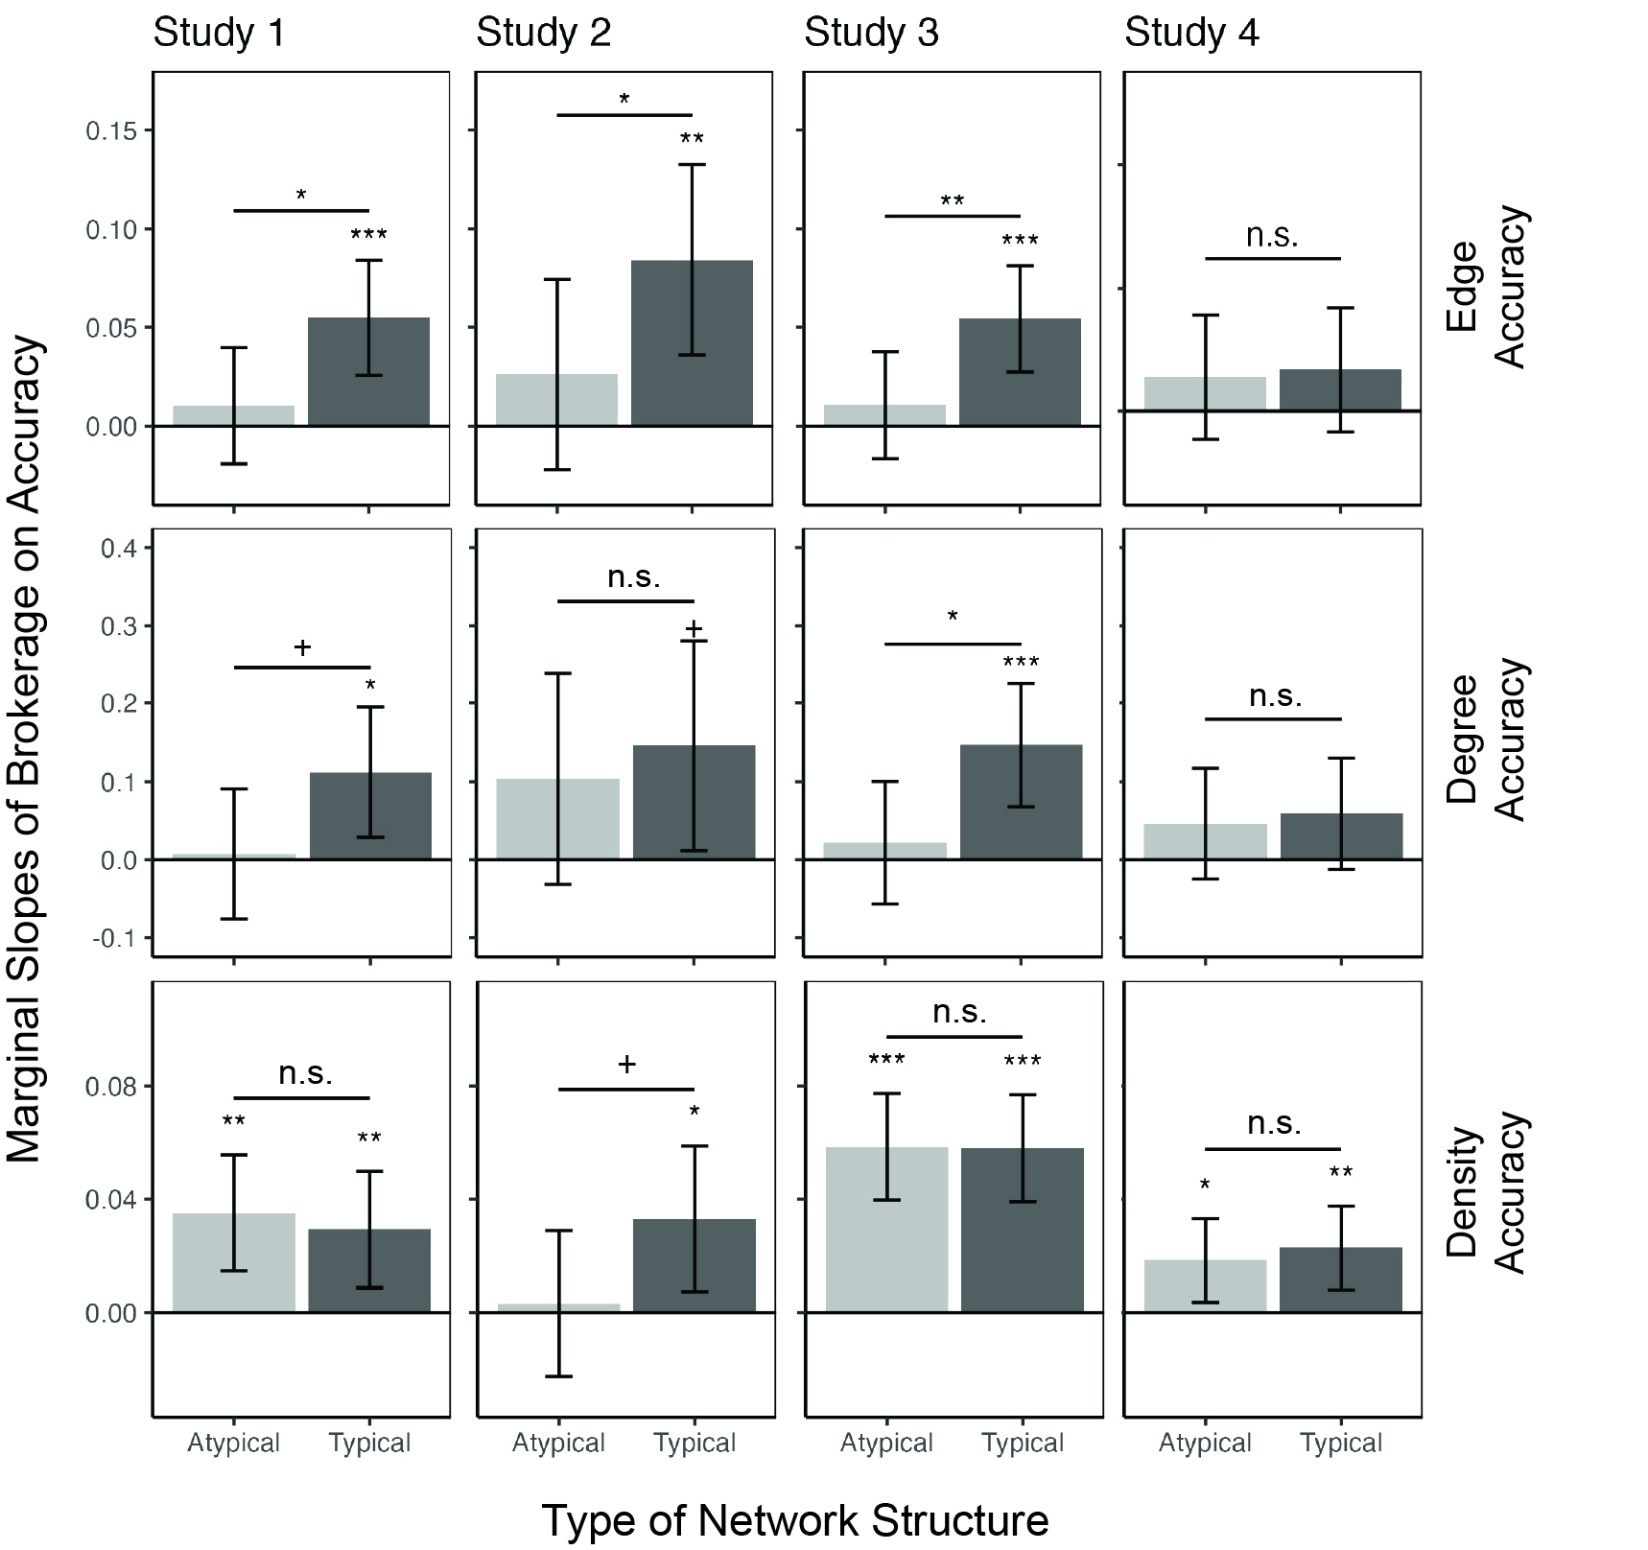
Note. The association between participant brokerage and better recall of edges (i.e., percent accuracy as described in the manuscript), degree centrality, and network density. Error bars reflect 95% CI. ***p < .001, **p < .01, *p < .05, ⁺p < .1, ^{n.s.}p > .1

Accuracy During Learning Phase
Our main results examine how participant brokerage relates to their ability to recall new networks after completing the learning task. To further examine when and how these effects arise, we examined participants’ performance during the feedback phase of the learning task, in which participants saw every possible pair of people and had to report if they were friends or not. To test if brokerage was associated with better learning during the first round of the learning task, before they received any direct feedback about specific relationships, we ran mixed effects models with accuracy predicted by structure type (typical, atypical), condition (social, non-social; Studies 2-4 only), and participant brokerage, as well as all interactions, and random by-participant intercepts. We then calculated the estimated marginal slopes of brokerage on accuracy for each level of network structure. Similar to our results using the drawing task data, we found that brokerage was associated with better learning, especially in the typical network in Studies 1-3, and no effect in Study 4 (Study 1: β_{Typical} = 0.06, t(213) = 2.19, p = .060, β_{Atypical} = 0.01, t(213) = 0.29, p = .775; Study 2: β_{Typical} = 0.15, t(163) = 3.89, p < .001, β_{Atypical} = 0.09, t(163) = 2.50, p = .013; Study 3: β_{Typical} = 0.05, t(467) = 3.04, p = .005, β_{Atypical} = 0.01, t(467) = 0.77, p = .444; Study 4: β_{Typical} = 0.01, t(832) = 0.43, p = .665, β_{Atypical} = 0.03, t(832) = 1.82, p = .137). However, this association was only marginally significant in Study 1, was not specific to the typical network in Study 2, and the 2-way interaction term only reached significance in Study 3, β = 0.02, F(1,467) = 4.17, p = .042.
Next, we examined the second round of the learning phase in Studies 1-2 (the only studies in which participants completed more than one round of the learning task) to test if brokers were particularly sensitive to the feedback they received in the first round. Specifically, we sought to disentangle network learning ability from sensitivity to feedback by testing if brokers were better at correcting the mistakes they had made in the first round, again using mixed effects models including structure type, condition (Study 2 only), and participant brokerage predicting the proportion of corrected mistakes. We then tested the estimated marginal slopes of brokerage on corrected mistakes for each type of network. In Study 1, we found that brokerage was marginally associated with correcting a greater proportion of errors within the typical network (b = 0.06, t(213) = 2.19, p = .060), but not within the atypical network (b = 0.01, t(213) = 0.29, p = .775). In Study 2, we found that brokerage was significantly associated with correcting more errors in both networks (Typical, b = 0.15, t(163) = 3.89, p < .001; Atypical, b = 0.09, t(163) = 2.50, p = .013). Together, these results suggest that brokers may be better at learning new networks from the beginning stages of the learning process, and that they may be more sensitive to feedback during this process.

References
Burt, R. S., Barnett, W., Baron, J., Bendor, J.-A., Birner, J., Bothner, M., Dobbin, F., Heath, C., Kranton, R., Khurana, R., Pfeffer, J., Podolny, J., Raider, H., & Rauch, J. (2004). Structural holes and good ideas. In AJS (Vol. 110, Issue 2).
Cohen, S., Doyle, W. J., Skoner, D. P., Rabin, B. S., & Gwaltney, J. M. (1997). Social ties and susceptibility to the common cold. Journal of the American Medical Association, 277(24), 1940–1944. https://doi.org/10.1001/jama.277.24.1940
Csárdi, G., & Nepusz, T. (2006). The igraph software package for complex network research. InterJournal, Complex Systems, 1695.
Ma, D., Correll, J., & Wittenbrink, B. (2015). The Chicago Face Database: A free stimulus set of faces and norming data. Behavior Research Methods, 47, 1122–1135. https://doi.org/https://doi.org/10.3758/s13428-014-0532-5

