Supplemental Materials

Table of Contents
Section | Title
Section S1 | Data quality and exclusion criteria
Section S2  Section S3 | Sample demographics  Descriptive statistics and internal consistency of questionnaire measures
Section S4 | Additional details on procedure
Section S5 | Zero-order correlations
Section S6 | Preregistered paranoia analyses
Section S7 | Déjà vu analyses covarying for psychoticism
Section S8 | Control slider analyses
Section S9 | Reanalysis with inclusion of all subjects

Section S1 – Data quality and exclusion criteria.
A number of steps were taken to ensure data quality, in line with methods described in the preregistration for Study 1 (osf.io/328g5). Participants were excluded from further analysis if A) their accuracy on the attention task during Encoding was equal to or below chance (50%; n=33), B) their self-reported attention was below 60 on a scale of 100 (n=19), C) they took over an hour to complete the experiment (n=14), or D) they failed other attention checks during the experiment (n=17). In total, 83 participants were excluded based on these criteria. As established by the preregistration, this resulted in a final sample of 250 participants.
In line with the preregistration for Study 2 (osf.io/wbj2p), participants were excluded from further analysis if A) their accuracy on the attention task during Encoding was equal to or below chance (50%; n=29), B) their self-reported attention was below 60 on a scale of 100 (n=47), C) they took over an hour to complete the experiment (n=95), D) they failed other attention checks during the experiment (n=30), or E) their mean error on the spatial control slider (described in more detail below) was greater than 15% (n=22). Finally, as noted in the Transparency and Openness section of the main manuscript, we additionally excluded participants who selected the same response on a slider measure on more than 10% of trials during recognition testing (i.e., 6 trials for each recognition phase of Study 2; n=18). In total, 241 participants were excluded based on these criteria. As established by the preregistration, this resulted in a final sample of 250 participants.

Section S2 – Sample demographics.
Table S1
Sample Demographics (Study 1 & Study 2)
Gender
Cisgender man | 284
Cisgender woman | 213
Prefer not to say | 3
Education
Less than high school degree | 2
High school graduate | 42
Some college but no degree | 54
Associate’s degree | 35
Bachelor’s degree | 251
Master’s degree | 111
Doctoral degree | 1
Professional degree | 4
Race
Black or African American | 56
Native American or Alaska Native | 8
Asian | 27
White | 403
Other | 2
Prefer not to say | 4
Ethnicity
Spanish, Hispanic, or Latino | 83
Not Spanish, Hispanic, or Latino | 399
Prefer not to say | 18
Age | 39.42 (SD = 11.46)
Note. Totals for race may be greater than the sample size due to the ability to select multiple categories.

Section S3 – Descriptive statistics and internal consistency of questionnaire measures.
Table S2
Frequency table of déjà vu questions
Déjà Vu Frequency | N | %
Never | 21 | 8.4%
Rarely | 110 | 44.0%
Pretty Often | 96 | 38.4%
All the Time | 23 | 9.2%
Déjà Vu Prescience
Never | 36 | 14.4%
Rarely | 82 | 32.8%
Pretty Often | 94 | 37.6%
All the Time | 38 | 15.2%

Table S3
Descriptive statistics and Omega Total of questionnaire measures
Study | Questionnaire | Mean (SD) | Omega Total (ω_{t})
1 | R-GPTS-B | 9.66 (11.86) | ω_{t} = .97
1 | MSS-N | 7.30 (5.86) | ω_{t} = .90
1 | MSS-P | 6.50 (7.68) | ω_{t} = .96
1 | MSS-D | 5.64 (6.97) | ω_{t} = .95
2 | R-GPTS-B | 15.21 (11.19) | ω_{t} = .95
2 | MSS-N | 5.06 (3.08) | ω_{t} = .79
2 | MSS-P | 6.05 (4.27) | ω_{t} = .91
2 | MSS-D | 4.48 (3.79) | ω_{t} = .89
2 | Déjà Vu | 1.51 (0.85) | ω_{t} = .70

Section S4 – Additional details on procedure.
All images were retrieved from bradylab.ucsd.edu/stimuli.html (Brady et al., 2008). During the Encoding phases of both studies, images appeared for 2500 ms and were followed by fixation cross (ISI ranged between 800 and 1100 ms). For the trial-wise attention check during the Encoding phases, participants used the keys “F” and “J” to indicate whether each image was natural (e.g., an apple) or manmade (e.g., a tractor), respectively. A summary of the different trial types present during the Recognition phases of Study 2 can be found below in Table S4.

Table S4
Study 2 Trial Types by Experiment Part
Experiment Part | Trial Type | Correct Response | # (%) of Trials
I | Target | Old | 32 (50%)
I | Novel Lure | New | 32 (50%)
II | Target | Old | 32 (50%)
II | Initial Lure | New | 16 (25%)
II | Novel Lure | New | 16 (25%)

Section S5 – Zero-order correlations.
Table S5
Zero-order correlations between variables of interest – Study 1
 | 2 | 3 | 4 | 5 | 6 | 7 | 8 | 9
1. R-GPTS-B | .77*** | .57*** | .74*** | -.48*** | .44*** | .46*** | -.59*** | -.12~
2. MSS-P | -- | .56*** | .78*** | -.59*** | .49*** | .53*** | -.59** | -.14*
3. MSS-N | -- | -- | .64*** | -.39*** | .25*** | .31*** | -.39*** | -.12~
4. MSS-D | -- | -- | -- | -.52*** | .44*** | .51*** | -.56*** | -.14*
5. d’ | -- | -- | -- | -- | -.29*** | -.47*** | .58*** | .18**
6. Mean temporal displacement (hits) | -- | -- | -- | -- | -- | .58*** | -.38*** | -.06
7. Mean temporal placement (false alarms) | -- | -- | -- | -- | -- | -- | -.42*** | -.09
8. Attention check performance | -- | -- | -- | -- | -- | -- | -- | .32***
9. Age | -- | -- | -- | -- | -- | -- | -- | --
Note. Non-parametric correlations (Spearman’s rho) are reported as variable distributions were non-normal. ~: p < .10, *: p < .05, **: p < 0.01, ***: p < .001.

Table S6
Zero-order correlations between variables of interest – Study 2
 | 2 | 3 | 4 | 5 | 6 | 7 | 8 | 9 | 10 | 11
1. R-GPTS-B | .73*** | .56*** | .76*** | .48*** | .46*** | -.54*** | .46*** | .56*** | -.58*** | -.12~
2. MSS-P | -- | .52*** | .72*** | .46*** | .44*** | -.52*** | .44*** | .53*** | -.53*** | -.06
3. MSS-N | -- | -- | .62*** | .25*** | .21** | -.37*** | .27*** | .34*** | -.33*** | -.07
4. MSS-D | -- | -- | -- | .43*** | .42*** | -.55*** | .47*** | .53*** | -.53*** | -.14*
5. Déjà vu frequency | -- | -- | -- | -- | .55*** | -.18** | .33*** | .36*** | -.29*** | -.03
6. Déjà vu prescience | -- | -- | -- | -- | -- | -.25*** | .34*** | .37*** | -.34*** | -.02
7. d’ | -- | -- | -- | -- | -- | -- | -.37*** | -.54*** | .51*** | .12~
8. Mean temporal displacement (hits) | -- | -- | -- | -- | -- | -- | -- | .86*** | -.30*** | -.02
9. Mean temporal placement (false alarms) | -- | -- | -- | -- | -- | -- | -- | -- | -.51*** | -.04
10. Attention check performance | -- | -- | -- | -- | -- | -- | -- | -- | -- | .19**
11. Age | -- | -- | -- | -- | -- | -- | -- | -- | -- | --
Note. Non-parametric correlations (Spearman’s rho) are reported as variable distributions were non-normal. ~: p < 0.10, *: p < 0.05, **: p < 0.01, ***: p < 0.001.

Section S6 – Preregistered paranoia analyses.
In our preregistrations (osf.io/328g5; osf.io/wbj2p), we focused on paranoia (as indexed by R-GPTS-B score) as the main independent variable of interest, yet in the final manuscript we focused instead on a composite psychoticism score (see main manuscript for more information). Here, we report the results of these analyses, which were in line with our preregistered hypotheses and consistent with the psychoticism results reported in the main manuscript.
More specifically, these analyses revealed a significant main effect of paranoia on timeline displacement of recognition hits in Study 1, t(230.65)=4.54, p<.001, η_{p}²=0.08 95% CI [0.03, 0.16], which was replicated in Study 2, t(222.78)=4.62, p<.001, η_{p}²=0.09 95% CI [0.03, 0.16]. This indicates that those higher in paranoia systematically recalled encountered items to have occurred more recently (i.e., later in the encoding phase) than they actually did. Further, there was a significant paranoia-by-direction interaction in Study 1, t(7406.48)=11.14, p<.001, η_{p}²=0.02, 95% CI [0.01, 0.02], which was replicated in Study 2, t(11430)=16.04, p<.001, η_{p}²=0.02, 95% CI [0.02, 0.03]. Again, those higher in paranoia tended to exhibit larger displacement errors in the positive (i.e., more recent) direction but smaller displacement errors in the negative (i.e., more distal) direction. We also found a significant main effect of paranoia on timeline placement of recognition false alarms in Study 1, t(195.82)=5.89, p<.001, η_{p}²=0.15, 95% CI [0.07, 0.24], which was replicated in Study 2, t(233.73)=5.73, p<.001, η_{p}²=0.12, 95% CI [0.06, 0.20]. Finally, in Study 2, there was a statistically significant paranoia-by-lure-type interaction, z(491)=-5.84, p<.001, OR=0.96, 95% CI [0.94, 0.97], indicating that as paranoia increased, the odds of false alarming to Novel lures increased, such that participants at the highest levels of paranoia tended to false alarm to both Initial and Novel lures at nearly identical rates.
Section S7 – Déjà vu analyses covarying for psychoticism.
In order to determine the extent to which déjà vu was associated with patterns of memory performance above and beyond psychoticism, we reran Models 4-6 (see manuscript for more details) with the inclusion of psychoticism (z-scored) as an additional covariate. These analyses revealed a significant main effect of déjà vu on timeline displacement of recognition hits, t(224.31)=2.31, p<.01, η_{p}²=0.02, 95% CI [0.00, 0.08] (see Figure S1a), while the psychoticism term also remained significant (p<.001). Further, the déjà-vu-by-direction interaction persisted with the inclusion of psychoticism, t(11270)=11.69, p<.001, η_{p}²=0.01, 95% CI [0.01, 0.02] (see Figure S1b). For timeline placement of recognition false alarms, a statistically significant main effect of déjà vu persisted, t(227.12)= 2.04, p=.04, η_{p}²=0.02, 95% CI [0.00, 0.07] (see Figure S1c), while the psychoticism term also remained significant (p<.001). Finally, the déjà-vu-by-lure-type interaction persisted with the inclusion of psychoticism, z(491)=-2.40, p=.02, OR=0.80, 95% CI [0.67, 0.96] (see Figure S1d).
In all cases, the qualitative patterns of associations between déjà vu and memory performance were similar (albeit slightly attenuated; see Figure S1) to those seen in analyses that omitted psychoticism (see Figure 5 in the main manuscript), suggesting some degree of overlap between déjà vu and aberrant mnemonic representations of recency that exists independent of psychoticism. This hints at a more general relationship between an illusion of recency and déjà vu in the general population – even among those who aren’t experiencing symptoms of psychosis. As such, future research should continue to disentangle the shared and unique variance in memory performance that is attributable to déjà vu versus psychotic-like experiences.

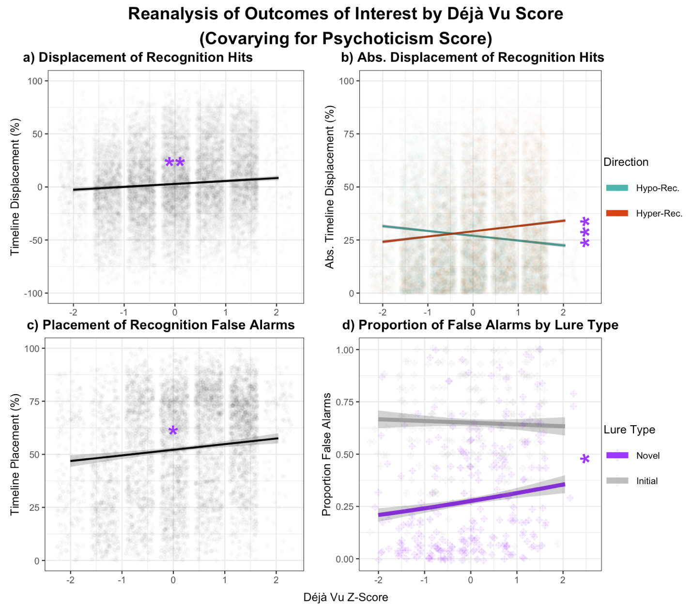
Figure S1
Note: Shaded area represents SE. *: p < .05, **: p < .01, ***: p < .001.

Section S8 – Control slider analyses.
Across both studies, we sought to confirm that any observed effects were due to differences in memory function per se, rather than differences in how participants responded to slider scales in general. To this end, we assessed the relationships between psychoticism and responses on a range of control sliders, including judgments of familiarity (ranging from 0 to 100), judgments of colorfulness (ranging from 0 to 100), and spatial judgments (i.e., displacement from a target prompt; ranging from -100 to 100). For both familiarity and colorfulness judgments, we created mixed-effects linear regressions of slider placement as a function of psychoticism (z-scored), with attention during the encoding phase included as a covariate. Due to underdispersion, we modeled spatial judgments using a poisson regression of slider displacement as a function of psychoticism (z-scored), with attention during the encoding phase included as a covariate. Note that in order to conform to the poisson distribution, we transformed our data by adding a constant (=100) to all values to eliminate negative integers (though these values were back-transformed for data visualization).
Critically, statistically significant main effects emerged in neither the familiarity, t(237.77)=-0.65, p=.52, η_{p}²=0.00, 95% CI [0.00, 0.03], nor the spatial slider, z=1.60, p=.11, IRR=1.00, 95% CI [1.00, 1.00] (see Figure S2a and S2c, respectively). For the colorfulness slider, a significant main effect of psychoticism emerged in the opposite direction of the pattern of responding observed on the timeline slider, t(229)=-2.92, p<.01, η_{p}²=0.04, 95% CI [0.00, 0.09]. As seen in Figure S2b, those higher in psychoticism tended to place their colorfulness estimates further to the lefthand side of the slider (corresponding to “more colorful”). Together, these analyses indicate that the hyper-recency effects reported above is unlikely to be explained by abnormal slider usage – only a strong association between psychoticism and a general rightward bias on the slider scales would undermine our interpretation.

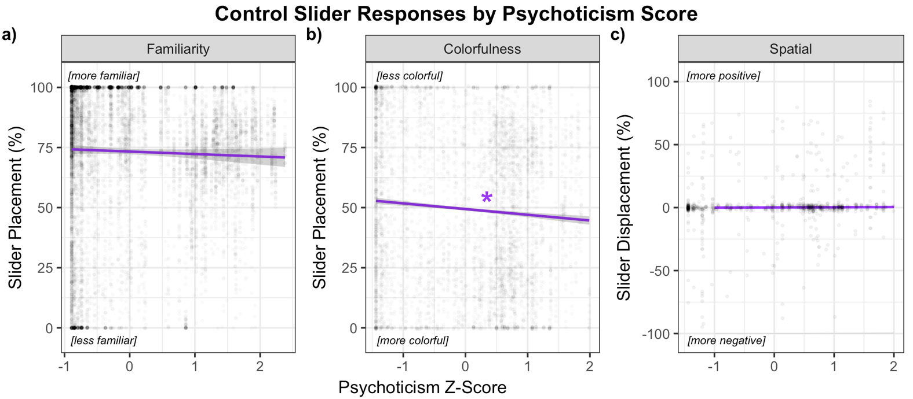
Figure S2
Note: Shaded area represents SE. *: p < .05, **: p < .01, ***: p < .001.

Section S9 – Reanalysis with inclusion of all subjects.
As mentioned in the main manuscript, several Study 2 participants were identified who seemed to respond to the slider-based measures in a stereotyped manner (e.g., selecting the same response many times in a row, regardless of the prompt). As this likely reflected inattentive responding that could inappropriately bias our results, we opted to exclude participants in both studies who made the same response on a slider measure on more than 10% of test trials. This resulted in the additional exclusion of 18 participants from Study 2 (no such participants were found in Study 1). To reach the preregistered sample size of 250, we collected an additional 18 usable participants using the methods described in the main manuscript. The results associated with this final sample (without invariant responders) are reported in the main manuscript. Since this represented a deviation from the preregistration of Study 2, we report the results associated with the original sample here. Importantly, results were entirely consistent across these two sets of analyses.
Model 1A revealed a statistically significant main effect of psychoticism on timeline displacement of recognition hits in Study 2, t(227.08)=5.57, p<.001, η_{p}²=0.12, 95% CI [0.05, 0.20]. By contrast, no significant main effect of MSS-N score emerged, t(223.19)=-0.02, p=.98, η_{p}²=0.00, 95% CI [0.00, 0.00]. In Model 1B, we sought to confirm that psychoticism was differentially related to timeline displacement in the hyper- (as compared to the hypo-) recent direction. Accordingly, Study 2 revealed a statistically significant psychoticism-by-direction interaction, t(7433.57)=17.07, p<.001, η_{p}²=0.02, 95% CI [0.02, 0.03], such that those higher in psychoticism tended to exhibit larger displacement errors in the more recent direction but smaller displacement errors in the hypo-recent direction. A similar pattern was seen for falsely recognized events, with Model 2 revealing a statistically significant main effect of psychoticism on timeline placement of recognition false alarms in Study 2, t(237.78)=6.36, p<.001, η_{p}²=0.15, 95% CI [0.07, 0.23]. By contrast, no significant main effect of MSS-N score emerged, t(249.67)=-0.32, p=.75, η_{p}²=0.00, 95% CI [0.00, 0.02]. Model 3 revealed a statistically significant psychoticism-by-lure-type interaction effect on proportion of falsely recognized lures, z(491)=-6.50, p<.001, OR=0.56, 95% CI [0.47, 0.67]. This model also showed a significant main effect of lure type, z(491)=16.97, p<.001, OR=5.13, 95% CI [4.25, 6.20], such that participants in general falsely recognized Initial lures at a higher rate than Novel lures. Further, a significant main effect of psychoticism, z(491)=5.11, p<.001, OR=1.69, 95% CI [1.38, 2.07], indicated that those higher in psychoticism made more false alarm errors overall, collapsing across lure type. Finally, there was no significant main effect of MSS-N score, z(491)=0.24, p=.81, OR=1.02, 95% CI [0.87, 1.19], indicating that negative schizotypy was not associated with proportion of falsely recognized lures above and beyond psychoticism. Finally, using déjà vu score as the independent variable of interest, Model 4A revealed a statistically significant main effect of déjà vu on timeline displacement of actual events, t(231.03)=5.51, p<.001, η_{p}²=0.12, 95% CI [0.05, 0.20]. Model 4B revealed a significant déjà-vu-by-direction interaction effect on timeline displacement of actual events, t(11459.78)=14.17, p<.001, η_{p}²=0.02, 95% CI [0.01, 0.02], in the same direction as psychoticism (larger displacement errors in the hyper- (versus hypo-) recent direction). Model 5 revealed a significant main effect of déjà vu on timeline placement of falsely recognized events, t(230.71)=5.82, p<.001, η_{p}²=0.13, 95% CI [0.06, 0.21]. Model 6 revealed a significant déjà-vu-by-lure-type interaction effect on proportion of falsely recognized lures, z(492)=-4.55, p<.001, OR=0.66, 95% CI [0.55, 0.79], such that participants reporting the most intense experiences of déjà vu tended to falsely recognize both Initial and Novel lures at a similar rate.
Finally, in order to confirm that the effects reported in the main manuscript were not a product of exclusion practices, we reran all analyses in the full, unexcluded samples (N=332 in Study 1; N=491 in Study 2). Importantly, all significant effects reported in the manuscript remained significant in this reanalysis, with similar effect sizes (see Table S7 below for more details). Further, as in the main manuscript, no significant effects emerged for the familiarity control slider (p=.99), while the colorfulness slider showed a small effect in the opposite direction of the pattern of responding observed on the timeline slider, (i.e., with greater psychoticism corresponding to a leftward bias). Unlike in the main manuscript, however, the spatial slider reanalysis did show a significant (but very small) main effect of psychoticism, such that those higher in psychoticism tended to make greater degrees of error in the positive (i.e., rightward) direction. The absence of this effect in the main manuscript suggests that exclusions were successful in screening out those who were not paying attention and may have been responding randomly.

Table S7
Reanalysis with inclusion of all subjects
Study | N | Model # | Description | Test Stat. | p | Effect Size [95% CI]
1 | 332 | 1A | Main effect of psychoticism on timeline displacement of hits | t(302.96)=6.18 | <0.001 | η_{p}²=0.11 [0.05, 0.18]
 |  | 1B | Psychoticism-by-error-direction interaction | t(9383.49)=15.49 | <0.001 | η_{p}²=0.02 [0.02, 0.04]
 |  | 2 | Main effect of psychoticism on timeline placement of false alarms | t(294.80)=7.58 | <0.001 | η_{p}²=0.16 [0.09, 0.24]
 |  | 7 | Main effect of psychoticism on control slider placement of familiarity judgments | t(319.06)=-0.01 | 0.99 | η_{p}²=0.00 [0.00, 0.00]
2 | 491 | 1A | Main effect of psychoticism on timeline displacement of hits | t(451.36)=7.00 | <0.001 | η_{p}²=0.10 [0.05, 0.15]
 |  | 1B | Psychoticism-by-error-direction interaction | t(21360.53)=20.71 | <0.001 | η_{p}²=0.02 [0.02, 0.02]
 |  | 2 | Main effect of psychoticism on timeline placement of false alarms | t(467.63)=8.20 | <0.001 | η_{p}²=0.13 [0.08, 0.18]
 |  | 3 | Psychoticism-by-lure-type interaction | z(969)=-8.34 | <0.001 | OR=0.58 [0.51, 0.66]
 |  | 4A | Main effect of déjà vu on timeline displacement of hits | t(456.36)=5.19 | <0.001 | η_{p}²=0.06 [0.02, 0.10]
 |  | 4B | Déjà-vu-by-error-direction interaction | t(21197.96)= 14.16 | <0.001 | η_{p}²=0.01 [0.01, 0.01]
 |  | 5 | Main effect of déjà vu on timeline placement of false alarms | t(451.44)=5.38 | <0.001 | η_{p}²=0.06 [0.02, 0.11]
 |  | 6 | Déjà-vu-by-lure-type interaction | z(970)=-3.30 | <0.001 | OR=0.80 [0.70, 0.92]
 |  | 8 | Main effect of psychoticism on spatial displacement (control slider) | z=8.35 | <0.001 | IRR=1.01 [1.00, 1.01]
 |  | 9 | Main effect of psychoticism on placement of colorfulness judgments (control slider) | t(457.00)=-2.17 | 0.03 | η_{p}²=0.01 [0.00, 0.04]

References
Brady, T. F., Konkle, T., Alvarez, G. A., & Oliva, A. (2008, Sep 23). Visual long-term memory has a massive storage capacity for object details. Proc Natl Acad Sci U S A, 105(38), 14325-14329. https://doi.org/10.1073/pnas.0803390105

