Supplementary Materials
This document is the supplementary materials for “On task errors drive effort avoidance more than opportunity costs” by J R. Embrey, A. Mason, C. Donkin, & B. R. Newell (2024). It contains the following subsections:
- Supplementary figures
- Details of priors for Bayesian Mixed Modelling
- Analysis on true switch out behaviours
- Accuracy analysis removing “no responses”
Section 1: Supplementary Figures

Figure S1
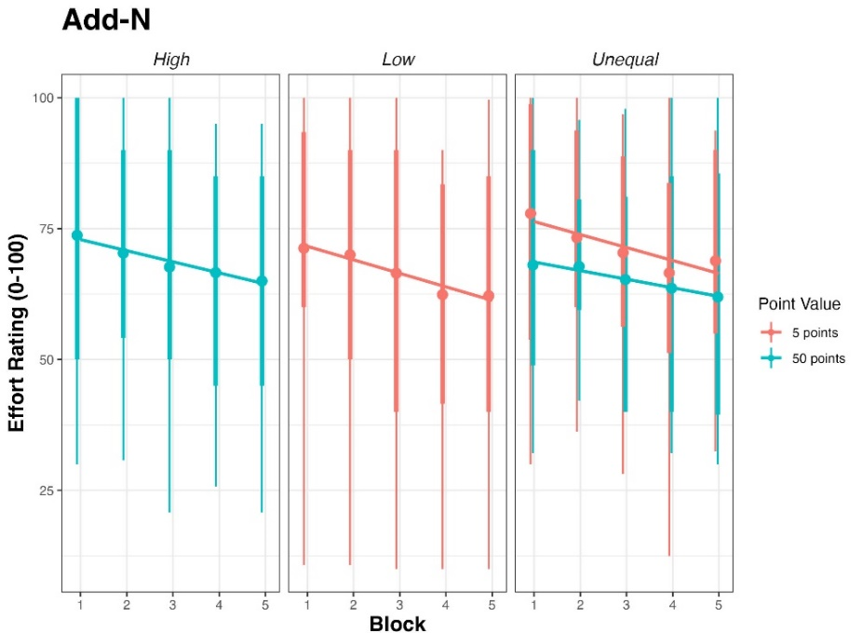
Effort ratings across blocks for conditions and task types for Experiment 1.

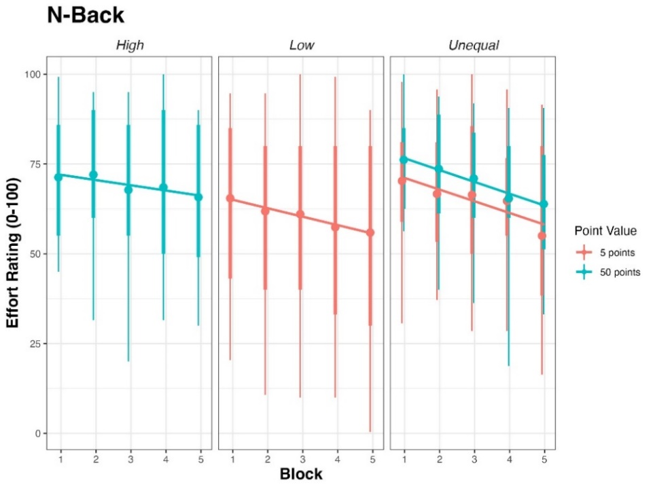

Note. Dots represent group means and whiskers represent the 95% quantile ranges. Facet labels (High, Low, Unequal) represent the between-subjects group.

Figure S2
Mean accuracy in the Add-N and N-Back tasks across blocks for the High, Low and Unequal Points conditions in Experiment 1.
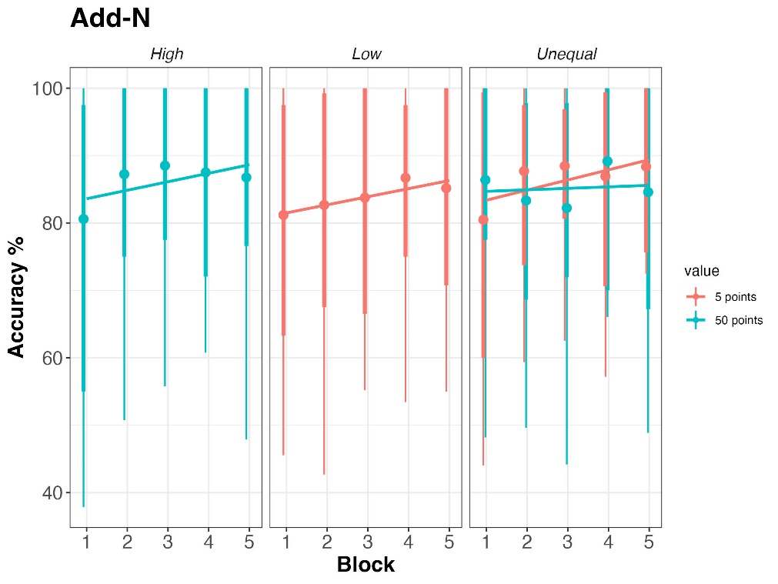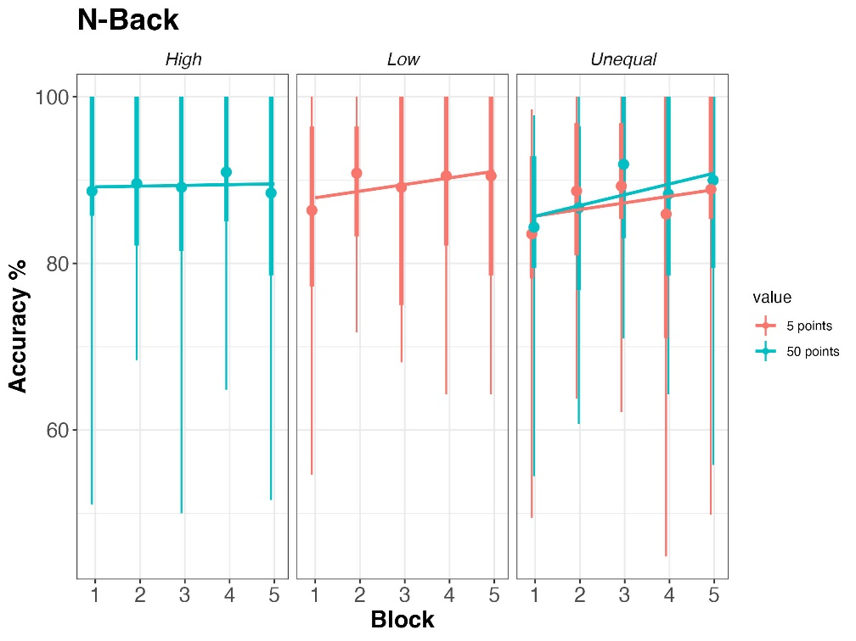
Note. Dots represent group means and whiskers represent quantile ranges. Facet labels (High, Low, Unequal) represent the between subjects group.

Figure S3
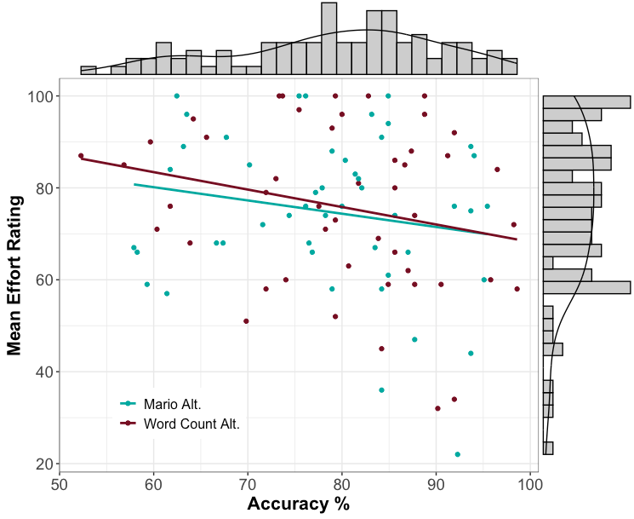
N-Back effort ratings and average accuracy in Experiment 2.

Note. Accuracy and effort ratings are averaged across the entire experiment for each participant.
Figure S4
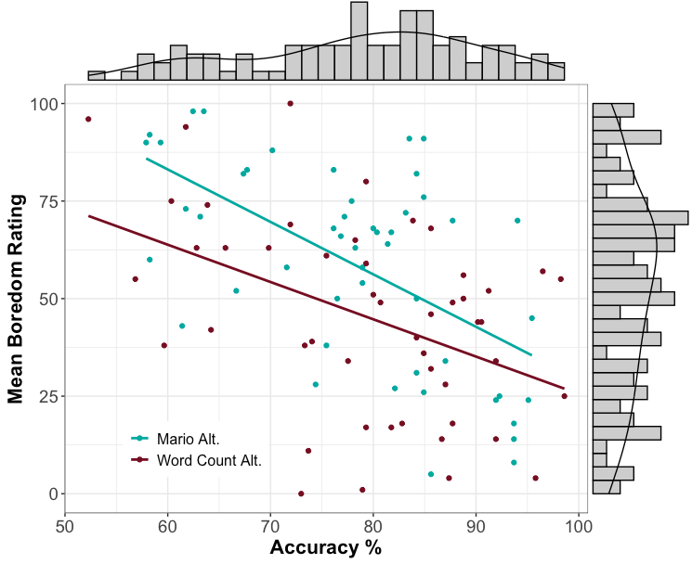
N-Back boredom ratings and average accuracy in Experiment 2.

Note. Accuracy and boredom ratings are averaged across the entire experiment for each participant.
Figure S5
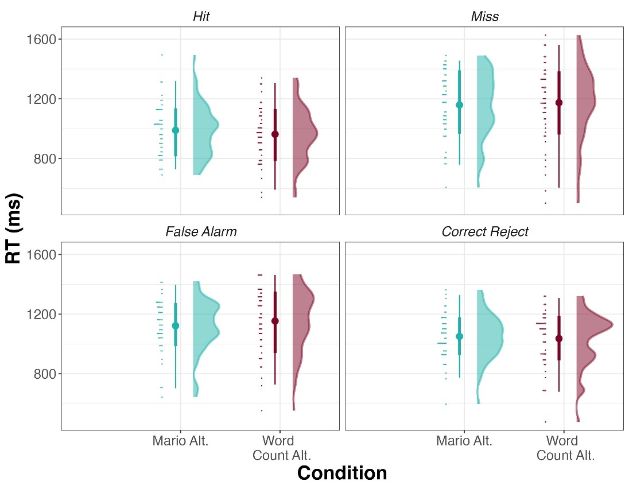
Average Response times for the four response categories for the two conditions in Experiment 2.

Note. Trials where participants gave no response (i.e., pressed neither ‘m’ or ‘z’) were removed from the above figure as there is no response time for these trials.

Figure S6
Response times for the four response categories in Experiment 3.
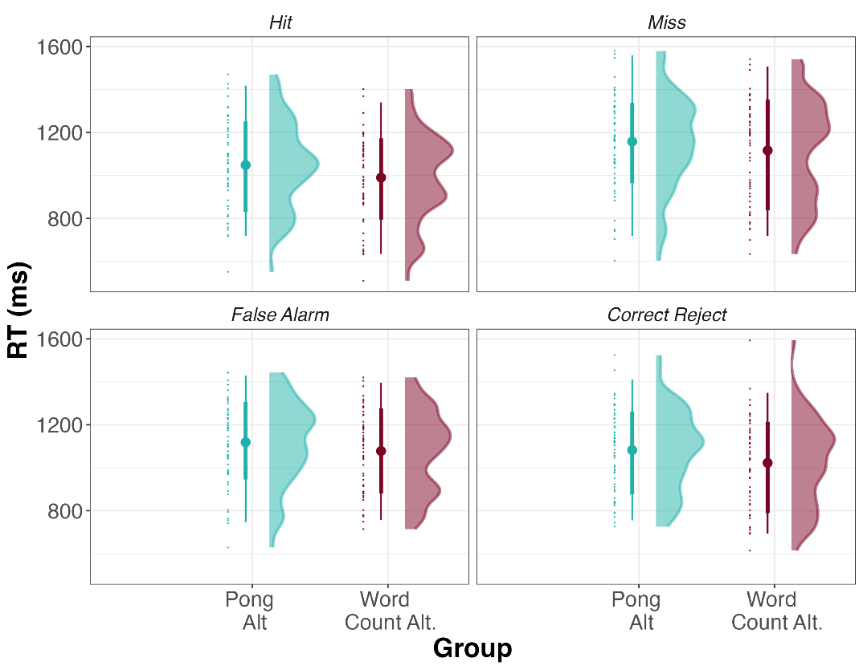

Section 2: Details of priors for Bayesian Mixed Modelling
Effort and Boredom Ratings
For all experiments, the prior distributions were Normal(0, 50) for all analyses investigating effort or boredom ratings.
Accuracy
For all experiments, the prior distributions were Normal(0, 5) for all analyses investigating accuracy.

Section 3: Analysis on true switch out behaviours
In Experiment 3 we also analysed people’s propensity to disengage with the N-Back by “switching out” and returning to the choice screen—where they can choose either N-Back or the alternative task. In the main manuscript we report the results of the analysis on all “switch outs” irrespective of whether a participant then went onto choose the alternative task or not. Below we report the results of the analysis on “true switches”—where a participant voluntarily stopped the N-Back task and then went on to choose the alternative.
The best fitting model (LOO-IC: 1137.7) was the full model, true switch ~ condition + trial number + p(errors) + (trial number + p(errors) | participant). The proportion of errors incurred in the current block was a reliable predictor of switch behaviour (β = 3.24; 95% CI: [.36, 5.31], $\hat{R}=1.00$), with a greater proportion of errors increasing the likelihood a participant would switch to the alternative. While participants in the Pong condition were more likely to switch overall, this effect was not reliable, with 95% credible intervals containing overlapping with zero (β = .48; 95% CI: [-.61, 1.64], $\hat{R}=1.00$). The only difference with the analysis on all switches in the main manuscript is that there is no longer a reliable effect of trial number (β = .48; 95% CI: [-.61, 1.64], $\hat{R}=1.00$)
Section 4: Accuracy analysis removing “no responses”
In the main manuscript we include “no responses” in the accuracy analysis and code these as incorrect. Below, we conduct the same Bayesian mixed modelling analysis but remove these “no responses” to investigate whether they notably alter the results. In Experiment 2 and 3 these “no responses” account for 5% and 6%, respectively, of total responses.
Experiment 2
The best fitting model for Experiment 2 is the full model containing condition, block and trial number. Commensurate with the analysis in the main manuscript there was a reliable effect of block (β = .17; 95% CI: [.11, .24]; R =1.00) and trial (β = -.01; 95% CI: [-.01, -.01]; R =1.00). There was no population level effect of condition on people’s accuracy (β = -.10; 95% CI: [-.46, .25]; R ̂=1.00). There was slight, but not credible evidence in favour of an interaction between participants’ condition and block (β = -.07; 95% CI: [-.16, .02]; R ̂=1.00).
Experiment 3
The best fitting model for Experiment 3 is the model containing trial as a fixed and random effect, analogous to the results reported in the main manuscript. The population level parameter estimates for trial indicate accuracy improved across trials (95% CI: [.001, .003], $\hat{R}=1.00$), noting that there were 200 trials in total.

