Revision of XGE-2024-2111 as invited by the action editor, Jared Medina, Ph.D.

The influence of blindness on auditory context dependency

Supplementary materials

Additional behavioral analysis
As an additional measure to evaluate the performance in the distance estimation task combining the precision and accuracy, we calculated a third parameter the total error (TE), computed as the Pythagorean sum of bias and CV for that stimulus:
${TE}_{i}= \sqrt{{BIAS}_{i}^{2}+{CV}_{i}^{2}}$ (4)

We find a difference among groups by looking at the total error (Fig. S1). Indeed, the main factor Group is significant (χ² = 22.54, p < 0.001), and the main factor Condition (χ² = 168.29, p < 0.001), while there is no significance for the interaction (χ² = 3.44, p = 0.18). The total error is generally smaller in the long compared to the short condition (t₃₃ = 12.63, p < 0.001), highlighting a difficulty more pronounced in estimating shorter distances. Moreover, the total error of the early blind was greater compared to the other two groups (early vs. late: t₃₃ = 4.07, p < 0.001; early vs. sighted: t₃₃ = 4.44, p < 0.001), while the performance of late blind and sighted participants was comparable (t₃₃ = 0.12 p = 1).
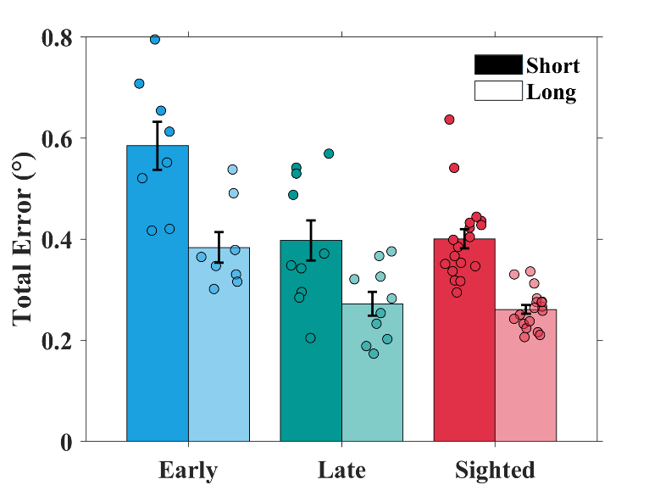
Figure S1. Average of the Total Error in the three groups. The Total Error is significantly greater in the early blind group (in blue) than in the late blind (in green) and the sighted controls (in red), regardless of the distances tested.

In an interesting paper by Aston et al. (2021), it is pointed out that in studies using a method that requires continuous response data, the "true" sensory precision in performing the task is masked by the central tendency effect. The reduction in variability in response does not depend on an actual increase in precision but simply on the central tendency effect. To show that the reduced precision of the early blind group is relative to the distance estimation task cleared by the central tendency effect, we calculated what Aston et al.(2021) call behavioral and sensory precision in all groups of participants using the data in the short-range as examples (for more information on the calculation of variables, refer to Aston et al. (2021)). The results are shown in Fig. S2. The top row shows the group averages of sensory precision (on the left) and behavioral precision (on the right), while the bottom row compares the two indices by showing individual participants' results for all groups. We run a linear mixed-effects model using REML as a convergence criterion. The fixed effects of the model were the between-participant "Group" (early blind, late blind, and sighted) and within-participant factor "Type of Precision" (behavioral, sensory). We found a significant interaction between the factors (χ² = 10.165, p < 0.01), as well as the main effects (Group: χ² = 10.25, p < 0.01; Type of Precision: χ² = 4.54, p < 0.05). The follow-up analyses highlight a significant difference between the early blind group and the other groups (early vs. late: t₆₆ = 3.71, p < 0.01; early vs. sighted: t₆₆ = 4.32, p < 0.001) in sensory precision that is greater, i.e., less precision. Conversely, there is no statistical difference among groups regarding behavioral precision, although graphically, it appears to be smaller for the early blind group. Moreover, the early blind group is the only one with a difference between sensory and behavioral precision (t₃₃ = 3.81, p < 0.001).
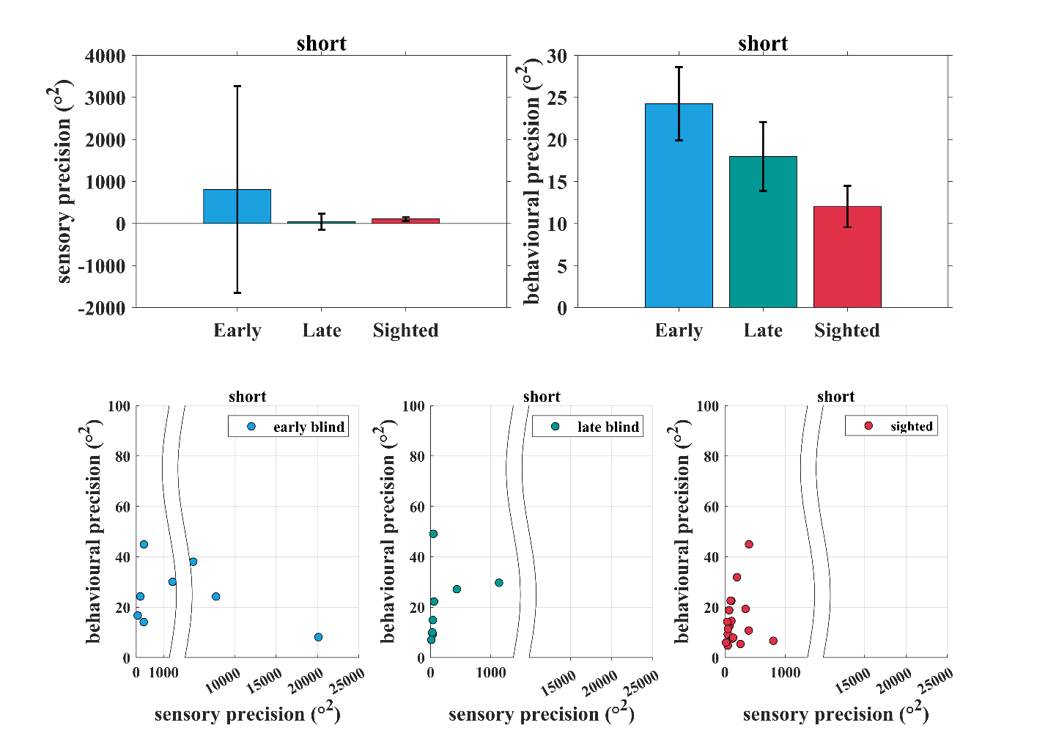
Figure S2. In the top row, average sensory (on the left) and behavioral (on the right) precision for all groups are plotted. In the bottom row, the single data for the two precisions, sensory on the x-axis and behavioral on the y-axis, are reported. Error bars represent ±s.e.m.

Additional Bayesian model analysis

Fig. S3 represents the Bayesian model’s prediction with respect to the bias and the CV. As in Fig. 7 of the manuscript, the predictions of the model (curves) are plotted together with the behavioral data of the three groups (circles). The curves show the predictions for bias and CV, resulting from the same prior width and the same range of WF used in Fig. 7. As in previous literature, when computing the prediction for the CV and Bias based on WF and Prior Width values, a constant non-sensory motor noise is added to the variability (CV). Therefore, to match the same non-sensory noise as Sciutti (2014), a 3° non-sensory noise was added to the model. As for the RI and WF, it is possible to compare how much the model’s prediction fits with the behavioral data (Bias and CV). As for the sighted and late group, the behavioral data are comparable to what the model predicts, and the width of the prior is equivalent. However, it should be noted that the model seems to work better for the data of the long condition compared with the short condition, which may be due to greater homogeneity of the data. We can conclude that the behavior falls within the Bayesian framework for the sighted and late group; the same does not apply to the early blind group. The prediction made by the model is totally different from what the actual data show. If early blind participants had behaved within the Bayesian framework, there would have been a decrease in both Bias and CV.
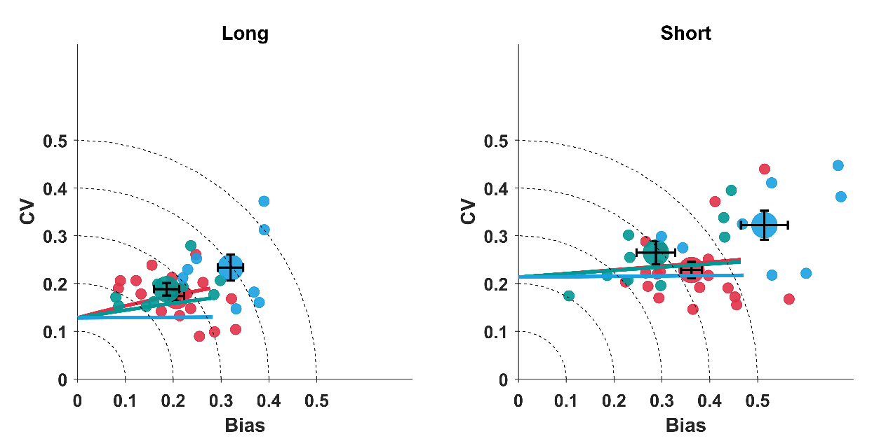
Figure S3 are plotted the average normalized CV against the averaged normalized bias (big circles) and single participants’ data (small circles) obtained from the experimental data. The colored curves represent the predictions of the Bayesian model, adding a fixed non-sensory motor noise of 3. Error bars represent ±s.e.m

Additional References
Aston, S., Negen, J., Nardini, M., & Beierholm, U. (2021). Central tendency biases must be accounted for to consistently capture Bayesian cue combination in continuous response data. Behavior Research Methods, 54(1), 508–521. https://doi.org/10.3758/s13428-021-01633-2
Sciutti, A., Burr, D. C., Saracco, A., Sandini, G., & Gori, M. (2014). Development of context dependency in human space perception. Experimental Brain Research, 232(12), 3965–3976. https://doi.org/10.1007/s00221-014-4021-y

