Revision of XGE-2024-2079R1 as invited by the action editor, Aysecan Boduroglu, Ph.D..
--------------------------------------------------------------------------------------------------------------------

Supplementary materials

1.1 Instructions for Experiment 1A (audiovisual occluder)
Below we provide the standard procedure that was used for conducting the motion prediction experiment in Experiment 1A (audiovisual occluder), including the detailed instructions given to the participants.
In the lab, before participants performed the motion prediction task, the experimenter gave the instructions to the participants with the help of a separate Matlab example program. This example program was the same as the main motion prediction task, except that it was paused after every event in a trial, so that the trial only continued after the experimenter pressed “spacebar” while providing verbal instructions.
The instructions followed the following structure and wording: “In each trial, either an auditory, visual or audiovisual target would be presented at the left edge of the screen and then move horizontally at a constant speed from left to right”. Then the experimenter would start the example trial and an audiovisual target would move from left to right and then stop. The experimenter would say: “Here is an example of an audiovisual trial. You can see a visual target moved from the left edge of the screen to the right. You can also hear a sound moving together with the visual target from left to right. The visual target is a huge blurred blob, even beyond the vertical screen range. Its center is more clear than its outer. The outer it goes, the more blurry it becomes. The sound is white noise, moved together with the visual blob. So the center of the blob was always on the mid-horizontal line and it moved on the mid-horizontal line. The sound was also always on the horizontal line at the center of the blob. So you can consider the blob and the sound as one object.” Then the experimenter would start the trial again, showing the occluder. The experimenter would say something like this: “So after the target moved for a while, it will be occluded by an audiovisual occluder. The visual part of the occluder is a full-screen random noise. The auditory part of the occluder is pink noise different from the target noise. So this means that you cannot see the target; you can not hear the target, but the target is still moving behind the occluder. Your task is to try to keep tracking the target and predict its motion. This audiovisual occluder would appear in all the trials.” Then the experimenter would start the trial again, explaining the task that participants had to do. “So after the target was occluded for a while, the occluder would disappear, along with the target. And a horizontal line would appear on the screen. You need to indicate where the target should be when the occluder is removed, using the computer mouse. For unisensory visual target, you need to click where you think the center of the blob was; for unisensory auditory target, you need to click where the sound was; for audiovisual target, just click where you think the audiovisual target was”. Then the experimenter would let the participants try the task and show them other example trials in the unisensory auditory and visual condition. The experimenter would also explain other details like this: “There are other things you need to know. First, try to fixate on the center cross as you perform the task. Try not to move your eyes. Second, in each trail the target moves at a constant speed. However, the speed may vary in different trials. Also, the time that you can see the target and the time the target is occluded would vary across trials. So try to actively track the target. Third, we do not collect response time data in this task, so you do not need to respond quickly. Try to do the task as accurately as possible. Any other questions?”. If participants had no further questions, the experimenter would start the main task with practice blocks. During the practice blocks, the experimenter would observe how participants responded to check whether they fully understood the task. Then the experimenter would ask participants if they had questions again after the practice blocks.

1.2 Movement speed
In Experiment 1A (audiovisual occluder), 1B (visual occluder) and 2 (no occluder), three stimulus speed conditions (6 degrees of visual angle (dva), 9 dva vs. 12 dva) were included, to discourage participants from performing the task simply by counting the amount of time that elapsed. To test whether participants used the speed information to perform the tasks, we fit a linear model between the participants’ response position and the amount of time that elapsed for each speed condition. The speed is reflected as the slope of this linear model such that the faster speed condition should have a larger slope, if participants used the speed information. On the contrary, if participants performed the task by counting time that elapsed, then the slope in different speed condition should not differ. For each experiment, we conducted repeated-measures ANOVAs with the factor Speed (6 dva, 9 dva, vs. 12 dva) on the slopes of the linear fits, for all target conditions combined. Following our discussion in the main manuscript and considering that participants might count the time that elapsed only for the auditory moving stimulus, we also conducted the same ANOVAs with the factor Speed (6 dva, 9 dva, vs. 12 dva) only for the auditory condition in three Experiments. In sum, we observed varying slopes for most of the different speed conditions in all three experiments, implying that participants indeed used speed information to localize the target, instead of solely counting time.
In Experiment 1A, 1B and 2, ANOVAs performed on slope averaged across different target modality conditions revealed a significant main effect of Speed (all F > 24.45, all p < .001, all $η_{p}^{2}$ > .42) (Figure S1). Post-hoc analyses showed similar results across these experiments. Specifically, the slope of the 12 dva speed was the largest (all t > 2.88, all p < .05, all d > .38); the slope of the 9 dva speed was also larger than that of the 6 dva speed (all t > 4.31, all p < .001, all d > .56)
In Experiment 1A, 1B and 2, ANOVAs performed on slope in auditory conditions revealed a significant main effect of Speed (all F > 6.20, all p < .01, all $η_{p}^{2}$ > .15). Post-hoc analyses showed that in Experiment 1B (visual occluder) the slope of the 12 dva speed was the largest; the slope of the 9 dva speed was also larger than that of the 6 dva speed (all t > 3.88, all p < .001, all d > .67). Instead, in Experiment 1A (audiovisual occluder) and 2 (no occluder), the slope of the 6 dva speed was the smallest (all t > 2.62, all p < .05, all d > .46); the slope of the 9 dva speed did not differ from that of 12 dva speed (all t < 1.42, all p > .05). To sum up, the results of this speed-dependent analysis showed that in the current study, observers could distinguish between different speeds and used the speed information to track the objects, thus excluding the possibility that observers simply counted the amount of elapsed time to track target objects irrespective of motion speed.
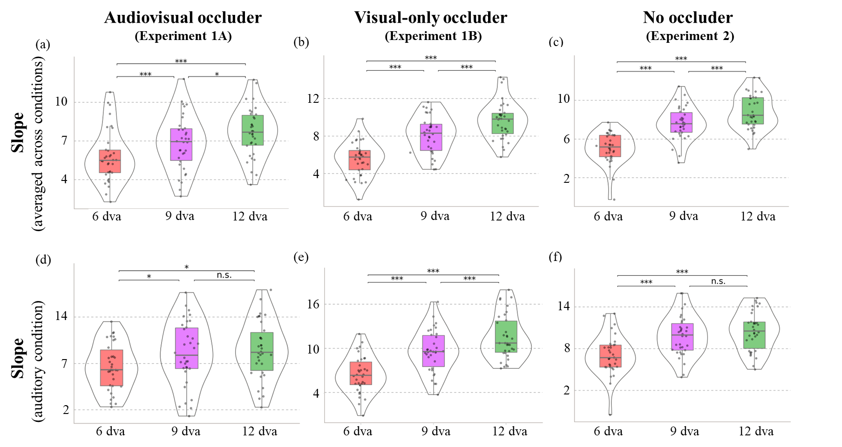
Figure S1. Results of speed-dependent analysis of slopes. Panels (a), (b) & (c) show the slopes averaged across A, V and AV conditions in 6 dva (pink), 9 dva (purple), and 12 dva (green) conditions in Experiment 1A (with an audiovisual occluder), Experiment 1B (visual-only occluder), and Experiment 2 (no occluder). Panels (d), (e) & (f) show the same for slopes in the auditory condition. * p<.05, *** p<.001.

1.3 Behavioral similarities between unimodal and multimodal conditions
To explore how participants used the available auditory and visual information to perform the tasks in all four experiments, we tested how well behavioral responses in the unisensory auditory and visual conditions could predict responses in the audiovisual condition. This was compared to how well responses in the audiovisual condition could predict behavior in (other trials of) the audiovisual condition itself. We did this by calculating the group-level correlation between conditions in a split-half bootstrapping procedure. If participants rely only on unisensory information, then we expect that performance in the audiovisual condition is as strongly correlated with itself (AV-AV condition) as with performance in one of the unisensory conditions (i.e. using only visual (AV-V condition) or auditory (AV-V condition) information). To do so, the data in all three conditions (A, V and AV conditions) were first randomly split into two halves while balancing the speed (i.e., each half includes equal trials from each speed condition, such that any differences between the conditions cannot be explained by speed). For both halves of the data, we calculated the localization error and precision in auditory, visual, and audiovisual conditions per participant. Then we calculated the correlations across participants between the first half of the audiovisual condition with the second half of the auditory, visual, and audiovisual conditions. By bootstrapping this procedure 1000 times, we could statistically compare the correlation between responses in different conditions (AV-AV condition vs. AV-V condition and AV-V condition).
In Experiment 1A (audiovisual occluder), for localization error, the audiovisual condition was more strongly correlated with itself than with unisensory auditory and visual conditions [audiovisual vs. auditory: $r_{mean}$=.78 vs. .59; t(999) = 129.27, p < .001, d = 4.09; audiovisual vs. visual: $r_{mean}$ =.78 vs. .61; t(999) = 106.70, p < .001, d = 3.37] (Figure S2). This indicates that localization error in the audiovisual condition was different from that in the unisensory conditions. For precision, however, the audiovisual condition was more strongly correlated with itself than with the unisensory auditory condition [$r_{mean}$ =.58 vs. .26; t(999) = 116.97, p < .001, d = 3.70], but there was no significant difference between AV-AV correlations audiovisual-unisensory visual correlations [$r_{mean}$ =.58 vs. .59; t(999)=-1.86, p > .05]. This shows that participants could utilize either unisensory inputs to localize target objects, but the auditory component did not contribute to response precision.
In Experiment 1B (visual occluder), 2 (no occluder), and 3 (static targets), for both localization error and precision, the audiovisual condition was more strongly correlated with itself than with unisensory auditory and visual condition (Experiment 1B: all t > 39.36, all p < .001, all d > 1.24; Experiment 2: all t > 64.79, all p < .001, all d > 2.04; Experiment 3: all t > 47.04, all p < .001, all d > 1.48) (Figure S2).
In sum, in all four experiments, behavior in the audiovisual target condition is distinguishable from behavior in the two unisensory conditions. This suggests that both components of the multisensory stimuli were used to affect behavior, even in Experiments 1 and 2 where no multisensory benefits were observed.
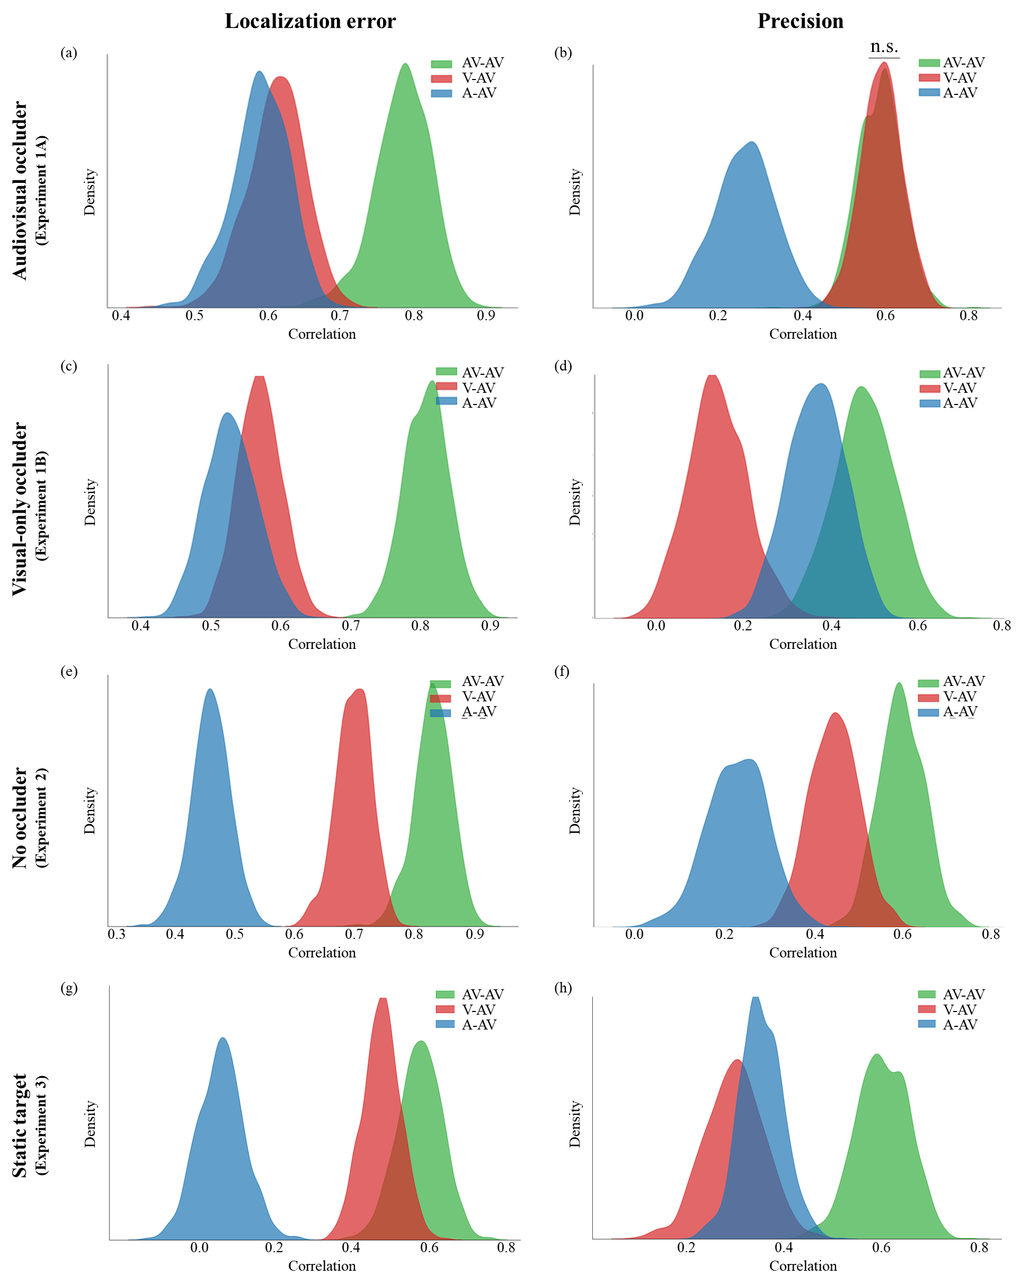
Figure S2. Correlation distribution for localization error and precision in all four experiments. The left column depicts the correlation distribution for localization error, and the right column depicts the correlation distribution for precision; each row depicts data of a different experiments. Each plot shows the distributions of 1000 permuted correlations in the A-AV (blue), V-AV (red), and AV-AV (green) conditions. n.s. = “not significant” (p > .05).

1.4 Predicted, observed, and simulated weights (complete results)
In Experiment 1A (audiovisual occluder), based on the model prediction, participants should weight the auditory and visual information with a ratio of 0.4 to 0.6. Interestingly, according to the observed data in the audiovisual condition, the visual component was weighted even more than predicted by the MLE model, with a mean ratio of 0.3 to 0.7. This weighting was less extreme, however, than what would be expected if responses were driven by the visual component only (as is reflected by single visual modality simulated weights with a ratio of 0 to 1). The same was true for Experiment 1B (visual occluder), based on the model prediction, participants should weight the auditory and visual information with a ratio of 0.6 to 0.4. In the actual data, participants weighted the auditory and visual information with a ratio of 0.9 to 0.1. However, this observed weight was less extreme than what would be expected if responses were driven by the auditory component only (as is reflected by single auditory modality simulated weights with a ratio of 1 to 0).
In Experiment 2 (no occluder), according to MLE, participants should weight the auditory and visual information with a ratio of 0.4 to 0.6. However, based on the observed data, participants weighted the auditory and visual information more extremely with a ratio of 0.3 to 0.7. This observed weight was less extreme for the single visual modality simulated weight (with a ratio of 0.2 to 0.8) if participants relied solely on visual information and ignored auditory information completely.
In Experiment 3 (static targets), based on the model prediction, participants should weight the auditory and visual information with a ratio of 0.5 to 0.5. In the actual data, participants weighted the auditory and visual information with a ratio of 0.3 to 0.7. This observed weight was less extreme than the single visual modality simulated weight (with a ratio of 0 to 1) if participants relied solely on visual information and ignored auditory information completely.
In sum, the predicted weights were less extreme that the observed weights, suggesting that participants weighed the most reliable component more than deemed optimal by the MLE model. The observed weights, however, were still less extreme than the single modality simulated weight (which reflected the exclusive usage of a single sensory modality), suggesting that participants did not solely rely on a single sensory modality to guide their behavior.

1.5 Individual MLE predictions of performance
In all experiments, localization precision in the AV condition was worse than the maximum likelihood estimation (MLE), which we took as evidence that integration of the auditory and visual components was suboptimal at best (and non-existent at worst). To test whether the model could predict the audiovisual condition consistently at an individual level, we correlated the performance (localization error and precision) predicted by the model with the observed audiovisual condition in all four experiments. If the model predicts the data consistently at an individual level, we expect a significant positive correlation. As shown in Figure S3, for both the localization error and precision in all four experiments, all the correlations between the observed data in audiovisual condition and their model predictions were significant (all r > .43, all p < .01).
Overall, the model captures a substantial amount of variance in the data. Yet, observers systematically perform less well than they could if they optimally combined information from both modalities as shown by the deviation from the identity line.
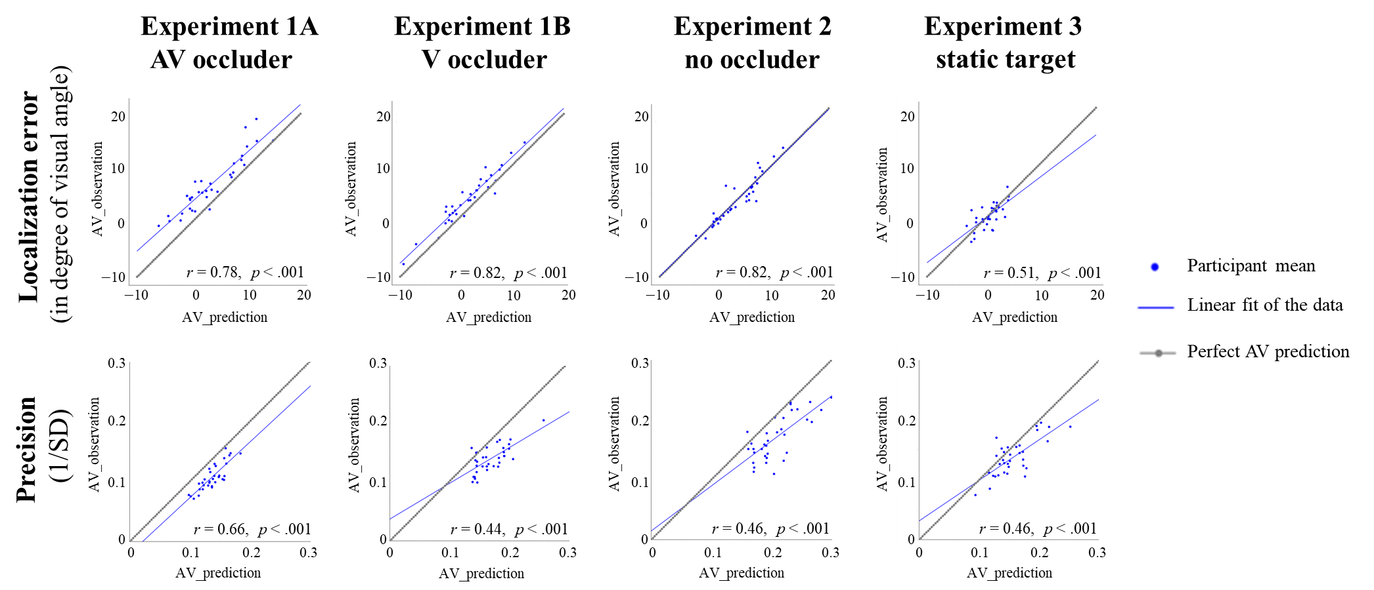
Figure S3. Relation between model prediction and observed behavior across participants, in all four experiments. The top row depicts the relation between observed and predicted localization error, and the bottom row depicts the relation between observed and predicted response precision; each column depicts data of a different experiments. In each plot, the identity line indicates perfect model prediction. If the model perfectly predicted performance in the audiovisual condition, all data points would lie on this line. Blue dots are individual subjects, and the blue line shows the linear fit of the data. Significant positive correlations indicate that the model could capture the data significantly.

1.6 Shared noise in MLE
One key assumption of the MLE model, is that all the variance in the two unimodal conditions can be combined, to generate an audiovisual response of reduced variance. This assumes that the variance in the two unimodal condition is fully independent. However, some variance might be shared between the unimodal conditions. This could include, for instance, noise that is introduced after the stimuli have been shown and internalized (e.g., behavioral response noise), or task-specific noise that similarly affects performance in both unimodal conditions (e.g., a bias toward the center of the screen, an attractive or repulsive inter-trial response bias, etc.) (Otto et al., 2013; Otto & Mamassian, 2012). Such shared noise would constitute a fixed amount of the observed variance in all conditions (A, V, and AV). If the amount of shared noise is non-zero, the amount of variance reduction in audiovisual conditions (and the weighing of unimodal components) predicted by the MLE model (Equation 3 in the main body text) describes not an optimal combination of unimodal conditions, but an upper limit thereof (one that only applies under the assumption of 0 shared noise). In this section, we investigate to what extent our conclusions reported in the main manuscript would change for various levels of shared noise between the different (A, V, and AV) conditions.
We define this shared noise as C, with $σ_{C}^{2}$ being the shared variance. Thus, the observed precision in auditory, visual, and audiovisual conditions, which we now term $σ_{A_C}^{2}, { σ}_{V_C}^{2}, and σ_{AV_C}^{2}$, would comprise both shared variance $σ_{C}^{2}$ (that is shared across A, V, and AV conditions) and unique variance $σ_{A}^{2}$, $σ_{V}^{2}$, $σ_{AV}^{2}$ (that is specific to each of the three conditions) (see Equation S1, S2, and S3).
$σ_{A_C}^{2}= σ_{A}^{2}+ σ_{C}^{2}$ (Equation S1)
$σ_{V_C}^{2}= σ_{V}^{2}+ σ_{C}^{2}$ (Equation S2)
$σ_{AV_C}^{2}= σ_{AV}^{2}+ σ_{C}^{2}$ (Equation S3)
Considering that only the condition-specific variance can be combined to produce variance reduction in the audiovisual condition, the variance reduction should be computed after removing the shared variance from the observed variance (by reversing Equations S1 and S2 to isolate the unique variance component), as is done in Equation S4; that is, using the unique variance $σ_{A}^{2}$ and $σ_{V}^{2}$ after subtracting the shared variance $σ_{C}^{2}$. Finally, the shared variance must be added to the predicted variance in the audiovisual condition, since it contributes equally to all conditions, including the audiovisual condition (Equation S5).
Depending on the different levels of shared variance across conditions, the difference between the MLE prediction ($σ_{AV_prediction_MLE}^{2}$ in Equation S6) and the adjusted MLE prediction described above ($σ_{AV_prediction_adjusted_MLE}^{2}$ in Equation S5) may change dramatically. When the amount of shared variance is 0, the (original) MLE prediction is identical to the adjusted MLE prediction. However, when the proportion of shared noise is larger, the MLE prediction would become more optimistic than the adjusted MLE prediction because it falsely assumes that all the observed variance can contribute to the variance reduction in the audiovisual condition. At the extreme end, where all observed variance is shared across conditions, the variance in all conditions (including the audiovisual condition) equals $σ_{C}^{2}$, so that there is no variance reduction, but this would still be ‘optimal’ based on the adjusted MLE model (Equation S5).
$σ_{AV_prediction}^{2}=\frac{{σ_{A}^{2}σ}_{V}^{2}}{σ_{A}^{2}+σ_{V}^{2}}$ (Equation S4)
$σ_{AV_prediction_adjusted_MLE}^{2}=σ_{AV_prediction}^{2}+σ_{C}^{2}$ (Equation S5)
$σ_{AV_prediction_MLE}^{2}=\frac{{σ_{A_C}^{2}σ}_{V_C}^{2}}{σ_{A_C}^{2}+σ_{V_C}^{2}}$ (Equation S6)
Because the true amount of shared variance is unknown in our study, we next evaluate how our conclusions would be affected by various levels of shared variance. This amount may vary in magnitude anywhere between 0 (there is no shared noise between conditions) and all of the variance observed in one of the three conditions (i.e., the conditions with the smallest variance then comprise only shared noise). Thus, for each participant, we iterated through this exhaustive range of calculated proportions of shared variance $σ_{C}^{2}$, ranging from 0% to 100% of shared variance, increasing 1% per step. Here, 100% means that the amount of shared variance $σ_{C}^{2}$ was equal to all of the observed variance in the condition with the lowest variance (e.g., the minimum of $σ_{A_C}^{2}$, $σ_{V_C}^{2}$, and $σ_{AV_C}^{2}$), as any higher level of variance could not be shared between all three conditions. At each of these 101 noise levels, we calculated the adjusted MLE prediction (based on Equation S1, S2, S4, and S5) for each participant. Finally, at each noise level, we conducted paired t-tests between the observed performance in the audiovisual condition and the adjusted MLE predictions (as we did in the main manuscript with the original MLE predictions). This allowed us to test from which proportion of shared noise onwards, the conclusions in the main manuscript (based on the original MLE predictions) may depend on the occurrence of shared variance.
As shown in Figure S4, the adjusted MLE prediction no longer differs from the observed audiovisual condition when the amount of shared variance between conditions exceeded 92%, 83%, 82%, 62% of the observed variance, in Exp 1A, 1B, 2 and 3, respectively. First, these results suggest that even when very substantial percentages of the variance observed in Experiments 1A, 1B, and 2 (91%, 82%, and 81%, respectively) would be shared between conditions, this would not alter the conclusion that hearing and vision were not optimally combined in these experiments. Conversely, the existence of shared variance may explain why in Experiment 3 hearing and vision were not optimally combined according to (original) MLE predictions; if 60% of the observed variance (or more) was shared between conditions, participants in fact did optimally combine hearing and vision for localizing static targets. Whether or not this is the case remains an open question. Future studies may attempt to experimentally or analytically estimate the true amount of shared variance, for instance by including dedicated experimental conditions or through computational modeling approaches.
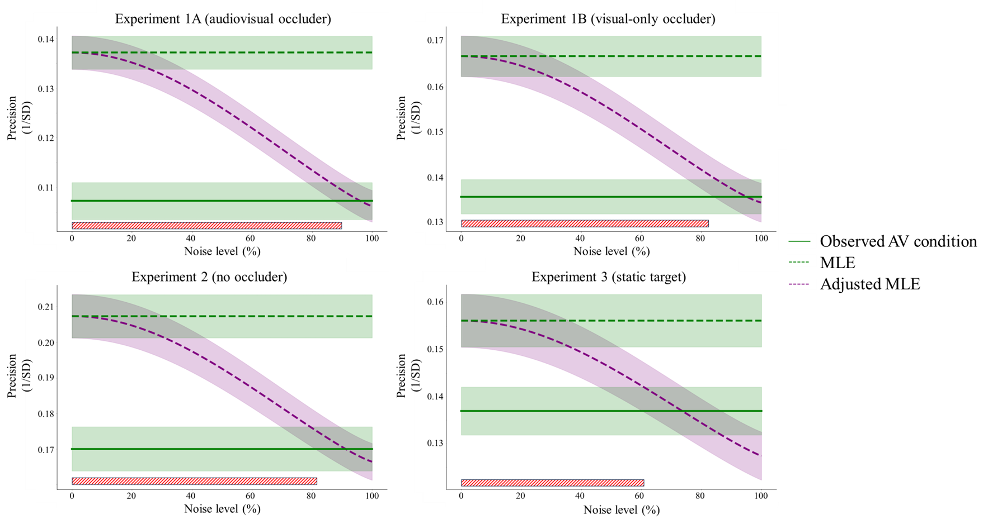
Figure S4. Response precision (y-axis) is depicted as a function of assumed shared variance between conditions (x-axis), for all four experiments. The observed audiovisual precision (solid green line) and the precision predicted by the traditional MLE models (dashed green line) are identical to those reported in the main manuscript. The dashed purple line depicts the precision predicted by the adjusted MLE model, and the red line at the bottom indicates where it significantly differs from the observed precision in the audiovisual condition. Shaded regions indicate the standard error.

Taking into account shared variance in the MLE model, also allows us to calculate the optimal weighing of the auditory and visual components, for different levels of shared variance (Equation S7). Comparing the observed weights (how participants actually weighed the auditory and visual information to localize an audiovisual target) to the traditional MLE estimates, led us to conclude that observers weighed the two modalities more extremely than is optimal. Here, we compared the observed weights to the weight predicted by the adjusted MLE, to explore at what level of shared variance, the observed weights could be considered optimal. As shown in Figure S5, the weights predicted by the adjusted MLE (although more extreme than those predicted by the traditional MLE) never reach the observed weight in Exp 1A, 2 and 3, irrespective of the assumed level of shared variance. In Exp 1B, the weights predicted by the adjusted MLE reach the observed weights if 92% or more of shared variance is assumed between conditions. These results suggest that participants tend to favor the most reliable component of a multimodal stimulus more than an ideal observer would.
$w_{A_MLE_adj}= \frac{σ_{V}^{2}}{σ_{A}^{2}+σ_{V}^{2}};w_{V_MLE_adj}=1-w_{A_MLE_adj}$ (Equation S7) 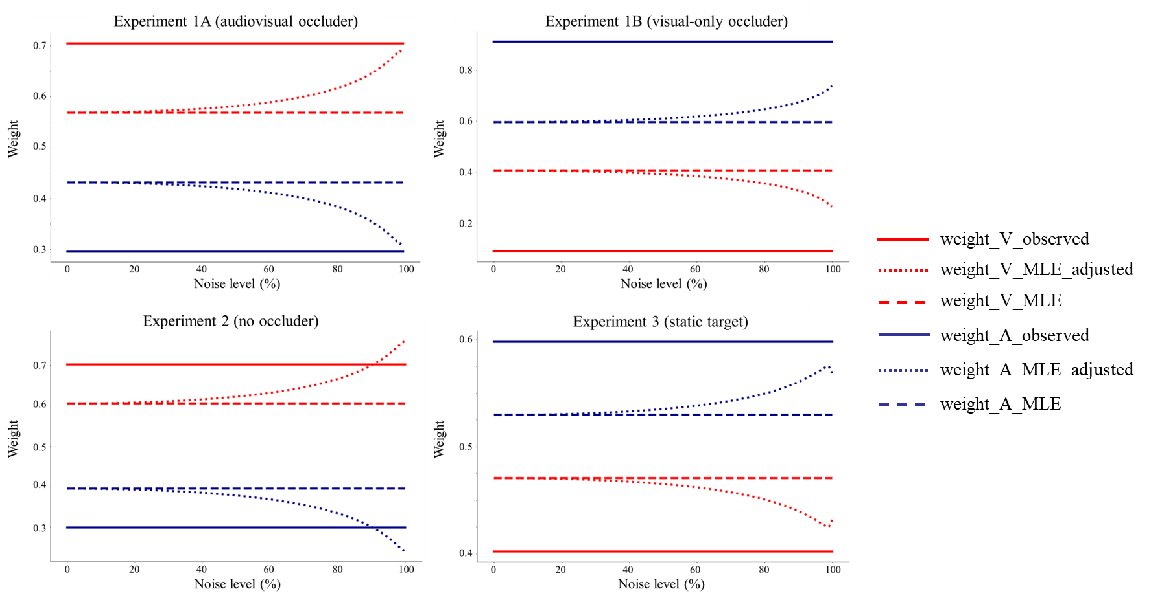
Figure S5. Relation between weight (y-axis) and noise level (x-axis) for observed weight (blue and red lines), MLE prediction (dashed blue and red lines), and adjusted MLE prediction (dotted blue and red lines), in all four experiments. Blue lines and red lines indicate the weights assigned to the auditory and visual components, respectively.

1.7 Bayesian statistics
Some of our conclusions partially rely on the interpretation of null effects. This includes, for instance, analyses indicating that performance in the audiovisual condition is not higher than in the two unisensory conditions. Although we find converging evidence for the claim that (say) participants in Experiments 1A and 1B rely almost exclusively on a single unimodal condition (with more evidence stemming from our correlation analyses, and weight analyses), it may still be useful to quantify the evidence for a null effect between audiovisual and unimodal conditions. To this end, we conduct Bayesian paired samples t-tests using JASP 0.17.3.0 (JASP Team, 2024). For both localization error and precision in all four experiments, we specifically tested whether or not the performance in the audiovisual condition was better than the unisensory auditory or visual conditions (i.e., auditory vs. audiovisual; visual vs. audiovisual). We used the labels suggested by Kass and Raftery (1995) for the interpretation of Bayes factors. Specifically, BFs larger than 3 provides evidence in favor of a difference between conditions; BFs between 0.3 and 3 indicate that there is insufficient evidence to adjudicate between the presence or absence of a difference between conditions; BFs smaller than 0.3 are taken as evidence for the null (no difference between conditions).
In Experiment 1A (audiovisual occluder), for localization error, we found evidence that mean localization error for audiovisual targets was not smaller than that for visual targets (${BF}_{-0}$ = .05) or auditory targets (${BF}_{-0}$ = .01), indicating localization performance in the audiovisual condition was not better than either unisensory conditions (20 and 100 times stronger evidence for the null than for an audiovisual advantage, respectively). For precision, we found decisive evidence that audiovisual targets yielded more precise localization than auditory targets (${BF}_{+0}$ = 1.07×${10}^{4}$), but we found no conclusive evidence that audiovisual targets yielded more precise localization than visual targets (${BF}_{+0}$ = 1.54).
In Experiment 1B (visual-only occluder), for localization error, we found evidence that mean localization error for audiovisual targets was not smaller for visual targets (${BF}_{-0}$ = .02) or auditory targets (${BF}_{-0}$ = .10), indicating localization performance in audiovisual condition was not better than both unisensory conditions (50 and 10 times stronger evidence for the null than for an audiovisual advantage, respectively). For precision, we found decisive evidence that audiovisual targets yielded more precise localization than visual targets (${BF}_{+0}$ = 1.24×${10}^{6}$), but we found no conclusive evidence that audiovisual targets yielded more precise localization than auditory targets (${BF}_{+0}$ = 2.02).
In Experiment 2 (no occluder), for localization error, we found evidence that mean localization error for audiovisual targets was not smaller than for visual targets (${BF}_{-0}$ = .07), with 14 times more evidence for the null than for an audiovisual advantage. The evidence for an advantage of audiovisual targets over auditory targets, however, was inconclusive (${BF}_{-0}$ = 1.36). For precision, we found decisive evidence that audiovisual targets yielded more precise localization than auditory targets (${BF}_{+0}$ = 6.05×${10}^{5}$), but we found no conclusive evidence that audiovisual targets yielded more precise localization than visual targets (${BF}_{+0}$ = 2.13).
Summarizing the Bayesian analyses for Experiments 1 and 2, in terms of localization error there is decisive evidence against a multimodal advantage. In terms of precision, there is no evidence for a multimodal advantage either, but the support for the null remains inconclusive.
In Experiment 3 (static targets), for localization error, we found evidence that mean localization error for audiovisual targets was not smaller than for visual targets (${BF}_{-0}$ = .26), with 4 times more evidence for the null than for an audiovisual advantage. We also found inconclusive evidence that localization error for audiovisual targets was smaller than auditory targets (${BF}_{-0}$ = .58). Importantly, for precision, we found decisive evidence that audiovisual targets yielded more precise localization than both auditory targets (${BF}_{+0}$ = 6.07×${10}^{2}$) and visual targets (${BF}_{+0}$ = 3.56×${10}^{6}$).
Summarizing the Bayesian analyses for Experiment 3, in terms of localization error there is no evidence for a multimodal advantage. In terms of precision, however there is substantial evidence for a multimodal advantage. Taken together, the Bayesian analyses confirm the key results reported in the main manuscript.

References:
JASP Team (2024). JASP (Version 0.19.0)[Computer software].
Kass, R. E., & Raftery, A. E. (1995). Bayes factors. Journal of the American Statistical Association, 90(430), 773-795. https://doi.org/10.1080/01621459.1995.10476572
Otto, T. U., Dassy, B., & Mamassian, P. (2013). Principles of multisensory behavior. Journal of Neuroscience, 33(17), 7463–7474. https://doi.org/10.1523/JNEUROSCI.4678-12.2013
Otto, T. U., & Mamassian, P. (2012). Noise and correlations in parallel perceptual decision making. Current Biology, 22(15), 1391–1396. https://doi.org/10.1016/j.cub.2012.05.031

