Supplemental Online Materials for Partitioned Prosociality:
Why Giving a Large Donation Bit-by-Bit Makes People Seem More Committed to Social Causes

Table of Contents

Description | Page Numbers
Full accounting of preregistered exclusion criteria for each study | S2-S3
Supplemental Study (S1) | S4
Stimuli for Study 3 | S5-S6
Results plotted by the specific donation log for Study 3 | S7
Supplemental Study (S2) | S8-S13
Stimuli and additional information for Study 4 | S14-S18
Plotting the results by the specific stimuli used to manipulate lump sum versus partitioned giving for Study 4 | S19
Supplemental Study (S3) | S20 – S23
Stimuli used in Studies 5a and 5b | S24 – S26
Analyses of exploratory measures from Studies 3, 5a, 5b | S27
Links to stimuli for Study 6 | S28

Table S1

Full accounting of the preregistered participant exclusions from each study

Note. The beginning number of observations can differ from the number of participants for whom the study was posted for the following reasons: Factors associated with the platform and the beginning number of observations including partial responses and/or duplicate responses.

Study 1 | N
obs begin | 258
obs after removing duplicate ids | 246
obs after removing progress < 100 | 244
obs after less than 30 seconds | 243
obs after failing one or both attn checks | 231
Study 2 | N
obs begin | 509
obs after removing duplicate ids | 501
obs after removing progress < 100 | 498
obs after less than 30 seconds | 489
obs after failing one or both attn checks | 472
Study 3 | N
obs begin | 404
obs after removing duplicate responses | 401
obs after removing progress < 100 | 399
obs after removing failed attn checks | 391
obs after dropping failed spreadsheet attn check | 389
Study 4 | N
obs begin | 509
obs after removing duplicate responses | 499
obs after removing progress < 100 | 495
obs after dropping failed attn checks | 442
obs after dropping failed spreadsheet attn check | 438
Study 5a | N
obs begin | 610
obs after removing duplicate responses | 596
obs after removing progress < 100 | 593
obs after removing failed attn checks | 543
obs after dropping failed spreadsheet attn check | 542
Study 5b | N
obs begin | 510
obs after removing duplicate responses | 506
obs after removing progress < 100 | 498
obs after removing failed attn checks | 473
obs after dropping failed spreadsheet attn check | 466
Study 6 | N
obs begin | 516
obs after removing duplicate responses | 503
obs after removing progress < 100 | 495
obs after removing failed rc intro | 485
obs after removing failed rc end (amount donated) | 466
obs after removing outliers (3 SD away mean) | 456
Study S1 | N
obs begin | 255
obs after removing duplicate ids | 246
obs after removing progress < 100 | 246
obs after less than 30 seconds | 237
obs after failing one or both attn checks | 219
Study S2 | N
obs begin | 448
obs after dropping read check fail | 438
obs after dropping attn check fail | 420
Study S3 | N
obs begin | 261
obs after removing duplicate ids | 243
obs after removing progress < 100 | 241
obs after failing one or both attn checks | 203
obs after failing check about logging values in calendar | 183

Supplemental Study 1 (S1)

Study S1 was identical to Study 1 except that we made it explicit to participants how much the donor earned each year.
Method
Participants
We posted the study for 250 responses to Mechanical Turk for adult participants from the United States. Following our preregistered data exclusions, there were 219 participants (see Table S1)
Procedure
Participants read the same scenario about the real estate attorneys as they did in the individual donor condition in Study 1. We made the following changes to the scenario. Participants learned that both attorneys earned $150,000 in 2020 after taxes. At the end of 2020, they both independently decided to give $2,200 to the same charity in 2021. One attorney gave a single donation of $2,200. The other attorney made 52 separate donations to the charity, for a total donation amount of $2,200.
Participants answered the same two questions about the individual donors as they did in Study 1: (1) If you had to say, which person do you think is more committed to giving back to the community? (2) If you had to say, which person do you think cares more about helping people in need?
For each of the two dependent variables, we ran a one-sample binomial test. This tests whether the proportion of participants selecting the company that gave in a lump sum versus the company that gave in partitions as the one that is more committed to prosocial giving differs significantly from 50%.
Results
For the first question, 80% of participants thought the donor who gave in partitions was more committed to giving back to the community, and 78% though this donor cared more about helping people in need. One-sample binomial tests show that the proportion of participants selecting the two donors differed significantly from 50% for both dependent variables, all p values < .001.
Does the effect depend on whether the partitioned or lump sum donor was presented first? A chi-square test of independence showed that the results did not significantly depend on the order in which the donors were presented, (the p values for both the dependent variables were greater than p = .304).
Discussion
This study equated the resources of the donors by holding their yearly salary constant. The results replicated the findings from Study 1, suggesting that inferences about the donor’s income do not account for the differences between the donor that gives in partitions and the one that gives in lump sums.

All stimuli used in Study 3
Lump sum condition
Donation Log 1 | Donation Log 2 | Donation Log 3
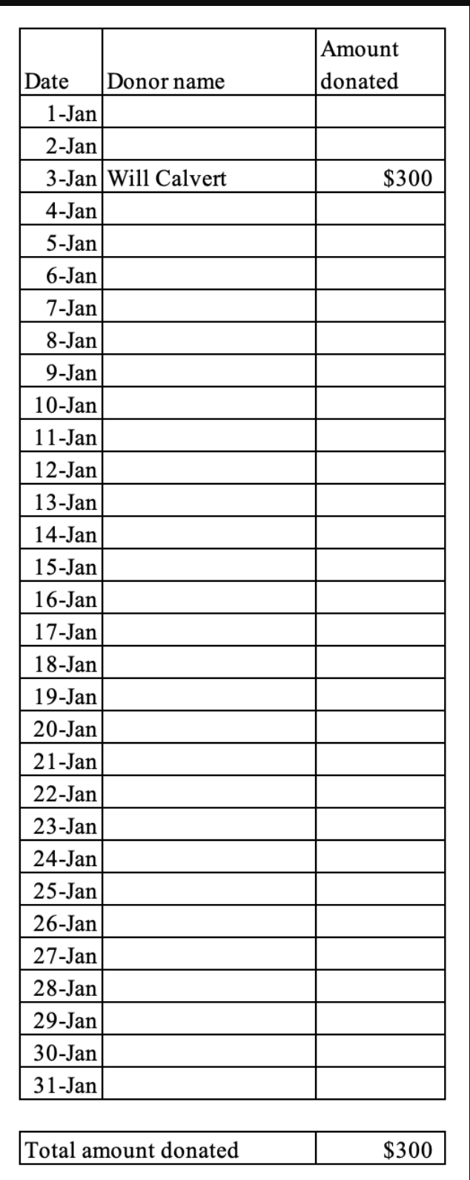 | 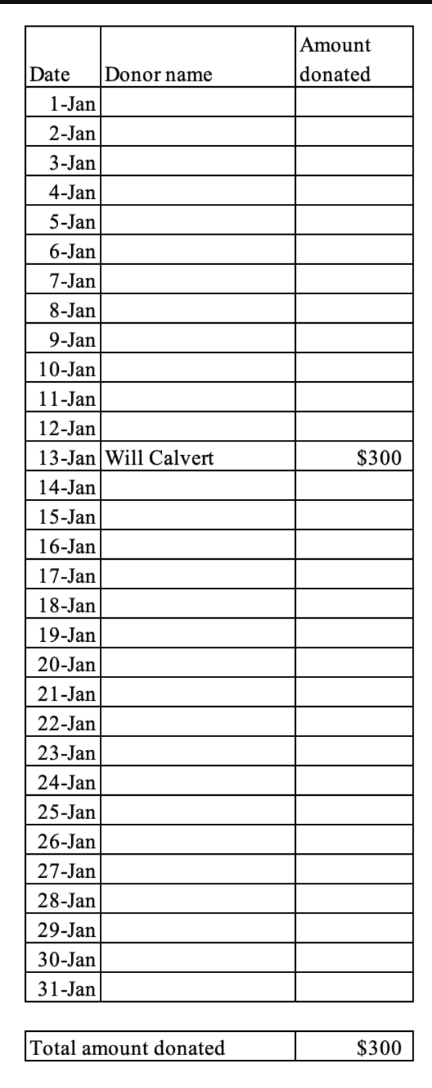 | 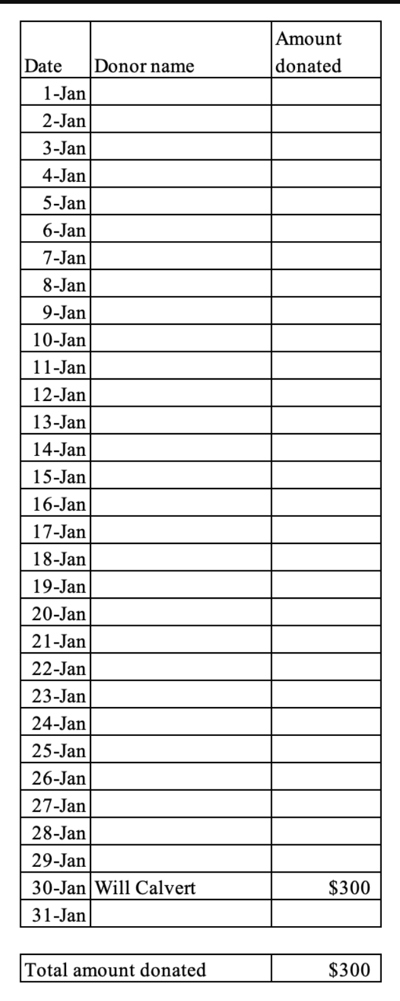

Partitioned (Logs with the same in the explicit and non-explicit pre-commitment conditions)
Donation Log 1 | Donation Log 2 | Donation Log 3
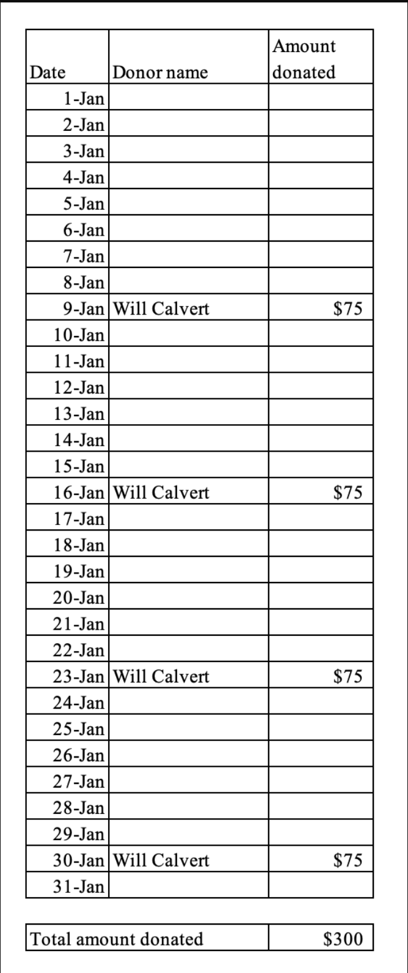 | 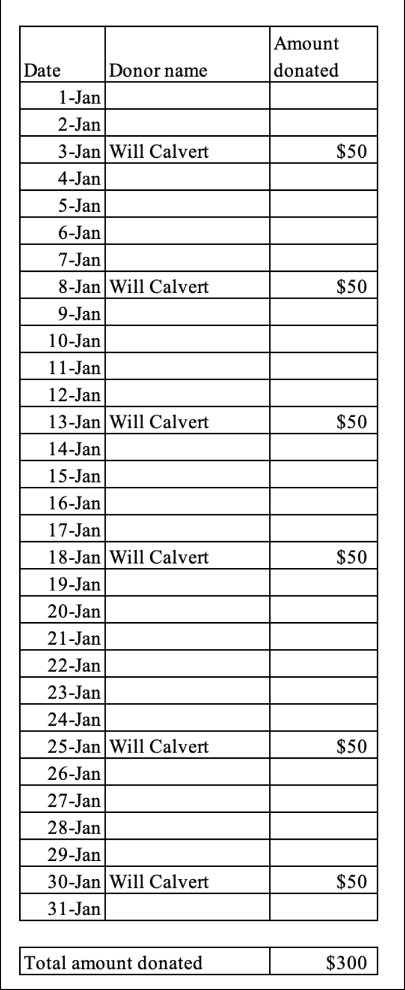 | 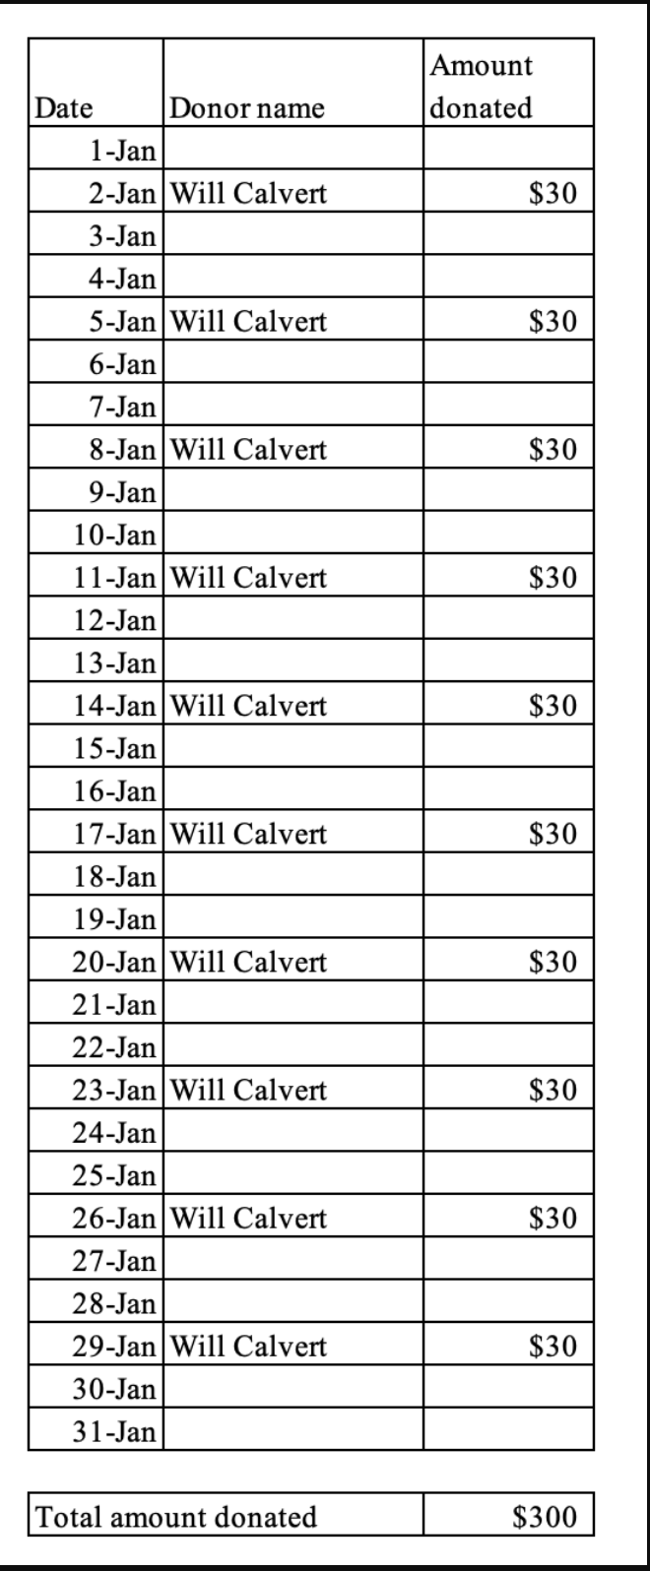

Results plotted by the specific donation log for Study 3

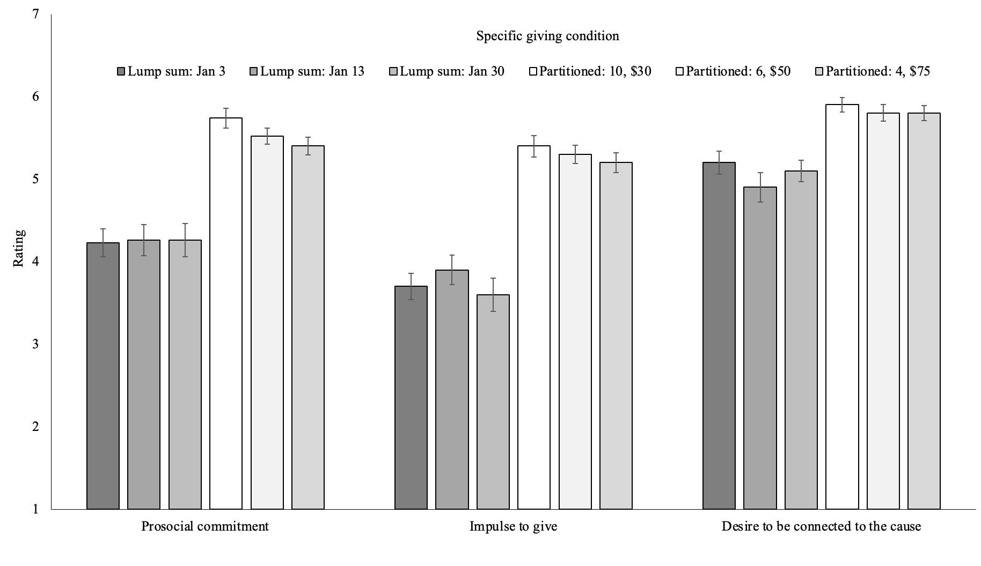
Note. Error bars are +/- SEM
Supplemental Study 2

The design of Study S2 was similar to that of Study 3. We did not vary whether the partitioned-giving donor pre-committed to giving in partitions. Instead, we varied whether this donor gave in equal or unequal partitions. We did not make specific predictions about this variable but manipulated it for exploratory reasons. In this study, we also made it more explicit to the participants when the fundraising initiative began and ended, and we measured a wider range of variables. We collected these data in the earlier stages of this project, so we included a wider range of moral-praise-related variables to get a better sense of the scope of the effect. Thus, in addition to measuring judgments of the donor’s prosocial commitment, we also measured judgments of their moral character, trustworthiness, and future prosocial actions. We included these variables in accordance with Anderson et al. (2020), who suggest that moral praise involves an assessment of a person’s moral character, trustworthiness, and predictions about their future actions.
We also explored whether people perceive the donation as more transactional when the donor engages in lump-sum giving versus partitioned giving. Additionally, we measured perceptions of the donor’s warmth and flakiness but did not make predictions about these variables. However, we did find that the effects on moral commitment and other moral-praise-related variables remained significant when we controlled for these other perceptions.
Method
Preregistration
We preregistered the study here: https://aspredicted.org/blind.php?x=78rz82
Participants
We opened the study to 450 participants on Prolific. We excluded participants according
to preregistered criteria, resulting in a final sample size of 420 participants (see Table S1 in the for a full accounting of these exclusions).
Procedure
This was a three-condition (Lump sum vs. Equal partitions vs. Unequal partitions) between-subjects design. We recruited participants for a study on how people perceive social and organizational practices and form impressions of people. We introduced participants to The Bethesda Project, a nonprofit organization that provides shelter, housing, and supportive services to adults experiencing chronic homelessness.
Participants read that The Bethesda Project, as part of its preparation for a new fundraising initiative, was reviewing donations to its previous fundraising initiative, which ran for five months. Participants then saw a blank spreadsheet. We explained that when it is completed, the spreadsheet shows the name of a donor, when the donor gave during the campaign, how much the donor gave each week during the campaign, and the total amount the donor donated during the campaign. The spreadsheet also showed the start of the fundraising drive and the end of it.
We clarified that donors chose how much and how often they wanted to donate during the campaign. We also specified that donations fund activities such as serving meals, providing social services, hosting activities for guests and residents, and carrying out daily site operations. Participants then saw a completed spreadsheet with information about a single donor, Mark P. Participants viewed a spreadsheet that reflected lump sum, equal partitions, or unequal partitions, depending on which condition they were randomly assigned to (see Figure S2.1). For the purposes of stimulus sampling, for each condition, we had three different donation logs (e.g., in the lump sum giving condition, we varied whether the donor gave during the first week, the fifth week, or the last week of the fundraising drive). We specified in our preregistration that we would collapse across these stimuli within the condition.
After reviewing the donation log, participants answered several questions about their moral praise of the donor. Participants concluded the study by answering demographic and attention check questions.
Figure S2.1
Examples of the manipulation of lump sum (A) equal partitions (B) unequal partitions (C) giving (Study S2)
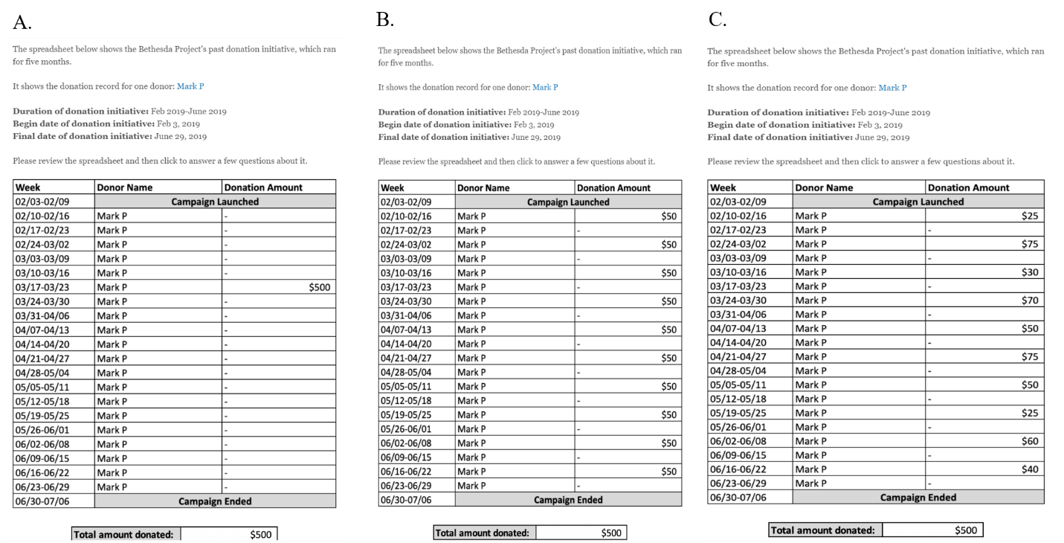
Note. Examples of the stimuli used in the lump sum condition (Panel A), equal partitions condition (Panel B), and unequal partitions condition (Panel C). There were three separate giving schedules for each condition

Dependent Measures
Prosocial Commitment: Participants indicated on 5-point scales the extent to which they agreed (1=strongly disagree; 5=strongly agree) that the donor (Mark P) is: 1) is willing to put in a great deal of effort beyond what is normally expected in order to help The Bethesda Project be successful; 2) would accept almost any assignment in order to help The Bethesda Project; 3) feels a great deal of loyalty to The Bethesda Project; 4) is highly committed to The Bethesda Project; 5) cares deeply about The Bethesda Project. We averaged the items (α = .88).
Future Donation Behavior and Future Volunteer Behavior. Participants answered the following questions about the donor’s future donation behavior and volunteer behavior: “The Bethesda Project is starting a fundraising initiative that will begin next month. How likely or unlikely do you think it is that the donor (Mark P) will donate to this new fundraising initiative at The Bethesda Project?” “The Bethesda Project is starting a new volunteer initiative that begins next month. How likely do you think it is that the donor (Mark P) will volunteer for this new initiative at The Bethesda Project? (1=not at all; 5=extremely). We assessed the items separately per the preregistration.
Moral Character. Participants saw a list of morality-related traits—courageous, fair, principled, responsible, just, honest, and trustworthy (see Goodwin & Darley, 2012). Participants then indicated the extent to which the traits described the donor (Mark P) (1 = not at all; 5 = extremely).
Affective Trust and Cognitive Trust We measured affective trust and cognitive trust with previously established 5-item scales (Dunn et al., 2012). An example item of affective trust is, “I would be willing to admit my worst mistakes to the donor (Mark P).” An example items of cognitive trust is, “I would be comfortable having the donor (Mark P) in a critical role on my team.” Participants indicated their agreement with each item on a 5-point scale (1=strongly disagree; 5=strongly agree). We averaged the items within their respective scales (α_{affective trust} = .85; α_{cognitive trust} = .64).
Personal Relevance of the Social Cause. Participants answered two questions about the personal relevance of the social cause to the donor. First, they were reminded, “The Bethesda Project’s mission is to provide shelter, housing and supportive services to adults experiencing chronic homelessness.” They then indicated on 5-point scales (1 = not at all, 5 = extremely) how personally important the cause was to the donor (Mark P), and how much the donor (Mark P) personally cared about this cause. We averaged the responses (α = .92).
Warmth and Flakiness. We measured warmth and flakiness each with a single item. Participants saw a list of warmth-related traits—warm, sociable, happy, agreeable, enthusiastic, easy-going, funny, and playful. Participants also saw a list of flakiness-related traits—flaky, unreliable, lazy. For each question, participants indicated the extent to which the traits described the donor (Mark P) (1 = not at all; 5 = extremely).
Transactionality. We measured transactionality with three items. Participants indicated the extent to which they agreed or disagreed (1 = strongly disagree; 5 = strongly agree) that the donor’s (Mark P’s) donations felt (1) impersonal, 2) detached, and 3) calculated. We averaged responses to the three items (α = .72).
Results
Table S2.1 shows correlations among all measured variables. We conducted an ANOVA to assess the effect of the manipulation on each of the dependent variables. We followed up significant condition effects with Bonferroni corrected pairwise comparisons. Table S2.2 shows the results of these analyses.
As shown in Table S2.2, participants judged the donor who gave in equal installments and the donor who gave in unequal installments to be more morally praiseworthy than the donor who gave in a lump sum. Moreover, for all moral praise-related dependent variables, no differences emerged between the equal installment or the unequal installment giving conditions.
Table S2.1
Correlations among all dependent measures (Study S2)
Variables | (1) | (2) | (3) | (4) | (5) | (6) | (7) | (8) | (9) | (10)
(1) Prosocial commitment | 1.00
(2) Future donating | 0.64* | 1.00
(3) Future volunteer | 0.58* | 0.52* | 1.00
(4) Moral character | 0.58* | 0.45* | 0.42* | 1.00
(5) Affective trust | 0.50* | 0.31* | 0.43* | 0.53* | 1.00
(6) Cognitive trust | 0.51* | 0.39* | 0.29* | 0.50* | 0.46* | 1.00
(7) Personal relevance | 0.70* | 0.57* | 0.46* | 0.51* | 0.36* | 0.40* | 1.00
(8) Transactionality | -0.30* | -0.23* | -0.14* | -0.16* | -0.08 | -0.39* | -0.31* | 1.00
(9) Warmth | 0.44* | 0.32* | 0.39* | 0.60* | 0.48* | 0.43* | 0.39* | -0.10* | 1.00
(10) Flakiness | -0.22* | -0.22* | -0.03 | -0.13* | 0.01 | -0.33* | -0.24* | 0.41* | -0.03 | 1.00
* p<0.05
We observed similar effects of the manipulation on assessments of the donor’s warmth. Participants viewed both the donor who gave in equal installments and the donor who gave in unequal installments to be warmer than the donor who gave in a lump sum.
We conducted exploratory regression analyses to control for perceived warmth to assess the discriminant validity of partitioned versus lumpsum giving on moral praise. We regressed each dependent variable on condition (treated as an indicator variable with the lumpsum condition as the reference category) and warmth. All effects shown in Table S2.3 remained significant in these exploratory analyses with one exception The comparison between “Partitioned giving: Unequal partitions” to “Lump sum giving” on the perceived transactional nature of of the donation became non-significant.
Table S2.2
Descriptive statistics by condition and ANOVA results for each dependent measure (Study S2)
Condition | Statistic | Prosocial commitment | Future donation behavior | Future volunteer behavior | Moral character | Affective trust | Cognitive trust | Personal relevance of cause | Transaction-ality | Warmth | Flaky
Lump sum | Mean | 3.36_{a} | 3.23_{a} | 2.63_{a} | 3.24_{a} | 2.46_{a} | 3.36_{a} | 3.43_{a} | 2.61_{a} | 3.06_{b} | 1.56_{a}
Lump sum | SD | 0.79 | 0.95 | 1.03 | 0.82 | 0.84 | 0.72 | 0.83 | 0.94 | 0.88 | 0.89
 | 95% CI | 3.22,3.49 | 3.07,3.39 | 2.46,2.80 | 3.11,3.38 | 2.32,2.60 | 3.24,3.48 | 3.29,3.57 | 2.45,2.77 | 2.92,3.21 | 1.41,1.71
Equal partitions | Mean | 4.08_{b} | 4.27_{b} | 3.36_{b} | 3.73_{b} | 2.89_{b} | 3.71_{b} | 4.04_{b} | 2.58_{a} | 3.37a_{b} | 1.35_{a}
Equal partitions | SD | 0.62 | 0.65 | 0.88 | 0.86 | 0.89 | 0.71 | 0.65 | 0.80 | 0.83 | 0.81
 | 95% CI | 3.98,4.18 | 4.16,4.38 | 3.21,3.51 | 3.59,3.88 | 2.74,3.04 | 3.59,3.83 | 3.93,4.15 | 2.44,2.71 | 3.23,3.51 | 1.21,1.48
Unequal partitions | Mean | 4.02_{b} | 4.18_{b} | 3.33_{b} | 3.68_{b} | 2.89_{b} | 3.67_{b} | 3.99_{b} | 2.31_{b} | 3.31_{a} | 1.34_{a}
Unequal partitions | SD | 0.61 | 0.72 | 1.01 | 0.80 | 0.88 | 0.65 | 0.67 | 0.93 | 0.92 | 0.87
Unequal partitions | 95% CI | 3.92,4.12 | 4.06,4.30 | 3.16,3.49 | 3.55,3.81 | 2.74,3.04 | 3.56,3.78 | 3.88,4.10 | 2.16,2.47 | 3.16,3.47 | 1.20,1.49
 | F (2, 417) | 48.87 | 75.55 | 25.13 | 14.83 | 11.42 | 10.98 | 31.24 | 4.71 | 4.72 | 2.91
 | p value | <.001 | <.001 | <.001 | <.001 | <.001 | <.001 | <.001 | 0.01 | 0.009 | 0.056
 | η² | .19 | .26 | .11 | .07 | .05 | .05 | .13 | .02 | .02 | .01
Note. Letter subscripts show pairwise comparisons of the three conditions for each dependent variable. Means sharing the same subscript do not significantly differ.

Table S2.3

The effect of manner of giving on the dependent variables controlling for perceived warmth (Study S2)
 | DV1 | DV2 | DV3 | DV4 | DV5 | DV6 | DV7 | DV8 | DV9
Partitioned: Equal | .63** | .96** | .61** | .32** | .29** | .26** | .52** | -.01 | -.21*
 | (.07) | (.09) | (.11) | (.08) | (.09) | (.08) | (.08) | (.11) | (.1)
Partitioned: Unequal | .58** | .89** | .60** | .30** | .32** | .23** | .49** | -.28* | -.21*
 | (.07) | (.09) | (.11) | (.08) | (.09) | (.08) | (.08) | (.11) | (.1)
Warmth | .33** | .26** | .41** | .55** | .46** | .32** | .30** | -.10 | -.01
 | (.03) | (.04) | (.05) | (.04) | (.04) | (.04) | (.04) | (.05) | (.05)
Constant | 2.35** | 2.42** | 1.37** | 1.56** | 1.05** | 2.37** | 2.51** | 2.91** | 1.58**
 | (.12) | (.14) | (.17) | (.13) | (.15) | (.12) | (.13) | (.17) | (.16)
Observations | 420 | 420 | 420 | 420 | 420 | 420 | 420 | 420 | 420
R-squared | .33 | .33 | .23 | .38 | .26 | .21 | .24 | .03 | .01
Note. Lump sum giving is the reference category. Standard errors are in parentheses
** p<.01, * p<.05.
DV1 = Prosocial commitment
DV2=Future donation behavior
DV3 = Future volunteer behavior
DV4 = Moral character
DV5 = Affective trust
DV6 = Cognitive trust
DV7 = Personal relevance of cause
DV8 = Transactionality
DV9 = Flakiness

Discussion
Participants praised a donor more when they donated in partitions than in a lump sum. This finding replicated the results of Studies 1 and 2, showing that the effect generalized to a separate evaluation of the targets and across measures of moral praise. We also found that the effect emerged both when the partitioned amounts were the same (e.g., giving $25 each week) or different (e.g., giving $15 some weeks, and $35 other weeks). We had explored the possibility that unequal partitioned giving would be viewed as more moral than equal partitioned giving, reasoning that paying unequal amounts may indicate greater prosocial impulses (as equal amounts may require little thought and be more habitual). However, we did not see evidence of this, suggesting that even habitual donations are viewed as separate impulses to donate.

The stimuli used to manipulate the type of giving from Study 4

Note. Participants received one of the stimuli from their assigned condition, determined at random.

Lump sum giving: 1
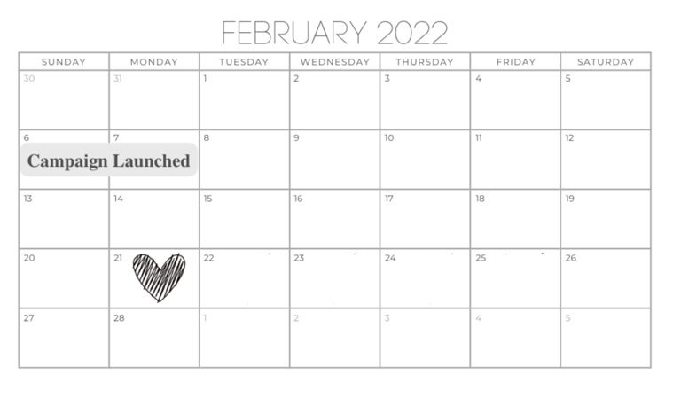
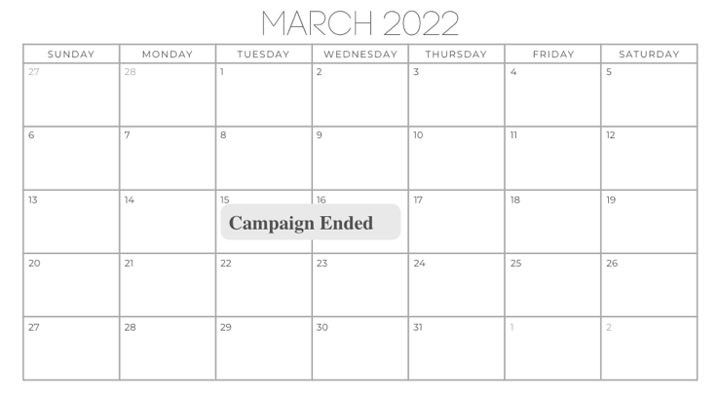

Lump sum giving: 2
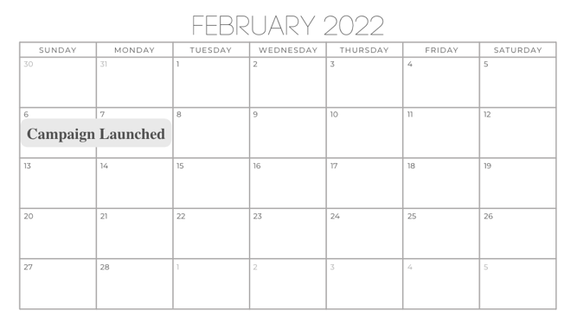
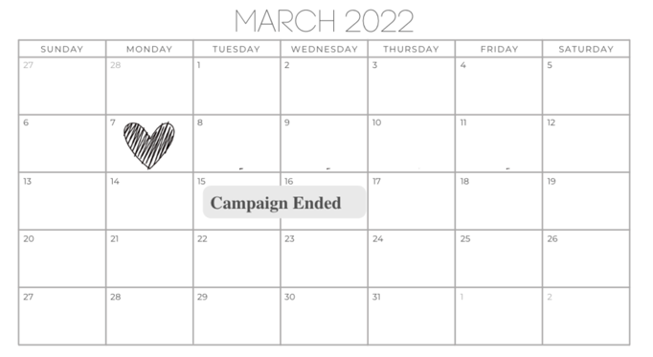

Lump sum giving: 3
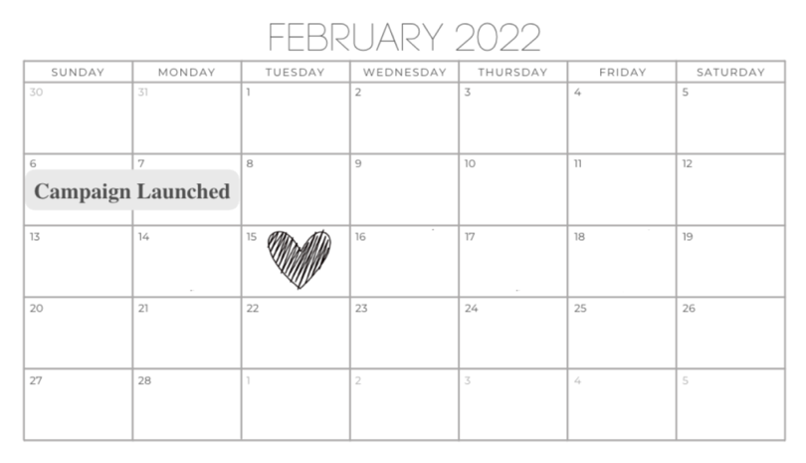

Partitioned giving: Consecutive: 1
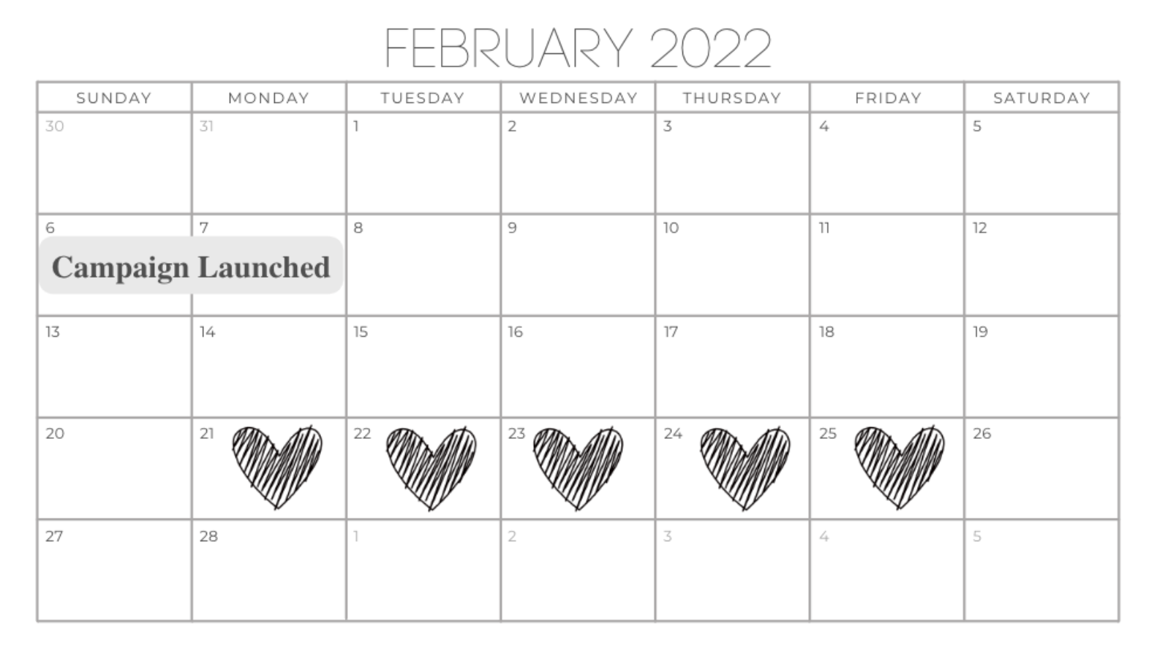
Partitioned giving: Consecutive: 2

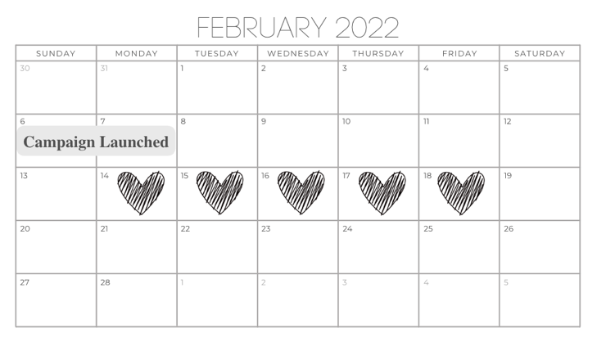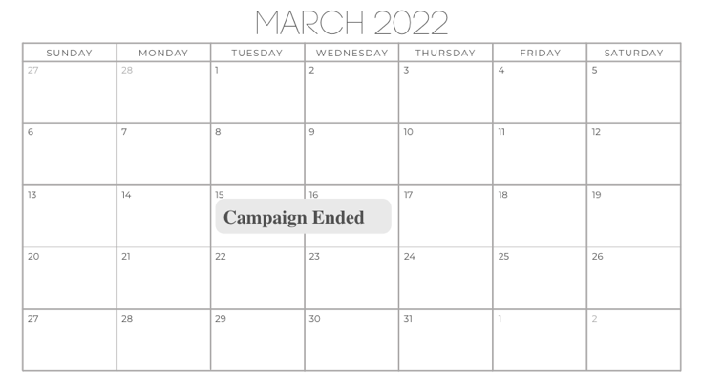
Partitioned giving: Consecutive: 3
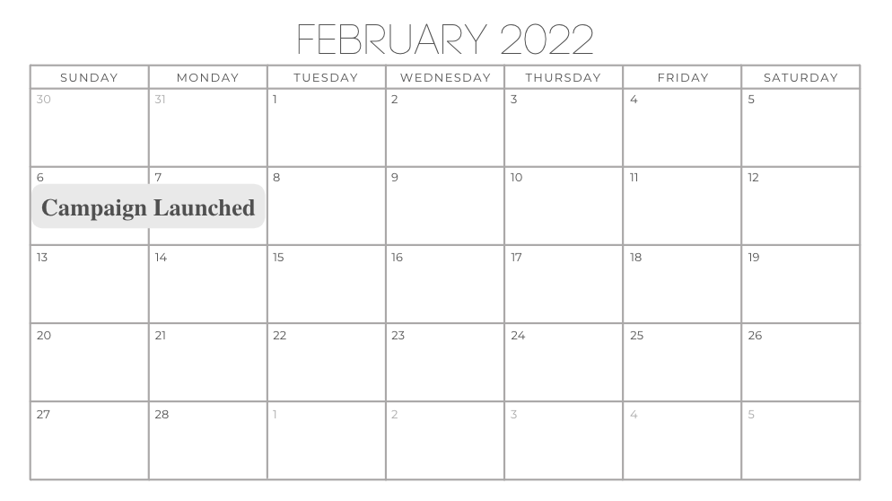
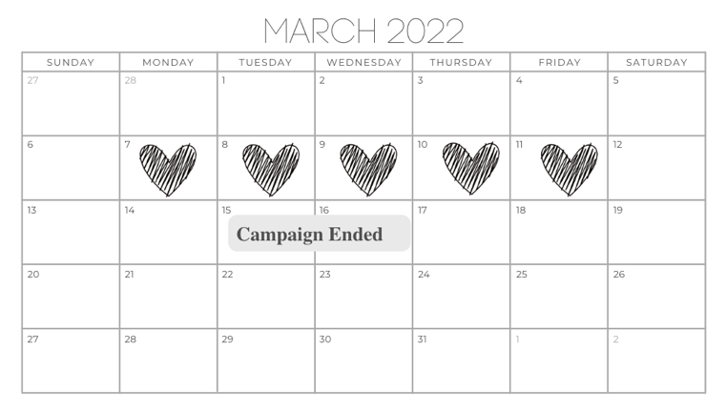

Partitioned giving: Nonconsecutive: 1
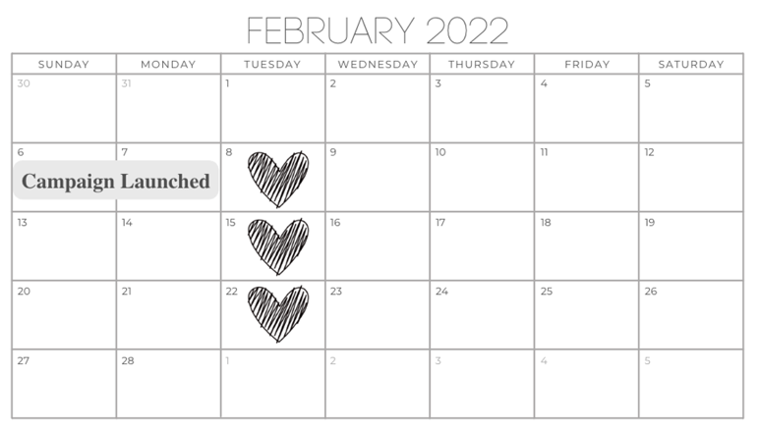
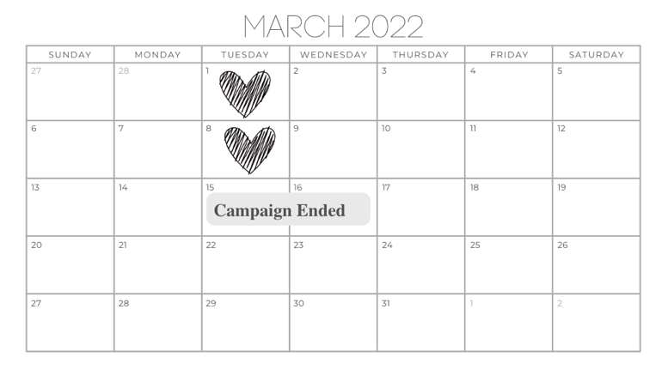

Partitioned giving: Nonconsecutive: 2
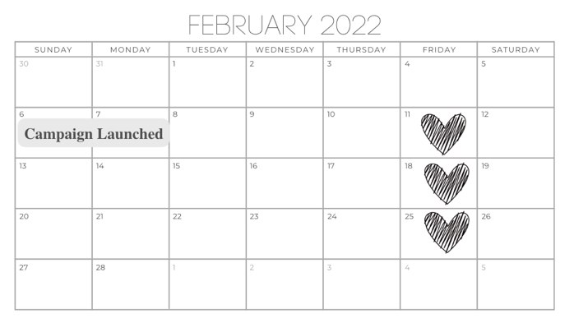
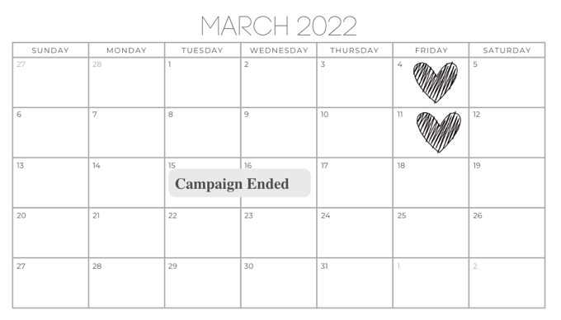

Partitioned giving: Nonconsecutive: 3
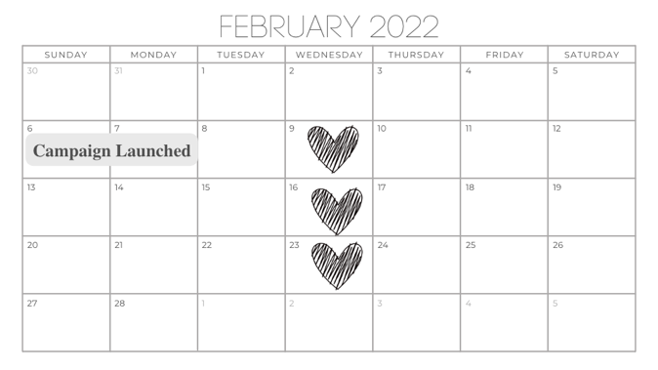
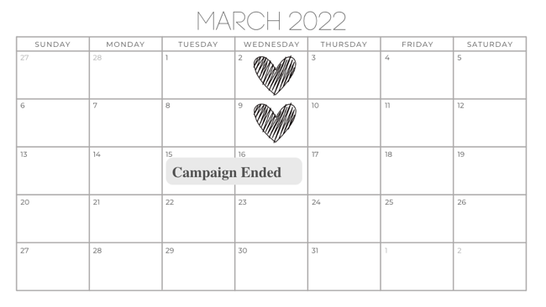

Plotting the results by the specific stimuli used to manipulate lump sum versus partitioned giving (Study 4)

Note. Error bars are +/- SEM
Supplemental Study 3 (Study S3)
The purpose of this study was to assess whether people see someone who gives on non-consecutive days as more prosocially committed than someone who gives on consecutive days in a within-subjects design. We varied whether the partitioned donor donated on consecutive days or nonconsecutive days, while holding constant the number of times they donated. We did not include a lump sum giving condition, and participants viewed both donors. We designed the study in this way with the primary purposes being to see whether people would continue to see non-consecutive day partitioned giving as signaling greater prosocial commitment than consecutive day partitioned giving when they full access to all the comparison information.
Method
Participants
We posted the study for 250 participants to Mechanical Turk for adult participants from
the United States. We excluded participants according to preregistered exclusion criteria, resulting in a final sample size of 183 (see Table S1 for more details).
Procedure
The study was a two-condition (Consecutive partitioned giving vs. Nonconsecutive partitioned giving) within-subject. The design was similar to the individual donor conditions of Studies 1 and 2, except participants jointly compared a donor that gave on nonconsecutive days to one that gave on consecutive days.
Participants read about two real estate attorneys who both donated four times for a total of $800 to Philabundance during its April and May 2023 fundraising drive. Participants received a table with the name of each donor and the dates on which the donor gave. Participants then logged the dates on which the donors gave on blank calendars.
In all cases, the donor gave four times on four different dates. We varied whether the dates were on consecutive days or nonconsecutive days. We stimulus sampled the specific dates the donors gave, with three sets of dates per condition. Figure S3.1 provides examples of the stimuli and Table S3.1 shows the full set of dates used.
After logging the dates on the calendar, participants answered one question about the donors, which was the same question asked in Studies 1 and 2: “If you had to say, which person do you think is more committed to giving back to the community?” Our dependent variable was whether participants selected the donor who gave on consecutive days or nonconsecutive days.
As in Studies 1 and 2, we randomized the name associated with the consecutive partitioned or nonconsecutive partitioned donor and the order in which the two donors were presented.
Results
Participants selected the donor that gave on nonconsecutive days 74.3% of the time, and
the donor that gave on consecutive days 25.7% of the time. A one-sample binomial tests showed that the proportion of participants selecting the two donors differed significantly from 50%, p < .001, Cohen’s g = 0.24.
There were three different sets of dates in each condition. Participants were randomly assigned to one date set for each condition, generating a total of nine different consecutive day/nonconsecutive day pairings. Table S3.2 shows the results broken down by each pairing.
The order of the donors was randomized. A chi-square test of independence showed that participants' likelihood of selecting each donor did not significantly depend on whether the donor was presented first or second, χ²(1) = 0.420, p = .517, Cohen’s w = 0.05.
Discussion
Study S3 replicated the findings comparison between partitioned giving the same number of times on nonconsecutive days than on consecutive days. The finding that this preference for nonconsecutive day giving emerged in a within-subjects provides some support that participants feel that giving on nonconsecutive days should be considered a relevant factor in deciding who is more prosocially committed.
Figure S3.1

Example of the stimuli used to manipulate the manner of giving (Study S3)
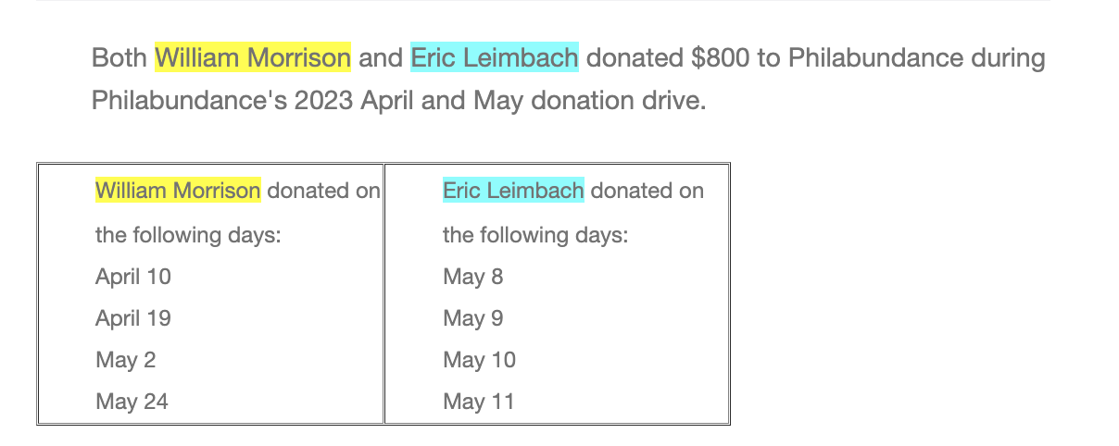
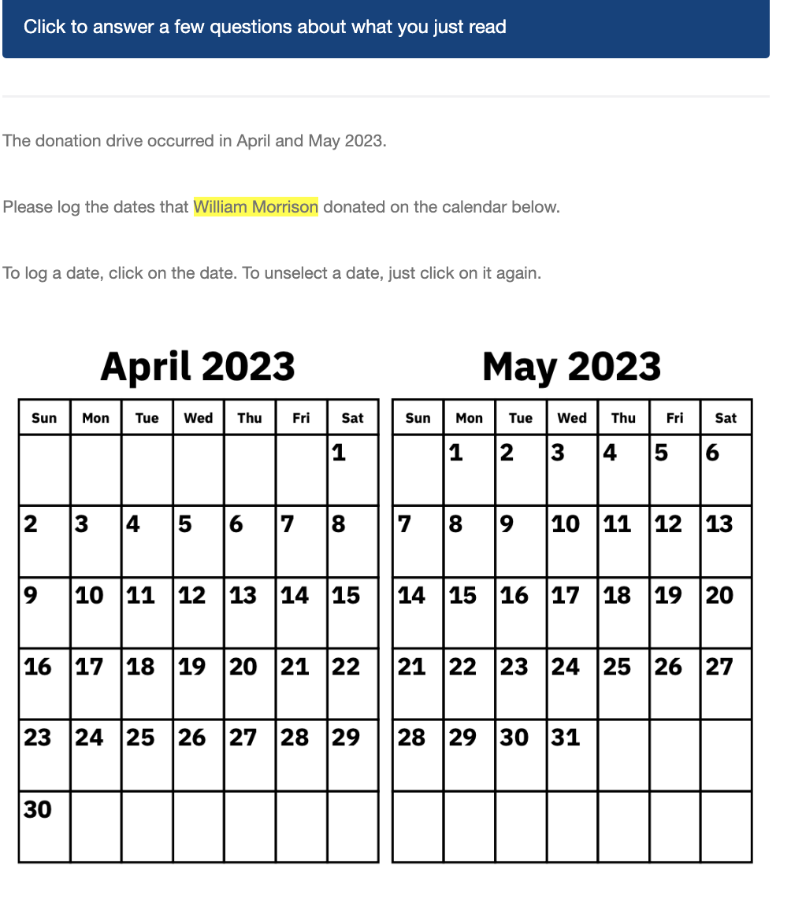
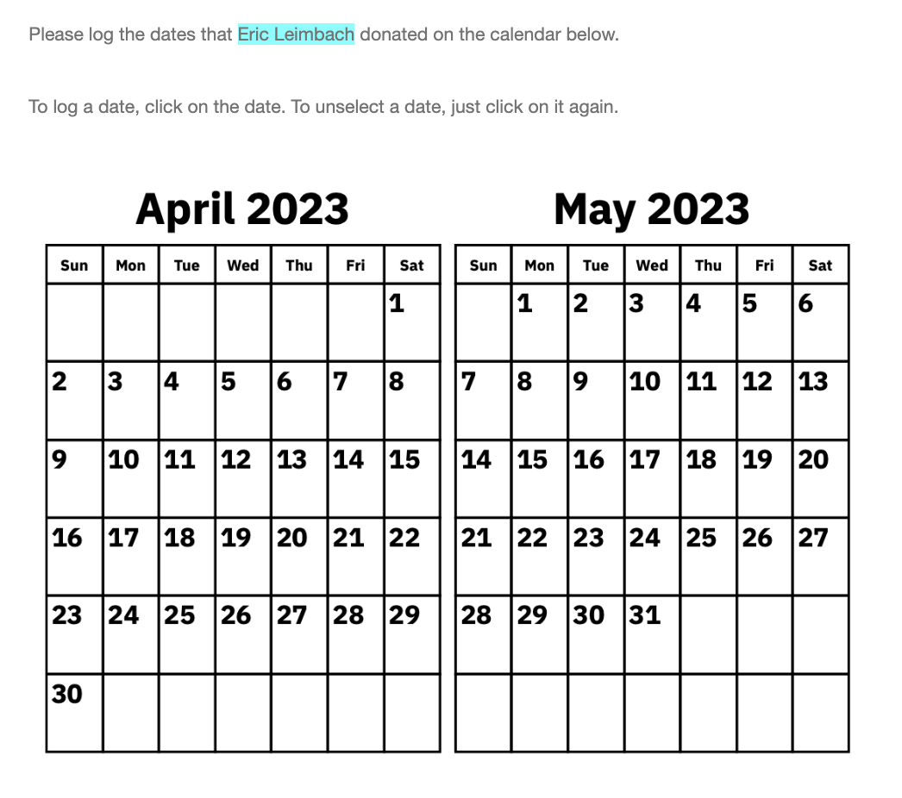

Table S3.1

The bank of dates used within each condition (Study S3)

Stimulus number | Lump sum dates | Partitioned dates
1 | April 4  April 5  April 6  April 7 | April 10  April 19  May 2  May 24
2 | May 22  May 23  May 24  May 25 | April 4  April 27  May 1  May 18
3 | May 8  May 9  May 10  May 11 | April 5  May 4  May 16  May 26
Note. Participants were randomly assigned a partitioned date set and a lump sum date set from There were three lump sum dates, and three partitioned dates, resulting in nine different “date pairs”

Table S3.2

The results broken down by the nine different “date pairs” (Study S3)

Stimulus pairing | Number of participants that elected the lump sum donor as the one that was more committed | Number of participants that selected the partitioned donor as the one that was more committed | Total number of participants
lump sum (1) partitioned (1) | 9 | 7 | 16
lump sum (1) partitioned (2) | 4 | 23 | 27
lump sum (1) partitioned (3) | 7 | 14 | 21
lump sum (2) partitioned (1) | 3 | 16 | 19
lump sum (2) partitioned (2) | 3 | 18 | 21
lump sum (2) partitioned (3) | 3 | 19 | 22
lump sum (3) partitioned (1) | 11 | 12 | 23
lump sum (3) partitioned (2) | 3 | 15 | 18
lump sum (3) partitioned (3) | 4 | 12 | 16

Note. Our study was not powered to test differences among the nine stimulus pairs. So, we exercise caution in interpreting the variation given the small sample sizes. Nevertheless, there is variation. A chi-square test of independence showed that the likelihood of choosing each donor as the one who was most committed to prosocial giving depended on the stimulus pairing participants saw, χ2(8) = 20.90, p = .007. However, with one exception, across the date pairs, participants chose the partitioned giving donor more often than the lump sum giving donor. This variation could be noise given the same samples. However, there may be other unobserved features of the giving schedules that have effects on moral praise. For instance, maybe people have different impressions of someone who gives early in a charitable campaign than someone who gives later in a charitable campaign.

Stimuli used in Studies 5a and 5b

Stimuli used to manipulate lump sum versus partitioned giving
Lump sum giving condition | Partitioned giving condition
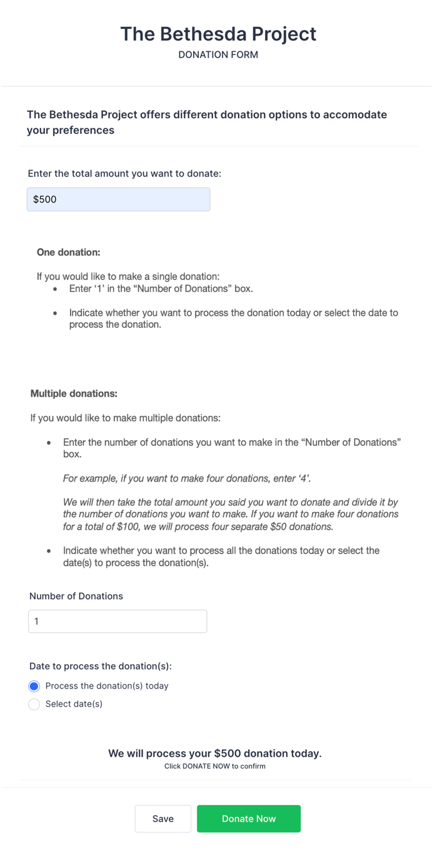 | 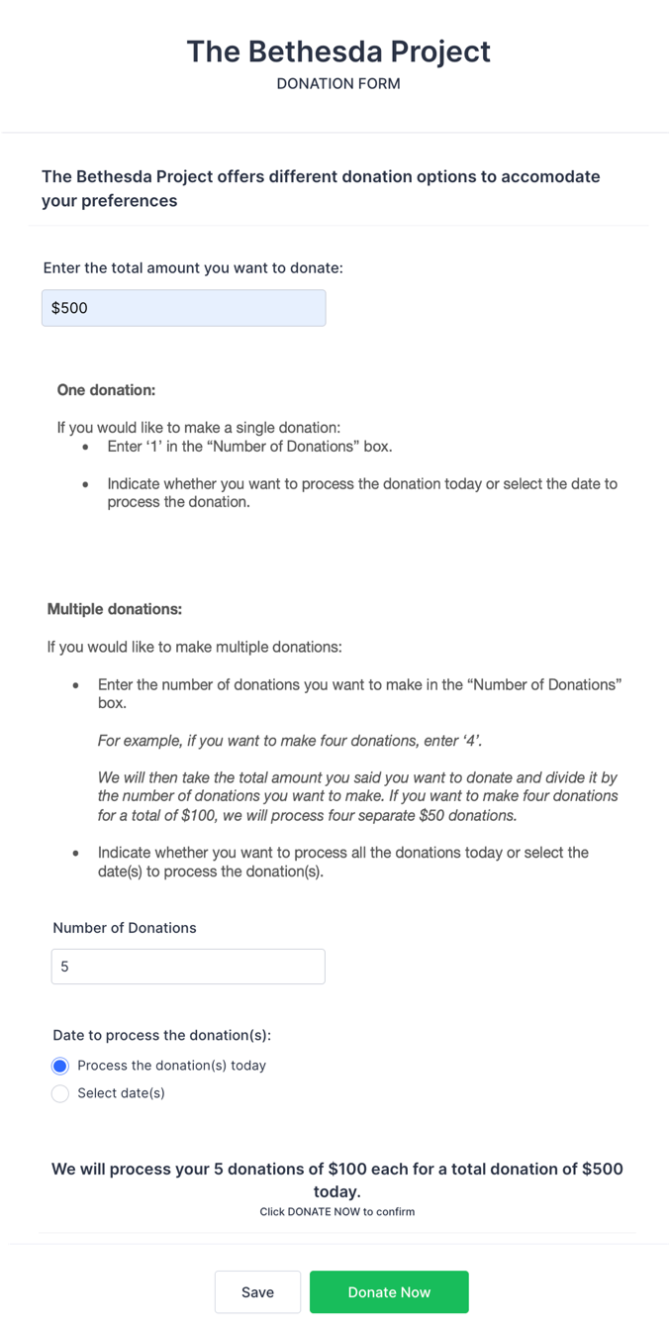
Note. We randomized whether the form presented the text about making one donation or multiple donations first. There is a typo in the description of the multiple donations that was present in all stimuli in all conditions “…we will process four separate $50 donations” should have been “$25 donations.”

The manipulation of lump sum giving and partitioned giving: donations processed on the same day were identical to Study 5a. This study included a third condition, “partitioned giving: donations processed on different days.” This is what the manipulation looked like in this condition.

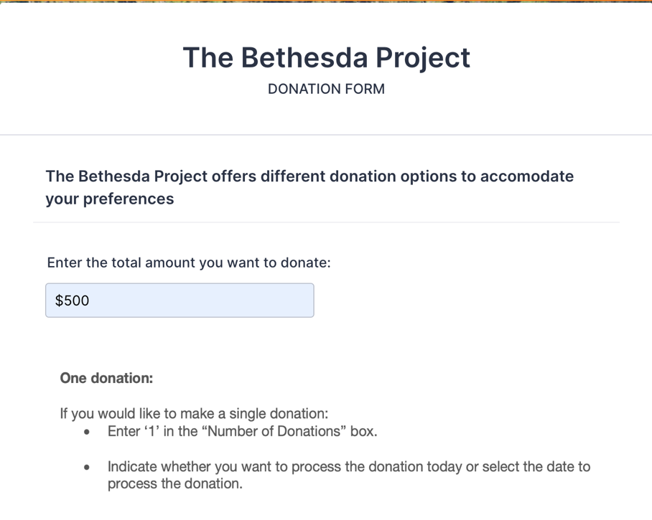

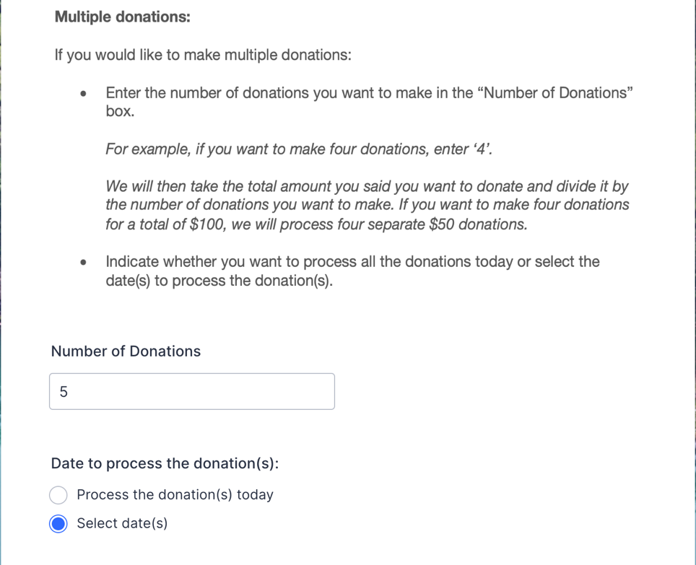
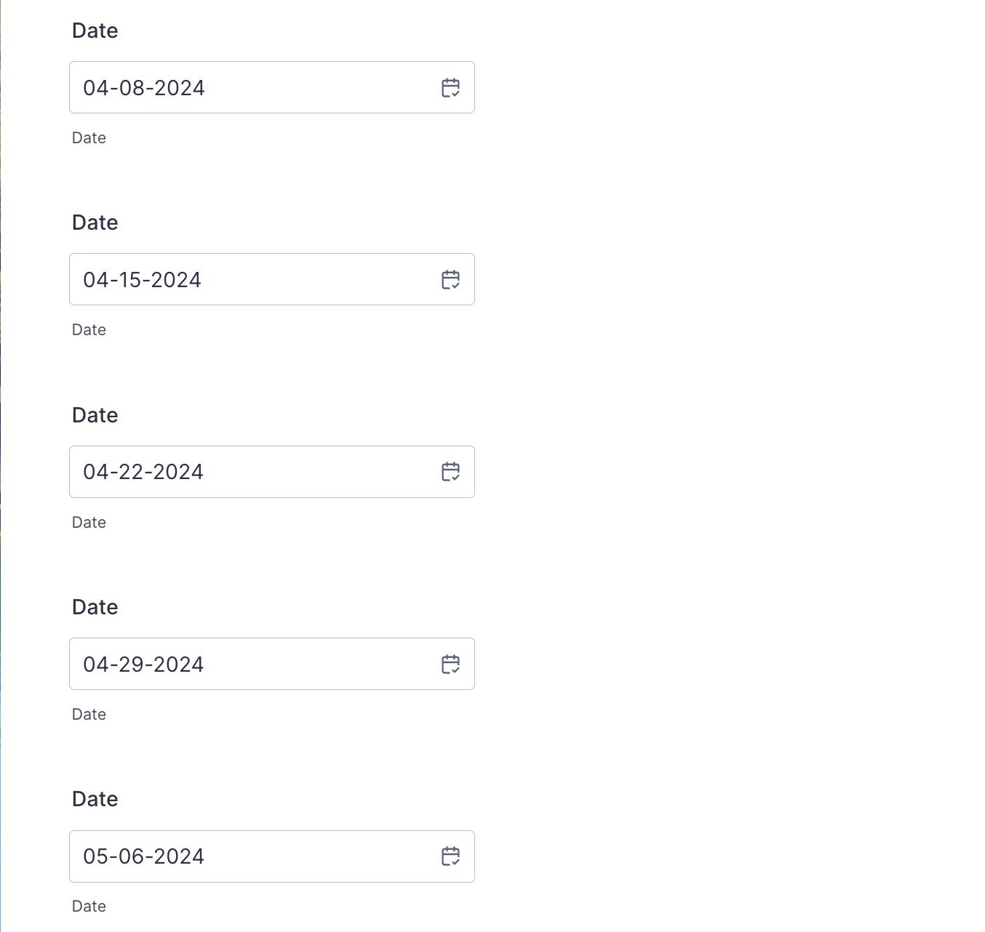


Note. We randomized whether the form presented the text about making one donation or multiple donations first. There is a typo in the description of the multiple donations that was present in all stimuli in all conditions “…we will process four separate $50 donations” should have been “$25 donations.”

Analyses of exploratory measures from Studies 3, 5a, 5b
Unemotional: [Donor’s name]’s donation feels unemotional
Impersonal: [Donor’s name]’s donation feels impersonal

 | Study 3 |  |  |  | Study 5a |  | Study 5b
 | Unemotional |  | Impersonal |  | Unemotional | Impersonal | Unemotional |  |  | Impersonal
 | (1) | (2) | (3) | (4) | (5) | (7) | (13) | (14) | (15) |  | (16)
Lump sum giving |  | .87** |  | .83** |  |  |  | -.20 |  |  | -.07
 |  | (.18) |  | (.18) |  |  |  | (.15) |  |  | (.14)
Partitioned giving 1 | -.87** |  | -.83** |  | .24 | .17 | .20 |  | .07
 | (.18) |  | (.18) |  | (.12) | (.12) | (.15) |  | (.14)
Partitioned giving 2 | -.84** | .03 | -.74** | .09 |  |  | -.21 | -.41** | -.34* |  | -.41**
 | (.18) | (.19) | (.18) | (.18) |  |  | (.15) | (.15) | (.14) |  | (.14)
0.givecond
_cons | 3.34** | 2.48** | 3.28** | 2.45** | 2.54** | 2.49** | 2.75** | 2.94** | 2.7** |  | 2.77**
 | (.13) | (.13) | (.12) | (.13) | (.09) | (.09) | (.1) | (.1) | (.1) |  | (.1)
Observations | 389 | 389 | 389 | 389 | 542 | 542 | 466 | 466 | 466 |  | 466
R-squared | .07 | .07 | .06 | .06 | .01 | 0 | .02 | .02 | .02 |  | .02
Note. In Study 3, partitioned giving 1 = partitioned giving without explicit precommitment; partitioned giving 2 = partitioned giving with explicit precommitment. In Study 5a, partitioned giving 1 = having the donations processed on the same day. In Study 5b, partitioned giving 1 = having the donations processed on the same day; partitioned giving 2 = having the donations processed on different days.
**p < .01 * p < .05

Links to view the animated versions of the websites from Study 6

Lumpsum prosociality condition: https://wharton.qualtrics.com/CP/Graphic.php?IM=IM_5zMAgw4v5NgPGPc

Partitioned prosociality condition: https://wharton.qualtrics.com/CP/Graphic.php?IM=IM_aYvSKjd5OA34di6

