Supplementary Figures

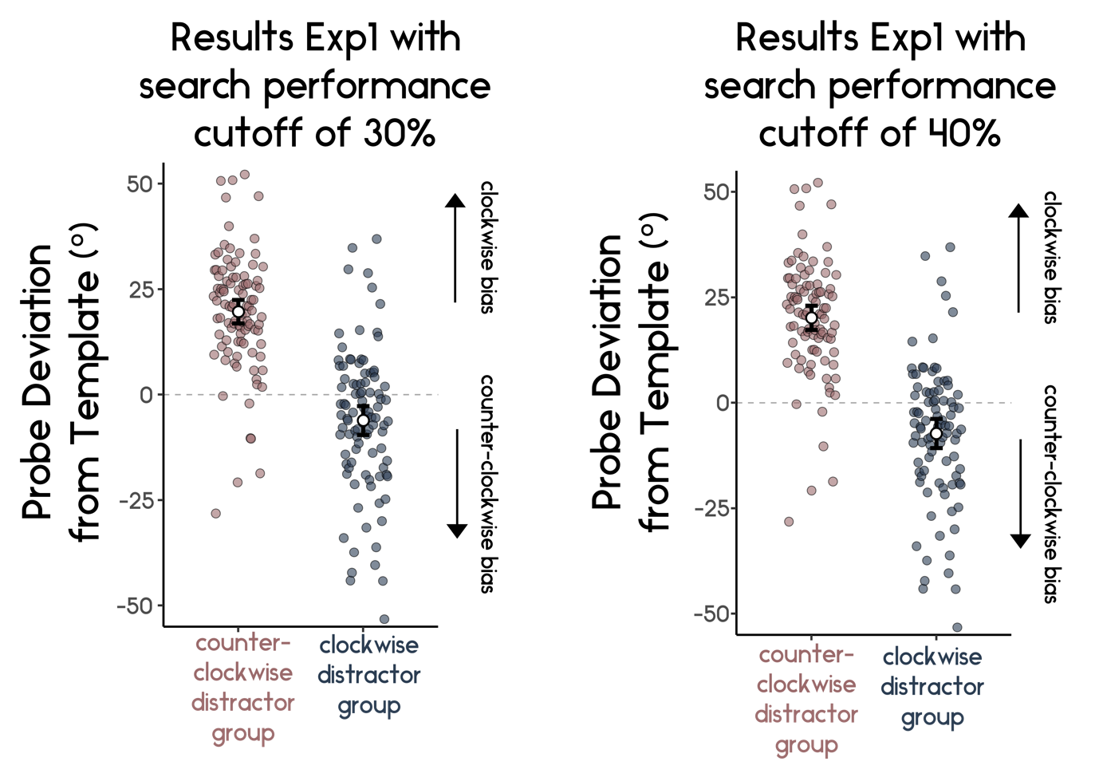
Supplementary Figure 1: Our results hold with more liberal data cleaning procedures, within the main analysis we used a predefined cut-off of 50% in the search task. Here the results stay largely the same with a cut-offs of 30% or 40%.

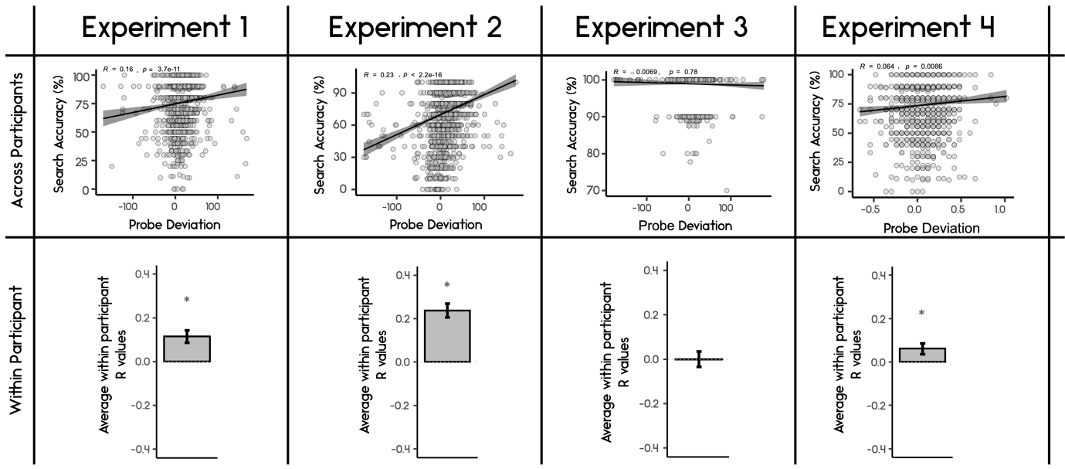
Supplementary Figure 2: Relationship between Search accuracy and Probe Deviation across the four experiments. Search Accuracy and Probe Deviation showed a significant positive correlation in all experiments except for Experiment 3 where Search Accuracy was at ceiling.

