**Unclearly Immoral: Low Self-Concept Clarity Increases Moral Disengagement**

**Supplemental Materials**

Table of Contents

Study 1 Materials 3

The self-concept clarity scale 3

Moral behavior scale 3

Study 2 Materials 5

The self-concept clarity scale 5

Dependent measure: donation to WWF 5

Study 3 Materials 6

Low self-concept clarity condition writing task 6

High self-concept clarity condition writing task 6

Dependent measure: the coin flip task 7

Study 4 Materials and Supplemental Results 9

The self-concept clarity scale 9

Moral disengagement scale 9

Dependent measure: tax compliance 9

Correlations of moral disengagement mechanisms with self-concept clarity and tax compliance 10

Study 5 Materials 11

Low self-concept clarity condition ad 11

High self-concept clarity condition ad 11

Dependent measure: dishonest reporting on car insurance 12

Attention checks 12

The moral disengagement scale 13

The moral identity internalization scale 13

The self-diagnosticity scale 13

Study 6 Materials 14

The honor pledge/moral engagement intervention 14

Study 7 Materials 15

Dependent measure: volunteering decision 15

# Study 1 Materials

## The self-concept clarity scale

1. My beliefs about myself often conflict with one another. (R)
2. On one day I might have one opinion of myself and on another day I might have a different opinion. (R)
3. I spend a lot of time wondering about what kind of person I really am. (R)
4. Sometimes I feel that I am not really the person that I appear to be. (R)
5. When I think about the kind of person I have been in the past, I’m not sure what I was really like. (R)
6. I seldom experience conflict between the different aspects of my personality.
7. Sometimes I think I know other people better than I know myself. (R)
8. My beliefs about myself seem to change very frequently. (R)
9. If I were asked to describe my personality, my description might end up being different from one day to another day. (R)
10. Even if I wanted to, I don’t think I could tell someone what I’m really like. (R)
11. In general, I have a clear sense of who I am and what I am.
12. It is often hard for me to make up my mind about things because I don’t really know what I want. (R)

## Moral behavior scale

*Note: we modified items 1 and 11 (the modified part is italicized) so that the items could be applicable to the student sample*

Please read each of the brief scenarios below and indicate how likely you would be to engage in the behavior described (1 = Absolutely not, 2 = Probably not, 3 = I’m not sure, 4 = Probably yes, 5 = Absolutely yes)

1. Your *school* has supplies that can be quite useful at home. Would you use these *school* supplies for your own personal purposes? (reverse-coded)
2. You bought a shirt from a store and wore it to an event, but now you realize that you will probably never wear it again. Would you return it for a full refund? (reverse-coded)
3. You have no internet connection at home, and you notice that your neighbor’s wireless internet is not password-protected. Would you use it? (reverse-coded)
4. You accidentally gain access to a buffet without having paid for it. Would you eat the food at a buffet? (reverse-coded)
5. You find money on the floor in a public space. Would you ask around to find the person who dropped it?
6. After buying something at a store, you realize that the cashier gave you extra change. Would you return the extra money?
7. You accidentally hit a dog with your car. Would you stop to check on the dog?
8. You accidentally break merchandise in a store. Would you report it to the store employees?
9. You borrowed money from someone a while ago, and the person seems to have forgotten all about it. Would you remind the person that you owe them money?
10. After buying something at a store, you realize that you walked out with another item for which you did not pay. Would you return the item your accidentally took from the store?
11. *You are an intern at a company.* Your co-worker gets blamed for something you did. No one knows that you did it; not even your co-worker. Would you confess that it was you and not your co-worker?
12. You accidentally hit a parked car while pulling out of a tight parking spot. Would you leave a note with your contact information on the parked car?

# Study 2 Materials

## The self-concept clarity scale

1. My beliefs about myself often conflict with one another. (R)
2. On one day I might have one opinion of myself and on another day I might have a different opinion. (R)
3. I spend a lot of time wondering about what kind of person I really am. (R)
4. Sometimes I feel that I am not really the person that I appear to be. (R)
5. When I think about the kind of person I have been in the past, I’m not sure what I was really like. (R)
6. I seldom experience conflict between the different aspects of my personality.
7. Sometimes I think I know other people better than I know myself. (R)
8. My beliefs about myself seem to change very frequently. (R)
9. If I were asked to describe my personality, my description might end up being different from one day to another day. (R)
10. Even if I wanted to, I don’t think I could tell someone what I’m really like. (R)
11. In general, I have a clear sense of who I am and what I am.
12. It is often hard for me to make up my mind about things because I don’t really know what I want. (R)

## Dependent measure: donation to WWF

Thank you for your responses! As a token of appreciation, we will send you a .50 CNY bonus on top of your base compensation. You have the choice to donate the bonus to the World Wildlife Fund or keep your bonus to receive it as extra compensation.

What would you like to do?

Donate my bonus to the World Wildlife Fund

Keep my bonus to receive it as extra compensation

# Study 3 Materials

## Low self-concept clarity condition writing task

## High self-concept clarity condition writing task

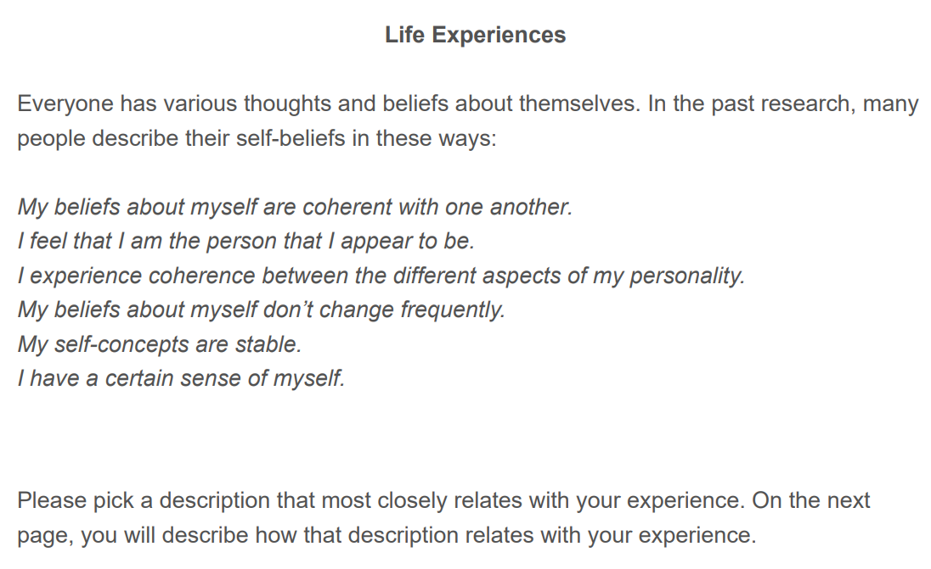

## Dependent measure: the coin flip task

*Note: The highlighted parts were only shown to participants in the incentivized condition.*

# Study 4 Materials and Supplemental Results

## The self-concept clarity scale

1. My beliefs about myself often conflict with one another. (R)
2. On one day I might have one opinion of myself and on another day I might have a different opinion. (R)
3. I spend a lot of time wondering about what kind of person I really am. (R)
4. Sometimes I feel that I am not really the person that I appear to be. (R)
5. When I think about the kind of person I have been in the past, I’m not sure what I was really like. (R)
6. I seldom experience conflict between the different aspects of my personality.
7. Sometimes I think I know other people better than I know myself. (R)
8. My beliefs about myself seem to change very frequently. (R)
9. If I were asked to describe my personality, my description might end up being different from one day to another day. (R)
10. Even if I wanted to, I don’t think I could tell someone what I’m really like. (R)
11. In general, I have a clear sense of who I am and what I am.
12. It is often hard for me to make up my mind about things because I don’t really know what I want. (R)

## Moral disengagement scale

1. Euphemistic Labeling: Underreporting income is just “smart financial planning.”
2. Moral Justification: It is alright to avoid taxes to meet my own needs or my family’s needs.
3. Advantageous Comparison: Compared to other illegal activities such as robbery, avoiding taxes is not very serious.
4. Displacement of Responsibility: If someone is struggling to make ends meet, they cannot be blamed for avoiding taxes.
5. Diffusion of Responsibility: Someone cannot be blamed for avoiding taxes when many people do it.
6. Distortion of Consequences: It is okay to avoid some taxes because it doesn’t really do any harm.
7. Dehumanization: Tax authorities are faceless entities.
8. Attribution of Blame: People are not at fault for avoiding taxes if the government fails to address tax loopholes.

## Dependent measure: tax compliance

Imagine that you had been wanting to buy a new car. Recently you had the opportunity to make some extra money and you ended up earning an additional $16,000 that could go toward the car.

But when you get your paycheck, you were reminded that the extra money you earned is subject to a 20% income tax. You realized that after deducting the income tax, you would be $3,000 short of the amount you need to buy the car.

While you were still trying to overcome the shock of the realization, you came across an article that mentioned a tax gap study conducted by the IRS. In the study, it was estimated that individuals underreport their overall income by 43%; and sole proprietors, who report self-employment income on schedule C of their tax returns, were estimated to underreport their income by 57%.

According to the article, a penalty of 75% of any underpayment will be imposed on taxpayers convicted of underreporting their income due to fraud. But due to resource constraint, the IRS could only conduct random audits to verify tax filings and identify underreporting.

Now imagine that you are still thinking about that new car. What is the probability that you would engage in the following behaviors? (1 = definitely not, 10 = definitely yes)

1. Pay the income tax, even though it means I can't buy the car I want.
2. Underreport my income, so that I can buy the car I want. (reverse-coded)
3. Not pay the income tax at all. (reverse-coded)

## Correlations of moral disengagement mechanisms with self-concept clarity and tax compliance

|  |  |  |  |  |
| --- | --- | --- | --- | --- |
| Variables | Self-Concept Clarity | | Tax Compliance | |
| Self-Concept Clarity | 1.00 |  | 0.26 | *** |
| Tax Compliance | 0.26 | *** | 1.00 |  |
| Underreporting income is just “smart financial planning.” | -0.30 | *** | -0.67 | *** |
| It is alright to avoid taxes to meet my own needs or my family’s needs. | -0.23 | *** | -0.52 | *** |
| Compared to other illegal activities such as robbery, avoiding taxes is not very serious. | -0.13 | * | -0.37 | *** |
| If someone is struggling to make ends meet, they cannot be blamed for avoiding taxes. | -0.25 | *** | -0.36 | *** |
| Someone cannot be blamed for avoiding taxes when many people do it. | -0.36 | *** | -0.58 | *** |
| Tax authorities are faceless entities. | -0.19 | ** | -0.29 | *** |
| People are not at fault for avoiding taxes if the government fails to address tax loopholes. | -0.26 | *** | -0.31 | *** |
| It is okay to avoid some taxes because it doesn’t really do any harm. | -0.24 | *** | -0.57 | *** |

*Note:* * p < .05, ** p < .01, *** p <.001

# Study 5 Materials

## Low self-concept clarity condition ad

## High self-concept clarity condition ad

## Dependent measure: dishonest reporting on car insurance

## Attention checks

## The moral disengagement scale

1. Sometimes getting ahead of the curve is more important than adhering to rules.
2. Cheating is appropriate behavior because no one gets hurt.
3. If others engage in cheating behavior, then the behavior is morally permissible.
4. It is appropriate to seek short-cuts as long as it is not at someone else’s expense.
5. End results are more important than the means by which one pursues those results.
6. It is alright to fight to protect your friends.
7. It is alright to beat up someone that bad-mouths your family.
8. It is ok to steal to take care of your family’s needs.
9. It is alright to lie to keep your friends out of trouble.
10. Rules should be flexible enough to be adapted to different situations.

## The moral identity internalization scale

1. It would make me feel good to be an honest person.
2. Being honest is an important part of who I am.
3. I would be ashamed to be a dishonest person. (R)
4. Being honest is not really important to me. (R)

## The self-diagnosticity scale

1. What I do says a lot about who I am.
2. The choices I make reflect my inner goals and values.
3. My actions are an indication of my personality.
4. My choices tell me a great deal about what I like.
5. There is a strong link between my actions and my personality.
6. What I do is a reflection of who I am.
7. My actions are very telling of my character.

# Study 6 Materials

## The honor pledge/moral engagement intervention

# Study 7 Materials

## Dependent measure: volunteering decision

