Supplementary Materials: “The curve of control: Non-monotonic effects of task difficulty on cognitive control”
Supplementary Text
Fitting shapes to individual data
To investigate which hypothetical patterns in control intensity scores were best supported by our data, we created five possible shapes for control intensity changes as a function of Inducer Difficulty Scores, see top row of Figure S1 predicted by the different theories: a linear shape (conflict monitoring theory), two variants of a curvilinear shape (expected value of control framework) and two variants of a shark-fin shape (motivational intensity theory) We created different contrasts that represent these patterns. A correlation analysis between the scaled contrasts and the scaled participant Control Intensity Scores on four Inducer Difficulty Scores was then conducted. The average of correlation coefficients is shown on the middle row of Figure S1 and the top 30 individuals with the best fitting curves are plotted in the bottom row. Numerically, the left-skewed curvilinear shape had the highest fit and the linear shape had the lowest fit with the data. We also tested whether there were differences between correlation coefficients, by pairwise comparisons using the Wilcoxon test (See Table S1). Although the uncorrected difference revealed that the fit for the left-skewed shape was significantly higher than the fit for the linear shape, no significant differences survived correcting for multiple comparisons using the False Discovery Rate method.

Figure S1.
Comparison of different shapes in congruency effects
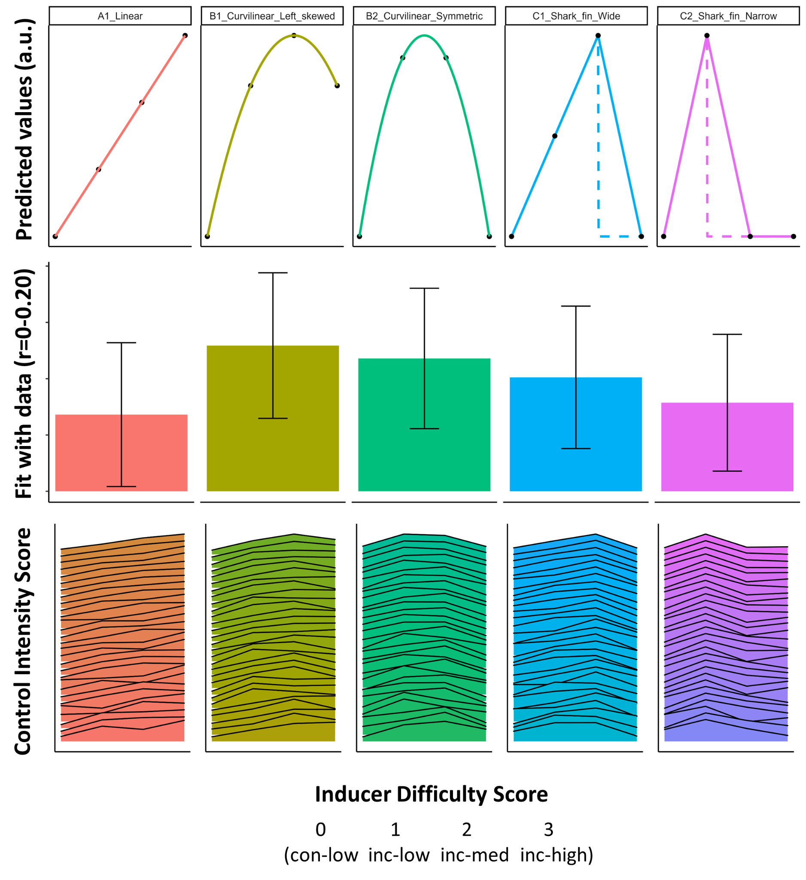
Comparison of five different shapes: a linear shape (A1), a curvilinear shape that is left skewed or fully symmetric (B1 and B2), or a shark-fin shaped function (C1 and C2). The figures in the top row show these shapes. The figures in the middle row show the average and 95% CIs of the correlation coefficients between the scaled shape and the scaled control intensity scores for each participant. The figures in the bottom row show the shapes of the control intensity scores for the 30 subjects that showed the best fit for that respective shape (ranked using the individual correlation coefficient).
Table S1.
Pair-wise comparisons between the coefficients of all models using the Wilcoxon test
group1 | group2 | n1 | η2 | statistic | p | p.adj | p.adj.signif
cor_A1_Linear | cor_B1_Curvilinear_Left_skewed | 321 | 321 | 21,374.00 | .007** | 0.07 | ns
cor_A1_Linear | cor_B2_Curvilinear_Symmetric | 321 | 321 | 23,966.00 | .260 | 0.43 | ns
cor_A1_Linear | cor_C1_Shark_fin_Wide | 321 | 321 | 24,472.00 | .411 | 0.59 | ns
cor_A1_Linear | cor_C2_Shark_fin_Narrow | 321 | 321 | 25,491.00 | .834 | 0.83 | ns
cor_B1_Curvilinear_Left_skewed | cor_B2_Curvilinear_Symmetric | 321 | 321 | 26,591.00 | .652 | 0.72 | ns
cor_B1_Curvilinear_Left_skewed | cor_C1_Shark_fin_Wide | 321 | 321 | 27,735.00 | .255 | 0.43 | ns
cor_B1_Curvilinear_Left_skewed | cor_C2_Shark_fin_Narrow | 321 | 321 | 27,904.00 | .215 | 0.43 | ns
cor_B2_Curvilinear_Symmetric | cor_C1_Shark_fin_Wide | 321 | 321 | 27,825.00 | .233 | 0.43 | ns
cor_B2_Curvilinear_Symmetric | cor_C2_Shark_fin_Narrow | 321 | 321 | 28,069.00 | .181 | 0.43 | ns
cor_C1_Shark_fin_Wide | cor_C2_Shark_fin_Narrow | 321 | 321 | 26,788.00 | .569 | 0.71 | ns

Separate analyses for experiments
While the analyses in the main text were conducted on merged data, we followed one of the reviewers’ suggestion to report separate analyses on the two experiments. The tables showing results in the two experiments are below. Table S2 and S3 show Perceived Difficulty across four difficulty levels of Inducer Trials.
Table S2.
The effect of Inducer Trial Type on Perceived Difficulty in Experiment 1
Inducer difficulty level | Mean rating | Rating SD
con-low | 3.53 | 1.73
inc-low | 4.63 | 1.89
inc-med | 4.90 | 1.71
inc-high | 5.20 | 2.11

Table S3.
The effect of Inducer Trial Type on Perceived Difficulty in Experiment 2
Inducer difficulty level | Mean rating | Rating SD
con-low | 3.90 | 2.06
inc-low | 4.44 | 1.94
inc-med | 4.81 | 1.72
inc-high | 5.24 | 2.07

Table S4 and S5 show the results of mixed effect linear regression analyses on the effect of parametric difficulty manipulation on reaction time separately on Experiment 1 and 2. In Experiment 1 there was a significant curvilinear interaction between Inducer Difficulty Score and Diagnostic Trial Congruency, t(22048) =2.776, p = .006. There was a non-significant interaction between the two predictors in Experiment 2 t(20508) = 1.776. p = .076.

Table S4.
Summary for the mixed-effect model for Reaction Time on Inducer Trial Difficulty Level x Diagnostic Trial Congruency in Experiment 1
 | Reaction Time
Predictors | Estimates | CI | p
(Intercept) | 498.03 | 488.56 – 507.50 | <0.001
Diagnostic Trial Congruency | 93.56 | 88.61 – 98.50 | <0.001
Inducer Trial Difficulty Level [linear] | 540.74 | 260.59 – 820.90 | <0.001
Inducer Trial Difficulty Level [curvilinear] | -459.14 | -739.57 – -178.71 | 0.001
Diagnostic Trial Congruency x Trial Difficulty Level [linear] | -639.76 | -1042.07 – -237.45 | 0.002
Diagnostic Trial Congruency x Trial Difficulty Level [curvilinear] | 569.37 | 167.37 – 971.37 | 0.006
Random Effects
σ² | 10431.57
τ₀₀ _{participant} | 3677.97
τ₁₁ participant.Diagnostic Trial Congruency | 732.21
ρ₀₁ _{participant} | -0.17
ICC | 0.26
N _{participant} | 164
Observations | 22357
Marginal R² / Conditional R² | 0.134 / 0.363

Table S5.
Summary for the mixed-effect model for Reaction Time on Inducer Trial Difficulty Level x Diagnostic Trial Congruency in Experiment 2
 | RT
Predictors | Estimates | CI | p
(Intercept) | 493.61 | 484.57 – 502.66 | <0.001
Diagnostic Trial Congruency | 106.34 | 100.11 – 112.56 | <0.001
Inducer Trial Difficulty Level [linear] | 513.56 | 228.39 – 798.73 | <0.001
Inducer Trial Difficulty Level [curvilinear] | -141.26 | -428.55 – 146.03 | 0.335
Diagnostic Trial Congruency x Trial Difficulty Level [linear] | -298.42 | -706.89 – 110.04 | 0.152
Diagnostic Trial Congruency x Trial Difficulty Level [curvilinear] | 370.15 | -38.38 – 778.68 | 0.076
Random Effects
σ² | 10753.77
τ₀₀ _{participant} | 3204.16
τ₁₁ participant.Diagnostic Trial Congruency | 1258.36
τ₁₁ participant.Trial Difficulty Level [linear] | 20428.01
τ₁₁ participantTrial Difficulty Level [curvilinear] | 88826.70
ρ₀₁ | -0.16
 | 0.45
 | 0.74
ICC | 0.25
N _{participant} | 158
Observations | 20842
Marginal R² / Conditional R² | 0.166 / 0.371

Table S6 and S7 show the results of the mixed-effect polynomial model analysis for Diagnostic Trial Congruency and Subjective Difficulty Rating in the two experiments separately. A significant linear interaction was found between the two predictors t(22046)=-4.108, p<.001, however no significant curvilinear interaction was detected in Experiment 1, only at trend level t(22047) = 1.906, p = .057. No evidence for interaction between Diagnostic Trial Congruency and Subjective Difficulty was found in Experiment 2 t(20510) = 1.695, p = .090.

Table S6.
Summary for the mixed-effect polynomial model for RT on Diagnostic Congruency x Subjective Difficulty in Experiment 1
 | RT
Predictors | Estimates | CI | p
Intercept | 498.03 | 488.56 – 507.50 | <0.001
Diagnostic Trial Congruency | 93.56 | 88.62 – 98.50 | <0.001
Subjective Difficulty[linear] | 678.60 | 398.19 – 959.00 | <0.001
Subjective Difficulty[curvilinear] | -265.84 | -545.95 – 14.26 | 0.063
Diagnostic Trial Congruency x Subjective Difficulty[linear] | -843.14 | -1245.39 – -440.90 | <0.001
Diagnostic Trial Congruency x Subjective Difficulty[curvilinear] | 391.03 | -11.05 – 793.11 | 0.057
Random Effects
σ² | 10430.47
τ₀₀ _{participant} | 3678.19
τ₁₁ participant.Diagnostic Trial Congruency | 731.92
ρ₀₁ _{participant} | -0.17
ICC | 0.26
N _{participant} | 164
Observations | 22357
Marginal R² / Conditional R² | 0.134 / 0.364

Table S7.
Summary for the mixed-effect polynomial model for RT on Diagnostic Congruency x Subjective Difficulty in Experiment 2
 | RT
Predictors | Estimates | CI | p
Intercept | 493.61 | 484.56 – 502.66 | <0.001
Diagnostic Trial Congruency | 106.34 | 100.12 – 112.57 | <0.001
Subjective Difficulty[linear] | 515.56 | 230.47 – 800.64 | <0.001
Subjective Difficulty[curvilinear] | -120.18 | -406.97 – 166.62 | 0.411
Diagnostic Trial Congruency x Subjective Difficulty[linear] | -305.56 | -714.00 – 102.89 | 0.143
Diagnostic Trial Congruency x Subjective Difficulty[curvilinear] | 353.25 | -55.30 – 761.79 | 0.090
Random Effects
σ² | 10754.62
τ₀₀ _{participant} | 3204.63
τ₁₁ participant.Diagnostic Trial Congruency | 1258.61
τ₁₁ participant.Subjective Difficulty[linear] | 16916.89
τ₁₁ participant.Subjective Difficulty[curvilinear] | 75999.29
ρ₀₁ | -0.16
 | 0.42
 | 0.82
ICC | 0.25
N _{participant} | 158
Observations | 20842
Marginal R² / Conditional R² | 0.166 / 0.371

Inducer trial analyses
Our main analyses were focused on the effect of previous trial (Inducer Trial) difficulty scores on the reaction times of diagnostic trials. We also tested how inducer trial reaction times and error rates were affected by Inducer Trial Difficulties, to reveal the processes that underlie the effect of increased perceived task difficulty and the associated adaptation effects reported in the main document. The tables below show the results of mixed-effect linear regressions on Inducer Reaction Time, Inducer Trial Error Rate, and Inducer Trial Ratings with Trial Difficulty Level and Inducer Trial Congruency as fixed predictors. As seen in Table S8, for RT analyses, the interaction between Trial Congruency and Difficulty level was significant, both between low-medium t(77143) = -4.026, p < .001, and low-high t(77143) = -8.719, p < .001 contrasts. Error rate analyses (see Table S9) showed no such interactions between Trial Congruency and Difficulty Level neither in low-medium z = -0.643, p = .520, nor in low-high contrasts z = -1.423, p = .155. Table S10 shows the effects of Trial Congruency and Difficulty Level on Difficulty Rating. Trial Congruency (t(1612) = -12.745 p < .001), Difficulty level on low-medium (t(1612) = 3.453, p = .001), and low-high (t(1612) = 6.852, p < .001) contrasts were significant predictors of Inducer Difficulty Rating.

Table S8.
Summary for the mixed-effect model for RT on Inducer Congruency x Difficulty Score
 | Inducer RT
Predictors | Estimates | CI | p
(Intercept) | 521.78 | 512.51 – 531.06 | <0.001
Trial Congruency | 89.66 | 85.91 – 93.40 | <0.001
Trial Difficulty Level: medium | 7.12 | 3.38 – 10.87 | <0.001
Trial Difficulty Level: high | 18.03 | 14.29 – 21.77 | <0.001
Trial Congruency × Trial Difficulty Level: medium | -9.57 | -14.86 – -4.28 | <0.001
Trial Congruency × Trial Difficulty Level: high | -21.62 | -26.91 – -16.33 | <0.001
Random Effects
σ² | 23788.73
τ₀₀ _{participant} | 6791.57
ICC | 0.22
N _{participant} | 330
Observations | 78372
Marginal R² / Conditional R² | 0.050 / 0.261
Table S9.
Summary for the mixed-effect model for error rate on Inducer Congruency x Difficulty

 | Inducer Error Rate
Predictors | Odds Ratios | CI | p
(Intercept) | 0.03 | 0.03 – 0.04 | <0.001
Trial Congruency | 1.97 | 1.77 – 2.19 | <0.001
Trial Difficulty Level: medium | 0.91 | 0.80 – 1.03 | 0.126
Trial Difficulty Level: high | 0.87 | 0.77 – 0.98 | 0.024
Trial Congruency × Trial Difficulty Level: medium | 0.95 | 0.81 – 1.11 | 0.520
Trial Congruency × Trial Difficulty Level: high | 0.89 | 0.76 – 1.04 | 0.155
Random Effects
σ² | 3.29
τ₀₀ _{participant} | 0.87
ICC | 0.21
N _{participant} | 329
Observations | 77477
Marginal R² / Conditional R² | 0.024 / 0.228

Table S10.
Summary of the mixed-effect model for subjective difficulty on Inducer Congruency x Difficulty Score
 | Subjective difficulty
Predictors | Estimates | CI | p
(Intercept) | 4.60 | 4.42 – 4.79 | <0.001
Trial Congruency | -0.91 | -1.05 – -0.77 | <0.001
Trial Difficulty Level: medium | 0.30 | 0.13 – 0.47 | 0.001
Trial Difficulty Level: high | 0.60 | 0.43 – 0.77 | <0.001
Random Effects
σ² | 2.45
τ₀₀ _{participant} | 1.26
ICC | 0.34
N _{participant} | 323
Observations | 1938
Marginal R² / Conditional R² | 0.067 / 0.384

Descriptive reaction time statistics on different Diagnostic trial congruencies and Inducer Difficulty scores
Table S11 shows the overall mean reaction times and standard deviations in milliseconds on eight different conditions by Diagnostic Trial Congruency and Inducer Difficulty Score.

Table S11.
The effect of Inducer Difficulty Score on Diagnostic trial reaction time
Diagnostic trial congruency | Inducer difficulty score | mean RT (ms) | SD RT
Congruent | con-low | 488.06 | 125.32
 | inc-low | 495.49 | 121.66
 | inc-med | 498.39 | 123.86
 | inc-high | 497.44 | 125.47
Incongruent | con-low | 593.23 | 111.85
 | inc-low | 590.05 | 111.62
 | inc-med | 591.41 | 112.34
 | inc-high | 592.49 | 113.59

