Supplementary file for “Loyalty from a personal point of view”
This supplementary file was prepared by Samuel Murray and Gino Carmona.

This supplementary file is organized in the following way:
- Modifications to Cultural Distance algorithm (pp. 1 – 2)
- Supplementary results for Study 1 (pp. 2 – 5)
- Supplementary results for Study 2 (pp. 5 – 11)
- Supplementary results for Study 3 (pp. 11 – 14)
- Supplementary results for Study 4 (pp. 14 – 21)
- Supplementary results for Study 5 (pp. 21 – 22)
- Supplementary results for Study 7 (pp. 22 – 24)
- References (p. 25)

- Modifications to Cultural Distance algorithm

The Cultural Fixation Index (CFst) is a measure that quantifies the cultural distance between different social groups, such as countries, regions, religions, or linguistic communities, by considering response variability to validated instruments within such groups. CFst is an adaptation of the Fixation Index (Fst), a widely used biological measure for estimating genetic distance between populations based on one or more characteristics. However, unlike Fst, which focuses on biological traits, CFst examines values, beliefs, behaviors, and traditions, providing insights into the extent of cultural material shared between two populations.
While the algorithm was first applied to cultural comparison research by Bell et al. (2009), Muthukrishna et al. (2020) expanded its scope through their work on cultural distances between the U.S. and China with 78 other countries using the 5th and 6th waves of the World Values Survey (WVS).
To calculate the index, cultural surveys are utilized as input data, specifically measuring the frequency of responses for a predefined set of items that capture cultural or psychological variables. The cultural distances between populations are then determined by analyzing the ratio of response frequency variances between and within groups. Therefore, CFst goes beyond comparing means of cultural variables between social groups to also consider the degree of variation within each group.
Here, we computed the CFst index for 40 countries using data from the 7th wave of the WVS, which includes the United States and Colombia (Haerpfer et al., 2020; Inglehart et al., 2020). We considered 255 questions. Similar to Muthukrishna et al. (2020), we excluded region-specific and demographic questions. Responses were entered as discrete variables in the algorithm to minimize the possibility that differences in answer distributions were influenced by response style rather than actual cultural patters. Figure S1 summarizes the positioning of different countries in terms of CFst relative to the United States.

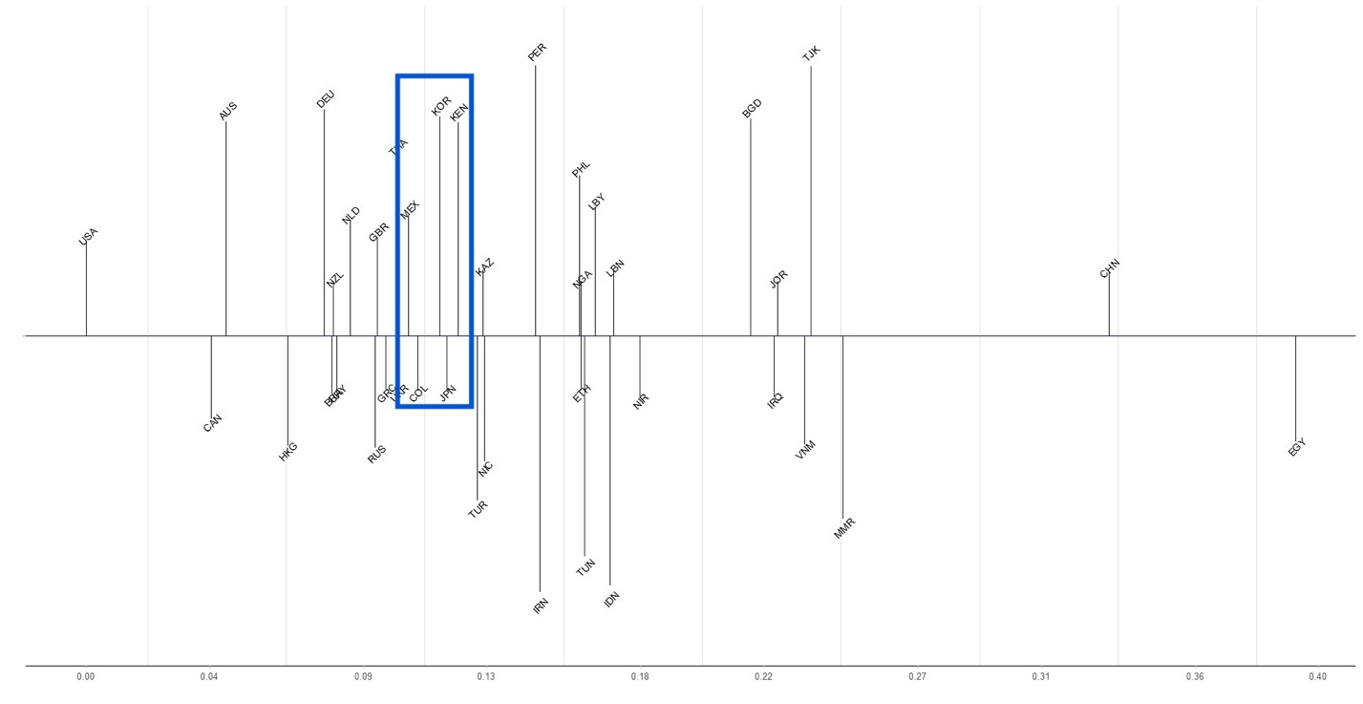
Figure S1. CFst estimates for a subset of countries based on WVS 7 responses. Canada and Australia are the countries closest to the United States, while China and Egypt are the most distant. Colombia is in the blue box near Japan, Kenya, Mexico, and South Korea.

- Supplementary results for Study 1

The full list of items generated during the free-listing task, along with frequency and centrality ratings, are summarized in Table S1 (US responses) and Table S2 (Colombian responses).

Table S1. Full list of frequency and centrality ratings of loyalty features for US participants
Feature | Frequency (Study 1) | Centrality (Study 2)
Not betraying you | 4.04% | 6.55 [6.44, 6.66]
Having your back | 3.03% | 6.51 [6.4, 6.62]
Being there for you | 27.27% | 6.45 [6.34, 6.57]
Not cheating on a romantic partner | 2.02% | 6.4 [6.25, 6.49]
Willing to defend you | 10.10% | 6.37 [6.26, 6.49]
Unconditional support | 3.03% | 6.33 [6.19, 6.47]
Sticking up for you | 7.07% | 6.34 [6.22, 6.45]
Being on your side no matter what | 3.03% | 6.21 [6.05, 6.38]
Not talking behind your back | 4.04% | 6.25 [6.11, 6.39]
Keeps promises | 3.03% | 6.17 [6.04, 6.3]
Trustworthiness | 43.43% | 6.16 [6.02, 6.29]
Helping you when you need it | 3.03% | 6.13 [5.99, 6.26]
Commitment | 6.06% | 6.1 [5.95, 6.24]
Being supportive | 18.18% | 6.06 [5.92, 6.2]
Reliability | 6.06% | 5.99 [5.84, 6.14]
Faithfulness | 15.15% | 5.98 [5.79, 6.18]
Not lying to you | 3.03% | 5.98 [5.8, 6.16]
Devotion | 7.07% | 5.97 [5.82, 6.13]
Being dependable | 24.24% | 5.94 [5.77, 6.11]
Being reliable | 10.10% | 5.88 [5.72, 6.04]
Good friend | 22.22% | 5.85 [5.7, 6.01]
Dedication | 18.18% | 5.76 [5.57, 5.95]
Being willing to keep secrets | 3.03% | 5.73 [5.53, 5.92]
Being trusting | 10.10% | 5.65 [5.45, 5.84]
Truthfulness | 12.12% | 5.63 [5.43, 5.82]
Honesty | 42.42% | 5.6 [5.42, 5.79]
Being willing to sacrifice | 3.03% | 5.47 [5.29, 5.66]
Caring about others over reputation | 3.03% | 5.4 [5.19, 5.61]
Sincerity | 4.04% | 5.24 [5.04, 5.44]
Consistency | 10.10% | 5.22 [5.01, 5.43]
Constant | 3.03% | 5.21 [4.99, 5.43]
Being understanding | 8.08% | 5.15 [4.95, 5.34]
Helpfulness | 14.14% | 5.08 [4.89, 5.27]
Selfless | 9.09% | 5.08 [4.88, 5.28]
Being honorable | 6.06% | 5.06 [4.83, 5.28]
Accountability | 3.03% | 5.03 [4.81, 5.24]
Being steadfast | 10.10% | 4.98 [4.77, 5.2]
Having close relationships | 3.03% | 4.98 [4.76, 5.2]
Authenticity | 3.03% | 4.96 [4.74, 5.19]
Caring | 31.31% | 4.91 [4.69, 5.13]
Responsibility | 6.06% | 4.9 [4.69, 5.13]
Nonjudgmental | 3.03% | 4.9 [4.68, 5.12]
Good listener | 7.07% | 4.85 [4.63, 5.07]
Empathetic | 13.13% | 4.81 [4.59, 5.03]
Loving | 20.20% | 4.8 [4.58, 5.02]
Being respectful | 15.15% | 4.79 [4.56, 5.02]
Thoughtfulness | 3.03% | 4.79 [4.58, 5.01]
Presence | 4.04% | 4.76 [4.53, 4.98]
Forgiving | 5.05% | 4.76 [4.55, 4.97]
Encouragement | 4.04% | 4.69 [4.48, 4.89]
Availability | 6.06% | 4.67 [4.45, 4.89]
Compassionate | 6.06% | 4.63 [4.41, 4.86]
Giving | 3.03% | 4.6 [4.38, 4.81]
Attentiveness | 4.04% | 4.58 [4.36, 4.8]
Communicative | 3.03% | 4.52 [4.29, 4.75]
Kindness | 21.21% | 4.41 [4.17, 4.65]
Perseverance | 6.06% | 4.32 [4.09, 4.56]
Determination | 3.03% | 4.11 [3.87, 4.36]
Warmth | 3.03% | 4.08 [3.85, 4.31]
Courage | 6.06% | 4.07 [3.83, 4.3]
Obedience | 6.06% | 4.05 [3.8, 4.3]
Positivity | 6.06% | 3.98 [3.73, 4.23]
Adaptability | 3.03% | 3.96 [3.72, 4.2]
Humility | 3.03% | 3.95 [3.7, 4.2]
Strength | 7.07% | 3.92 [3.67, 4.16]
Frankness | 4.04% | 3.9 [3.69, 4.12]
Bravery | 6.06% | 3.89 [3.66, 4.12]
Being admirable | 4.04% | 3.87 [3.62, 4.12]
Nice | 3.03% | 3.82 [3.57, 4.08]
Motivation | 4.04% | 3.74 [3.48, 3.99]
Hard worker | 5.05% | 3.73 [3.47, 3.99]
Competence | 3.03% | 3.7 [3.46, 3.95]
Confidence | 4.04% | 3.67 [3.42, 3.92]
Sweet | 3.03% | 3.56 [3.3, 3.81]
Happiness | 3.03% | 3.51 [3.25, 3.76]
Self-sufficient | 3.03% | 3.47 [3.22, 3.72]
Intelligence | 8.08% | 3.28 [3.03, 3.54]
Being patriotic | 0% | 3.18 [2.91, 3.44]
Taking risks | 3.03% | 2.93 [2.72, 3.15]
Fun | 3.03% | 2.83 [2.6, 3.06]
Note: Features are sorted by centrality

Table S2. Frequency and centrality of loyalty features for Colombian participants
Feature | Frequency | Centrality
Fidelidad | 32.73% | 6.49 [6.36, 6.61]
Confiabilidad | 52.73% | 6.41 [6.27, 6.54]
Honestidad | 62.73% | 6.34 [6.17, 6.51]
Sinceridad | 37.27% | 6.34 [6.17, 6.51]
Respeto | 38.18% | 6.24 [6.06, 6.42]
Ética | 24.55% | 6.19 [6.01, 6.37]
Compromiso | 14.55% | 6.09 [5.91, 6.28]
Principios | 2.73% | 6.08 [5.88, 6.28]
Cumplimiento promesas | 11.82% | 6.08 [5.88, 6.27]
Honradez | 6.36% | 6.03 [5.83, 6.24]
Guarda secretos | 4.55% | 5.99 [5.79, 6.2]
Franqueza | 11.82% | 5.97 [5.77, 6.17]
Transparencia | 5.45% | 5.96 [5.74, 6.17]
Fiabilidad | 2.73% | 5.94 [5.75, 6.13]
Buen amigo | 35.54% | 5.9 [5.7, 6.1]
Apoyo | 21.82% | 5.86 [5.68, 6.05]
Incondicionalidad | 25.45% | 5.85 [5.66, 6.04]
Respaldo | 2.73% | 5.83 [5.65, 6.01]
Defender | 4.55% | 5.81 [5.61, 6.01]
Honorabilidad | 4.55% | 5.81 [5.6, 6.03]
Responsabilidad | 16.36% | 5.8 [5.57, 6.02]
Coherencia | 16.36% | 5.78 [5.59, 5.98]
Discreción | 5.45% | 5.75 [5.54, 5.96]
Firmeza | 9.09% | 5.73 [5.53, 5.94]
Justicia | 3.64% | 5.71 [5.47, 5.94]
Seriedad | 4.55% | 5.7 [5.47, 5.92]
Solidaridad | 8.18% | 5.65 [5.43, 5.86]
Prudencia | 5.45% | 5.63 [5.41, 5.85]
Disposición a escuchar | 7.27% | 5.6 [5.37, 5.83]
Empatía | 10.91% | 5.59 [5.37, 5.81]
Compañerismo | 10.91% | 5.57 [5.37, 5.77]
Constancia | 10% | 5.57 [5.36, 5.79]
Ser cumplido | 8.18% | 5.57 [5.35, 5.8]
Reserva | 2.72% | 5.56 [.32, 5.81]
Ejemplaridad | 2.72% | 5.51 [5.27, 5.76]
Tolerancia | 8.18% | 5.44 [5.21, 5.67]
Comprensión | 11.82% | 5.43 [5.2, 5.65]
Seguridad | 5.45% | 5.41 [5.17, 5.66]
Humanidad | 2.73% | 5.34 [5.11, 5.57]
Razonable | 10.91% | 5.31 [5.07, 5.55]
Dedicación | 5.45% | 4.9 [4.68, 5.12]
Fraternidad | 2.73% | 5.25 [5.03, 5.47]
Disponibilidad | 6.36% | 5.2 [4.97, 5.43]
Humildad | 6.36% | 5.2 [4.94, 5.47]
Nobleza | 9.09% | 5.19 [4.94, 5.45]
Buenos consejos | 6.36% | 5.19 [4.93, 5.44]
Bondad | 7.27% | 5.17 [4.92, 5.42]
Asertividad | 2.73% | 5.1 [4.85, 5.35]
Paciencia | 7.27% | 5.1 [4.87, 5.34]
Ser atento | 9.09% | 5.08 [4.83, 5.34]
Generosidad | 15.45% | 5.07 [4.83, 5.31]
Inteligencia | 2.73% | 5.07 [4.82, 5.33]
Cariño | 26.36% | 5.05 [4.8, 5.3]
Servicialidad | 20% | 5.01 [4.75, 5.27]
Amabilidad | 19.09% | 5.01 [4.74, 5.27]
Bienestar | 5.45% | 5 [4.75, 5.25]
Tranquilidad | 7.23% | 4.95 [4.69, 5.21]
Calidez | 2.73% | 4.95 [4.7, 5.2]
Liderazgo | 4.54% | 4.93 [4.66, 5.2]
Cordialidad | 2.73% | 4.92 [4.66, 5.18]
Sacrificio | 1.82% | 4.92 [4.66, 5.18]
Familiaridad | 2.73% | 4.9 [4.64, 5.16]
Altruismo | 3.64% | 4.82 [4.58, 5.07]
Afectuosidad | 3.64% | 4.77 [4.52, 5.01]
Carisma | 2.73% | 4.76 [4.49, 5.02]
Sencillez | 2.73% | 4.75 [4.47, 5.02]
Trabajador | 3.64% | 4.72 [4.45, 5]
Complicidad | 2.73% | 4.72 [4.46, 4.98]
Patriotismo* | 0% | 4.32 [4.05, 4.6]
Religiosidad | 3.64% | 3.77 [3.47, 4.06]
Note: Features are sorted by centrality. Values in brackets represent 95% confidence intervals.

We conducted a series of proportion tests to see whether there was evidence for statistically significant differences across countries in the frequencies of the five most mentioned items (US: Trustworthiness, Honesty, Caring, Being there for you, Being dependable; COL: Honestidad, Confiabilidad, Respeto, Sinceridad, Buen amigo). Bonferroni correction was applied to account for multiple comparisons. There was evidence that Colombians mentioned honestidad significantly more than Americans mentioned trustworthiness (χ²(1)= 7.04, p = .04, h = -0.17, 95% CI[-0.39, 0.05]), but there was no evidence for other differences. This suggests that the features constituting the associative meaning of loyalty within each group share similar levels of accessibility.

- Supplementary results for Study 2

Many items were considered good indicators of loyalty. However, US participants judged nearly a third of the terms to be poor or unclear indicators of loyalty (23/80). For these items, the lower bound of the confidence interval was under or included the indifference point (M = 4). Of these, 14% (11/80) were considered poor indicators of loyalty, with the upper bound of the confidence interval falling under the indifference point. ‘Being patriotic’ was one of the terms considered a poor indicator of loyalty. Colombian participants, on the other hand, considered only religiosidad as an unclear indicator of loyalty.

Table S3. Rotated factor loadings for US participants from Study 2
Item | Factor
 | Warmth/ Competence | Interpersonal Commitment | Personal Integrity | Authority | Trustworthiness
Adaptability | .71 | - | .20 | .24 | -
Attentiveness | .58 | .11 | .38 | - | .18
Being admirable | .73 | - | .12 | .24 | -
Being respectful | .67 | - | .33 | - | -
Being understanding | .67 | .12 | .34 | -.12 | -
Communicative | .64 | - | .35 | .13 | .22
Compassionate | .67 | .16 | .35 | -.17 | -
Competence | .68 | - | .23 | .38 | .16
Courage | .56 | - | .39 | .36 | .26
Empathetic | .69 | - | .36 | -.23 | -
Encouragement | .60 | .11 | .34 | - | -
Forgiving | .54 | - | .36 | - | .14
Giving | .65 | .25 | .15 | - | -
Good listener | .70 | .21 | .24 | - | -
Happiness | .83 | - | - | .26 | -
Having close relationships | .53 | .23 | .21 | - | .12
Helpfulness | .54 | .26 | .22 | .12 | -
Humility | .64 | - | .11 | .18 | .24
Kindness | .85 | - | .11 | -.15 | .10
Loving | .72 | .21 | .16 | - | -
Motivation | .77 | -.14 | - | .34 | .10
Nice | .85 | - | - | - | -
Nonjudgmental | .51 | .18 | .21 | - | .24
Perseverance | .63 | - | .17 | .32 | -
Positivity | .80 | - | .14 | .21 | .15
Presence | .55 | .18 | .27 | .19 | -
Responsibility | .55 | - | .25 | .24 | .32
Self-sufficiency | .79 | -.11 | - | .30 | .14
Selfless | .51 | .27 | .33 | - | .15
Sincerity | .61 | .17 | .15 | - | .25
Strength | .67 | - | .22 | .37 | .13
Sweet | .86 | - | - | - | -
Taking risks | .61 | -.16 | - | .39 | -
Thoughtfulness | .69 | .16 | .20 | - | -
Warmth | .86 | - | .12 | - | -
Authenticity | .48 | - | .29 | .18 | .26
Frankness | .50 | -.11 | .22 | .14 | .21
Being honorable | .43 | - | .36 | .16 | .16
Being on your side no matter what | -.27 | .56 | - | - | -
Being there for you | - | .62 | .23 | - | -
Having your back | - | .66 | - | - | -
Helping you when you need it | .26 | .63 | .11 | - | -
Not betraying you | -.16 | .61 | .12 | -.14 | .18
Not talking behind your back | .14 | .61 | - | - | .30
Standing by you | - | .71 | .14 | - | -
Sticking up for you | - | .75 | - | - | -
Unconditional support | - | .58 | .19 | - | -
Willing to defend you | - | .67 | - | - | -
Being supportive | .27 | .48 | .27 | - | -
Being willing to keep secrets | - | .38 | .21 | - | -
Not cheating on a romantic partner | .16 | .49 | - | - | -
Good friend | .39 | .41 | .18 | - | -
Being dependable | .19 | .24 | .52 | - | .26
Being steadfast | .25 | - | .45 | .25 | -.20
Caring about others over reputation | .20 | .15 | .46 | -.12 | -
Commitment | .12 | .36 | .51 | - | .12
Consistency | .31 | .19 | .54 | .21 | -
Constant | .31 | .20 | .54 | .17 | -
Dedication | .28 | .38 | .53 | .15 | -
Faithfulness | .16 | .28 | .36 | - | -
Being reliable | .21 | .28 | .44 | .13 | .32
Being willing to sacrifice | - | .34 | .41 | .16 | -
Devotion | - | .39 | .44 | .15 | -
Obedience | .23 | - | - | .55 | -
Being patriotic | .20 | - | .17 | .42 | -.11
Honesty | .46 | .14 | .17 | - | .59*
Trustworthiness | .24 | .36 | .25 | - | .45
Truthfulness | .47 | .18 | - | - | .65*
Note. * = items that did not meet strict cut-off standards.

Table S4. Rotated factor loadings for Colombian participants from Study 2
Item | Factor
 | Warmth/ Competence | Moral Values | Truthfulness | Perseverance | Defensiveness
Cariño | .62 | - | - | .30 | .24
Servicialidad | .79 | - | .20 | .24 | .12
Amabilidad | .78 | - | .20 | .27 | -
Responsabilidad | .54 | .24 | .37 | .29 | -.13
Generosidad | .71 | - | .29 | .21 | .21
Nobleza | .73 | - | .29 | .22 | -
Solidaridad | .54 | .21 | .33 | .32 | .10
Buenos consejos | .65 | - | .28 | .25 | .16
Disponibilidad | .54 | - | .26 | .25 | .38
Humildad | .77 | .18 | .16 | - | .15
Bienestar | .76 | .37 | - | - | -
Liderazgo | .71 | .36 | .14 | - | -
Afectuosidad | .75 | .27 | -.11 | .24 | .18
Altruismo | .66 | .25 | .19 | - | -
Religiosidad | .66 | .11 | - | - | .19
Trabajador | .81 | .24 | - | - | -
Calidez | .69 | .37 | - | .14 | .20
Carisma | .77 | .33 | .10 | .11 | .14
Cordialidad | .80 | .27 | - | .25 | -
Familiaridad | .66 | .34 | - | - | .17
Humanidad | .62 | .38 | .18 | - | -
Inteligencia | .66 | .39 | .12 | - | -
Sencillez | .80 | .23 | .15 | - | -
Patriotismo | .64 | .31 | - | - | .26
Sacrificio | .66 | - | - | - | .27
Compañerismo | .41
Buen amigo | .42 | - | .38 | .22 | .16
Compañerismo | .48 | .13 | .30 | .25 | .33
Ser cumplido | .43 | .27 | .30 | .32 | -
Complicidad | .47 | .12 | - | - | .39
Discreción | .25 | .61 | .11 | .30 | .30
Transparencia | .24 | .66 | .23 | .12 | -
Prudencia | .33 | .68 | - | .25 | .25
Justicia | .29 | .54 | .32 | - | -
No habla mal a sus espaldas | .12 | .51 | .20 | - | -
Principios | .13 | .67 | .29 | - | .16
Reserva | .33 | .56 | .14 | .17 | .30
Coherencia | .11 | .42 | .35 | .31 | -
Seriedad | .31 | .41 | .30 | - | .33
Honestidad | .19 | .27 | .58 | .18 | -.19
Confiabilidad | - | .13 | .73 | .21 | .11
Sinceridad | - | - | .69 | - | .24
Ética | .15 | .28 | .66 | - | -
Cumplimiento promesas | .11 | .34 | .53 | .10 | .26
Franqueza | .27 | .20 | .54 | .13 | .20
Fidelidad | -.11 | .10 | .46 | - | .15
Constancia | .36 | .25 | .20 | .49 | -
Incondicionalidad | .10 | - | .50 | .11 | .28
Guarda secretos | .20 | .28 | .22 | - | .59
Defender | .26 | .19 | .30 | - | .59
Respaldo | .13 | .27 | .28 | .26 | .49

- Supplementary results for Study 3
We first compared centrality ratings with Study 2 to assess whether different samples from each country rated the centrality of loyalty features differently. A two-sample t-test found no evidence for an effect of study on ratings of centrality for participants from Colombia (t(172) = -0.25, p = .81, d = -0.04, 95% CI[-0.34, 0.27]). There was evidence for a small but significant difference in centrality ratings for US participants, with participants in Study 3 (M = 5.15, 95% CI[5.01, 5.28]) rating features as less central overall compared to participants in Study 2 (M = 5.45, 95% CI[5.30, 5.60]) (t(150) = 2.99, d = 0.49, 95% CI[0.16, 0.81]). Bayesian analyses provided strong evidence for the alternative hypothesis that US participants in Study 3 rated the centrality of loyalty features significantly lower than US participants in Study 2 (BF10 = 9.89).

Table S5. Rotated factor loadings for centrality judgments across US and Colombia in Study 3.
 | Colombia |  |  | United States
Feature | Moral values | Personal Trust | Interpersonal Commitment | Moral values | Interpersonal commitment | Concern | Honesty | Authority
Cordial | .56 | .35 | .32 | .68 | .29 | - | .23 | -
Authenticity | .69 | .17 | .20 | .45 | .14 | .39 | .36 | -.18
Caring* | .66 | .22 | .19 | .45 | .13 | .60 | .19 | -.13
Responsibility | .57 | .34 | -.16 | .53 | .19 | .38 | .22 | -
Nonjudgmental* | .57 | .27 | - | .45 | .15 | .46 | .17 | -.15
Good listener | .69 | .32 | - | .62 | .19 | .33 | .15 | -.32
Empathetic | .65 | .14 | .18 | .38 | .26 | .61 | .19 | -.13
Loving | .63 | .12 | .39 | .39 | - | .59 | .13 | -
Thoughtfulness* | .62 | .33 | .16 | .50 | .20 | .60 | .12 | -
Forgiving* | .61 | .11 | .25 | .55 | .18 | .40 | - | -
Encouragement | .74 | .15 | .25 | .62 | .11 | .32 | - | -.28
Availability | .58 | .31. | 23 | .61 | .29 | .21 | - | -.20
Compassionate* | .69 | - | .12 | .42 | .24 | .60 | .11 | .11
Giving* | .69 | .11 | .33 | .48 | .16 | .48 | .17 | .13
Communicative | .68 | .37 | - | .62 | .13 | .34 | .26 | -.22
Attentiveness | .76 | .18 | .17 | .64 | .18 | .31 | - | -
Kindness* | .74 | .17 | .26 | .55 | .12 | .59 | .18 | -
Determination | .64 | .28 | - | .68 | - | .25 | .19 | .21
Perseverance | .70 | .16 | .15 | .67 | .17 | .32 | .12 | .20
Warmth* | .76 | .20 | .19 | .57 | .22 | .50 | - | -
Courage | .73 | - | .22 | .72 | .13 | .26 | .14 | .24
Positivity | .76 | .15 | .32 | .68 | - | .39 | .21 | -.13
Adaptability | .59 | .19 | .18 | .74 | .12 | .23 | .11 | -
Humility | .76 | .19 | - | .52 | - | .37 | .28 | -
Strength | .64 | .23 | - | .78 | .11 | .16 | - | .18
Being admirable | .60 | .20 | .12 | .72 | - | .25 | - | -
Bravery | .72 | .11 | .24 | .72 | - | .23 | .21 | .15
Nice* | .78 | - | .25 | .68 | .12 | .43 | .15 | -
Collegiality | .54 | .26 | .14 | .63 | .17 | - | .12 | -
Reasonable* | .72 | .28 | - | .64 | .21 | .42 | .19 | -
Noble | .66 | .19 | .37 | .62 | - | .24 | .15 | .24
Fulfilling duties* | .67 | .30 | - | .35 | .26 | .11 | -.12 | .33
Tolerant | .76 | .25 | - | .60 | .17 | .37 | - | -
Good hearted* | .75 | .13 | .30 | .45 | - | .64 | .23 | -
Patient* | .75 | .23 | - | .53 | .14 | .46 | .14 | -.16
Relaxed | .72 | .16 | - | .88 | - | .14 | .11 | -
Gives good advice | .58 | .22 | .33 | .66 | .25 | .12 | - | -
Prudent | .61 | .35 | - | .62 | - | .30 | .20 | .30
Good leadership | .72 | - | .17 | .79 | - | .16 | .12 | -
Altruistic | .53 | - | .23 | .51 | .13 | .33 | .19 | .21
Strong sense of justice | .51 | .33 | - | .61 | - | .27 | .27 | .30
Religious | .54 | -.13 | .38 | .59 | - | - | .11 | .11
Assertive | .69 | .23 | - | .81 | - | - | - | -
Charismatic | .75 | - | .32 | .81 | - | .18 | .15 | -
Familiar | .67 | - | .38 | .66 | .11 | .13 | - | -
Treating you like family* | .52 | .23 | .32 | .39 | .34 | .24 | -.11 | -
Humanistic | .63 | .36 | - | .61 | - | .33 | .14 | .13
Simplicity | .80 | - | .19 | .79 | - | .19 | .12 | -.17
Intelligent | .48 | .38 | .11 | .79 | - | -.11 | .39 | -
Hard worker | .47 | .34 | .33 | .67 | .13 | - | .35 | -
Presence | .49 | .21 | .33 | .61 | .18 | .21 | - | -
Frankness | .44 | .32 | .11 | .59 | - | .21 | .16 | -.29
Solidarity* | .47 | .27 | .23 | .24 | .37 | .29 | -.11 | .13
Not stealing | .47 | .23 | - | .47 | .21 | .20 | .26 | .15
Being reserved | .41 | .24 | - | .80 | -.14 | - | - | -
Helpfulness** |  |  |  | .54 | .28 | .20 | .39 | -
Good health** |  |  |  | .78 | - | - | .35 | -
Discrete** |  |  |  | .51 | - | - | - | -.25
Obedience** |  |  |  | .49 | - | .14 | - | .32
Not betraying you | - | .71 | .16 | -.10 | .69 | - | - | -
Being there for you | - | .60 | .35 | - | .77 | - | .13 | -
Not cheating | .16 | .56 | .22 |  |  |  | .74
Not talking behind your back | .12 | .56 | .13 | .10 | .66 | - | .22 | -.17
Trustworthiness* | - | .71 | - | .10 | .41 | .11 | .50 | .27
Helping you when you need it | .11 | .63 | .18 | .20 | .59 | - | .19 | -
Dedication** |  |  |  | .23 | .51 | .14 | .16 | -
Unconditional support** |  |  |  | -.22 | .62 | - | - | -
Willing to defend you** |  |  |  | - | .68 | - | .12 | -.12
Commitment | .37 | .61 | - | .10 | .58 | - | .18 | .23
Constant |  |  |  | .34 | .54 | - | .22 | .22
Being supportive | .21 | .64 | .27 | .22 | .60 | .17 | - | -
Being dependable** |  |  |  | - | .68 | .11 | .27 | -
Reliability | .18 | .73 | - | .28 | .58 | .14 | .31 | .20
Faithfulness | - | .69 | .27 | - | .51 | .19 | - | -
Makes you feel safe** |  |  |  | .39 | .41 | .20 | .38 | -.31
Keeps promises |  |  |  | - | .63 | .11 | .34 | .11
Not lying to you* | .15 | .65 | .36 | .18 | .48 | .17 | .40 | .12
Good friend | .27 | .61 | .39 | .28 | .55 | - | .12 | -
Being willing to keep secrets | - | .56 | - | - | .55 | - | - | -.11
Being trusting | .23 | .66 | .16 | .38 | .41 | - | .33 | -.12
Truthfulness | .28 | .69 | - | .18 | .22 | .27 | .76 | -
Honesty | .18 | .73 | - | .21 | .35 | - | .71 | -
Sincerity | .18 | .72 | .18 | .33 | .35 | .31 | .55 | -
Consistency | .37 | .59 | .14 | .39 | .52 | .18 | .35 | .18
Being understanding* | .39 | .64 | .25 | .48 | .39 | .26 | .42 | -
Being honorable* | .28 | .65 | .10 | .41 | .26 | - | .51 | .24
Being steadfast | .32 | .59 | .31 | .31 | .35 | - | .24 | .23
Transparent | .20 | .60 | - | .36 | .18 | .22 | .52 | -.13
Having your back | .23 | .48 | .32 | -.10 | .79 | - | - | -
Accountability | .30 | .40 | .19 | .33 | .34 | .24 | .55 | -
Ethical* | .37 | .44 | - | .55 | - | .46 | .29 | .19
Being principled* | .29 | .41 | .11 | .50 | .18 | .20 | .15 | .41
Standing by you | .22 | .35 | .60 | - | .66 | - | - | -
Sticking up for you | - | .33 | .73 | - | .78 | - | - | -
Devotion | .27 | .15 | .57 | - | .52 | - | - | -
Being willing to sacrifice* | .25 | .31 | .63 | .26 | .39 | - | .12 | .10
Caring about others over reputation | .12 | - | .54 | .27 | .42 | .16 | .18 | -
Having close relationships* | .31 | .29 | .59 | .38 | .37 | .10 | .26 | -
Being reliable | .12 | - | .50 | .21 | .59 | .12 | .36 | -
Close ally | .32 | .11 | .40 | .13 | .53 | .14 | - | -
Note. Items without an asterisk reflect shared items, items with a single asterisk reflect unique features from Colombian sample, and items with two asterisks reflects unique features from the US sample.

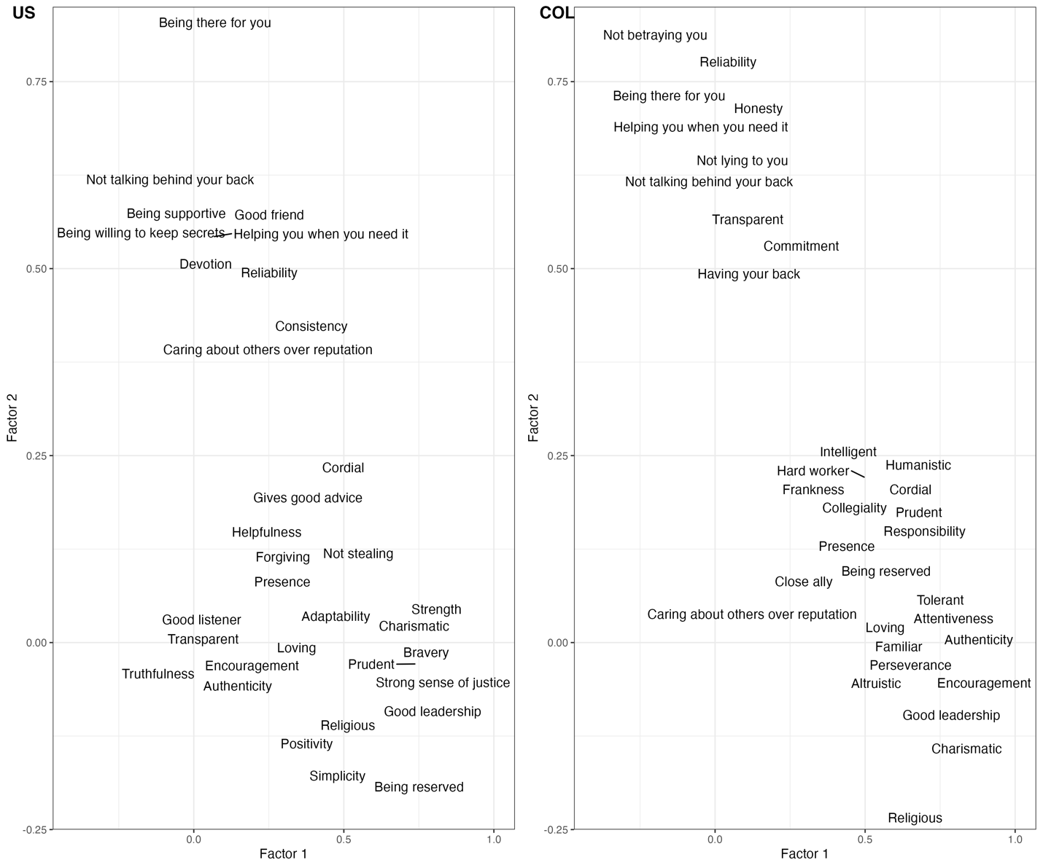
Figure S2. Rotated factor loadings for random sample of items shared across United States and Colombian participants. Loadings are drawn from the two factors that explain the most variance in participant responses. For US participants, both factors explain 32% of total variance (Factor 1 = 17% and Factor 2 = 15%). For Colombian participants, both factors explain 46% of total variance (Factor 1 = 29% and Factor 2 = 17%).

- Supplementary analyses for Study 4

Table S6. Frequency and centrality ratings of honesty features for US participants
Feature | Frequency | Centrality
Not lying | 15% | 6.53 [6.39, 6.68]
Truthfulness | 42% | 6.53 [6.4, 6.65]
Not cheating | 3% | 6.06 [5.9, 6.22]
Trustworthy | 42% | 6.06 [5.89, 6.22]
Being transparent | 12% | 5.89 [5.72, 6.06]
Having integrity | 11% | 5.8 [5.62, 5.99]
Admitting mistakes | 3% | 5.73 [5.56, 5.9]
Accountability | 3% | 5.66 [5.47, 5.85]
Being ethical | 10% | 5.59 [5.4, 5.79]
Authenticity | 4% | 5.54 [5.35, 5.74]
Being genuine | 11% | 5.53 [5.32, 5.74]
Taking responsibility | 6% | 5.52 [5.33, 5.71]
Keeping promises | 3% | 5.46 [5.25, 5.66]
Forthcoming | 7% | 5.42 [5.23, 5.62]
Being moral | 13% | 5.32 [5.11, 5.54]
Being straightforward | 16% | 5.31 [5.12, 5.51]
Sincerity | 17% | 5.28 [5.05, 5.52]
Principled | 3% | 5.24 [5.05, 5.43]
Being fair | 12% | 5.03 [4.81, 5.24]
Following the rules | 3% | 5.01 [4.77, 5.25]
Using facts | 3% | 5.01 [4.79, 5.23]
Being frank | 3% | 4.91 [4.68, 5.14]
Being direct | 6% | 4.9 [4.68, 5.12]
Openness | 14% | 4.85 [4.63, 5.08]
Reliability | 14% | 4.82 [4.6, 5.03]
Dependable | 7% | 4.73 [4.5, 4.96]
Trusting | 3% | 4.62 [4.35, 4.89]
Respectable | 3% | 4.5 [4.25, 4.74]
Being good | 4% | 4.45 [4.21, 4.68]
Consistency | 10% | 4.44 [4.2, 4.67]
Loyalty | 10% | 4.43 [4.17, 4.68]
Respectful | 7% | 4.27 [4.02, 4.52]
Self awareness | 3% | 4.15 [3.9, 4.39]
Thoughtfulness | 10% | 4.11 [3.87, 4.35]
Humility | 8% | 3.95 [3.72, 4.19]
Understanding | 3% | 3.95 [3.72, 4.19]
Selflessness | 10% | 3.93 [3.68, 4.18]
Wisdom | 3% | 3.91 [3.67, 4.16]
Caring | 20% | 3.9 [3.64, 4.16]
Compassionate | 7% | 3.87 [3.62, 4.13]
Empathetic | 12% | 3.87 [3.62, 4.12]
Steadfast | 3% | 3.86 [3.64, 4.07]
Helpfulness | 9% | 3.72 [3.48, 3.96]
Kind | 26% | 3.71 [3.47, 3.96]
Loving | 7% | 3.7 [3.44, 3.95]
Good leader | 3% | 3.69 [3.43, 3.94]
Sympathetic | 3% | 3.69 [3.43, 3.94]
Good listener | 3% | 3.58 [3.33, 3.83]
Giving | 5% | 3.57 [3.34, 3.81]
Being nice | 9% | 3.45 [3.21, 3.69]
Warmth | 8% | 3.42 [3.16, 3.67]
Generous | 3% | 3.39 [3.15, 3.63]
Intelligence | 8% | 3.33 [3.09, 3.57]
Bravery | 3% | 3.31 [3.07, 3.55]
Keeping secrets | 3% | 3.28 [3.0, 3.57]
Being friendly | 8% | 3.24 [2.99, 3.49]
Confidence | 6% | 3.13 [2.9, 3.37]
Happiness | 3% | 3.09 [2.85, 3.34]
Spiritual | 3% | 3.05 [2.77, 3.32]
Being calm | 10% | 2.98 [2.75, 3.22]
Being harsh | 3% | 2.52 [2.29, 2.76]
Note. Features are sorted by centrality. Values in brackets represent 95% confidence intervals.

Table S7. Frequency and centrality ratings of honesty features for Colombian participants
Feature | Frequency | Centrality
Honradez (Honesty/Integrity)* | 25% | 6.42 [6.28, 6.56]
Actuar correctamente (Act correctly) | 11% | 6.39 [6.24, 6.55]
Decir la verdad (Tell the truth) | 13% | 6.36 [6.22, 6.5]
Transparencia (Transparency) | 21% | 6.32 [6.16, 6.47]
Confiabilidad (Reliability) | 17% | 6.29 [6.14, 6.43]
No engañar (Not deceiving) | 5% | 6.26 [6.1, 6.42]
Tener principios (Having principles) | 3% | 6.26 [6.1, 6.42]
Tener valores (Having values) | 3% | 6.24 [6.08, 6.39]
No mentir (Not lying) | 59% | 6.22 [6.05, 6.39]
Sinceridad (Sincerity) | 12% | 6.22 [6.05, 6.38]
Ética (Ethical) | 9% | 6.2 [6.03, 6.37]
Rectitud (Rectitude) | 9% | 6.19 [6.03, 6.36]
Ser incorruptible (Being incorruptible) | 8% | 6.14 [5.95, 6.33]
Franqueza (Frankness) | 16% | 6.1 [5.93, 6.26]
Integridad (Having integrity) | 14% | 6.1 [5.92, 6.27]
Fidelidad (Faithful) | 7% | 6.08 [5.89, 6.27]
Lealtad (Loyalty) | 33% | 6.07 [5.88, 6.26]
Conciencia (Awareness) | 7% | 6.05 [5.87, 6.22]
Honorabilidad (Honorable) | 5% | 5.99 [5.8, 6.18]
Credibilidad (Credibility) | 3% | 5.97 [5.78, 6.15]
Cumplimiento de promesas (Keeping promises) | 8% | 5.96 [5.77, 6.15]
Moralidad (Morality) | 4% | 5.95 [5.76, 6.14]
Veracidad (Veracity) | 4% | 5.94 [5.76, 6.12]
Responsabilidad (Being responsible) | 34% | 5.92 [5.73, 6.11]
Ser justo (Being fair) | 10% | 5.9 [5.71, 6.1]
Coherencia (Being consistent) | 8% | 5.89 [5.71, 6.08]
Ser claro (Being clear) | 8% | 5.87 [5.67, 6.06]
Respeto (Being respectful) | 32% | 5.78 [5.57, 5.99]
Compromiso (Commitment) | 7% | 5.72 [5.52, 5.92]
Sensatez (Sanity) | 4% | 5.62 [5.43, 5.81]
Disciplina (Discipline) | 3% | 5.53 [5.32, 5.75]
Decencia (Decency) | 8% | 5.5 [5.28, 5.72]
Autenticidad (Authenticity) | 10% | 5.42 [5.2, 5.64]
Discreción (Discretion) | 8% | 5.42 [5.19, 5.66]
Seriedad (Seriousness) | 3% | 5.42 [5.19, 5.65]
Bondad (Goodness) | 7% | 5.39 [5.17, 5.61]
Empatía (Empathy) | 7% | 5.39 [5.16, 5.62]
Seguridad (Security) | 6% | 5.39 [5.16, 5.62]
Sabiduría (Wisdom) | 3% | 5.37 [5.13, 5.6]
Disposición a escuchar (Willingness to listen to others) | 3% | 5.36 [5.13, 5.59]
Ser directo (Being direct) | 8% | 5.35 [5.11, 5.59]
Nobleza (Nobility) | 8% | 5.34 [5.11, 5.57]
Brindar ayuda a los demás (Provide help to others) | 3% | 5.33 [5.1, 5.56]
Tener carácter (Having character) | 3% | 5.32 [5.09, 5.55]
Puntualidad (Punctuality) | 5% | 5.3 [5.05, 5.56]
No juzgar (Nonjudgmental) | 3% | 5.24 [5.0, 5.48]
Amistad (Friendship) | 5% | 5.21 [4.97, 5.45]
Humildad (Modesty) | 10% | 5.19 [4.95, 5.44]
Ser realista (Being realistic) | 3% | 5.17 [4.92, 5.42]
Eficacia (Effectiveness) | 3% | 5.16 [4.93, 5.4]
Fortaleza (Strength) | 6% | 5.13 [4.89, 5.38]
Tener educación (Being educated) | 3% | 5.13 [4.89, 5.37]
Tolerancia (Tolerance) | 3% | 5.12 [4.88, 5.37]
Protege a los demás (Protect others) | 3% | 5.09 [4.84, 5.34]
Valentía (Courage) | 5% | 5.07 [4.82, 5.32]
Inteligencia (Intelligence) | 7% | 5.06 [4.81, 5.3]
Generosidad (Generosity) | 3% | 5.05 [4.81, 5.3]
Pulcritud (Neatness) | 3% | 5.05 [4.81, 5.3]
Sencillez (Simplicity) | 7% | 5.04 [4.8, 5.29]
Capacidad (Ability) | 3% | 5.03 [4.78, 5.28]
Benevolencia (Benevolence) | 3% | 5.02 [4.8, 5.24]
Ser trabajador (Hard working) | 3% | 5.0 [4.76, 5.25]
Amabilidad (Kindness) | 26% | 4.99 [4.74, 5.24]
Ser comprensivo (Being understanding) | 6% | 4.99 [4.73, 5.25]
Ser decidido (Being determined) | 3% | 4.99 [4.74, 5.24]
Paciencia (Patience) | 5% | 4.93 [4.67, 5.19]
Ser colaborador (Collaborative) | 4% | 4.91 [4.65, 5.17]
Ser servicial (Being helpful) | 3% | 4.91 [ 4.66, 5.16]
Ser organizado (Being organized) | 24% | 4.9 [4.64, 5.17]
Tranquilidad (Tranquility) | 3% | 4.9 [4.65, 5.16]
Ser compasivo (Being compassionate) | 7% | 4.88 [4.63, 5.14]
Felicidad (Happiness) | 6% | 4.87 [4.61, 5.13]
Ser atento (Being attentive) | 3% | 4.79 [4.54, 5.04]
Alegría (Joyful) | 8% | 4.75 [4.49, 5.01]
Carisma (Charisma) | 3% | 4.75 [4.5, 5.01]
Limpieza (Cleaning) | 3% | 4.74 [4.47, 5.01]
Tener una buena familia (Having a good family) | 3% | 4.64 [4.36, 4.93]
Ser pacífico (Being peaceful) | 3% | 4.6 [4.34, 4.85]
Ser amigable (Being friendly) | 6% | 4.58 [4.31, 4.85]
Ser sociable (Being sociable) | 3% | 4.52 [4.25, 4.79]
Ser cariñoso (Being affectionate) | 6% | 4.42 [4.14, 4.69]
Ser descomplicado (Down to earth) | 3% | 4.4 [4.13, 4.68]
Note. Features are sorted by centrality. Values in brackets represent 95% confidence intervals.

Table S8. Rotated factor loadings for centrality judgments of honesty features for US participants in Study 4.

Feature | Factor 1 | Factor 2
Being calm | .79 | -
Being friendly | .82 | .16
Being good | .62 | .28
Being nice | .83 | .14
Bravery | .71 | .14
Caring | .86 | .17
Compassionate | .85 | .17
Consistency | .52 | .20
Confidence | .70 | .16
Empathetic | .79 | .22
Generous | .80 | -
Giving | .76 | .21
Good leader | .70 | .27
Good listener | .81 | .16
Happiness | .79 | .16
Helpfulness | .85 | .15
Humility | .65 | .21
Intelligence | .76 | -
Kind | .87 | .12
Loving | .86 | .13
Loyalty | .62 | .22
Respectable | .63 | .37
Respectful | .74 | .32
Self-awareness | .61 | .24
Selflessness | .70 | .16
Spiritual | .64 | .15
Steadfast | .57 | .21
Sympathetic | .84 | .15
Thoughtfulness | .76 | .22
Trusting | .58 | .32
Understanding | .79 | .24
Warmth | .86 | .12
Wisdom | .67 | .24
Admitting mistakes | .23 | .58
Being direct | - | .60
Being ethical | .18 | .59
Being genuine | .27 | .55
Being straightforward | .12 | .58
Being transparent | - | .66
Forthcoming | - | .56
Having integrity | .18 | .60
Not cheating | - | .63
Taking responsibility | .32 | .63
Trustworthy | .13 | .60
Being frank | - | .40
Following the rules | .32 | .47
Keeping promises | .38 | .49
Not lying | -.15 | .49
Openness | .30 | .45
Principled | .32 | .47
Sincerity | .36 | .48
Truthfulness | -.21 | .47
Using facts | .21 | .40

Table S9. Rotated factor loadings for centrality judgments of honesty features for Colombian participants in Study 4.

Feature | Factor 1 | Factor 2
Joy | .76 | .17
Kindness | .76 | .12
Friendship | .68 | .23
Authenticity | .57 | .31
Benevolence | .63 | .25
Goodness | .66 | .23
Provide help to others | .68 | .27
Ability | .77 | .14
Confidence | .79 | .13
Decency | .62 | .28
Discipline | .67 | .36
Discretion | .58 | .39
Willingness to listen to others | .74. | 24
Effectiveness | .68 | .20
Empathy | .59 | .33
Happiness | .82 | .19
Strength | .77 | .22
Generosity | .81 | .10
Modesty | .78 | .17
Intelligence | .78 | .16
Cleaning | .81 | -
Nonjudgmental | .66 | .20
Nobility | .70 | .26
Patience | .82 | .15
Protecting others | .79 | .22
Neatness | .78 | .20
Punctuality | .69 | .21
Wisdom | .63 | .23
Security | .68 | .28
Simplicity | .78 | .14
Being friendly | .87 | -
Being attentive | .87 | -
Being affectionate | .85 | .-
Being collaborative | .87 | -
Being compassionate | .83 | -
Being understanding | .78 | .13
Being determined | .78 | .15
Being uncomplicated | .81 | -
Being direct | .58 | .17
Being organized | .84 | -
Being peaceful | .84 | -
Being realistic | .68 | .16
Being helpful | .84 | -
Being sociable | .87 | -
Being a worker | .77 | -
Seriousness | .61 | .32
Having character | .67 | .25
Being educated | .63 | -
Having a good family | .75 | -
Tolerance | .78 | .12
Tranquility | .80 | .11
Courageous | .71 | .17
Acting correctly | - | .55
Coherence | .36 | .51
Awareness | .26 | .60
Reliability | .14 | .60
Credibility | .16 | .52
Keeping promises | .19 | .56
Telling the truth | - | .70
Being ethical | - | .70
Fidelity | .17 | .59
Honorable | .25 | .57
Not stealing (honradez) | - | .69
Integrity | .19 | .70
Loyalty | .30 | .57
Being moral | .24 | .55
Not deceiving | - | .60
Not lying | - | .64
Rectitude | .12 | .70
Sincerity | .15 | .54
Having principles | - | .64
Having values | .14 | .70
Transparency | - | .58
Frankness | - | .50
Being clear | .33 | .41
Being incorruptible | - | .48
Veracity | .15 | .47
Because of similarities in the underlying factor structure of the centrality responses for features related to honesty, we conducted a Procrustean analysis using the vegan package in R (Oksanen et al., 2022), which compares complex data structures by superimposing the centroids of the objects and rotating them to maximize overlap. Responses within each dataset are standardized before redundancy analysis was performed. For the Procrustes analysis, the United States data was treated as the normative group. Significance of the goodness-of-fit statistic (m²) is tested by permutation, where single rows from one matrix are randomly permuted to create null distributions. If the degree of congruence between matrices is greater than the expected associations given random inter-matrix associations (as determined by permutation), then the test is significant (Jackson, 1995). 10,000 permutations were used. There was a null finding (m² = 0.99, p = .41). This means that the degree of congruence between the matrices was no greater than expected given random inter-matrix associations (see Figure S3).

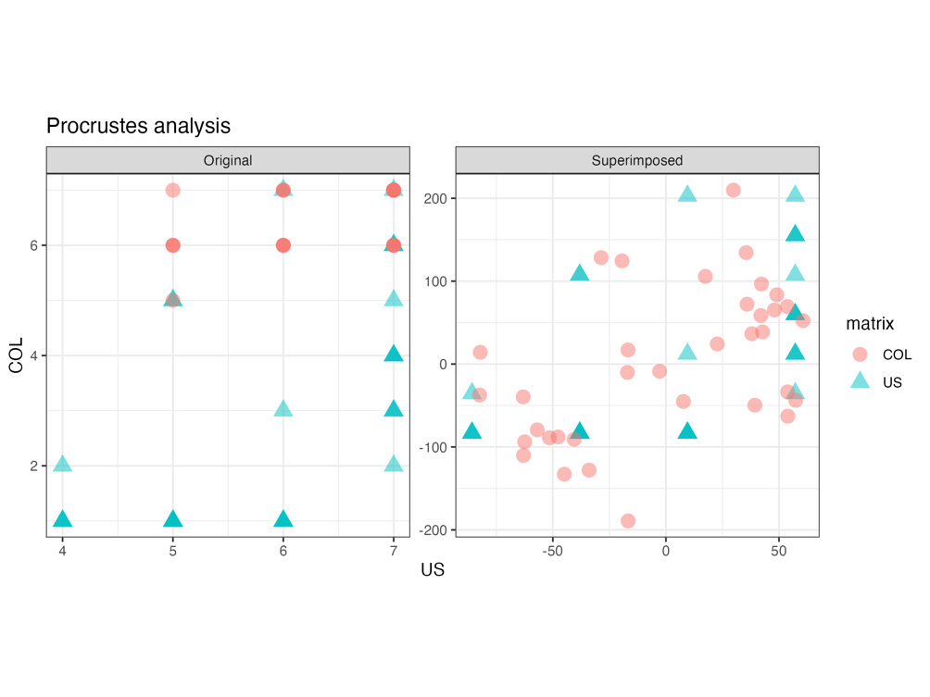
Figure S3. Visualization of non-normalized responses (left panel) and maximally superimposed responses (right panel).

- Supplementary analyses for Study 5

In this section, estimated marginal means and exploratory analyses comparing attributions of loyalty and morality by feature across samples are described.

Table S10. Estimated marginal means and pairwise comparisons for loyalty attributions by feature and country.

Feature | emm | df | t | p | d [95% CI]
Admirable | COL: 1.79  US: 1.36 | 700 | 2.38 | .02 | 0.51 [0.09, 0.94]
Attentive | COL: 1.62  US: 0.96 | 700 | 3.73 | <.001 | 0.81 [0.38, 1.23]
Collegial | COL: 2.17  US: 1.02 | 700 | 6.47 | <.001 | 1.40 [0.97, 1.82]
Communicative | COL: 1.10  US: 0.71 | 700 | 2.17 | .03 | 0.47 [0.04, 0.89]
Courageous | COL: 1.89  US: 1.49 | 700 | 2.26 | .02 | 0.49 [0.06, 0.91]
Devoted | COL: 1.75  US: 2.53 | 700 | -4.39 | <.001 | -0.95 [-1.37, -0.52]
Encouraging | COL: 1.68  US: 1.49 | 700 | 1.07 | .28 | 0.23 [-0.19, 0.66]
Ethical | COL: 2.06  US: 1.32 | 700 | 4.14 | <.001 | 0.89 [0.47, 1.32]
Good listener | COL: 1.78  US: 1.33 | 700 | 2.47 | .01 | 0.53 [0.11, 0.96]
Humanistic | COL: 1.94  US: 1.39 | 700 | 3.08 | .002 | 0.67 [0.24, 1.09]
Intelligent | COL: 1.51  US: 0.50 | 700 | 5.65 | <.001 | 1.22 [0.79, 1.64]
Not lying | COL: 1.92  US: 1.36 | 700 | 3.09 | .002 | 0.67 [0.24, 1.09]
Principled | COL: 2.13  US: 1.29 | 700 | 4.70 | <.001 | 1.02 [0.59, 1.44]
Reasonable | COL: 1.78  US: 1.03 | 700 | 4.17 | <.001 | 0.90 [0.48, 1.33]
Sacrifice | COL: 2.03  US: 2.44 | 700 | -2.31 | .02 | -0.50 [-0.92, -0.07]
Selfless | COL: 2.17  US: 2.24 | 700 | -0.41 | .68 | -0.09 [-0.51, 0.34]

- Supplementary materials for Study 6

Table S11. Full item list for Study 6

Term (English) | Term (Spanish) | Proximity* | Uniqueness* | Category
Has clear values | Tener valores claros |  |  | Principled
Law-abiding | Ser apegado(a) a la ley |  |  | Principled
Has strong beliefs | Tener fuertes creencias |  |  | Principled
Able to distinguish right from wrong | Ser capaz de distinguir entre el bien y el mal |  |  | Principled
Highly developed conscience | Conciencia altamente desarrollada |  |  | Principled
Maintains high standards | Mantener altos estandares |  |  | Principled
Self-disciplined | Autodisciplina |  |  | Principled
Upright | Cumplir con sus deberes |  |  | Principled
Has convictions | Tener convicciones |  |  | Principled
Exemplary | Ser ejemplar |  |  | Principled
Proper | Actuar de forma apropiada |  |  | Principled
Unswerving | Ser inquebrantable |  |  | Principled
Has integirty | Integridad |  |  | Caring
Good | Ser bueno(a) |  |  | Caring
Sincere | Sinceridad |  |  | Caring
Genuine | Ser genuino(a) |  |  | Caring
Caring | Solidaridad |  |  | Caring
Thoughtful | Ser considerado(a) |  |  | Caring
Helpful | Servicialidad |  |  | Caring
Considerate | Ser considerado(a) |  |  | Caring
Virtuous | Ser virtuoso(a) |  |  | Fair
Fair | Ser equitativo(a) |  |  | Fair
Just | Ser justo(a) |  |  | Fair
Strong | Fortaleza |  |  | Confident
Self-assured | Estar seguro(a) de sí mismo(a) |  |  | Confident
Self-confident | Autoconfianza |  |  | Confident
Confident | Confianza en sí mismo(a) |  |  | Confident
Frying food | Freír comida |  |  | Nonloyal
Exploring | Explorar |  |  | Nonloyal
Jumping | Saltar |  |  | Nonloyal
Twisting | Revolcarse |  |  | Nonloyal
Acknowledges others | Reconocer a los demás |  |  | Nonloyal
Walking | Caminar |  |  | Nonloyal
Faithfulness | Fidelidad | Prototypical | Shared | Loyalty
Trustworthiness | Confiabilidad | Prototypical | Shared | Loyalty
Honesty | Honestidad | Prototypical | Shared | Loyalty
Keeps promises | Cumplimiento de promesas | Prototypical | Shared | Loyalty
Good friend | Ser buen amigo(a) | Prototypical | Shared | Loyalty
Dedication | Dedicación | Prototypical | Shared | Loyalty
Being dependable | Incondicionalidad | Prototypical | Shared | Loyalty
Willing to defend you | Disposición a defenderte | Prototypical | Shared | Loyalty
Consistency | Coherencia | Central | Shared | Loyalty
Constant | Constancia | Central | Shared | Loyalty
Being understanding | Ser comprensivo(a) | Central | Shared | Loyalty
Helpfulness | Servicialidad | Central | Shared | Loyalty
Being honorable | Honorabilidad | Peripheral | Shared | Loyalty
Being steadfast | Firmeza | Peripheral | Shared | Loyalty
Giving | Generosidad | Peripheral | Shared | Loyalty
Attentiveness | Ser atento(a) | Peripheral | Shared | Loyalty
Warmth | Calidez | Peripheral | Shared | Loyalty
Humility | Humildad | Peripheral | Shared | Loyalty
Hard worker | Ser trabajador(a) | Peripheral | Shared | Loyalty
Intelligence | Inteligencia | Peripheral | Shared | Loyalty
Ethical | Ética | Central | Unique COL | Loyalty
Being principled | Tener principios | Central | Unique COL | Loyalty
Not stealing | Honradez | Central | Unique COL | Loyalty
Transparent | Transparencia | Central | Unique COL | Loyalty
Collegiality | Compañerismo | Central | Unique COL | Loyalty
Discrete | Discresión | Central | Unique COL | Loyalty
Treating you like family | Fraternidad | Peripheral | Unique COL | Loyalty
Noble | Nobleza | Peripheral | Unique COL | Loyalty
Not betraying you | No te traiciona | Central | Unique US | Loyalty
Being there for you | Está ahí para ti | Central | Unique US | Loyalty
Standing by you | Está de tu lado | Central | Unique US | Loyalty
Sticking up for you | Dar la cara por ti | Central | Unique US | Loyalty
Unconditional support | Apoyo incondicional | Central | Unique US | Loyalty
Being on your side no matter what | Está de tu lado pase lo que pase | Central | Unique US | Loyalty
Communicative | Comunicación | Peripheral | Unique US | Loyalty
Obedience | Obediencia | Peripheral | Unique US | Loyalty

Note. Proximity and Uniqueness cannot be determined for items derived from values identified in Walker & Pitts (1998).

- References

Bell, A. V., Richerson, P. J., & McElreath, R. (2009). Culture rather than genes provides greater scope for the evolution of large-scale human prosociality. Proceedings of the National Academy of Sciences, USA, 106, 17671–17674.

Haerpfer, C., Inglehart, R., Moreno, A., Welzel, C., Kizilova, K., Diez-Medrano J., M. Lagos, P. Norris, E. Ponarin & B. Puranen et al. (eds.). 2020. World Values Survey: Round Seven – Country-Pooled Datafile. Madrid, Spain & Vienna, Austria: JD Systems Institute & WVSA Secretariat. doi.org/10.14281/18241.1

Inglehart, R., Haerpfer, C., Moreno, A., Welzel, C., Kizilova, K., Diez-Medrano J., M. Lagos, P. Norris, E. Ponarin & B. Puranen et al. (eds.). 2020. World Values Survey: All Rounds – Country-Pooled Datafile. Madrid, Spain & Vienna, Austria: JD Systems Institute & WVSA Secretariat [Version: http://www.worldvaluessurvey.org/WVSDocumentationWVL.jsp].

Jackson DA (1995) PROTEST: A PROcrustean randomization TEST of community environment concordance. Ecoscience 2(3), 297-303.

Muthukrishna, M., Bell, A. V., Henrich, J., Curtin, C. M., Gedranovich, A., McInerney, J., & Thue, B. (2020). Beyond Western, Educated, Industrial, Rich, and Democratic (WEIRD) psychology: Measuring and mapping scales of cultural and psychological distance. Psychological science, 31(6), 678-701.

Oksanen J, Simpson G, Blanchet F, Kindt R, Legendre P, Minchin P, O'Hara R, Solymos P, Stevens M, Szoecs E, Wagner H, Barbour M, Bedward M, Bolker B, Borcard D, Carvalho G, Chirico M, De Caceres M, Durand S, Evangelista H, FitzJohn R, Friendly M, Furneaux B, Hannigan G, Hill M, Lahti L, McGlinn D, Ouellette M, Ribeiro Cunha E, Smith T, Stier A, Ter Braak C, Weedon J (2022). _vegan: Community Ecology Package_. R package version 2.6-4, <https://CRAN.R-project.org/package=vegan>.

Reynolds, C. J., Stokes, E., Jayawickreme, E., & Furr, R. M. (2023). Truthfulness Predominates in Americans' Conceptualizations of Honesty: A Prototype Analysis. Personality & social psychology bulletin, 1461672231195355. Advance online publication. https://doi.org/10.1177/01461672231195355.

Being patriotic and patriotismo were not listed during Study 1. We included it in Study 2 because patriotism is considered a core virtue associated with Loyalty according to Moral Foundations Theory (Graham et al., 2013).

