Supplementary Information

Feedback Exercises Boost Discernment for Gamified Misinformation Interventions

Supplementary Information 1
Supplement A: Exclusion Criteria Experiments 1 and 2 2
Supplement B: Analysis Plan Experiments 1 and 2 4
Supplement C: Sample Descriptives Experiments 1-5 9
Supplement D: Descriptive Statistics Experiments 1-5 14
Supplement E: Raw Data Plots Experiments 1 & 2 16
Supplement F: Ordinal Bayesian Regression Results Experiments 1 and 2. 22
Supplement G: Self Efficacy and Treatment Effect Experiments 1 & 2. 24
Supplement H: Exploratory Analyses Experiment 2 30
Supplement I: Descriptives And Supplementary Results Experiments 3-5 34
Supplement J: Item & Feedback Headline Wordings Experiments 3-5. 43
Supplement K: Experiment 6 (Design & Results). 45

Supplement A: Exclusion Criteria Experiments 1 and 2
To control for previous gameplay, participants were asked twice, before and after playing Bad News, whether they had played the game before. Only participants who did not answer yes to one of the questions could participate. We used two attention checks based on Shamon and Berning (2020) (we excluded ten participants due to attention check failures); attention checks were slightly modified for this research and the adapted tasks can be found below. To make sure that participants played the Bad News game, we included a threshold and excluded participants taking less than 5 minutes to play the game.
Attention Check 1
When asked to estimate the gross monthly earnings of the doctor in general practice please enter ‘0’. Feel free to enter any values you would like to for the other occupations.
We included this question in our questionnaire to see, whether you read the instructions carefully. Based on the text you read above, what do you think are the gross monthly earnings of the people listed below?
- shop assistant
- doctor in general practice
- unskilled factory worker
- minister in the national government
- chairman of an executive board
- facility manager
Attention Check 2
You will now be asked how confident you feel about your media literacy skills.
Please indicate your level of confidence on a scale ranging from 1 'not confident at all' to 7 'very confident'.
SE02
How confident are you that you can successfully identify deception strategies which are frequently used in the production of fake news?
not confident at all 2 3 Neutral 5 6 very confident
DS10
In this line, we ask you to mark the left option ‘not confident at all’ on the answer scale to show that you have read this sentence.
not confident at all 2 3 Neutral 5 6 very confident

Supplement B: Analysis Plan Experiments 1 and 2
Experiment 1
The regression equation for the fixed effects estimating the response to each news item is given in Equation (1) – this equation is used to test H2. Highlighted in bold are the terms testing the hypotheses reflecting the improvement of detecting misinformation for Bad News in the control condition (H1a) and the different effects of feedback (H2a) on responses immediately post-gameplay and seven days later.
Equation (1) | $$rating_{item i}=β_{0}+ β_{1}Feedback+β_{2}RealNews+β_{3}t2+β_{4}Feedback* RealNews+β_{5}Feedback* t2+β_{6} RealNews * t1 + β_{7}Feedback * RealNews * t2$$

The intercept β₀ reflects the rating of misinformation items in the control group at T0. β₁ captures the difference between the feedback and control group at the baseline (T0). β₂ captures the difference between the real news and misinformation items at the baseline in the control group. β₃ captures the difference of the ratings of misinformation items at the baseline and seven days later in the control group (H1a). β₄ captures the difference of ratings in the feedback group and for real news compared to misinformation items at the baseline. β₅ captures the effect of feedback on the change of ratings from baseline to seven days later – this is the effect of interest for H2a. β₆ captures the difference of ratings when moving from baseline to seven days later (T2) in the control group for real news compared to misinformation items. β₇ captures the difference of ratings when moving from baseline (T0) to seven days later (T2) in the feedback group on top of the change of the control group for real news compared to misinformation items.
The intercept reflects the rating of misinformation items in the control group at T0. We fitted two model families: a linear regression, which assumes that the dependent variable is drawn from a Gaussian normal distribution, and a probit regression, which assumes that the dependent variable presents an ordered categorical variable that is normally distributed under a cumulative probit-link function.
In the frequentist framework, to fit the linear regressions we used the R package lmer (Kuznetsova et al., 2017) and for the ordered probit we used ordinal (Christensen, 2019). For the Bayesian models we used brms (Bürkner, 2018). To compare models, we used the approximate LOOCV (leave-one-out cross validation) which calculates the LOOIC, the leave-one-out information criterion. For a general introduction to Bayesian models for ordinal models in psychology, please see Bürkner and Vuorre (2019).
Power analysis
We used G*Power to estimate the required sample size. The power analysis was based on an ANOVA (repeated measures between factors) and not on the cumulative probit model mixed model that was run Experiment 1. We address this in Experiment 2 (see below).
Protocol of the Power Analysis:
F tests - ANOVA: Repeated measures, between factors
Analysis: A priori: Compute required sample size
Input: Effect size f = 0,175
α err prob = 0,05
Power (1-β err prob) = 0,8
Number of groups = 2
Number of measurements = 2
Corr among rep measures = 0,5
Output: Noncentrality parameter λ = 8,0033333
Critical F = 3,8898392
Numerator df = 1,0000000
Denominator df = 194
Total sample size = 196
Actual power = 0,8037312

Experiment 2
Like in Experiment 1, we used a cumulative probit model mixed model to accommodate the ordinal data and repeated measurement. We included participants and items as a random effect. Furthermore, the slope of time was allowed to vary between participants (random slope). The feedback (control vs. feedback group), time (pre- vs. post-test) and item type (real news vs. misinformation) were modelled as fixed effects. We deviated from the preregistration in that we only compared T0 and T2 when testing the hypotheses. The reasons are the same as in Experiment 1. The regression equation for the fixed effects estimating the response to each news item is given by Equation (2). The terms in bold show betas testing the hypotheses reflecting the improvement of detecting misinformation for Bad News in the control condition and the different effects of feedback on responses seven days post-gameplay (T2).
Equation (2) | $$rating_{item i}=β_{0}+ β_{1}Feedback+β_{2}Feedback\&Polarization+β_{3}Feedback\&Strategy⤶+β_{4}RealNews⤶+ β_{5}Feedback* RealNews+ β_{6}Feedback\&Polarization* RealNews+β_{7}Feedback\&Strategy*RealNews+{β_{8}t2+β}_{9}Feedback* t2+β_{10}Feedback\&Polarization*t2+β_{11}Feedback\&Strategy*t2+ β_{12}RealNews * t2 +{ β_{13}Feedback * RealNews * t2+ β}_{14}Feedback\&Polarization * RealNews * t2 + β_{15}Feedback\&Strategy * RealNews * t2.$$

The intercept, $β_{0},$ reflects the rating of misinformation items in the control group at t0.
$β_{1}$to$β_{3}$ captures the difference between the feedback groups and control group at the baseline (T0). $β_{4}$ captures the difference between real news items from misinformation items at T0. $β_{5}$-$β_{7}$ captures the difference of slopes from the control group in the feedback group between real news items from misinformation items at T0. $β_{8 }$captures the difference between the reliability ratings of misinformation before and seven days after Bad News in the control group (H1a). $β_{9}$captures the difference between slopes of the measurement point of the feedback only group compared to the control group for misinformation (H2a). $β_{10}$captures the difference between slopes of the measurement point of the feedback + polarization group compared to the control group for misinformation (H2a). $β_{11}$captures the difference between slopes of the measurement point of the feedback + manipulation technique group compared to the control group for misinformation (H2a). $β_{12}$ captures the effect Bad News on the difference between reliability ratings of real news and misinformation items in the control group (H1b). $β_{13}$ captures the effect of feedback only on the difference between reliability ratings of real and misinformation items in the control group (H2b). $β_{14}$ captures the effect of feedback + polarization with Bad News on the difference between reliability ratings of real and misinformation items in the control group (H2b). $β_{15}$ captures the effect of feedback + manipulation technique with Bad News on the difference between reliability ratings of real and misinformation items in the control group (H2b).
Power analysis
As there was no standard R package available to carry out an ordinal regression we wrote our own simulation in R. The code and the respective power curves are found on the OSF, in the Power Simulation folder.
For the power simulation we simulated data according to the regression equation (2). We estimated the estimates once with 100% and once with 50% of the size of the estimates from Experiment 1. We simulated data 1000 times for a given sample size. We then fitted the regression and then calculated power by calculating the proportion of p-values smaller than .05. This value and its 95% CI are shown in the power curve on the OSF.
Analyses
To investigate the difference between the feedback conditions (H3a,b), we preregistered the same analysis but using feedback only as reference group and comparing it to feedback with polarization and feedback with manipulation technique recognition. We present the results of this approach in Supplement E. For the main results, we deviated from this approach by using the more intuitive approach of computing the difference between the posteriors obtained in the Bayesian model.
We used the same modeling approach as in Experiment 1, only now we fitted Equation (2). Comparing the LOOIC, the cumulative probit model allowing for heterogeneous variance between experimental groups and time of measurement fit the data best, see Table S1.
Table S1
Leave-One-Out Information Criterion (LOOIC) Comparing Four Bayesian Ordinal Models for the Responses in Bad News, Experiment 2.
 | LOOIC | SE
Probit heterogenous variance | 36949.01 | 150.44
Probit heterogenous variance with controls | 36949.09 | 150.58
Probit homogenous variance | 37060.08 | 150.78
Probit homogenous variance with controls | 37060.69 | 150.88

Supplement C: Sample Descriptives Experiments 1-5
Table S2
Demographic Information of the Sample for Experiment 1 (Bad News).
Overall (N = 191)
Age
18-29 125 (65.4%)
30-49 60 (31.4%)
over 50 5 (2.6%)
under 18 1 (0.5%)
Gender
Female 94 (49.2%)
Male 94 (49.2%)
Other 3 (1.6%)
Country
UK 26 (13.6%)
Ireland 2 (1.0%)
Italy 6 (3.1%)
Poland 8 (4.2%)
Spain 8 (4.2%)
France 2 (1.0%)
Germany 7 (3.7%)
US 8 (4.2%)
Other 24 (12.6%)
South Africa 77 (40.3%)
Portugal 7 (3.7%)
Hungary 6 (3.1%)
Mexico 10 (5.2%)
Primary Language
English 114 (59.7%)
French 3 (1.6%)
German 10 (5.2%)
Italian 6 (3.1%)
Other 30 (15.7%)
Polish 8 (4.2%)
Spanish 20 (10.5%)

Table S3
Demographic Information of the Sample for Experiment 2 (Bad News).
Overall (N = 312)
Age
Mean (SD) | 39.939 (12.367)
Range | 18 - 80
Gender
Female | 205 (65.7%)
Male | 105 (33.7%)
Other | 2 (0.6%)
Country
Ireland | 3 (1.0%)
UK | 309 (99.0%)
Primary Language
English | 290 (92.9%)
French | 3 (1.0%)
Italian | 3 (1.0%)
Other | 12 (3.8%)
Polish | 1 (0.3%)
Spanish | 3 (1.0%)

Table S4
Demographic Information of the Sample for Experiment 3 (Harmony Square).
Variable | Condition | N | % of Total | Cumulative %
Age
18-24 | No feedback | 136 | 24.3 % | 24.3 %
 | Feedback | 177 | 31.7 % | 56.0 %
25-34 | No feedback | 49 | 8.8 % | 64.8 %
 | Feedback | 60 | 10.7 % | 75.5 %
35-44 | No feedback | 27 | 4.8 % | 80.3 %
 | Feedback | 25 | 4.5 % | 84.8 %
45-54 | No feedback | 17 | 3.0 % | 87.8 %
 | Feedback | 15 | 2.7 % | 90.5 %
55-64 | No feedback | 13 | 2.3 % | 92.8 %
 | Feedback | 12 | 2.1 % | 95.0 %
65+ | No feedback | 15 | 2.7 % | 97.7 %
 | Feedback | 13 | 2.3 % | 100.0 %
Gender
Female | No feedback | 112 | 20.0 % | 20.0 %
 | Feedback | 123 | 22.0 % | 42.0 %
Male | No feedback | 125 | 22.4 % | 64.4 %
 | Feedback | 156 | 27.9 % | 92.3 %
Other | No feedback | 14 | 2.5 % | 94.8 %
 | Feedback | 12 | 2.1 % | 97.0 %
Prefer not to say | No feedback | 6 | 1.1 % | 98.0 %
 | Feedback | 11 | 2.0 % | 100.0 %
Education
High school or less | No feedback | 97 | 17.4 % | 17.4 %
 | Feedback | 124 | 22.2 % | 39.5 %
Professional qualification | No feedback | 20 | 3.6 % | 43.1 %
 | Feedback | 30 | 5.4 % | 48.5 %
University/college degree (bachelor's) | No feedback | 79 | 14.1 % | 62.6 %
 | Feedback | 94 | 16.8 % | 79.4 %
University/college degree (master's) | No feedback | 41 | 7.3 % | 86.8 %
 | Feedback | 47 | 8.4 % | 95.2 %
Doctorate | No feedback | 20 | 3.6 % | 98.7 %
 | Feedback | 7 | 1.3 % | 100.0 %
Political Ideology |  | Mean | SD
 | No feedback | 3.48 | 1.65
 | Feedback | 3.47 | 1.51

Table S5
Demographic Information of the Sample for Experiment 4 (Bad News).
Variable | Condition | N | % of Total | Cumulative %
Age
19-25 | No feedback | 599 | 23.4% | 23.4 %
 | Feedback | 581 | 22.7 % | 46.1 %
26-35 | No feedback | 265 | 10.4 % | 56.5 %
 | Feedback | 236 | 9.2 % | 65.7 %
36-45 | No feedback | 176 | 6.9 % | 72.6 %
 | Feedback | 157 | 6.1 % | 78.7 %
46-55 | No feedback | 83 | 3.2 % | 82.0 %
 | Feedback | 79 | 3.1 % | 85.1 %
56-65 | No feedback | 45 | 1.8 % | 86.8 %
 | Feedback | 30 | 1.2 % | 88.0 %
Over 65 | No feedback | 174 | 6.8 % | 94.8 %
 | Feedback | 133 | 5.2 % | 100.0 %
Gender
Female | No feedback | 527 | 20.6 % | 20.6 %
 | Feedback | 525 | 20.5 % | 41.1 %
Male | No feedback | 592 | 23.1 % | 64.3 %
 | Feedback | 513 | 20.1 % | 84.3 %
Non-binary | No feedback | 73 | 2.9 % | 87.2 %
 | Feedback | 74 | 2.9 % | 90.1 %
Other | No feedback | 26 | 1.0 % | 91.1 %
 | Feedback | 27 | 1.1 % | 92.1 %
Prefer not to say | No feedback | 124 | 4.8 % | 97.0 %
 | Feedback | 77 | 3.0 % | 100.0 %
Political Ideology
Very left-wing | No feedback | 253 | 9.9 % | 9.9 %
 | Feedback | 241 | 9.4 % | 19.3 %
Left-wing | No feedback | 214 | 8.4 % | 27.7 %
 | Feedback | 235 | 9.2 % | 36.9 %
A bit left-wing | No feedback | 173 | 6.8 % | 43.6 %
 | Feedback | 155 | 6.1 % | 49.7 %
Middle of the road | No feedback | 459 | 17.9 % | 67.6 %
 | Feedback | 359 | 14.0 % | 81.7 %
A bit right-wing | No feedback | 96 | 3.8 % | 85.4 %
 | Feedback | 88 | 3.4 % | 88.9 %
Right-wing | No feedback | 81 | 3.2 % | 92.0 %
 | Feedback | 80 | 3.1 % | 95.2 %
Very right-wing | No feedback | 66 | 2.6 % | 97.7 %
 | Feedback | 58 | 2.3 % | 100.0 %
Trust in Media
Not at all | No feedback | 281 | 11.0 % | 11.0 %
 | Feedback | 240 | 9.4 % | 20.4 %
Not really | No feedback | 220 | 8.6 % | 29.0 %
 | Feedback | 208 | 8.1 % | 37.1 %
Neither trust nor distrust | No feedback | 401 | 15.7 % | 52.8 %
 | Feedback | 316 | 12.4 % | 65.1 %
A bit | No feedback | 304 | 11.9 % | 77.0 %
 | Feedback | 304 | 11.9 % | 88.9 %
A lot | No feedback | 136 | 5.3 % | 94.2 %
 | Feedback | 148 | 5.8 % | 100.0 %

Table S6
Demographic Information of the Sample for Experiment 5 (Bad News – MIST).
Variable | N | % of Total | Cumulative %
Age
18-25 | 146 | 34.8 % | 34.8 %
26-35 | 101 | 24.1 % | 58.9 %
36-45 | 82 | 19.6 % | 78.5 %
46-55 | 29 | 6.9 % | 85.4 %
56-65 | 20 | 4.8 % | 90.2 %
Over 65 | 41 | 9.8 % | 100.0 %
Gender
Female | 181 | 43.2 % | 43.2 %
Male | 196 | 46.8 % | 90.0 %
Non-binary | 16 | 3.8 % | 93.8 %
Other | 4 | 1.0 % | 94.7 %
Prefer not to say | 22 | 5.3 % | 100.0 %
Political Ideology
Very left-wing | 55 | 13.1 % | 13.1 %
Left-wing | 76 | 18.1 % | 31.3 %
A bit left-wing | 62 | 14.8 % | 46.1 %
Middle of the road | 152 | 36.3 % | 82.3 %
A bit right-wing | 37 | 8.8 % | 91.2 %
Right-wing | 23 | 5.5 % | 96.7 %
Very right-wing | 14 | 3.3 % | 100.0 %
Trust in Media
Not at all | 84 | 20.0 % | 20.0 %
Not really | 90 | 21.5 % | 41.5 %
Neither trust nor distrust | 111 | 26.5 % | 68.0 %
A bit | 88 | 21.0 % | 89.0 %
A lot | 46 | 11.0 % | 100.0 %

Supplement D: Descriptive Statistics Experiments 1-5
Table S7
Mean Reliability Ratings and its 95% CI for each Experimental Group, News Type and Measurement Point, By Experiment.
Study | Condition | Type | T0 (pre) | T1 (post) | T2 (1 week)
Exp. 1 | Control (no feedback) | Misinformation | 3.29 [3.17, 3.41] | 3.10 [2.98, 3.22] | 3.09 [2.98, 3.21]
 |  | Real | 5.77 [5.61, 5.94] | 4.40 [4.20, 4.60] | 5.63 [5.46, 5.79]
 | Feedback | Misinformation | 3.41 [3.28, 3.53] | 2.33 [2.20, 2.47] | 2.71 [2.58, 2.85]
 |  | Real | 5.94 [5.78, 6.10] | 4.88 [4.59, 5.16] | 5.97 [5.79, 6.16]
Exp. 2 | Control | Misinformation | 3.11 [2.99, 3.23] | 2.53 [2.42, 2.65] | 2.73 [2.61, 2.85]
 |  | Real | 5.78 [5.63, 5.93] | 4.49 [4.25, 4.72] | 5.62 [5.46, 5.79]
 | Feedback only | Misinformation | 3.11 [2.99, 3.24] | 2.87 [2.74, 3.00] | 2.43 [2.31, 2.56]
 |  | Real | 5.72 [5.56, 5.88] | 4.83 [4.59, 5.07] | 5.60 [5.41, 5.80]
 | Feedback + polarization | Misinformation | 3.27 [3.14, 3.39] | 2.37 [2.24, 2.49] | 2.27 [2.15, 2.40]
 |  | Real | 5.64 [5.46, 5.83] | 4.55 [4.28, 4.83] | 5.48 [5.27, 5.69]
 | Feedback + Manip. Tech. | Misinformation | 3.28 [3.16, 3.41] | 2.63 [2.51, 2.74] | 2.67 [2.56, 2.79]
 |  | Real | 5.78 [5.63, 5.93] | 5.11 [4.91, 5.31] | 5.84 [5.68, 6.00]
Exp. 3 | Control (no feedback) | Misinformation | 2.75 [2.60, 2.90] | 2.37 [2.21, 2.54]
 |  | Real | 3.94 [3.75, 4.12] | 3.57 [3.36, 3.79]
 |  | Discernment | 1.18 [1.00, 1.37] | 1.20 [1.00, 1.40]
 | Feedback | Misinformation | 2.73 [2.60, 2.87] | 2.54 [2.39, 2.70]
 |  | Real | 3.95 [3.79, 4.12] | 4.72 [4.53, 4.91]
 |  | Discernment | 1.22 [1.05, 1.39] | 2.18 [1.96, 2.41]
Exp. 4 | Control (no feedback) | Misinformation | 2.80 [2.71, 2.88] | 2.45 [2.37, 2.52]
 |  | Real | 5.37 [5.28, 5.45] | 5.11 [5.02, 5.20]
 |  | Discernment | 2.57 [2.46, 2.68] | 2.66 [2.56, 2.77]
 | Feedback | Misinformation | 2.69 [2.61, 2.76] | 2.51 [2.43, 2.59]
 |  | Real | 5.33 [5.24, 5.41] | 5.50 [5.42, 5.58]
 |  | Discernment | 2.63 [2.52, 2.75] | 2.98 [2.87, 3.09]
Exp. 5 | Feedback | Misinformation | 2.43 [2.29, 2.57] | 2.24 [2.11, 2.39]
 |  | Real | 4.57 [4.44, 4.69] | 4.76 [4.62, 4.90]
 |  | Discernment | 2.14 [1.96, 2.32] | 2.51 [2.32, 2.71]
Note: mean values for Exp. 4 are slightly different for the post-test compared to those reported in Table 1; Table 1 values are for paired responses (pre-post, n = 960) whereas here mean values are reported for all post-test responses (n = 1,342)

Table S8
Cronbach's Alpha, Mean and Standard Deviation for Aggregated Measures, Experiments 1 and 2. Note: 0 = pre-test, 1 = post=test, 2 = 1-week follow-up.
 |  | Experiment 1 |  |  | Experiment 2
News type | Time | α | M | SD | α | M | SD
Misinformation | 0 | 0.660 | 3.363 | 0.878 | 0.722 | 3.192 | 0.852
Misinformation | 1 | 0.813 | 2.790 | 1.215 | 0.781 | 2.600 | 0.962
Misinformation | 2 | 0.763 | 2.912 | 1.047 | 0.818 | 2.534 | 0.939
Real News | 0 | 0.149 | 5.830 | 0.835 | 0.579 | 5.732 | 0.912
Real News | 1 | 0.536 | 4.643 | 1.454 | 0.425 | 4.748 | 1.146
Real News | 2 | 0.393 | 5.792 | 1.025 | 0.562 | 5.639 | 1.018

Table S9
Cronbach's Alpha, Mean and Standard Deviation for Aggregated Measures, Experiments 3-5.
 |  | Experiment 3 |  |  | Experiment 4 |  |  | Experiment 5
News type | Time | α | M | SD | α | M | SD | α | M | SD
Misinformation | Pre | 0.68 | 2.74 | 1.19 | 0.78 | 2.75 | 1.31 | 0.8 | 2.43 | 1.44
Misinformation | Post | 0.77 | 2.46 | 1.32 | 0.86 | 2.48 | 1.45 | 0.81 | 2.25 | 1.45
Real News | Pre | 0.83 | 3.95 | 1.49 | 0.32 | 5.35 | 1.34 | 0.64 | 4.57 | 1.27
Real News | Post | 0.89 | 4.19 | 1.79 | 0.52 | 5.29 | 1.54 | 0.75 | 4.78 | 1.48

Supplement E: Raw Data Plots Experiments 1 & 2
Figure S1
Observed Reliability Ratings for Each News Item for Each Experimental Group and News Type, Experiment 1.
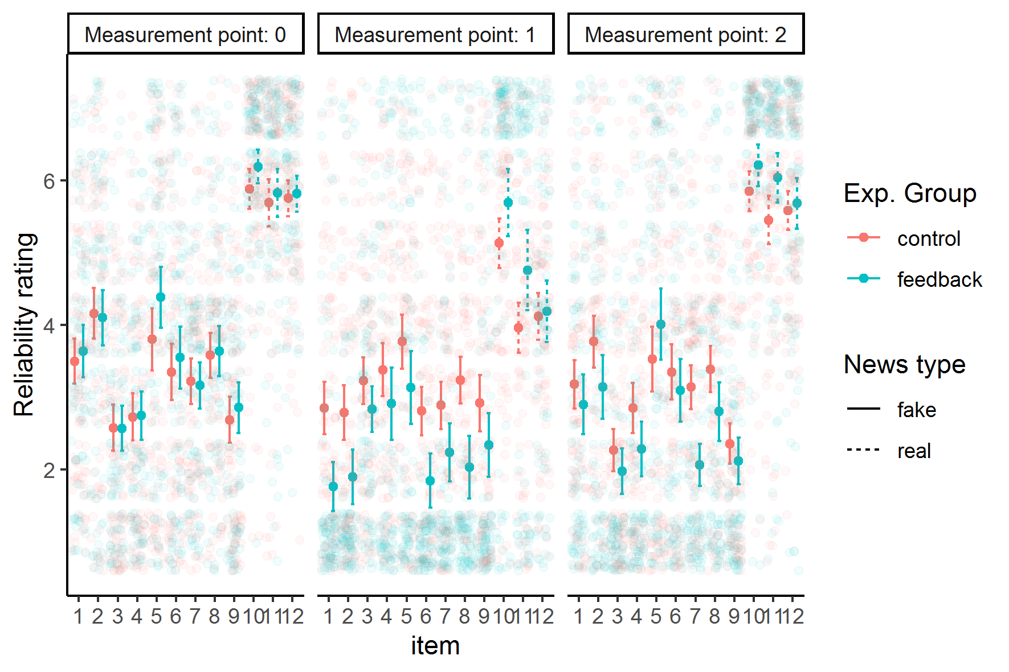
Note. Jittered points are individual observations. Point and Error Bar show mean and 95% CI.

Figure S2
Observed Reliability Ratings Aggregated to Mean Scale Values, Experiment 1.
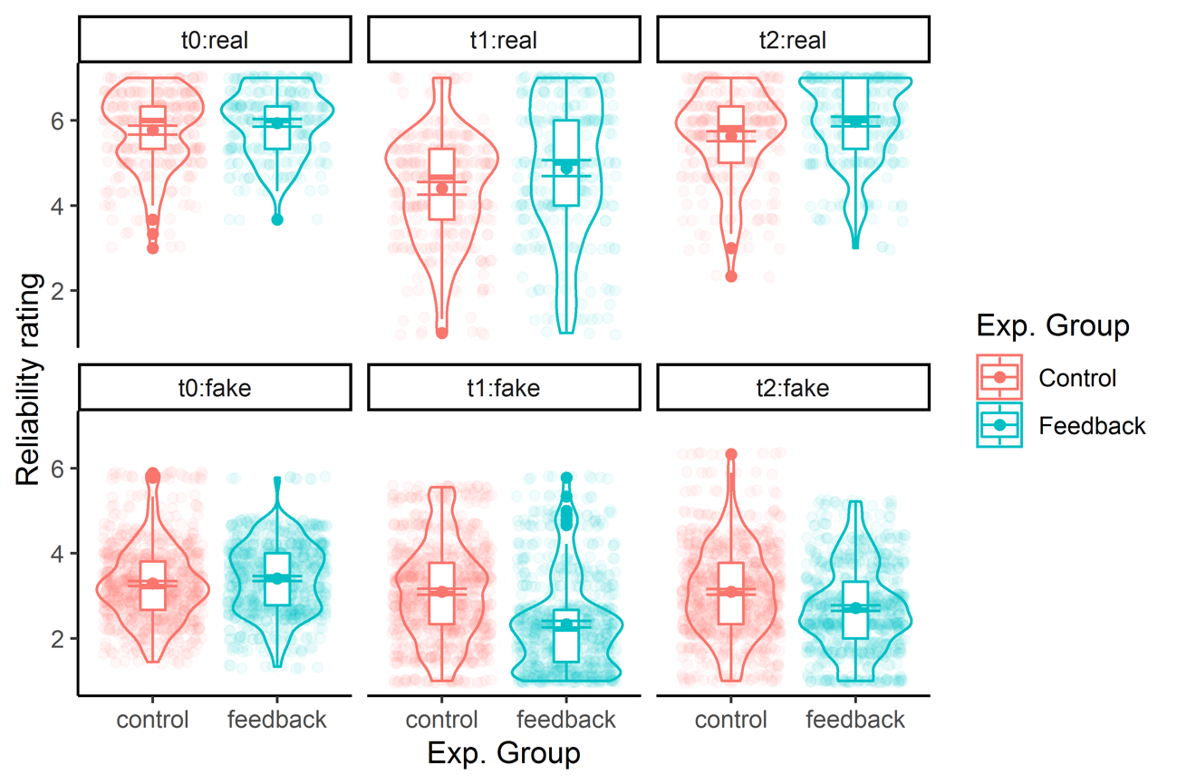
Note. Jittered points are individual observations aggregated to the respective scale (misinform. vs. real news). Violins show distribution. Point and Error Bar show mean and 95% CI.

Figure S3
Observed Reliability Ratings NOT Aggregated to Mean Scale Values, Experiment 1.
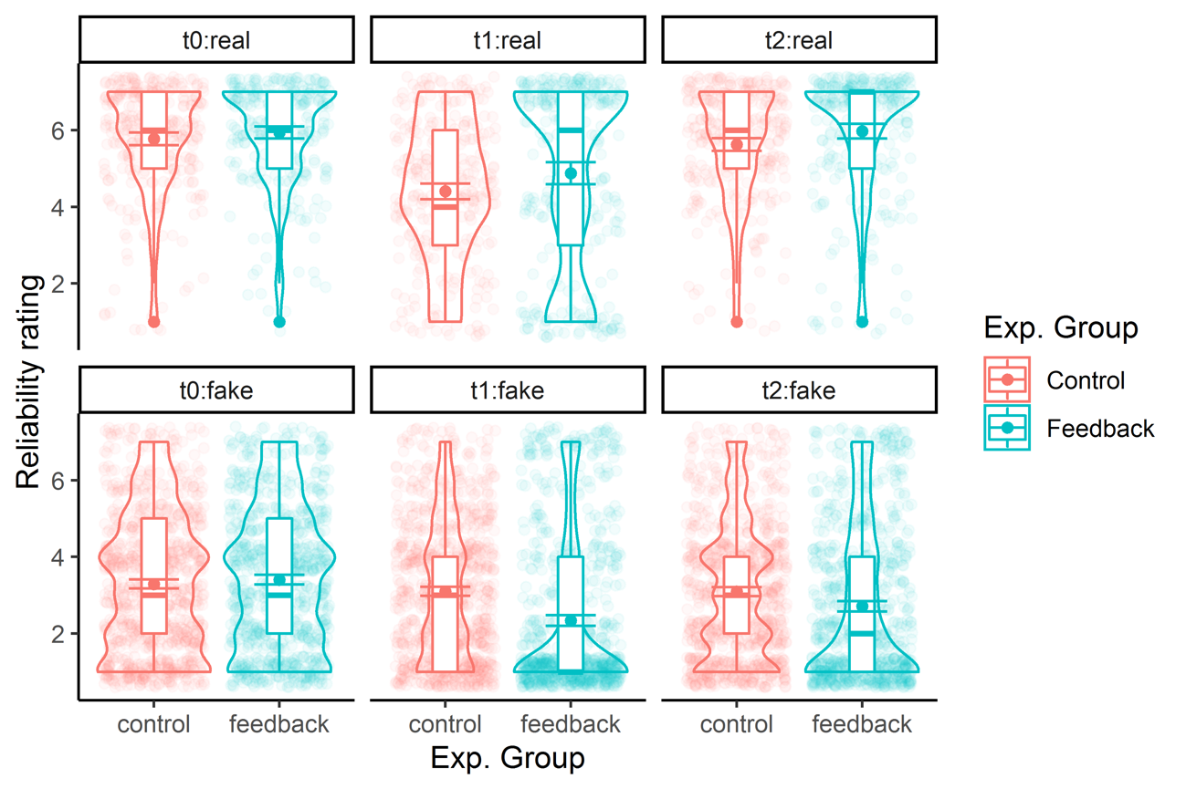
Note. Jittered points are individual observations. Violins show distribution. Point and Error Bar show mean and 95% CI.

Figure S4
Observed Reliability Ratings for Each News Item for Each Experimental Group and News Type, Experiment 2.
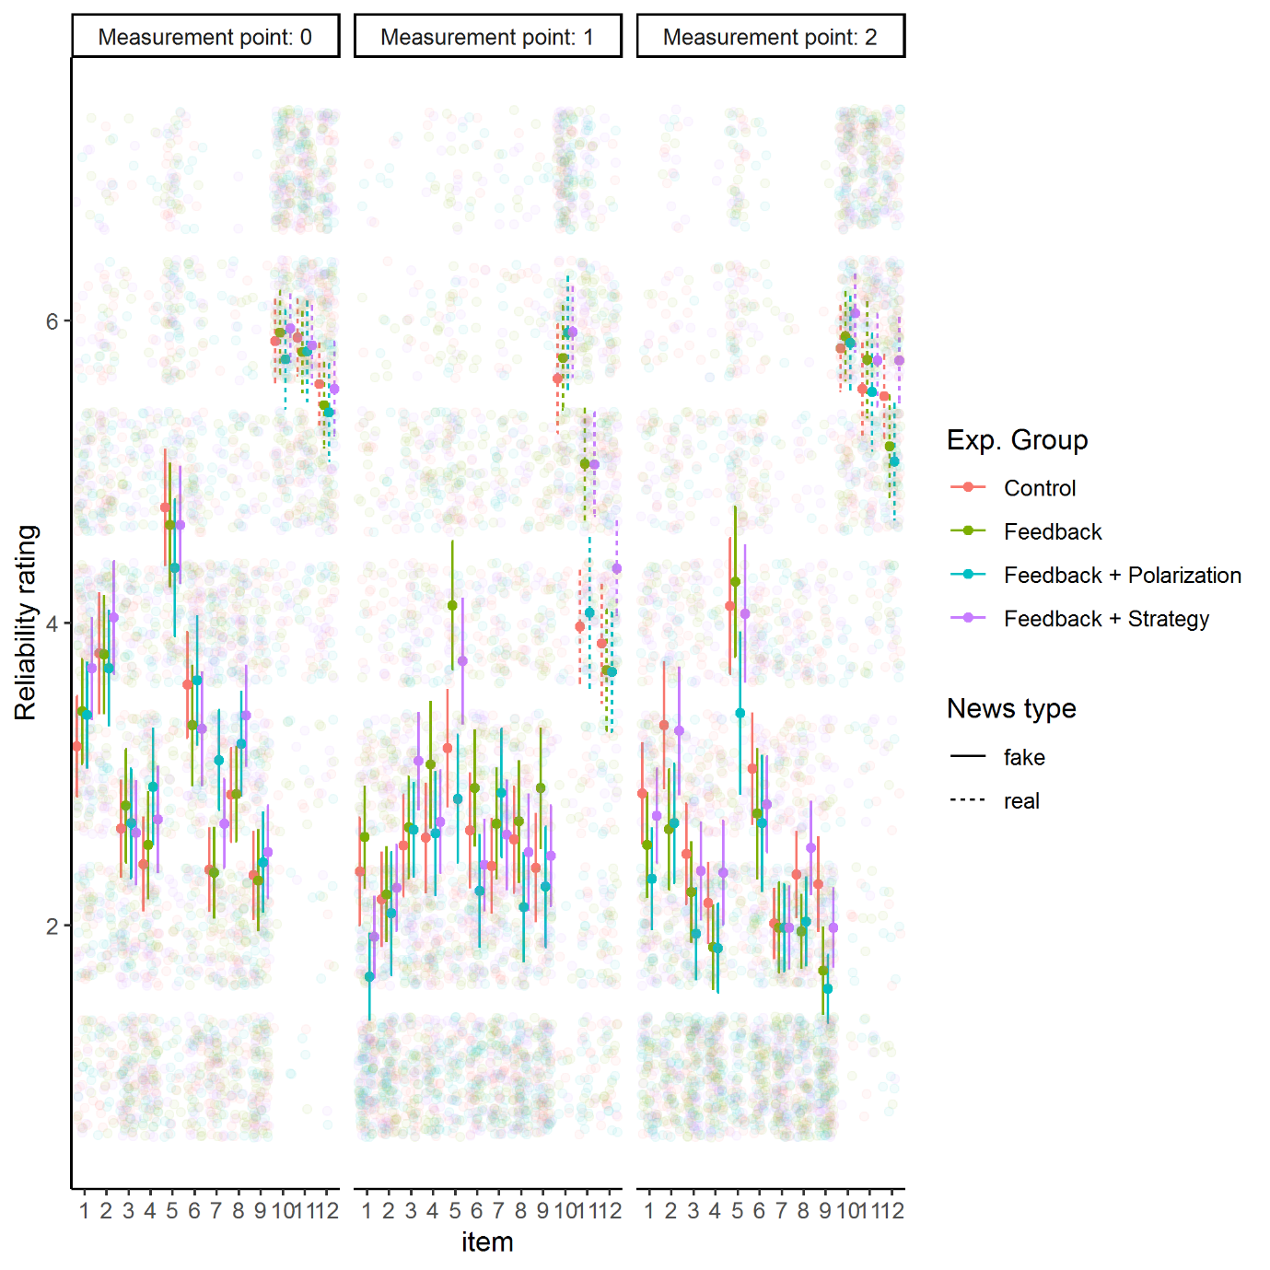
Note. Jittered points are individual observations. Point and Error Bar show mean and 95% CI.

Figure S5
Observed Reliability Ratings Aggregated to Mean Scale Values, Experiment 2.
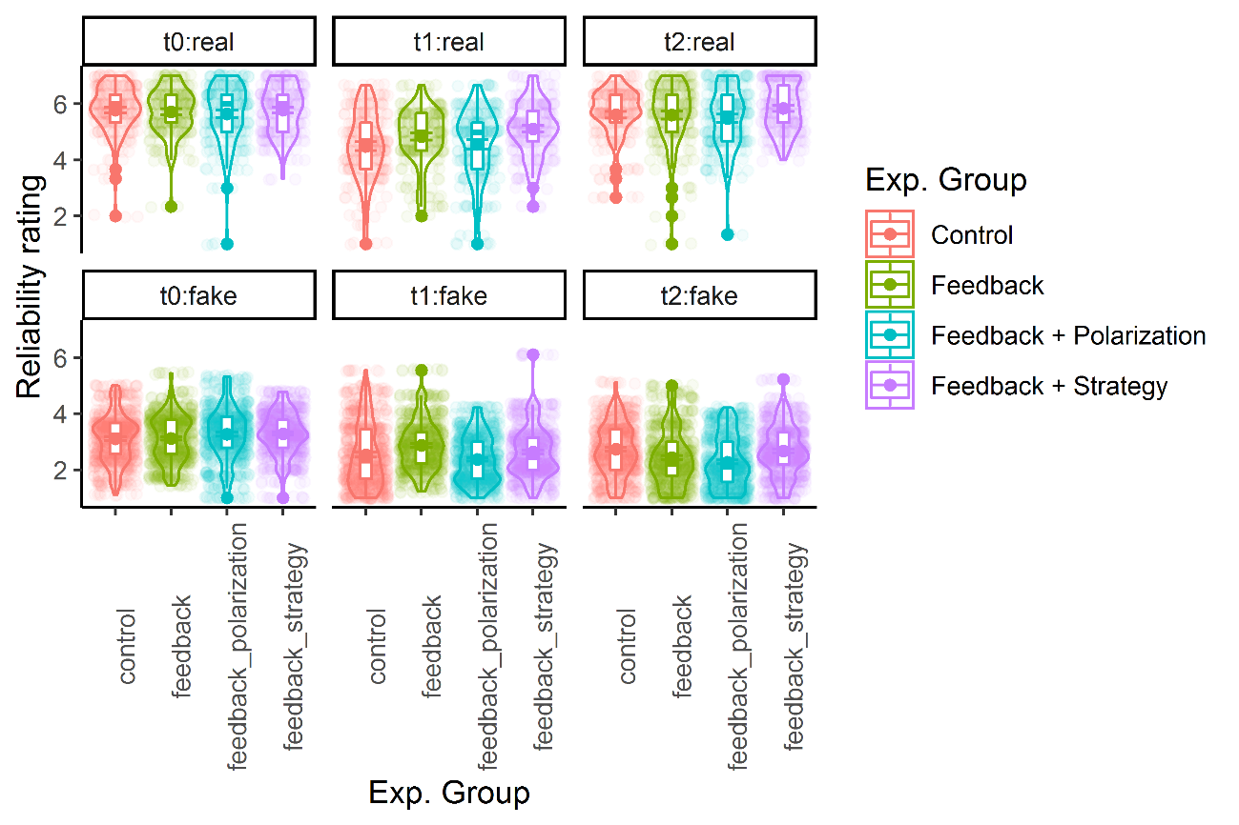
Note. Jittered points are individual observations aggregated to the respective scale (misinform. vs. real news). Violins show distribution. Point and Error Bar show mean and 95% CI.

Figure S6
Observed Reliability Ratings NOT Aggregated to Mean Scale Values, Experiment 2.
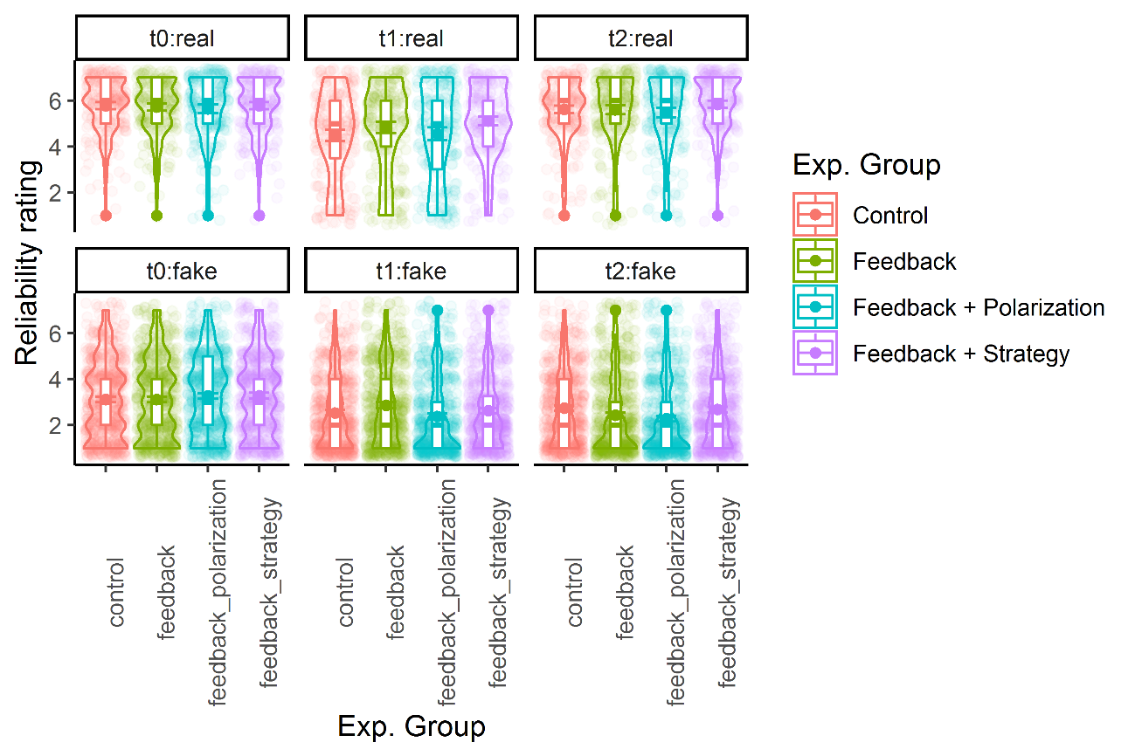
Note. Jittered points are individual observations. Violins show distribution. Point and Error Bar show mean and 95% CI.

Supplement F: Ordinal Bayesian Regression Results Experiments 1 and 2.
Table S10
Experiment 1: Results For Ordinal Regression With Heterogenous Variance for Group and Time (As Preregistered).
 | Treatment | Treatment with controls
Predictors | Odds Ratios | Odds Ratios
Feedback (1) | 1.07 (0.92,1.24) | 1.07 (0.92,1.24)
Real news (2) | 4.74 (4.05,5.53) | 4.76 (4.09,5.56)
T1 (3) | 0.88 (0.80,0.97) | 0.89 (0.81,0.97)
T2 (4) | 0.89 (0.81,0.98) | 0.89 (0.82,0.98)
1 X 2 | 1.11 (0.89,1.36) | 1.10 (0.89,1.35)
1 X 3 | 0.23 (0.18,0.30) | 0.23 (0.17,0.30)
1 X 4 | 0.59 (0.50,0.70) | 0.59 (0.50,0.69)
2 X 3 | 0.46 (0.38,0.55) | 0.46 (0.38,0.55)
2 X 4 | 1.00 (0.82,1.22) | 1.00 (0.82,1.21)
1 X 2 X 3 | 7.58 (4.90,12.41) | 7.81 (4.85,12.96)
1 X 2 X 4 | 2.71 (1.91,3.92) | 2.77 (1.98,3.98)
Var. 1 | 0.97 (0.90,1.05) | 0.97 (0.90,1.05)
Var. 3 | 1.05 (0.98,1.14) | 1.05 (0.97,1.13)
Var. 4 | 1.06 (0.98,1.14) | 1.06 (0.98,1.14)
Var. 1 X 3 | 0.40 (0.35,0.46) | 0.40 (0.35,0.46)
Var. 1 X 4 | 0.65 (0.58,0.74) | 0.65 (0.58,0.74)
Gender male |  | 0.89 (0.78,1.03)
Gender Other |  | 0.82 (0.49,1.39)
Age: 30 - 49 |  | 1.02 (0.88,1.19)
Age: > 50 |  | 0.67 (0.43,1.01)
Age: < 18 |  | 0.81 (0.34,1.98)
Random Effects
σ² | 0.17 | 0.16
τ₀₀ | 4.43 | 4.44
ICC | 0.04 | 0.03
N | 191 _{SERIAL} | 191 _{SERIAL}
Observations | 6876 | 6876

Table S11
Experiment 2: Results for Bayesian Generalized Linear Hierarchical Model Cumulative Probit Link Assuming Heterogenous Variance Across Time and Condition Comparing a Model Without and With Control Variables – Reference Group is Control.
 | Treatment | Treatment with controls
Predictors | Odds Ratios | Odds Ratios
Feedback only (1) | 1.00 (0.83,1.20) | 1.00 (0.83,1.21)
Feedback + polarization (2) | 1.12 (0.92,1.34) | 1.12 (0.92,1.34)
Feedback + strategy (3) | 1.14 (0.94,1.36) | 1.14 (0.95,1.36)
Real news (4) | 6.47 (5.42,7.75) | 6.50 (5.43,7.70)
T1 (5) | 0.64 (0.57,0.72) | 0.64 (0.57,0.72)
T2 (6) | 0.76 (0.68,0.85) | 0.76 (0.68,0.85)
1 X 4 | 0.96 (0.77,1.22) | 0.97 (0.77,1.23)
2 X 4 | 0.83 (0.66,1.04) | 0.83 (0.66,1.04)
3 X 4 | 0.90 (0.72,1.13) | 0.91 (0.73,1.15)
1 X 5 | 1.27 (1.06,1.51) | 1.27 (1.07,1.51)
2 X 5 | 0.66 (0.54,0.79) | 0.66 (0.55,0.80)
3 X 5 | 0.99 (0.84,1.17) | 1.00 (0.85,1.17)
1 X 6 | 0.72 (0.60,0.86) | 0.72 (0.61,0.86)
2 X 6 | 0.55 (0.46,0.65) | 0.55 (0.46,0.66)
3 X 6 | 0.84 (0.72,1.00) | 0.85 (0.72,1.00)
4 X 5 | 0.61 (0.48,0.75) | 0.61 (0.49,0.75)
4 X 6 | 1.15 (0.92,1.44) | 1.15 (0.92,1.46)
1 X 4 X 5 | 1.07 (0.76,1.50) | 1.07 (0.74,1.49)
2 X 4 X 5 | 1.86 (1.31,2.72) | 1.86 (1.30,2.68)
3 X 4 X 5 | 1.54 (1.14,2.12) | 1.53 (1.13,2.12)
1 X 4 X 6 | 1.53 (1.07,2.19) | 1.54 (1.09,2.20)
2 X 4 X 6 | 1.98 (1.38,2.86) | 1.98 (1.39,2.85)
3 X 4 X 6 | 1.45 (1.05,2.00) | 1.44 (1.04,2.00)
Var. 1 | 0.93 (0.85,1.01) | 0.92 (0.85,1.00)
Var. 2 | 0.96 (0.89,1.05) | 0.96 (0.89,1.05)
Var. 3 | 0.95 (0.88,1.03) | 0.95 (0.87,1.03)
Var. 5 | 0.99 (0.91,1.08) | 0.98 (0.90,1.08)
Var. 6 | 0.98 (0.90,1.06) | 0.97 (0.90,1.06)
Var. 1 X 5 | 0.90 (0.79,1.01) | 0.90 (0.79,1.01)
Var. 2 X 5 | 0.72 (0.63,0.82) | 0.72 (0.63,0.81)
Var. 3 X 5 | 0.99 (0.87,1.12) | 0.99 (0.87,1.12)
Var. 1 X 6 | 0.89 (0.79,1.01) | 0.90 (0.79,1.01)
Var. 2 X 6 | 0.82 (0.73,0.94) | 0.83 (0.73,0.94)
Var. 3 X 6 | 1.00 (0.88,1.12) | 1.00 (0.89,1.13)
Gender male |  | 0.93 (0.83,1.05)
Gender Other |  | 0.66 (0.34,1.33)
Age |  | 1.00 (1.00,1.01)
Random Effects
σ2 | 0.16 | 0.15
τ00 | 3.86 | 3.86
ICC | 0.04 | 0.04
N | 312 SERIAL | 312 SERIAL
Observations | 11,222 | 11,222
Note. The table shows odds ratios and 95% Credibility Intervals. Predictors starting with Var. refer to the effect of the odds ratio for the change in variance for the respective group. Values larger than 1 indicate an increase in variance, values smaller than 1 indicate a decrease in variance. NOTE: Our preregistration stated we would use the Feeback Only condition as the reference group, but this table uses the control group as such.

Supplement G: Self Efficacy and Treatment Effect Experiments 1 & 2.
Figure S4
Self-efficacy Reported after T1 depending on Experimental Group.
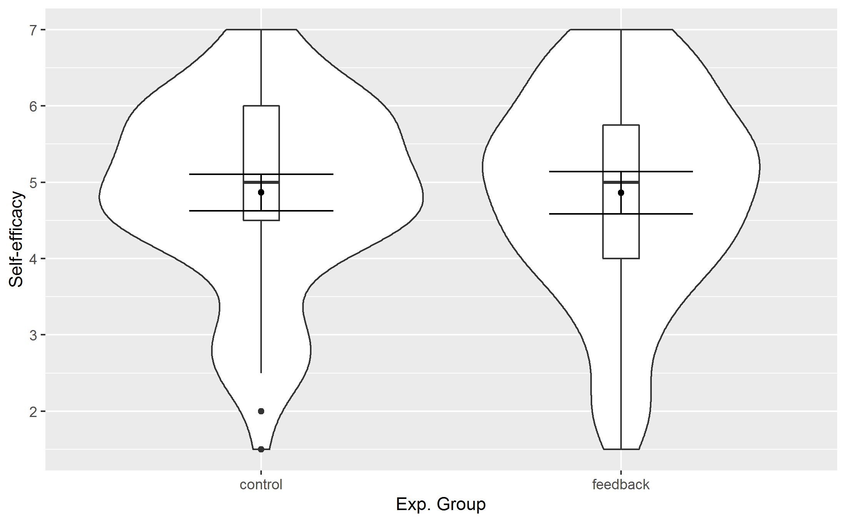

Figure S5
Self-efficacy Reported after T1 and its Relationship with Reliability Ratings for each Measurement Point Depending on Experimental Group, Experiment 1.
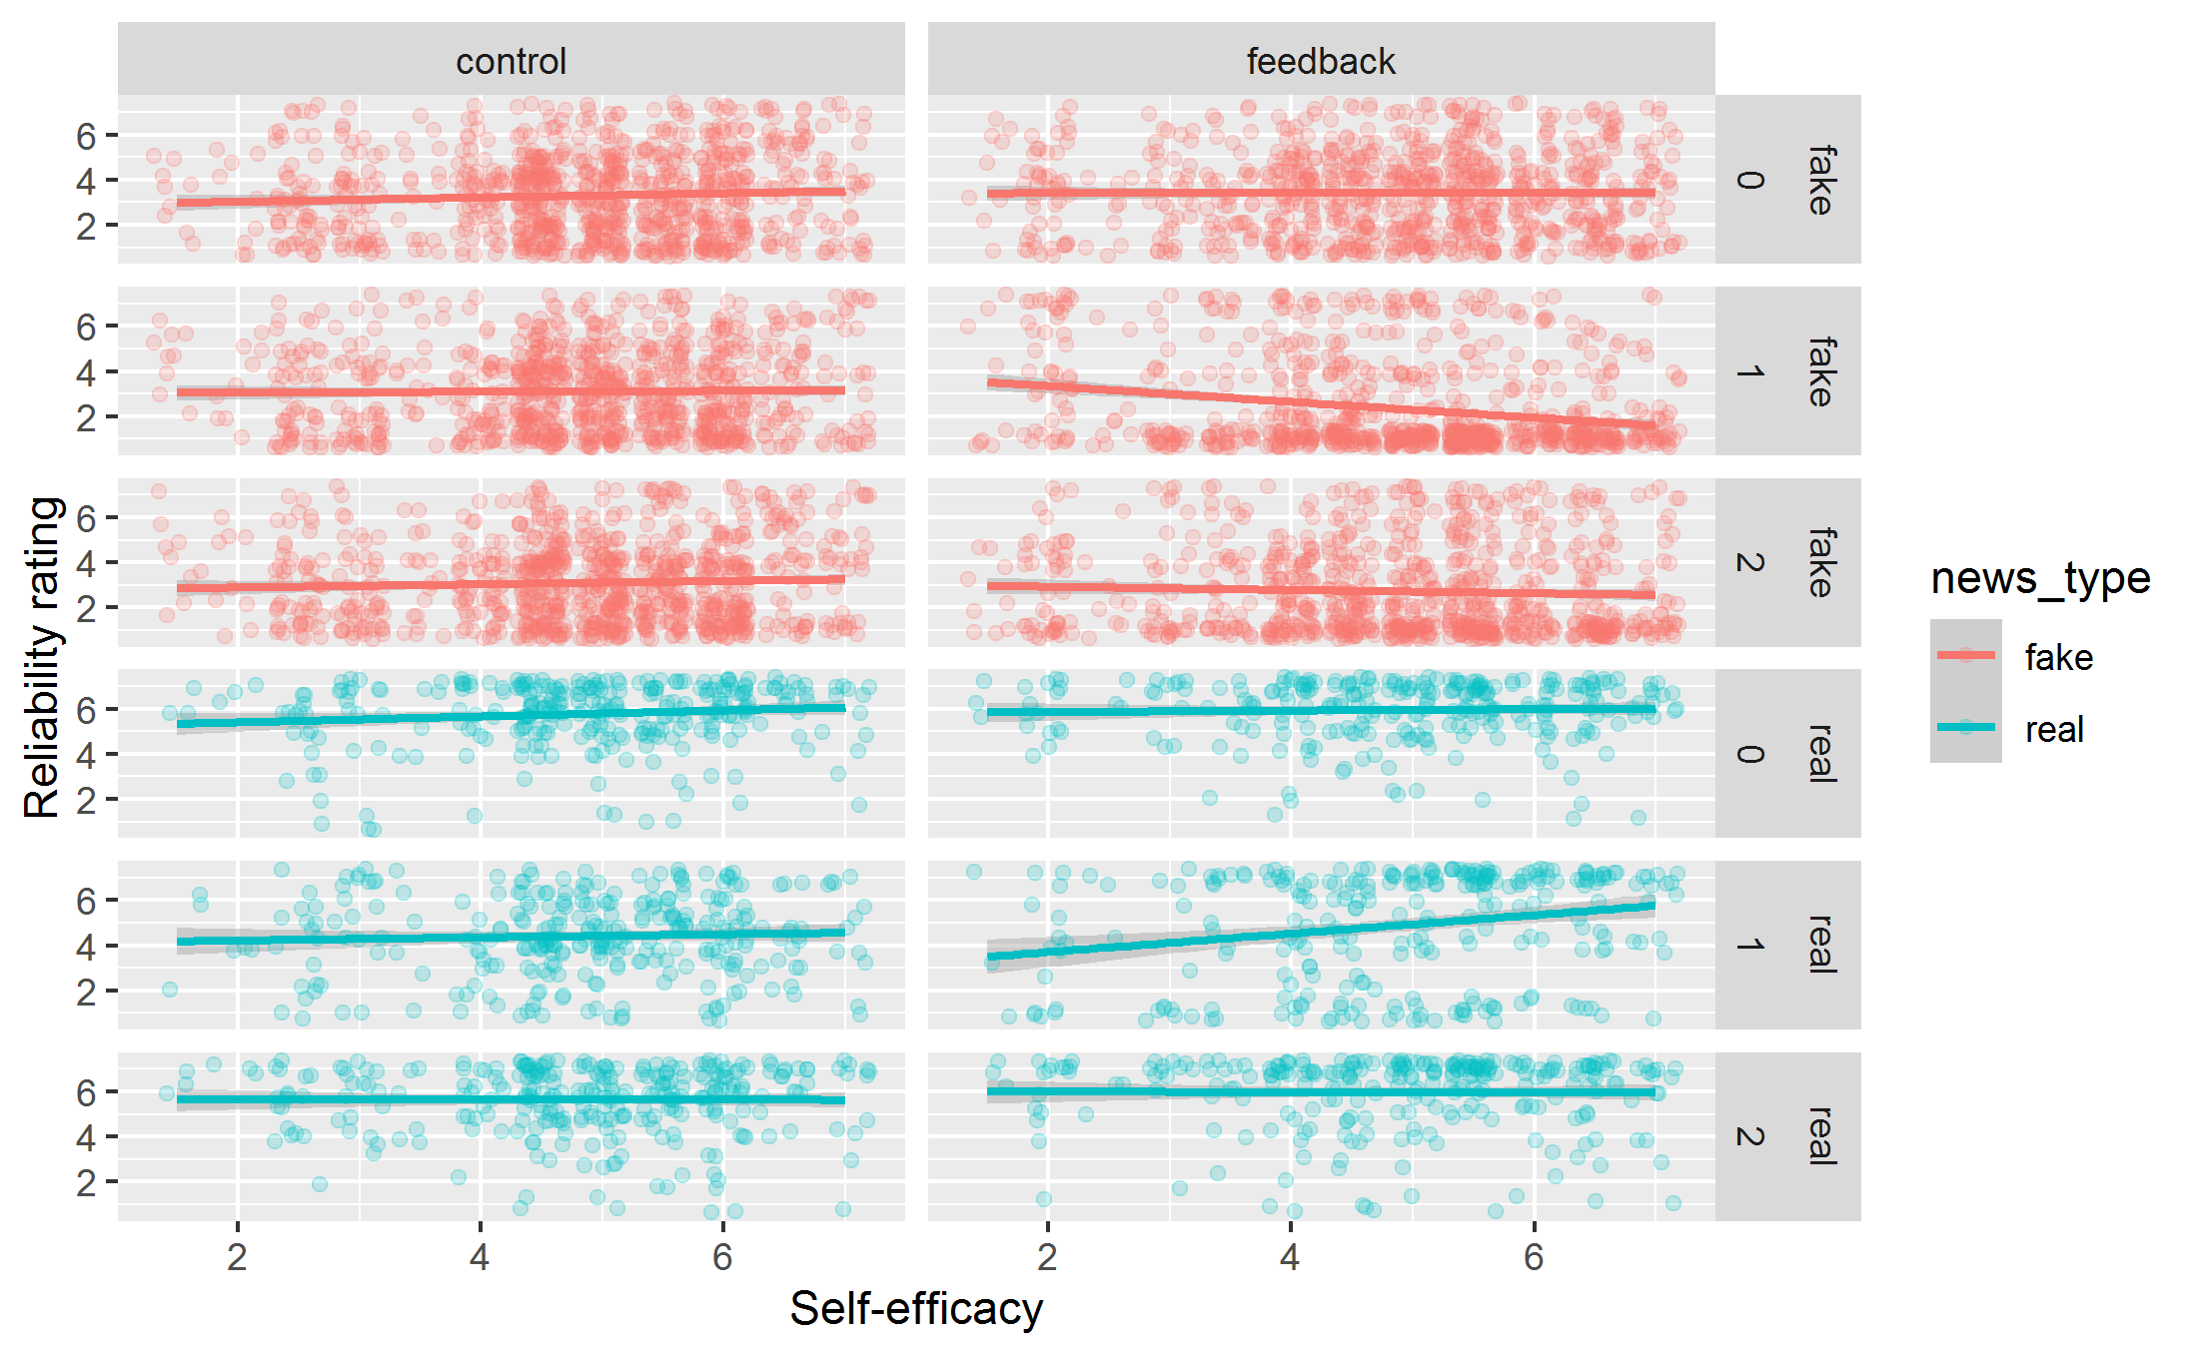

Figure S9
Self-efficacy Reported after T1 depending on Experimental Group, Experiment 2.
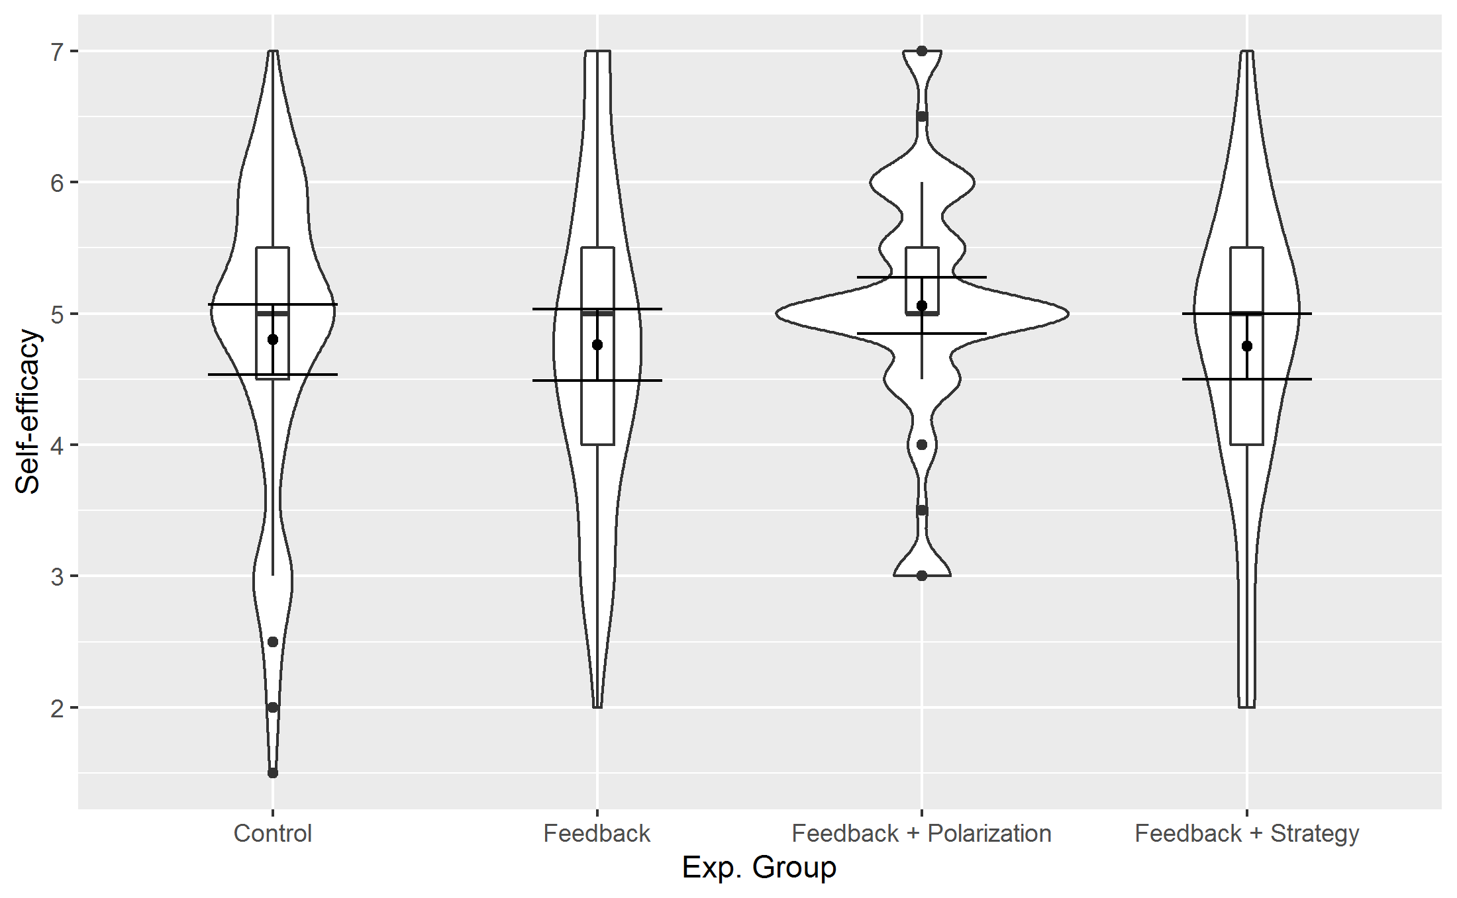

Figure S10
Self-efficacy Reported after T1 and its Relationship with Reliability Ratings for each Measurement Point Depending on Experimental Group, Experiment 2.
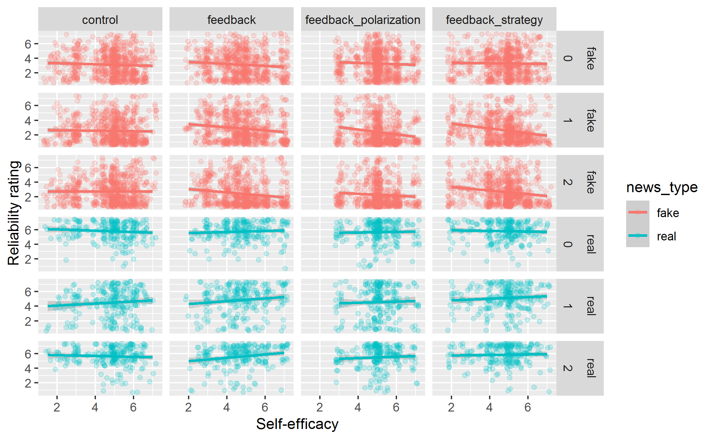

Table S12
Regression Models Assessing Indirect Effect Experimental Group on Ratings via Self-Efficacy, Experiment 1.
 | Experimental Group |  | Experimental Group + Self-efficacy |  | Self-efficacy on Experimental Group
Predictors | Odds Ratios | p | Odds Ratios | p | Estimates | p
Feedback | 0.54 (0.40,0.73) | <0.001 | 0.54 (0.40,0.73) | <0.001 | -0.00 (-0.36,0.36) | 0.990
Real news | 12.69 (9.83,16.39) | <0.001 | 8.87 (4.24,18.55) | <0.001
Feedback X Real news | 3.72 (2.57,5.37) | <0.001 | 3.71 (2.57,5.35) | <0.001
Self-efficacy |  |  | 0.96 (0.85,1.08) | 0.490
Real news X Self-efficacy |  |  | 1.08 (0.93,1.25) | 0.311
Int. |  |  |  |  | 4.86 (4.61,5.12) | <0.001
Random Effects
σ² | 3.29 |  | 3.29
τ₀₀ | 0.77 _{SERIAL} |  | 0.77 _{SERIAL}
ICC | 0.19 |  | 0.19
N | 191 _{SERIAL} |  | 191 _{SERIAL}
Observations | 2292 |  | 2292 |  | 191
Marginal R² / Conditional R² | 0.328 / 0.455 |  | 0.329 / 0.456 |  | 0.000 / -0.005

Table S13
Regression Models Assessing Indirect Effect Experimental Group on Ratings via Self-Efficacy – Mediation Model, Experiment 2.
 | Exp. Group only |  | Exp. Group + Self-efficacy |  | Self-efficacy on Exp. Group
Predictors | Odds Ratios | p | Odds Ratios | p | Estimates | p
Feedback | 0.60 (0.42,0.84) | 0.003 | 0.59 (0.42,0.83) | 0.003 | -0.04 (-0.39,0.31) | 0.811
Feedback polarization | 0.50 (0.35,0.70) | <0.001 | 0.53 (0.37,0.75) | <0.001 | 0.26 (-0.10,0.61) | 0.153
Feedback strategy | 0.92 (0.66,1.30) | 0.645 | 0.92 (0.65,1.29) | 0.617 | -0.05 (-0.40,0.30) | 0.767
Real news | 26.58 (20.01, 35.31) | <0.001 | 4.40 (2.33,8.30) | <0.001
Feedback X Real news | 1.77 (1.21,2.60) | 0.003 | 1.77 (1.21,2.60) | 0.003
Feedback polarization X Real news | 1.90 (1.28,2.80) | 0.001 | 1.67 (1.13,2.48) | 0.010
Feedback strategy X Real news | 1.54 (1.06,2.25) | 0.023 | 1.54 (1.06,2.24) | 0.025
Self-efficacy |  |  | 0.80 (0.72,0.90) | <0.001
Real news X Self-efficacy |  |  | 1.47 (1.30,1.66) | <0.001
Int. |  |  |  |  | 4.80 (4.56,5.05) | <0.001
Random Effects
σ² | 3.29 |  | 3.29
τ₀₀ | 0.84 _{SERIAL} |  | 0.83 _{SERIAL}
ICC | 0.20 |  | 0.20
N | 312 _{SERIAL} |  | 312 _{SERIAL}
Observations | 3734 |  | 3734 |  | 312
Marginal R² / Conditional R² | 0.388 / 0.512 |  | 0.399 / 0.519 |  | 0.012 / 0.003

Supplement H: Exploratory Analyses Experiment 2
For exploratory purposes, we analyzed whether there is a difference in the identification of manipulation techniques between groups. As people in the strategy (feedback + manipulation technique) condition received feedback about manipulation techniques, we hypothesized that participants in this condition show increased identification of the correct technique compared to the other conditions (control, feedback only, feedback + polarization).
To analyze the data, the responses were recoded into a binary variable: correct identification = 1; incorrect identification = 0. A new variable ‘Number of Correct Responses’ was created by finding the sum of all four items. A Poisson regression was run to predict the number of correct responses based on condition. Results indicated no significant difference between conditions (see Table S14), although a negative skew in the feedback strategy group can be observed (see Figure S11).

Table S14
Results Poisson Regression – the Reference Group is Feedback Strategy.
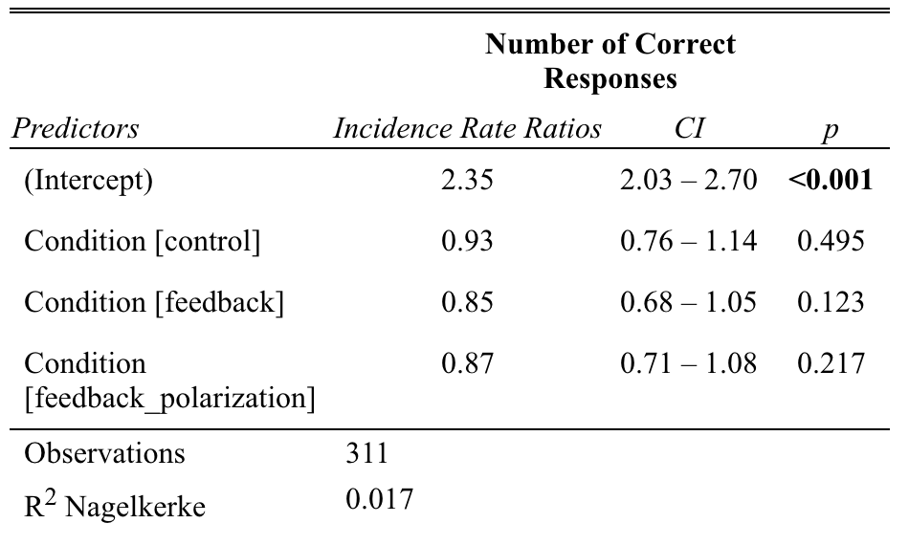

To further explore whether the intervention improves manipulation technique detection, we collected some additional pretest data (n = 55). A 2-minute study was conducted and the same set of 4 items was employed. In a between-subject analysis, we compared the results of the pretest condition (no treatment at all) with the results from Experiment 2 (see Figure S11) carrying out a Poisson regression.
Results showed that participants assigned to the control condition (𝛽 = 1.37, 95% CI [ 1.06 – 1.77], p = .017) and feedback strategy condition (𝛽 = 1.47, 95% CI [ 1.14 – 1.90, p = .003) detected significantly more techniques compared to participants in the pretest condition (see Table S15).
Interestingly, no effect was observed for the feedback only and feedback + polarization conditions. This finding is surprising as the feedback only, control and feedback + polarization condition did not receive any additional treatment in terms of manipulation techniques, and one would expect no difference between groups. In general, the validity of the findings is limited as only a small set of 4 items was employed and no baseline measure was established to allow for a within-subjects analysis.
Table S15
Results Poisson Regression – the Reference Group is the Additional Pretest Condit.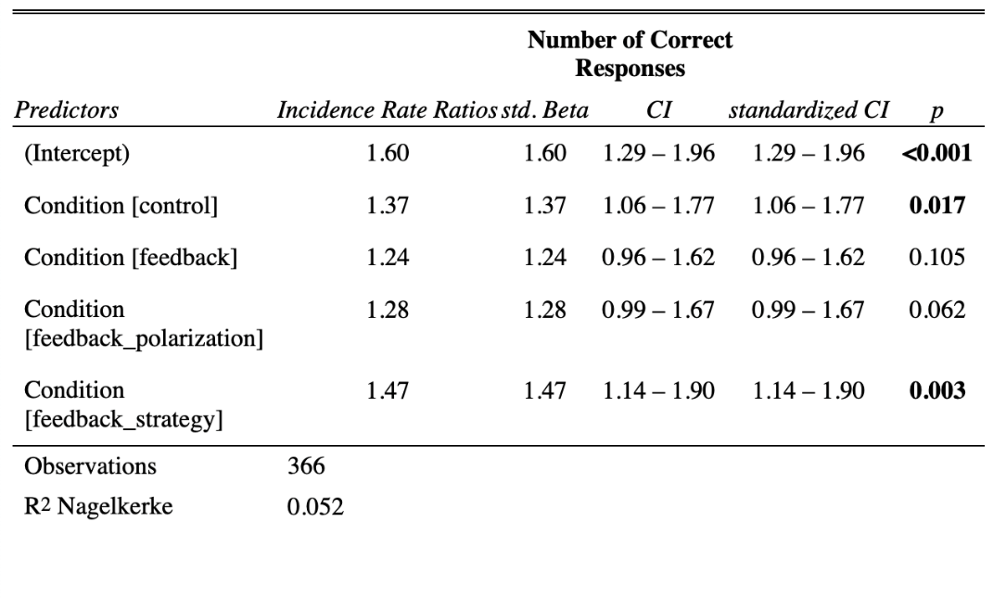

Figure S11
Histogram Depicting the Number of Correct Responses for all Conditions in Experiment 2 and the Additional Pretest.
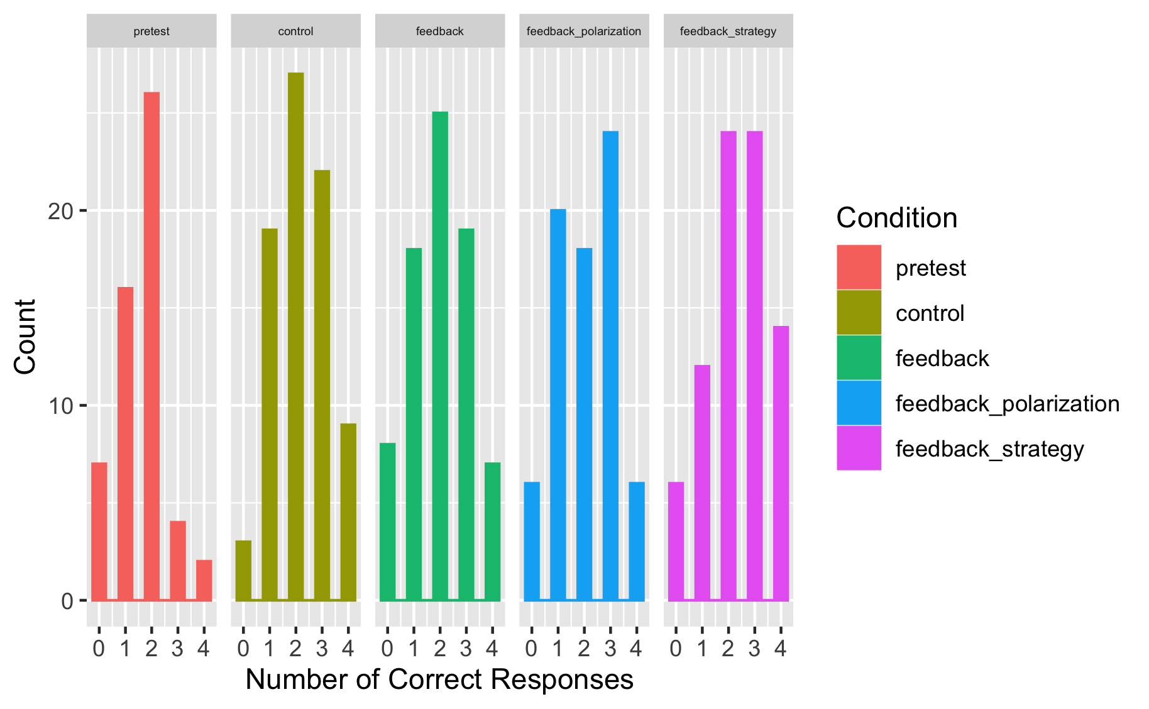
Note. Number of Correct Responses: 4 = all techniques were identified correctly; 0 = no technique was identified correctly.

Timing
For Experiments 1 and 2, we recorded the time that participants spent in the feedback condition (i.e., the item rating task at T1 with or, in the case of the control group, without feedback). Please see the results in the table below.
Condition | Time in min
Experiment 1
feedback | 7.37
control (no feedback) | 2.60
Experiment 2:
control (no feedback) | 1.66
feedback only | 2.55
feedback + polarization | 2.43
feedback + manipulation technique rec. | 5.47

We note that these results are as expected, in the sense that participants in feedback conditions spend more time in the T1 item task than control group participants. Moreover, the lengthiest feedback exercise (feedback + manipulation technique recognition) takes the longest average time to complete.

Supplement I: Descriptives And Supplementary Results Experiments 3-6
Table S16
Item-Level Descriptives for Experiment 3 (Harmony Square), by Condition.
 | No feedback |  |  |  |  |  | Feedback
Item | N | Mean | Median | SD | SE |  | N | Mean | Median | SD | SE
Fake.Post | 257 | 2.37 | 2 | 1.33 | 0.083 |  | 302 | 2.54 | 2.25 | 1.32 | 0.076
Fake.Pre | 257 | 2.75 | 2.5 | 1.2 | 0.075 |  | 302 | 2.73 | 2.5 | 1.19 | 0.068
Real.Post | 257 | 3.57 | 3.75 | 1.72 | 0.107 |  | 302 | 4.72 | 5 | 1.67 | 0.096
Real.Pre | 257 | 3.94 | 4 | 1.51 | 0.094 |  | 302 | 3.95 | 4 | 1.48 | 0.085
Disc.Post | 257 | 1.2 | 0.75 | 1.61 | 0.101 |  | 302 | 2.18 | 2.25 | 1.99 | 0.115
Disc.Pre | 257 | 1.18 | 1 | 1.52 | 0.095 |  | 302 | 1.22 | 1 | 1.49 | 0.086
Emotion.Post | 257 | 2.55 | 2 | 1.66 | 0.103 |  | 302 | 2.57 | 2 | 1.68 | 0.097
Emotion.Pre | 257 | 2.82 | 3 | 1.5 | 0.094 |  | 302 | 2.74 | 2.5 | 1.54 | 0.089
Conspiracy.Post | 257 | 2.11 | 1 | 1.62 | 0.101 |  | 302 | 2.46 | 2 | 1.79 | 0.103
Conspiracy.Pre | 257 | 2.43 | 2 | 1.6 | 0.100 |  | 302 | 2.52 | 2 | 1.7 | 0.098
Polarization.Post | 257 | 2.78 | 2 | 1.7 | 0.106 |  | 302 | 2.87 | 2 | 1.83 | 0.105
Polarization.Pre | 257 | 3.27 | 3 | 1.66 | 0.104 |  | 302 | 3.18 | 3 | 1.73 | 0.099
Trolling.Post | 257 | 2.06 | 1 | 1.63 | 0.101 |  | 302 | 2.25 | 1 | 1.77 | 0.102
Trolling.Pre | 257 | 2.49 | 2 | 1.78 | 0.111 |  | 302 | 2.49 | 2 | 1.77 | 0.102
Real_Biden.Post | 257 | 3.32 | 3 | 1.97 | 0.123 |  | 302 | 4.71 | 5 | 2 | 0.115
Real_Biden.Pre | 257 | 3.35 | 3 | 1.81 | 0.113 |  | 302 | 3.49 | 4 | 1.94 | 0.112
Real_Labour.Post | 257 | 3.37 | 3 | 1.93 | 0.120 |  | 302 | 4.52 | 5 | 2 | 0.115
Real_Labour.Pre | 257 | 3.62 | 4 | 1.85 | 0.115 |  | 302 | 3.7 | 4 | 1.87 | 0.107
Real_NASA.Post | 257 | 4.06 | 4 | 2.09 | 0.131 |  | 302 | 5.14 | 6 | 1.98 | 0.114
Real_NASA.Pre | 257 | 4.54 | 5 | 1.87 | 0.117 |  | 302 | 4.57 | 5 | 1.84 | 0.106
Real_Honda.Post | 257 | 3.55 | 4 | 1.92 | 0.120 |  | 302 | 4.52 | 5 | 1.98 | 0.114
Real_Honda.Pre | 257 | 4.23 | 4 | 1.75 | 0.109 |  | 302 | 4.05 | 4 | 1.75 | 0.101

Table S17
Item-Level Descriptives for Experiment 4 (Bad News), by Condition.
 | No feedback |  |  |  |  |  | Feedback
Item | N | Mean | Median | SD | SE |  | N | Mean | Median | SD | SE
Fake.Post | 960 | 2.43 | 2 | 1.48 | 0.048 |  | 930 | 2.43 | 2 | 1.43 | 0.047
Fake.Pre | 960 | 2.80 | 2.67 | 1.33 | 0.043 |  | 930 | 2.69 | 2.5 | 1.28 | 0.042
Real.Post | 960 | 5.09 | 5.5 | 1.66 | 0.054 |  | 930 | 5.52 | 6 | 1.39 | 0.046
Real.Pre | 960 | 5.37 | 5.5 | 1.36 | 0.044 |  | 930 | 5.33 | 5.5 | 1.32 | 0.043
Disc.Post | 960 | 2.67 | 3 | 2.02 | 0.065 |  | 930 | 3.09 | 3.33 | 1.94 | 0.064
Disc.Pre | 960 | 2.57 | 2.67 | 1.71 | 0.055 |  | 930 | 2.63 | 2.83 | 1.73 | 0.057
Impersonation.Post | 960 | 2.49 | 2 | 1.89 | 0.061 |  | 930 | 2.75 | 2 | 1.97 | 0.065
Impersonation.Pre | 960 | 2.81 | 2 | 1.92 | 0.062 |  | 930 | 2.82 | 2 | 1.95 | 0.064
Emotion.Post | 960 | 2.25 | 1 | 1.8 | 0.058 |  | 930 | 2.15 | 1 | 1.82 | 0.060
Emotion.Pre | 960 | 2.55 | 2 | 1.88 | 0.061 |  | 930 | 2.45 | 2 | 1.81 | 0.059
Polarization.Post | 960 | 2.29 | 1 | 1.75 | 0.056 |  | 930 | 2.19 | 1 | 1.66 | 0.054
Polarization.Pre | 960 | 2.45 | 2 | 1.75 | 0.057 |  | 930 | 2.3 | 2 | 1.62 | 0.053
Conspiracy.Post | 960 | 2.65 | 2 | 1.93 | 0.062 |  | 930 | 2.6 | 2 | 1.89 | 0.062
Conspiracy.Pre | 960 | 3.33 | 3 | 1.96 | 0.063 |  | 930 | 3.19 | 3 | 1.87 | 0.061
Discredit.Post | 960 | 2.76 | 2 | 2.07 | 0.067 |  | 930 | 2.68 | 2 | 2.04 | 0.067
Discredit.Pre | 960 | 3.38 | 3 | 2.12 | 0.068 |  | 930 | 3.22 | 3 | 2.15 | 0.070
Trolling.Post | 960 | 2.12 | 1 | 1.81 | 0.058 |  | 930 | 2.23 | 1 | 1.85 | 0.061
Trolling.Pre | 960 | 2.24 | 1 | 1.84 | 0.059 |  | 930 | 2.18 | 1 | 1.73 | 0.057
Real_Brands.Post | 960 | 5.17 | 6 | 1.94 | 0.063 |  | 930 | 5.6 | 6 | 1.72 | 0.057
Real_Brands.Pre | 960 | 5.27 | 6 | 1.78 | 0.058 |  | 930 | 5.26 | 6 | 1.71 | 0.056
Real_Brain.Post | 960 | 5.02 | 6 | 2.01 | 0.065 |  | 930 | 5.45 | 6 | 1.76 | 0.058
Real_Brain.Pre | 960 | 5.46 | 6 | 1.7 | 0.055 |  | 930 | 5.39 | 6 | 1.78 | 0.058

Table S18
Item-Level Descriptives for Experiment 5 (Bad News – MIST).
Item | N | Mean | Median | SD | SE
Fake.Post | 419 | 2.25 | 1.75 | 1.45 | 0.0711
Fake.Pre | 419 | 2.43 | 2 | 1.44 | 0.0705
Real.Post | 419 | 4.76 | 5 | 1.48 | 0.0723
Real.Pre | 419 | 4.57 | 4.75 | 1.27 | 0.0621
Disc.Post | 419 | 2.51 | 2.75 | 2.01 | 0.0984
Disc.Pre | 419 | 2.14 | 2.5 | 1.86 | 0.0908
F1.Post | 419 | 2.75 | 2 | 2.03 | 0.0992
F1.Pre | 419 | 3.02 | 3 | 1.89 | 0.0925
F2.Post | 419 | 2.35 | 2 | 1.8 | 0.0879
F2.Pre | 419 | 2.55 | 2 | 1.83 | 0.0893
F3.Post | 419 | 2.09 | 1 | 1.81 | 0.0886
F3.Pre | 419 | 2.31 | 1 | 1.94 | 0.0949
F4.Post | 419 | 1.8 | 1 | 1.64 | 0.0802
F4.Pre | 419 | 1.83 | 1 | 1.6 | 0.078
R1.Post | 419 | 4.59 | 5 | 1.85 | 0.0902
R1.Pre | 419 | 4.02 | 4 | 1.73 | 0.0846
R2.Post | 419 | 4.78 | 5 | 2.11 | 0.1029
R2.Pre | 419 | 4.36 | 5 | 1.95 | 0.0952
R3.Post | 419 | 4.72 | 5 | 1.97 | 0.0962
R3.Pre | 419 | 4.84 | 5 | 1.82 | 0.089
R4.Post | 419 | 4.95 | 5 | 1.92 | 0.0939
R4.Pre | 419 | 5.06 | 5 | 1.85 | 0.0902

Table S19
Item-Level Independent-Samples and Bayesian T-Tests for Experiment 3 (Harmony Square).
Condition | Item |  | Statistic |  | ±% | df | p | M_{diff} | Cohen's d | 95% CI
No feedback | Fake.Post | Fake.Pre | t | -7.337 |  | 256 | < .001 | -0.378 | -0.458 | -0.586 | -0.329
 |  |  | BF₁₀ | 2.22E+09 | 5.23E-18
 | Real.Post | Real.Pre | t | -5.126 |  | 256 | < .001 | -0.361 | -0.320 | -0.445 | -0.194
 |  |  | BF₁₀ | 16551.368 | 1.24E-12
 | Disc.Post | Disc.Pre | t | 0.259 |  | 256 | 0.796 | 0.018 | 0.016 | -0.106 | 0.138
 |  |  | BF₁₀ | 0.0722 | 0.0028
 | Emotion.Post | Emotion.Pre | t | -3.416 |  | 256 | < .001 | -0.269 | -0.213 | -0.337 | -0.089
 |  |  | BF₁₀ | 19.7147 | 1.32e0-5
 | Conspiracy.Post | Conspiracy.Pre | t | -4.053 |  | 256 | < .001 | -0.319 | -0.253 | -0.377 | -0.128
 |  |  | BF₁₀ | 183.428 | 1.54e0-6
 | Polarization.Post | Polarization.Pre | t | -5.28 |  | 256 | < .001 | -0.494 | -0.329 | -0.455 | -0.204
 |  |  | BF₁₀ | 33917.875 | 5.93E-13
 | Trolling.Post | Trolling.Pre | t | -5.251 |  | 256 | < .001 | -0.432 | -0.328 | -0.453 | -0.202
 |  |  | BF₁₀ | 29600.841 | 6.80E-13
 | Real_Biden.Post | Real_Biden.Pre | t | -0.393 |  | 256 | 0.695 | -0.035 | -0.025 | -0.147 | 0.098
 |  |  | BF₁₀ | 0.0754 | 0.00269
 | Real_Labour.Post | Real_Labour.Pre | t | -2.679 |  | 256 | 0.008 | -0.253 | -0.167 | -0.290 | -0.044
 |  |  | BF₁₀ | 2.3119 | 1.03e0-4
 | Real_NASA.Post | Real_NASA.Pre | t | -5.192 |  | 256 | < .001 | -0.475 | -0.324 | -0.449 | -0.198
 |  |  | BF₁₀ | 22391.186 | 9.09E-13
 | Real_Honda.Post | Real_Honda.Pre | t | -7.517 |  | 256 | < .001 | -0.681 | -0.469 | -0.597 | -0.340
 |  |  | BF₁₀ | 6.62E+09 | 1.62E-18
Feedback | Fake.Post | Fake.Pre | t | -2.725 |  | 301 | 0.007 | -0.192 | -0.157 | -0.270 | -0.043
 |  |  | BF₁₀ | 2.4394 | 9.77e0-5
 | Real.Post | Real.Pre | t | 9.896 |  | 301 | < .001 | 0.769 | 0.570 | 0.447 | 0.691
 |  |  | BF₁₀ | 1.17E+17 | 3.68E-26
 | Disc.Post | Disc.Pre | t | 9.847 |  | 301 | < .001 | 0.961 | 0.567 | 0.445 | 0.688
 |  |  | BF₁₀ | 8.13E+16 | 5.40E-26
 | Emotion.Post | Emotion.Pre | t | -1.669 |  | 301 | 0.096 | -0.169 | -0.096 | -0.209 | 0.017
 |  |  | BF₁₀ | 0.2548 | 8.58e0-4
 | Conspiracy.Post | Conspiracy.Pre | t | -0.632 |  | 301 | 0.528 | -0.060 | -0.036 | -0.149 | 0.077
 |  |  | BF₁₀ | 0.0786 | 0.00265
 | Polarization.Post | Polarization.Pre | t | -2.708 |  | 301 | 0.007 | -0.301 | -0.156 | -0.269 | -0.042
 |  |  | BF₁₀ | 2.3338 | 1.02e0-4
 | Trolling.Post | Trolling.Pre | t | -2.524 |  | 301 | 0.012 | -0.238 | -0.145 | -0.259 | -0.032
 |  |  | BF₁₀ | 1.4657 | 1.60e0-4
 | Real_Biden.Post | Real_Biden.Pre | t | 10.361 |  | 301 | < .001 | 1.222 | 0.596 | 0.473 | 0.718
 |  |  | BF₁₀ | 3.83E+18 | 1.04E-27
 | Real_Labour.Post | Real_Labour.Pre | t | 8.451 |  | 301 | < .001 | 0.821 | 0.486 | 0.367 | 0.605
 |  |  | BF₁₀ | 4.04E+12 | 2.34E-21
 | Real_NASA.Post | Real_NASA.Pre | t | 5.574 |  | 301 | < .001 | 0.566 | 0.321 | 0.205 | 0.436
 |  |  | BF₁₀ | 148388.495 | 1.37E-13
 | Real_Honda.Post | Real_Honda.Pre | t | 4.7 |  | 301 | < .001 | 0.467 | 0.270 | 0.155 | 0.385
 |  |  | BF₁₀ | 2485.44 | 1.19e0-7
Note. Hₐ μ _{Measure 1 - Measure 2} ≠ 0

Table S20
Item-Level Independent-Samples and Bayesian T-Tests for Experiment 4 (Bad News).
Condition | Item |  | Statistic |  | ±% | df | p | M_{diff} | Cohen's d | 95% CI
No feedback | Fake.Post | Fake.Pre | t | -9.75 |  | 959 | < .001 | -0.370 | -0.315 | -0.379 | -0.250
 |  |  | BF₁₀ | 1.49E+18 | 1.35E-26
 | Real.Post | Real.Pre | t | -5.88 |  | 959 | < .001 | -0.272 | -0.190 | -0.253 | -0.126
 |  |  | BF₁₀ | 800656.050 | 3.32E-10
 | Disc.Post | Disc.Pre | t | 2.02 |  | 959 | 0.044 | 0.098 | 0.065 | 0.002 | 0.128
 |  |  | BF₁₀ | 0.274 | 8.42e0-4
 | Impersonation.Post | Impersonation.Pre | t | -5.61 |  | 959 | < .001 | -0.326 | -0.181 | -0.245 | -0.117
 |  |  | BF₁₀ | 180913.188 | 1.45e0-9
 | Emotion.Post | Emotion.Pre | t | -5.21 |  | 959 | < .001 | -0.300 | -0.168 | -0.232 | -0.104
 |  |  | BF₁₀ | 22552.959 | 1.14e0-8
 | Polarization.Post | Polarization.Pre | t | -2.97 |  | 959 | 0.003 | -0.168 | -0.096 | -0.159 | -0.032
 |  |  | BF₁₀ | 2.899 | 8.15e0-5
 | Conspiracy.Post | Conspiracy.Pre | t | -11.03 |  | 959 | < .001 | -0.677 | -0.356 | -0.421 | -0.291
 |  |  | BF₁₀ | 2.34E+23 | 7.69E-32
 | Discredit.Post | Discredit.Pre | t | -9.57 |  | 959 | < .001 | -0.626 | -0.309 | -0.373 | -0.244
 |  |  | BF₁₀ | 3.06E+17 | 6.67E-26
 | Trolling.Post | Trolling.Pre | t | -2.22 |  | 959 | 0.027 | -0.125 | -0.072 | -0.135 | -0.008
 |  |  | BF₁₀ | 0.421 | 5.51e0-4
 | Real_Brands.Post | Real_Brands.Pre | t | -1.83 |  | 959 | 0.068 | -0.102 | -0.059 | -0.122 | 0.004
 |  |  | BF₁₀ | 0.191 | 0.0012
 | Real_Brain.Post | Real_Brain.Pre | t | -7.25 |  | 959 | < .001 | -0.442 | -0.234 | -0.298 | -0.170
 |  |  | BF₁₀ | 4.23e0+9 | 6.75E-14
Feedback | Fake.Post | Fake.Pre | t | -7.165 |  | 929 | < .001 | -0.259 | -0.235 | -0.300 | -0.170
 |  |  | BF₁₀ | 2.43e0+9 | 1.18E-13
 | Real.Post | Real.Pre | t | 4.504 |  | 929 | < .001 | 0.196 | 0.148 | 0.083 | 0.212
 |  |  | BF₁₀ | 813.845 | 3.07e0-7
 | Disc.Post | Disc.Pre | t | 9.007 |  | 929 | < .001 | 0.455 | 0.295 | 0.230 | 0.361
 |  |  | BF₁₀ | 2.55E+15 | 8.31E-24
 | Impersonation.Post | Impersonation.Pre | t | -1.219 |  | 929 | 0.223 | -0.072 | -0.040 | -0.104 | 0.024
 |  |  | BF₁₀ | 0.077 | 0.00294
 | Emotion.Post | Emotion.Pre | t | -5.134 |  | 929 | < .001 | -0.296 | -0.168 | -0.233 | -0.104
 |  |  | BF₁₀ | 15642.209 | 1.65e0-8
 | Polarization.Post | Polarization.Pre | t | -2.04 |  | 929 | 0.042 | -0.112 | -0.067 | -0.131 | -0.003
 |  |  | BF₁₀ | 0.2925 | 7.89e0-4
 | Conspiracy.Post | Conspiracy.Pre | t | -9.845 |  | 929 | < .001 | -0.585 | -0.323 | -0.389 | -0.257
 |  |  | BF₁₀ | 3.38E+18 | 5.85E-27
 | Discredit.Post | Discredit.Pre | t | -8.35 |  | 929 | < .001 | -0.541 | -0.274 | -0.339 | -0.208
 |  |  | BF₁₀ | 1.32E+13 | 2.31E-17
 | Trolling.Post | Trolling.Pre | t | 0.914 |  | 929 | 0.361 | 0.051 | 0.030 | -0.034 | 0.094
 |  |  | BF₁₀ | 0.056 | 0.00405
 | Real_Brands.Post | Real_Brands.Pre | t | 6.316 |  | 929 | < .001 | 0.336 | 0.207 | 0.142 | 0.272
 |  |  | BF₁₀ | 1.06e0+7 | 2.59E-11
 | Real_Brain.Post | Real_Brain.Pre | t | 0.933 |  | 929 | 0.351 | 0.056 | 0.031 | -0.034 | 0.095
 |  |  | BF₁₀ | 0.057 | 0.00398
Note. Hₐ μ _{Measure 1 - Measure 2} ≠ 0

Table S21
Item-Level Independent-Samples and Bayesian T-Tests for Experiment 5 (Bad News - MIST).
Item |  | Statistic |  | ±% | df | p | M_{diff} | Cohen's d | 95% CI
Fake.Post | Fake.Pre | t | -2.976 |  | 418 | 0.003 | -0.180 | -0.145 | -0.242 | -0.049
 |  | BF₁₀ | 4.254 | 5.65e0-5
Real.Post | Real.Pre | t | 3.490 |  | 418 | < .001 | 0.190 | 0.171 | 0.074 | 0.267
 |  | BF₁₀ | 21.310 | 1.17e0-5
Disc.Post | Disc.Pre | t | 5.421 |  | 418 | < .001 | 0.370 | 0.265 | 0.167 | 0.362
 |  | BF₁₀ | 73361.484 | 4.04e0-9
F1.Post | F1.Pre | t | -2.802 |  | 418 | 0.005 | -0.272 | -0.137 | -0.233 | -0.041
 |  | BF₁₀ | 2.613 | 9.09e0-5
F2.Post | F2.Pre | t | -2.166 |  | 418 | 0.031 | -0.198 | -0.106 | -0.202 | -0.010
 |  | BF₁₀ | 0.557 | 4.10e0-4
F3.Post | F3.Pre | t | -2.500 |  | 418 | 0.013 | -0.215 | -0.122 | -0.218 | -0.026
 |  | BF₁₀ | 1.195 | 1.95e0-4
F4.Post | F4.Pre | t | -0.468 |  | 418 | 0.64 | -0.036 | -0.023 | -0.119 | 0.073
 |  | BF₁₀ | 0.061 | 0.00352
R1.Post | R1.Pre | t | 6.495 |  | 418 | < .001 | 0.570 | 0.317 | 0.219 | 0.415
 |  | BF₁₀ | 25700000.000 | 7.90E-16
R2.Post | R2.Pre | t | 4.395 |  | 418 | < .001 | 0.420 | 0.215 | 0.118 | 0.311
 |  | BF₁₀ | 647.646 | 4.17e0-7
R3.Post | R3.Pre | t | -1.305 |  | 418 | 0.193 | -0.117 | -0.064 | -0.160 | 0.032
 |  | BF₁₀ | 0.128 | 0.00172
R4.Post | R4.Pre | t | -1.459 |  | 418 | 0.145 | -0.115 | -0.071 | -0.167 | 0.025
 |  | BF₁₀ | 0.157 | 0.0014
Note. Hₐ μ _{Measure 1 - Measure 2} ≠ 0

Table S22
Summary Of Bayesian T-test Results for Experiments 3-6. Note: BF₁₀ = Bayes Factor₁₀. Prior used is 0.707 (default). Bayes Factors > 10 (strong evidence) are marked in bold. See also Tables S19-S21.
Experiment |  | BF₁₀ | Error
 | Without feedback
Harmony Sq. | Misinformation | 2.220*10⁹ | -5.23E-18
(Exp. 3) | Real news | 16,551.37 | -1.244E-12
 | Discernment | 0.072 | +- 0.003
 | With feedback
 | Misinformation | 2.44 | -0.0000977
 | Real news | 1.172*10¹⁷ | -3.684E-26
 | Discernment | 8.133*10¹⁶ | -5.402E-26
 | Without feedback
Bad News | Misinformation | 1.490*10¹⁸ | 1.35E-26
(Exp. 4) | Real news | 800,656.05 | -3.322E-10
 | Discernment | 0.274 | +- 0.001
 | With feedback
 | Misinformation | 2.429*10⁹ | -1.178E-13
 | Real news | 813.845 | -3.075E-07
 | Discernment | 2.547*10¹⁵ | -8.312E-24
Bad News | With feedback
(Exp. 5) | Misinformation | 4.254 | -0.0000564
 | Real news | 21.31 | 1.17E-05
 | Discernment | 73361.484 | 4.04E-09
Bad News | With feedback
(Exp. 6) | Misinformation | 23.10 | 1.05E-5
 | Real news | 7.39*10⁹ | 3.94E-14
 | Discernment | 5.58*10¹⁸ | 3.45E-27

Table S23
Summary Of T-test Results For SDT (Signal Detection Theory) Analysis, Experiments 3-6. Note: BF₁₀ = Bayes Factor₁₀. Prior used is 0.707 (default).
Analysis | Condition | t | df | p | M_{diff} | 95% CI | Cohen's d | BF₁₀
AUC
Exp. 3 (Harmony Square) | No feedback | -0.096 | 256 | 0.923 | -0.001 | [-.023, .021] | -0.005 | .070 +- .29%
 | Feedback | 6.707 | 301 | < .001 | 0.087 | [.062, .113] | 0.388 | 6.784E7 +- 0%
Exp. 4 (Bad News) | No feedback | -1.553 | 959 | 0.121 | -0.009 | [-.021, .002] | -0.045 | .121 +- .19%
 | Feedback | 2.084 | 929 | 0.037 | 0.013 | [.001, .025] | 0.063 | .320 +-.07%
Exp. 5 (Bad News - MIST) | Feedback | 1.501 | 418 | 0.134 | 0.014 | [-.004, .032] | 0.06 | .167 +-.13%
Exp. 6 (Bad News -Har Sq) | Feedback | 5.750 | 881 | < .001 | 0.042 | [0.028, 0.057] | 0.185 | 400398.5 +-0%
B''D
Exp. 3 (Harmony Square) | No feedback | 6.932 | 256 | < .001 | 0.133 | [.096, .171] | 0.306 | 2.043E7 +-0%
 | Feedback | -5.003 | 301 | < .001 | -0.105 | [-.147, =.064] | -0.258 | 9617.325 +-0%
Exp. 4 (Bad News) | No feedback | 11.519 | 959 | < .001 | 0.151 | [.125, .176] | 0.345 | 2.954E25 +- 0%
 | Feedback | 5.381 | 929 | < .001 | 0.065 | [.041, .089] | 0.161 | 54979.94 +-0%
Exp. 5 (Bad News - MIST) | Feedback | 0.031 | 418 | 0.975 | 0.001 | [-.038, .039] | 0.002 | .055 +- .39%
Exp. 6 (Bad News -Har Sq) | Feedback | -2.831 | 881 | 0.004 | -0.041 | [-.069, -.013] | -0.097 | 2.027 +.01%

Figure S12
Experiments 3-5: AUC Plots For SDT Analysis.
Experiment | Feedback | No Feedback
Experiment 3  (Harmony Square) | 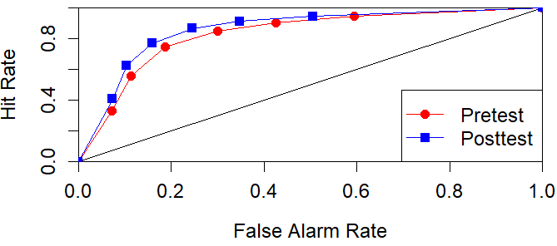 | 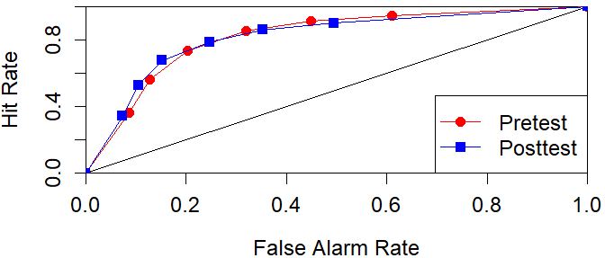
Experiment 4  (Bad News) | 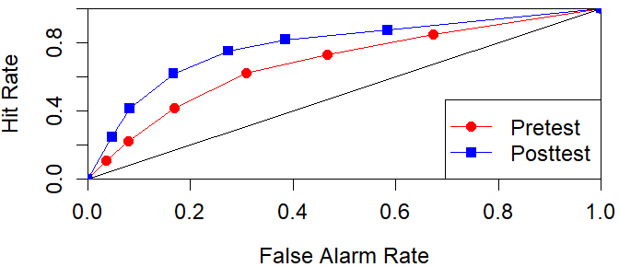 | 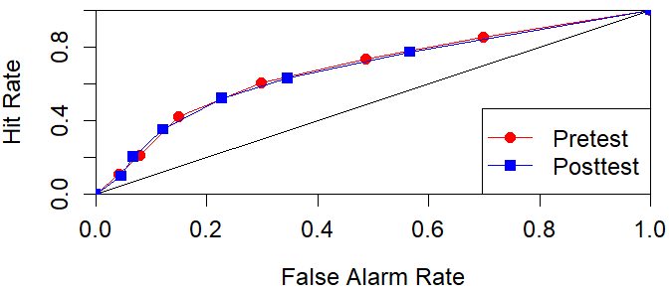
Experiment 5  (Bad News – MIST) | 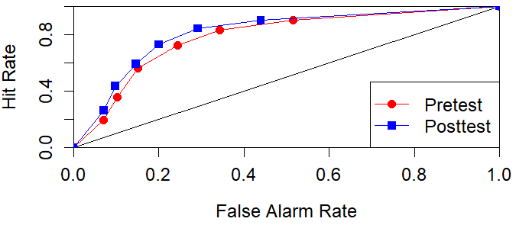

Supplement J: Item & Feedback Headline Wordings Experiments 3-6.
Table S24
Item-Level Wordings for Experiments 3-5.
Study | Item name | Wording | Source | Item name | Wording | Source
Harmony Sq (Exp 3) | Real_Biden | US President Joe Biden argues for childcare and free university in speech to Congress | - | Emotion | Horrific" TV-show inspiring suicide, says filmmaker | -
& Bad News (Exp. 6) | Real_Labour | UK Labour Party to shuffle leadership positions after election losses | - | Conspiracy | In the last few hundred years we've gone from an agrarian society to hypermach stealth aircraft, space travel, and having supercomputers connected to all of the libraries of the world in our pockets. What if this isn't the first time this happened?... | -
 | Real_NASA | NASA spacecraft starts trip back to Earth after collecting asteroid samples | - | Polarization | professor calls right-wing reporting a "form of violence" | -
 | Real_Honda | U.S. opens safety probe into 1.1 million Honda Accord vehicles | - | Trolling | My cousin is studying sociology in university. Last week she and her classmates polled over 1,000 conservative Christians. "What would you do if you discovered that your child is a homo sapiens?" 55% said they would disown them and force them to leave their home. | -
Bad News (Exp 4) | Real_Brands | Apple, Google and Amazon named as most valuable brands in the world. | The Guardian | Polarisation | The myth of "equal IQ" between left-wing and right-wing people exposed #TruthMatters | Rapid Updates
 | Real_Brain | Physical exercise keeps your brain in good shape | Psychology Today | Conspiracy | The Bitcoin exchange rate is being manipulated by a small group of rich bankers #InvestigateNow | Daily Web News
 | Impersonation | Investment advice: buy only stocks that make you happy | Warren Büffet | Discredit | The mainstream media has been caught in so many lies that it can't be trusted as a reliable news source #FakeNews | The International Post Online
 | Emotion | NEWS ALERT: Baby formula caused HORRIFIC outbreak of new, terrifying disease among helpless infants. Parents despair. | Parents Weekly | Trolling | Hey @LeoDiCaprio, it's snowing and freezing in New York. Could use some of that global warming you're always going on about! | Johnson Crude Oil
Bad News (Exp. 5) | R1 | Attitudes towards EU are largely positive, both within Europe and outside it | - | F1 | Government officials have manipulated stock prices to hide scandals | -
MIST-8 (Maertens et al., 2023) | R2 | Hyatt will remove small bottles from hotel bathrooms | - | F2 | New study: left-wingers are more likely to lie to get a higher salary | -
 | R3 | Republicans divided in views of Trump's conduct, Democrats are broadly critical | - | F3 | Certain vaccines are loaded with dangerous chemicals and toxins | -
 | R4 | Global Warming age gap: younger Americans most worried | - | F4 | The government is knowingly spreading disease through the airwaves and food supply | -
Table S25
Wordings of Feedback Headlines (Implemented In-Game).
Headline | Misleading/not | Technique used | Comments
President approves $10 billion funding package to prevent future pandemics | Not misleading
Celebrity denies accusations of inappropriate behavior | Not misleading
SHOCK: Cute, innocent baby dies one month after receiving a vaccine! | Misleading | Emotion
Chipping imminent? Microchip company sets up office in 'Big Pharma's hometown'. | Misleading | Conspiracy
The difference in IQ between left-wing and right-wing people EXPOSED! | Misleading | Polarization | (Harmony Square, Exp 3, only)

Supplement K: Experiment 6 (Design & Results).
Experiment 6 was identical to Experiment 5 (a pre-post survey implemented in the Bad News game with the feedback tool activated), except we used the item set from Experiment 3 (the 8-item set originally implemented in the Harmony Square game, consisting of 4 real and 4 misinformation-containing Twitter posts). We include this experiment because doing so allows us to compare Harmony Square and Bad News’ performance on the same item rating task. Data was collected between 1 and 24 January 2024.
Our final sample consisted of N = 882 participants, 43.7% of whom were women, 43.3% men, with 4.8% non-binary, 1.9% “other”, and 6.3% “prefer not to say”. 50.3% of participants were between 18 and 25 years old (19.8% between 26-35, ~20.6% 36 and up). Participants were on average slightly left-leaning (M = 3.37 on a 7-point scale, SD = 1.59). A plurality of participants reported neither trusting nor distrusting the mainstream media (27.6%), with 23.4% trusting it “a bit”, 20.9% “not at all”, 18.9% “not really”, and 9.3% “a lot”. We test the same hypotheses and perform the same analyses as for Experiment 5. Cleaning and analysis scripts as well as the raw and cleaned datasets can be found on our OSF page: https://osf.io/cnr6t/?view_only=1aed1a8bacb849ddab45af84bfd14daa.
Results
We find that after playing Bad News, participants rate misinformation as significantly less reliable than before gameplay (p < .001, d = -.121, BF₁₀ = 23.10), in support of H1. Second, we find that after playing participants rate real news (non-misinformation) as significantly more reliable than before playing (p < .001, d = .247, BF₁₀ = 7.39*10⁹), in support of H2. Finally, we find that veracity discernment is significantly higher post-gameplay than pre-gameplay (p < .001, d = .334, BF₁₀ = 5.56*10¹⁸), supporting H3. These findings also hold up under a Signal Detection Theory framework (see our OSF page for the analysis script): the game significantly improved the Area Under Curve (p < .001, d = .185, BF₁₀ = 400397.50), and significantly reduced response bias (p = .005, d = .097), although this is weakly supported under a Bayesian framework (BF₁₀ = 2.03). See Figure S13.
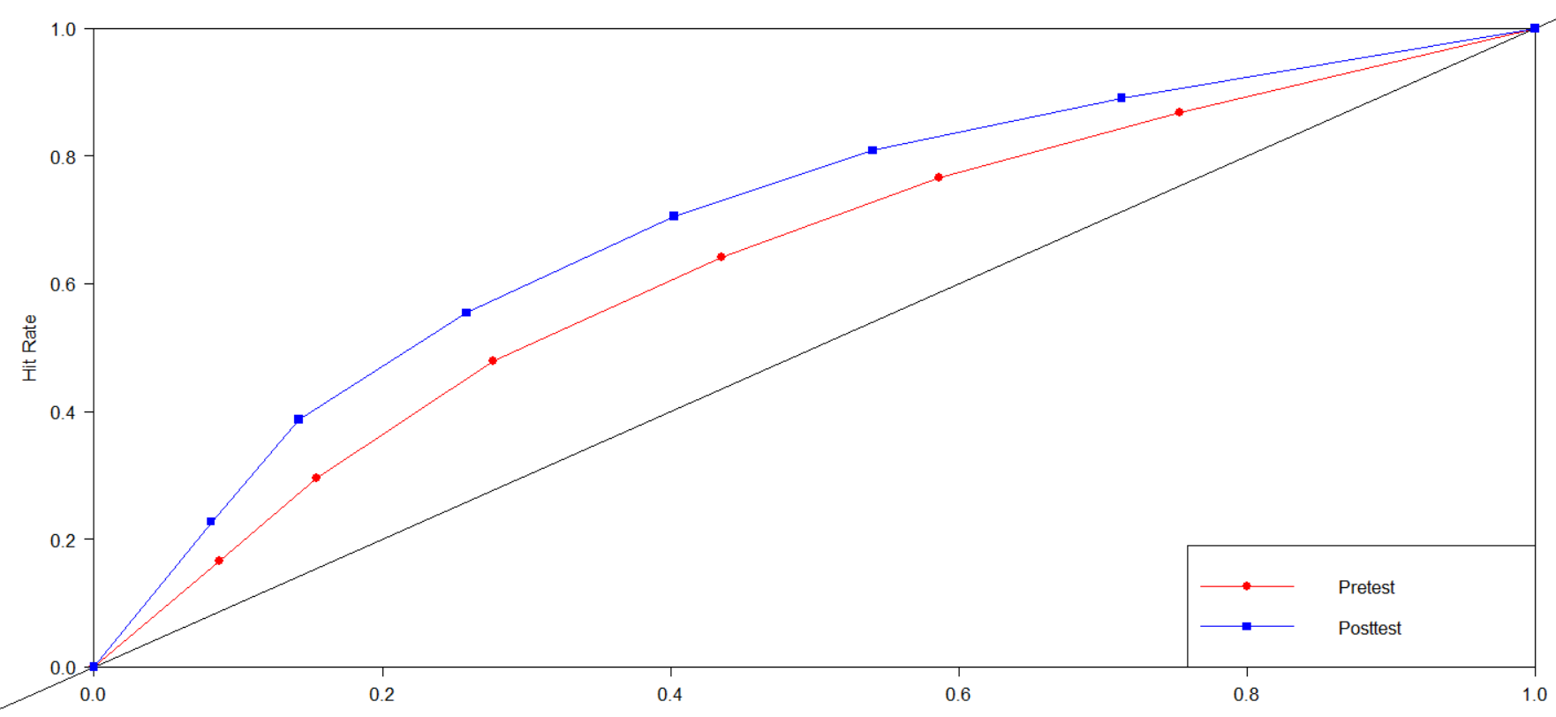
Figure S13. AOC plot for SDT analysis (Experiment 6).

These results show that the feedback exercise implemented in the Bad News game indeed improves veracity discernment under a variety of disparate statistical frameworks. However, the effect size was lower than for the Harmony Square game (Experiment 3, d = .567 versus d = .334 for the present experiment). This may be due to minor differences in the feedback tool or gameplay. Nonetheless, we also find that veracity discernment improves descriptively more in this experiment compared to Experiments 4 and 5 (which were both conducted using the Bad News game but with different item sets; d_{exp.4} = .295, d_{exp.5} = .265). This is especially the case when analyzing the data under a Signal Detection Theory framework, for which Experiment 6 shows the most robust improvement for the AUC. This may indicate that SDT is better suited for experiments that use item sets that are balanced in terms of the number of real and misinformation items (which we did not do in Experiment 4, as we used fewer real than misinformation items), or that better results can be expected when using an item set that uses misinformation items that are more closely aligned with the lessons from the game (as we used the MIST in Experiment 5 and a set of items containing trolling, polarization, emotional manipulation, and conspiratorial reasoning in Experiment 6, all of which are manipulation techniques learned in the Bad News game as well as Harmony Square).

