Supplementary materials
Table 1. Contrasts coding for word position.
 | medial vs final | medial vs initial | medial vs isolation
medial | -0.25 | -0.25 | -0.25
final | 0.75 | -0.25 | -0.25
initial | -0.25 | 0.75 | -0.25
isolation | -0.25 | -0.25 | 0.75

Table 2. Summary of regression model fitted to word duration.
Word duration | Estimate | Est. Error | t-value
Intercept | 5.460 | 0.015 | 353.83
Age of acquisition | -0.036 | 0.001 | -23.39
Age of acquisition x Group | -0.005 | 0.003 | -1.63
Baseline word duration | 0.203 | 0.002 | 121.85
Baseline word duration x Group | -0.002 | 0.003 | -0.54
Position (initial vs. medial) | 0.010 | 0.004 | 2.43
Position (initial vs. medial) x Group | -0.018 | 0.008 | -2.25
Position (medial vs. final) | 0.466 | 0.003 | 138.99
Position (medial vs. final) x Group | 0.178 | 0.007 | 26.62
Position (medial vs. isolation) | 0.867 | 0.009 | 99.24
Position (medial vs. isolation) x Group | 0.030 | 0.017 | 1.71
Session | -0.020 | 0.003 | -5.79
Session x Group | 0.020 | 0.007 | 2.89
Order | 0.006 | 0.021 | 0.28
Order x Group | 0.028 | 0.042 | 0.66
Order x Session | 0.030 | 0.005 | 6.11
Order x Session x Group | -0.044 | 0.009 | -4.69
Word frequency | -0.228 | 0.002 | -106.49
Word frequency x Group | -0.021 | 0.004 | -4.97
Group (CDL vs ADL) | 0.022 | 0.030 | 0.73
Surprisal | 0.075 | 0.003 | 21.52
Surprisal x Group | -0.017 | 0.007 | -2.57

Descriptives
Variable | Mean | Median | SD | Range
Age of acquisition | 4.68 | 4.39 | 1.49 | 1.89 - 18.33
Baseline word duration | 363.91 | 360.00 | 181.83 | 35.00 - 2040.0
Word frequency | 6.27 | 6.27 | 1.13 | 1.17 - 7.67
Surprisal | 5.22 | 4.46 | 3.35 | 0.005 - 19.52
Word duration | 239.60 | 180.00 | 210.06 | 3.37 - 8468.84
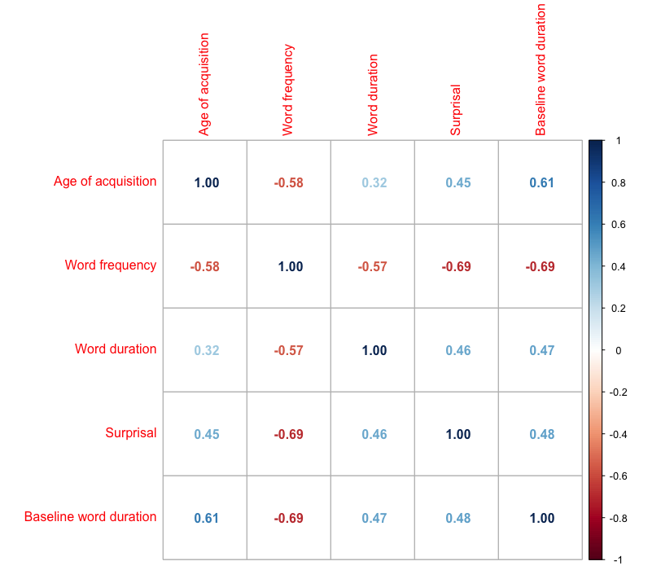
Model Assumptions and Diagnostics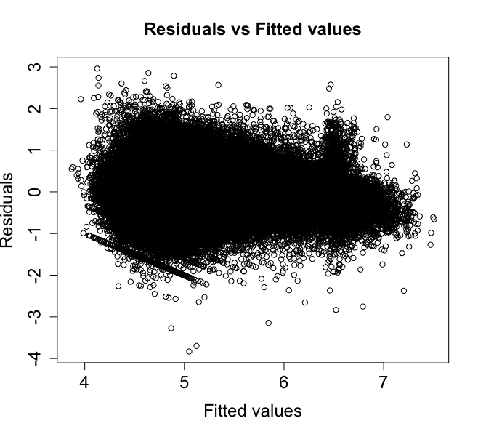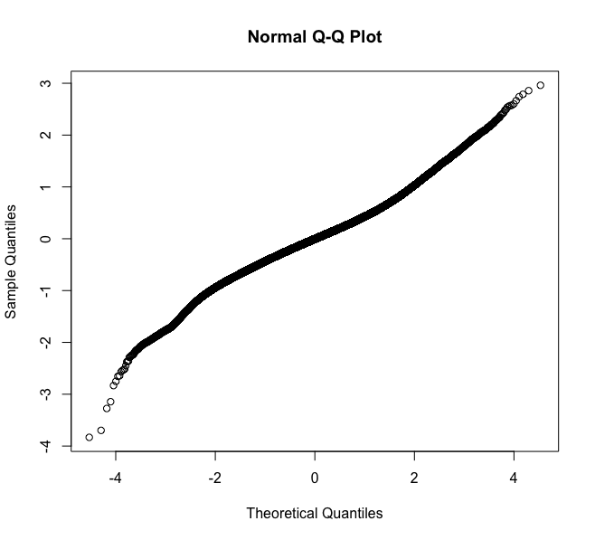

Predictor | VIF
Age of acquisition | 1.41
Age of acquisition x Group | 1.41
Baseline word duration | 1.68
Baseline word duration x Group | 1.68
Position (initial vs. medial) | 1.08
Position (initial vs. medial) x Group | 1.08
Position (medial vs. final) | 1.11
Position (medial vs. final) x Group | 1.11
Position (medial vs. isolation) | 1.13
Position (medial vs. isolation) x Group | 1.17
Session | 2.06
Session x Group | 2.10
Order | 1.00
Order x Group | 2.02
Order x Session | 2.06
Order x Session x Group | 2.10
Word frequency | 1.96
Word frequency x Group | 1.96
Group (CDL vs ADL) | 2.06
Surprisal | 1.19
Surprisal x Group | 1.20

Table 3. Summary of regression model fitted to word duration separately for ADL and CDL.
Word duration | Estimate | Est. Error | t-value
ADL
Intercept | 5.45 | 0.02 | 240.49
Age of acquisition | -0.03 | 0.002 | -16.04
Baseline word duration | 0.21 | 0.002 | 88.29
Position (initial vs. medial) | 0.02 | 0.006 | 3.10
Position (medial vs. final) | 0.38 | 0.005 | 77.11
Position (medial vs. isolation) | 0.85 | 0.01 | 59.82
Session | -0.03 | 0.005 | -5.89
Order | -0.01 | 0.03 | -0.23
Order x Session | 0.05 | 0.007 | 7.29
Word frequency | -0.21 | 0.003 | -65.44
Surprisal | 0.08 | 0.005 | 15.58
CDL
Intercept | 5.47 | 0.021 | 261.52
Age of acquisition | -0.03 | 0.002 | -17.18
Baseline word duration | 0.19 | 0.002 | 84.89
Position (initial vs. medial) | 0.001 | 0.005 | 0.12
Position (medial vs. final) | -0.55 | 0.004 | 121.39
Position (medial vs. isolation) | 0.88 | 0.01 | 85.88
Session | -0.01 | 0.005 | -1.95
Order | 0.02 | 0.028 | 0.67
Order x Session | 0.01 | 0.007 | 1.18
Word frequency | -0.24 | 0.003 | -87.87
Surprisal | 0.07 | 0.007 | 1.18

Table 4. Summary of regression model fitted to gesture presence.
Gesture Presence | Estimate | Est. Error | z-value | p-value
Intercept | -3.86 | 0.15 | -24.94 | < .00001
Age of acquisition | -0.38 | 0.02 | -15.79 | < .00001
Age of acquisition x Group | -0.11 | 0.05 | -2.40 | < .05
Position (initial vs. medial) | -0.74 | 0.11 | -6.52 | < .00001
Position (initial vs. medial) x Group | -0.04 | 0.23 | -0.19 | 0.85
Position (medial vs. final) | -0.25 | 0.05 | -5.36 | < .00001
Position (medial vs. final) x Group | 0.05 | 0.09 | 0.54 | 0.59
Position (medial vs. isolation) | -1.13 | 0.19 | -5.96 | < .00001
Position (medial vs. isolation) x Group | 1.78 | 0.38 | 4.72 | < .00001
Session | -1.65 | 0.07 | -23.66 | < .00001
Session x Group | -0.86 | 0.14 | -6.17 | < .00001
Order | 0.01 | 0.18 | 0.06 | 0.95
Order x Group | 0.47 | 0.35 | 1.32 | 0.18
Order x Session | 0.23 | 0.09 | 2.39 | < .05
Order x Session x Group | 0.03 | 0.19 | 0.14 | 0.89
Word duration | 0.31 | 0.03 | 11.14 | < .00001
Word duration x Group | -0.12 | 0.06 | -2.12 | < .05
Word frequency | -0.48 | 0.03 | -13.41 | < .00001
Word frequency x Group | -0.21 | 0.07 | -2.96 | < .01
Group (CDL vs ADL) | -1.15 | 0.28 | -4.03 | < .00001
Surprisal | 0.39 | 0.05 | 7.69 | < .00001
Surprisal x Group | -0.05 | 0.09 | -0.52 | 0.60

Descriptives

Variable | Mean | Median | SD | Range
Age of acquisition | 4.94 | 4.62 | 1.70 | 2.31-18.33
Word frequency | 5.59 | 5.87 | 1.13 | 1.17-7.19
Surprisal | 6.35 | 5.71 | 3.65 | 0.008-19.52
Word duration | 312.23 | 258.0 | 232.72 | 3.0 - 9711.0

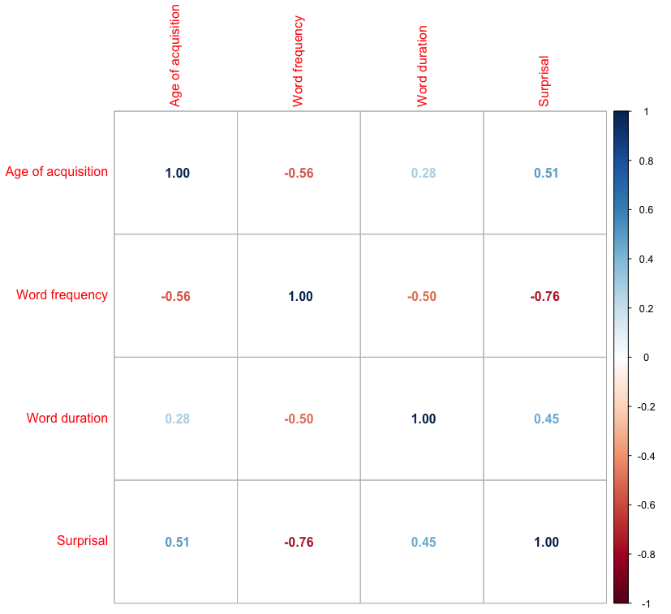

Model Assumptions and Diagnostics

Gesture Presence | VIF
Age of acquisition | 1.43
Age of acquisition x Group | 1.49
Position (initial vs. medial) | 1.08
Position (initial vs. medial) x Group | 1.15
Position (medial vs. final) | 1.23
Position (medial vs. final) x Group | 1.24
Position (medial vs. isolation) | 3.76
Position (medial vs. isolation) x Group | 3.93
Session | 2.45
Session x Group | 2.51
Order | 1.03
Order x Group | 2.02
Order x Session | 2.62
Order x Session x Group | 2.66
Word duration | 1.36
Word duration x Group | 1.41
Word frequency | 1.79
Word frequency x Group | 1.96
Group (CDL vs ADL) | 2.39
Surprisal | 1.43
Surprisal x Group | 1.61

Table 5. Summary of regression model fitted to gesture presence separately for CDL and ADL.
Gesture Presence | Estimate | Est. Error | z-value | p-value
ADL
Intercept | -3.09 | 0.18 | -16.78 | < .00001
Age of acquisition | -0.32 | -0.03 | -10.69 | < .00001
Position (initial vs. medial) | -0.71 | 0.17 | -4.10 | < .00001
Position (medial vs. final) | -0.28 | 0.06 | -4.81 | < .00001
Position (medial vs. isolation) | -1.97 | 0.35 | -5.57 | < .00001
Session | -1.23 | 0.08 | -14.42 | < .00001
Order | -0.23 | 0.18 | -1.30 | 0.19
Order x Session | 0.28 | 0.11 | 2.56 | <0.05
Word duration | 0.32 | 0.03 | 9.30 | < .00001
Word frequency | -0.34 | 0.05 | -6.82 | < .00001
Surprisal | 0.36 | 0.06 | 5.56 | < .00001
CDL
Intercept | -4.67 | 0.25 | -18.55 | < .00001
Age of acquisition | -0.48 | 0.04 | -12.57 | < .00001
Position (initial vs. medial) | -0.75 | 0.15 | -5.10 | < .00001
Position (medial vs. final) | -0.21 | 0.07 | -2.96 | < .01
Position (medial vs. isolation) | -0.22 | 0.12 | -1.81 | 0.07
Session | -2.15 | 0.11 | -19.34 | < .00001
Order | 0.32 | 0.33 | 0.97 | 0.33
Order x Session | 0.20 | 0.16 | 1.28 | 0.20
Word duration | 0.27 | 0.04 | 6.36 | < .00001
Word frequency | -0.61 | 0.05 | -12.58 | < .00001
Surprisal | 0.42 | 0.07 | 6.30 | < .00001

Table 6. Summary of regression model fitted to word duration, with Gesture Presence included as predictor.

Word duration | Estimate | Est. Error | t-value
Intercept | 5.647 | 0.014 | 393.41
Age of acquisition | -0.031 | 0.003 | -10.97
Age of acquisition x Group | -0.006 | 0.006 | -1.08
Baseline word duration | 0.199 | 0.003 | 70.79
Baseline word duration x Group | 0.031 | 0.005 | 5.59
Position (initial vs. medial) | -0.102 | 0.010 | -9.90
Position (initial vs. medial) x Group | 0.084 | 0.020 | 4.08
Position (medial vs. final) | 0.388 | 0.005 | 75.91
Position (medial vs. final) x Group | 0.139 | 0.010 | 13.61
Position (medial vs. isolation) | 0.635 | 0.016 | 39.28
Position (medial vs. isolation) x Group | 0.393 | 0.032 | 12.19
Session | -0.044 | 0.006 | -6.77
Session x Group | 0.036 | 0.013 | 2.80
Session x Order | 0.060 | 0.009 | 6.86
Word frequency | -0.168 | 0.004 | -38.39
Word frequency x Group | 0.012 | 0.009 | 1.45
Order | -0.027 | 0.018 | -1.46
Order x Group | 0.042 | 0.036 | 1.14
Order x Group x Session | -0.056 | 0.017 | -3.19
Group (CDL vs ADL) | 0.130 | 0.028 | 4.66
Surprisal | 0.070 | 0.006 | 10.71
Surprisal x Group | -0.025 | 0.012 | -2.14
Gesture presence | 0.123 | 0.010 | 12.65
Gesture presence x Group | 0.007 | 0.019 | 0.37
Surprisal x Gesture presence | -0.035 | 0.009 | -3.87
Surprisal x Gesture presence x Group | 0.044 | 0.018 | 2.43

Descriptives
Variable | Mean | Median | SD | Range
Age of acquisition | 4.94 | 4.62 | 1.70 | 2.31-18.33
Word frequency | 5.59 | 5.87 | 1.13 | 1.17-7.19
Surprisal | 6.35 | 5.71 | 3.65 | 0.008-19.52
Baseline word duration | 440.0 | 385.0 | 183.56 | 70–1465
Word duration | 312.23 | 258.0 | 232.72 | 3.0 - 9711.0

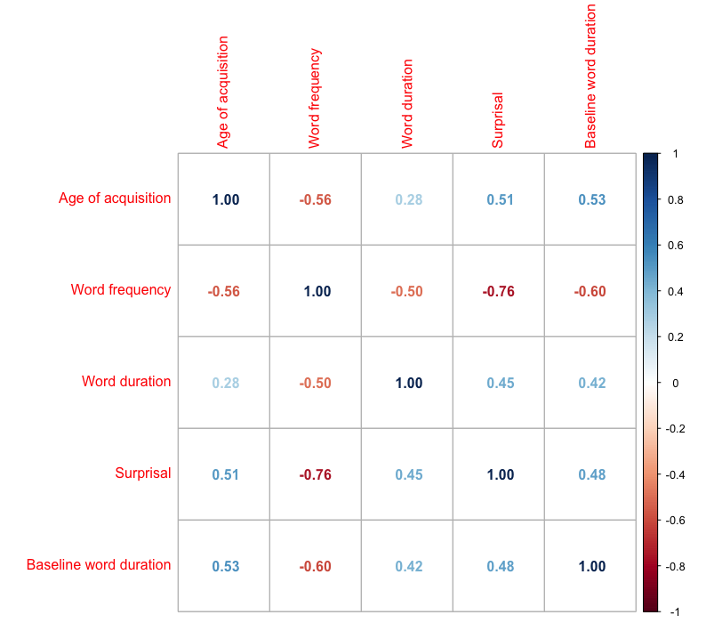

Model Assumptions and Diagnostics
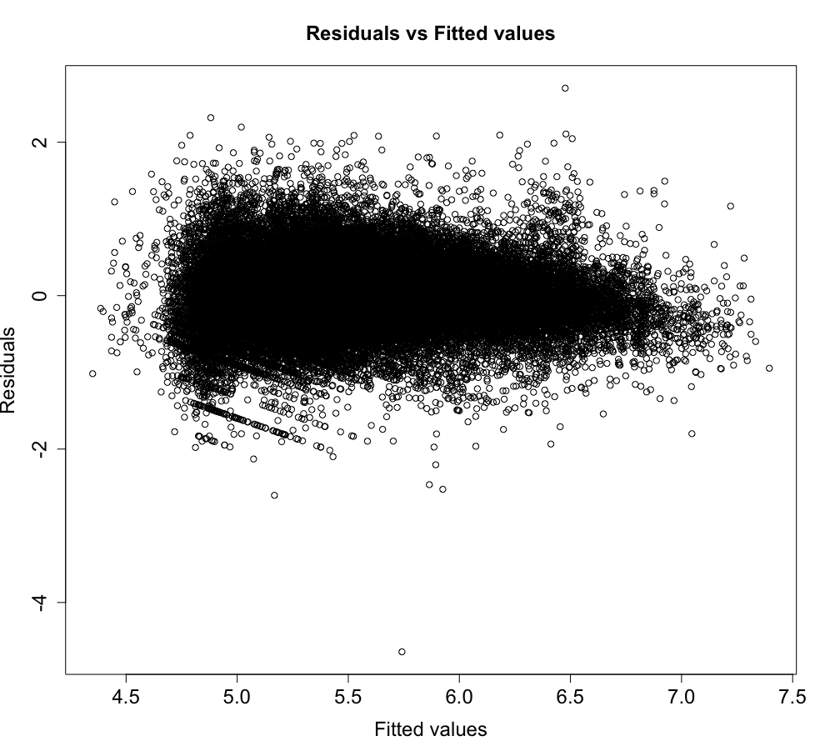
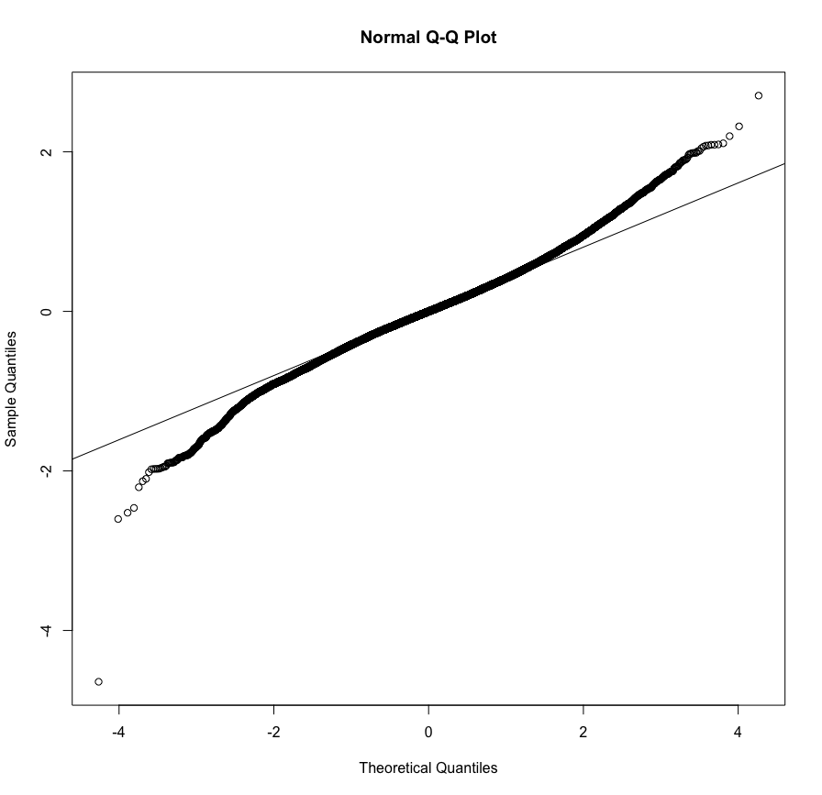

Word duration | VIF
Age of acquisition | 2.24
Age of acquisition x Group | 2.39
Baseline word duration | 2.31
Baseline word duration x Group | 2.22
Position (initial vs. medial) | 1.37
Position (initial vs. medial) x Group | 1.37
Position (medial vs. final) | 1.86
Position (medial vs. final) x Group | 1.78
Position (medial vs. isolation) | 1.29
Position (medial vs. isolation) x Group | 1.36
Session | 3.02
Session x Group | 3.76
Session x Order | 3.26
Word frequency | 2.17
Word frequency x Group | 2.71
Order | 1.98
Order x Group | 3.24
Order x Group x Session | 4.01
Group | 3.27
Surprisal | 6.42
Surprisal x Group | 6.65
Gesture presence | 3.42
Gesture presence x Group | 4.27
Surprisal x Gesture presence | 6.76
Surprisal x Gesture presence x Group | 6.60

Table 7. Summary of regression model fitted to word duration, with Gesture Presence included as predictor.

Word duration | Estimate | Est. Error | t-value
ADL
Intercept | 5.58 | 0.02 | 249.75
Age of acquisition | -0.03 | 0.004 | -7.38
Baseline word duration | 0.18 | 0.004 | 47.69
Position (initial vs. medial) | -0.14 | 0.016 | -8.78
Position (medial vs. final) | 0.32 | 0.007 | 45.05
Position (medial vs. isolation) | 0.44 | 0.03 | 16.44
Session | -0.06 | 0.01 | -6.38
Session x Order | 0.08 | 0.01 | 6.87
Word frequency | -0.17 | 0.007 | -26.06
Order | -0.05 | 0.03 | -1.74
Surprisal | 0.08 | 0.008 | 9.79
Gesture presence | 0.12 | 0.01 | 10.66
Surprisal x Gesture presence | -0.05 | 0.01 | -4.77
CDL
Intercept | 5.71 | 0.02 | 332.67
Age of acquisition | -0.03 | 0.004 | -8.68
Baseline word duration | 0.21 | 0.004 | 55.50
Position (initial vs. medial) | -0.06 | 0.01 | -6.20
Position (medial vs. final) | 0.46 | 0.007 | 66.19
Position (medial vs. isolation) | 0.83 | 0.01 | 62.46
Session | -0.02 | 0.008 | -3.24
Session x Order | 0.03 | 0.011 | 2.99
Word frequency | -0.16 | 0.005 | -33.86
Order | -0.006 | 0.02 | -0.27
Surprisal | 0.060 | 0.009 | 6.59
Gesture presence | 0.13 | 0.01 | 8.03
Surprisal x Gesture presence | -0.01 | 0.01 | -0.90

