Supplementary Materials
to accompany

Uncertainty-modulated attentional capture: Outcome variance increases attentional priority
Daniel Pearson¹, Amy Chong², Julie Y. L. Chow², Kelly G. Garner², Jan Theeuwes^{3,4,5} and
Mike E. Le Pelley²
¹ School of Psychology, The University of Sydney, Sydney, New South Wales, Australia
² School of Psychology, UNSW Sydney, Sydney, New South Wales, Australia
³ Department of Experimental and Applied Psychology, Vrije Universiteit Amsterdam, The Netherlands
⁴ Institute of Brain and Behaviour Amsterdam (iBBA), The Netherlands
⁵ William James Center for Research, ISPA-Instituto Universitario, Lisbon, Portugal

Corresponding author:
Daniel Pearson
School of Psychology, The University of Sydney
Brennan MacCallum Building A18
Camperdown NSW 2006
Australia
Email: daniel.pearson@sydney.edu.au

Search Task Analyses by Block
Here we report, for each experiment, analyses of data from single-distractor trials as a function of trial blocks to examine how the attentional bias to the high-variance (HV) distractor over the low-variance (LV) distractor emerged over the course of training. For each experiment, the search task consisted of 16 blocks of 42 trials. The first 8 of these blocks consisted of 14 trials with each type of single-distractor trial. The latter 8 blocks contained 12 trials with each type of single-distractor trial, and 2 trials with each type of double-distractor trial.

Experiment 1
Figure S1a shows the proportion of single-distractor trials with gaze on each distractor across blocks of the search task in Experiment 1 (data from one participant were excluded from this analysis as they did not have any valid LV distractor trials in the first two blocks). We analysed these data using a 2 (distractor type: HV, LV) × 16 (block) ANOVA, applying Greenhouse-Geisser correction to degrees of freedom as appropriate to correct for non-sphericity. This analysis revealed a significant main effect of distractor type, F(1, 29) = 16.7, p < .001, η_{p}² = 0.365, with a higher proportion of trials with gaze on the HV distractor than the LV distractor. The main effect of block was not significant, F(8.17, 237.02) = 1.51, p = .154, η_{p}² = 0.049, nor was the distractor type × block interaction, F(9.69, 281.14) = 0.81, p = .613, η_{p}² = 0.027.
In order to further explore how the attentional bias to the HV distractor over the LV emerged over the course of training, we conducted a paired samples t-test comparing the proportion of trials with gaze on the HV and LV distractors in the first block of the search task. This difference was non-significant, t(29) = 1.04, p = .309, d_{z} = 0.19. A Bayesian paired-samples t-test on these data indicated moderate support for the null hypothesis, BF₀₁ = 3.16, suggesting that there was no difference in the rate of looking at the HV and LV distractors in the first block of the task.

Experiment 2
Findings were similar to those of Experiment 1: ANOVA revealed a significant main effect of distractor type, F(1, 35) = 10.2, p = .003, η_{p}² = 0.226, with greater capture by the HV distractor than the LV distractor when averaged across blocks (see Figure S1b). The main effect of block, F(8.51, 297.69) = 1.67, p = .101, η_{p}² = 0.045, and a distractor type × block interaction, F(9.76, 341.56) = 0.57, p = .838, η_{p}² = 0.016, were both non-significant. There was no significant difference in the proportion of trials with gaze on the HV and LV distractors in the first block of trials, t(35) = 1.62, p = .115, d_{z} = 0.27. A Bayesian paired samples t-test indicated anecdotal support for the null hypothesis over the alternative, BF₀₁ = 1.72.

Experiment 3
For Experiment 3, ANOVA revealed a significant main effect of distractor type, F(1, 59) = 4.93, p = .030, η_{p}² = 0.077, with greater capture by the HV distractor than the LV distractor (see Figure S1c). There was also a significant main effect of block, F(9.71, 573.01) = 2.10, p = .024, η_{p}² = 0.034, indicating that the proportion of trials with gaze on either distractor varied over the course of training. The trial type × block interaction was non-significant, F(10.73, 633.13) = 1.33, p = .203, η_{p}² = 0.022. There was no significant difference in the proportion of trials with gaze on the HV and LV distractors in the first block, t(59) = 0.943, p = .350, d_{z} = 0.12, with a Bayesian analysis indicating moderate support for the null hypothesis of no difference, BF₀₁ = 4.64.
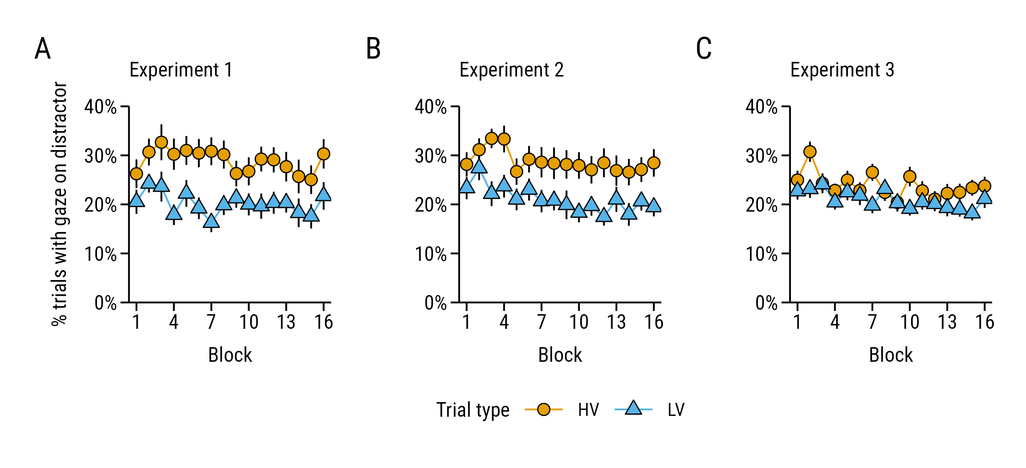
Figure S1. Proportion of trials in which participants looked at the distractor for single-distractor trials featuring a high-variance (HV) or low-variance (LV) distractor, across blocks of the search task in (a) Experiment 1, (b) Experiment 2, and (c) Experiment 3.

Discussion
Across all three experiments, ANOVA analysis of the single-distractor trial data across blocks revealed a significant main effect of trial type and non-significant trial type × block interaction. One possible interpretation of this pattern of results is that the UMAC effect does not vary as a function of participants’ experience of reward uncertainty, such that the attentional bias to the HV distractor was present from the first trial on which it was presented. However, analysis of the data from the first block of the search task indicated that there was no significant difference in the rate at which participants looked at the HV and LV distractors early in training, with Bayes factors supporting the null hypothesis of no difference over the alternative in all three experiments. On this point, it is important to note that the only difference between the HV and LV distractors in these experiments was participants’ experience of their paired outcomes: participants were provided with no instructions to differentiate the distractors prior to each experiment, and the distractor colours were counterbalanced across participants to account for any potential differences in rates of capture driven by their physical characteristics. Therefore, any differences in the rate of capture between the HV and LV distractors must be a consequence of participants learning about which outcomes were paired with each distractor as a consequence of trial-by-trial experience.
Consequently, we take the findings of ANOVA analyses and Bayesian t-tests to suggest that the UMAC effect developed rapidly via learning based on reward feedback, and then remained relatively stable throughout the remainder of the task. This pattern of results is similar to that typically observed in studies of value-modulated attentional capture, where a learned attentional bias to a distractor signalling high-value reward versus a distractor signalling low-value reward develops rapidly (often within one or two blocks of trials) and then remains stable throughout the subsequent task (e.g., Le Pelley et al., 2015; Pearson et al., 2015, 2020; Pearson & Le Pelley, 2020).

References
Le Pelley, M. E., Pearson, D., Griffiths, O., & Beesley, T. (2015). When goals conflict with values: Counterproductive attentional and oculomotor capture by reward-related stimuli. Journal of Experimental Psychology: General, 144, 158–171. https://doi.org/10.1037/xge0000037
Pearson, D., Donkin, C., Tran, S. C., Most, S. B., & Le Pelley, M. E. (2015). Cognitive control and counterproductive oculomotor capture by reward-related stimuli. Visual Cognition, 23, 41–66. https://doi.org/10.1080/13506285.2014.994252
Pearson, D., & Le Pelley, M. E. (2020). Learning to avoid looking: Competing influences of reward on overt attentional selection. Psychonomic Bulletin & Review, 27(5), 998–1005. https://doi.org/10.3758/s13423-020-01770-3
Pearson, D., Watson, P., Cheng, P. (Xin), & Le Pelley, M. E. (2020). Overt attentional capture by reward-related stimuli overcomes inhibitory suppression. Journal of Experimental Psychology: Human Perception and Performance, 46(5), 489–501. https://doi.org/10.1037/xhp0000728

