Supplementary Material

The results of the systematic review for the papers that used the emotional conflict task but did not assess conflict resolution are outlined in the following sections.
Adapted versions of the emotional conflict task. The emotional conflict task has been adapted multiple times in different ways. An adapted version of the emotional conflict task used a variety of word stimuli varying in their relevance to the faces in the task. This study found that distractor and stimulus relevance are important predictors of processing times during the conflict task, which was shown by task-irrelevant emotional distracters causing a reduction in reaction speed to the same magnitude as task-relevant non-emotional distracters, but task-irrelevant non-emotional distracters did not result in reduced speed and accuracy in the task when compared to task-relevant emotional distracters (Reeck & Egner, 2011). Ovaysikia et al. (2011) also used an adapted version of the task, where participants were required to respond to words rather than facial expressions. The findings of this study indicated that responses to words recruited different regions of the prefrontal cortex compared to responses to faces, and that responses were generally faster when participants were required to respond to words when compared to faces (Bayer et al., 2018; Ma et al., 2016; Ovaysikia et al., 2011). Zhu et al. (2010) found evidence using event-related potentials (ERPs) that N170 responses during incongruent trials were differentially affected by whether participants were required to identify the word emotion (lower N170 compared to congruent trials) or the face emotion (larger N170 activation compared to congruent trials). Other adaptations based on clinical characteristics of participants are outlined in the following sections.
Individual characteristics. It has been reported that men perform better than women on the emotional conflict task, although women appear to recall faces from the task to a greater extent (Wang et al., 2017). Women in the follicular phase of the menstrual cycle (compared to luteal phase) had significantly slower reaction times to incongruent trials (Hoyer et al., 2013). Adults perform better than children – measured by faster reaction times and accuracy overall – and children perform particularly poorly during the emotionally incongruent trials (Liu et al., 2019). These age differences are possibly due to higher proactive control exhibited by older adults during the task (Berger et al., 2019), though elderly adults perform slower than younger adults and this difference is associated with stronger activation in frontoparietal and salience networks in younger participants (Almdahl et al., 2021).
Thompson et al. (2022) found that increased trait levels of empathy were correlated with faster response times on incongruent trials in the emotional conflict task, suggesting that emotional empathy assists in identifying facial expressions more easily. Similarly, high socially adjusted individuals had better behavioural performance in the emotional conflict task and this was associated with less negative event-related N200 amplitudes compared to low socially adjusted individuals (Hu et al., 2019). However, trait levels of impulsivity did not predict performance on the emotional conflict task (Lai et al., 2011). One study primed participants by instructing them to recall past situations where they were in positions of power (high power) or where they were in low power positions (low power). This study found that priming resulted in differential event-related components and response time effects, such that early visual processing (P100) was higher in high-power individuals, whereas low-power individuals had higher N170 amplitudes overall and slower response times to happy faces, but faster reaction times for fearful faces (Ma & Zhang, 2021). Sleep deprivation and emotional instability also lead to slower processing of incongruent trials (Floros et al., 2021).
Mechanisms underlying performance in the emotional conflict task. Many studies have been dedicated to uncovering the mechanisms underlying congruency effects in the emotional conflict task. An emerging theory is that processing of emotionally incongruent information occurs at a reasonably late stage of cognitive processing. By combining an inhibition of return paradigm with the emotional conflict task, Zhao et al. (2017) found evidence suggesting that conflict processing arises from impaired late-stage stimulus-response processing rather than early stage of perceptual processing. Similarly, Wang et al. (2021) reported that the N400 (frontal region) response was not, whereas the N700 was, associated with incongruent trial performance. This finding contrasted slightly to Shen et al. (2013) and Fan et al. (2016), who found that both the N350-550 and P700 were associated with responding to incongruent trials. However, all of these studies reported a lack of any difference between congruent and incongruent trials in ERPs prior to 300 ms. Xue et al. (2016) compared a cognitive conflict effect (response times of judging the gender of the faces) to emotional conflict and found that cognitive conflict was larger than the emotional conflict effect, which was supported by response time, N200, and N450 data.
Recently detoxified participants with alcohol use disorder showed better performance on the emotional conflict task, as indexed by overall response times, after undergoing emotional training compared to neutral training, or treatment as usual (Lewis et al., 2022). This finding further supports the hypothesis that the emotional conflict effect is driven by emotional processes (rather than cognitive processes), which may activate brain networks later in the cognitive processing pipeline. In contrast, however, Chen et al. (2016) found differences in the N200 components between cognitive and affective Stroop tasks, though similar responses to conflict between the two task types at later latencies. This study suggests that further work is needed to elucidate the exact mechanisms involved in emotional conflict processing.
Various studies have also reported that emotional conflict is moderated by hormonal status. Young Kuchenbecker et al. (2021) found that participants who watched an emotionally stressful video had faster response times during the emotional conflict task compared to a control condition, but these effects were moderated by oxytocin and cortisol levels. In contrast, Stickel et al. (2019) reported that women in the third trimester of pregnancy with lower hair cortisol levels showed higher activation of brain areas that govern emotional cognitive control, whereas Young Kuchenbecker et al. did not report a direct cortisol effect on emotional recognition. In support of this, Shields et al. (2016) found that salivary cytokines, but not cortisol, were significantly associated with a smaller difference between congruent and incongruent trials. Similarly, higher androstadiene levels were associated with slower reaction times on incongruent trials as well as higher activation of the right fusiform gyrus, inferior frontal gyrus and dorsomedial cortex (Hornung et al., 2018). One study reported that short allele-carriers of the 5-HTTLPR genotype displayed decreased inhibitory control of negative word processing, whereas long allele-carriers displayed decreased inhibitory control over positive word processing (Koizumi et al., 2010).
Preoccipital, parietal, and temporal regions of the brain, including the dorsal, rostral and caudal anterior cingulate cortices, locus coeruleus and striatum, are activated during the emotional conflict task (Grueschow et al., 2022; Haas et al., 2006; Hassel et al., 2020). Chechko et al. (2012) additionally found that the extrastriate visual and posterodorsal medial frontal cortices, as well as the supplemental motor area, the anterior insula and the inferior prefrontal cortex were activated during the task. Critically, these brain regions were activated during emotional and cognitive conflict versions of the task, suggesting a commonality in the mechanisms underlying these processes (Chechko et al., 2012). However, this evidence does not entirely agree with the ERP evidence reviewed above. fMRI evidence further suggests that coupling of the default mode network with the dorsolateral prefrontal cortex is associated with slower response times to positive incongruent faces, but not negative incongruent faces (Yang et al., 2016). Performance on incongruent trials also predicts increased activation in the left frontal cortex compared to congruent trials (DeSouza et al., 2012) and increased regional grey matter density in multiple brain regions including ventral medial prefrontal cortex and dorsal anterior cingulate cortex (Deng et al., 2014).
Interventional studies in healthy participants. Four studies have tested the effect of various interventions on emotional conflict task performance in healthy participants. Transcranial direct current stimulation applied to the dorsolateral prefrontal cortex slowed response times to incongruent but not congruent trials, and this effect was associated with reductions of N170 amplitude but no changes were reported to behavioural outcomes (Kuehne et al., 2019). Yan et al. (2021) reported that acute and long-term consumption of action video games resulted in greater changes in N170 and N400 event-related potentials during the emotional conflict task, which suggests that emotional processing may decrease with increased consumption of this type of media. Interestingly, modafinil – a cognitive enhancer – improved performance on a cognitive conflict task, but not the emotional conflict task in healthy participants (Li et al., 2020). Performance of an emotional Go/No go task prior to the emotional conflict task reduced the difference between incongruent and congruent response times (Soutschek & Schubert, 2013), suggesting that priming participants with an emotional inhibitory response task increases task performance. These studies show that emotional conflict processing can be affected by transcranial direct current stimulation, action video game playing, inhibitory priming, but not modafinil.
Task performance in clinical populations. Multiple studies have used the emotional conflict task to understand emotional processing differences between clinical and healthy populations. Zhu et al. (2018) reported that, compared with healthy controls, participants with major depression showed different response times, P300 activation, and N450 activation in response to happy or sad congruent and incongruent faces during the emotional conflict task. Similarly, participants with treatment-resistant depression had slower and less accurate responses to congruent and incongruent stimuli, but also displayed higher N200 amplitudes throughout the experiment, as well as larger P300 amplitudes to incongruent stimuli (Xue et al., 2017). This finding is qualified by an intriguing study where bipolar disorder patients during hypomanic, depressive, and euthymic states showed that distinct components of the default mode network were differentially activated during emotional processing depending on the emotional state of the patient (Rey et al., 2014). Similarly, participants who underwent negative mood induction had slower reaction times and accuracy during the conflict task, and higher N200, N300, and late positive component event-related potential amplitudes compared to participants who received neutral or positive mood induction (Liu et al., 2021). Higher levels of neuroticism are also associated with higher activation of amygdala and subgenual anterior cingulate cortex during incongruent trials (Haas et al., 2007), and depressed patients show greater brain activation in the visual areas, cerebellum, medial prefrontal cortex, and inferior parietal lobule regardless of face type or congruency (Chechko et al., 2013; Chechko et al., 2016). However, no task related differences between depressed and non-depressed individuals were identified by Keedwell et al. (2016), Alders et al. (2020), or Cheng et al. (2015), and Hu et al. (2012) found that depressed individuals only responded slower to trials using depression-related words. One study reported the opposite effect, such that healthy controls had slower response times to incongruent trials compared to depressed participants (Başgöze et al., 2015).
Patients with Parkinson’s disease were slower in response to fearful faces compared to healthy controls and medication with levodopa, but not subthalamic brain stimulation, normalised N170 event-related potentials in response to the emotional conflict task in patients, but did not alter the performance of healthy controls (Fleury et al., 2014; Martínez-Fernández et al., 2018). Participants with high alexithymia levels also underperformed on the emotional conflict task relative to controls, which was established by lower levels of error-monitoring activity during the task (Maier et al., 2016).
Participants with posttraumatic stress disorder (PTSD) and anxiety show poorer attention and slower overall speed of responding during the emotional conflict task (du Rocher & Pickering, 2017; Weaver et al., 2020). High schizotypy is also associated with slower reaction times during the task, but only to incongruent trials when compared to controls (Hurtado et al., 2018). Conversely, healthy participants who completed a schizotypy questionnaire show decreased N170 and N200 amplitudes during congruent trials, but no ERP difference between high and low schizotypy participants was identified for incongruent trials (Jia et al., 2023). These conflicting findings warrant future replication attempts in this clinical population. Finally, women who were in recovery from anorexia had similar brain activity to healthy controls during incongruent trials, but only healthy controls had amygdala, hippocampal, and basal ganglia activation during congruent trials (Bang et al., 2016).
Overall, findings from the clinical literature show discrepant findings, even in the most researched subfield of depression. Future studies with larger samples sizes will be important to better understand the effect of psychiatric illness on emotional conflict processing.

Meta-analysis supplementary figures

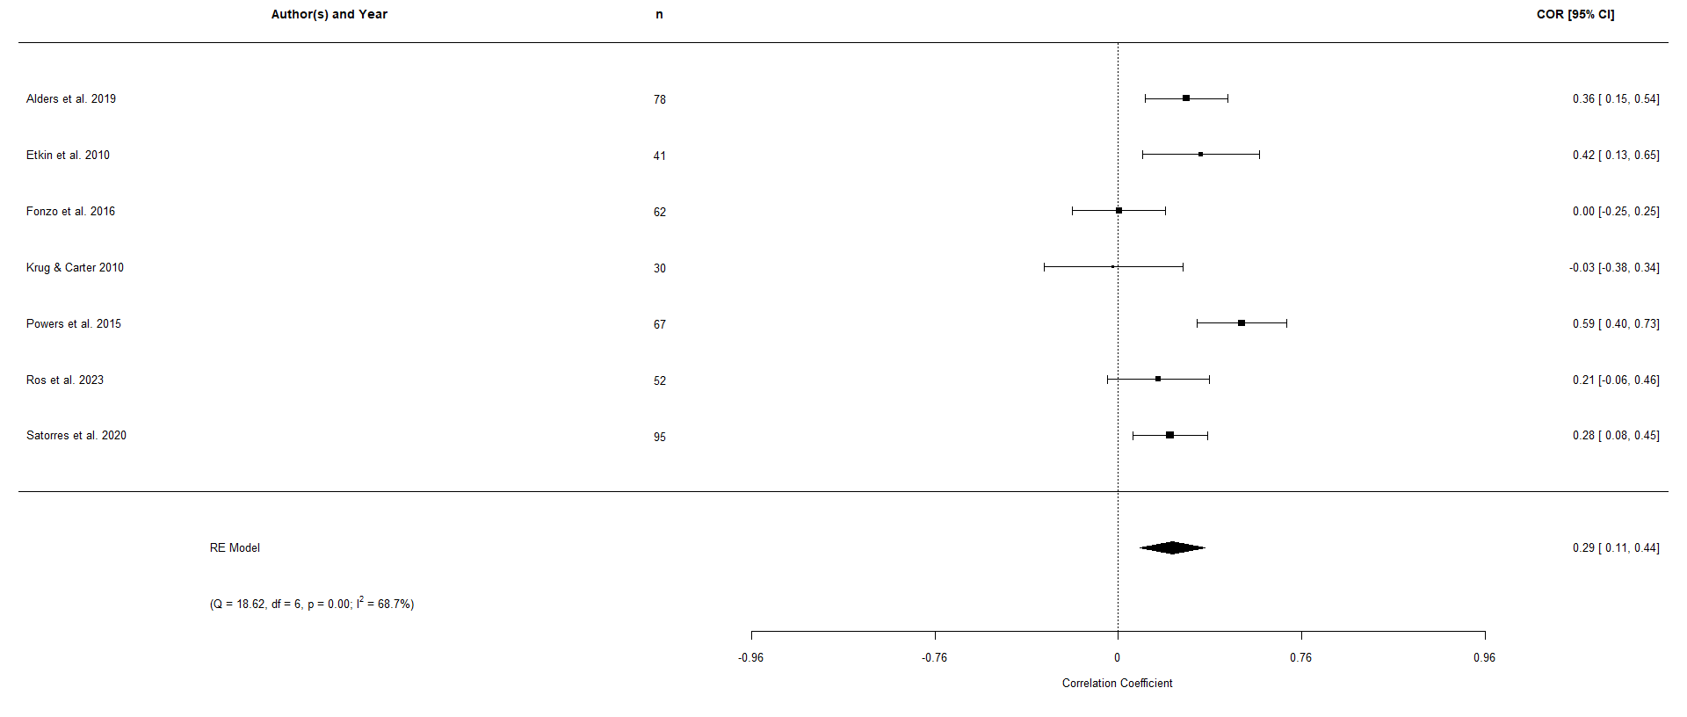
Supplementary Figure 1. Conflict resolution effects between healthy and clinical populations. Note that the clinical populations include anxious participants (k = 2), depressed participants (k = 2), participants with posttraumatic stress disorder (k = 2), and participants with Alzheimer’s disease (k = 1). There was overall significantly better conflict resolution in healthy participants, though heterogeneity is extremely high, and the effect is not moderated by clinical diagnosis.

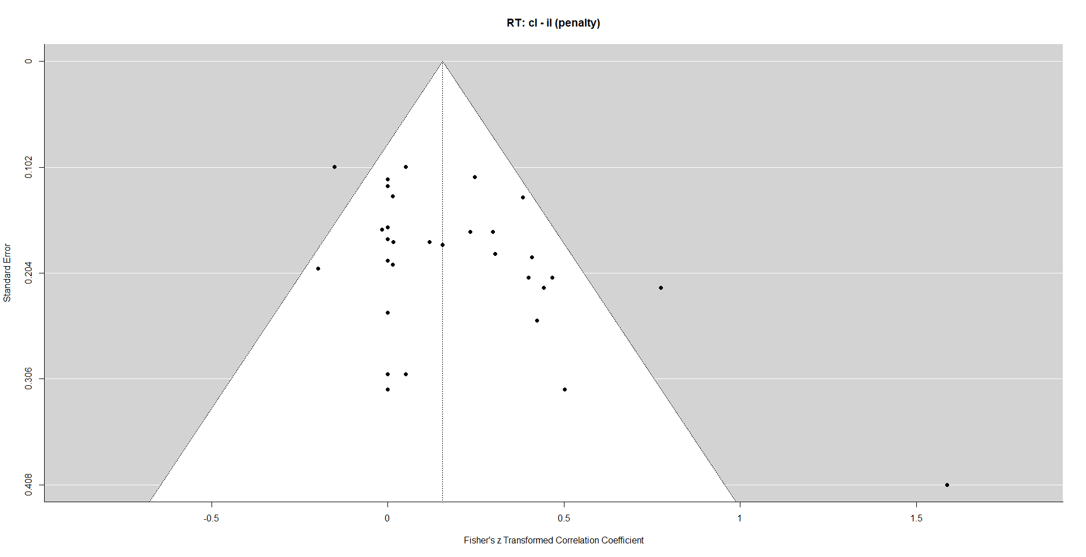
Supplementary Figure 2. Funnel plot of conflict resolution reaction times from the primary meta-analysis.
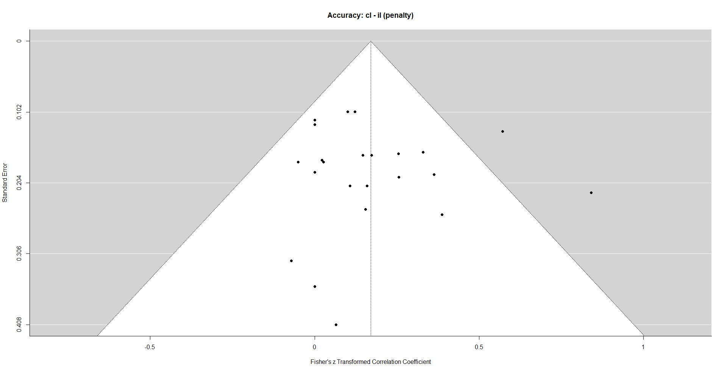
Supplementary Figure 3. Funnel plot of conflict resolution accuracy from the primary meta-analysis.

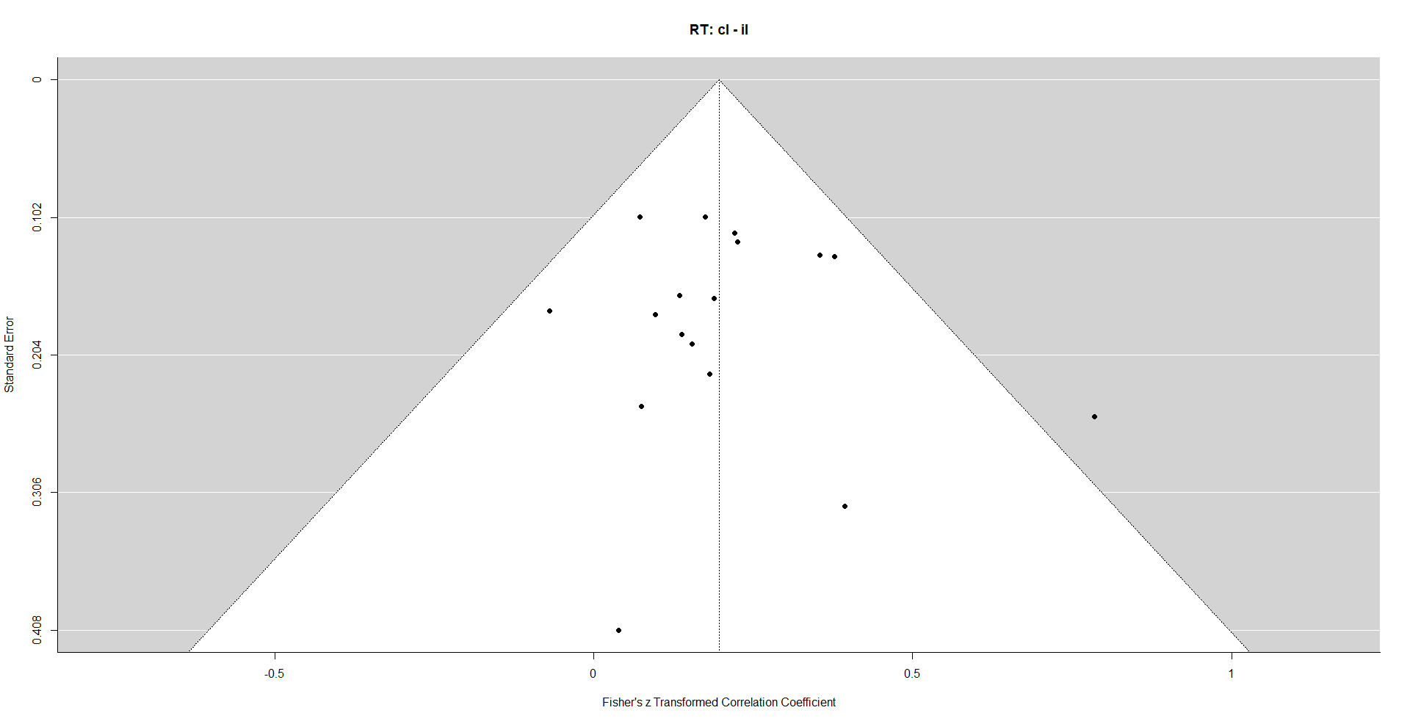
Supplementary Figure 4. Funnel plot of conflict adaptation reaction times from the primary meta-analysis.

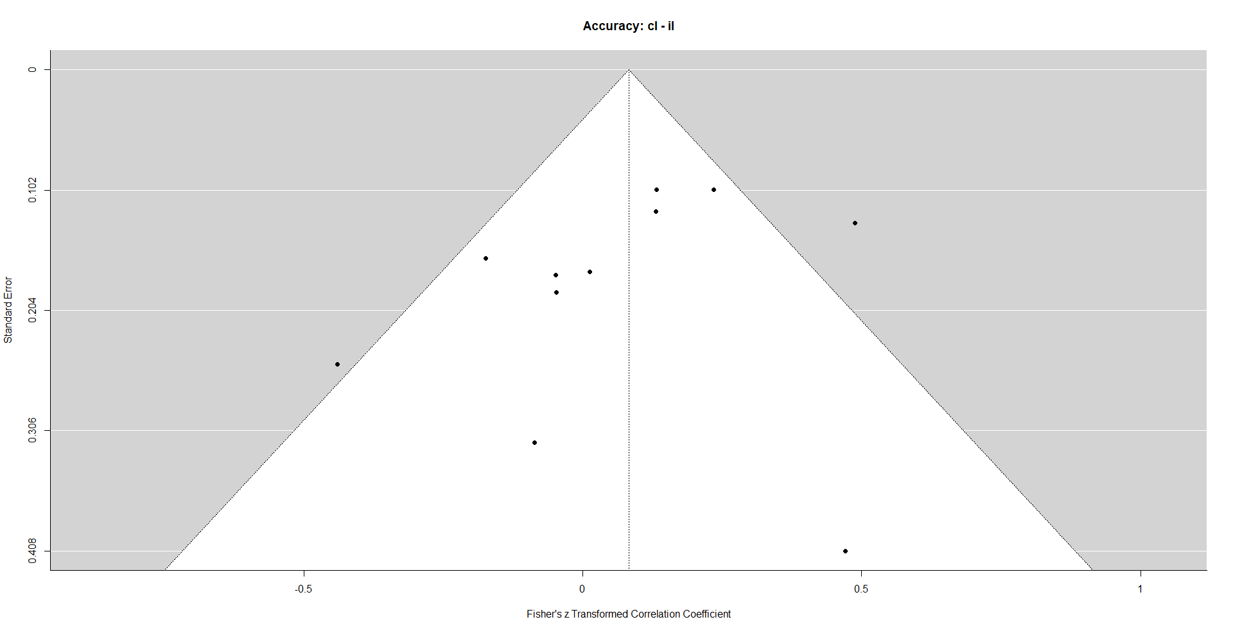
Supplementary Figure 5. Funnel plot of conflict adaptation accuracy from the primary meta-analysis.

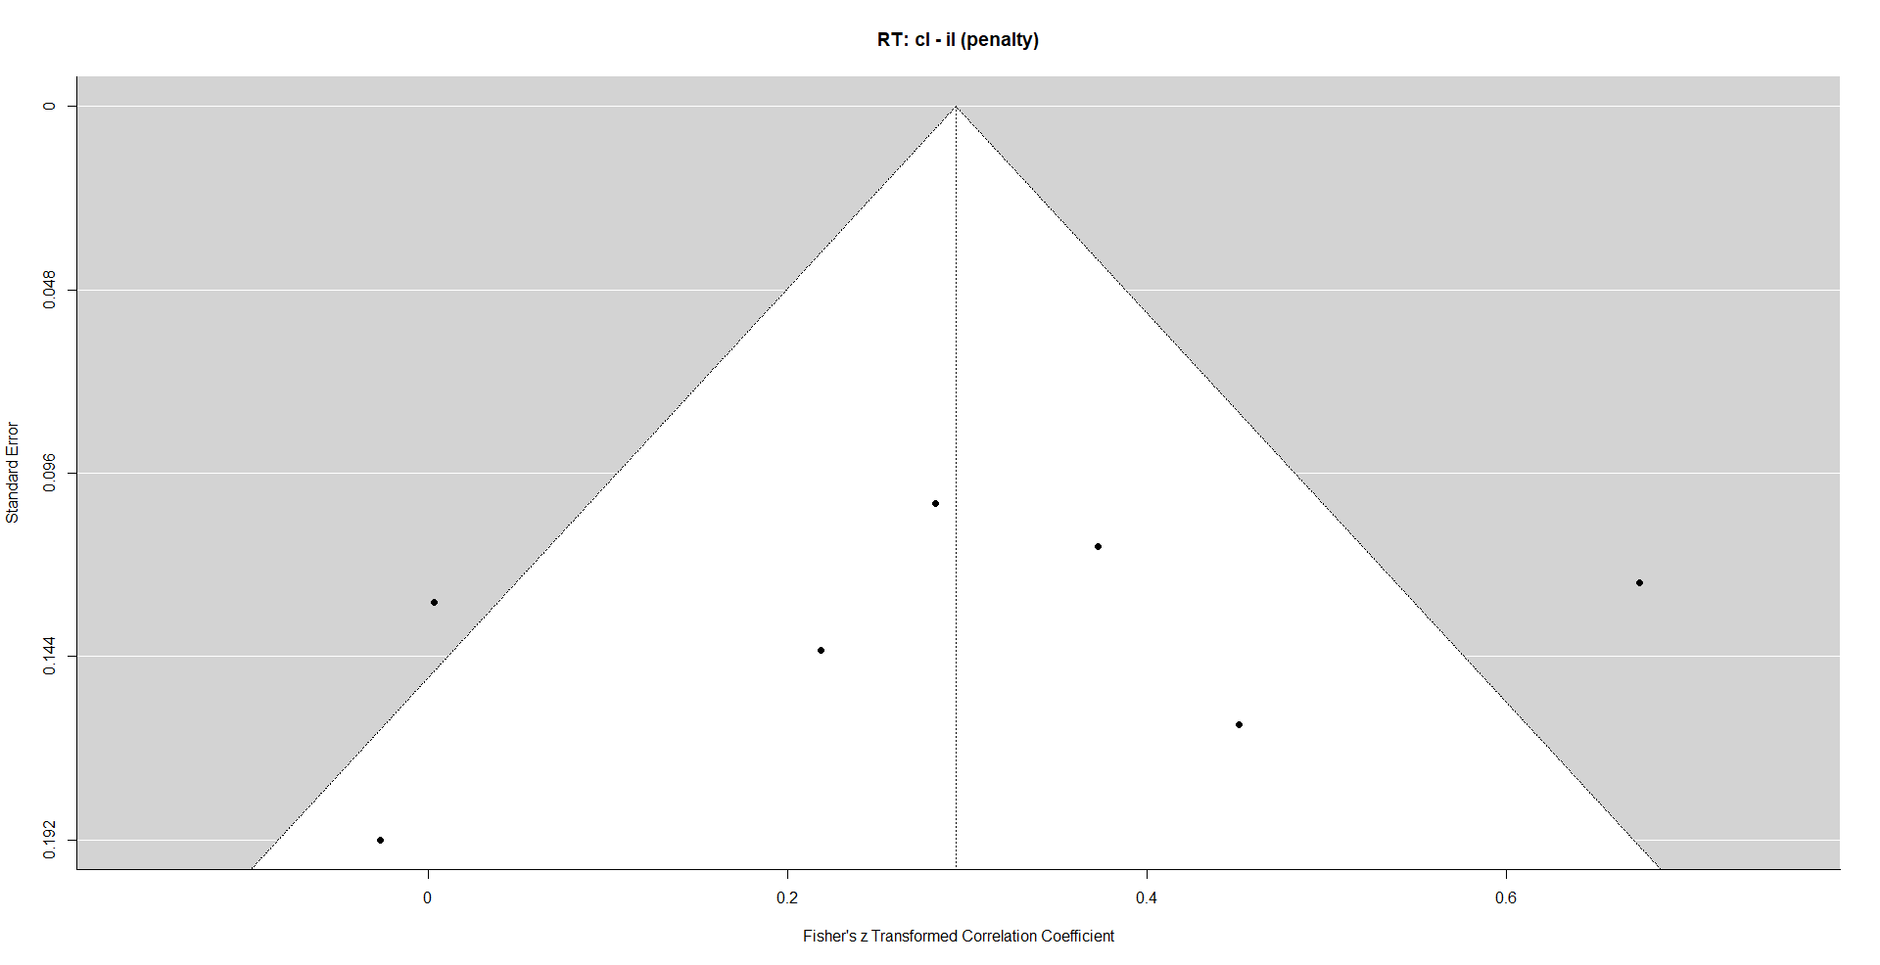
Supplementary Figure 6. Funnel plot of conflict resolution reaction times between healthy and clinical participants.
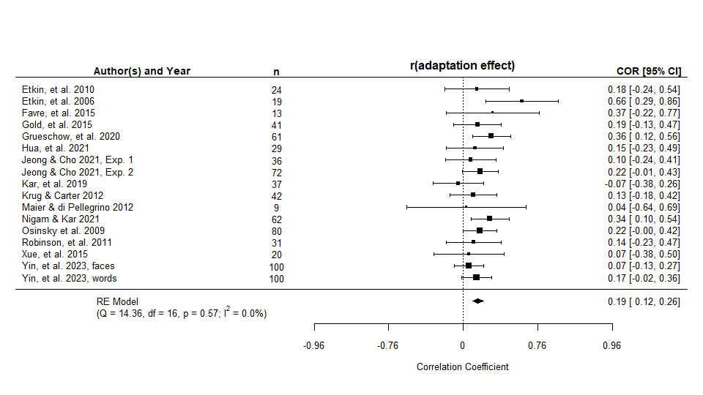
Supplementary Figure 7. Forest plot of the meta-analytic conflict adaptation effect for reaction time during the emotional conflict task.

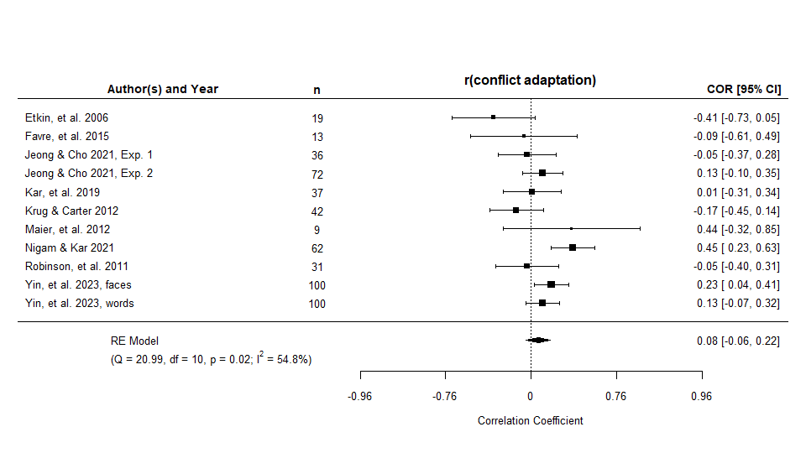
Supplementary Figure 8. Forest plot of the meta-analytic difference between accuracy of responses calculated as part of the conflict adaptation effect during the emotional conflict task.

References
Alders, G. L., Davis, A. D., MacQueen, G., Strother, S. C., Hassel, S., Zamyadi, M., Sharma, G. B., Arnott, S. R., Downar, J., Harris, J. K., Lam, R. W., Milev, R., Müller, D. J., Ravindran, A., Kennedy, S. H., Frey, B. N., Minuzzi, L., & Hall, G. B. (2020). Escitalopram ameliorates differences in neural activity between healthy comparison and major depressive disorder groups on an fMRI Emotional conflict task: A CAN-BIND-1 study. J Affect Disord, 264, 414-424. https://doi.org/10.1016/j.jad.2019.11.068
Almdahl, I. S., Martinussen, L. J., Agartz, I., Hugdahl, K., & Korsnes, M. S. (2021). Inhibition of emotions in healthy aging: age-related differences in brain network connectivity. Brain Behav, 11(5), e02052. https://doi.org/10.1002/brb3.2052
Bang, L., Rø, Ø., & Endestad, T. (2016). Amygdala alterations during an emotional conflict task in women recovered from anorexia nervosa. Psychiatry Res Neuroimaging, 248, 126-133. https://doi.org/10.1016/j.pscychresns.2015.12.008
Başgöze, Z., Gönül, A. S., Baskak, B., & Gökçay, D. (2015). Valence-based Word-Face Stroop task reveals differential emotional interference in patients with major depression. Psychiatry Res, 229(3), 960-967. https://doi.org/10.1016/j.psychres.2015.05.099
Bayer, M., Rubens, M. T., & Johnstone, T. (2018). Simultaneous EEG-fMRI reveals attention-dependent coupling of early face processing with a distributed cortical network. Biol Psychol, 132, 133-142. https://doi.org/10.1016/j.biopsycho.2017.12.002
Berger, N., Richards, A., & Davelaar, E. J. (2019). Preserved Proactive Control in Ageing: A Stroop Study With Emotional Faces vs. Words [Original Research]. Frontiers in Psychology, 10. https://doi.org/10.3389/fpsyg.2019.01906
Chechko, N., Augustin, M., Zvyagintsev, M., Schneider, F., Habel, U., & Kellermann, T. (2013). Brain circuitries involved in emotional interference task in major depression disorder. J Affect Disord, 149(1-3), 136-145. https://doi.org/10.1016/j.jad.2013.01.013
Chechko, N., Kellermann, T., Augustin, M., Zvyagintsev, M., Schneider, F., & Habel, U. (2016). Disorder-specific characteristics of borderline personality disorder with co-occurring depression and its comparison with major depression: An fMRI study with emotional interference task. NeuroImage: Clinical, 12, 517-525. https://doi.org/https://doi.org/10.1016/j.nicl.2016.08.015
Chechko, N., Kellermann, T., Zvyagintsev, M., Augustin, M., Schneider, F., & Habel, U. (2012). Brain circuitries involved in semantic interference by demands of emotional and non-emotional distractors. PLoS One, 7(5), e38155. https://doi.org/10.1371/journal.pone.0038155
Chen, T., Kendrick, K. M., Feng, C., Sun, S., Yang, X., Wang, X., Luo, W., Yang, S., Huang, X., Valdés-Sosa, P. A., Gong, Q., Fan, J., & Luo, Y.-J. (2016). Dissociable early attentional control mechanisms underlying cognitive and affective conflicts. Scientific Reports, 6(1), 37633. https://doi.org/10.1038/srep37633
Cheng, P., Preston, S. D., Jonides, J., Mohr, A. H., Thummala, K., Casement, M., Hsing, C., & Deldin, P. J. (2015). Evidence against mood-congruent attentional bias in Major Depressive Disorder. Psychiatry Res, 230(2), 496-505. https://doi.org/10.1016/j.psychres.2015.09.043
Deng, Z., Wei, D., Xue, S., Du, X., Hitchman, G., & Qiu, J. (2014). Regional gray matter density associated with emotional conflict resolution: evidence from voxel-based morphometry. Neuroscience, 275, 500-507. https://doi.org/10.1016/j.neuroscience.2014.06.040
DeSouza, J. F., Ovaysikia, S., & Pynn, L. (2012). Correlating behavioral responses to FMRI signals from human prefrontal cortex: examining cognitive processes using task analysis. J Vis Exp(64). https://doi.org/10.3791/3237
du Rocher, A. R., & Pickering, A. D. (2017). Trait anxiety, infrequent emotional conflict, and the emotional face Stroop task. Personality and Individual Differences, 111, 157-162. https://doi.org/https://doi.org/10.1016/j.paid.2017.02.017
Fan, L., Xu, Q., Wang, X., Zhang, F., Yang, Y., & Liu, X. (2016). Neural Correlates of Task-Irrelevant First and Second Language Emotion Words – Evidence from the Emotional Face–Word Stroop Task [Original Research]. Frontiers in Psychology, 7. https://doi.org/10.3389/fpsyg.2016.01672
Fleury, V., Cousin, E., Czernecki, V., Schmitt, E., Lhommée, E., Poncet, A., Fraix, V., Troprès, I., Pollak, P., Krainik, A., & Krack, P. (2014). Dopaminergic modulation of emotional conflict in Parkinson's disease. Front Aging Neurosci, 6, 164. https://doi.org/10.3389/fnagi.2014.00164
Floros, O., Axelsson, J., Almeida, R., Tigerström, L., Lekander, M., Sundelin, T., & Petrovic, P. (2021). Vulnerability in Executive Functions to Sleep Deprivation Is Predicted by Subclinical Attention-Deficit/Hyperactivity Disorder Symptoms. Biological Psychiatry: Cognitive Neuroscience and Neuroimaging, 6(3), 290-298. https://doi.org/https://doi.org/10.1016/j.bpsc.2020.09.019
Grueschow, M., Kleim, B., & Ruff, C. C. (2022). Functional Coupling of the Locus Coeruleus Is Linked to Successful Cognitive Control. Brain sciences, 12(3).
Haas, B. W., Omura, K., Constable, R. T., & Canli, T. (2006). Interference produced by emotional conflict associated with anterior cingulate activation. Cognitive, Affective, & Behavioral Neuroscience, 6(2), 152-156. https://doi.org/10.3758/CABN.6.2.152
Haas, B. W., Omura, K., Constable, R. T., & Canli, T. (2007). Emotional conflict and neuroticism: personality-dependent activation in the amygdala and subgenual anterior cingulate. Behav Neurosci, 121(2), 249-256. https://doi.org/10.1037/0735-7044.121.2.249
Hassel, S., Sharma, G. B., Alders, G. L., Davis, A. D., Arnott, S. R., Frey, B. N., Hall, G. B., Harris, J. K., Lam, R. W., Milev, R., Müller, D. J., Rotzinger, S., Zamyadi, M., Kennedy, S. H., Strother, S. C., & MacQueen, G. M. (2020). Reliability of a functional magnetic resonance imaging task of emotional conflict in healthy participants. Hum Brain Mapp, 41(6), 1400-1415. https://doi.org/10.1002/hbm.24883
Hornung, J., Kogler, L., Erb, M., Freiherr, J., & Derntl, B. (2018). The human body odor compound androstadienone increases neural conflict coupled to higher behavioral costs during an emotional Stroop task. Neuroimage, 171, 364-375. https://doi.org/10.1016/j.neuroimage.2018.01.027
Hoyer, J., Burmann, I., Kieseler, M. L., Vollrath, F., Hellrung, L., Arelin, K., Roggenhofer, E., Villringer, A., & Sacher, J. (2013). Menstrual cycle phase modulates emotional conflict processing in women with and without premenstrual syndrome (PMS)--a pilot study. PLoS One, 8(4), e59780. https://doi.org/10.1371/journal.pone.0059780
Hu, Y. Y., Zhu, J. C., Ge, Y., Luo, W. B., Liu, T. T., & Pu, X. (2019). Differences in the emotional conflict task between individuals with high and low social adjustment: An ERP study. PLoS One, 14(6), e0217962. https://doi.org/10.1371/journal.pone.0217962
Hu, Z., Liu, H., Weng, X., & Northoff, G. (2012). Is there a valence-specific pattern in emotional conflict in major depressive disorder? An exploratory psychological study. PLoS One, 7(2), e31983. https://doi.org/10.1371/journal.pone.0031983
Hurtado, M. M., Triviño, M., Panadero, M. A., Arnedo, M., & Tudela, P. (2018). Comparing adaptation in emotional and non-emotional conflict in patients with schizophrenia and borderline personality disorder. Neuropsychologia, 117, 558-565. https://doi.org/10.1016/j.neuropsychologia.2018.07.016
Jia, L. X., Ye, J. Y., Cui, J. F., Shi, H. S., Yang, T. X., & Wang, Y. (2023). Proactive and reactive cognitive control for emotional conflict in individuals with high schizotypy: An ERP study. Clin Neurophysiol, 145, 36-44. https://doi.org/10.1016/j.clinph.2022.10.016
Keedwell, P. A., Doidge, A. N., Meyer, M., Lawrence, N., Lawrence, A. D., & Jones, D. K. (2016). Subgenual Cingulum Microstructure Supports Control of Emotional Conflict. Cereb Cortex, 26(6), 2850-2862. https://doi.org/10.1093/cercor/bhw030
Koizumi, A., Kitagawa, N., Kitamura, M. S., Kondo, H. M., Sato, T., & Kashino, M. (2010). Serotonin transporter gene and inhibition of conflicting emotional information. Neuroreport, 21(6), 422-426. https://doi.org/10.1097/WNR.0b013e32833833f0
Kuehne, M., Schmidt, K., Heinze, H.-J., & Zaehle, T. (2019). Modulation of Emotional Conflict Processing by High-Definition Transcranial Direct Current Stimulation (HD-TDCS) [Original Research]. Frontiers in Behavioral Neuroscience, 13. https://doi.org/10.3389/fnbeh.2019.00224
Lai, F. D., Ip, A. K., & Lee, T. M. (2011). Impulsivity and pathological gambling: Is it a state or a trait problem? BMC Res Notes, 4, 492. https://doi.org/10.1186/1756-0500-4-492
Lewis, B., Garcia, C. C., Price, J. L., Schweizer, S., & Nixon, S. J. (2022). Cognitive training in recently-abstinent individuals with alcohol use disorder improves emotional stroop performance: Evidence from a randomized pilot trial. Drug Alcohol Depend, 231, 109239. https://doi.org/10.1016/j.drugalcdep.2021.109239
Li, J., Yang, X., Zhou, F., Liu, C., Wei, Z., Xin, F., Daumann, B., Daumann, J., Kendrick, K. M., & Becker, B. (2020). Modafinil enhances cognitive, but not emotional conflict processing via enhanced inferior frontal gyrus activation and its communication with the dorsomedial prefrontal cortex. Neuropsychopharmacology, 45(6), 1026-1033. https://doi.org/10.1038/s41386-020-0625-z
Liu, T., Liu, X., Li, D., Shangguan, F., Lu, L., & Shi, J. (2019). Conflict control of emotional and non-emotional conflicts in preadolescent children. Biol Psychol, 146, 107708. https://doi.org/10.1016/j.biopsycho.2019.05.008
Liu, X., Liu, Y., Shi, H., Li, L., & Zheng, M. (2021). Regulation of Mindfulness-Based Music Listening on Negative Emotions Related to COVID-19: An ERP Study. Int J Environ Res Public Health, 18(13). https://doi.org/10.3390/ijerph18137063
Ma, J., Liu, C., & Chen, X. (2016). Emotional Modulation of Conflict Processing in the Affective Domain: Evidence from Event-related Potentials and Event-related Spectral Perturbation Analysis. Scientific Reports, 6(1), 31278. https://doi.org/10.1038/srep31278
Ma, X., & Zhang, E. (2021). The influence of social power on neural responses to emotional conflict. PeerJ, 9, e11267. https://doi.org/10.7717/peerj.11267
Maier, M. E., Scarpazza, C., Starita, F., Filogamo, R., & Làdavas, E. (2016). Error monitoring is related to processing internal affective states. Cogn Affect Behav Neurosci, 16(6), 1050-1062. https://doi.org/10.3758/s13415-016-0452-1
Martínez-Fernández, R., Kibleur, A., Chabardès, S., Fraix, V., Castrioto, A., Lhommée, E., Moro, E., Lescoules, L., Pelissier, P., David, O., & Krack, P. (2018). Different effects of levodopa and subthalamic stimulation on emotional conflict in Parkinson's disease. Hum Brain Mapp, 39(12), 5014-5027. https://doi.org/10.1002/hbm.24341
Ovaysikia, S., Tahir, K. A., Chan, J. L., & DeSouza, J. F. (2011). Word wins over face: emotional Stroop effect activates the frontal cortical network. Front Hum Neurosci, 4, 234. https://doi.org/10.3389/fnhum.2010.00234
Reeck, C., & Egner, T. (2011). Affective Privilege: Asymmetric Interference by Emotional Distracters [Original Research]. Frontiers in Psychology, 2. https://doi.org/10.3389/fpsyg.2011.00232
Rey, G., Desseilles, M., Favre, S., Dayer, A., Piguet, C., Aubry, J.-M., & Vuilleumier, P. (2014). Modulation of brain response to emotional conflict as a function of current mood in bipolar disorder: Preliminary findings from a follow-up state-based fMRI study. Psychiatry Research: Neuroimaging, 223(2), 84-93. https://doi.org/https://doi.org/10.1016/j.pscychresns.2014.04.016
Shen, Y., Xue, S., Wang, K., & Qiu, J. (2013). Neural time course of emotional conflict control: an ERP study. Neurosci Lett, 541, 34-38. https://doi.org/10.1016/j.neulet.2013.02.032
Shields, G. S., Kuchenbecker, S. Y., Pressman, S. D., Sumida, K. D., & Slavich, G. M. (2016). Better cognitive control of emotional information is associated with reduced pro-inflammatory cytokine reactivity to emotional stress. Stress, 19(1), 63-68. https://doi.org/10.3109/10253890.2015.1121983
Soutschek, A., & Schubert, T. (2013). Domain-specific control mechanisms for emotional and nonemotional conflict processing. Cognition, 126(2), 234-245. https://doi.org/10.1016/j.cognition.2012.10.004
Stickel, S., Eickhoff, S., Goecke, T. W., Schneider, F., Quinete, N. S., Lang, J., Habel, U., & Chechko, N. (2019). Cumulative cortisol exposure in the third trimester correlates with postpartum mothers' neural response to emotional interference. Biol Psychol, 143, 53-61. https://doi.org/10.1016/j.biopsycho.2019.02.008
Thompson, N. M., van Reekum, C. M., & Chakrabarti, B. (2022). Cognitive and Affective Empathy Relate Differentially to Emotion Regulation. Affective Science, 3(1), 118-134. https://doi.org/10.1007/s42761-021-00062-w
Wang, K., Wu, W., Zhong, H., & Cheng, J. (2017). Gender differences in performance for young adults in cognitive tasks under emotional conflict. Neurosci Lett, 661, 77-83. https://doi.org/10.1016/j.neulet.2017.09.061
Wang, X., Liu, S., Ma, J., Wang, K., Wang, Z., Li, J., Chen, J., Zhan, H., & Wu, W. (2021). The Inhibitory Effect of Emotional Conflict Control on Memory Retrieval. Neuroscience, 468, 29-42. https://doi.org/https://doi.org/10.1016/j.neuroscience.2021.05.032
Weaver, S. S., Birn, R. M., & Cisler, J. M. (2020). A Pilot Adaptive Neurofeedback Investigation of the Neural Mechanisms of Implicit Emotion Regulation Among Women With PTSD [Original Research]. Frontiers in systems neuroscience, 14. https://doi.org/10.3389/fnsys.2020.00040
Xue, S., Li, Y., Kong, X., He, Q., Liu, J., & Qiu, J. (2016). The dissociable neural dynamics of cognitive conflict and emotional conflict control: An ERP study. Neurosci Lett, 619, 149-154. https://doi.org/10.1016/j.neulet.2016.03.020
Xue, S., Wang, S., Kong, X., & Qiu, J. (2017). Abnormal Neural Basis of Emotional Conflict Control in Treatment-Resistant Depression. Clin EEG Neurosci, 48(2), 103-110. https://doi.org/10.1177/1550059416631658
Yan, Y., Li, Y., Lou, X., Li, S., Yao, Y., Gong, D., Ma, W., & Yan, G. (2021). The Influence of Action Video Gaming Experience on the Perception of Emotional Faces and Emotional Word Meaning. Neural Plast, 2021, 8841156. https://doi.org/10.1155/2021/8841156
Yang, Q., Wang, X., Yin, S., Zhao, X., Tan, J., & Chen, A. (2016). Improved emotional conflict control triggered by the processing priority of negative emotion. Scientific Reports, 6(1), 24302. https://doi.org/10.1038/srep24302
Young Kuchenbecker, S., Pressman, S. D., Celniker, J., Grewen, K. M., Sumida, K. D., Jonathan, N., Everett, B., & Slavich, G. M. (2021). Oxytocin, cortisol, and cognitive control during acute and naturalistic stress. Stress, 24(4), 370-383. https://doi.org/10.1080/10253890.2021.1876658
Zhao, X., Li, X., & Shi, W. (2017). Influence of inhibitory tagging (IT) on emotional and cognitive conflict processing: Evidence from event-related potentials. Neurosci Lett, 657, 120-125. https://doi.org/10.1016/j.neulet.2017.08.014
Zhu, J., Li, J., Li, X., Rao, J., Hao, Y., Ding, Z., & Wang, G. (2018). Neural Basis of the Emotional Conflict Processing in Major Depression: ERPs and Source Localization Analysis on the N450 and P300 Components. Front Hum Neurosci, 12, 214. https://doi.org/10.3389/fnhum.2018.00214
Zhu, X. R., Zhang, H. J., Wu, T. T., Luo, W. B., & Luo, Y. J. (2010). Emotional conflict occurs at an early stage: evidence from the emotional face-word Stroop task. Neurosci Lett, 478(1), 1-4. https://doi.org/10.1016/j.neulet.2010.04.036

