Supplementary Materials

Interaction with the Robot
For a full video, click here.

Experiment 1

Procedural Schematic
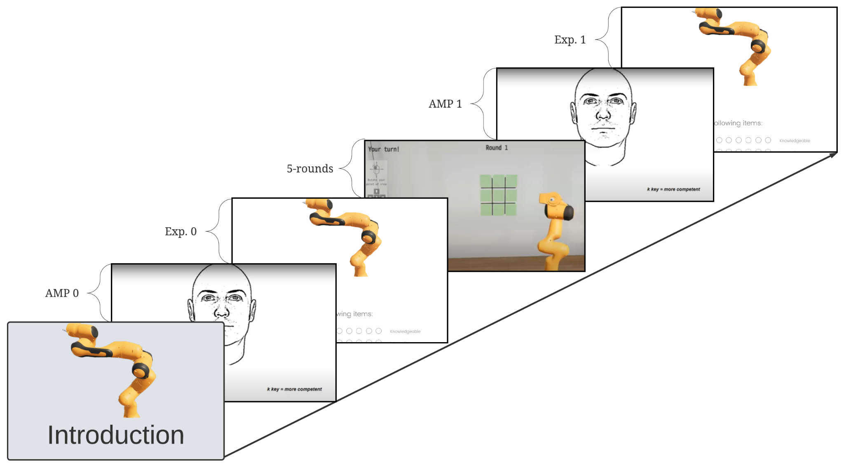

Protocol
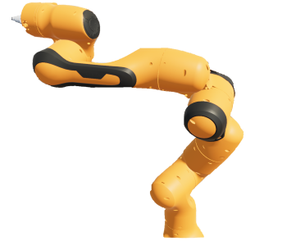
This is Taylor. Though researchers and the developers that created Taylor have worked on this project for a while, Taylor is still in the early testing phase.
<screen>
<same image>
Taylor is designed to play interactive and competitive games with people like you. Several different games have been tested, but today you will play Tic-Tac-Toe with Taylor.
<screen>
<same image>
In Tic-Tac-Toe, you have a 3 by 3 grid that looks like a # sign. You and Taylor will take turns putting X's and O's on the grid, with the first player to get 3 in a row being the winner.
<screen>
<same image>
Since Taylor is still in early development, it is not clear how well Taylor plays different types of games. The games today will be fun and interesting to see how Taylor performs in a series of Tic-Tac-Toe games against you.
<screen>
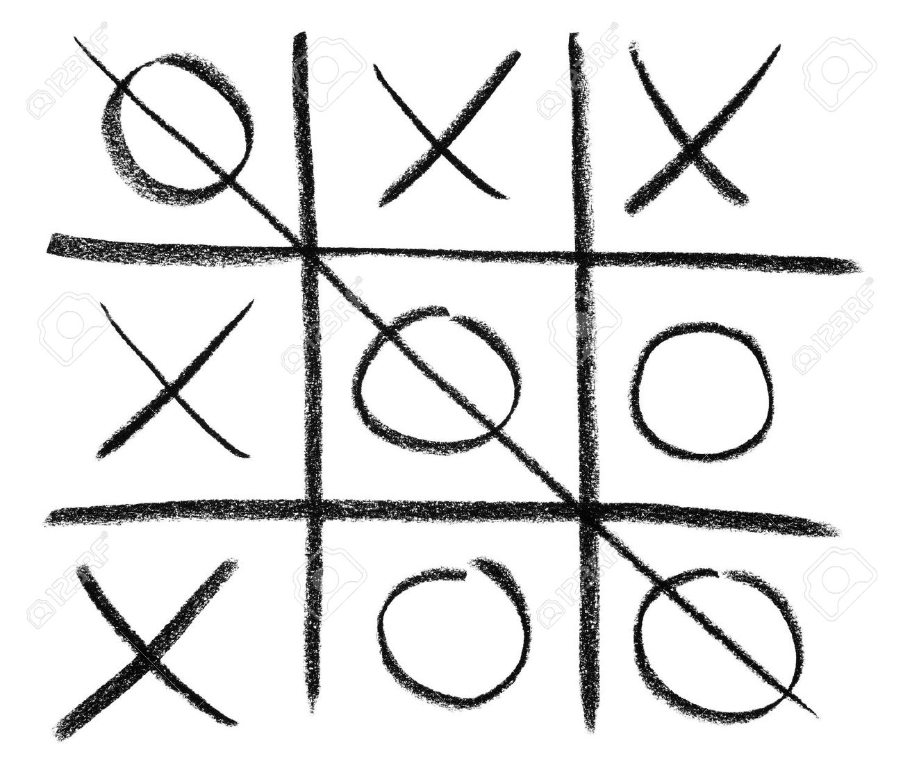
Remember, Tic-Tac-Toe has a 3x3 grid (as seen above). Your goal is to get three X's or O's in a row. If you get three in a row, as in the photo, you win!

By continuing you are confirming that you understand how to play…

I understand
o Yes (1)

<screen>

Redirect to AMP0
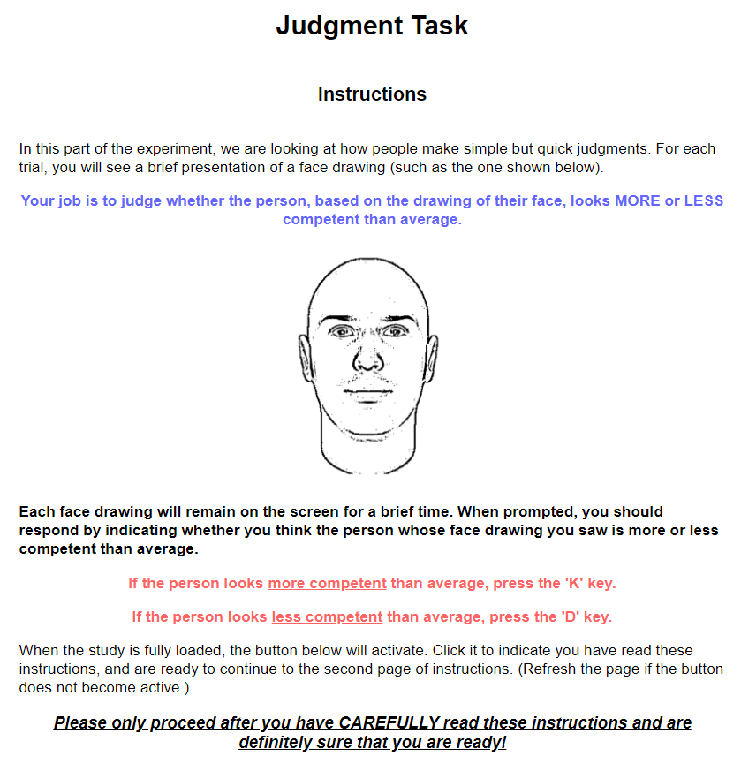
<screen>
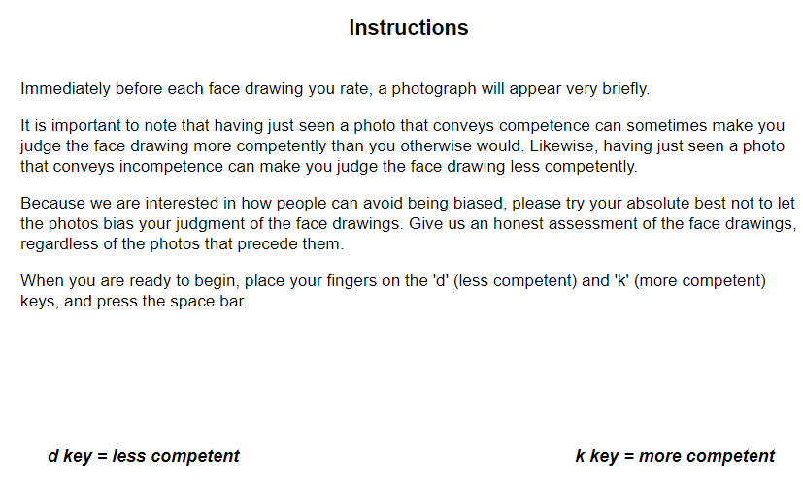
AMP Stimuli

Taylor (one image was randomly selected to serve as the prime for Taylor):
(1) 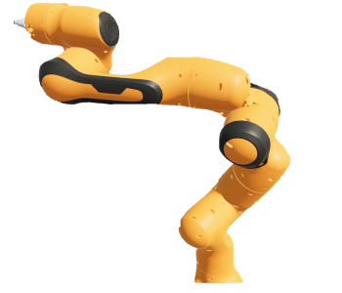(2)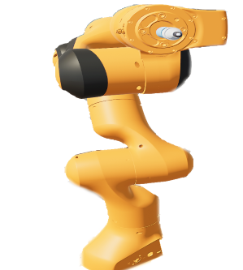
(3)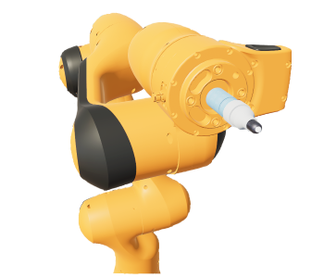 (4) 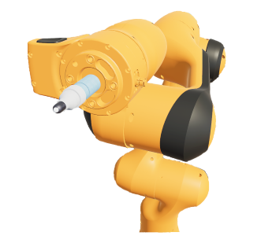
(5) 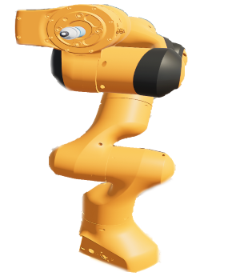
Control: The control robot images were collected from Barret Technology’s WAM robot arm image archive.

Example Target:

40 Trials (20 prime, 20 control)
Redirect to Qualtrics

Please rate Taylor on the following items:
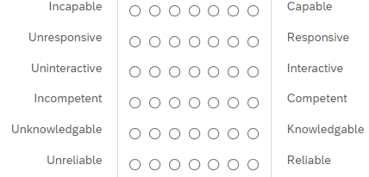

<screen>
<same image>
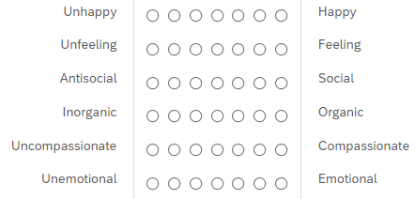
<screen>
<same image>
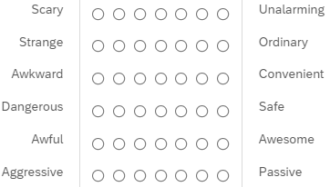
<screen>
How familiar are you with Tic-Tac-Toe?
o I have never heard of it before this study. (1)
o I have heard of it before this study, but never played it. (2)
o I have played it once or twice. (3)
o I have played it multiple times. (4)
o I play it often. (5)
<screen>
Redirect to Tic-Tac-Toe webpage
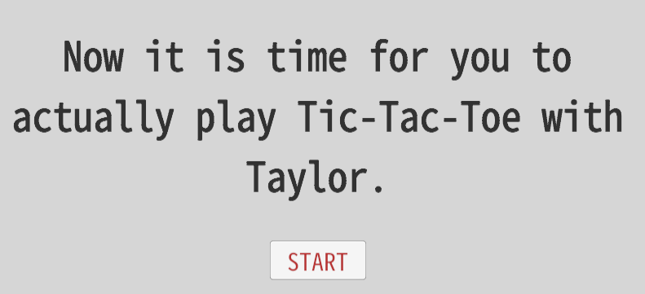
<start button>
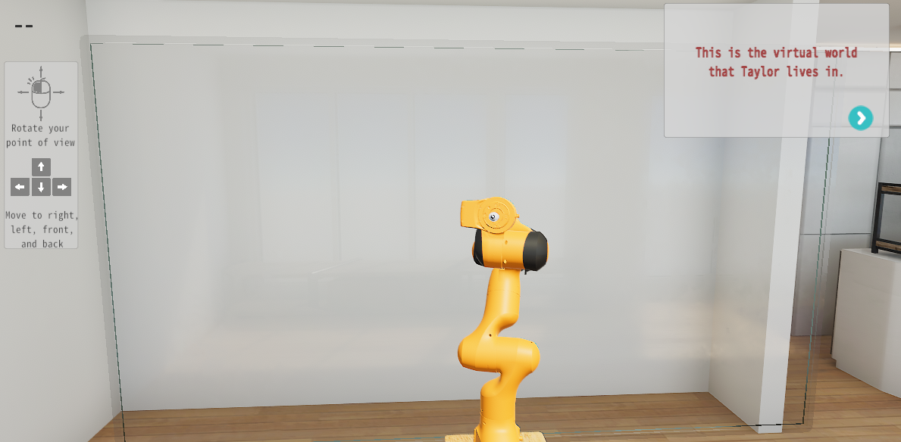
<arrow>
Use your mouse and keyboard to move around the room and find Taylor.
<arrow>
Once you find Taylor, try walking closer using the ‘W’ or up-arrow key.
<arrow>
After you finish reading the rules, Taylor will draw a board to play on.
<arrow>
The board will have green icons that you click on to make your move.
<arrow>
The first player to get three X’s or O’s in a row, vertically, horizontally, or diagonally wins.
<arrow>
Your goal is to play your best to try to win.
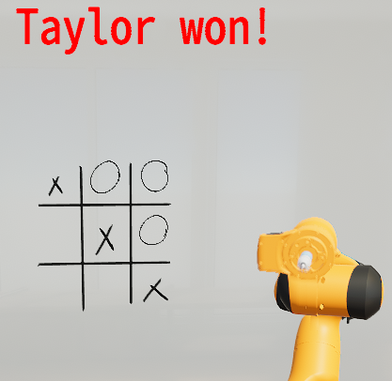
<arrow>
Good luck!
*The game board is drawn, rounds are played. End-of-game feedback appears after each round*
*after 5-rounds, redirect message appears*

Redirect to AMP1 – same procedure as AMP0
Redirect to Qualtrics

We are almost done, just a few more questions!
Keep up the great work!
<screen>

<same explicit items as before>
<screen>
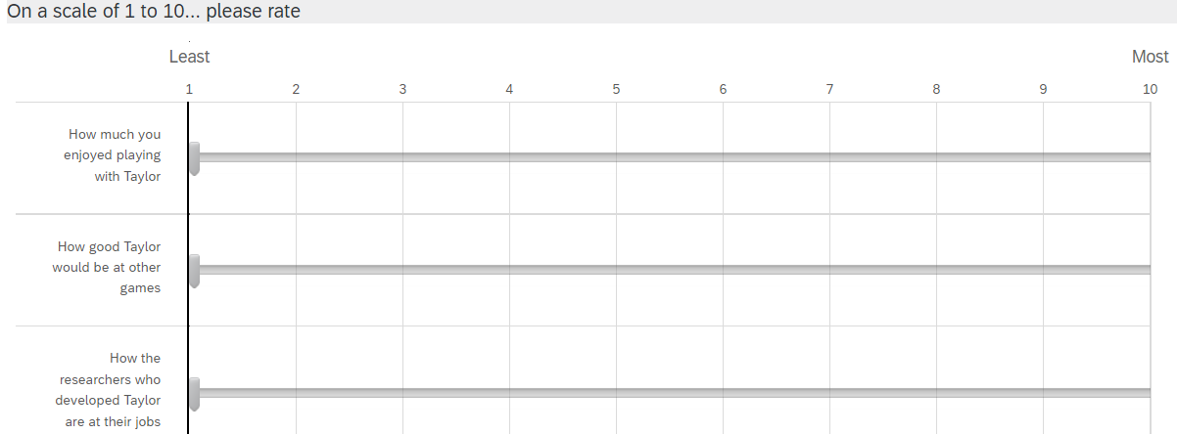
<screen>
What is Taylor's gender most aligned with?
o Man (1)
o Woman (2)
<screen>
Demographics
Debriefing

Experiment 2

Procedural Schematic
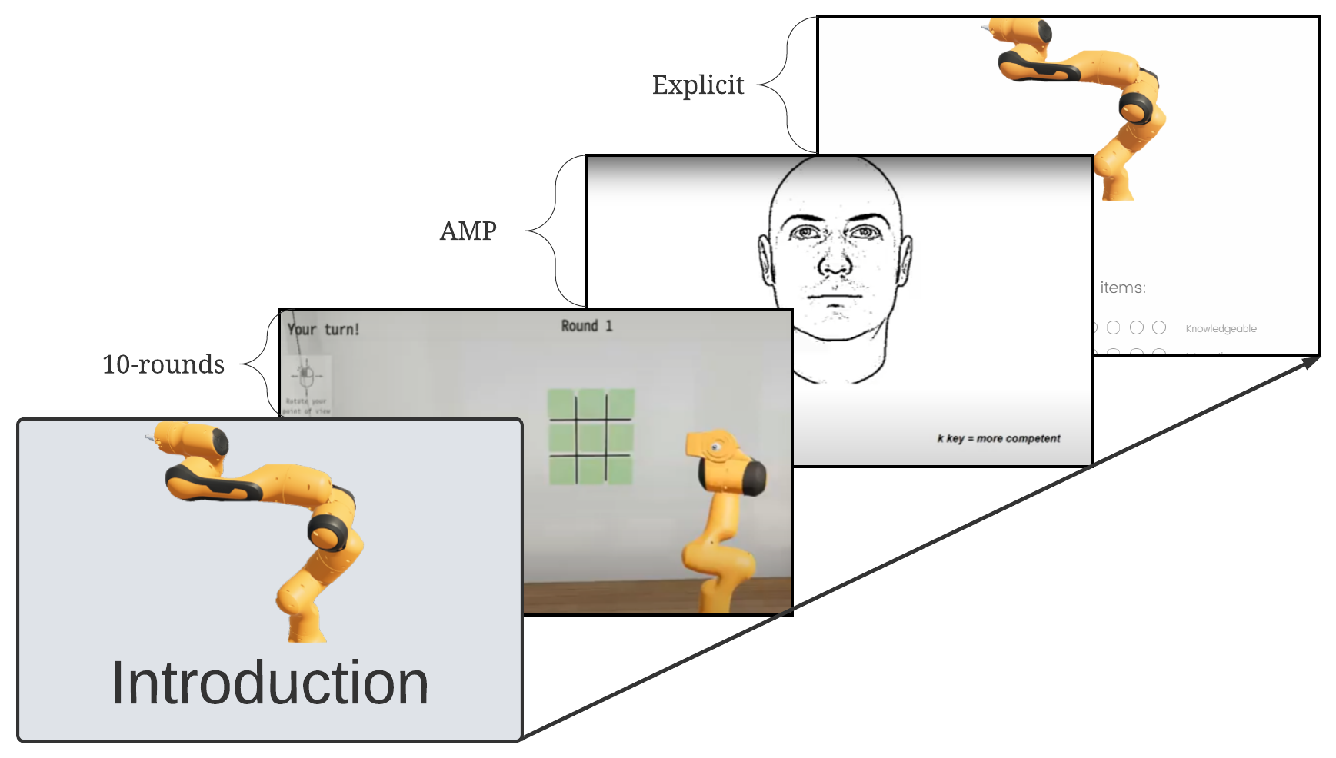

Protocol
Landing page was Qualtrics
Introduction to Taylor was identical to Experiment 1.

Redirect to Tic-Tac-Toe webpage
Procedure was identical to Experiment 1, except there are 10-rounds instead of 5-rounds.

Redirect to AMP
Procedure was identical to Experiment 1, except the Taylor and control robot pictures were static.

Redirect to Qualtrics
Procedure was identical to Experiment 1, except we removed the question about Taylor’s gender.

Experiment 3

Procedural Schematic
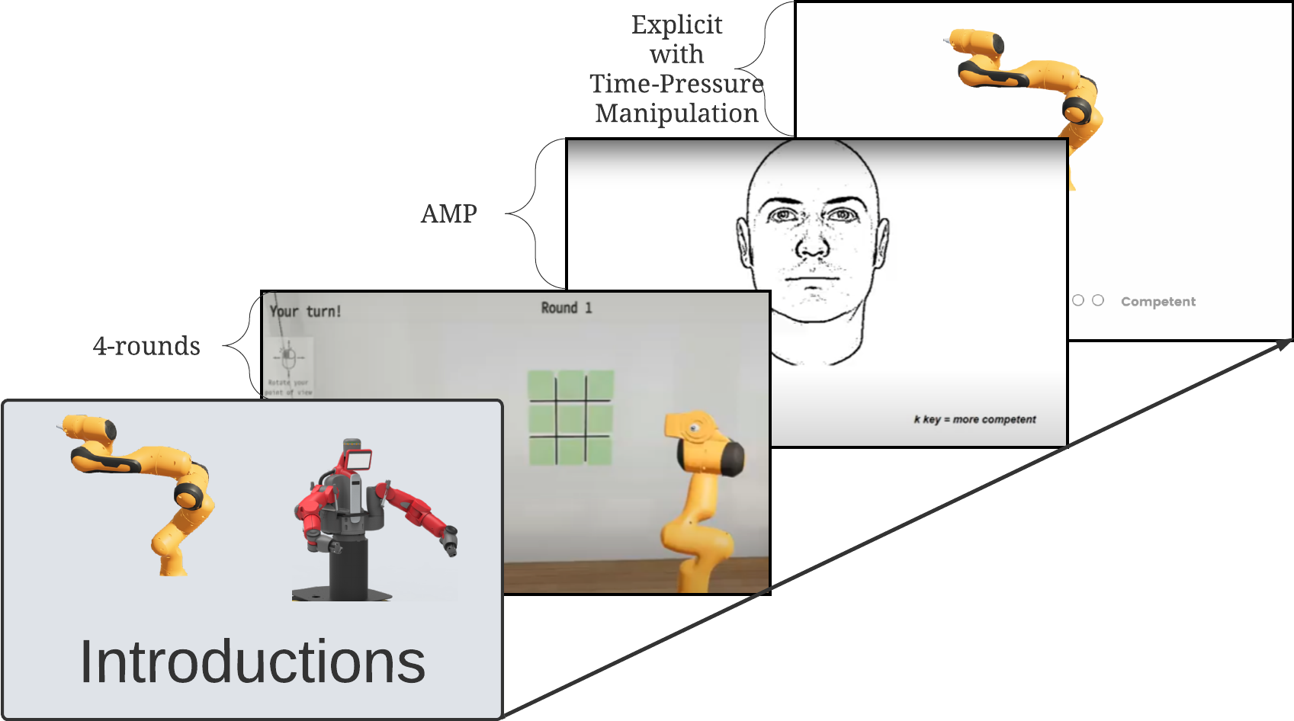

Protocol
Landing page was Qualtrics
We will now introduce you to two different robots. Afterwards, you will play a series of competitive games against one of these robots.
<screen - robot order was counterbalanced>
Identical introduction to Taylor as in Experiment 1.
<screen>
Now that you have met Taylor, please proceed to meet Jessie, the other robot.
<screen>
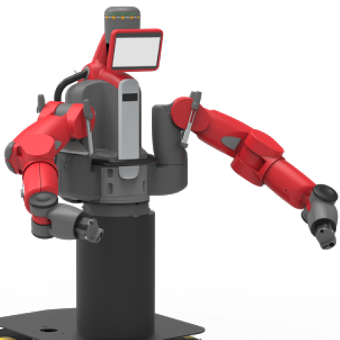
This is Jessie. Although researchers and the developers that created Jessie have worked on this project for a while, Jessie is still in the early testing phase.
<screen>
<same image>
Jessie is designed to play interactive and competitive games with people like you. Jessie is new to all testers.
<screen>
<same image>
Since Jessie is still in early development, it is not clear how well Jessie plays different types of games.
<screen>
You have been selected to play with Taylor!
Today, you play Tic-Tac-Toe with Taylor.
<screen>
Then the remainder of the introduction is the same as in Experiment 2.

Redirect to Tic-Tac-Toe webpage
Procedure was identical to Experiment 2, except there are 4-rounds instead of 10-rounds.

Redirect to AMP
Procedure was similar to Experiment 2, but we added Jessie as a third prime. We also modified the number of trials to sum to 45 Trials (15 prime, 15 Jessie, 15 original control)

Redirect to Qualtrics
In this last section, you will be presented with a photo of a robot and be asked to rate the robot on a scale.

The questions will all look the same. There will be a photo of a robot and it is your job to rate that robot on the basis of the scale provided.

Importantly, this section [will only allow you 2.5 seconds to respond to each question. If you take longer than 2.5 seconds, the question will time-out. So please try to respond as quickly as possible! / OR / will only allow you as much time as you need to respond to each question.]
<screen>
Question loading... please prepare to respond:
<lasted 1.5 seconds, then automatically advanced to next screen>
Then participants went through each item in the scale for the control robot (WAM), followed by either Jessie or Taylor, and then finally the remaining robot.
<screen>
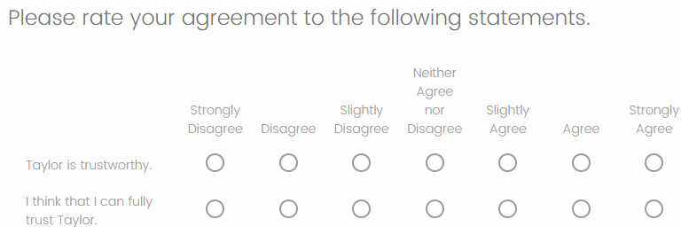
<screen>
Then the demographics and debriefing.

Experiment 4

Procedural Schematic
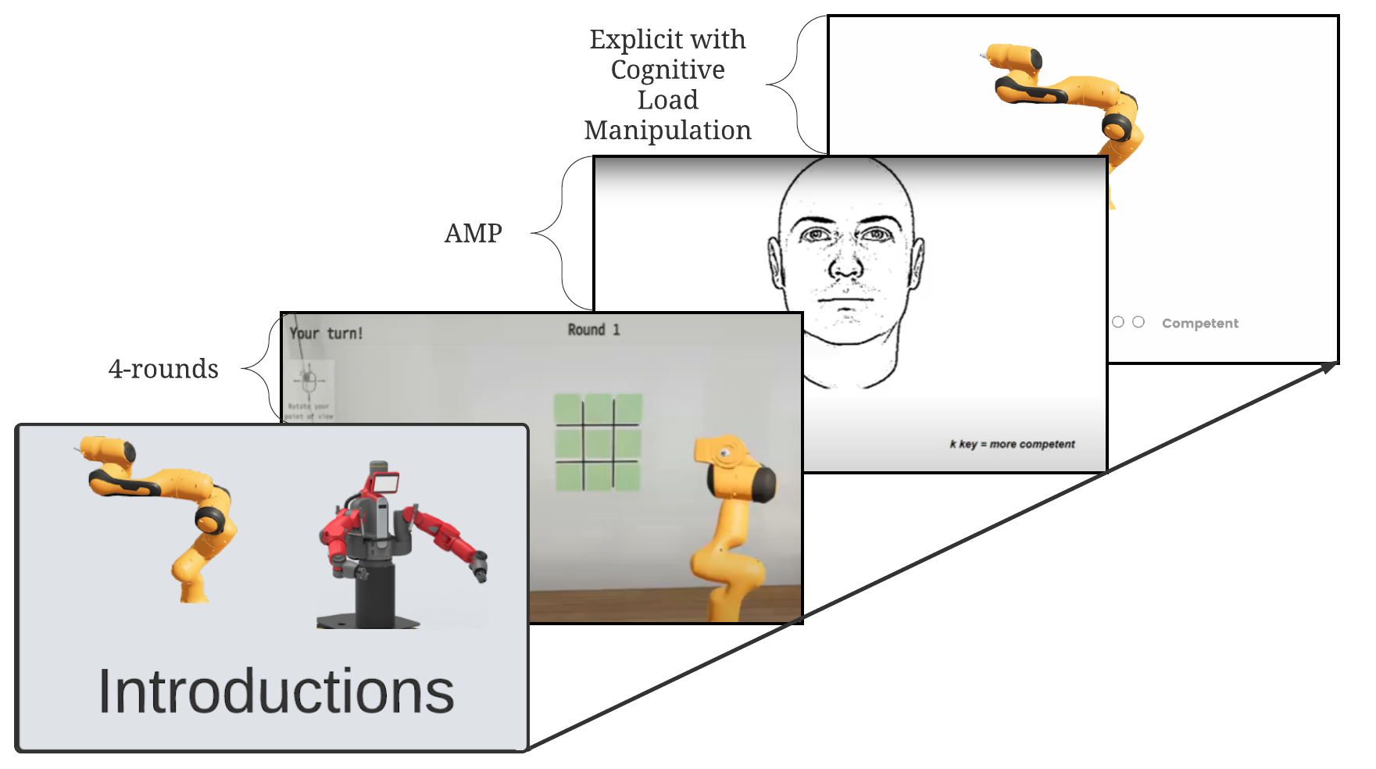

Protocol
Landing page was Qualtrics
Introduction to Taylor was identical to Experiment 3.

Redirect to Tic-Tac-Toe webpage
Procedure was identical to Experiment 3.

Redirect to Qualtrics
In this last section, you will be presented with a photo of a robot and be asked to rate the robot on a scale.

To make sure that you're paying attention, we'll be asking you to keep track of your survey's ID number.

Please do not copy down the ID number. Please do your best to memorize them without assistance.
o I will, please show me the ID number.
<screen>
Your ID number is: 68654463.

Please memorize this number, we will ask you for it later. Please do not write it down.
<screen>
Then participants rate Taylor, Jessie, and WAM’s explicit competence, as in Experiment 2.
<screen>
Please enter the ID that we asked you to memorize.
<screen>

<screen>
Then participants completed the trust scale from Experiment 3.
<screen>
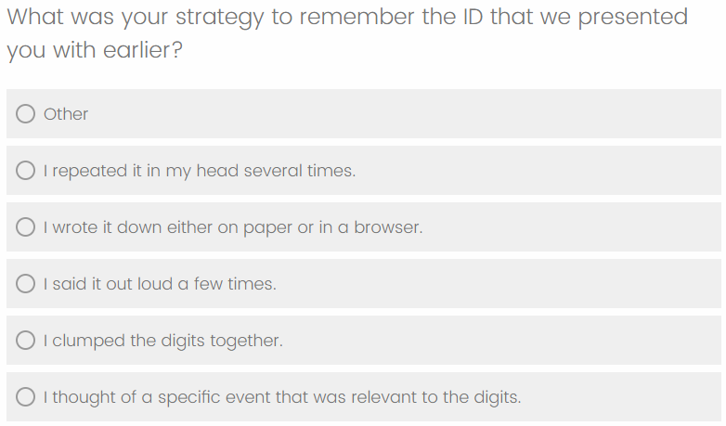
<screen>
Finally, participants completed their demographics and were debriefed.

Experiment 5

Procedural Schematic
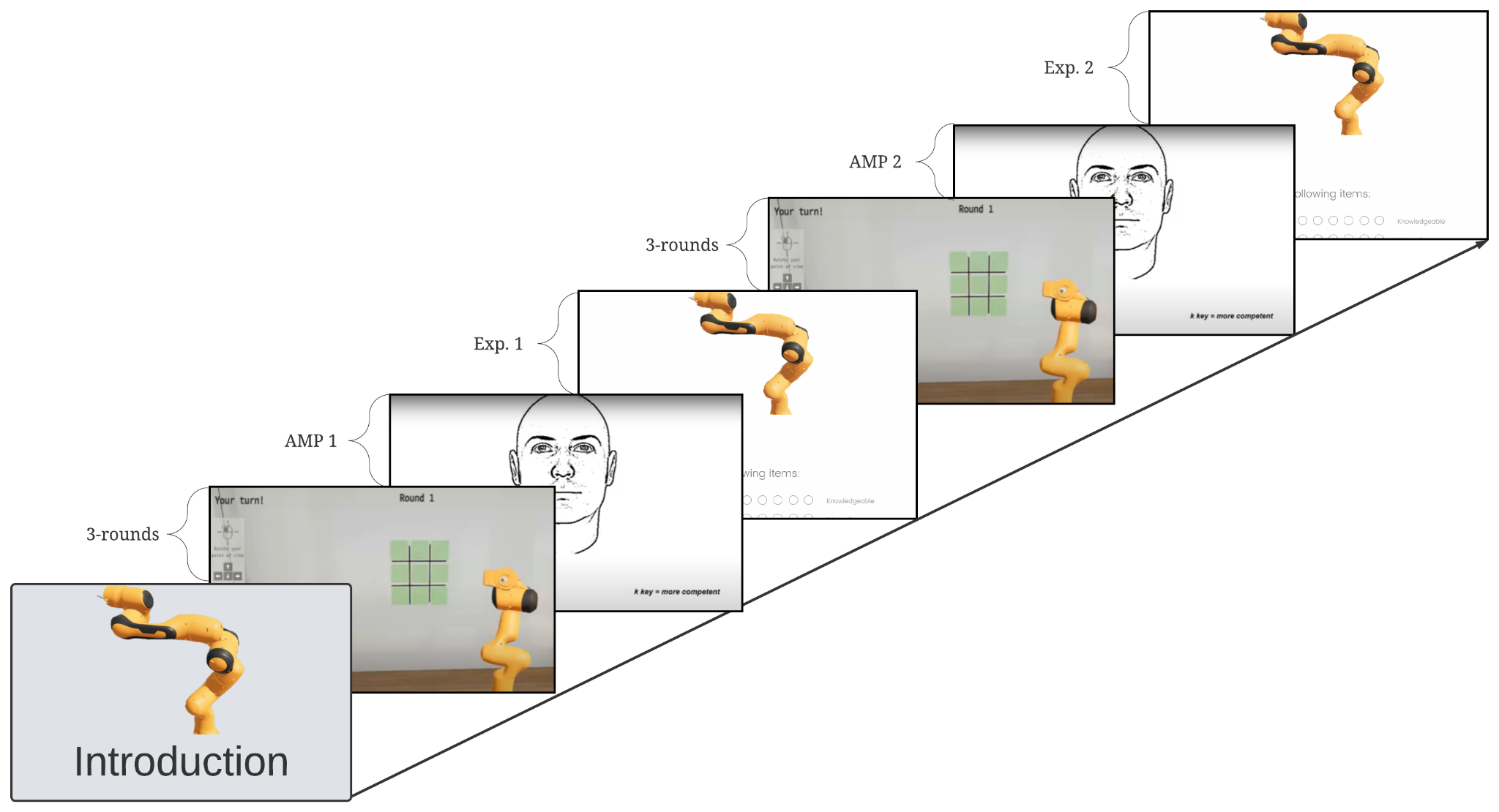

Protocol
Landing page was Qualtrics
Introduction to Taylor was identical to Experiment 2.

Redirect to Tic-Tac-Toe webpage
Procedure was identical to Experiment 1, except there are 3-rounds instead of 5-rounds.

Redirect to AMP1
Procedure was identical to Experiment 2.

Redirect to Qualtrics
“We appreciate your honest and dutiful efforts in this study.
You're about halfway done.
Keep up the great work!”
<screen>

Please rate Taylor on the following items:
<screen>
“Previous participants found that 3-rounds of Tic-Tac-Toe was not enough to determine how reliable and competent Taylor is. Therefore, you will now play 3 additional rounds. Remember, your goal is to win as many games as possible!”
Redirect to Tic-Tac-Toe webpage
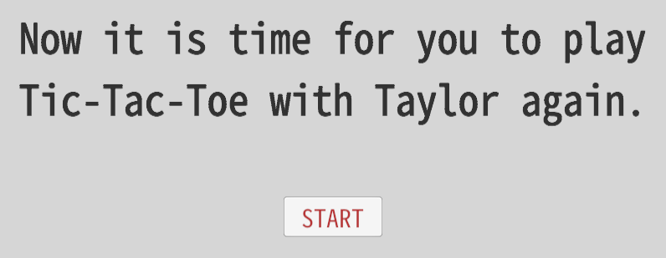
<start button>
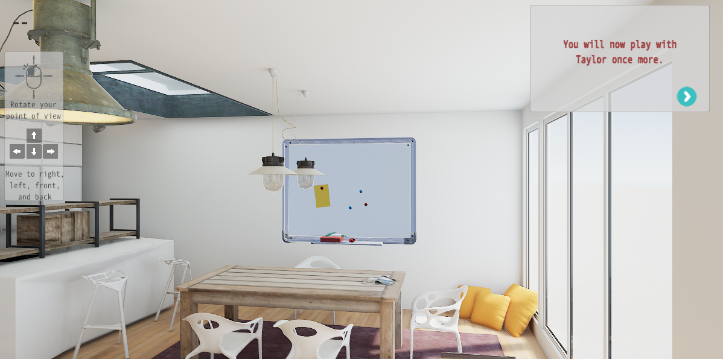
<arrow>
When Taylor makes a move, consider whether you would have made that move if it were your turn.
<arrow>
Remember, your goal is to win as many games as possible.
<arrow>
Good Luck!
<participant then plays 3 additional rounds of Tic-Tac-Toe>

Redirect to AMP2
Procedure was identical to AMP1.

Redirect to Qualtrics
“We are almost done, just a few more questions!
Keep up the great, diligent, and honest work!”

<screen>
Explicit competence item again, as in previous Qualtrics section

<screen>
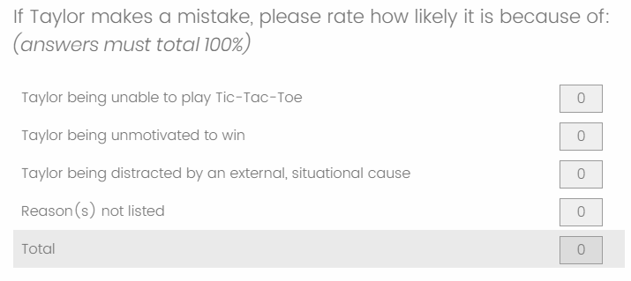
<screen>
Demographics
Debriefing

Experiment 6

Procedural Schematic

Protocol
Landing page was Qualtrics
Introduction to Taylor was identical to Experiment 4.

Redirect to Tic-Tac-Toe webpage
Procedure was identical to Experiment 5.

Redirect to AMP1
Procedure was identical to Experiment 4.

Redirect to Qualtrics
Procedure was almost identical to Experiment 5, except we also collected explicit competence ratings of Jessie and WAM (counterbalanced order).

Redirect to Tic-Tac-Toe webpage
Procedure was identical to Experiment 5.

Redirect to AMP2
Procedure was identical to AMP1.

Redirect to Qualtrics
Procedure was almost identical to Experiment 5, except we also collected explicit competence ratings of Jessie and WAM (counterbalanced order).

