Appendix A
Experiment1

Experiment 1: Reaction Time

Raw Data
1.5
2.0
2.5
3.0
3.5
%
20
30
%
40
%
50
%
60
%
70
%
80
%
Actual Percentage of Movement
Reaction Time (s)
Experimental
Condition
adaptation
control
in the Adaptation Direction

Figure S1
Experiment 1: Reaction times of all subjects(n=60). The reaction time increased as the actual percentage approached 50%. Solid lines indicate the grand average value, and the shaded area indicate 1 standard error of means.

Experiment 1: Separate Results for Sun and Moon Groups
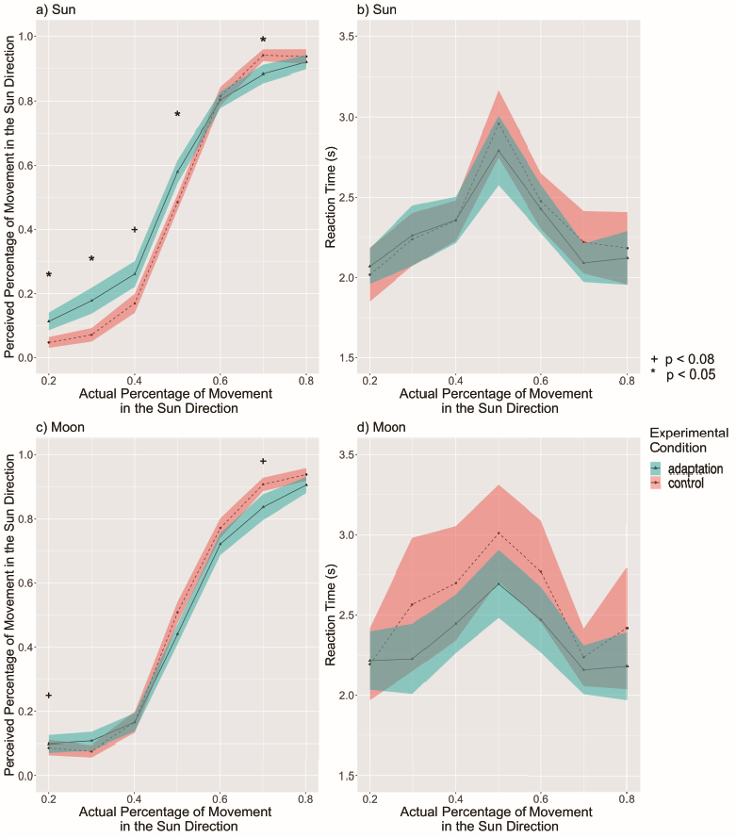

Figure S2
The perceived percentage of movement in the sun direction compared with the actual percentage for all subjects. a) The reported rate of the sun group. The sun adaptation condition had an overall higher percent of trials selecting the adapted direction than the control condition. This result suggests an aftereffect in the same direction of travel (p = 0.012). The adaptation condition showed higher percent of trials selecting the adapted direction than corresponding control conditions at 20%, 30%, 40%, and 50%, supporting this aftereffect. This result also suggests an aftereffect in the same direction of travel. There was also a significant interaction between condition and the actual percentage. b) Reaction times of the sun group. The reaction time increased as the actual percentage approached 50%. c) The reported rate of the moon group. The moon adaptation had a marginally lower percent of trials selecting the adapted direction overall than the control condition (p = 0.051). This result suggests an aftereffect in the same direction of travel. The adaptation condition showed marginally lower percent of trials selecting the adapted direction than corresponding control conditions at the 50% and 70%, supporting this aftereffect. d) The reaction time of the moon group. The reaction time increased as the actual percentage got closer to 50%. Solid lines indicate the grand average value, and the shaded area indicate 1 standard error of means. ⁺ p < 0.08; * p < 0.05, Tukey correction.

Experiment 1: Serial Position Effects for Sun and Moon Adaptation Groups
In order to determine if any portion of the 10-second test phase contributed to the reported rate, we tested for a serial position effect. A serial position effect occurs when people tend to remember the first items (the primacy effect) or the last items (the recency effect) best in a list. In this case, if there is a serial position effect for movements within the 10-second test trial, people’s performance could be influenced by the movement towards the sun in the first few seconds (primacy effect) or the last few seconds (recency effect) of movement. For example, if by chance the last 3 seconds of movement in the 10-second test phase was in the sun direction, perhaps people would be more inclined to select "sun", even if the overall movement was more toward the moon. If people’s judgements were based on only a portion of the test trial, then the actual percentage of the 10-second trial was not fully used for judgements. Therefore, we first recalculated the "actual percentage" assuming people only made judgements based on the first 1 - 9 seconds or the last 1- 9 seconds separately and then conducted the same analysis protocol used in the full 10-second test trials to see if the adaptation effect would be found in certain partial movement steps.
For convenience, in both groups, "percentage" refers to the percentage of movement in the sun direction.

Primacy Effects
We first calculated the actual movement percentage of each of the 9 possible first time steps (i.e., 1 s, 1 s – 2 s, 1 s – 3 s, 1 s – 4 s, 1 s – 5 s, 1 s – 6 s, 1 s – 7 s, 1 s – 8 s, and 1 s – 9 s). Next, we conducted the 2-way experimental condition × actual percentage within-subjects repeated measures ANOVA and then Tukey HSD paired t-tests for adaptation trials and control trials within each actual percentage in each of the 9 first time steps. Note that the possible actual percentages vary in different time steps. For perceived percentage, results in both the sun group (see Figure S3a) and the moon group (see Figure S3b) revealed "opposite aftereffects" that adaptation increased the reported rate in the same direction, which is similar to the previous full 10-second results. Also similar to previous results, reaction time in both the sun group (see Figure S4a) and the moon group (see Figure S4b) did not have any differences between the adaptation condition and the control condition. Therefore, no primacy effect was found to affect the results in either the sun group or the moon group.
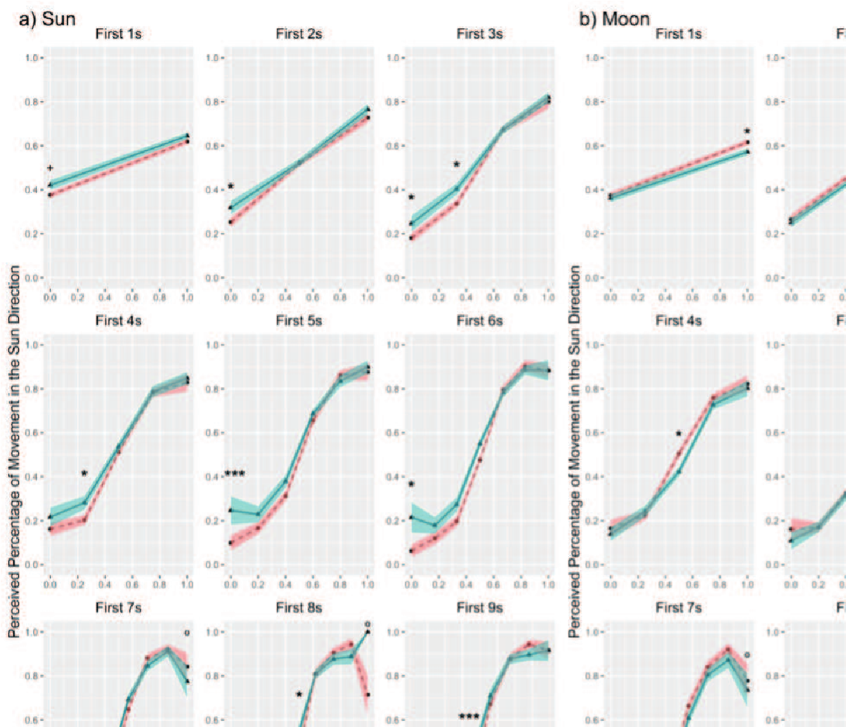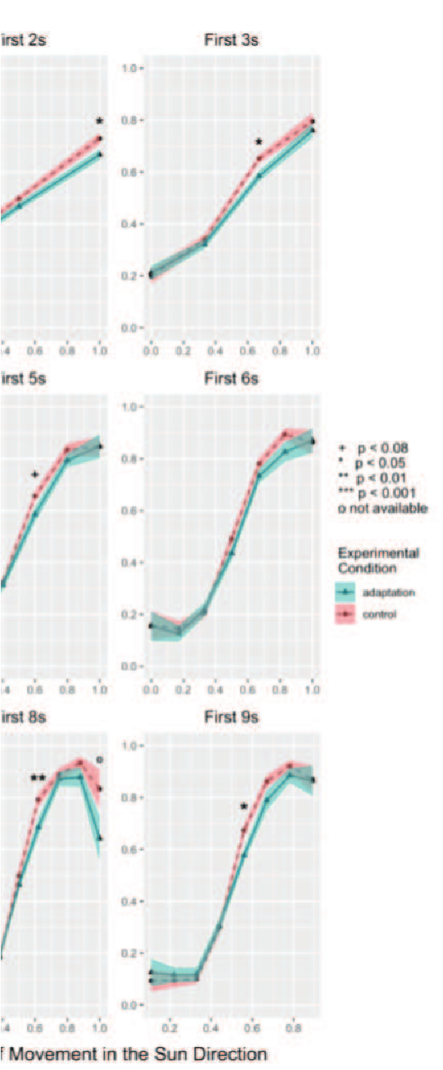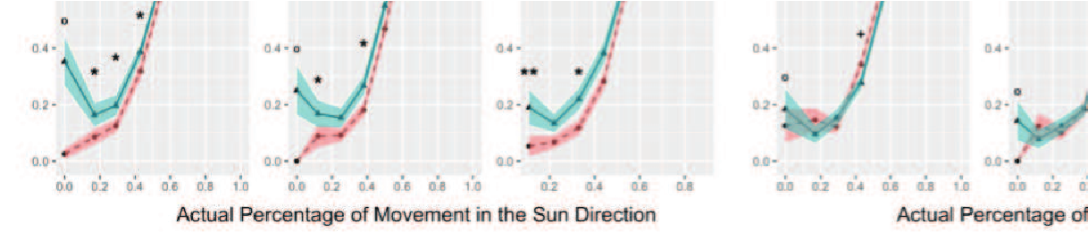

Figure S3
Experiment 1: We looked for primacy effects by examining the percent of trials selecting the adapted direction of the first 1 – 9 seconds of travel. a) The sun group. Adaptation toward the sun direction increased the perceived percentage of movement in the sun direction, similar to the full 10-second trial. b) The moon group. Adaptation toward the moon direction decreased the perceived percentage of movement in the sun direction, i.e., increased perceived percentage of movement in the moon direction, similar to the full 10-second trial. Solid lines indicate the grand average value, and the shaded area indicate 1 standard error of means. ⁺ p < 0.08; * p < 0.05; ** p < 0.01; *** p < 0.001; o not enough data for analysis under the corresponding condition, Tukey correction.

Figure S4
Experiment 1: We looked for primacy effects by examining the reaction time of the first 1 – 9 seconds of travel. a) The sun group. We did not observe any differences between the adaptation condition and the control condition. b) The moon group. We did not observe any differences between the adaptation condition and the control condition. Solid lines indicate the grand average value, and the shaded area indicate 1 standard error of means.

Recency Effects
We first calculated the actual movement percentage of each of the 9 possible last time steps (i.e., 10 s, 9 s – 10 s, 8 s – 10 s, 7 s – 10 s, 6 s – 10s, 5 s – 10 s, 4 s – 10 s, 3 s – 10 s, and 2 s – 10 s). Next, we conducted the 2-way experimental condition × actual percentage within-subjects repeated measures ANOVA and then Tukey HSD paired t-tests for adaptation trials and control trials within each actual percentage in each of the 9 last time steps. Note that the possible actual percentages vary in different time steps. The results of the perceived percentage in both the sun group (see Figure S5a) and the moon group (see Figure S5b) showed similar "opposite aftereffects" as found in the full 10-second trial analyses. Also similar to previous analyses, the results of reaction time in both the sun group and the moon group did not show any differences between the adaptation condition and the control condition. Therefore, no recency effect was found to affect the results in either the sun group (see Figure S6a) or the moon group (see Figure S6b). The lack of primacy or recency effects suggests that people used the entire test phase to make their judgments.
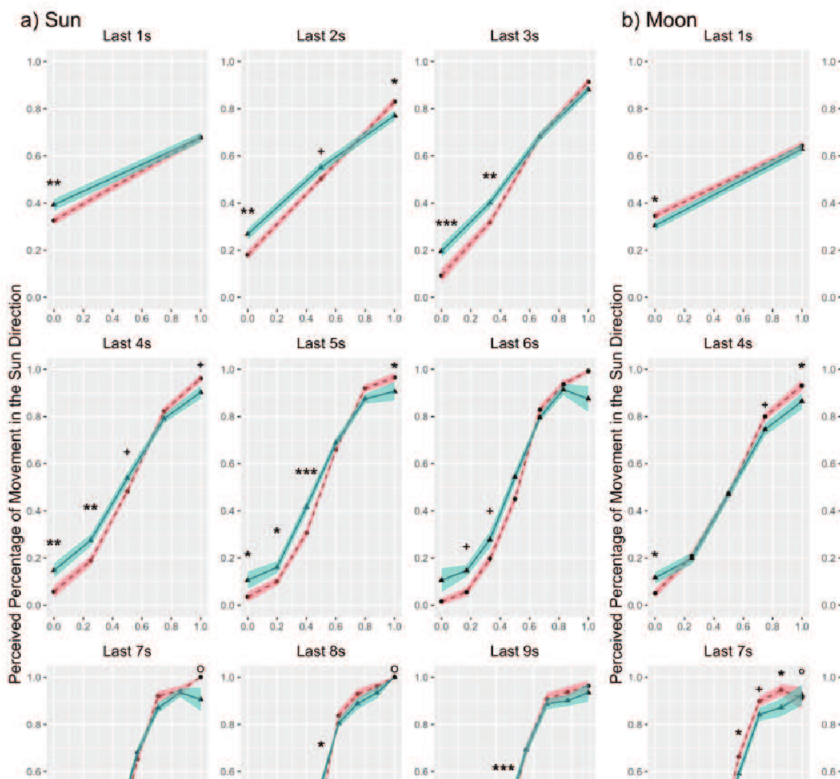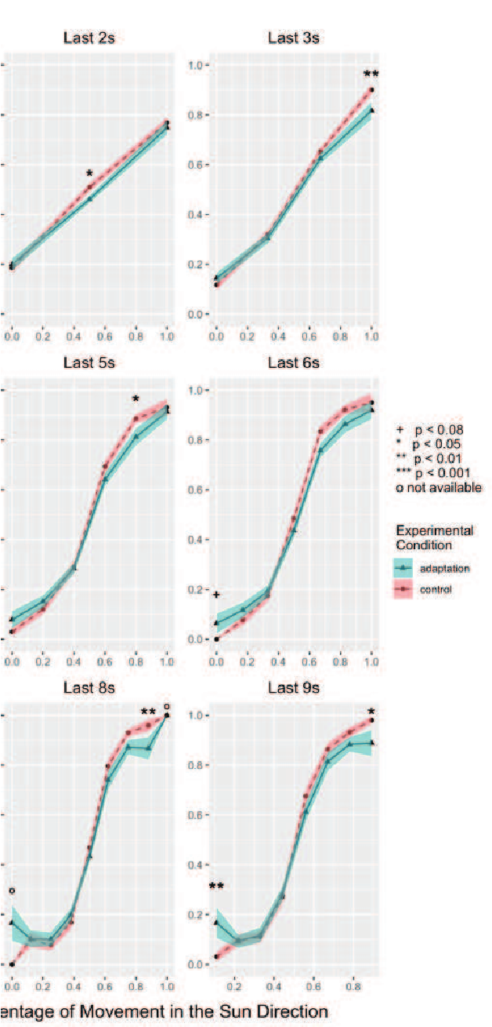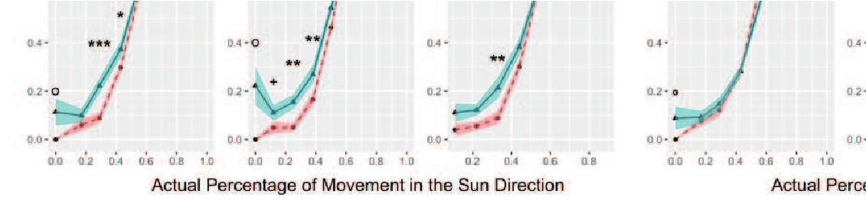

Figure S5
Experiment 1: We looked for recency effects by examining the percent of trials selecting the adapted direction of the last 1 – 9 seconds of travel. a) The sun group. Adaptation toward the sun direction increased the perceived percentage of movement in the sun direction, similar to the full 10-second trial. b) The moon group. Adaptation toward the moon direction decreased the perceived percentage of movement in the sun direction, i.e., increased perceived percentage of movement in the moon direction, similar to the full 10-second trial. Solid lines indicate the grand average value, and the shaded area indicate 1 standard error of means. ⁺ p < 0.08; * p < 0.05; ** p < 0.01; *** p < 0.001; o not enough data for analysis under the corresponding condition, Tukey correction.

Figure S6
Experiment 1: We looked for recency effects by examining the reaction time of the first 1 – 9 seconds of travel. a) The sun group. We did not observe any differences between the adaptation condition and the control condition. b) The moon group. We did not observe any differences between the adaptation condition and the control condition. Solid lines indicate the grand average value, and the shaded area indicate 1 standard error of means.

Experiment 1: Initial Trial Results for Sun and Moon Adaptation Groups
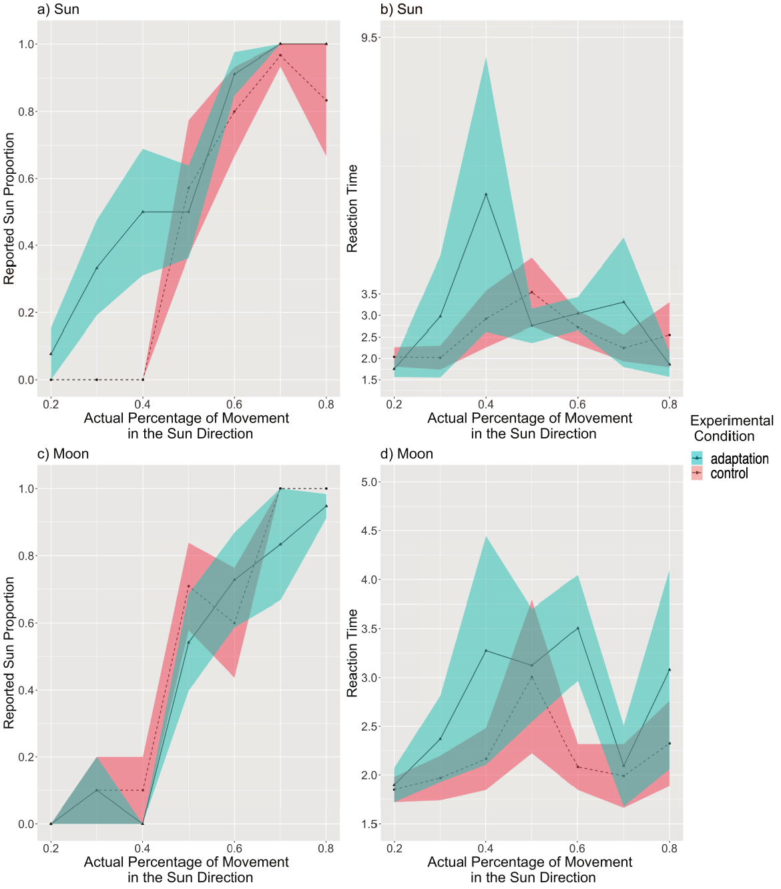

Figure S7
The perceived percentage of movement in the sun direction compared with the actual percentage for all initial trials. a) The reported rate of the sun group. The sun adaptation condition showed a tendency of overall higher percent of trials selecting the adapted direction than the control condition. b) Reaction times of the sun group. No difference were observed in reaction time between the two conditions. c) The reported rate of the moon group. The moon adaptation showed a tendency of lower percent of trials selecting the adapted direction overall than the control condition. d) The reaction time of the moon group. Reaction times of the sun group. No difference were observed in reaction time between the two conditions. Solid lines indicate the grand average value, and the shaded area indicate 1 standard error of means. No inferential statistical analyses was conducted due to not enough initial trials.

Experiment 1: Filtered Data
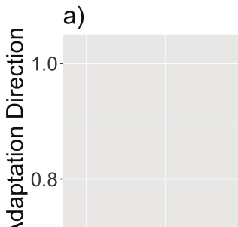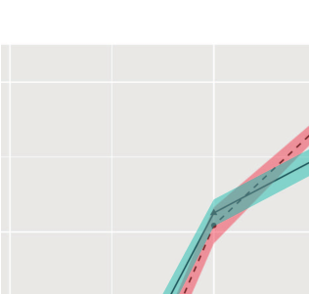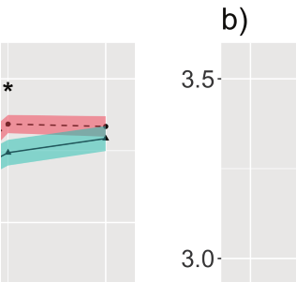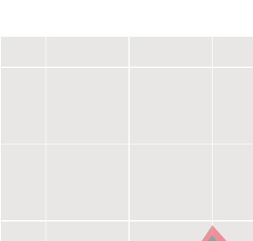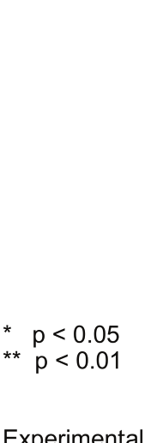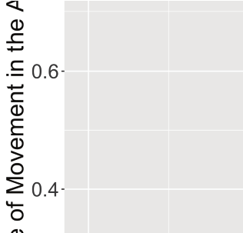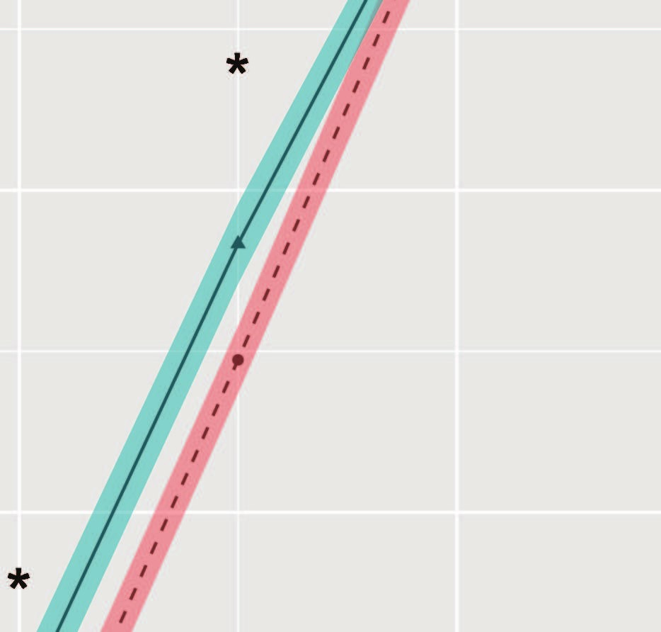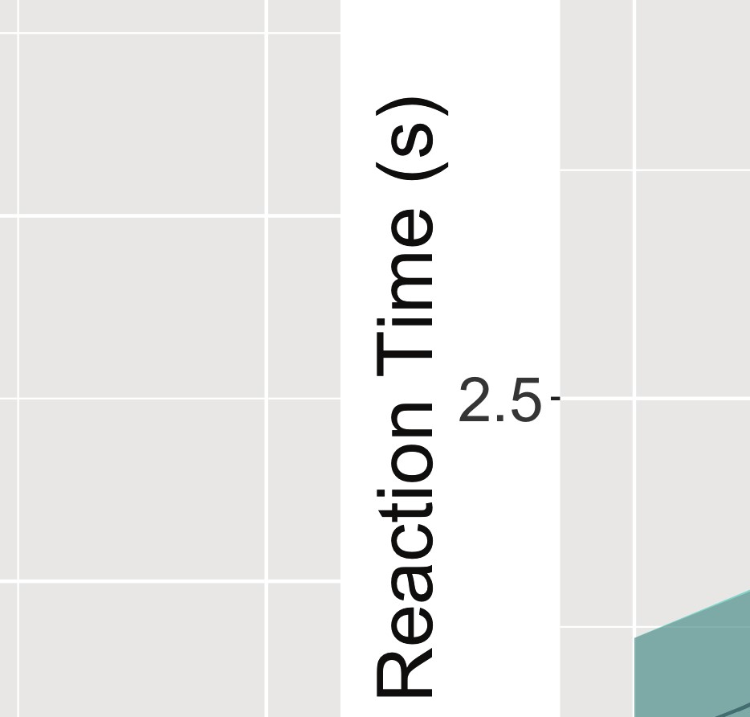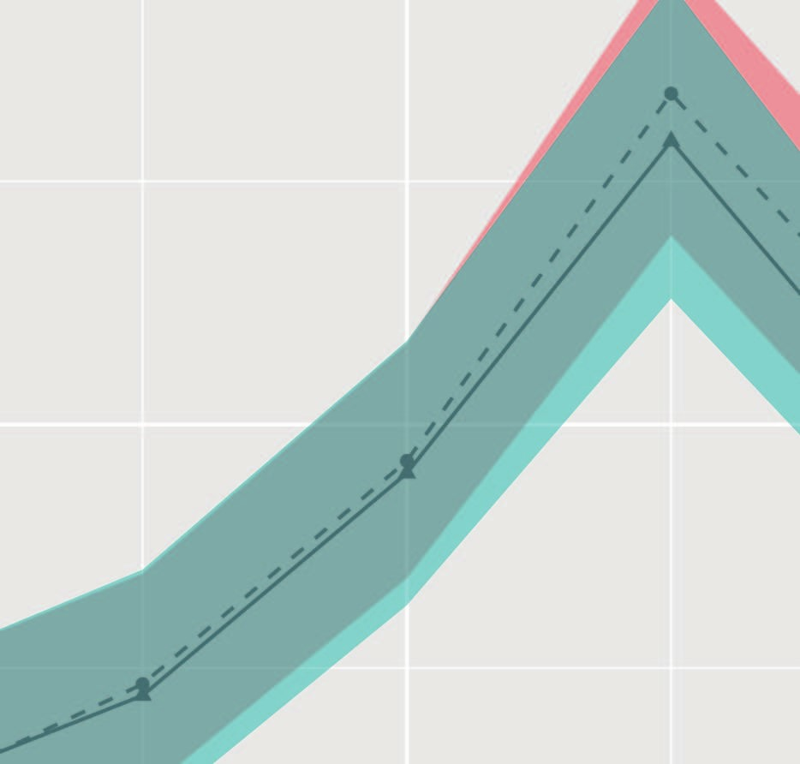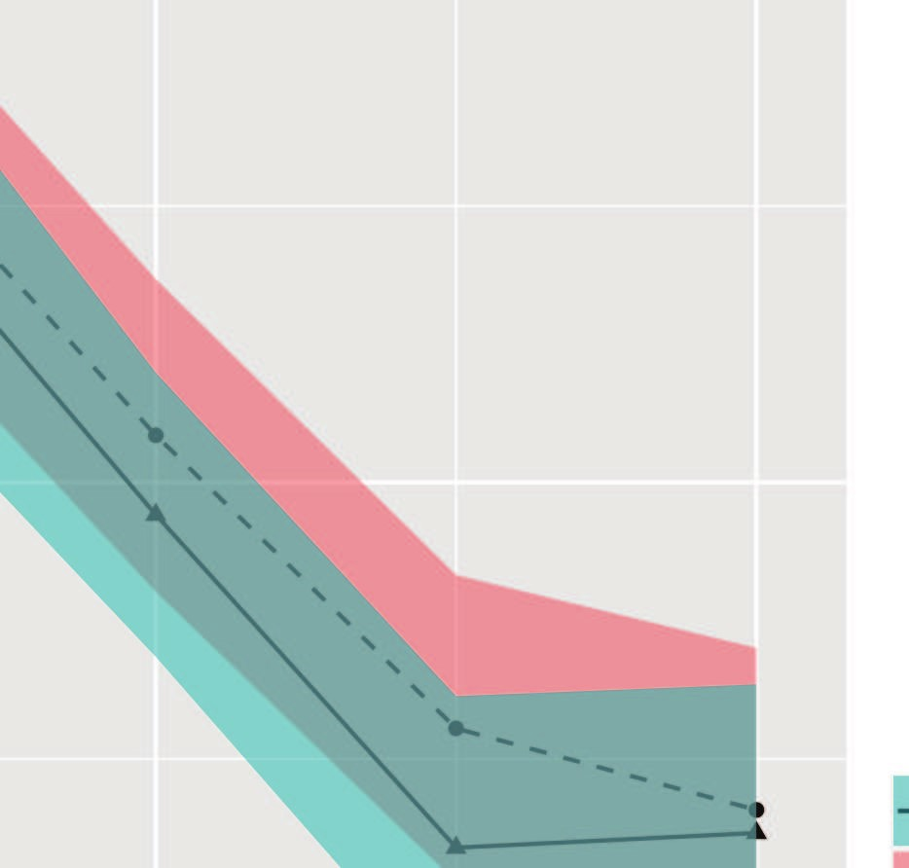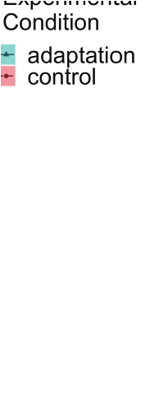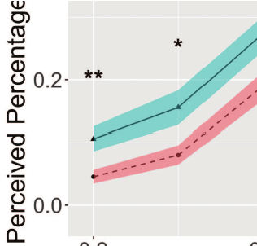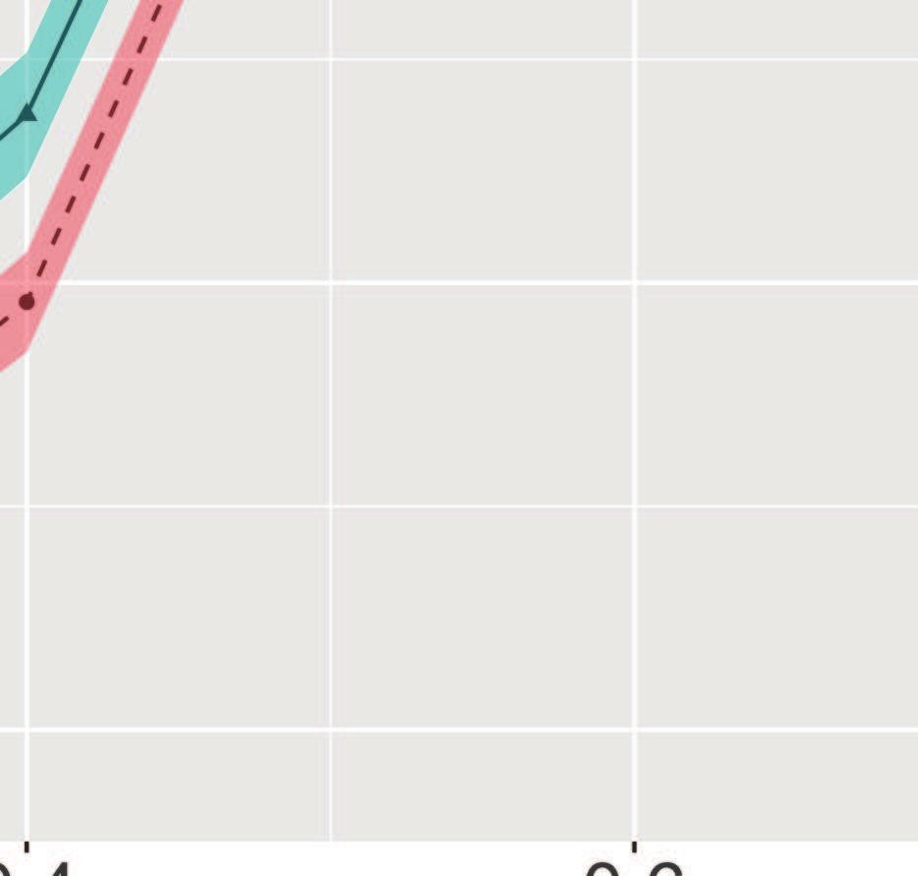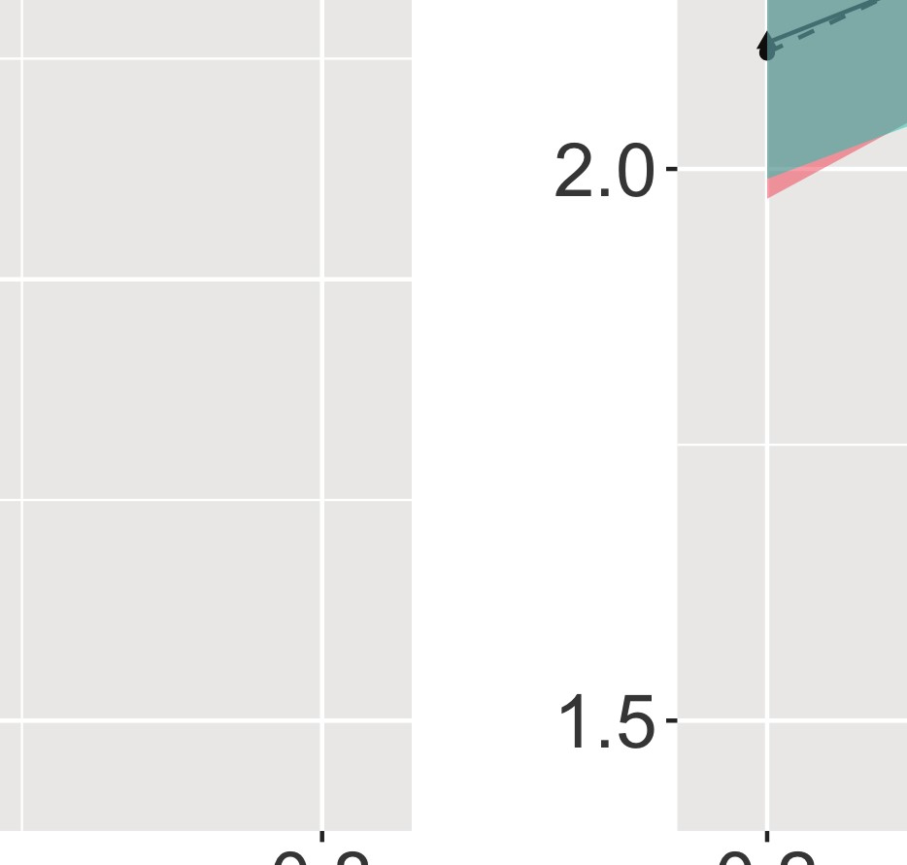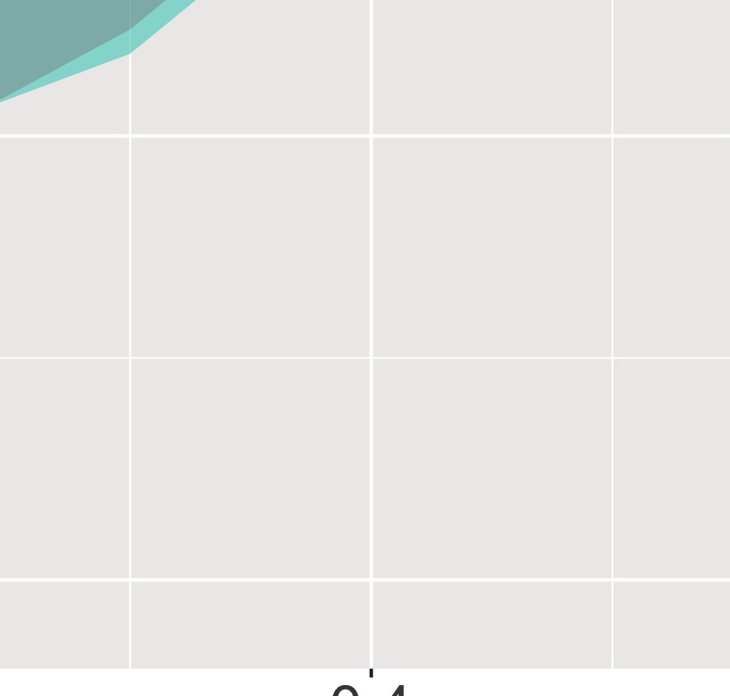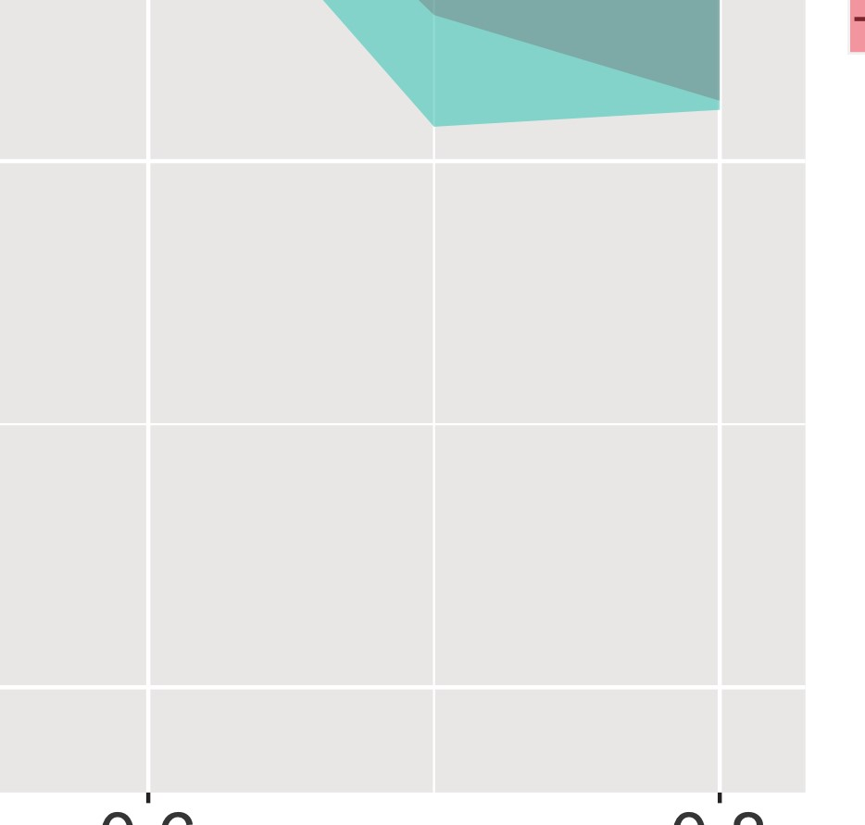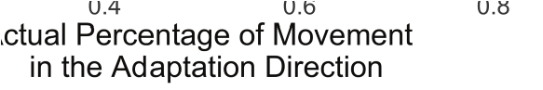

Figure S8
Experiment 1: The perceived percentage of movement in the adaptation direction compared with the actual percentage for filtered subjects (n = 51). a) The reported rate of filtered subjects. The adaptation condition had an overall higher percent of trials selecting the adapted direction than the control condition (p = 0.002). The adaptation condition showed higher percent of trials selecting the adapted directions than corresponding control conditions at 20%, 30%, 40%, and 50%, supporting the aftereffect. This result suggests an aftereffect in the same direction of travel. There was also a significant interaction between condition and the actual percentage. b) Reaction times of filtered subjects. The reaction time increased as the actual percentage approached 50%. Solid lines indicate the grand average value, and the shaded area indicate 1 standard error of means. * p < 0.05; ** p < 0.01, Tukey correction.

Appendix B
Experiment2

Experiment 2: Raw Data

Reaction Time
0.5
1.0
1.5
2.0
2.5
3.0
3.5
20
%
30
%
40
%
50
%
60
%
70
%
80
%
Reaction Time (s)
Experimental
Condition
adaptation
control
Actual Percentage of Movement in the Adaptation Direction

Figure S9
Experiment 2: Reaction times of all subjects (n=30). The reaction time increased as the actual percentage approached 50%. Solid lines indicate the grand average value, and the shaded area indicate 1 standard error of means.

Experiment 2: Filtered Data
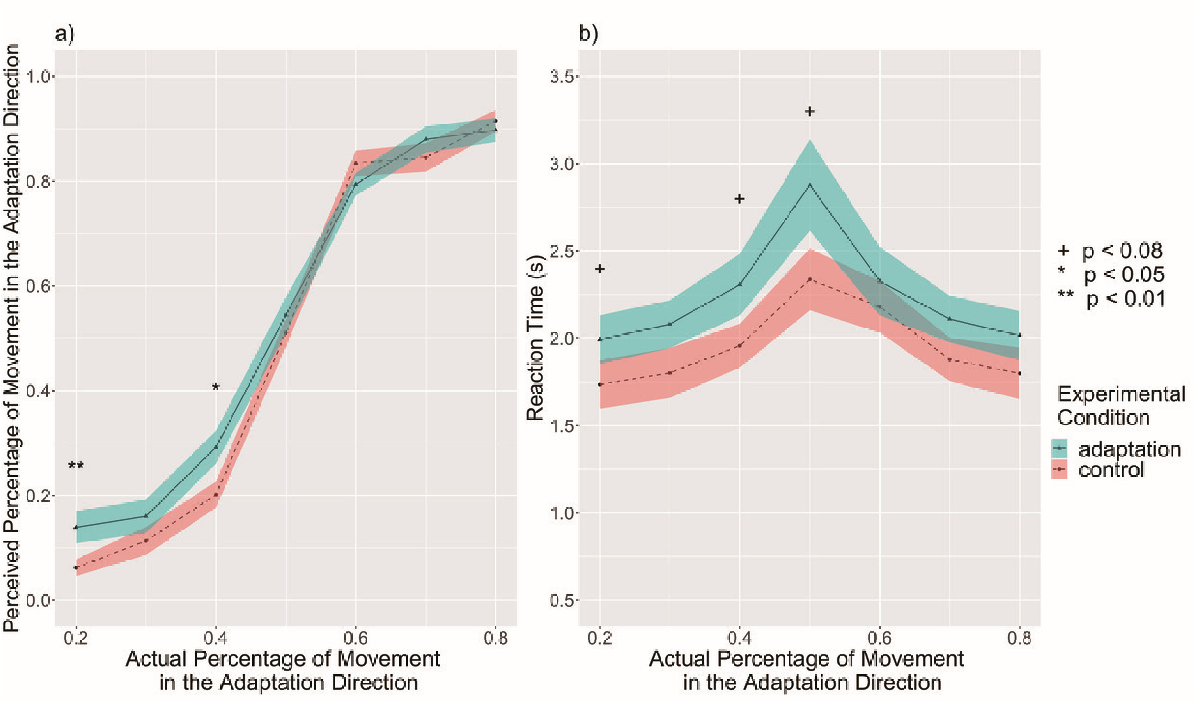

Figure S10
Experiment 2: The perceived percentage of movement in the adaptation direction compared with the actual percentage for filtered subjects (n = 23). a) The reported rate of filtered subjects. The adaptation condition had an overall marginally higher percent of trials selecting the adapted direction than the control condition (p = 0.078). The adaptation condition showed higher percent of trials selecting the adapted directions than corresponding control conditions at 20% and 40%, supporting the aftereffect. This result suggests an aftereffect in the same direction of travel. There was also a marginally significant interaction between condition and the actual percentage. b) Reaction times of filtered subjects. The reaction time increased as the actual percentage approached 50%. Solid lines indicate the grand average value, and the shaded area indicate 1 standard error of means. ⁺ p < 0.08; * p < 0.05; ** p < 0.01, Tukey correction.

Appendix C
Experiment 3a

Experiment 3a: Raw Data

Reported Rate by Adaptation Time Periods
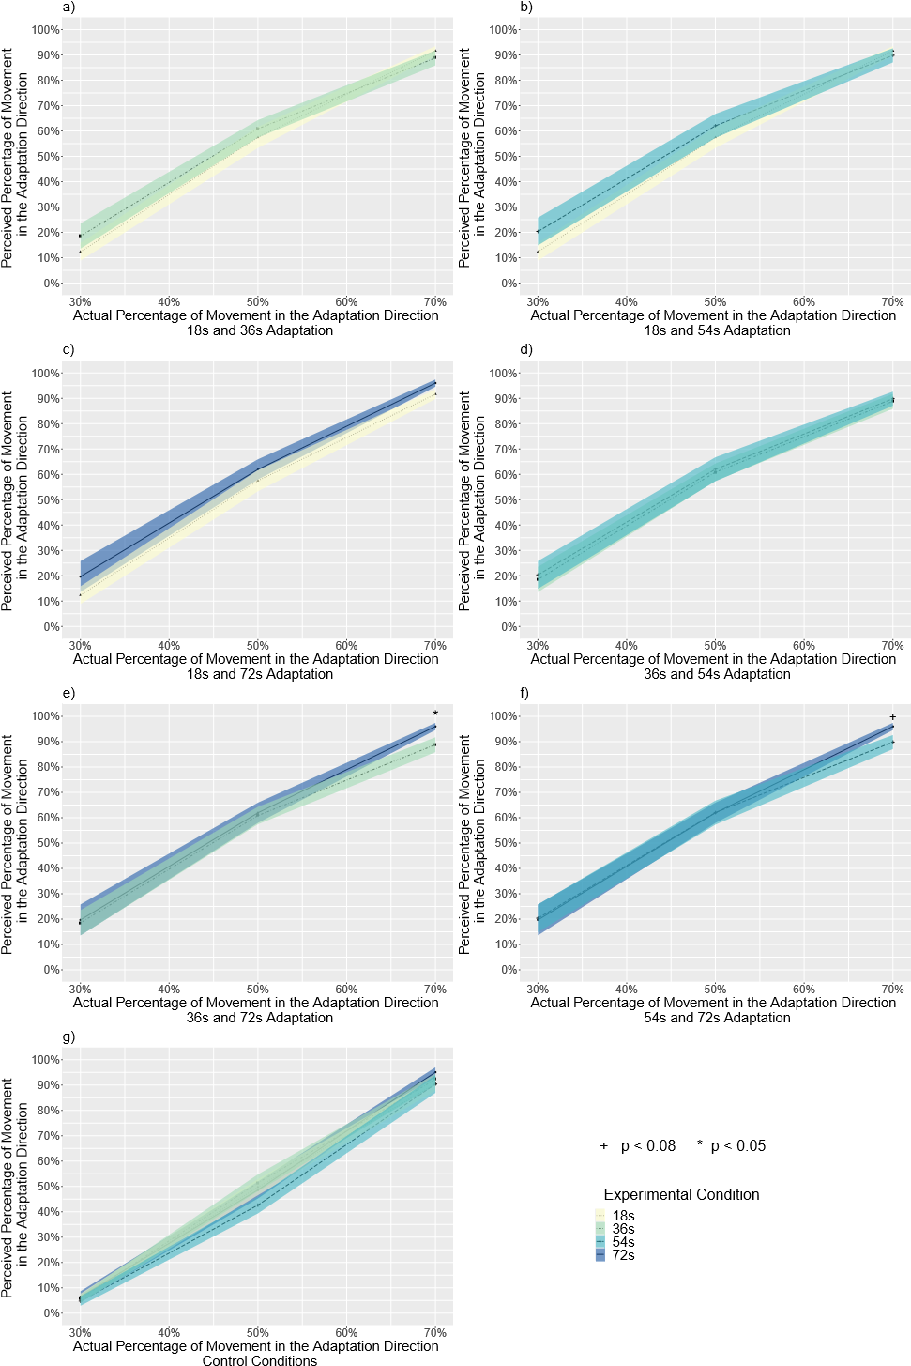

Figure S11
Experiment 3a. The perceived percentage of movement in the adaptation direction compared with the actual percentage for all subjects, separated by experimental conditions (n = 28). a) The reported rate for the 18s and 36s adaptation conditions. b) The reported rate for the 18s and 54s adaptation conditions. c) The reported rate for the 18s and 72s adaptation conditions. d) The reported rate for the 36s and 54s adaptation conditions. e) The reported rate for the 36s and 72s adaptation conditions. At 70%, 72s adaptation trials had a significantly higher perceived percentage than 36s adaptation trials (p = 0.014), supporting that the aftereffect increased with adaptation time. The aftereffect is in the same direction of travel. f) The reported rate for the 54s and 72s adaptation conditions. At 70%, 72s adaptation trials had slightly higher perceived percentage than 54s adaptation trials (p = 0.055), supporting that the aftereffect increased with adaptation time. The aftereffect is in the same direction of travel. g) The reported rate for all four control conditions. There were no differences between trials with different adaptation time periods within any actual percentage. Solid lines indicate the grand average value, and the shaded area indicate 1 standard error of means. + p < 0.08, * p < 0.05. All results are reported with the Tukey correction for multiple comparisons.

Reported Rate by Control Conditions
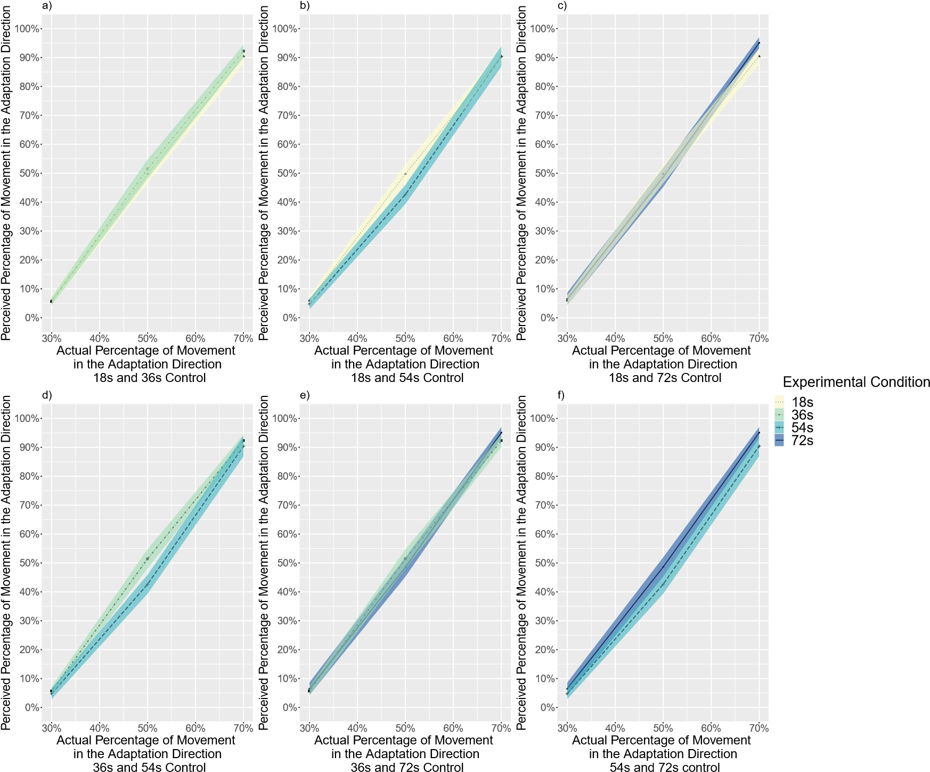

Figure S12
Experiment 3a: The perceived percentage of movement in the adaptation direction compared with the actual percentage for all subjects, separated by control conditions (n = 28). a) The reported rate for the 18s and 36s control conditions. b) The reported rate for the 18s and 54s control conditions. c) The reported rate for the 18s and 72s control conditions. d) The reported rate for the 36s and 54s control conditions. e) The reported rate for the 36s and 72s control conditions. f) The reported rate for the 54s and 72s control conditions. Solid lines indicate the grand average value, and the shaded area indicate 1 standard error of means. All results are reported with the
Tukey correction for multiple comparisons.

Reaction Times by Adaptation Time Periods
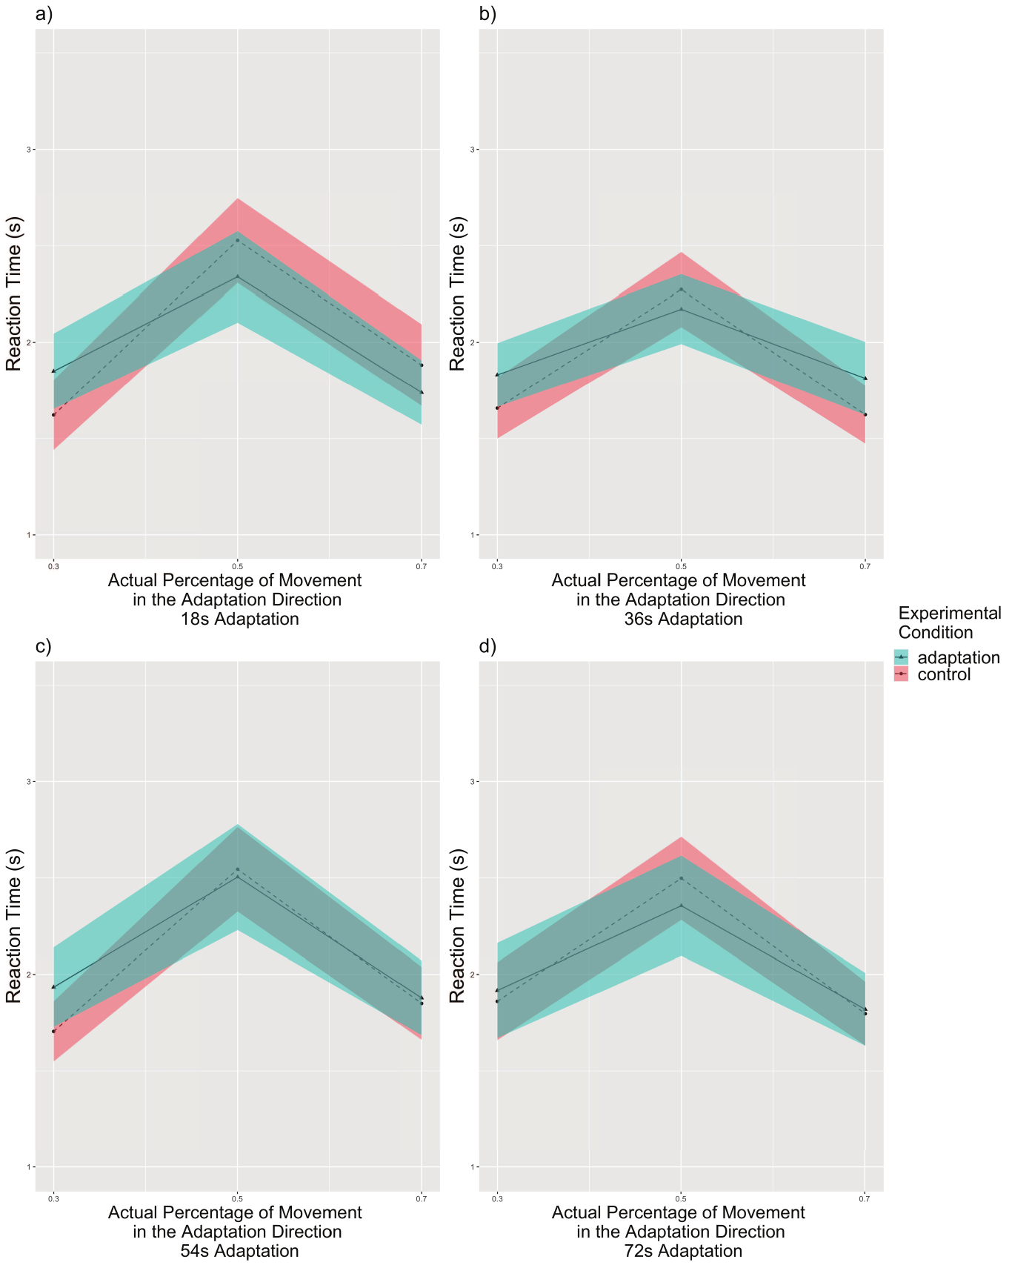

Figure S13
Experiment 3a: Reaction times compared with the actual percentage for all subjects, separated by adaptation time periods (n = 28). The reaction time increased as the actual percentage approached 50% in all adaptation time periods. a) Reaction times for 18s adaptation trials. b) Reaction times for 36s adaptation trials. c) Reaction times for 54s adaptation trials. d) Reaction times for 72s adaptation trials. Solid lines indicate the grand average value, and the shaded area indicate 1 standard error of means. Tukey correction.

Reaction Times by Experimental Conditions
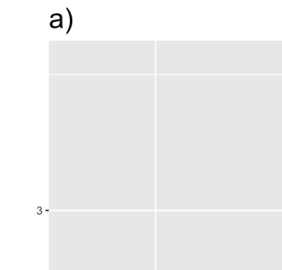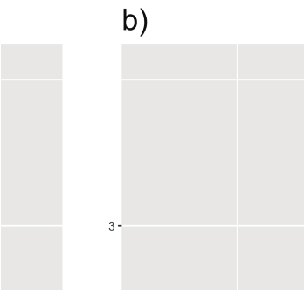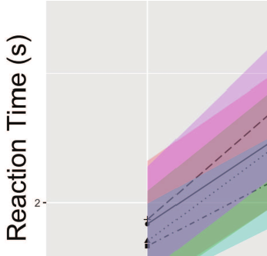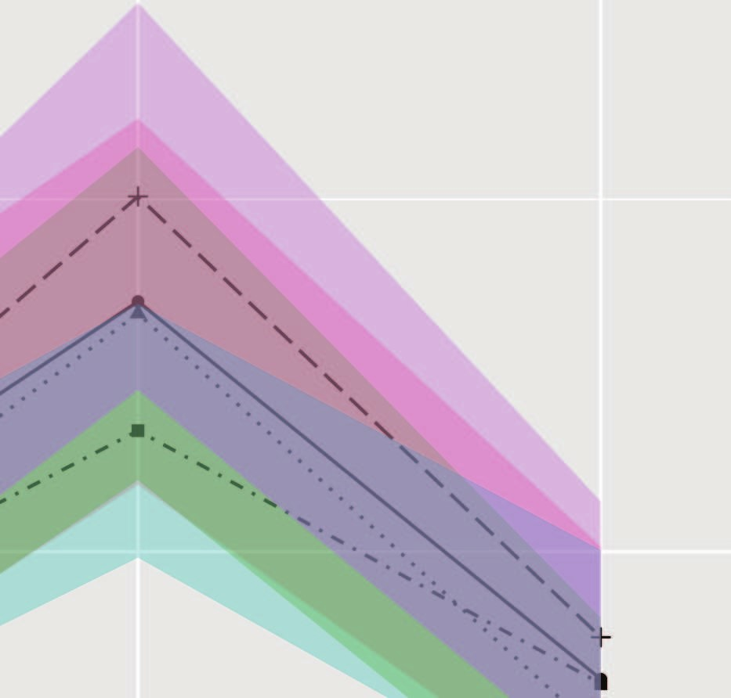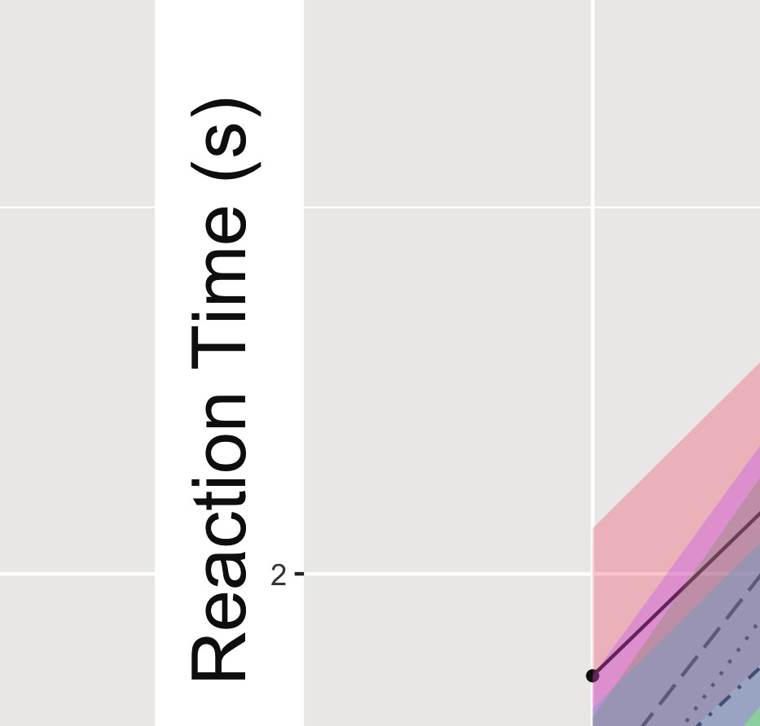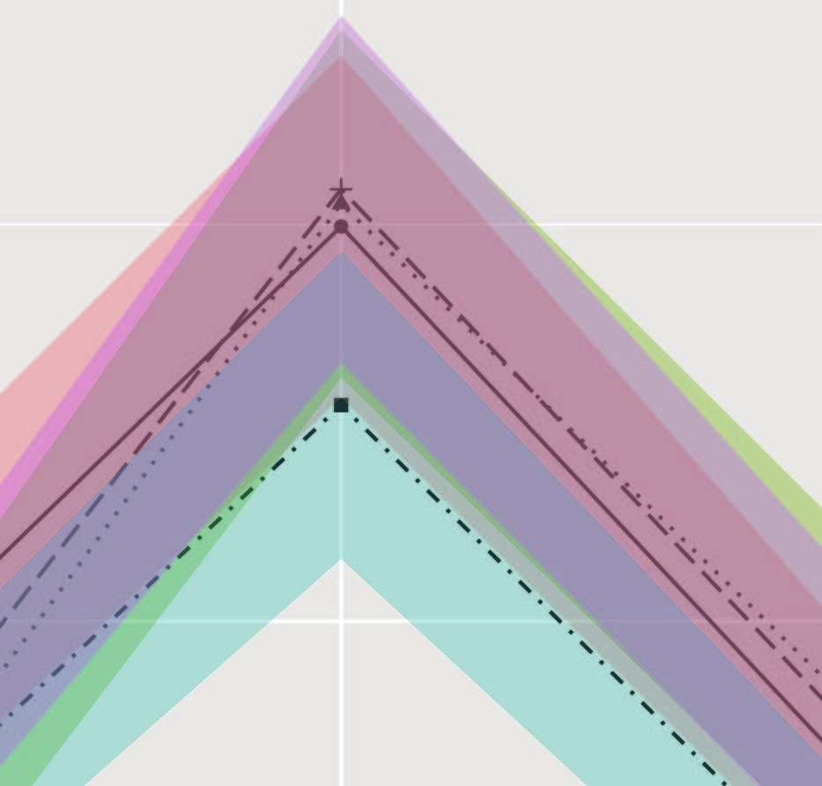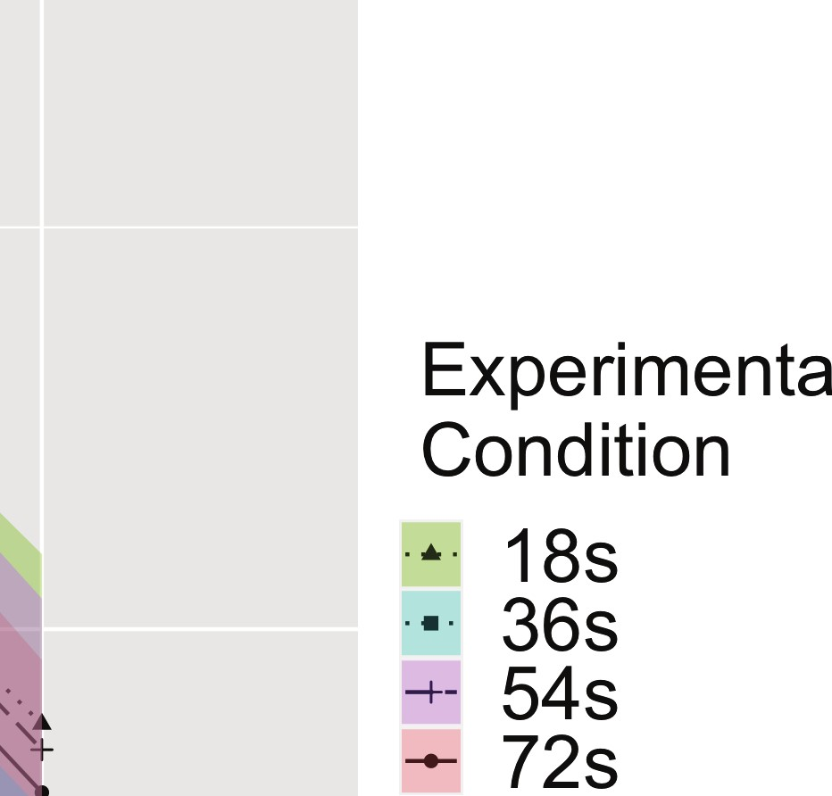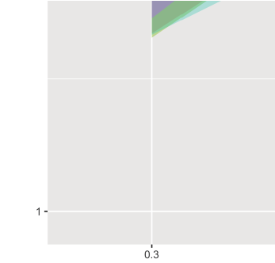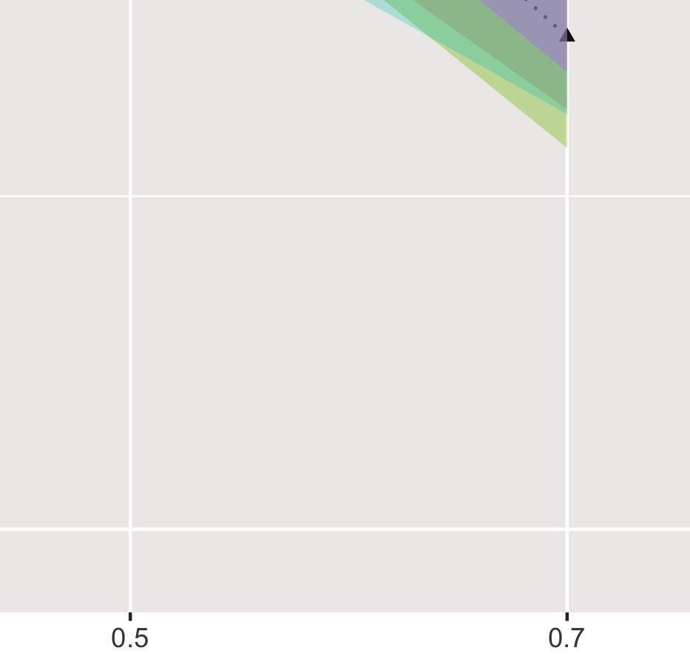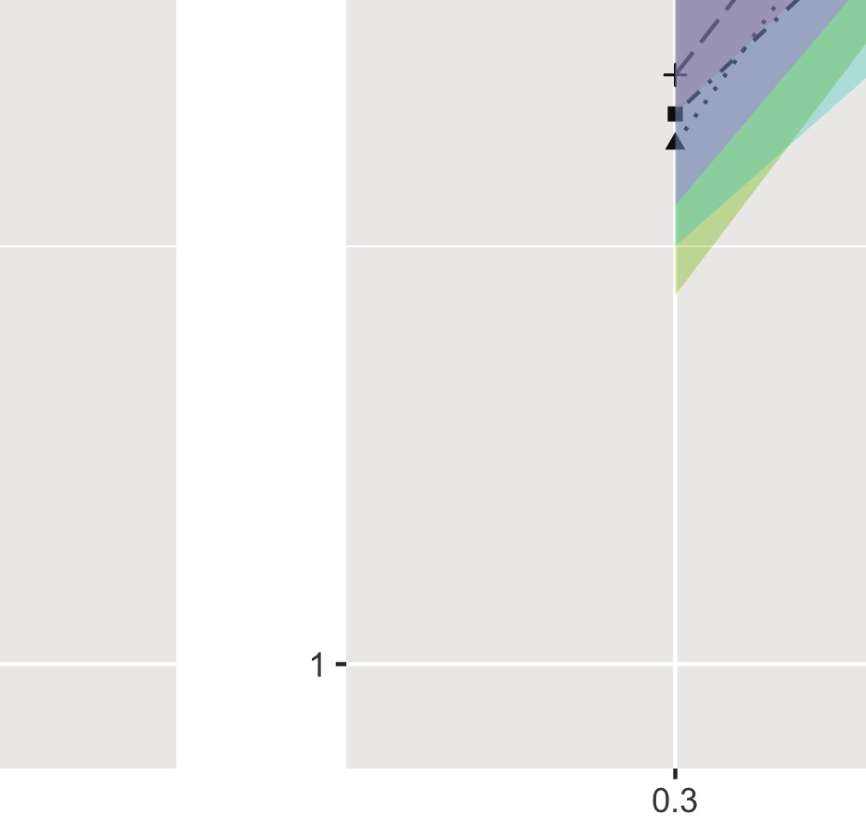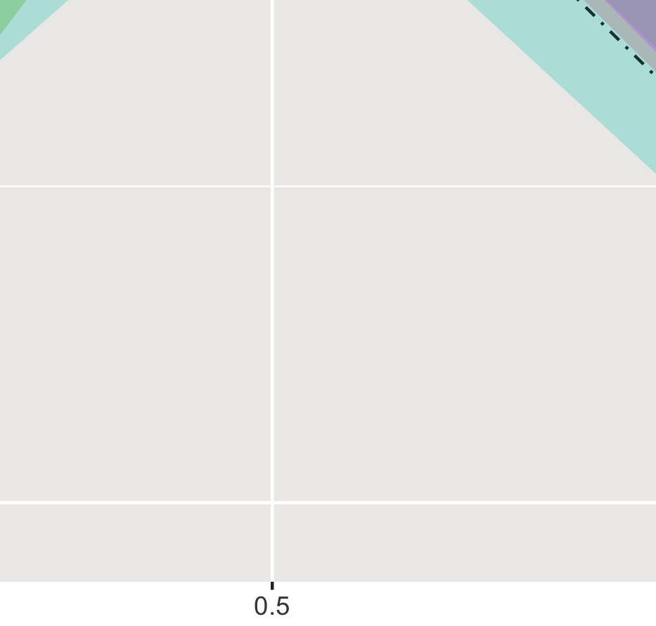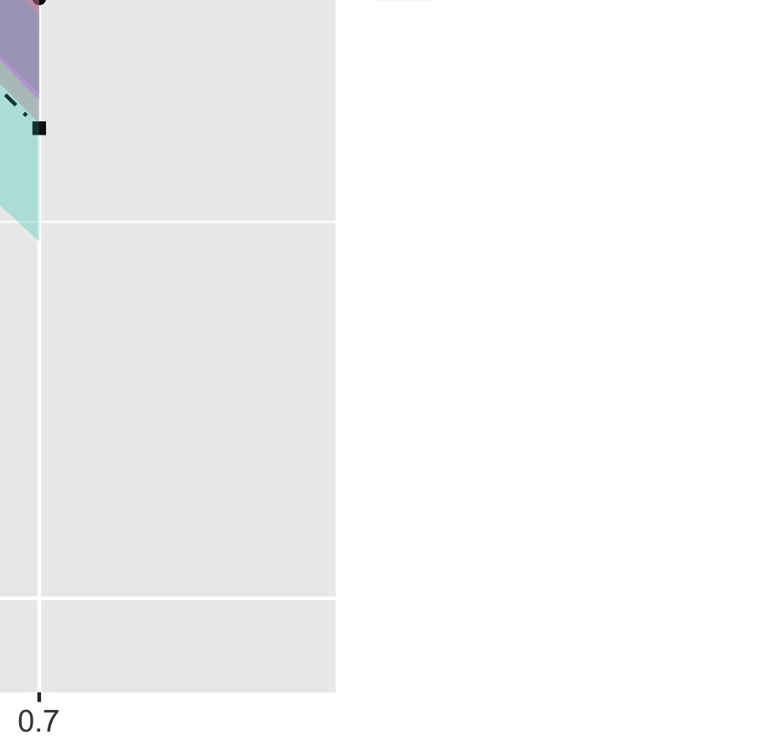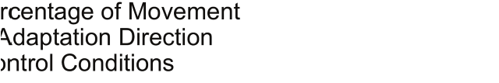

Figure S14
Experiment 3a: Reaction times compared with the actual percentage for all subjects, separated by experimental conditions (n = 28). The reaction time increased as the actual percentage approached 50% in both experimental conditions. a) Reaction times for adaptation condition. b) Reaction times for control condition. At 30%, people responded slightly slower to 72s adaptation trials than to 18s adaptation trials (p = 0.054). At 70%, people responded slightly slower to 54s adaptation trials than to 36s adaptation trials (p = 0.074). Solid lines indicate the grand average value, and the shaded area indicate 1 standard error of means. Tukey correction.

Experiment 3a: Filtered Data

Reported Rate by Adaptation Time Periods
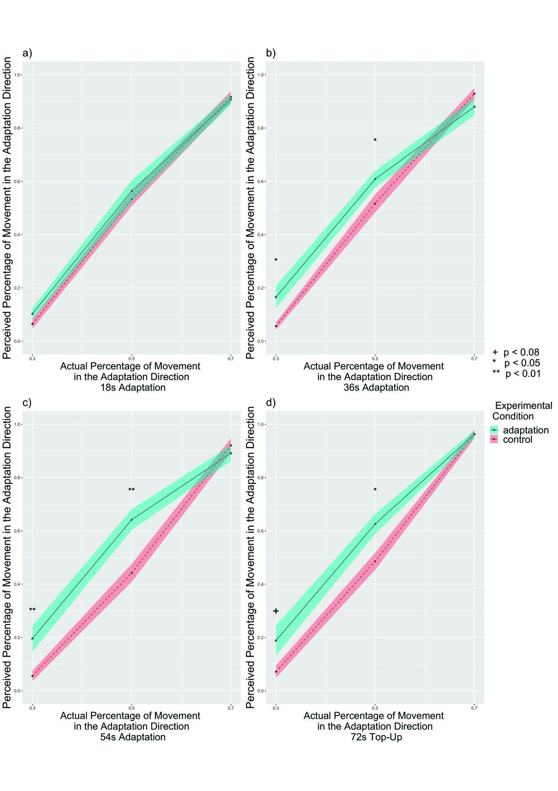

Figure S15
Experiment 3a: The perceived percentage of movement in the adaptation direction compared with the actual percentage for filtered subjects, separated by adaptation time periods (n = 24). a) The reported rate for 18s adaptation trials. The adaptation condition showed no difference from the control condition (p = 0.367). b) The reported rate for 36s adaptation trials. The adaptation condition showed slightly higher percent of trials selecting the adapted directions than control conditions (p = 0.061) particularly at 30% (p = 0.013) and 50% (p = 0.048), supporting the aftereffect in the same direction of travel. c) The reported rate for 54s adaptation trials. The adaptation condition showed higher percent of trials selecting the adapted directions than control conditions (p = 0.004) particularly at 30% (p = 0.009) and 50% (p = 0.001), supporting the aftereffect. d) The reported rate for 72s adaptation trials. The adaptation condition showed higher percent of trials selecting the adapted directions than control conditions (p = 0.022) particularly at 30% (p = 0.076) and 50% (p = 0.027), supporting the aftereffect in the same direction of travel. Solid lines indicate the grand average value, and the shaded area indicate 1 standard error of means. + p < 0.08, * p < 0.05, ** p < 0.01, Tukey correction.

Reaction Times by Adaptation Time Periods
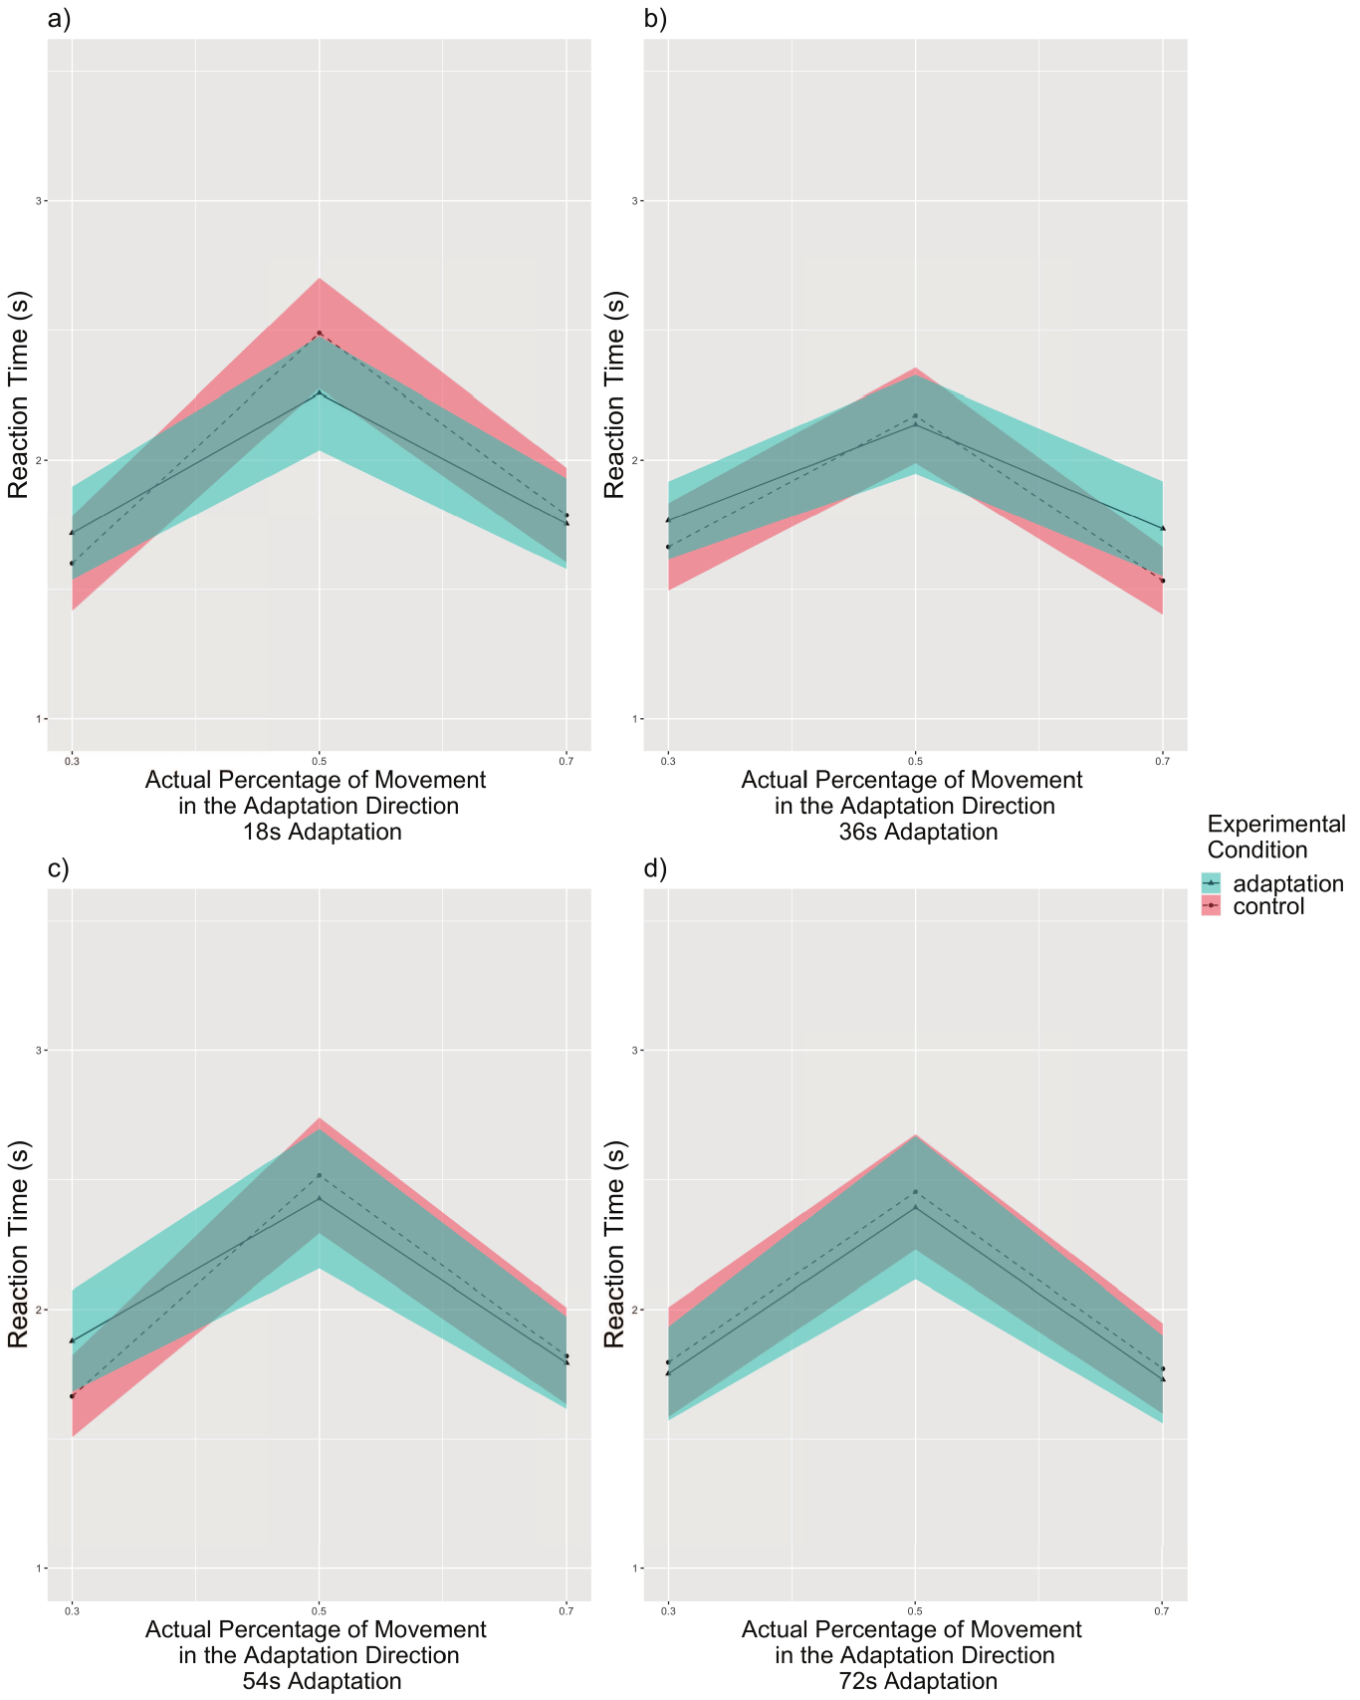

Figure S16
Experiment 3a: Reaction times compared with the actual percentage for filtered subjects, separated by adaptation time periods (n = 24). The reaction time increased as the actual percentage approached 50% in all adaptation time periods. a) Reaction times for 18s adaptation trials. b) Reaction times for 36s adaptation trials. c) Reaction times for 54s adaptation trials. d) Reaction times for 72s adaptation trials. Solid lines indicate the grand average value, and the shaded area indicate 1 standard error of means. Tukey correction.

Reported Rate by Experimental Conditions
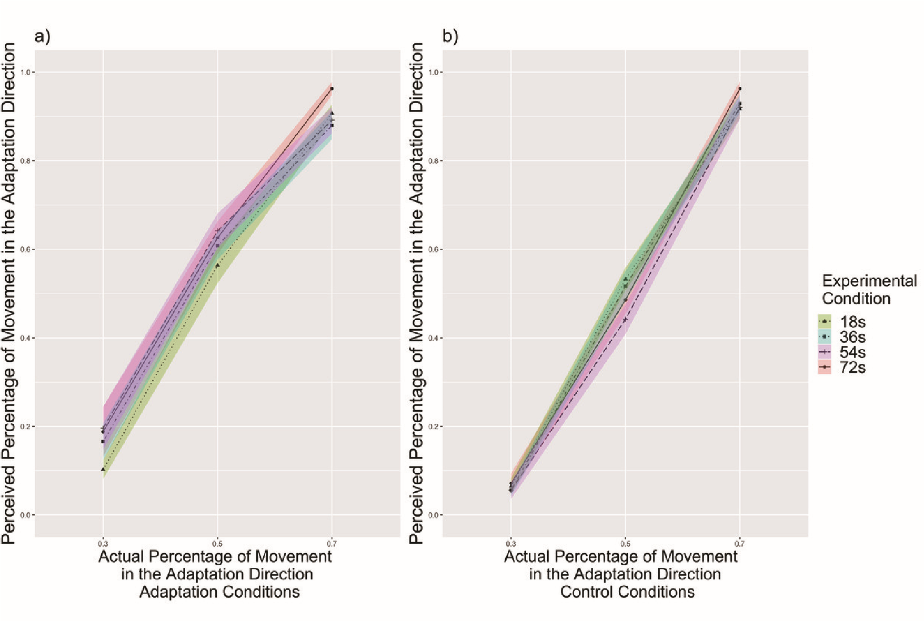

Figure S17
Experiment 3a: The perceived percentage of movement in the adaptation direction compared with the actual percentage for filtered subjects, separated by experimental conditions (n = 24). a) The reported rate for adaptation condition. At 70%, 72s adaptation trials had higher perceived percentage than 36s adaptation trials (p = 0.014) and slightly higher than 54s adaptation trials (p = 0.053), supporting that the aftereffect increased with adaptation time. The aftereffect is in the same direction of travel. b) The reported rate for control condition. There were no differences between trials with different adaptation time periods within any actual percentage. Tukey correction.
Note: Significant result from pairwise comparisons is only reported in the text, but not labeled in the figure to avoid confusion.

Reaction Times by Experimental Conditions
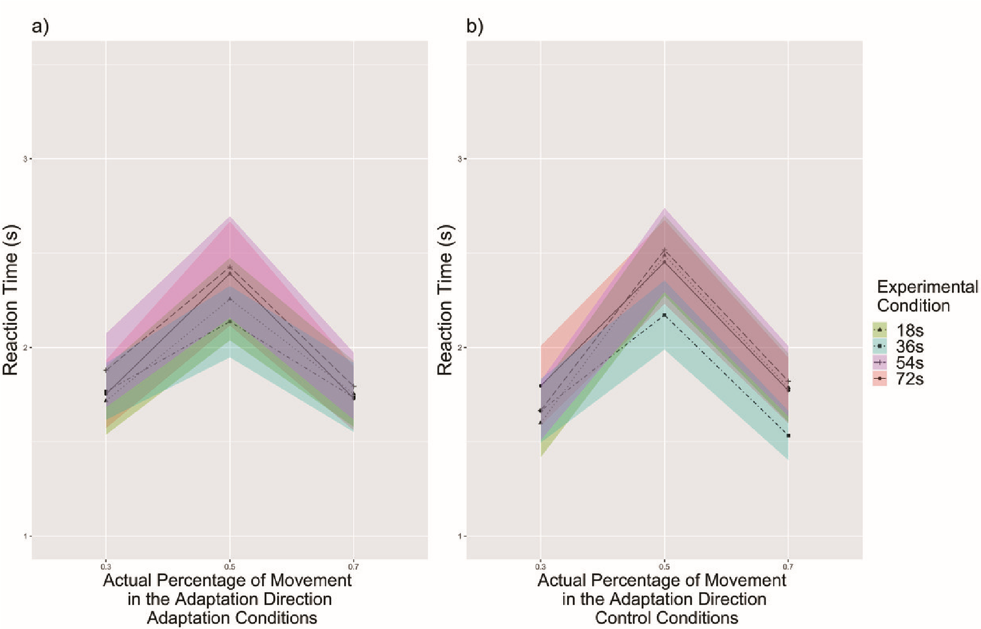

Figure S18
Experiment 3a: Reaction times compared with the actual percentage for filtered subjects, separated by experimental conditions (n = 24). The reaction time increased as the actual percentage approached 50% in both experimental conditions. a) Reaction times for adaptation condition. b) Reaction times for control condition. At 30%, people responded slightly slower to 72s adaptation trials than to 18s adaptation trials (p = 0.054). At 70%, people responded slower to 54s adaptation trials than to 36s adaptation trials (p = 0.034). Solid lines indicate the grand average value, and the shaded area indicate 1 standard error of means. Tukey correction.
Note: Significant result from pairwise comparisons is only reported in the text, but not labeled in the figure to avoid confusion.
Appendix D
Experiment 3b

Experiment 3b: Raw Data

Reaction Time

Figure S19
Experiment 3b: Reaction times of all subjects (n=32). The reaction time increased as the actual percentage approached 50%. Solid lines indicate the grand average value, and the shaded area indicate 1 standard error of means.

Experiment 3b: Filtered Data

Reported Rate

Figure S20
Experiment 3b: The perceived percentage of movement in the adaptation direction compared with the actual percentage for filtered subjects (n = 15). The adaptation condition had no difference in percent of trials selecting the adapted direction with the control condition (p = 0.793, n.s.). Bayes factor for condition + subject model was 0.214 (± 0.85%) compared to the subject-only model; the strongest model was actual percentage + subject model, with a Bayes factor of 1.071× 10³⁷ (± 1.11%). Solid lines indicate the grand average value, and the shaded area indicate 1 standard error of means.

Reaction Time

Figure S21
Experiment 3b: Reaction times of filtered subjects (n=15). The reaction time showed no difference between the adaptation and the control conditions (p = 0.318, n.s.). Solid lines indicate the grand average value, and the shaded area indicate 1 standard error of means.

Appendix E
Experiment 4

Experiment 4: Methods

Participants, Stimuli, Task, Design, and Procedure
Similar to Experiment 2 and 3, we calculated a sample size of 24 for within-group comparison in Experiment 4 determined based on power analysis using G*Power software
(http://www.gpower.hhu.de/) (Erdfelder et al., 1996) based on the weakest effect size from Experiment 1. We recruited 37 participants for Experiment 4, which is more than adequate for the main objectives of this study. All participants were UCI students who participated in return for course credit or monetary incentive ($12/hour). Six participants were discarded for not completing both control and adaptation sessions (n = 6). The final pool consisted of 31 participants (15 males, 16 females; 24 not Hispanic or Latino, 5 Hispanic or Latino, 2 not reported; 17 Asian, 6 White, 2 African American, 1 American Indian/Alaskan Native, 4 more than one race, 1 not reported). Ages of the remaining 31 participants ranged from 18 to 31 (mean 21.71). All participants signed an informed consent form in agreement with the UCI Institutional Review Board requirements in accordance with the Declaration of Helsinki.
The Stimuli, Task, Design, and Procedure are the same as Experiment 3. The only change was that in the adaptation session, a few (0 - 3) blocks were inadvertently randomly changed to adaptation to the moon direction. Regardless of whether the block was adapted to the sun or to the moon direction, within each block the initial trial and top-up trials all adapted to the same direction. Participants were not informed of this change in advance.
Data from both directions were combined for analysis based on the adaptation direction.

Data Analysis
We first removed outlier trials that were 3 standard deviations above or below of the mean of each subject’s reaction time. Approximately 1.88% of trials were removed: 1.70% trials were removed from the experimental session and 2.06% trials were removed from the control session. From the remaining trials for each participant, we calculated the percent of trials selecting the adapted direction of movement toward the adaptation direction as well as mean reaction time for each percentage level at each adaptation condition (the initial adaptation trial in each block were not included). We filtered 4 subjects’ data based on the same criteria from Weibull model fit in Experiment 3. The rest of the data analyses were the same as Experiment.
Same as we have observed in Experiment 1, 2, and 3, people’s report covered three main types of strategies in Experiment 4: counting strategies (n = 18), keeping focus on a certain part of the environment for distance estimation (n = 4), and a unique strategy (n = 9). For the filtered data, there were still subjects using counting (n = 15), focusing on a part of the environment (n = 4), and a unique strategy (n = 8). Again, we controlled for the influence of strategies by adding strategy as a factor in the above ANOVA analyses for reported rate and reaction time.

Experiment 4: Reaction Times

Reaction Times by Adaptation Time Periods
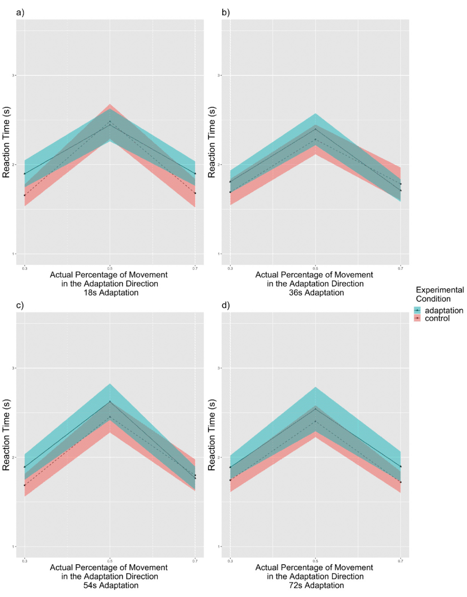

Figure S22
Experiment 4: Reaction times compared with the actual percentage for all subjects, separated by adaptation time periods (n = 31). The reaction time increased as the actual percentage approached 50% in all adaptation time periods. a) Reaction times for 18s adaptation trials. b) Reaction times for 36s adaptation trials. c) Reaction times for 54s adaptation trials. d) Reaction times for 72s adaptation trials. Solid lines indicate the grand average value, and the shaded area indicate 1 standard error of means. Tukey correction.

Reaction Times by Experimental Conditions
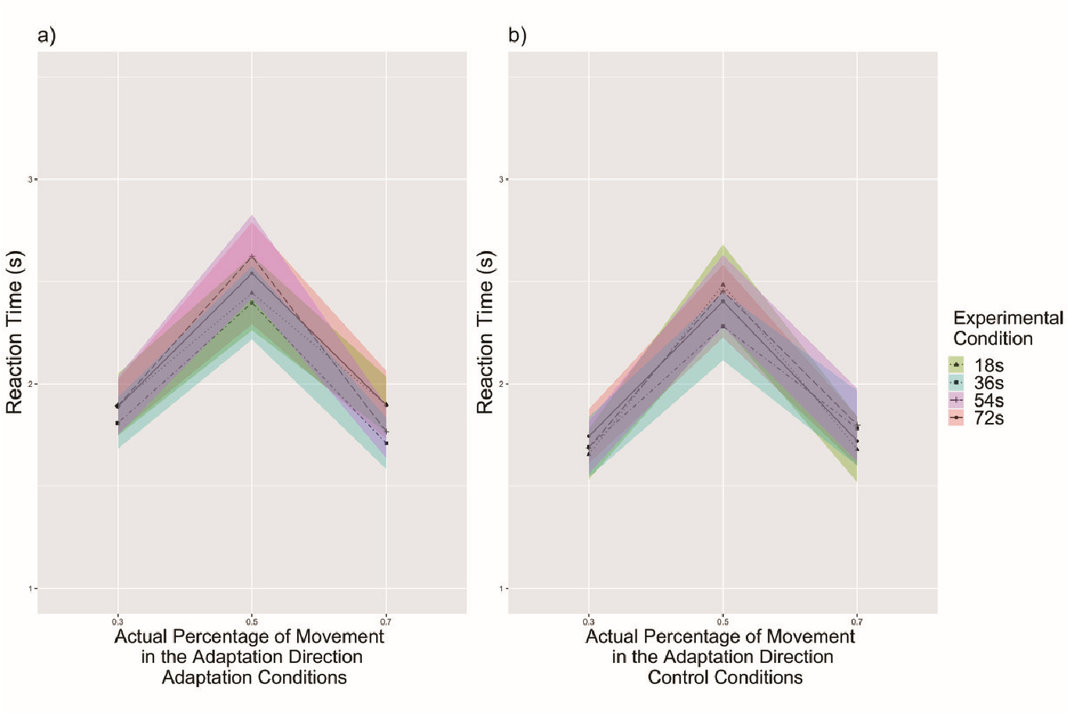

Figure S23
Experiment 4: Reaction times compared with the actual percentage for all subjects, separated by experimental conditions (n = 31). The reaction time increased as the actual percentage approached 50% in both experimental conditions. a) Reaction times for adaptation conditions. b) Reaction times for control conditions. Solid lines indicate the grand average value, and the shaded area indicate 1 standard error of means.

Experiment 4: Filtered Data

Reported Rate by Adaptation Time Periods
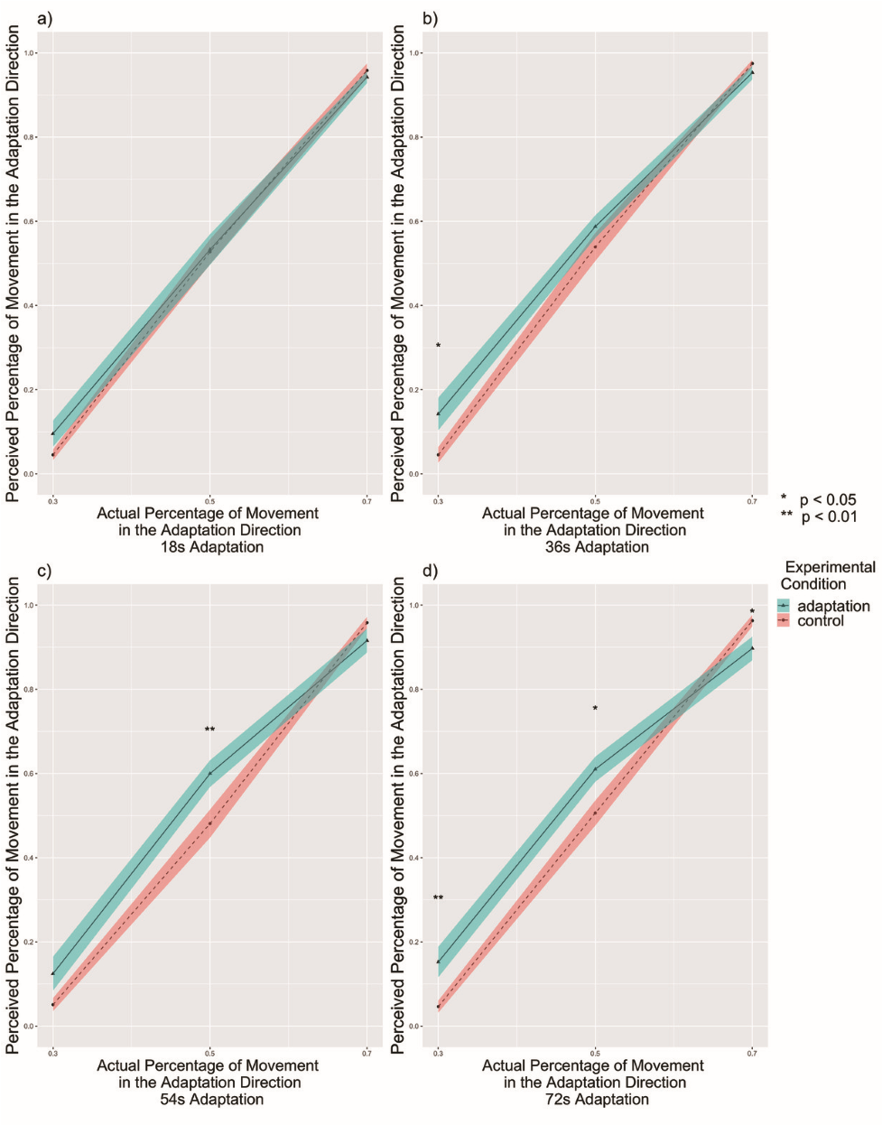

Figure S24
Experiment 4: The perceived percentage of movement in the adaptation direction compared with the actual percentage for filtered subjects, separated by adaptation time periods (n = 27). a) The reported rate for 18s adaptation trials. The adaptation condition showed no difference from the control condition (p = 0.474). b) The reported rate for 36s adaptation trials. The adaptation condition showed higher percent of trials selecting the adapted directions than control conditions (p = 0.029) particularly at 30% (p = 0.012), supporting the aftereffect in the same direction of travel. c) The reported rate for 54s adaptation trials. The adaptation condition showed higher percent of trials selecting the adapted directions than control conditions (p = 0.043) particularly at 50% (p = 0.006), supporting the aftereffect. d) The reported rate for 72s adaptation trials. The adaptation condition showed slightly higher percent of trials selecting the adapted directions than control conditions (p = 0.055) particularly at 30% (p = 0.004) and 50% (p = 0.015), supporting the aftereffect in the same direction of travel. Higher percent of trials selecting the adapted directions was shown in the control condition than in the adaptation condition at 70% (p = 0.043) though. Solid lines indicate the grand average value, and the shaded area indicate 1 standard error of means. * p < 0.05, ** p < 0.01, Tukey correction.

Reaction Times by Adaptation Time Periods
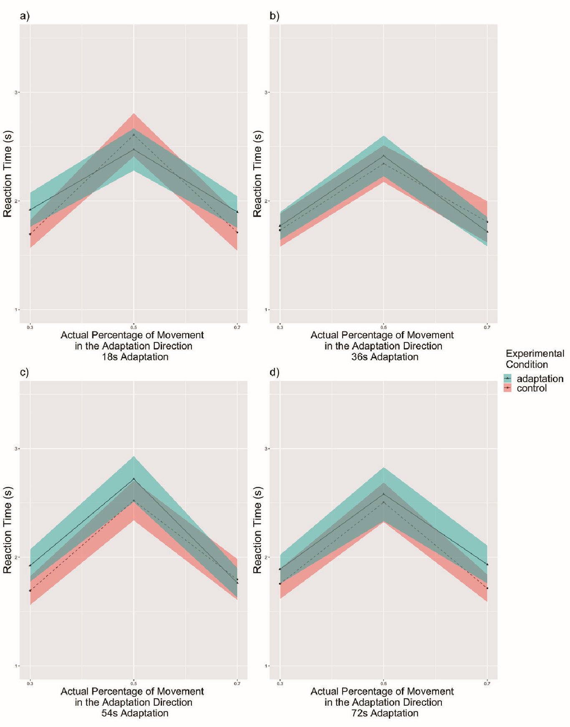

Figure S25
Experiment 4: Reaction times compared with the actual percentage for filtered subjects, separated by adaptation time periods (n = 27). The reaction time increased as the actual percentage approached 50% in all adaptation time periods. a) Reaction times for 18s adaptation trials. b) Reaction times for 36s adaptation trials. c) Reaction times for 54s adaptation trials. d) Reaction times for 72s adaptation trials. Solid lines indicate the grand average value, and the shaded area indicate 1 standard error of means. Tukey correction.

Reported Rate by Experimental Conditions
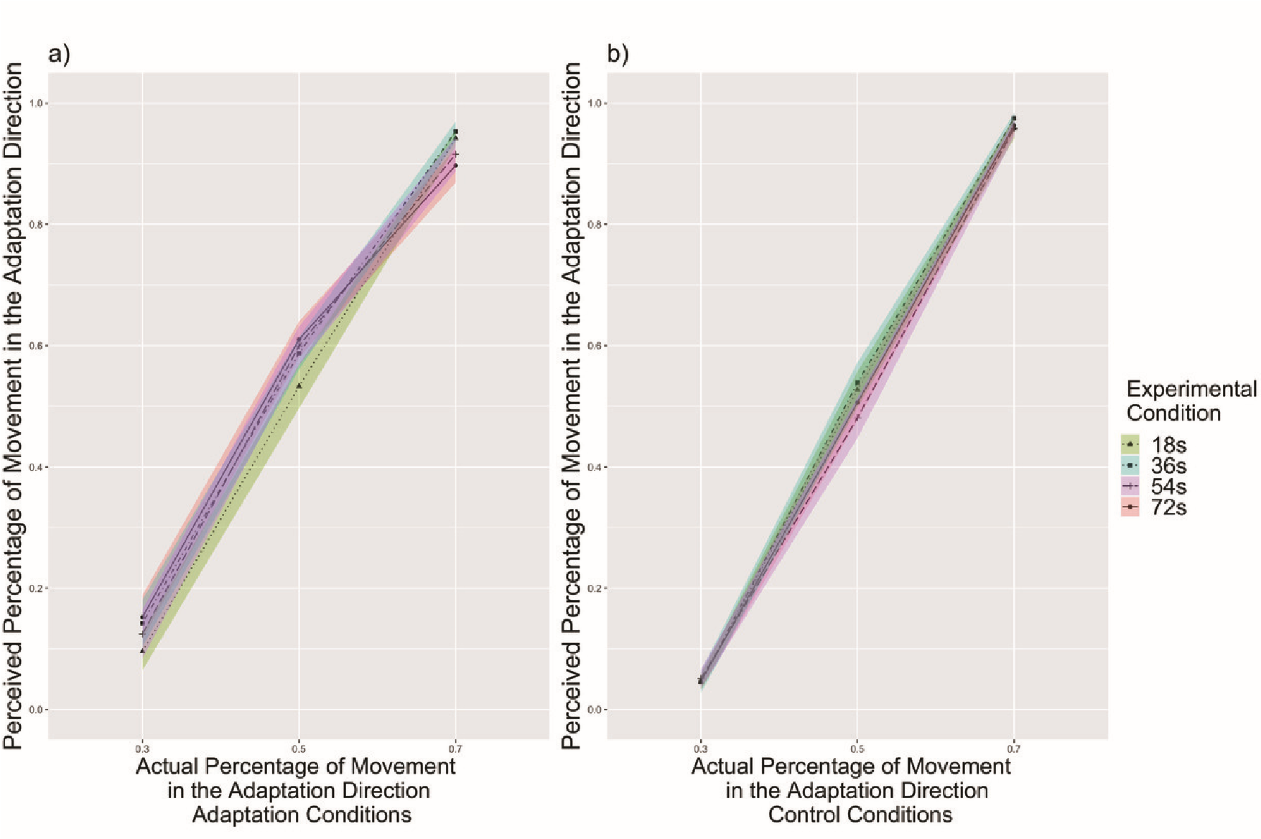

Figure S26
Experiment 4: The perceived percentage of movement in the adaptation direction compared with the actual percentage for filtered subjects, separated by experimental conditions (n = 27). a) The reported rate for adaptation conditions. At 70%, 72s adaptation trials had slightly higher perceived percentage than 36s adaptation trials (p = 0.058), supporting that the aftereffect increased with adaptation time. The aftereffect is in the same direction of travel. b) The reported rate for control conditions. There were no differences between trials with different adaptation time periods within any actual percentage. Tukey correction.
Note: Significant result from pairwise comparisons is only reported in the text, but not labeled in the figure to avoid confusion.

Reaction Times by Experimental Conditions
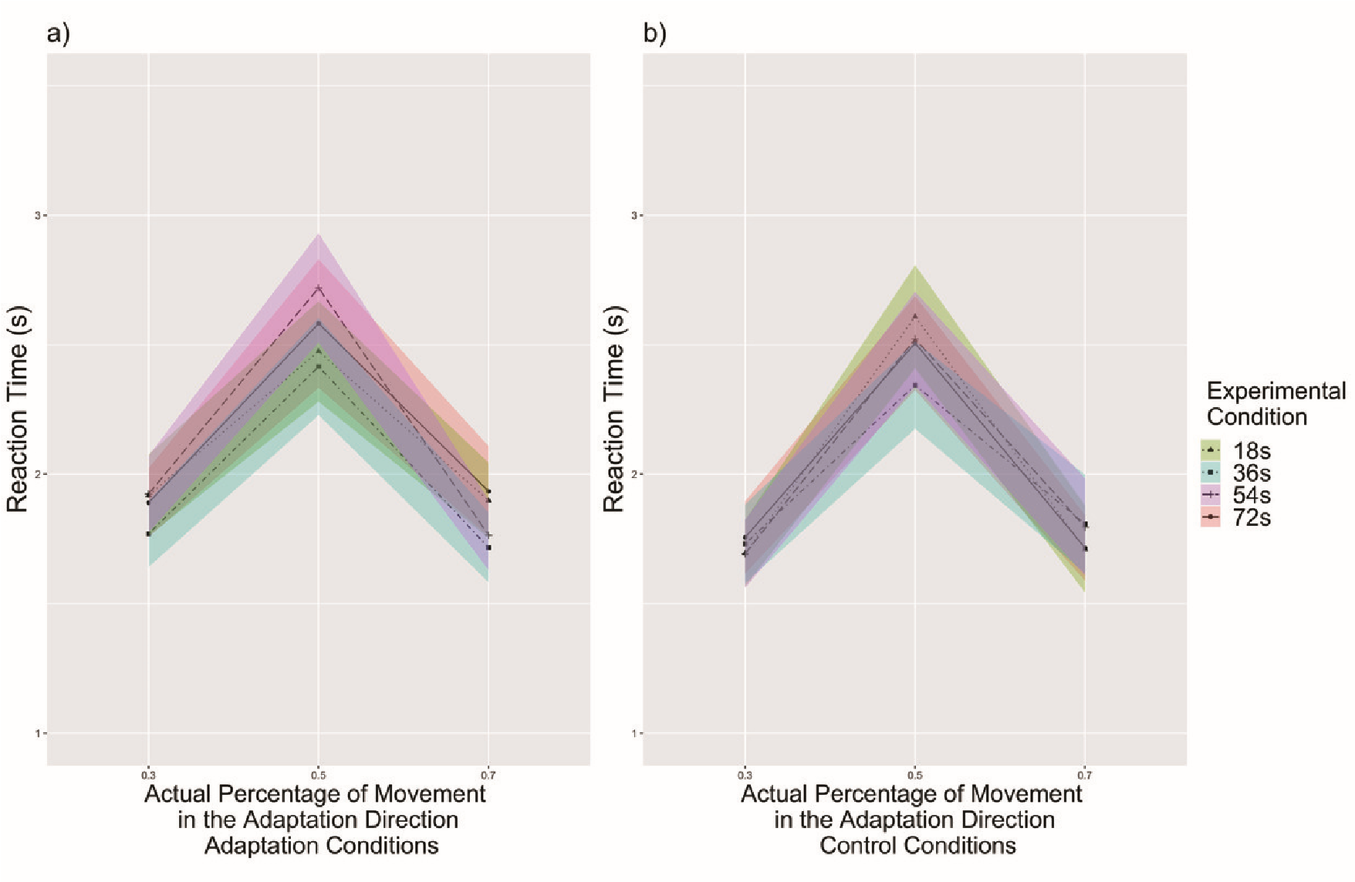

Figure S27
Experiment 4: Reaction times compared with the actual percentage for filtered subjects, separated by experimental conditions (n = 27). The reaction time increased as the actual percentage approached 50% in both experimental conditions. a) Reaction times for adaptation conditions. b) Reaction times for control conditions. Solid lines indicate the grand average value, and the shaded area indicate 1 standard error of means. Tukey correction.
Appendix E

Difficulty
When comparing difficulty ratings across experiments, there was a main effect of experimental condition that people overall rated adaptation condition to be more difficult than control condition (F(1, 145) = 4.57, p = 0.034, η_{p}² = 0.031, 95%C.I. = [0.000, 0.104]), and Experiment 3 was rated more difficult than Experiment 1 (p = 0.003) (Appendix Section Difficulty Raw Data Fig. S25, Appendix Section Difficulty Filtered Data Fig. S26).

Raw Data
For the task difficulty, we conducted an experimental condition (adaptation, control) × Experiments (Experiment 1, Experiment 2, Experiment 3, Experiment 4) mixed-subjects repeated measures ANOVA. We found a main effect of the experimental condition (F(1, 145) = 4.57, p = 0.034, η_{p}² = 0.031, 95%C.I. = [0.000, 0.104]) such that subjects found the adaptation condition (M = 3.93% ± 0.12%) to be more difficult than the control condition (M = 3.68% ± 0.12%). There was also a main effect of the experiments (F(3, 145) = 4.16, p = 0.007, η_{p}² = 0.079, 95%C.I. = [0.007, 0.162]). Pairwise t-tests showed people rated Experiment 3 to be more difficult than Experiment 1 (p = 0.003) and Experiment 3 to be slightly more difficult than Experiment 4 (p = 0.079). There was no interaction between the experimental condition and experiments (F(3, 145) = 1.82, p = 0.146, η_{p}² = 0.036, 95%C.I. = [0.000, 0.099], ns). See Figure S25.
Sidak post-hoc analyses revealed that people rated the adaptation session in
Experiment 3 to be more difficult than the adaptation session in Experiment 1 (p = 0.018). People rated the control session in Experiment 3 to be marginally more difficult than the control session in Experiment 1 (p = 0.051). No difference in difficulty ratings were found between adaptation and control conditions within each experiment (all p > 0.08).
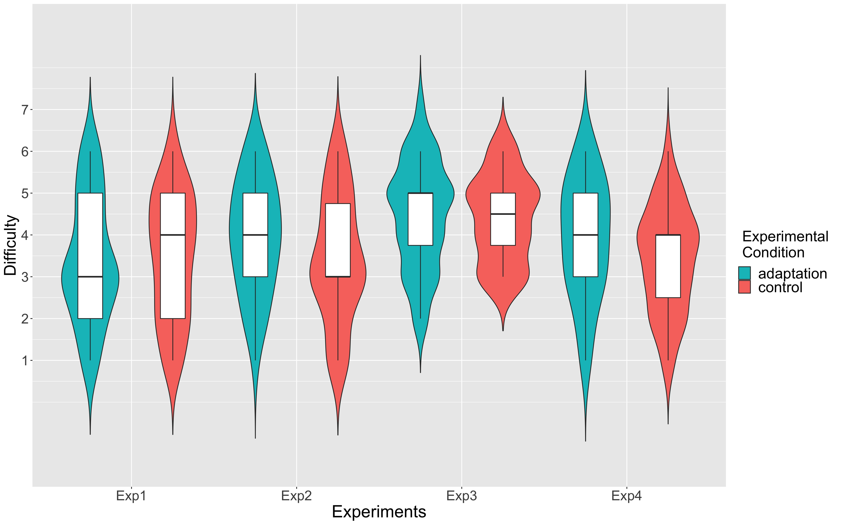

Figure S28
Task difficulty, separated by experiments and adaptation conditions. People reported the adaptation condition to be around the same as the control condition in Experiment 1 (p = 0.992), Experiment 2 (p = 0.164), Experiment 3 (p = 0.998), and Experiment 4 (p = 0.176). Note:
Experiment 1 (n = 60), Experiment 2 (n = 30), Experiment 3 (n = 28), Experiment 4 (n = 31)

Filtered Data
Then we conducted same analyses for task difficulty on filtered data. We found a main effect of the experimental condition (F(1, 122) = 4.99, p = 0.027, η_{p}² = 0.039,
95%C.I. = [0.000, 0.127]) such that subjects found the adaptation condition (M =
3.95% ± 0.14%) to be more difficult than the control condition (M = 3.67% ± 0.13%).
There was also a main effect of the experiments (F(3, 122) = 3.31, p = 0.023, η_{p}² = 0.075, 95%C.I. = [0.001, 0.164]). Pairwise t-tests showed people rated Experiment 3 to be more difficult than Experiment 1 (p = 0.014). There was a interaction between the experimental condition and experiments (F(3, 122) = 2.91, p = 0.037, η_{p}² = 0.067, 95%C.I. = [0.000,
0.152]). See Figure S26.
Sidak post-hoc analyses revealed that people rated the adaptation session in
Experiment 3 to be more difficult than the adaptation session in Experiment 1 (p = 0.041). In Experiment 2, people rated the adaptation session to be only marginally more difficult than the control session (p = 0.067).
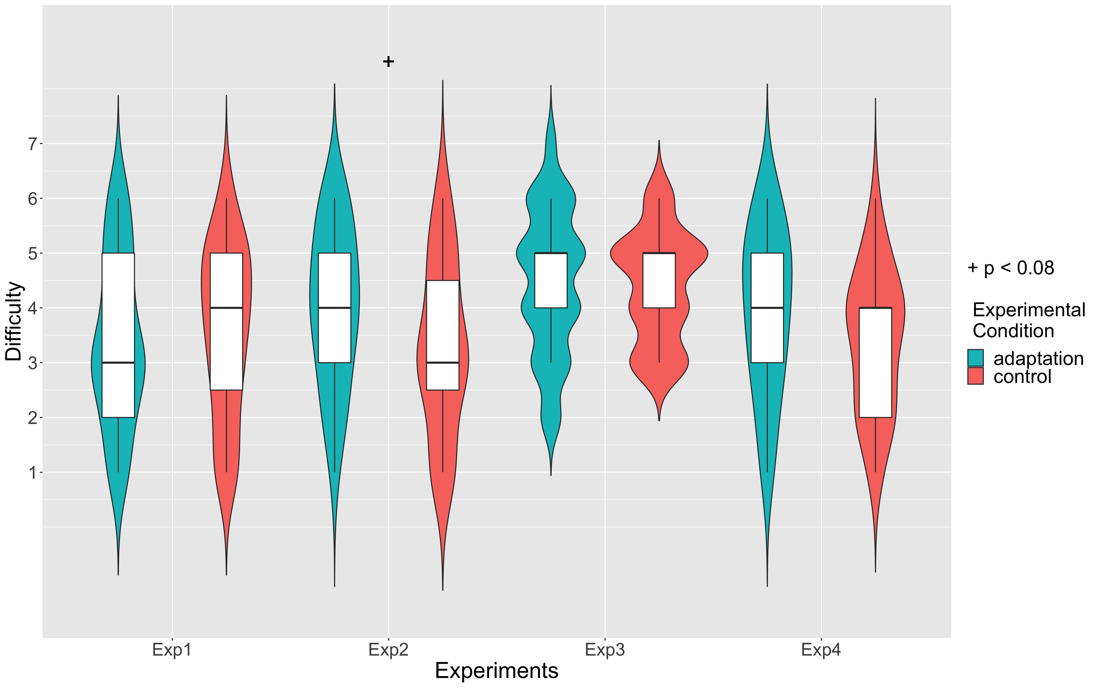

Figure S29
Task difficulty, separated by experiments and adaptation conditions. People reported the adaptation condition to be marginally more difficult than the control condition in Experiment 2 (p = 0.067), but not in Experiment 1 (p = 0.836), Experiment 3 (p = 0.997), or Experiment 4 (p =
0.146) (Sidek corrected). Note: Experiment 1 (n = 51), Experiment 2 (n = 23), Experiment 3 (n
= 24), Experiment 4 (n = 27)
Appendix F
Strategies

Experiment1

Reported Rate
Raw Data. For the perceived percentage, we conducted an experimental condition (adaptation, control) × actual percentage (20%, 30%, 40%, 50%, 60% ,70%, 80%) × strategy (counting strategies, focusing on part of the environment, unique strategies) mixed-subjects repeated measures ANOVA. There was no main effect of strategy (F(2, 53)
< 0.001, p = 0.398, η_{p}² < 0.001, 95%CI = [0.000,0.000], ns), condition (F(1, 53) = 2.62, p = 0.112, η_{p}² = 0.047, 95%CI = [0.000,0.196], ns), or interaction between strategy and condition (F(2, 53) = 0.87, p = 0.424, η_{p}² = 0.032, 95%CI = [0.000,0.148], ns). As expected, there was also a main effect of the actual percentage (F(2.08, 110.39) = 257.10, p < 0.001, η_{p}² = 0.829, 95%CI = [0.799,0.852]) that showed the perceived percentage increased with the actual percentage. We also found a marginally significant interaction between strategy and the actual percentage (F(4.17, 110.39) = 2.34, p = 0.057, η_{p}² = 0.081, 95%CI = [0.007,0.113]). There was no interaction between condition and the actual percentage (F(4.04, 214.16) = 1.47, p = 0.213, η_{p}² = 0.027, 95%CI = [0.000,0.053], ns), or interaction among strategy, condition, and the actual percentage (F(8.08, 214.16) = 1.34, p = 0.224, η_{p}² = 0.048, 95%CI = [0.000,0.066], ns). Mixed-subjects repeated measures ANOVA on the filtered report rate revealed the same pattern of results as the raw data except that there was no interaction between strategy and the actual percentage. For more details, see below.
Filtered Data. Then we conducted the same ANOVA analyses on filtered data.
There was no main effect of strategy (F(2, 44) = 0.02, p = 0.977, η_{p}² = 0.001, 95%CI = [0.000,0.000], ns), condition (F(1, 44) = 2.82, p = 0.100, η_{p}² = 0.060, 95%CI = [0.000,0.234], ns), or interaction between strategy and condition (F(2, 44) = 0.97, p = 0.386, η_{p}² = 0.042, 95%CI = [0.000,0.182], ns). As expected, there was also a main effect of the actual percentage (F(2.13, 93.83) = 312.39, p < 0.001, η_{p}² = 0.877, 95%CI = [0.852,0.895]) that showed the perceived percentage increased with the actual percentage. We found no interaction between strategy and the actual percentage (F(4.27, 93.83) = 1.38, p = 0.244, η_{p}² = 0.059, 95%CI = [0.000,0.109]), between condition and the actual percentage (F(3.76, 165.34) = 1.03, p = 0.393, η_{p}² = 0.023, 95%CI = [0.000,0.047], ns), or among strategy, condition, and the actual percentage (F(7.52, 165.34) = 1.71, p = 0.105, η_{p}² = 0.072, 95%CI = [0.000,0.100], ns).

Reaction Time
There were also no reaction time differences in strategies. For more details, see below.
Raw Data. For the reaction time, we conducted an experimental condition (adaptation, control) × actual percentage (20%, 30%, 40%, 50%, 60% ,70%, 80%) × strategy (counting strategies, focusing on part of the environment, unique strategies) mixed-subjects repeated measures ANOVA. There was no main effect of strategy (F(2, 53)
= 1.56, p = 0.220, η_{p}² = 0.056, 95%CI = [0.000,0.192], ns), condition (F(1, 53) = 2.49, p = 0.121, η_{p}² = 0.045, 95%CI = [0.000,0.192], ns), or interaction between strategy and condition (F(2, 53) = 4.37, p = 0.224, η_{p}² = 0.055, 95%CI = [0.000,0.191], ns). As expected, there was a main effect of the actual percentage (F(4.23, 223.96) = 7.34, p < 0.001, η_{p}² = 0.122, 95%CI = [0.051,0.179]) that showed the perceived percentage increased with the actual percentage. We found no interaction between strategy and the actual percentage (F(8.45, 223.96) = 1.32, p = 0.229, η_{p}² = 0.048, 95%CI = [0.000,0.089], ns), between condition and the actual percentage (F(3.79, 200.86) = 0.41, p = 0.790, η_{p}² = 0.008, 95%CI = [0.000,0.014], ns), or interaction among strategy, condition, and the actual percentage (F(7.58, 200.86) = 0.66, p = 0.715, η_{p}² = 0.024, 95%CI = [0.000,0.025], ns).
Filtered Data. Then we conducted the same ANOVA analyses on filtered data.
There was no main effect of strategy (F(2, 44) = 0.69, p = 0.506, η_{p}² = 0.030, 95%CI = [0.000,0.157], ns), condition (F(1, 44) = 2.98, p = 0.091, η_{p}² = 0.063, 95%CI = [0.000,0.238], ns), or interaction between strategy and condition (F(2, 44) = 1.60, p = 0.213, η_{p}² = 0.068, 95%CI = [0.000,0.225], ns). As expected, there was a main effect of the actual percentage (F(4.19, 184.32) = 7.40, p < 0.001, η_{p}² = 0.144, 95%CI = [0.061,0.210]) that showed the perceived percentage increased with the actual percentage. We found no interaction between strategy and the actual percentage (F(8.38, 184.32) = 1.37, p = 0.208, η_{p}² = 0.059, 95%CI = [0.000,0.108], ns), between condition and the actual percentage (F(4.54, 199.65) = 0.31, p = 0.891, η_{p}² = 0.007, 95%CI = [0.000,0.010], ns), or interaction among strategy, condition, and the actual percentage (F(9.07, 199.65) = 0.56, p = 0.831, η_{p}² = 0.025, 95%CI = [0.000,0.021], ns).

Experiment 2

Reported Rate
Raw Data. For the perceived percentage, we conducted an experimental condition (adaptation, control) × actual percentage (20%, 30%, 40%, 50%, 60% ,70%, 80%) × strategy (counting strategies, focusing on part of the environment, unique strategies) mixed-subjects repeated measures ANOVA. There was a main effect of strategy (F(2, 27) = 8.79, p = 0.001, η_{p}² = 0.394, 95%CI = [0.097,0.597]) where people who focused on a certain part of the environment (M = 0.578 ± 0.037) reported more toward adaptation direction than people using counting strategies (M = 0.496 ± 0.029;p = 0.003) or unique strategies (M = 0.487 ± 0.029;p = 0.002). There was no difference in report rate between people who used counting strategies or unique strategies (p = 0.886).
There was also a main effect of condition (F(1, 27) = 5.58, p = 0.026, η_{p}² = 0.171, 95%CI = [0.000,0.418]) where people reported more toward the adaptation direction in the adaptation session (M = 0.532 ± 0.025) than in the control session (M = 0.493 ± 0.026).
There was a marginally significant interaction between strategy and condition (F(2, 27) = 3.10, p = 0.061, η_{p}² = 0.187, 95%CI = [0.000,0.417]). As expected, there was also a main effect of the actual percentage (F(2.12, 57.37) = 214.78, p < 0.001, η_{p}² = 0.888, 95%CI = [0.859,0.909]) that showed the perceived percentage increased with the actual percentage. There was no interaction between strategy and the actual percentage (F(4.25, 57.37) = 1.33, p = 0.269, η_{p}² = 0.090, 95%CI = [0.000,0.122], ns).
There was a significant interaction between condition and the actual percentage (F(3.53, 95.40) = 3.23, p = 0.020, η_{p}² = 0.107, 95%CI = [0.012,0.178]). Tukey HSD analyses revealed that people reported more toward the adaptation direction in the adaptation session than in the condition session at 20% (p = 0.003), 40% (p = 0.005), 50% (p = 0.031), and marginally significant at 30% (p = 0.070).
There was a marginally significant interaction among strategy, condition, and the actual percentage (F(7.07, 95.40) = 2.10, p = 0.050, η_{p}² = 0.135, 95%CI = [0.003,0.185]).
The filtered data had similar results; for more details, see below.
Filtered Data. Then we conducted the same ANOVA analyses on filtered data.
There was a main effect of strategy (F(2, 20) = 13.83, p < 0.001, η_{p}² = 0.580, 95%CI = [0.241,0.747]) where people who focused on a certain part of the environment (M = 0.582 ± 0.046) reported more toward adaptation direction than people using counting strategies (M = 0.497 ± 0.029;p < 0.001) or unique strategies (M = 0.503 ± 0.033; p < 0.001). There was no difference in report rate between people who used counting strategies or unique strategies (p = 0.910).
There was also a main effect of condition (F(1, 27) = 5.58, p = 0.026, η_{p}² = 0.171, 95%CI = [0.000,0.418]) where people reported more toward the adaptation direction in the adaptation session (M = 0.532 ± 0.025) than in the control session (M = 0.493 ± 0.026).
There was no interaction between strategy and condition (F(2, 20) = 2.03, p = 0.158, η_{p}² = 0.169, 95%CI = [0.000,0.428], ns). As expected, there was also a main effect of the actual percentage (F(2.30, 45.93) = 151.55, p < 0.001, η_{p}² = 0.883,95%CI = [0.847,0.908]) that showed the perceived percentage increased with the actual percentage. There was no interaction between strategy and the actual percentage (F(4.59, 45.93) = 1.24, p = 0.307, η_{p}² = 0.110, 95%CI = [0.000,0.194], ns).
There was a significant interaction between condition and the actual percentage (F(3.94, 78.80) = 4.90, p = 0.001, η_{p}² = 0.197, 95%CI = [0.056,0.295]). Tukey HSD analyses revealed that people reported more toward the adaptation direction in the adaptation session than in the condition session at 20% (p < 0.001) and 40% (p = 0.004), and marginally significant at 50% (p = 0.073).
There was a significant interaction among strategy, condition, and the actual percentage (F(7.88, 78.80) = 3.21, p = 0.003, η_{p}² = 0.243, 95%CI = [0.060,0.320]). Tukey HSD analyses revealed that people who used strategy of focusing on part of the environment reported more toward the adaptation direction in the adaptation session than in the condition session at 20% (p = 0.012), 40% (p = 0.021), and marginally significant at 50% (p = 0.072). People who used unique strategies reported more toward the adaptation direction in the adaptation session than in the condition session at 20% (p = 0.029). At 40% actual percentage, people who focused on part of the environment reported more toward the adaptation direction in adaptation sessions than people with counting strategies in adaptation sessions (p = 0.014) and people with unique strategies in control sessions (p = 0.018). At 50% actual percentage, people who focused on part of the environment reported more toward the adaptation direction in adaptation sessions than people with unique strategies in both adaptation sessions (p = 0.018) and control sessions (p = 0.042), as well as people with counting strategies in both adaptation sessions (p = 0.021) and control sessions (p = 0.017).

Reaction Time
There were no reaction time differences in strategies. For more details, see below.
Raw Data. For the reaction time, we conducted an experimental condition (adaptation, control) × actual percentage (20%, 30%, 40%, 50%, 60% ,70%, 80%) × strategy (counting strategies, focusing on part of the environment, unique strategies) mixed-subjects repeated measures ANOVA. There was no main effect of strategy (F(2, 27) = 0.77, p = 0.472, η_{p}² = 0.054, 95%CI = [0.000,0.244], ns), condition (F(1, 27) = 0.44, p = 0.514, η_{p}² = 0.016, 95%CI = [0.000,0.202], ns), or interaction between strategy and condition (F(2, 27) = 0.59, p = 0.560, η_{p}² = 0.042, 95%CI = [0.000,0.220], ns). As expected, there was a main effect of the actual percentage (F(2.61, 70.40) = 14.51, p < 0.001, η_{p}² = 0.349, 95%CI = [0.221,0.440]) such that the reaction time increased with actual percentage, peaking at 50%. We found no interaction between strategy and the actual percentage (F(5.21, 70.40) = 0.73, p = 0.608, η_{p}² = 0.051, 95%CI = [0.000,0.058], ns), between condition and the actual percentage (F(2.72, 73.32) = 1.02, p = 0.384, η_{p}² = 0.036, 95%CI = [0.000,0.077], ns), or interaction among strategy, condition, and the actual percentage (F(5.43, 73.32) = 1.66, p = 0.150, η_{p}² = 0.109, 95%CI = [0.000,0.193], ns).
Filtered Data. Then we conducted the same ANOVA analyses on filtered data.
We found a marginally significant main effect of strategy (F(2, 20) = 2.68, p = 0.093, η_{p}² = 0.211, 95%CI = [0.000,0.471]). Tukey HSD analyses did not found difference in reaction time between people focusing on part of the environment (M = 1.555 ± 0.096s) and people using counting strategies (M = 2.348 ± 0.072s; p = 0.089), or people using unique strategies (M = 1.986 ± 0.081s; p = 0.513). There was also no difference in reaction time between people using counting strategies and people using unique strategies (p = 0.444). We found a main effect of experimental condition (F(1, 20) = 4.82, p = 0.040, η_{p}² = 0.194, 95%CI = [0.000,0.474]) where people responded slower in the adaptation session (M = 2.244 ± 0.077s) than in the control session (M = 1.956 ± 0.063a).
There was no interaction between strategy and condition (F(2, 20) = 0.56, p = 0.580, η_{p}² = 0.053, 95%CI = [0.000,0.271], ns). As expected, there was a main effect of the actual percentage (F(2.43, 48.62) = 7.14, p = 0.001, η_{p}² = 0.263, 95%CI = [0.112,0.366]) such that the reaction time increased with actual percentage, peaking at 50%. We found no interaction between strategy and the actual percentage (F(4.86, 48.62) = 0.56, p = 0.729, η_{p}² = 0.053, 95%CI = [0.000,0.046], ns), between condition and the actual percentage (F(3.40, 68.05) = 0.90, p = 0.457, η_{p}² = 0.043, 95%CI = [0.000,0.088], ns), or interaction among strategy, condition, and the actual percentage (F(6.81, 68.05) = 1.16, p = 0.337, η_{p}² = 0.104, 95%CI = [0.000,0.185], ns).

Experiment 3

Reported Rate
Raw Data. For the perceived percentage, we conducted an experimental condition (adaptation, control) × actual percentage(30%, 50%, 70%) × adaptation time periods (18s, 36s, 54s, 72s) × strategy(counting strategies, focusing on part of the environment, unique strategies) mixed-subjects repeated measures ANOVA. There was a main effect of condition (F(1, 25) = 4.69, p = 0.040, η_{p}² = 0.129, 95%CI = [0.000,0.383]) where people reported more toward the adaptation direction in the adaptation session (M = 0.566 ± 0.020) than in the control session (M = 0.486 ± 0.021). As expected, there was also a main effect of the actual percentage (F(1.37, 34.18) = 298.65, p < 0.001, η_{p}² = 0.920, 95%CI = [0.849,0.951]) that showed the perceived percentage increased with the actual percentage. There was a marginally significant interaction between the experimental condition and the actual percentage (F(1.65, 41.22) = 2.99, p = 0.070, η_{p}² = 0.107, 95%CI = [0.000,0.270]). Because the interaction was only marginally significant, we did not conduct further post-hoc analyses.
There were no main effect of strategy (F(2, 25) = 0.06, p = 0.946, η_{p}² = 0.004,
95%CI = [0.000,0.060], ns), no main effect of adaptation time periods (F(2.68, 66.89) = 0.72, p = 0.529, η_{p}² = 0.014, 95%CI = [0.000,0.056], ns), no interaction between the strategy and the experimental condition (F(2, 25) = 0.33, p = 0.725, η_{p}² = 0.020, 95%CI = [0.000,0.167], ns), no interaction between the strategy and the actual percentage (F(2.73, 34.18) = 2.50, p = 0.081, η_{p}² = 0.162, 95%CI = [0.000,0.356], ns), no interaction between the strategy and adaptation time periods (F(5.35, 66.89) = 0.64, p = 0.684, η_{p}² = 0.024, 95%CI = [0.000,0.000], ns), no interaction between the actual percentage and adaptation time periods (F(4.41, 110.33) = 1.33, p = 0.269, η_{p}² = 0.090, 95%CI = [0.000,0.122], ns), no interaction between the experimental condition and adaptation time periods (F(4.25, 57.37) = 0.66, p = 0.637, η_{p}² = 0.026, 95%CI = [0.000,0.053], ns), no interaction among the strategy, the experimental condition, and the actual percentage (F(3.30, 41.22) = 2.10, p = 0.050, η_{p}² = 0.103, 95%CI = [0.000,0.234], ns), no interaction among the strategy, the experimental condition, and adaptation time periods (F(4.77, 59.61) = 0.73, p = 0.601, η_{p}² = 0.055, 95%CI = [0.000,0.112], ns), no interaction among the strategy, the actual percentage, and adaptation time periods (F(8.83, 110.33) = 0.82, p = 0.594, η_{p}² = 0.062, 95%CI = [0.000,0.074], ns), no interaction among the experimental condition, the actual percentage, and adaptation time periods (F(4.13, 103.23) = 1.45, p = 0.223, η_{p}² = 0.055, 95%CI = [0.000,0.106], ns), or interaction among the strategy, the experimental condition, the actual percentage, and adaptation time periods (F(8.26, 103.23) = 1.18, p = 0.318, η_{p}² = 0.086, 95%CI = [0.000,0.155], ns).
Filtered Data. For the perceived percentage, we conducted an experimental condition (adaptation, control) × actual percentage(30%, 50%, 70%) × adaptation time periods (18s, 36s, 54s, 72s) × strategy(counting strategies, focusing on part of the environment, unique strategies) mixed-subjects repeated measures ANOVA. There was a main effect of condition (F(1, 21) = 4.66, p = 0.043, η_{p}² = 0.203, 95%CI = [0.000,0.476]) where people reported more toward the adaptation direction in the adaptation session (M = 0.561 ± 0.021) than in the control session (M = 0.496 ± 0.022). As expected, there was also a main effect of the actual percentage (F(1.32, 27.71) = 281.68, p < 0.001, η_{p}² = 0.964, 95%CI = [0.927,0.979]) that showed the perceived percentage increased with the actual percentage. There was a significant interaction between the experimental condition and the actual percentage (F(1.98, 41.56) = 4.57, p = 0.016, η_{p}² = 0.179, 95%CI = [0.007,0.368]). Tukey HSD post-hoc analyses revealed that people had increased report rate in the adaptation condition than the control condition at 50% actual percentage (p = 0.011).
There were no main effect of strategy (F(2, 21) = 0.14, p = 0.866, η_{p}² = 0.014,
95%CI = [0.000,0.147], ns), no main effect of adaptation time periods (F(2.63, 55.16) = 0.82, p = 0.474, η_{p}² = 0.037, 95%CI = [0.000,0.169], ns), no interaction between the strategy and the experimental condition (F(2, 21) = 0.01, p = 0.993, η_{p}² < 0.001, 95%CI = [0.000,0.000], ns), no interaction between the strategy and the actual percentage (F(2.64, 27.71) = 1.58, p = 0.220, η_{p}² = 0.231, 95%CI = [0.000,0.449], ns), no interaction between the strategy and adaptation time periods (F(5.25, 55.16) = 0.77, p = 0.578, η_{p}² = 0.067, 95%CI = [0.000,0.069], ns), no interaction between the actual percentage and adaptation time periods (F(4.78, 100.36) = 0.71, p = 0.614, η_{p}² = 0.033, 95%CI = [0.000,0.067], ns), no interaction between the experimental condition and adaptation time periods (F(2.51, 52.76) = 1.84, p = 0.160, η_{p}² = 0.080, 95%CI = [0.000,0.204], ns), no interaction among the strategy, the experimental condition, and the actual percentage (F(3.96, 41.56) = 2.00, p = 0.113, η_{p}² = 0.160, 95%CI = [0.000,0.320], ns), no interaction among the strategy, the experimental condition, and adaptation time periods (F(5.02, 52.76) = 0.61, p = 0.690, η_{p}² = 0.055, 95%CI = [0.000,0.112], ns), no interaction among the strategy, the actual percentage, and adaptation time periods (F(9.56, 100.36) = 0.90, p = 0.535, η_{p}² = 0.079, 95%CI = [0.000,0.098], ns), no interaction among the experimental condition, the actual percentage, and adaptation time periods (F(3.81, 79.98) = 1.80, p = 0.140, η_{p}² = 0.079, 95%CI = [0.000,0.146], ns), or interaction among the strategy, the experimental condition, the actual percentage, and adaptation time periods (F(7.62, 79.98) = 1.20, p = 0.311, η_{p}² = 0.103, 95%CI = [0.000,0.137], ns).

Reaction Time
There were also no reaction time differences in strategies. For more details, see below.
Raw Data. For the reaction time, we conducted an experimental condition (adaptation, control) × actual percentage(30%, 50%, 70%) × adaptation time periods (18s, 36s, 54s, 72s) × strategy(counting strategies, focusing on part of the environment, unique strategies) mixed-subjects repeated measures ANOVA. We only observed a main effect of the actual percentage (F(1.29, 32.36) = 37.87, p < 0.001, η_{p}² = 0.087, 95%CI = [0.000,0.305]) such that the reaction time increased with actual percentage, peaking at 50%.
There were no effect of condition (F(1, 25) = 0.26, p = 0.612, η_{p}² < 0.001,
95%CI = [0.000,0.113], ns), no main effect of strategy (F(2, 25) = 0.81, p = 0.455, η_{p}² =
0.061, 95%CI = [0.000,0.264], ns), no main effect of adaptation time periods (F(2.55, 63.65) = 1.52, p = 0.223, η_{p}² = 0.004, 95%CI = [0.000,0.000], ns), no interaction between the experimental condition and the actual percentage (F(1.79, 44.70) = 0.98, p = 0.374, η_{p}² = 0.038, 95%CI = [0.000,0.164], ns), no interaction between the strategy and the experimental condition (F(2, 25) = 0.11, p = 0.896, η_{p}² < 0.001, 95%CI = [0.000,0.000], ns), no interaction between the strategy and the actual percentage (F(2.59, 32.36) = 2.25, p = 0.109, η_{p}² = 0.011, 95%CI = [0.000,0.000], ns), no interaction between the strategy and adaptation time periods (F(5.09, 63.65) = 0.46, p = 0.809, η_{p}² = 0.002, 95%CI = [0.000,0.000], ns), no interaction between the actual percentage and adaptation time periods (F(4.18, 104.47) = 0.74, p = 0.573, η_{p}² = 0.029, 95%CI = [0.000,0.060], ns), no interaction between the experimental condition and adaptation time periods (F(2.71, 67.72) = 0.46, p = 0.691, η_{p}² = 0.018, 95%CI = [0.000,0.079], ns), no interaction among the strategy, the experimental condition, and the actual percentage (F(3.58, 44.70) = 0.75, p = 0.551, η_{p}² = 0.056, 95%CI = [0.000,0.157], ns), no interaction among the strategy, the experimental condition, and adaptation time periods (F(5.42, 67.72) = 1.11, p = 0.367, η_{p}² = 0.081, 95%CI = [0.000,0.159], ns), no interaction among the strategy, the actual percentage, and adaptation time periods (F(8.36, 104.47) = 0.59, p = 0.795, η_{p}² = 0.045, 95%CI = [0.000,0.041], ns), no interaction among the experimental condition, the actual percentage, and adaptation time periods (F(3.80, 94.98) = 0.73, p = 0.568, η_{p}² = 0.028, 95%CI = [0.000,0.059], ns), or interaction among the strategy, the experimental condition, the actual percentage, and adaptation time periods (F(7.60, 94.98) = 0.41, p = 0.907, η_{p}² =
0.032, 95%CI = [0.000,0.010], ns).
Filtered Data. Then we conducted the same ANOVA analyses on filtered data. Again, we only observed a main effect of the actual percentage (F(1.22, 25.52) = 36.42, p < 0.001, η_{p}² = 0.101, 95%CI = [0.000,0.343]) such that the reaction time increased with actual percentage, peaking at 50%. There were no effect of condition (F(1, 21) = 0.15, p = 0.705, η_{p}² < 0.001, 95%CI = [0.000,0.108], ns), no main effect of strategy (F(2, 21) = 0.43, p = 0.655, η_{p}² = 0.040, 95%CI = [0.000,0.238], ns), no main effect of adaptation time periods (F(2.53, 53.17) = 1.80, p = 0.166, η_{p}² = 0.005, 95%CI = [0.000,0.000], ns), no interaction between the experimental condition and the actual percentage (F(1.71, 35.88) = 0.58, p = 0.539, η_{p}² = 0.027, 95%CI = [0.000,0.152], ns), no interaction between the strategy and the experimental condition (F(2, 21) = 0.24, p = 0.791, η_{p}² = 0.022, 95%CI = [0.000,0.000], ns), no interaction between the strategy and the actual percentage (F(2.43, 25.52) = 2.19, p = 0.124, η_{p}² = 0.013, 95%CI = [0.000,0.000], ns), no interaction between the strategy and adaptation time periods (F(5.06, 53.17) = 0.52, p = 0.761, η_{p}² = 0.003, 95%CI = [0.000,0.000], ns), no interaction between the actual percentage and adaptation time periods (F(4.19, 88.07) = 1.30, p = 0.275, η_{p}² = 0.058, 95%CI = [0.000,0.114], ns), no interaction between the experimental condition and adaptation time periods (F(2.75, 57.79) = 0.36, p = 0.768, η_{p}² = 0.017, 95%CI = [0.000,0.194], ns), no interaction among the strategy, the experimental condition, and the actual percentage (F(3.42, 35.88) = 0.58, p = 0.653, η_{p}² = 0.052, 95%CI = [0.000,0.153], ns), no interaction among the strategy, the experimental condition, and adaptation time periods (F(5.50, 57.79) = 1.18, p = 0.328, η_{p}² = 0.101, 95%CI = [0.000,0.194], ns), no interaction among the strategy, the actual percentage, and adaptation time periods (F(8.39, 88.07) = 1.01, p = 0.438, η_{p}² = 0.088, 95%CI = [0.000,0.158], ns), no interaction among the experimental condition, the actual percentage, and adaptation time periods (F(3.69, 77.59) = 0.74, p = 0.558, η_{p}² = 0.034, 95%CI = [0.000,0.070], ns), or interaction among the strategy, the experimental condition, the actual percentage, and adaptation time periods (F(7.39, 77.59) = 0.62, p = 0.750, η_{p}² = 0.055, 95%CI = [0.000,0.054], ns).

Experiment 4

Reported Rate
Raw Data. For the perceived percentage, we conducted an experimental condition(adaptation, control) × actual percentage(30%, 50%, 70%) × adaptation time periods (18s, 36s, 54s, 72s) × strategy(counting strategies, focusing on part of the environment, unique strategies) mixed-subjects repeated measures ANOVA. There was a main effect of condition (F(1, 28) = 5.23, p = 0.030, η_{p}² = 0.135, 95%CI = [0.000,0.376]) where people reported more toward the adaptation direction in the adaptation session (M = 0.555 ± 0.019) than in the control session (M = 0.503 ± 0.020). As expected, there was also a main effect of the actual percentage (F(1.46, 40.91) = 570.20, p < 0.001, η_{p}² = 0.972, 95%CI = [0.948,0.982]) that showed the perceived percentage increased with the actual percentage. There was a significant interaction between the experimental condition and the actual percentage (F(1.57, 43.96) = 3.87, p = 0.038, η_{p}² = 0.121, 95%CI = [0.000,0.279]). Post-hoc Tukey analyses revealed that adaptation increased perceived percentage at 30% (p = 0.038) and 50% (p = 0.016). All other main effects and interactions were not significant (all p > 0.08).
Filtered Data. For the perceived percentage, we conducted an experimental condition(adaptation, control) × actual percentage(30%, 50%, 70%) × adaptation time periods (18s, 36s, 54s, 72s) × strategy(counting strategies, focusing on part of the environment, unique strategies) mixed-subjects repeated measures ANOVA. There was a main effect of condition (F(1, 24) = 4.93, p = 0.036, η_{p}² = 0.123, 95%CI = [0.000,0.381]) where people reported more toward the adaptation direction in the adaptation session (M = 0.542 ± 0.018) than in the control session (M = 0.503 ± 0.006). As expected, there was also a main effect of the actual percentage (F(1.49, 35.67) = 579.28, p < 0.001, η_{p}² = 0.980, 95%CI = [0.962,0.988]) that showed the perceived percentage increased with the actual percentage. There was a significant interaction between the experimental condition and the actual percentage (F(1.67, 40.17) = 4.89, p = 0.017, η_{p}² = 0.169, 95%CI = [0.010,0.346]). Tukey HSD post-hoc analyses revealed that people had increased report rate in the adaptation condition than the control condition at 50% (p = 0.032) and 50% (p = 0.019).
All other main effects and interactions were not significant (all p > 0.08).

Reaction Time
Raw Data. For the reaction time, we conducted an experimental condition (adaptation, control) × actual percentage (30%, 50%, 70%) × adaptation time periods (18s, 36s, 54s, 72s) × strategy (counting strategies, focusing on part of the environment, unique strategies) mixed-subjects repeated measures ANOVA. We observed a main effect of the actual percentage (F(1.14, 31.92) = 34.57, p < 0.001, η_{p}² = 0.185, 95%CI = [0.000,0.411]) such that the reaction time increased with actual percentage, peaking at 50%. There was a significant interaction between the strategy and the experimental condition (F(2, 28) = 3.79, p = 0.035, η_{p}² = 0.065, 95%CI = [0.000,0.260]). Post-hoc Tukey paired t-tests did not found difference between any pairs of strategies and conditions. There was also a marginally significant interaction among the experimental condition, the actual percentage, and adaptation time periods (F(4.57, 128.02) = 2.11, p = 0.074, η_{p}² = 0.070, 95%CI = [0.000,0.128]). Because this interaction was only marginally significant, we did not conduct further posthoc analyses. All other main effects and interactions were not significant (all p > 0.08).
Filtered Data. Then we conducted the same ANOVA analyses on filtered data.
Again, we observed a main effect of the actual percentage (F(1.13, 27.04) = 33.88, p < 0.001, η_{p}² = 0.204, 95%CI = [0.000,0.446]) such that the reaction time increased with actual percentage, peaking at 50%. There was a significant interaction between the strategy and the experimental condition (F(2, 24) = 3.95, p = 0.033, η_{p}² = 0.078, 95%CI = [0.000,0.296]). Post-hoc Tukey paired t-tests found that people with the strategy of focusing on part of the environment responded slower in the adaptation condition than the control condition (p = 0.024). There was also a marginally significant interaction among the experimental condition, the actual percentage, and adaptation time periods (F(4.59, 110.13) = 2.26, p = 0.059, η_{p}² = 0.086, 95%CI = [0.000,0.153]). Because this interaction was only marginally significant, we did not conduct further posthoc analyses.
All other main effects and interactions were not significant (all p > 0.08).

Appendix G

Experimental Videos
Experiment 1 Videos
adaptation phase https://www.youtube.com/watch?v=bdRy1KF68F8
control phase https://www.youtube.com/watch?v=pWrbw4O9xfY
test phase 20% condition https://www.youtube.com/watch?v=zjR_-h_90lg
test phase 50% condition https://www.youtube.com/watch?v=pWrbw4O9xfY

Experiment 2 Video adaptation and test phases https://www.youtube.com/watch?v=42p0SjKMkfc
Experiment 3b Video adaptation and test phases
https://www.youtube.com/watch?v=nwL28VXN6oI

