**Supplementary Material**

**1. Experiment 1S**

The goal of Experiment 1S was to provide supporting behavioural evidence for multiple-item suppression in small search displays. Rather than six shapes (like Experiment 1), there were four shapes.

**1.1 Methods**

Twenty-four (24) participants were recruited for Experiment 1 (age: *M* = 27.21, *SD* = 5.71; 19 female and 5 male, 2 left-handed and 22 right-handed). All participants reported having normal or corrected-to-normal vision. Sample size selection was the same as Experiment 1.

The experimental design and analyses were the same as Experiment 1 except for the following changes. All search displays contained four items instead of six items, two on the vertical midline (above and below fixation) and two on the horizontal midline (to the left and right of fixation). Figure 1A illustrates displays with none, one, or two salient distractors. A target was always present and could be a diamond, a circle, or a hexagon (between-subjects; same dimensions as Experiment 1). The target was equally likely to appear in any of the four display locations. The remaining three items in the display was a square, and the other target shapes that did not serve as the target for that subject (i.e., if the target was a hexagon, the diamond and circle were distractor items for this subject). The gate stimuli used in Experiments 1, 2, 3, and 4 was not used in Experiment 1S. Each display always contained four different shapes. The colour red was slightly different in Experiments 1S and 2S compared with Experiments 1, 2, 3 and 4 (CIE coordinates and values for luminance for red were .633/.334 and 50.1 cd/m2, respectively).

*Figure 1.* Possible number of salient items in each display and results for Experiment 1S.

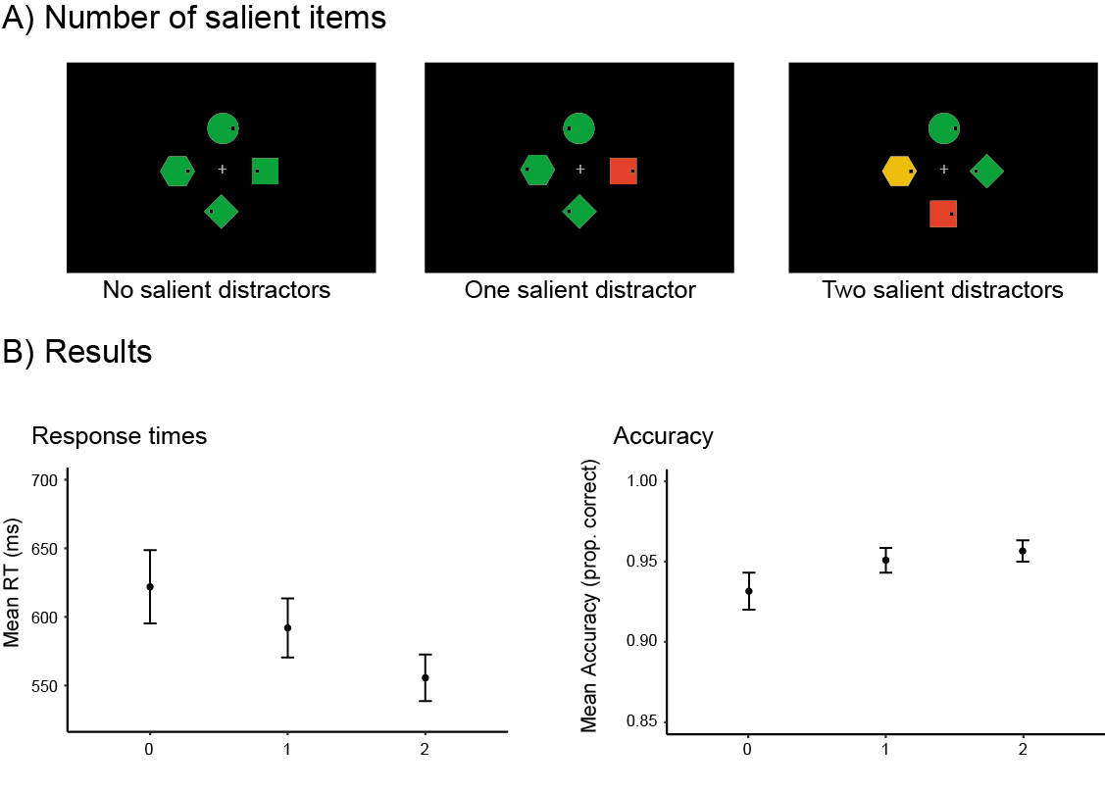

*Note.* Figure 1A shows example search displays used in Experiment 1S without a salient distractor item, or with one or two of these items. Figure 1B provides the corresponding RT and accuracy results for the effect of the number of salient distractors. A decrease in RTs with an increase in the number of salient distractors, with corresponding results for accuracy, was observed. Error bars represent the standard error of the mean for each condition.

**1.2 Results**

Similar to Experiment 1, there was a singleton benefit, as RTs decreased with an increase in the number of salient distractors (*F*(2, 44) = 24.60, *p* < .0001, *ηp2* = .53; no salient distractors: *M* = 622 ms, *SE* = 27 ms; one salient distractor: *M* = 592 ms, *SE* = 22 ms; two salient distractors: *M* = 556 ms, *SE* = 17 ms; see Figure 1B). Subsequent paired t-tests showed significant differences (*p* values corrected using Bonferroni for three comparisons) between all three search display configurations (0 vs 1: *t*(23) = 4.59, *p* = .0004, *d* = .25; 0 vs 2: *t*(23) = 5.17, *p* = .0001, *d* = .61; 1 vs 2: *t*(23) = 5.12, *p* = .0001, *d* = .38). There was no main effect of colour scheme, nor did colour scheme interact with the number of salient distractors (*F*s < 1). The relative salience of the colour singleton in displays with one salient item (S+ or S-) had no effect on RTs (S+ vs S-; *F*(1, 22) = 0.98, *p* = .33). In this analysis, there was also no main effect of colour scheme (*F*(1, 22) = 0.17, *p* = .69), and no interaction between both factors (*F*(1, 22) = 0.15, *p* = .70).

Accuracy was generally high (see right panel of Figure 1B), but clear singleton benefits were still present, as accuracy increased with the number of salient distractors, *F*(2, 44) = 8.59, *p* = .004, *ηp2* = .28 (No salient distractors: *M* = 0.932, *SE* = .012; One salient distractor: *M* = 0.951, *SE* = .008; Two salient distractors: *M* = 0.957, *SE* = .007). Paired t-tests (corrected for multiple comparisons using Bonferroni) showed reliable singleton benefits for displays with one relative to no salient singleton (*t*(23) = 2.82, *p* = .029, *d* = 0.40), but no reliable further increase in accuracy for displays with two as compared to one salient singleton (*t*(23) = 1.63, *p* = 0.35; 0 vs 2: *t*(23) = 3.32, *p* = .009, *d* = 0.54). There was no main effect of colour scheme, nor did colour scheme interact with the number of salient distractors, *F*s > 1. Finally, when comparing S+ and S- in displays with one salient distractor, the mixed ANOVA revealed no effects, *F*s < 2.47, *p*s > .13.

Experiment 1S obtained clear behavioural evidence for multiple-item suppression in 4 item displays, replicating the results and supporting the conclusions of Experiment 1.

**2. Experiment 2S**

Experiment 2S of the supplementary materials replicated the electrophysiological findings of Experiment 3 but with four items rather than six. Like Experiment 3, participants had to monitor four successive search displays, in order to report the number of displays that included a target after all displays have been presented.

**2.1 Methods**

Twenty (20) participants were recruited for Experiment 2S. All participants reported having normal or corrected-to-normal vision. Sample size calculation was determined in the same way as in Experiment 3. One participant was removed from the final sample due to excessive oscillatory activity in the alpha frequency and another participant for saccadic eye movements (see pre-processing of Experiment 3 for exclusion details). Eighteen (18) participants were included in the final sample (age: *M* = 32.44 years, *SE* = 7.75 years, 12 female and 6 male, 1 left-handed and 17 right-handed). Three participants in Experiment 2S also participated in Experiment 3.

Experiment 2S was identical to Experiment 3 except for the following changes. Instead of six items, four items were presented in each display, placed on the left, right, above, and below fixation. The target was equally probable at each of the four locations. When a target was present, the remaining three non-target shapes were selected at random and could not be the same. The shape possibilities were the same as Experiment 1S. There were always two salient items in each display, meaning that target-present displays contained a target and a green non-target distractor whereas target-absent displays contained two green non-target distractors. Figure 2A shows the different S+/S- configurations of interest. EEG recordings and analyses were the same as Experiment 3. Similar to Experiment 1S, the colour coordinates of were slightly different for the colour red compared with Experiments 1, 2, 3 and 4. To assure that this did not affect results, we conducted a one-way between-subjects ANOVA comparing the PD component (110 ms – 160 ms) for S+ (MS- / S+) for experiments 2S, 3, and 4 (with any redundant participants removed, meaning that Experiment 2S had 16 participants, Experiment 3 had 16 participants, and Experiment 4 had 17 participants). No significant difference in PD amplitude was observed between experiments (*F* < 1).

*Figure 2.* Display configurations and results of Experiment 2S.

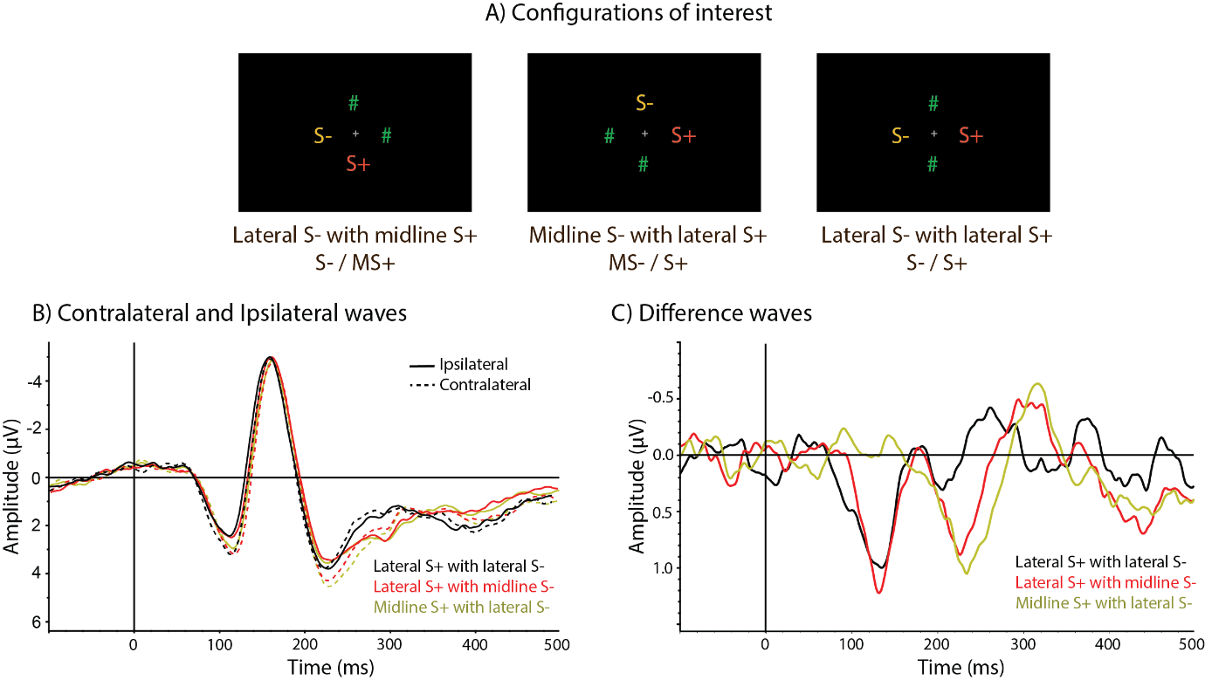

Note. Figure 2A shows the configurations of interest for Experiment 2S. We compared displays that elicited lateralised EEG activity associated with S- only (left panel), S+ only (middle panel), and both S- and S+ (right panel). The hash symbols represent placeholders for non-salient distractors and/or targets (when present). Waveforms for electrode sites PO7 and PO8 of Experiment 2S associated with lateral salient distractors are presented in Figure 2B and 2C. The contralateral and ipsilateral activity associated with lateral salient distractors are depicted in Figure 2B. Figure 2C shows the corresponding difference wave. The first positivity is a PD component to lateral S+ items. For displays where both S+ and S- were lateral (black lines), contra/ipsilateral were defined relative to the side of S+.

**2.2 Results**

Overall accuracy of reporting the correct number of target-present frames on a trial was high (proportion correct: .96). Similar to Experiment 3, an initial contralateral positivity (PD component) was present for displays that included a lateral S+, regardless of whether S- appeared on the vertical midline or on the opposite side (see Figure 2). No such PD was present for displays with a lateral S- and a midline S+. Also like Experiment 3, a second contralateral positivity starting around 200 ms after display onset that was more pronounced for displays with one lateral salient distractor was observed.

*2.2.1 PD component.*

The PD was quantified using a time window from 110 ms to 160 ms after search display onset (like Experiment 3 and 4). Data were submitted to a 2 (Laterality: ipsilateral vs contralateral) × 3 (Configuration: S- / MS+, MS- / S+, S- / S+) repeated-measures ANOVA[1]. A main effect of laterality was observed, *F*(1, 17) = 19.16, *p* = .0004, *ηp2* = .53, demonstrating the existence of an overall PD. Laterality interacted with configuration, F(2, 22) = 14.55, *p* < .0001, *ηp2* = .46. As can be seen in Figure 2C, a PD was elicited by displays with a lateral S+ (red) item (MS- / S+ and S- / S+), but not by displays with a lateral S- (yellow) item (S- / MS+). Paired t-tests (with a Bonferroni correction for three comparisons applied to the p values) comparing contralateral and ipsilateral ERPs confirmed the presence of an PD for MS- / S+ displays, *t*(17) = 5.22, *p* = .0002, *d* = 0.36, and for S- / S+ displays, *t*(17) = 3.69, *p* = .005, *d* = 0.29, but not for S- / MS+ displays, *t* < 1, showing that a PD was only elicited by the more salient red item (S+). To test whether the location of S- affected the PD elicited by lateral S+ items, we compared displays where a lateral S+ was presented together with a midline S- or with an S- on the opposite side. No difference in PD amplitude was found between these displays, *t* < 1.

*2.2.2 Second contralateral positivity.*

The presence of a second contralateral positivity following the PD component was unexpected. As shown in Figure 2C, this positivity was only elicited by displays that contained one lateral salient item. Its presence was confirmed when mean amplitudes measured between 200-250 ms post-stimulus were submitted to a 2 (Laterality: ipsilateral vs contralateral) × 2 (Configuration: S- / MS+, MS- / S+) repeated-measures ANOVA. There was a main effect of laterality, *F*(1, 17) = 18.23, *p* < .001, *ηp2* = .52, which did not interact with configuration, *F*(1, 17) = 1.19, *p* = .29.[2]

**2.3 Discussion**

Generally speaking, Experiment 2S replicated results from Experiment 3. One marked difference is that the second contralateral positivity appears larger in Experiment 2S compared with Experiment 3. The small display set size used in Experiment 2S may provide an explanation for the unexpected presence of a larger second positive component. This component was only observed for displays that contained only one lateral salient item that was accompanied by a target-colour (green) distractor on the opposite side. Because displays always contained only two target-colour objects, participants may have attended to the lateral target-coloured distractor opposite to S+ or S- on a substantial number of trials, resulting in an N2pc component (i.e., a negativity contralateral to this distractor that would appear as a contralateral positivity when plotted relative to the location of S+/S-). The increase in items from four to six between Experiments 2S and Experiment 3 could have decreased the probability that a specific opposing lateral item was systematically attended, reducing the corresponding N2pc component (or second contralateral positivity). As such an effect was not observed in similar previous experiments for four-item displays with only one colour singleton distractor (Drisdelle & Eimer, 2021; Gaspelin & Luck, 2018a; Kerzel & Burra, 2020), it may be specific to displays that include two uniquely coloured objects.

1. Data were first analysed with target presence (absent vs present) as a factor. There was no significant interaction between target presence on laterality in either of the two analysis windows (PD and the second contralateral positivity; all *F*s < 2.67, *p*s > .08), so data were collapsed over this condition to improve power for both components.
2. The difference waveform for displays that contained lateral S+ and S- items on opposite sides (Figure 4B, black line) suggests a small contralateral negativity between 180 ms and 230 ms post-stimulus. While this negativity could in principle reflect a delayed second PD component elicited by S-, a post hoc t test against baseline failed to reach significance, *t*(17) = 1.27, *p* = .22.