Supplementary Materials

Results
For all tasks, response times were log transformed prior to analysis to increase normality in the data due to positively skewed response times (particularly among the older participants), as recommended by Baayen (2008).

Hierarchy of social inferences (reaction times)
Reaction times were calculated for trials with a “yes” response. Outliers were excluded from the analysis of reaction times if they fell more than 2.5 standard deviations from the age group’s mean response time and if they were lower than 400ms. Figure A shows the average reaction times to make social inferences for each social inference type and age group. A 3 x 4 mixed design ANOVA was used to analyse the log-transformed reaction time data, crossing the between-subjects variable Age Group (adolescents vs. young adults vs. older adults) with the within-subjects variable Inference (Intention, Desire, Belief, Personality). Full statistical effects are reported for likelihood and for reaction times in Table A.

Table A: Statistical effects for log reaction times in the Hierarchy of social inferences task. Asterisks show significance of effects, where * p < .05; *** p < .001.
 | df | F | p | η_{p}²
Age Group | (2, 260) | 28.04 | < .001*** | .18
Inference | (3, 780) | 10.63 | < .001*** | .04
Age Group x Inference | (6, 780) | 2.09 | .05* | .02

Results revealed significant main effects for both variables. The main effect of Age Group showed that older adults were slower to make social inferences (M = 2114ms) compared to young adults (M = 1718ms; t(174) = 7.88, p < .001, d = 1.19), and young adults were faster compared to adolescents (M = 1840ms; t(173) = 2.06, p = .04, d = .31). The main effect of Inference showed that participants were equally fast at inferring a desire (M = 1861ms) and an intention (M = 1834ms; t(262) = 1.03, p = .30, d = .05), faster to infer an intention compared to a belief (M = 1915ms; t(262) = 3.74, p < .001, d = .12), faster to infer a desire compared to a belief (t(262) = 2.71, p < .001, d = .12), and did not differ for inferring a belief and personality (M = 1953ms; t(262) = 1.54, p =.12, d = .09).
The Age Group x Inference interaction was also significant. Follow-up analyses used 1-way ANOVAs to test whether the speed of responses of making each social inference differed between the three age groups. Results revealed that Age Group modulated the response times of making inferences about the main character’s intentions, F(2, 260) = 17.07, p < .001, η_{p}² = .12, desires, F(2, 260) = 32.26, p < .001, η_{p}² = .20, beliefs, F(2, 260) = 15.78, p < .001, η_{p}² = .11, and personality, F(2, 260) = 17.53, p < .001, η_{p}² = .12. Planned comparisons between age groups revealed that adolescents were faster than young adults to infer intentions, t(173) = 2.50, p = .01, d = .38 and desires, t(173) = 1.99, p = .05, d = .30, in the videos. In contrast, older adults were slower than young adults to infer all social behaviours in the videos [intentions, t(174) = 6.41, p < .001, d = .97; desires, t(174) = 8.17, p < .001, d = 1.23; beliefs, t(174) = 5.74, p < .001, d = .87; personality, t(174) = 5.74, p < .001, d = .87]. The other contrasts did not reach significance. Contrasts between Inference Types were conducted separately for each Age Group, revealed comparable patterns of social hierarchy. Adolescents responded significantly faster when judging desires (M = 1785ms) compared to beliefs (M = 1863ms, t(86) = 2.06, p = .04, d = .16), young adults responded significantly faster when judging both intentions (M = 1655ms) and desires (M = 1654ms) compared to beliefs (M = 1763ms; t(87) = 2.88, p = .005, d = .27, and t(102) = 3.32, p = .001, d = .28, respectively), and older adults responded significantly faster when judging intentions (M = 2017ms) compared to desires (M = 2143ms, t(87) = 3.50, p < .001, d = .29) and beliefs (M = 2118ms, t(87) = 2.72, p = .008, d = .23).

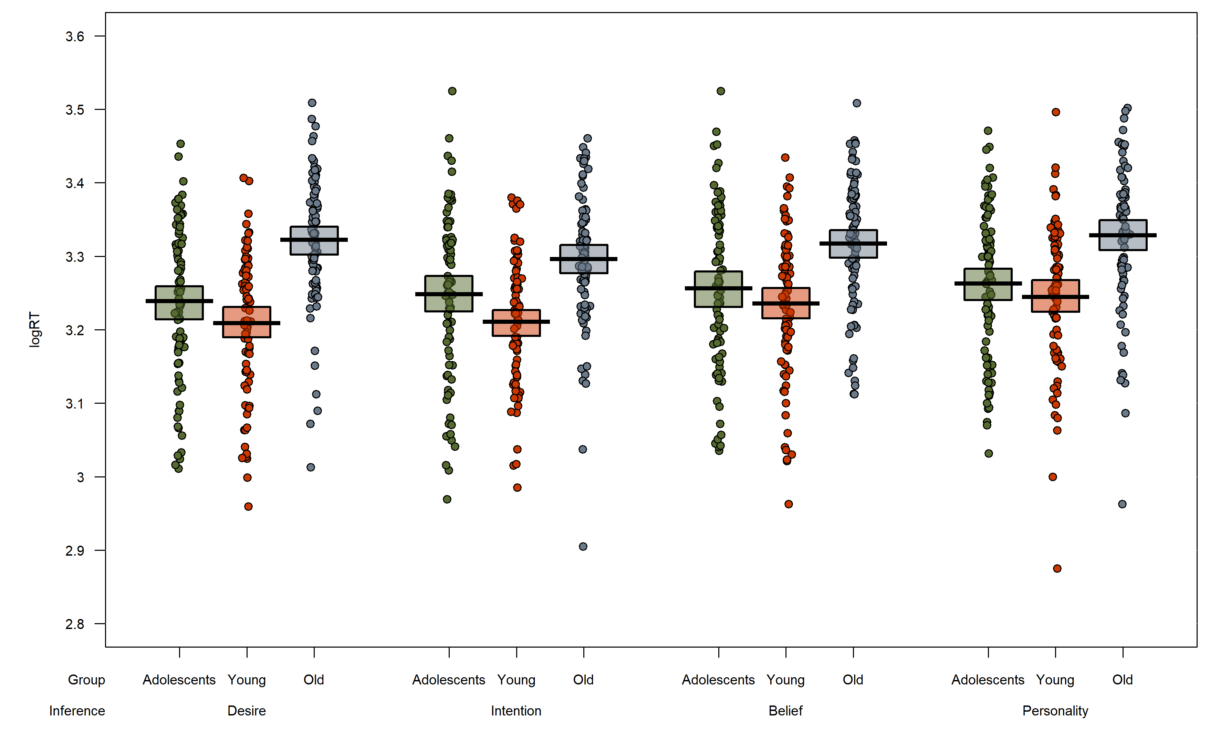Figure A: The log reaction time to correctly make social inferences in each age group in the Hierarchy of social inferences task. The plots show raw data points, a horizontal line reflecting the condition mean, and a rectangle representing the Bayesian highest density interval.
b)

VSPT
Analyses revealed significant main effects for all variables. Overall participants responded slower when making spatial compared to visual judgements (994ms vs. 874ms), and when adopting a level 2 perspective compared to a level 1 perspective (1052ms vs. 816ms). The main effect of Angle showed that response times increased as the angle of rotation increased (M_{0°} = 879; M_{60°} = 895; M_{120°} = 947; M_{180°} = 1015; all contrasts p < .001). The main effect of Age Group showed that older adults spent longer judging the avatar’s perspective (1073ms) compared to both adolescents (915ms) and young adults (813ms), and adolescents were slower compared to young adults (all contrasts p < .001).
As expected, the Content x Level interaction was significant. Follow-up analyses tested the effect of content separately for each level, and showed that response times were longer when judging the avatar’s spatial vs. visual perspective for both level 1, t(262) = 2.30, p = .02, d = .08, and level 2 judgements, t(262) = 14.42, p < .001, d = .82, though this difference was greater for level 2 judgments. The Angle x Level interaction was also significant. Follow-up analyses tested the effect of angle separately for each level, and showed a significant effect of Angle on both level 1, F(3, 786) = 18.14, p < .001, ηp² = .07, and level 2 perspective-taking, F(3, 786) = 517.82, p < .001, ηp² = .66. For Level 1 judgements, the pattern was non-linear as significant differences only emerged on angle contrasts 0° vs. 60°, t(262) = 3.74, p < .001, d = .09, and 120° vs. 180°, t(262) = 6.37, p < .001, d = .15, but for level 2 judgements response times increased linearly with increasing angle and all angle contrasts were significant (all ts > 9.76, ps < .001), showing that the increasing angle of rotation has a stronger effect on response times for level 2 judgements. In addition, the Angle x Content interaction was significant. Follow-up analyses tested the effect of angle separately for each content type, and showed a significant effect of Angle on both spatial, F(3, 786) = 152.02, p < .001, ηp² = .37, and visual perspective-taking, F(3, 786)= 274.61, p < .001, ηp² = .51. Response times increased as the angle of rotation increased (all contrasts p < .01), though this increase was steeper for visual than spatial judgements.

Interactive reference assignment
Figure B shows the average accuracy and log reaction times for each condition and age group. A 3 x 2 mixed design ANOVA was used for analysis of accuracy and log-transformed reaction time data, crossing the between-subjects factor Age Group (adolescents vs. young adults vs. older adults) with the within-subjects factor Condition (listener only vs. shared view). Full statistical effects are reported in Table B for accuracy and for reaction times.

Table B: Statistical effects for accuracy and for log reaction times in the Director task. Asterisks show significance of effects, where *** p < .001.
 | df | F | p | η_{p}²
Accuracy
Age Group | (2, 260) | 8.72 | < .001*** | .06
Condition | (1, 260) | 30.64 | < .001*** | .11
Age Group x Condition | (2, 260) | 6.90 | .001*** | .05
Reaction Times
Age Group | (2, 260) | 64.36 | < .001*** | .33
Condition | (1, 260) | 2.20 | .14 | < .01
Age Group x Condition | (2, 260) | 1.15 | .32 | < .01

Accuracy Analysis of accuracy revealed significant main effects for both variables. The main effect of Age Group showed that overall, young adults (M = .98) were more accurate at selecting the target object compared to both older adults (M = .93; t(174) = 3.84, p < .001, d = .58) and adolescents (M = .96, t(173) = 2.25, p = .03, d = .34). The main effect of Condition confirmed our prediction that participants would commit more errors in the listener only condition (M = .94) compared to the shared view condition (M = .98; t(262) = 5.42, p < .001, d = .43). The Age Group x Condition interaction was also significant. Follow-up analyses used 1-ANOVAs to test whether accuracy differed between the three age groups, separately for each condition. Results revealed that Age Group modulated accuracy in the listener only condition, F(2, 260) = 8.30, p < .001, η_{p}² = .06, but not in the shared view condition, F (2, 260) = 2.23, p = .11. Planned comparisons between age groups in the listener only condition revealed that young adults were significantly more accurate than both older adults, t(174) = 3.61, p < .001, d = .54, and adolescents, t(173) = 1.83, p = .07, d = .28.

Reaction Times Analysis of reaction times revealed significant a significant main effect only for Age Group, confirming our hypothesis that older adults would be slower to respond (M = 3673ms) compared to young adults (M = 2734ms; t(174) = 9.07, p < .001, d = 1.37). Response times in younger adults and adolescents did not differ (M = 2694ms, t(173) = .60, p = .52, d = .08).
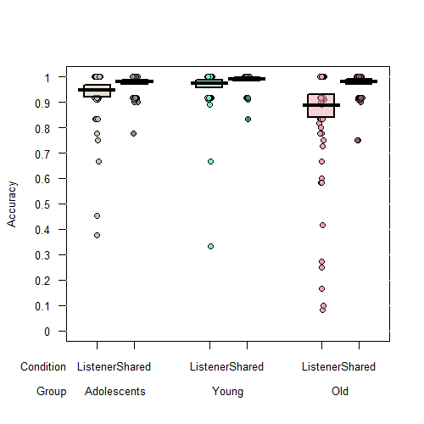
a)

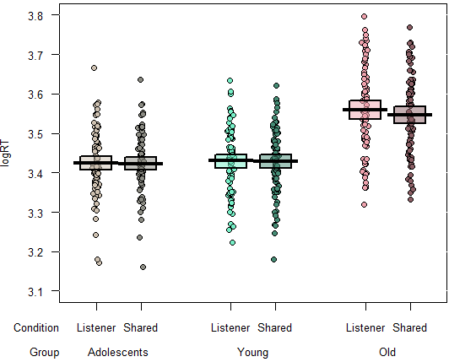
b)

Figure B: The accuracy (a) and log reaction times (b) in each condition and age group in the Director task. The plots show raw data points, a horizontal line reflecting the condition mean, and a rectangle representing the Bayesian highest density interval.

Note that .058 of responses [adolescents M=.039, young M=.024, old M=.11] reflected egocentric errors (i.e. selecting the competitor object in the occluded slot), and .009 [adolescents M=.015, young M=.006, old M=.008] reflected other errors (i.e. selecting any other object, most likely due to inattention).

