Supplementary Materials

Supplementary Analysis 1: The relationship between mean ratings per item and acoustics

We extracted acoustic features, specifically F0, corresponding to voice pitch and F1, the first formant, extracted here to be a proxy for vocal tract length (VTL). The mean F0 was 229.5Hz (SD: 30.0 Hz) for female voices and 127.7Hz (SD: 24.7 Hz) for male voices. The F1 was 806.5Hz (SD: 105.4 Hz) for female voices and 639.9Hz (SD: 24.7 Hz) for male voices (see Supplementary Figure 1 below for the distribution of F0 and F1 values).

Supplementary Figure 1

Histograms Showing the Distributions of F0 and F1 Values for Male and Female Voices

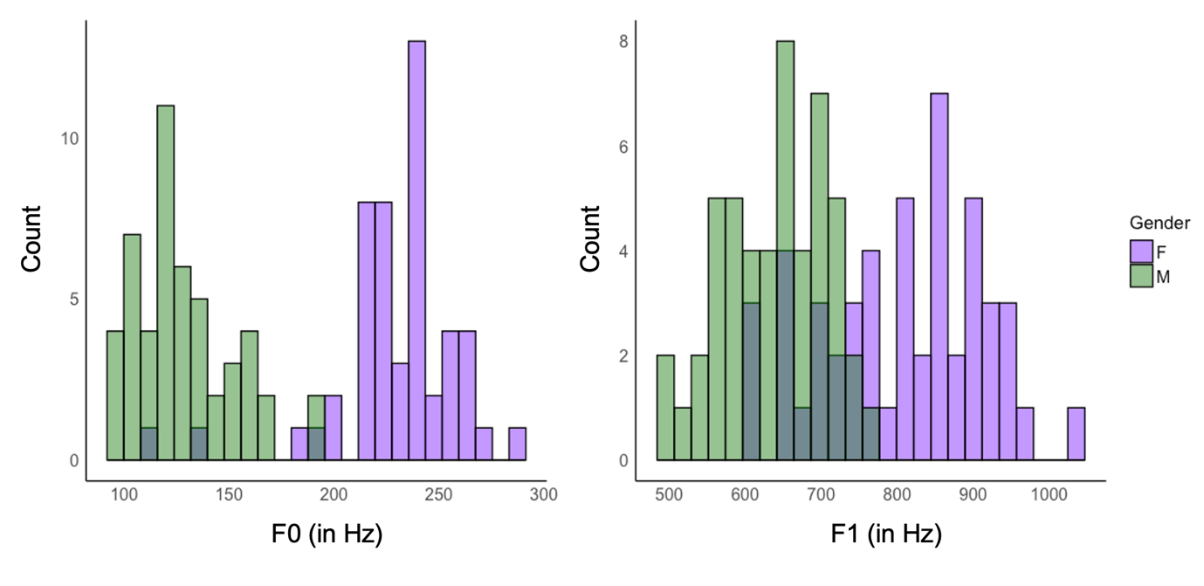
Supplementary Table 1

Correlations Between Item-Wise Mean Ratings by Trait, Gender, and Exposure Time with Two Acoustic Measures: F0 (Top Table) and F1 (Bottom Table)
F0
Exposure Duration | Attractiveness |  |  |  |  | Dominance |  |  | Trustworthiness
Exposure Duration | All voices |  | F |  | M | All voices | F | M | All voices | F | M
50ms | -.82*** |  | -0.17 |  | -.50*** | -.88*** | -.45** | -.48*** | .53*** | .47*** | -0.01
100ms | -.29** |  | .24 |  | -.47*** | -.77*** | -.12 | -.38** | .71*** | 0.17 | 0.05
200ms | .15 |  | .29* |  | -.22 | -.78*** | -.16 | -.42** | .79*** | .37** | 0.16
400ms | -.10 |  | .05 |  | -.46*** | -.73*** | -.11 | -.38** | .67*** | 0.01 | 0.16
800ms | -.15 |  | .23 |  | -.44** | -.76*** | -.06 | -.48*** | .5*** | 0.05 | 0.12
F1 (proxy for vocal tract length)
Exposure Duration | Attractiveness |  |  |  |  | Dominance |  |  | Trustworthiness
Exposure Duration | All voices |  | F |  | M | All voices | F | M | All voices | F | M
50ms | -.22 |  | -.22 |  | -.29* | -.66*** | -.09 | -.23 | .47*** | .42*** | -.22
100ms | .31* |  | .31* |  | -.07 | -.54*** | .10 | -.21 | .69*** | .47*** | .20
200ms | .36** |  | .26** |  | .16 | -.55*** | -.02 | -.15 | .71*** | .54*** | .24
400ms | .29* |  | .29* |  | .01 | -.44*** | .22 | .02 | .50*** | .06 | -.03
800ms | .29* |  | .29* |  | -.16 | -.40*** | .44*** | .07 | .42*** | .19 | -.05
Note. F = female voices, M = male voices; * p < .05, ** p < .01, *** p < .001, significant correlations in bold, negative correlations in red, positive correlations in green
These kinds of acoustic measures have been previously shown to be influential for trait impressions from voices (McAleer et al., 2014). As can be seen from Supplementary Table 1, we observe consistent and significant negative relationships between F0 and attractiveness and dominance ratings for male voices: The lower the pitch, the more attractive and dominant male voices are perceived to be. No such relationship emerges for trustworthiness, although most correlations are weakly positive. For female voices, no consistent significant relationships between F0 and trait ratings emerge, if anything, there are trends suggesting that female voices that are higher in F0 are perceived as more attractive and trustworthy while female voices that are lower in F0 are perceived as more dominant. When looking across both male and female voices, the effects of gender on trait impressions becomes apparent: We observe consistently strong negative correlations for dominance impressions, confirming that male voices (which are usually lower in F0 than female voices) are perceived as overall more dominant. Conversely, we observe a moderate-to-strong positive correlation between F0 and trustworthiness impressions, reflecting that female voices (which are usually higher in F0 than male voices) are perceived as overall more trustworthy than male voices.

For correlations with F1, as a proxy for vocal tract length, fairly consistent relationships emerge for attractiveness and trustworthiness ratings for female voices: Higher F1 is associated with shorter vocal tract lengths. As such, female voices are perceived as more trustworthy and attractive when the voice overall sounds smaller in terms of the voice quality. No clear relationship between F1 and dominance impressions for female voices was apparent. Furthermore, there were also no consistent relationships between F1 and trait impressions for male voices. Looking across female and male voices, we can again observe the effects of gender on the correlations between F1 on dominance ratings: Males tend to have longer vocal tracts and thus lower F1s. As a result, we observe a negative relationship between voices F1 and dominance ratings. For trustworthiness (and to a lesser degree for attractiveness) impressions, we observe the opposite pattern, largely reflecting that females are perceived to be more trustworthy.

Supplementary Analysis 2: Inter-rater agreement for female and male voices combined

Trait impressions of attractiveness based on both male and female voices converge on acceptable agreement at 400ms, such that no systematic increase in agreement is observed after this exposure time (see Supplementary Table 2). However, surprisingly, trait impressions based on the shortest exposure time (50ms) also already exhibit high agreement. Dominance impressions across both male and female voices show very high inter-rater agreement even at the shortest exposure time. For trustworthiness impressions, acceptable agreement is reached after 100ms, with agreement being overall relatively stable across all exposure durations other than 50ms, where agreement is quite low.

Supplementary Table 2
Inter-Rater Agreement (Cronbach’s Alpha and Intraclass Correlation Coefficients, with 95% Confidence Intervals) for Male and Female Voices Combined.

Trait | Exposure Duration | Cronbach’s Alpha  [95% CIs] | ICC  [95% CIs]
Attractiveness | 50ms | .83 [.78, .87] | .81*** [.75, .86]
Attractiveness | 100ms | .47 [.30, .61] | .40*** [.24, .54]
Attractiveness | 200ms | .47 [.30, .61] | .42*** [.26, .56]
Attractiveness | 400ms | .70 [.61, .78] | .64*** [.54, .73]
Attractiveness | 800ms | .66 [.56, .75] | .57*** [.45, .67]
Dominance | 50ms | .93 [.90, .95] | .90*** [.87, .93]
Dominance | 100ms | .84 [.79, .88] | .79*** [.73, .85]
Dominance | 200ms | .86 [.82, .90] | .82*** [.76, .87]
Dominance | 400ms | .90 [.86, .92] | .88*** [.84, .91]
Dominance | 800ms | .91 [.89, .94] | .88*** [.84, .91]
Trustworthiness | 50ms | .20 [-.04, .41] | .16* [-.03, .34]
Trustworthiness | 100ms | .76 [.68, .82] | .71*** [.62, .78]
Trustworthiness | 200ms | .78 [.71, .84] | .71*** [.63, .79]
Trustworthiness | 400ms | .74 [.67, .81] | .68*** [.59, .76]
Trustworthiness | 800ms | .65 [.54, .74] | .61*** [.50, .71]
Note. * p < .05, *** p < .001, significant ICCs in bold

Supplementary Table 3
Inter-Rater Agreement (Cronbach’s Alpha and Intraclass Correlation Coefficients, with 95% Confidence Intervals) for Female Voices.

Trait | Exposure Duration | Cronbach’s Alpha  [95% CIs] | ICC  [95% CIs]
Attractiveness | 50ms | .52 [.30, .69] | .40*** [.06, .47]
Attractiveness | 100ms | .59 [.41, .74] | .47*** [.29, .64]
Attractiveness | 200ms | .67 [.52, .79] | .52*** [.35, .68]
Attractiveness | 400ms | .76 [.65, .84] | .63*** [.49, .75]
Attractiveness | 800ms | .73 [.62, .83] | .57*** [.42, .71]
Dominance | 50ms | .20 [-.16, .49] | .12 [-.09, .35]
Dominance | 100ms | .35 [.06, .58] | .27** [.04, .49]
Dominance | 200ms | .22 [-.13, .50] | .15 [-.08, .38]
Dominance | 400ms | .65 [.50, .78] | .55*** [.38, .70]
Dominance | 800ms | .70 [.56, .81] | 53*** [.37, .68]
Trustworthiness | 50ms | .39 [.11, .61] | .26** [.06, .47]
Trustworthiness | 100ms | .58 [.39, .73] | .48*** [.29, .64]
Trustworthiness | 200ms | .57 [.37, .72] | .46*** [.27, .63]
Trustworthiness | 400ms | .56 [.36, .72] | .46*** [.27, .63]
Trustworthiness | 800ms | .67 [.52, .79] | .58*** [.42, .72]
Note. ** p < .01, *** p < .001, significant ICCs in bold

Supplementary Table 4
Inter-Rater Agreement (Cronbach’s Alpha and Intraclass Correlation Coefficients, with 95% Confidence Intervals) for Male Voices.

Trait | Exposure Duration | Cronbach’s Alpha  [95% CIs] | ICC  [95% CIs]
Attractiveness | 50ms | .72 [.60, .82] | .62*** [.47, .75]
Attractiveness | 100ms | .54 [.34, .71] | .40*** [.21, .58]
Attractiveness | 200ms | .53 [.32, .70] | .43*** [.23, .61]
Attractiveness | 400ms | .77 [.67, .85] | .70*** [.57, .80]
Attractiveness | 800ms | .77 [.66, .85] | .62*** [.47, .74]
Dominance | 50ms | .87 [.81, .91] | .78*** [.69, .86]
Dominance | 100ms | .81 [.73, .88] | .70*** [.57, .80]
Dominance | 200ms | .80 [.72, .87] | .72*** [.61, .82]
Dominance | 400ms | .86 [.80, .91] | .82*** [.74, .88]
Dominance | 800ms | .88 [.82, .92] | .82*** [.74, .88]
Trustworthiness | 50ms | -.10 [-.59, .30] | -.05 [-.24, .18]
Trustworthiness | 100ms | .53 [.33, .70] | .43*** [.24, .61]
Trustworthiness | 200ms | .39 [.11, .61] | .29** [.07, .50]
Trustworthiness | 400ms | .47 [.23, .66] | .36*** [.16, .56]
Trustworthiness | 800ms | .48 [.25, .67] | .41*** [.20, .60]
Note. ** p < .01, *** p < .001, significant ICCs in bold

Supplementary Figure 2

Scatterplots of the Relationships Between Item-Wise Mean Ratings for Trait Impressions After 800ms and the Shorter Exposure Durations. Data are Plotted by Trait and Voice Gender.
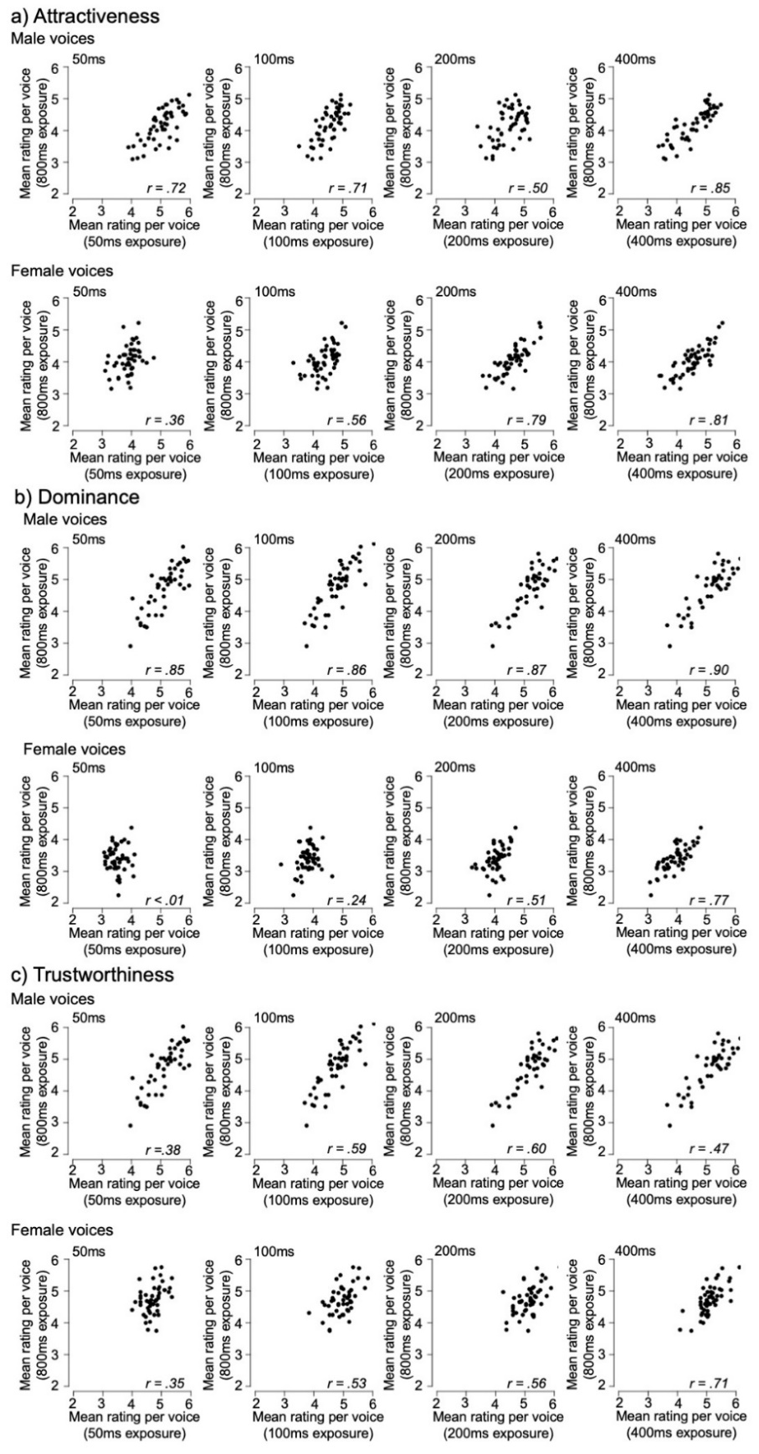
Supplementary Table 5
Correlation Coefficients for Correlations Between Item-Wise Mean Ratings After an 800ms Exposure and Those for the Remaining Shorter Exposure Durations by Trait and Voice Gender
Trait | Exposure Duration | Female | Male
Attractiveness | 50ms | .36 | .72
Attractiveness | 100ms | .56 | .71
Attractiveness | 200ms | .79 | .50
Attractiveness | 400ms | .81 | .85
Dominance | 50ms | <.01 | .85
Dominance | 100ms | .24 | .86
Dominance | 200ms | .51 | .87
Dominance | 400ms | .77 | .90
Trustworthiness | 50ms | .35 | .38
Trustworthiness | 100ms | .53 | .59
Trustworthiness | 200ms | .56 | .60
Trustworthiness | 400ms | .71 | .47
Note. Significant correlations after multiple comparison correction in bold

Supplementary Analysis 3: Correlations between 800ms and shorter durations for female and male voices combined

Supplementary Table 6 shows the correlations between item-wise mean ratings for different exposure durations (50ms, 100ms, 200ms, 400ms) and 800ms when looking across female and male voices. We find strong positive correlations across all exposure durations and traits, with these effects most likely being driven by underlying gender differences in trait impressions for male vs female voices. These data clearly show a distinct pattern of development for each trait. Dominance judgements seem to be well formed, even at 50ms, whereas trustworthiness judgements require a little longer (100ms). The development of attractiveness judgements seems to be much more gradual and only approaches stability at 400ms.

Supplementary Table 6
Correlation Coefficients for Correlations Between Item-Wise Mean Ratings after an 800ms Exposure and the Remaining Shorter Exposure Durations by Trait for Male and Female Voices Combined
Trait | Exposure Duration | Correlation Coefficient
Attractiveness | 50ms | .45***
Attractiveness | 100ms | .65***
Attractiveness | 200ms | .60***
Attractiveness | 400ms | .83***
Dominance | 50ms | .89***
Dominance | 100ms | .88***
Dominance | 200ms | .92***
Dominance | 400ms | .94***
Trustworthiness | 50ms | .52***
Trustworthiness | 100ms | .71***
Trustworthiness | 200ms | .72***
Trustworthiness | 400ms | .74***
Note. *** p < .001

Supplementary Analysis 4: Hierarchical regression analysis for female and male voices combined

Supplementary Table 7
Overview of the Hierarchical Regression Analysis, Prediction Item-Wise Mean Ratings after 800ms Exposure for Each Trait for Female and Male Voices Combined
Trait | Predictors | R² (A) | R² (B) | R² Change | p
Attractiveness | A: 50ms, B: A + 100ms | 0.20 | 0.44 | 0.24 | <.001
Attractiveness | A: 100ms, B: A + 200ms | 0.42 | 0.51 | 0.09 | <.001
Attractiveness | A: 200ms, B: A + 400ms | 0.36 | 0.69 | 0.33 | <.001
Dominance | A: 50ms, B: A + 100ms | 0.78 | 0.82 | 0.03 | <.001
Dominance | A: 100ms, B: A + 200ms | 0.78 | 0.85 | 0.07 | <.001
Dominance | A: 200ms, B: A + 400ms | 0.84 | 0.91 | 0.07 | <.001
Trustworthiness | A: 50ms, B: A + 100ms | 0.27 | 0.53 | 0.25 | <.001
Trustworthiness | A: 100ms, B: A + 200ms | 0.51 | 0.57 | 0.06 | <.001
Trustworthiness | A: 200ms, B: A + 400ms | 0.52 | 0.61 | 0.09 | <.001

For completeness, we present the hierarchical regression analysis reported for female and male voices separately in the main text here when considering all voices together in the same analysis (see Supplementary Table 7). The picture that emerged from these three hierarchical regression analyses (one per trait) is similar to what we observed when splitting the data by gender: With increasing exposure duration, modelled here via additional predictors, unique and significant portions of variance are explained with each increase in exposure duration. Final models, account for most of the variance in trait impressions based on 800ms exposure (61% - 91%) for all traits.

