Supplementary Material
Message self and social relevance increases intentions to share content:
Correlational and causal evidence from six studies

Danielle Cosme
Christin Scholz
Hang-Yee Chan
Bruce P. Doré
Prateekshit Pandey
José Carreras-Tartak
Nicole Cooper
Alexandra Paul
Shannon M. Burns
Emily B. Falk

Additional demographic information
Here, we report available demographic information collapsed across studies. Additional tables summarizing this information for each study separately is available online (https://cnlab.github.io/self-social-sharing/analysis/demographics). In Studies 1, 5, and 6 we also measured socioeconomic status using education and household incoming as indicators. With respect to education, participants reported the following as highest degree completed: 46.3% Bachelor’s degree, 16.1% some college, 15.8% Master’s degree, 9.9% Associate’s degree, 8.7% high school graduate, 1.6% Doctorate degree, 1.4% Professional school degree, and 0.2% less than high school. With respect to household income, participants reported the following income brackets: 26.5% $50,000 - $74,999, 16.8% $75,000 - $99,999, 16.1% > $100,000, 15.1% $35,000 - $49,999, 10.1% $25,000 - $34,999, 6.5% $16,000 - $24,999, 3.2% $5,000 - $11,999, 2.8% $12,000 - $15,999, 1.3% < $5,000, and 1.6% not reported.

Study-specific participant information
Study 1. In this study, we used existing data from a project investigating the degree to which several message framing interventions might enhance message effectiveness and intentions, norms, and beliefs related to social distancing as a response to the COVID-19 pandemic. This project includes four sub-studies. For the purposes of this paper, the data were collapsed across message framing conditions, since our focus in this paper is on relationships between self and social-relevance and sharing. This study was conducted online through Amazon’s Mechanical Turk (MTurk). Participants were included if they were adults 18 or older, residing in the United States, were fluent in English, and passed an initial attention screening question. Participants were excluded based on the standard operating procedures for this project (SOP; https://osf.io/bgs5y/). To be consistent across studies reported in this manuscript, we deviated from the project SOP by not trimming outliers to +/- 3 SD. Of the 2470 participants initially recruited, participants were excluded if they failed the English comprehension question (n = 46), the attention screening (n = 291), knowledge questions about COVID-19 (n = 14), had invariant responses that were more than 3 SDs from the median (n = 13), or had more than one of these issues (n = 29). This yielded a final sample of 2081.
Study 2. This study used existing data from a project examining the effect of several message framing interventions on intentions to vote and perception of norms related to voting. For the purposes of this study, we collapse across message framing conditions, since our focus in this paper is on relationships between self and social-relevance and sharing. The study was conducted online through MTurk. Participants were included if they were adults 18 or older, residing in the United States, were fluent in English, eligible to vote in the U.S. general election, and passed an initial attention screening question. Of the 632 participants initially recruited, participants were excluded if they failed the English comprehension question (n = 10), one or more attention check (n = 14), or had invariant responses that were more than 3 SDs from the median (n = 29; Med = 22.2%, SD = 21.3%), or for more than one of these reasons (n = 32). This yielded a final sample of N = 547.
Study 3. This study (N = 248) used existing data from a project on civic engagement in college students. The study was conducted online at the University of Pennsylvania. Participants were included if they were adults 18 or older and eligible to vote in the United States. Participants were randomized to one of two message framing conditions, but for the purposes of this paper, the data were collapsed across conditions, since our focus in this paper is on relationships between self and social-relevance and sharing.
Study 4. This study used existing data from a project examining relationships between various message properties and broadcast sharing intentions using headlines from the New York Times. The study was conducted online through MTurk. Participants were included if they were adults 18 or older and were fluent in English. Of the 200 participants who completed the survey, 61 participants were excluded for failing one or more of the English comprehension questions. This yielded a final sample of N = 139.
Study 5. This preregistered study (https://osf.io/bgs5y/registrations/) was conducted online through MTurk. Participants were included if they were adults 18 or older, residing in the United States, were fluent in English, and passed an initial attention screening question. Participants were excluded based on the standard operating procedures for this project (https://osf.io/bgs5y/). Sample size was based on a power analysis. We determined that with N = 300, we would have >80% power to detect an effect size of d = 0.05 for within-person effects and >95% power to detect an effect of d = 0.10 for within- and between-person effects. Of the 408 participants initially recruited, participants were excluded if they failed the English comprehension question (n = 15), one or more attention checks (n = 75), or the knowledge questions about COVID-19 (n = 15). This yielded a final sample of N = 315.
Study 6. This preregistered study (https://osf.io/bgs5y/registrations/) was conducted online through MTurk. The same inclusion and exclusion criteria from Study 5 were used here. Sample size was based on a power analysis. We determined that with N = 420, we would have >80% power to detect an effect of d = 0.10 and >95% power to detect an effect of d = 0.15. Of the 644 participants initially recruited, participants were excluded if they failed the English comprehension question (n = 20), one or more attention checks (n = 80), or did not provide comprehensible text during the experimental manipulation (n = 233). This yielded a final sample of N = 397.

Study-specific procedures
Study 1. Participants were exposed to health messages about social distancing, framed as social media posts on Instagram. In three of the four sub-studies from this project, each participant was exposed to 5 messages drawn randomly from a pool of 15 messages. For the fourth sub-study, each participant saw the same 5 messages. For each message, participants rated self (“This message is relevant to me”) and social relevance (“This message is relevant to other people I know”), as well as their intention to share on social media (“I would share this message on social media”) using a 7-point scale (1 = strongly disagree, 7 = strongly agree).
Study 2. Participants were exposed to messages about voting, framed as social media posts for Twitter. Each participant was exposed to 5 messages about voting. For each message, they rated self (“This message is relevant to me”) and social relevance (“This message is relevant to people I know”), as well as their intention to share on social media (“I would share this message on social media”) using a 100-point scale (0 = strongly disagree, 100 = strongly agree).
Study 3. Participants were exposed to messages about voting, framed as social media posts for Instagram. Each participant was exposed to 5 messages about voting. For each message, they rated self (“This message is relevant to me”) and social relevance (“This message is relevant to people I know”), as well as their broadcast intention to share on social media (“I would share this message on social media”) and narrowcast intention to share directly with someone (“I would share this message directly with a friend”) using a 100-point scale (0 = strongly disagree, 100 = strongly agree).
Study 4. Participants were exposed to messages (headline and brief abstract) about health from the New York Times. Each participant was exposed to 8 messages randomly drawn from a pool of 80 articles. For each message, they rated self (“How relevant is this content to you?”) and social relevance (“How relevant is this content to other people?”), as well as their sharing intention (“How much would you want to share this article with other people?”) using a 10-point scale (0 = not at all, 10 = very much).
Study 5. Participants were exposed to messages (headline and brief abstract) about COVID-19 or climate change from the New York Times. Each participant was exposed to 10 messages, 5 about COVID-19 and 5 about climate change. Each participant was randomly assigned to one of 11 stimuli sets that included articles matched for popularity. For each message, they rated self (“This message is relevant to me”) and social relevance (“This message is relevant to people I know”) using a 100-point scale (0 = strongly disagree, 100 = strongly agree), as well as their broadcast intention to share on social media (“How much do you want to share this article by posting on your social media (on Facebook, Twitter, etc)?”) and narrowcast intention to share directly with someone (“How much do you want to share this article directly with someone you know (via email, direct message, etc)?”) using a 100-point scale (0 = not at all, 100 = very much).
Study 6. Participants saw the following instructions at the beginning of the study:

In this study, we are interested in understanding how different people react to online news, and in what ways information is shared among people. You will review a set of 10 actual news headlines taken from the internet. We would like you to read the article headlines, write short comments and give ratings. This writing task will help you reflect upon the headlines in different ways.

In order to help you reflect on these articles in different ways, we’d like you to write short comments to accompany each article, as if you were sharing on social media. In particular, we will ask you to write comments for each article with one of these specific goals in mind:
Write a short comment to describe why this article matters to you personally.
Write a short comment to describe why this article matters to people you know.
Write a short comment to describe what this article is about.

Messages consisted of a news headline and brief abstract from the New York Times about general health or climate change. These messages were sampled from a pool of 55 articles per topic and each participant was randomized to one of 11 sets of articles that contained 5 messages about health and 5 about climate change, matched with respect to the web traffic the news article has generated (specifically, the number of click-throughs for the article URL). For each message, participants wrote a comment based on the experimental condition and rated self (“This message is relevant to me”) and social relevance (“This message is relevant to people I know”) using a 100-point scale (0 = strongly disagree, 100 = strongly agree), as well as their broadcast intention to share on social media (“I would share this article by posting on social media (on Facebook, Twitter, etc)”) and narrowcast intention to share directly with someone (“I would share this article directly with someone I know (via email, direct message, etc)”) using a 100-point scale (0 = strongly disagree, 100 = strongly agree).

Software packages
All models were estimated using the lme4 (Version 1.1-26; Bates et al., 2015) and lmerTest (Version 3.1-3; Kuznetsova, Brockhoff, & Christensen, 2017) for significance testing in R (Version 3.6.3; R Core Team, 2020). The specification curve analysis was implemented using code adapted from specr (Masur & Scharkow, 2020). The Bayesian mediation analyses were conducted using brms (Version 2.16.3; Bürkner, 2017) and visualized using tidybayes (Version 3.0.2; Kay, 2022). Additional software packages used to conduct these analyses in R include: boot (Version 1.3-24; Canty & Ripley, 2019), broom.mixed (Version 0.2.7; Bolker & Robinson, 2021), dplyr (Version 1.0.7; Wickham et al., 2021), forcats (Version 0.5.1; Wickham, 2021), EMAtools (Version 0.1.4; Kleiman, 2021) furrr (Version 0.2.2; Vaughn & Dancho, 2021), ggplot2 (Version 3.3.5; Wickham, 2019), ggpubr (Version 0.4.0; Kassambara, 2020), kableExtra (Version 1.3.1; Zhu, 2020), knitr (Version 1.31; Xie, 2021), Matrix (Version 1.2-18; Bates & Maechler, 2019), purrr (Version 0.3.4; Henry & Wickham, 2020), rmcorr (Version 0.4.5; Bakdash & Marusich, 2017), readr (Version 1.4.0; Wickham & Hester, 2020), report (Version 0.3.5; Makowski et al., 2020), stringr (Version 1.4.0; Wickham, 2019), tibble (Version 3.1.2; Müller & Wickham, 2021), tidyr (Version 1.1.3; Wickham, 2021), tidytext (Version 0.3.2; Silge & Robinson, 2016), and tidyverse (Wickhman, 2019).

Mega-analysis with downsampled data
Message-level correlations between self and social relevance. First, we conducted exploratory analyses looking at the correlation between self and social relevance for each message in each study. These correlations are visualized in Figure S1, and the average correlation strength and variability for each study and message content domain are reported in Table S1. The messages about climate change were used in both Study 5 and 6, but are treated separately for each study.

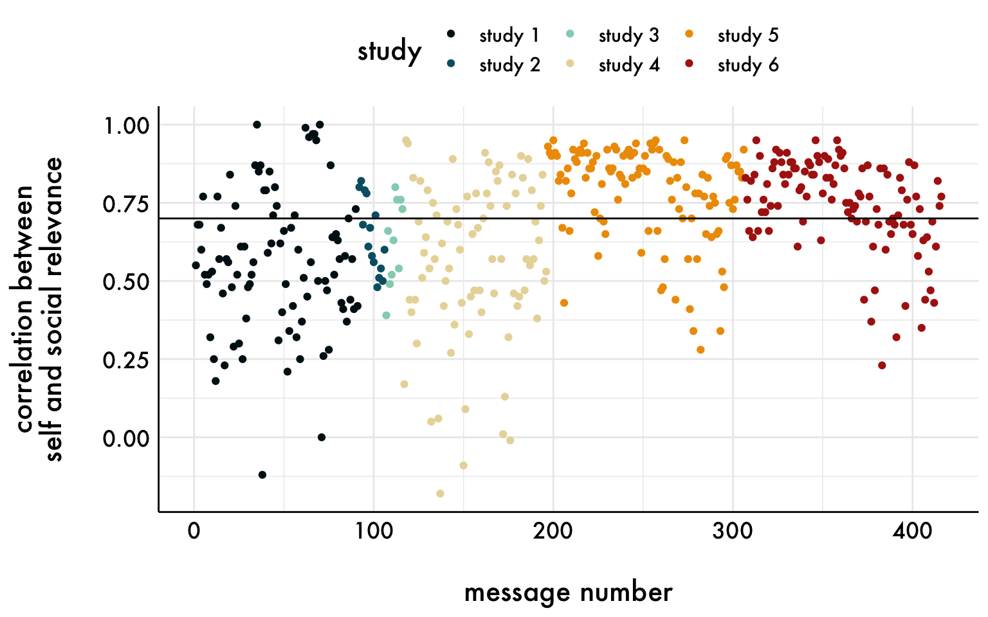
Figure S1. Message-level correlations between self and social relevance as a function of study. The horizontal line is r = .70 and is the cutoff used in the downsampled mega-analysis.

Table S1
Descriptive statistics about message-level correlations between self and social relevance as a function of study and content domain
Study | Content | Correlation M | Correlation SD | Correlation Range
Study 1 | COVID-19 | 0.56 | 0.23 | -0.12, 1.00
Study 2 | Voting | 0.64 | 0.12 | 0.48, 0.82
Study 3 | Voting | 0.63 | 0.14 | 0.39, 0.80
Study 4 | Health | 0.56 | 0.26 | -0.18, 0.95
Study 5 | Climate | 0.84 | 0.11 | 0.43, 0.95
 | COVID-19 | 0.73 | 0.17 | 0.28, 0.95
Study 6 | Climate | 0.82 | 0.09 | 0.61, 0.95
 | Health | 0.67 | 0.16 | 0.23, 0.88

Downsampled mega-analysis. Although the variance inflation factors (VIF) for the variables included in the mega-analysis reported in the main manuscript were small to moderate (VIF range = 1.00 - 4.24), we conducted a sensitivity analysis to assess the impact of multicollinearity on the model. Specifically, we estimated the same mega-analysis model reported in the main manuscript in a subset of the data that had message-level correlations below r = .70. This threshold for downsampling was selected as a benchmark because it means that half (49%) of the variance is shared between variables.
These results are consistent with those reported in the main manuscript (Figure S2; Table S2). All parameter estimates were in the same direction and did not deviate substantially with respect to magnitude from those in the original model (deviation range = 0.00 - 0.04). The largest deviation was for the interaction between sharing type and between-person self-relevance, such that the difference between broadcasting and narrowcasting decreased.

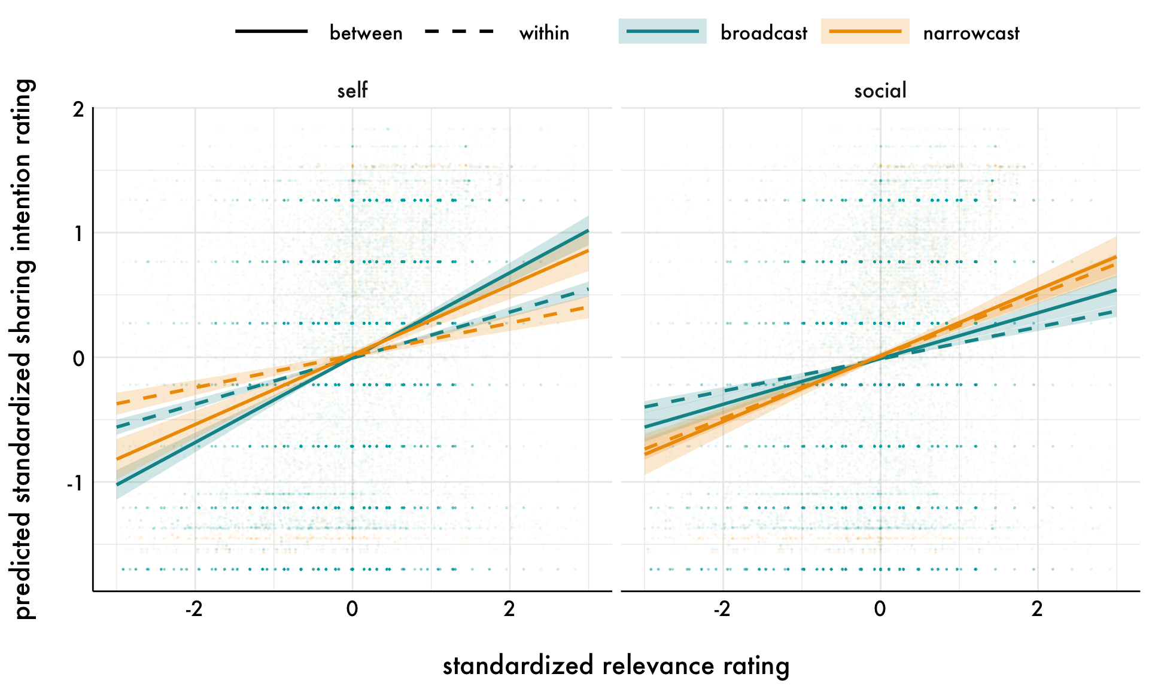
Figure S2. The predicted within- and between-person relationships for relevance ratings and sharing intention ratings from the mega-analysis as a function of within- and between-person relevance variable (self or social) and sharing type (broad- or narrowcasting) estimated from the downsampled data. The points represent the raw message-level responses; error bands are 95% confidence intervals. The left panel visualizes the relationships between sharing intentions and self-relevance, and shows that the relationship with sharing intentions is stronger when broadcasting compared to narrowcasting for both within- and between-person self-relevance. The right panel visualizes the relationships between sharing intentions and social relevance, and shows that the relationship with sharing intentions is stronger when narrowcasting compared to broadcasting for within- and between-person social relevance.

Table S2
Results from the downsampled mega-analysis model
Parameter | 𝛽 [95% CI] | df | t | p
Sharing type | 0.02 [-0.00, 0.04] | 12764.56 | 1.54 | .120
Self between | 0.34 [0.30, 0.38] | 3683.12 | 16.80 | < .001
Self within | 0.18 [0.16, 0.20] | 136.37 | 18.01 | < .001
Social between | 0.18 [0.14, 0.22] | 3653.76 | 9.08 | < .001
Social within | 0.13 [0.11, 0.14] | 77.55 | 16.08 | < .001
Self between x Sharing type | -0.06 [-0.10, -0.02] | 12786.35 | 2.87 | < .001
Self within x Sharing type | -0.06 [-0.08, -0.03] | 5772.64 | 4.17 | < .001
Social between x Sharing type | 0.08 [0.04, 0.12] | 12780.84 | 3.77 | < .001
Social within x Sharing type | 0.12 [0.09, 0.15] | 3203.99 | 8.80 | < .001
Note. “Within” parameters refer to the person-centered level-1 predictors, whereas “between” parameters refer to grand-mean centered level-2 predictors. The reference group for sharing type is broadcast sharing intentions. Coefficients are in standardized units. Degrees of freedom (df) were calculated using the Satterthwaite approximation.

Mega-analysis estimated separately for self and social relevance
Although the down-sampled analyses replicate the results in the main manuscript and suggest that the findings hold when self and social relevance are less strongly correlated, we also estimated post-hoc mega-analyses for self and social relevance separately (Table S3; Figure S3). These results are consistent with the results reported from the mega-analysis estimating the unique associations with sharing intentions reported in the main manuscript with the exception that within- and between-person self-relevance were no longer more strongly associated with broadcasting compared to narrowcasting.

Table S3
Results from the separated mega-analysis models
Self-relevance
Parameter | 𝛽 [95% CI] | df | t | p
Sharing type | -0.00 [-0.01, 0.01] | 25634.78 | 0.02 | .990
Self between | 0.50 [0.47, 0.52] | 3835.90 | 44.57 | < .001
Self within | 0.26 [0.24, 0.28] | 428.70 | 32.55 | < .001
Self between x Sharing type | -0.01 [-0.02, 0.00] | 25347.91 | 1.31 | .190
Self within x Sharing type | 0.01 [-0.00, 0.03] | 22988.68 | 1.91 | .060
Social relevance
Parameter | 𝛽 [95% CI] | df | t | p
Sharing type | -0.00 [-0.01, 0.01] | 25349.81 | 0.05 | .960
Social between | 0.46 [0.44, 0.48] | 3812.97 | 40.34 | < .001
Social within | 0.24 [0.23, 0.26] | 409.77 | 32.52 | < .001
Social between x Sharing type | 0.02 [0.00, 0.03] | 25050.87 | 2.28 | .020
Social within x Sharing type | 0.07 [0.06, 0.08] | 22318.42 | 9.59 | < .001
Note. “Within” parameters refer to the person-centered level-1 predictors, whereas “between” parameters refer to grand-mean centered level-2 predictors. The reference group for sharing type is broadcast sharing intentions. Coefficients are in standardized units. Degrees of freedom (df) were calculated using the Satterthwaite approximation.

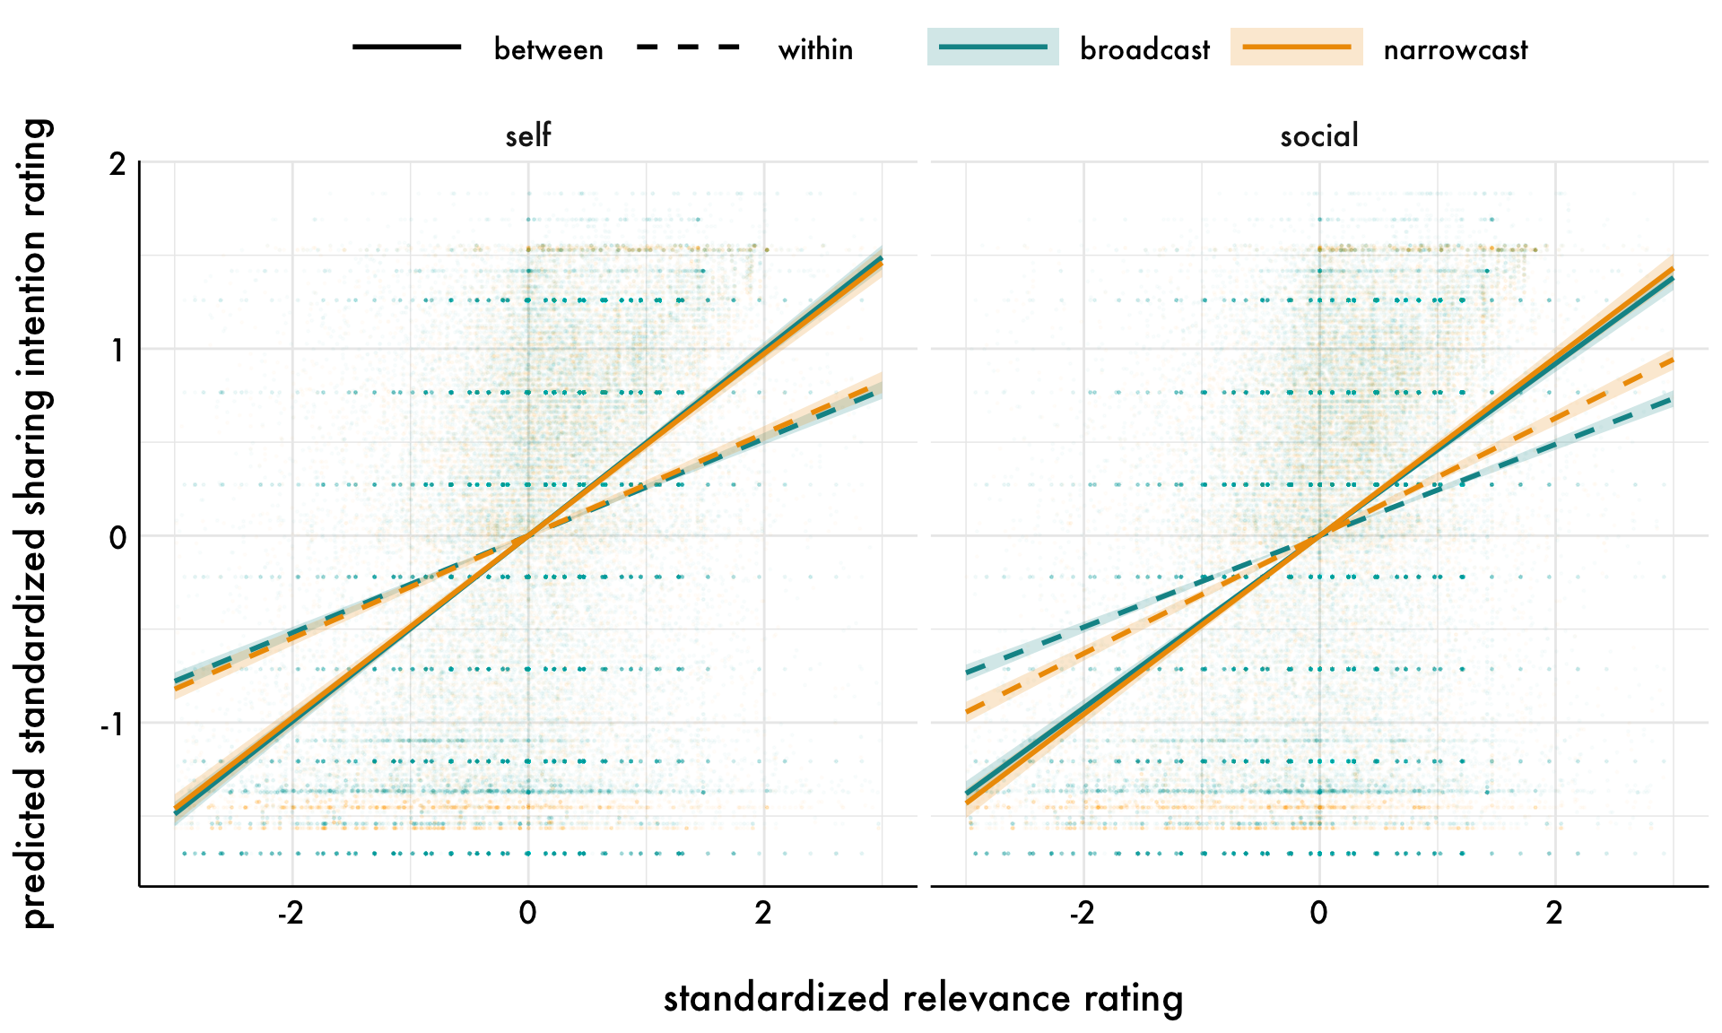
Figure S3. The predicted within- and between-person relationships for relevance ratings and sharing intention ratings from the mega-analyses estimated for self and social relevance separately, as a function of within- and between-person relevance variable (self or social) and sharing type (broad- or narrowcasting) estimated from the downsampled data. The points represent the raw message-level responses; error bands are 95% confidence intervals. The left panel visualizes the relationships between sharing intentions and self-relevance, and shows that the relationship with sharing intentions is equivalent when broadcasting and narrowcasting for both within- and between-person self-relevance. The right panel visualizes the relationships between sharing intentions and social relevance, and shows that the relationship with sharing intentions is stronger when narrowcasting compared to broadcasting for within- and between-person social relevance.

Additional information about the specification curve analysis
As described in the main manuscript, the specification curve analysis explores the robustness of the relationships between self and social relevance and sharing intentions to inclusion of covariates and across different subsets of the data. Table S4 describes the 13 subsets that were included in the analysis. Figures S4-5 depict the curve for each relevance variable including a marker for which subset the model was estimated in. Descriptive statistics for the curve for each relevance variable separately is reported in Table S5 as a function of sharing type and message medium. Figure S5-6 includes all relevance variables in the same specification curve in order to compare them (versus showing the curve for each relevance variable separately in the main manuscript).

Table S4
Data subsets included in the specification curve analysis
Subset | Content | Medium | Sharing type | Studies | N models
1 | COVID-19 | Social media | Broadcast | 1 | 28
2 | COVID-19 | Newspapers | Broadcast | 5 | 28
3 | COVID-19 | Newspapers | Narrowcast | 5 | 28
4 | Voting | Social media | Broadcast | 2 & 3 | 20
5 | Voting | Social media | Narrowcast | 3 | 16
6 | Health | Newspapers | Broadcast | 4 & 6 | 28
7 | Health | Newspapers | Narrowcast | 6 | 28
8 | Climate change | Newspapers | Broadcast | 5 & 6 | 28
9 | Climate change | Newspapers | Narrowcast | 5 & 6 | 28
10 | COVID-19 | Social media & newspapers | Broadcast | 1 & 5 | 28
11 | COVID-19 & voting | Social media | Broadcast | 1, 2 & 3 | 28
12 | COVID-19, health & climate change | Newspapers | Broadcast | 4, 5 & 6 | 28
13 | COVID-19 & climate change | Newspapers | Narrowcast | 5 & 6 | 28

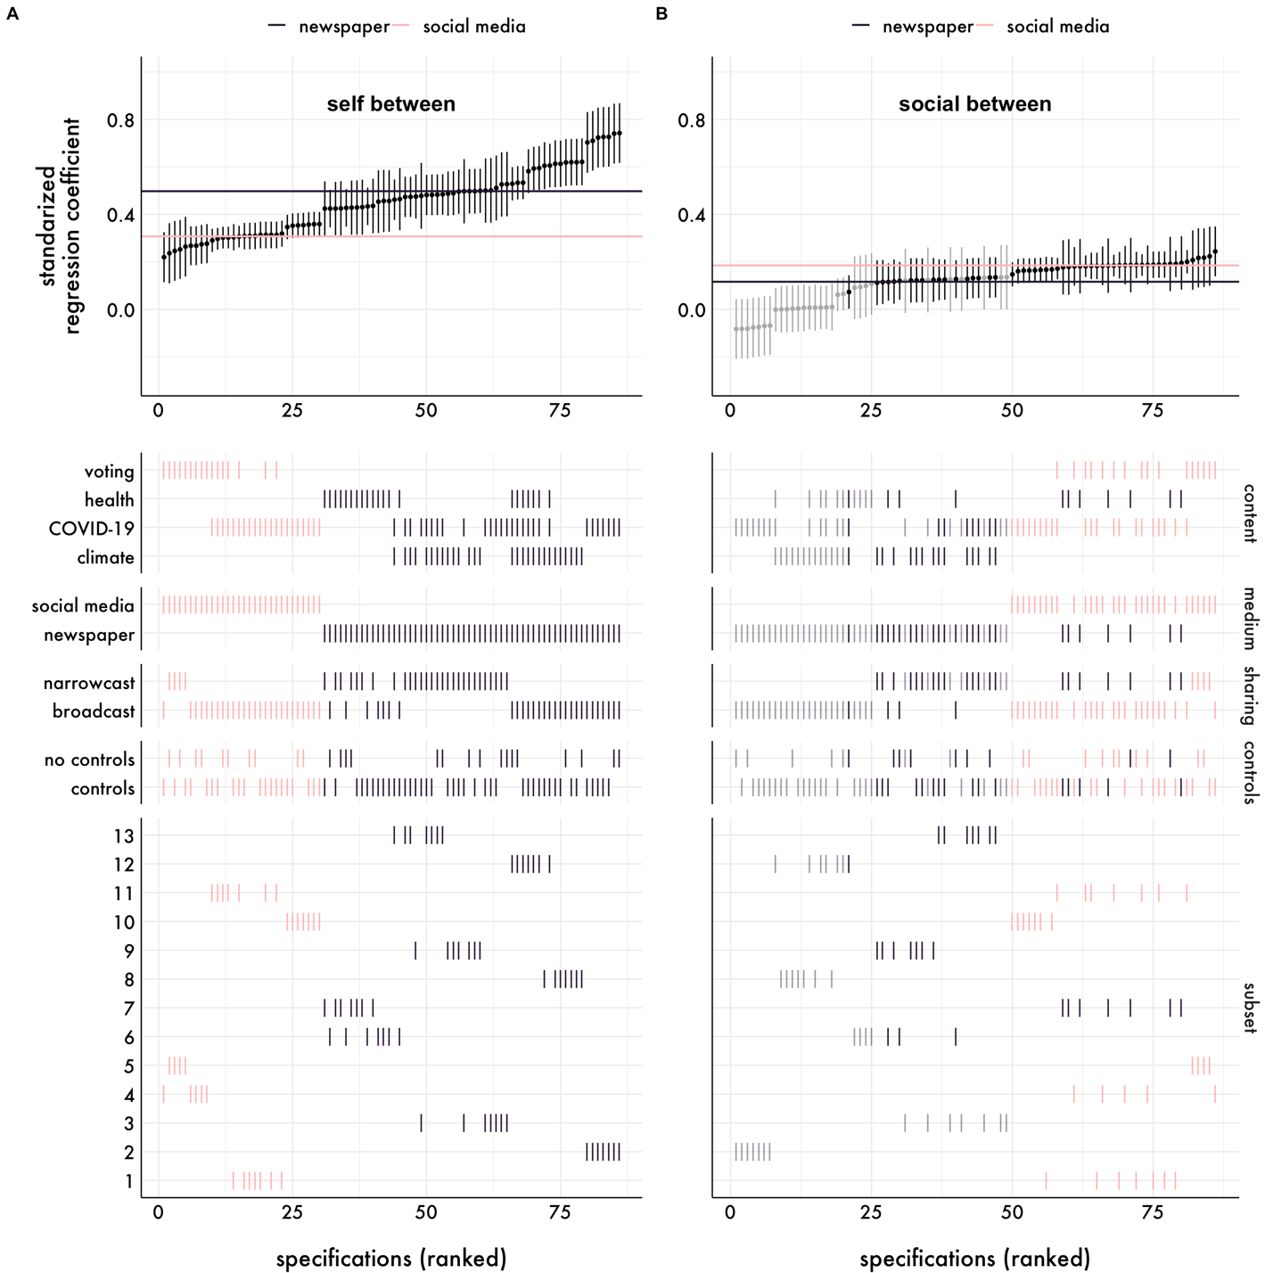
Figure S4. Specification curves for the between-person relevance variables reported in Figure 3A-B including an additional marker for which subset the model was estimated in. The subsets are described in Table S4.

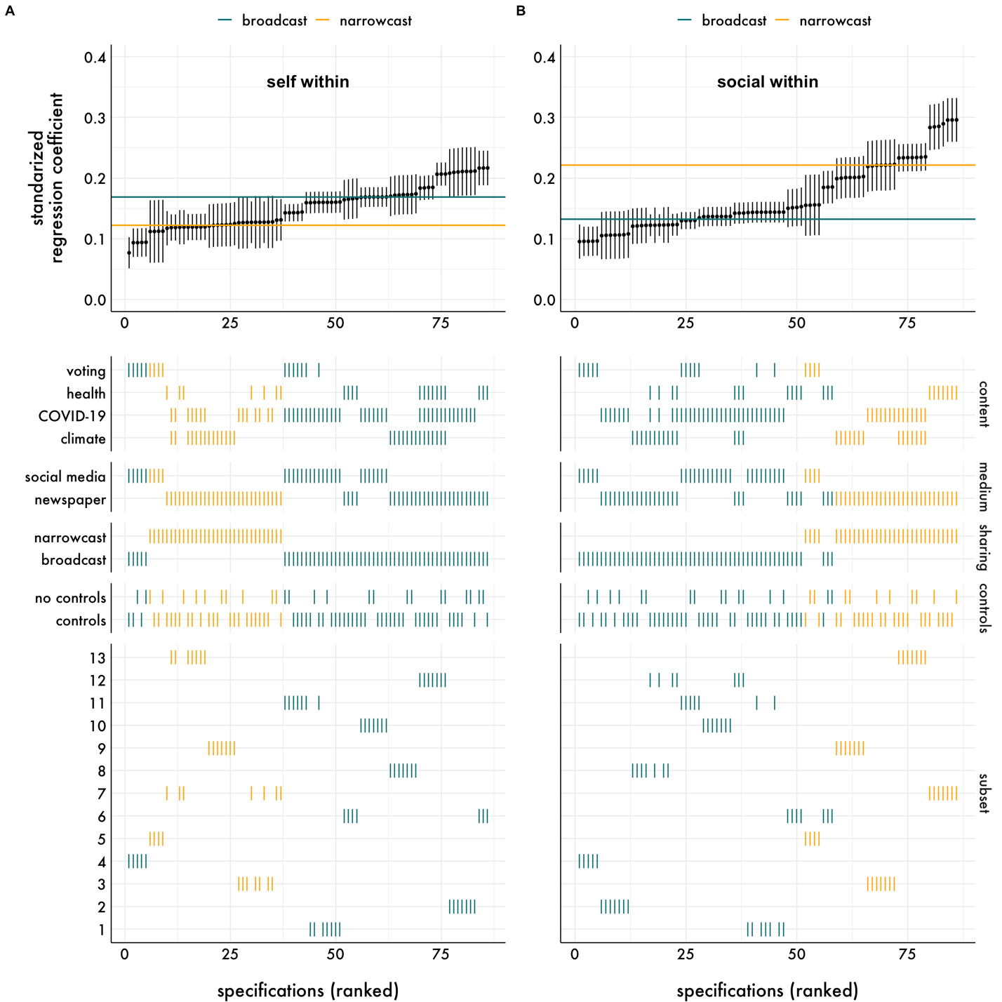
Figure S5. Specification curves for the within-person relevance variables reported in Figure 3C-D including an additional marker for which subset the model was estimated in. The subsets are described in Table S4.

Table S5
Specification curve descriptives statistics by sharing type and message medium
Sharing type
Parameter | Grouping variable | Median 𝛽 | 𝛽 Range | Positive & significant | Negative & significant
Self between | Broadcast | 0.43 | 0.22, 0.74 | 100.00% | 0.00%
 | Narrowcast | 0.48 | 0.24, 0.53 | 100.00% | 0.00%
Self within | Broadcast | 0.17 | 0.08, 0.22 | 100.00% | 0.00%
 | Narrowcast | 0.12 | 0.11, 0.13 | 100.00% | 0.00%
Social between | Broadcast | 0.12 | -0.08, 0.24 | 55.56% | 0.00%
 | Narrowcast | 0.13 | 0.11, 0.22 | 78.12% | 0.00%
Social within | Broadcast | 0.13 | 0.10, 0.19 | 100.00% | 0.00%
 | Narrowcast | 0.22 | 0.16, 0.30 | 100.00% | 0.00%
Message medium
Parameter | Grouping variable | Median 𝛽 | 𝛽 Range | Positive & significant | Negative & significant
Self between | Newspaper | 0.50 | 0.42, 0.74 | 100.00% | 0.00%
 | Social media | 0.31 | 0.22, 0.36 | 100.00% | 0.00%
Self within | Newspaper | 0.15 | 0.12, 0.22 | 100.00% | 0.00%
 | Social media | 0.16 | 0.08, 0.17 | 100.00% | 0.00%
Social between | Newspaper | 0.12 | -0.08, 0.20 | 44.64% | 0.00%
 | Social media | 0.18 | 0.15, 0.24 | 100.00% | 0.00%
Social within | Newspaper | 0.19 | 0.11, 0.30 | 100.00% | 0.00%
 | Social media | 0.14 | 0.10, 0.16 | 100.00% | 0.00%

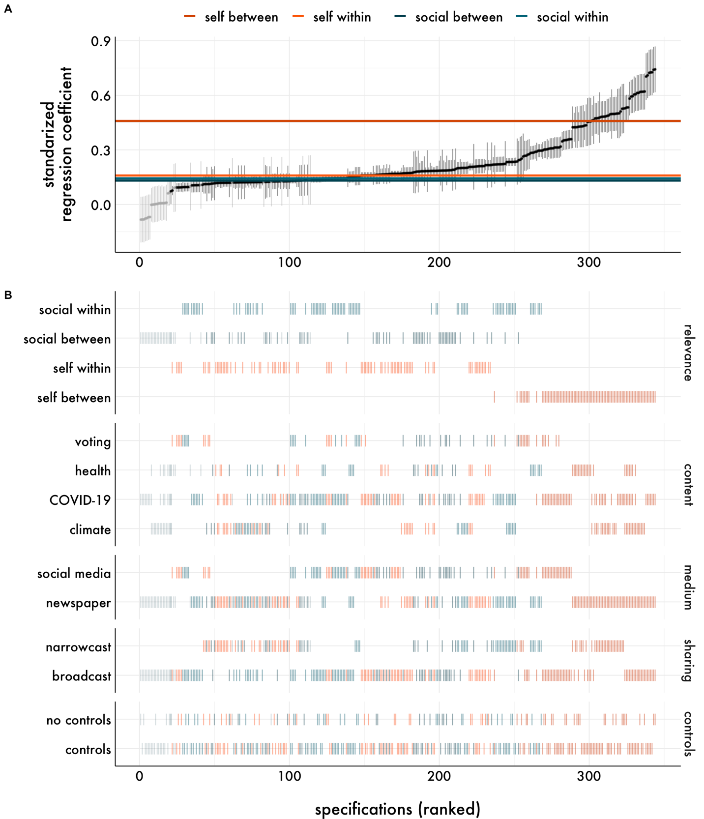

Figure S6. Specification curve visualizing the relationship between self and social relevance and sharing intentions across analytic decisions and subsets of the data. (A) The top panel depicts the relationship between the relevance variables and sharing intentions. Each dot represents the standardized regression coefficient for the relevance variable of interest from a unique model specification with a 95% confidence interval around it. Model specifications are ordered by the regression coefficient; models for which the regression coefficient of interest was statistically significant at p < .05 are visualized in black, whereas coefficients p > .05 are in gray. The colored horizontal lines represent the median regression coefficient across model specifications for each relevance variable, separately. (B) The bottom panel shows the relevance variables and analytic decisions that were included in each model specification. Model specifications are colored based on the relevance variable; models for which the regression coefficient of interest was statistically significant at p < 0.05 are visualized are opaque, whereas coefficients p > 0.05 are partially opaque. Content = content type; medium = message medium; type = sharing type; controls = inclusion of demographic covariates.

Results from analyses estimated separately for each study
For completeness and to be consistent with our preregistered analysis plans for Studies 5 and 6, we also report the results for each study separately. As in the mega-analysis reported in the main manuscript, we investigated the relationships between message self and social relevance and broadcast sharing intentions using multilevel modeling. Self and social relevance ratings were disaggregated into within and between-person variables. The “within-person” self and social relevance variables were level 1 predictors, centered within-person (i.e., “centered within context”) and standardized across people. Each of the “between-person” variables were level 2 predictors created by averaging across message self or social relevance ratings to create a single average per person that was then grand-mean centered and standardized across people.
For each study, we estimated three multilevel models regressing message sharing intentions on 1) within- and between-person self-relevance, 2) within- and between-person social relevance, and 3) within- and between-person self-relevance, and within- and between-person social relevance. The first and second models estimate the relationship between sharing intentions and self and social relevance separately, whereas the third model estimates each variables’ unique association with sharing intentions after adjusting for the others. In all models, intercepts and within-person relevance variables were allowed to vary randomly across people and intercepts could vary across messages. This was the least constrained random effects structure that converged across studies. All models were estimated using the lme4 (Version 1.1-26; Bates et al., 2015) and lmerTest (Version 3.1-3; Kuznetsova, Brockhoff, & Christensen, 2017) for significance testing in R (Version 3.6.3; R Core Team, 2020).
For the studies that included broad- and narrowcasting, we examined potential differences between broadcast and narrowcast sharing intentions by estimating a fourth model that included sharing type (broadcast or narrowcast) as a moderator of the relationship between self or social relevance and sharing intentions. In these models, intercepts and within-person relevance variables were allowed to vary randomly across people and messages, which was the least constrained random effects structure that converged across studies.

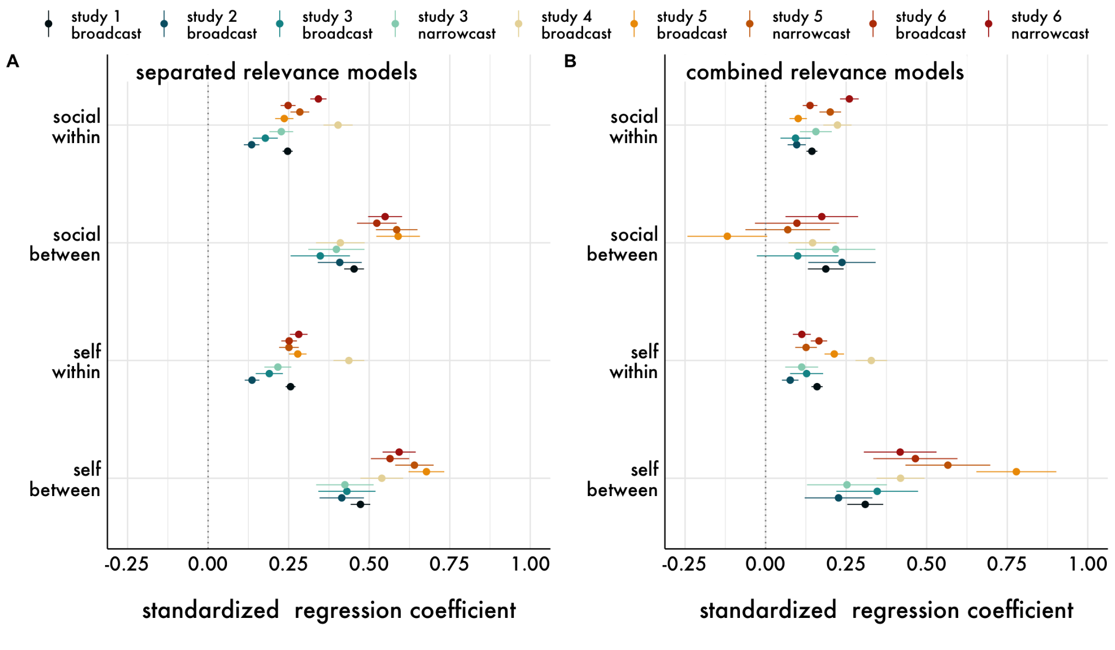
Figure S7. Standardized regression coefficients from (A) the models run separately including either the self-relevance or social relevance variables only, and (B) the models including the self and social relevance variables within the same model. “Within” parameters refer to the person-centered level 1 predictors, whereas “between” parameters refer to grand-mean centered level 2 predictors. Error bars around the point estimates are 95% confidence intervals.

First, we estimated the association between each relevance variable and sharing intention separately (Figure S7A; Tables S6-7). In all studies, within- and between-person self and social relevance were positively related to broad- and narrowcast sharing intentions, and the magnitude ranged from small to large effects.

Table S6
Results from the self-relevance multilevel models
Model | Parameter | 𝛽 [95% CI] | df | t | p
Study 1 broadcast | Self between | 0.47 [0.44, 0.50] | 2145.50 | 30.47 | < .001
 | Self within | 0.26 [0.24, 0.27] | 1181.80 | 32.32 | < .001
Study 2 broadcast | Self between | 0.41 [0.35, 0.48] | 555.65 | 11.81 | < .001
 | Self within | 0.14 [0.11, 0.16] | 265.79 | 11.74 | < .001
Study 3 broadcast | Self between | 0.43 [0.34, 0.52] | 247.14 | 9.51 | < .001
 | Self within | 0.19 [0.15, 0.23] | 158.23 | 8.82 | < .001
Study 3 narrowcast | Self between | 0.42 [0.34, 0.51] | 249.16 | 9.32 | < .001
 | Self within | 0.22 [0.17, 0.26] | 161.08 | 10.14 | < .001
Study 4 broadcast | Self between | 0.54 [0.47, 0.61] | 142.31 | 15.88 | < .001
 | Self within | 0.44 [0.39, 0.48] | 121.19 | 17.93 | < .001
Study 5 broadcast | Self between | 0.68 [0.62, 0.73] | 324.22 | 23.96 | < .001
 | Self within | 0.28 [0.25, 0.31] | 245.44 | 19.97 | < .001
Study 5 narrowcast | Self between | 0.64 [0.58, 0.70] | 317.64 | 21.03 | < .001
 | Self within | 0.25 [0.22, 0.28] | 229.36 | 16.06 | < .001
Study 6 broadcast | Self between | 0.56 [0.51, 0.62] | 405.99 | 18.60 | < .001
 | Self within | 0.25 [0.23, 0.28] | 334.94 | 20.35 | < .001
Study 6 narrowcast | Self between | 0.59 [0.54, 0.64] | 398.73 | 22.62 | < .001
 | Self within | 0.28 [0.25, 0.31] | 328.95 | 20.12 | < .001
Note. “Within” parameters refer to the person-centered level 1 predictors, whereas “between” parameters refer to grand-mean centered level 2 predictors. Coefficients are in standardized units. Degrees of freedom (df) were calculated using the Satterthwaite approximation.

Table S7
Results from the social relevance multilevel models
Model | Parameter | 𝛽 [95% CI] | df | t | p
Study 1 broadcast | Social between | 0.45 [0.42, 0.48] | 2133.49 | 28.84 | < .001
 | Social within | 0.25 [0.23, 0.26] | 967.20 | 30.88 | < .001
Study 2 broadcast | Social between | 0.41 [0.34, 0.48] | 548.93 | 11.74 | < .001
 | Social within | 0.14 [0.11, 0.16] | 272.42 | 10.95 | < .001
Study 3 broadcast | Social between | 0.35 [0.26, 0.44] | 239.36 | 7.41 | < .001
 | Social within | 0.18 [0.14, 0.22] | 128.06 | 8.95 | < .001
Study 3 narrowcast | Social between | 0.40 [0.31, 0.49] | 234.77 | 8.95 | < .001
 | Social within | 0.23 [0.19, 0.26] | 111.96 | 12.07 | < .001
Study 4 broadcast | Social between | 0.41 [0.33, 0.49] | 139.34 | 10.66 | < .001
 | Social within | 0.40 [0.36, 0.45] | 103.95 | 17.47 | < .001
Study 5 broadcast | Social between | 0.59 [0.52, 0.66] | 316.18 | 17.05 | < .001
 | Social within | 0.24 [0.21, 0.26] | 224.97 | 16.29 | < .001
Study 5 narrowcast | Social between | 0.59 [0.52, 0.65] | 317.74 | 17.76 | < .001
 | Social within | 0.28 [0.26, 0.31] | 225.47 | 19.10 | < .001
Study 6 broadcast | Social between | 0.52 [0.46, 0.59] | 402.78 | 16.68 | < .001
 | Social within | 0.25 [0.22, 0.27] | 303.88 | 20.92 | < .001
Study 6 narrowcast | Social between | 0.55 [0.50, 0.60] | 401.49 | 20.42 | < .001
 | Social within | 0.34 [0.32, 0.37] | 287.96 | 26.55 | < .001
Note. “Within” parameters refer to the person-centered level 1 predictors, whereas “between” parameters refer to grand-mean centered level 2 predictors. Coefficients are in standardized units. Degrees of freedom (df) were calculated using the Satterthwaite approximation.

Next, we tested whether self and social relevance accounted for unique variance when estimated within the same model, meaning that parameter estimates reflect the relationship after adjusting for the other variables in the model (Figure S7B; Table S8). All relationships between within- and between-person self and social relevance and sharing intentions were positive except in Study 5. In this study, between-person social relevance was negatively related to broadcast sharing intentions when adjusting for the other relevance variables in the model. In addition, this relationship did not differ significantly from zero in Studies 3 and 6. Together, this indicates that there is less consistency in the magnitude and direction of this relationship (compared to the other relevance variables) across studies.

Table S8
Results from the combined/ adjusted multilevel models
Model | Parameter | 𝛽 [95% CI] | df | t | p
Study 1 broadcast | Self between | 0.31 [0.25, 0.37] | 2097.70 | 10.85 | < .001
 | Self within | 0.16 [0.14, 0.18] | 833.22 | 17.79 | < .001
 | Social between | 0.19 [0.13, 0.24] | 2073.58 | 6.59 | < .001
 | Social within | 0.14 [0.13, 0.16] | 781.23 | 16.49 | < .001
Study 2 broadcast | Self between | 0.23 [0.12, 0.33] | 548.60 | 4.23 | < .001
 | Self within | 0.08 [0.05, 0.10] | 182.45 | 5.83 | < .001
 | Social between | 0.24 [0.13, 0.34] | 538.39 | 4.45 | < .001
 | Social within | 0.10 [0.07, 0.12] | 258.92 | 6.72 | < .001
Study 3 broadcast | Self between | 0.35 [0.22, 0.47] | 246.17 | 5.35 | < .001
 | Self within | 0.13 [0.08, 0.18] | 115.16 | 4.86 | < .001
 | Social between | 0.10 [-0.03, 0.23] | 242.43 | 1.54 | .130
 | Social within | 0.09 [0.05, 0.14] | 128.47 | 3.88 | < .001
Study 3 narrowcast | Self between | 0.25 [0.13, 0.38] | 252.18 | 3.99 | < .001
 | Self within | 0.11 [0.06, 0.16] | 91.050 | 4.28 | < .001
 | Social between | 0.22 [0.09, 0.34] | 245.30 | 3.45 | < .001
 | Social within | 0.16 [0.11, 0.21] | 109.51 | 6.18 | < .001
Study 4 broadcast | Self between | 0.42 [0.34, 0.49] | 134.43 | 11.03 | < .001
 | Self within | 0.33 [0.28, 0.38] | 120.99 | 13.08 | < .001
 | Social between | 0.15 [0.07, 0.22] | 136.50 | 3.83 | < .001
 | Social within | 0.22 [0.18, 0.27] | 130.95 | 9.96 | < .001
Study 5 broadcast | Self between | 0.78 [0.65, 0.90] | 322.02 | 12.28 | < .001
 | Self within | 0.21 [0.18, 0.24] | 220.10 | 13.76 | < .001
 | Social between | -0.12 [-0.24, 0.00] | 319.53 | 1.88 | .060
 | Social within | 0.10 [0.07, 0.13] | 199.76 | 7.33 | < .001
Study 5 narrowcast | Self between | 0.57 [0.43, 0.70] | 316.41 | 8.42 | < .001
 | Self within | 0.13 [0.09, 0.16] | 240.21 | 7.33 | < .001
 | Social between | 0.07 [-0.06, 0.20] | 316.03 | 1.02 | .310
 | Social within | 0.20 [0.17, 0.23] | 235.61 | 11.72 | < .001
Study 6 broadcast | Self between | 0.46 [0.33, 0.60] | 376.82 | 6.97 | < .001
 | Self within | 0.17 [0.14, 0.19] | 316.63 | 12.71 | < .001
 | Social between | 0.10 [-0.03, 0.23] | 374.09 | 1.46 | .140
 | Social within | 0.14 [0.12, 0.16] | 250.99 | 11.81 | < .001
Study 6 narrowcast | Self between | 0.42 [0.30, 0.53] | 380.44 | 7.25 | < .001
 | Self within | 0.11 [0.08, 0.14] | 279.68 | 7.92 | < .001
 | Social between | 0.17 [0.06, 0.29] | 378.34 | 3.03 | < .001
 | Social within | 0.26 [0.23, 0.29] | 281.19 | 17.57 | < .001
Note. “Within” parameters refer to the person-centered level 1 predictors, whereas “between” parameters refer to grand-mean centered level 2 predictors. Coefficients are in standardized units. Degrees of freedom (df) were calculated using the Satterthwaite approximation.

Finally, for Studies 3, 5, and 6, we tested whether the relationships differed as a function of sharing type and directly compared broad- and narrowcast sharing intentions. Overall, the relationship between social relevance within- and between-person tended to be more strongly related to sharing intentions when narrowcasting than when broadcasting, whereas self-relevance tended to be more weakly related to sharing intentions when narrowcasting than when broadcasting (Table S9).

Table S9
Results from the sharing type interaction models
Model | Parameter | 𝛽 [95% CI] | df | t | p
Study 3 | Sharing type | -0.00 [-0.04, 0.04] | 1987.51 | -0.08 | .940
 | Social between | 0.11 [-0.01, 0.23] | 281.29 | 1.74 | .080
 | Social within | 0.10 [0.05, 0.15] | 248.94 | 3.64 | < .001
 | Self between | 0.34 [0.22, 0.46] | 284.52 | 5.60 | < .001
 | Self within | 0.13 [0.07, 0.18] | 180.74 | 4.48 | < .001
 | Social between x Sharing type | 0.10 [0.03, 0.16] | 1926.52 | 3.04 | < .001
 | Social within x Sharing type | 0.05 [-0.01, 0.11] | 1927.26 | 1.54 | .120
 | Self between x Sharing type | -0.08 [-0.14, -0.01] | 1926.33 | -2.40 | .020
 | Self within x Sharing type | -0.01 [-0.07, 0.05] | 1938.52 | -0.29 | .770
Study 5 | Sharing type | -0.00 [-0.02, 0.02] | 5741.47 | 0.00 | 1.000
 | Social between | -0.14 [-0.27, -0.02] | 346.17 | -2.27 | .020
 | Social within | 0.10 [0.06, 0.13] | 372.59 | 6.17 | < .001
 | Self between | 0.81 [0.68, 0.93] | 347.20 | 12.78 | < .001
 | Self within | 0.21 [0.18, 0.24] | 408.53 | 12.96 | < .001
 | Social between x Sharing type | 0.23 [0.18, 0.28] | 5436.83 | 9.12 | < .001
 | Social within x Sharing type | 0.11 [0.08, 0.14] | 5436.83 | 6.98 | < .001
 | Self between x Sharing type | -0.26 [-0.31, -0.21] | 5436.83 | -10.14 | < .001
 | Self within x Sharing type | -0.09 [-0.12, -0.06] | 5436.83 | -5.58 | < .001
Study 6 | Sharing type | -0.00 [-0.02, 0.02] | 7181.45 | 0.00 | 1.000
 | Social between | 0.13 [0.01, 0.25] | 418.42 | 2.14 | .030
 | Social within | 0.12 [0.10, 0.15] | 509.14 | 9.41 | < .001
 | Self between | 0.45 [0.33, 0.57] | 419.87 | 7.39 | < .001
 | Self within | 0.16 [0.14, 0.19] | 543.19 | 12.43 | < .001
 | Social between x Sharing type | 0.04 [-0.01, 0.08] | 6801.62 | 1.46 | .140
 | Social within x Sharing type | 0.14 [0.11, 0.17] | 6801.63 | 9.93 | < .001
 | Self between x Sharing type | -0.02 [-0.07, 0.03] | 6801.62 | -0.92 | .360
 | Self within x Sharing type | -0.06 [-0.09, -0.03] | 6801.72 | -4.03 | < .001
Note. “Within” parameters refer to the person-centered level 1 predictors, whereas “between” parameters refer to grand-mean centered level 2 predictors. The reference group for sharing type is broadcast sharing intentions. Coefficients are in standardized units. Degrees of freedom (df) were calculated using the Satterthwaite approximation.

Preregistered mediation analyses including a single mediator
We estimated four within-person mediation models (http://www.page-gould.com/r/indirectmlm/) testing the degree to which the effect of the experimental condition (self v. control, or social v. control) on sharing intentions was mediated by self-relevance in the self condition or social relevance in the social condition, estimating these models separately for broadcasting and narrowcasting. The raw units were retained here (versus standardizing) to facilitate interpretation in meaningful units. Bootstrapping was used to generate 95% confidence intervals.
For the self condition (Figure S8A), 81% of the total effect was mediated by changes in self-relevance for broadcast sharing intentions, and 79% was mediated by changes in self-relevance for narrowcast sharing intentions. A similar pattern was observed for the social condition (Figure S8B); 119% of the total effect was mediated by changes in social relevance for broadcast sharing intentions, and 64% was mediated by changes in social relevance for narrowcast sharing intentions.

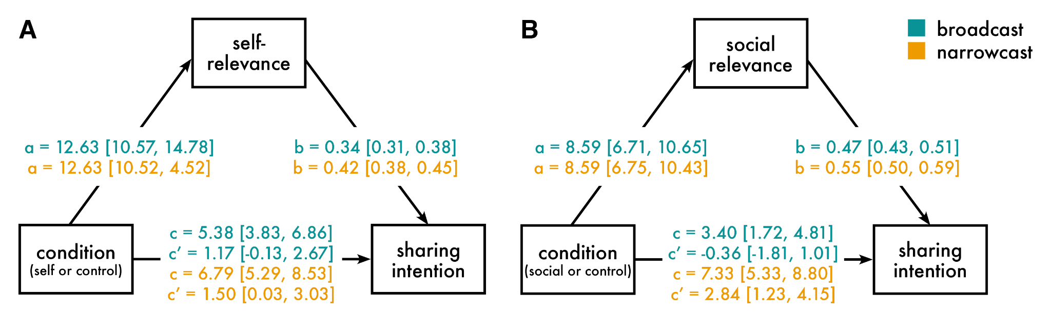
Figure S8. Path diagrams of the within-person multilevel mediation models for the (A) self condition and (B) social condition. Parameter estimates and bootstrapped 95% confidence intervals are reported for broadcast and narrowcast sharing intentions separately. c = total effect (direct + indirect effect of condition on sharing intention); c′ = direct effect.

Post-hoc causal study analyses
Moderation by article content type. We explored whether the effectiveness of the experimental manipulations was moderated by article content type (general health or climate change) in Study 6. To do so, we estimated the multilevel models reported in the main manuscript, but included content type and its interactions with experimental condition (all models) and sharing type (sharing intention model only). Compared to health content, climate content was rated as 1) more self-relevant, 2) less socially relevant, and 3) having lower sharing intentions when narrowcasting compared to broadcasting (Figure S9, Table S10). Finally, although there were mean level differences between content types, the effects of the experimental manipulation were similar across content; that is, content type did not moderate the effects of experimental condition on self-relevance, social relevance, or sharing intentions.

Table S10
Results from the moderation analyses
Self-relevance
Parameter | 𝛽 [95% CI] | df | t | p
Control (intercept, health) | 51.33 [48.66, 54.00] | 386.91 | 37.77 | < .001
Self | 13.30 [10.27, 16.34] | 234.52 | 8.64 | < .001
Social | 4.88 [1.75, 8.02] | 224.15 | 3.07 | < .001
Content (climate) | 3.30 [0.51, 6.10] | 396.79 | 2.32 | .020
Self x Content (climate) | -2.71 [-6.26, 0.84] | 253.60 | 1.50 | .130
Social x Content (climate) | 0.61 [-3.30, 4.51] | 241.31 | 0.31 | .760
Social relevance
Parameter | 𝛽 [95% CI] | df | t | p
Control (intercept, health) | 61.45 [59.02, 63.88] | 387.62 | 49.71 | < .001
Self | 7.72 [5.22, 10.22] | 239.9 | 6.09 | < .001
Social | 7.22 [4.27, 10.18] | 230.84 | 4.82 | < .001
Content (climate) | -5.82 [-8.26, -3.38] | 394.4 | 4.70 | < .001
Self x Content (climate) | 1.33 [-2.11, 4.78] | 273.77 | 0.76 | .450
Social x Content (climate) | 3.10 [-0.35, 6.55] | 236.9 | 1.77 | .080
Sharing intentions
Parameter | 𝛽 [95% CI] | df | t | p
Control (intercept, health, broadcasting) | 44.39 [41.26, 47.53] | 477.23 | 27.85 | < .001
Self | 4.28 [2.05, 6.52] | 7084.00 | 3.76 | < .001
Social | 3.94 [1.70, 6.17] | 7067.02 | 3.45 | < .001
Sharing type | 2.09 [0.08, 4.11] | 1504.98 | 2.04 | .040
Content (climate) | 1.45 [-0.56, 3.46] | 1695.61 | 1.41 | .160
Self x Sharing type | 2.23 [-0.78, 5.24] | 7101.11 | 1.45 | .150
Social x Sharing type | 3.98 [0.97, 6.99] | 7082.51 | 2.59 | .010
Self x Content (climate) | 1.47 [-1.60, 4.55] | 7301.86 | 0.94 | .350
Social x Content (climate) | -1.38 [-4.46, 1.71] | 7291.96 | 0.87 | .380
Sharing type x Content (climate) | -3.91 [-6.28, -1.54] | 6964.98 | 3.23 | < .001
Self x Sharing type x Content (climate) | -0.25 [-4.40, 3.89] | 7063.14 | 0.12 | .900
Social x Sharing type x Content (climate) | -0.76 [-4.92, 3.40] | 7053.97 | 0.36 | .720
Note. The reference group for sharing type is broadcast sharing intentions, health for content type, and control for experimental condition. Degrees of freedom (df) were calculated using the Satterthwaite approximation.

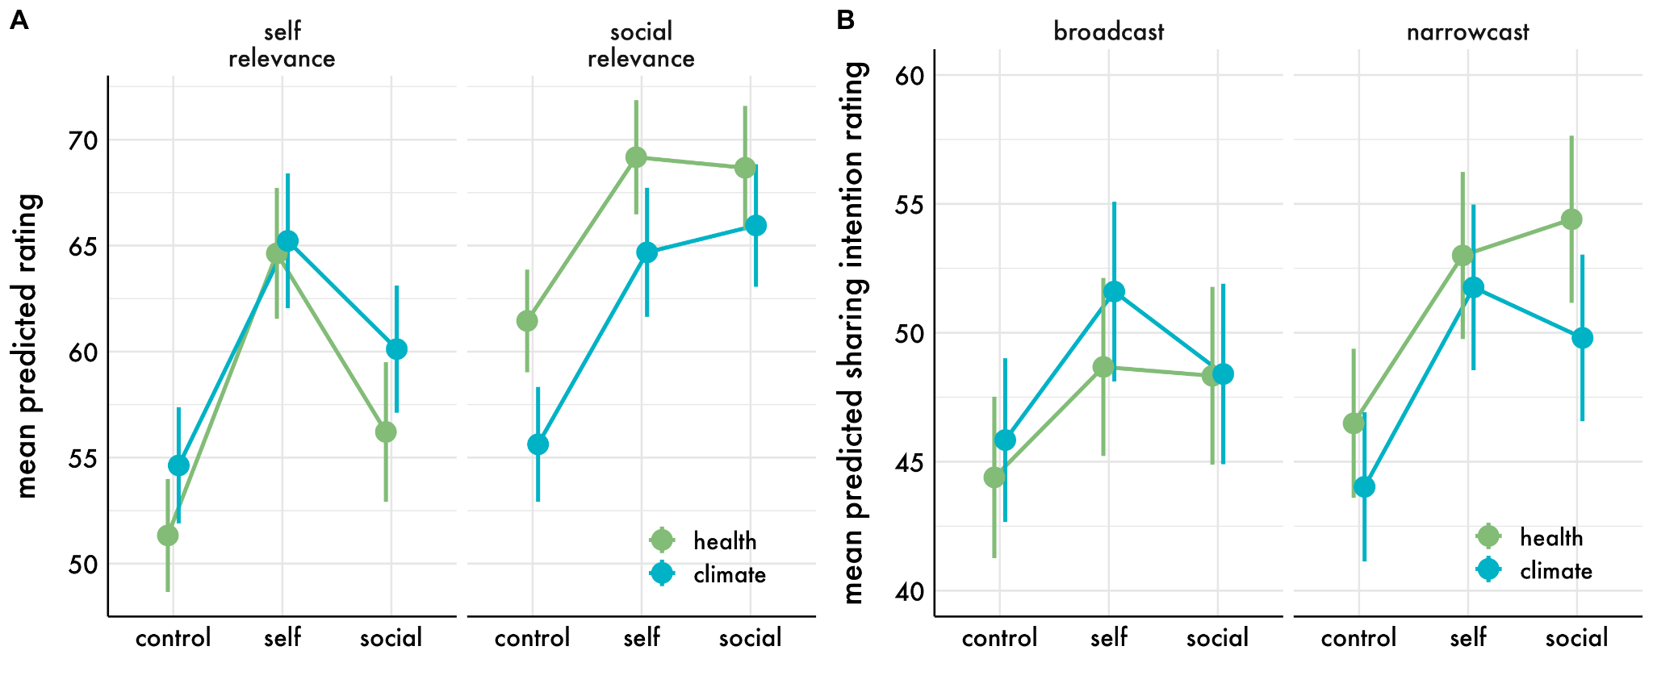
Figure S9. Mean predicted (A) self and social relevance ratings and (B) broad- and narrowcast sharing intentions as a function of experimental condition (self, social, or control) and article content type (health or climate). Error bars are 95% confidence intervals.

Depth of processing. To examine the potential role of depth of processing in the experiment, we conducted a post-hoc sensitivity analysis using word count as a proxy for depth of processing. Consistent with hypothesis that depth the experimental manipulations increased the depth of processing of the messages, participants wrote more in the self (b = 3.08, 95% CI [2.60, 3.56], t(3725.05) = 12.63, p < .001) and social (b = 3.05, 95% CI [2.57, 3.54], t(3727.22) = 12.43, p < .001) conditions compared to the control condition. Because word count was also positively related to self (b = 0.50, 95% CI [0.32, 0.67], t(273.86) = 5.62, p < .001) and social relevance (b = 0.48, 95% CI [0.33, 0.63], t(236.60) = 6.45, p < .001), we tested the degree to which the effects of the experimental manipulations on relevance was mediated by word count. For the self experimental manipulation, we found that 19% of the total effect on self-relevance and 13% of the total effect on social relevance was mediated by word count. For the social experimental manipulation, we found that 15% of the total effect on social relevance and 17% of the total effect on self-relevance was mediated by word count. This suggests that depth of processing may partially explain the effect of the experimental manipulations on self and social relevance, but is not sufficient to explain the full effect.

References
Bakdash, J. Z., & Marusich, L. R. (2017). Repeated Measures Correlation. Frontiers in Psychology, 8, 456. https://doi.org/10.3389/fpsyg.2017.00456
Bates, D. & Maechler, M. (2019). Matrix: Sparse and Dense Matrix Classes and Methods. R package version 1.2-18. https://CRAN.R-project.org/package=Matrix
Bates, D., Maechler, M., Bolker, B., & Walker, S. (2015). Fitting Linear Mixed-Effects Models Using lme4. Journal of Statistical Software, 67(1), 1-48. https://doi.org/10.18637/jss.v067.i01.
Bolker, B. & Robinson, D. (2021). broom.mixed: Tidying Methods for Mixed Models. R package version 0.2.7. https://CRAN.R-project.org/package=broom.mixed
Bürkner, P-C. (2017). brms: An R Package for Bayesian Multilevel Models Using Stan. Journal of Statistical Software, 80(1), 1-28. doi:10.18637/jss.v080.i01
Canty, A., & Ripley, B. (2019). boot: Bootstrap R (S-Plus) Functions. R package version 1.3-24.
Henry, L., & Wickham, H. (2020). purrr: Functional Programming Tools. R package version 0.3.4. https://CRAN.R-project.org/package=purrr
Kassambara, A. (2020). ggpubr: 'ggplot2' Based Publication Ready Plots. R package version 0.4.0. https://CRAN.R-project.org/package=ggpubr
Kay, M. (2022). tidybayes: Tidy Data and Geoms for Bayesian Models. doi: 10.5281/zenodo.1308151
Kleiman, E. (2021). EMAtools: Data Management Tools for Real-Time Monitoring/Ecological Momentary Assessment Data. R package version 0.1.4. https://CRAN.R-project.org/package=EMAtools
Kuznetsova, A., Brockhoff, P. B., & Christensen, R. H. B. (2017). lmerTest Package:Tests in Linear Mixed Effects Models. Journal of Statistical Software, 82(13), 1-26. https://doi.org/10.18637/jss.v082.i13
Makowski, D., Ben-Shachar, M.S., Patil, I. & Lüdecke, D. (2020). Automated Results Reporting as a Practical Tool to Improve Reproducibility and Methodological Best Practices Adoption. CRAN. Available from https://github.com/easystats/report
Masur, Philipp K. & Scharkow, M. (2020). specr: Conducting and Visualizing Specification Curve Analyses. Available from https://CRAN.R-project.org/package=specr
Silge, J. & Robinson, D. (2016). tidytext: Text Mining and Analysis Using Tidy Data Principles in R. Journal of Open Source Software, 1(3). doi: 10.21105/joss.00037
Vaughan, D. and Dancho, M. (2021). furrr: Apply Mapping Functions in Parallel using Futures. R package version 0.2.2. https://CRAN.R-project.org/package=furrr
Wickham, H. & Hester, J. (2020). readr: Read Rectangular Text Data. R package version 1.4.0. https://CRAN.R-project.org/package=readr
Wickham, H. (2016) ggplot2: Elegant Graphics for Data Analysis. Springer-Verlag New York.
Wickham, H. (2019). stringr: Simple, Consistent Wrappers for Common String Operations. R package version 1.4.0. https://CRAN.R-project.org/package=stringr
Wickham, H. (2021). forcats: Tools for Working with Categorical Variables (Factors). R package version 0.5.1. https://CRAN.R-project.org/package=forcats
Wickham, H. (2021). tidyr: Tidy Messy Data. R package version 1.1.3. https://CRAN.R-project.org/package=tidyr
Wickham, H., Averick, M., Bryan, J., Chang, W., McGowan, L. D. A., François, R., ... & Yutani, H. (2019). Welcome to the Tidyverse. Journal of open source software, 4(43), 1686. doi: https://doi.org/10.21105/joss.01686
Wickham, H., François, R., Henry, L., & Müller, K. (2021). dplyr: A Grammar of Data Manipulation. R package version 1.0.7. https://CRAN.R-project.org/package=dplyr
Yihui Xie (2021). knitr: A General-Purpose Package for Dynamic Report Generation in R. R package version 1.31.
Zhu, H. (2020). kableExtra: Construct Complex Table with 'kable' and Pipe Syntax. R package version 1.3.1. https://CRAN.R-project.org/package=kableExtra

