Revision of XGE-2021-3833R2” as invited by the action editor, Tim Curran.

Supplemental Materials

Woo-Tek Lee^{1,2}, Eliot Hazeltine^{1,2} and Jiefeng Jiang^{1,2}
¹Cognitive Control Collaborative, University of Iowa, Iowa City, IA 52242
²Department of Psychological and Brain Sciences, University of Iowa, Iowa City, IA 52242

Supplementary Experiment

Experiment S1

Method
Participants.
For this experiment, the target sample size was 25 based on the size of the hierarchical task learning effect (i.e., effect between training and new superordinate tasks) in Experiment 1 with an alpha level of 0.05 and a beta level of 0.9. A total of 35 participants completed the experiment through Amazon’s Mechanical Turk online with monetary compensation of $6 for the whole experiment. Ten participants were removed from analysis due to low accuracy (below 60%) in either phase (9 participants) or to more than half of trials in any of the blocks in the superordinate task phase being removed in the data trimming process (1 participant; see below). The final sample consisted of 25 participants (7 females, 18 males; age: M = 37.00 years, sd = 9.22). The study was approved by the University of Iowa Institutional Review Board.

Stimuli
The stimuli were identical to Experiment 1.

Procedure
The procedure was the same as Experiment 1 except for the following changes. Participants completed two phases: a subordinate task phase (2 blocks of 64 trials each) followed by a superordinate task phase (2 blocks of 48 trials each). In the subordinate task phase, only two subordinate tasks were used for training (A & B). In the superordinate task phase, participants performed two superordinate tasks: one that consisted of already learned subordinate tasks (AB) and the other that consisted of new subordinate tasks (CD). Before the subordinate task phase, participants performed 24 training trials consisting of four possible subordinate tasks (A, B, C, D).

Data Analyses.
Data processing was identical to the Experiment 1 with one exception: The regressors representing individual subordinate tasks were removed when computing RT residuals because the experimental design leads to perfect collinearity between subordinate and superordinate task regressors. For this analysis, we compared behavioral performance (residual RTs, accuracy) between the learned (AB) and new superordinate tasks (CD) using paired t-test.

Results
We compared performance between superordinate tasks consisting of already learned subordinate tasks (AB) and superordinate tasks consisting new subordinate tasks (CD) using paired t-test (Fig S1). We did not find significant differences in residual RTs (t₂₄ = -0.31, p = .760) between the two conditions, but we found significantly higher accuracy (t₂₄ = 2.31, p = .030) in the learned condition (AB) than the new condition (CD). Thus, this experiment supports the notion of hierarchical task learning, that is, knowledge of subordinate tasks is re-used during the learning of superordinate task.
Supplementary Figure

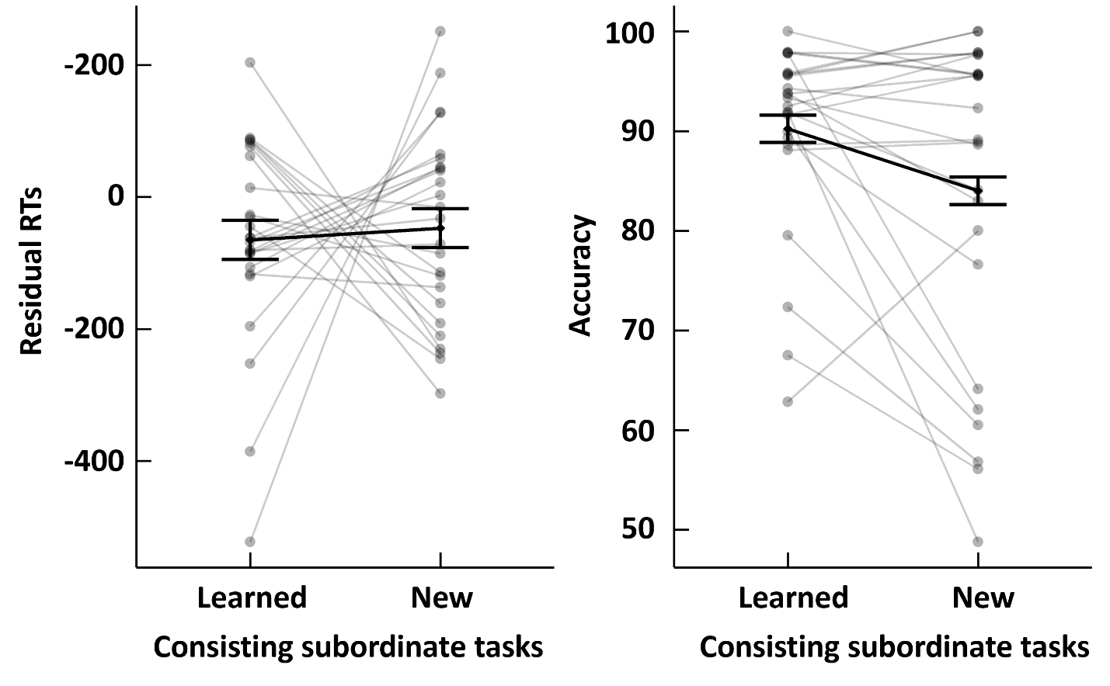

Figure S1. Results of Experiment S1. Individual RT (left) and accuracy (right) at the superordinate task phase, imposed with group mean and SEM plotted as a function of experimental condition (superordinate tasks consisted of already learned subordinate tasks or new subordinate tasks).

Supplementary Table

Table S1. Summary statistics of logistic mixed-effect model analysis for accuracy

 | Subordinate | Superordinate
Exp 1 | z₅₀ = 6.61, p < .001, Cohen’s d = 0.94 | z₅₀ = 5.47, p < .001, Cohen’s d = 0.78
Exp 2a | z₅₀ = 8.21, p < .001, Cohen’s d = 1.17 | Odd: z₅₀ = 3.91, p < .001, Cohen’s d = 0.56  Even: z₅₀ = 2.04, p = .042, Cohen’s d = 0.29
Exp 2b | z₈₄ = 5.23, p < .001, Cohen’s d = 0.57 | Odd: z₈₄ = 4.01, p < .001, Cohen’s d = 0.44  Even: z₈₄ = -1.00, p = .316, Cohen’s d = 0.11
Note. Each cell includes group-mean value with standard error in parentheses, z- statistic and p-value. Cells are organized based on experimental phase, parameter and dependent variable.

Detailed statistics of logistic mixed-effect model analysis for accuracy. Overall, logistic mixed effect model analysis with trial-wise accuracy data replicated all the results using linear-mixed effect model analysis with averaged accuracy data.
Table S2. Summary statistics of nonlinear mixed-effect model with exponential function
 |  | Subordinate |  | Superordinate
 |  | saturation (‘$β_{1}$’) | Learning rate (‘$β_{2}$’) | saturation (‘$β_{1}$’) | Learning rate (‘$β_{2}$’)
Exp 1 | RTs | -0.13 (0.02)  t₁₄₈ = -5.52, p < .001 | 1.86 (0.48)  t₁₄₈ = 3.88, p < .001 | -0.36 (0.11)  t₁₄₈ = -3.39, p < .001 | 0.44 (0.14)  t₁₄₈ = 3.11, p = .002
Exp 1 | Accuracy | 0.21 (0.48)  t₁₄₈ = 0.44, p = .663 | 0.11 (0.34)  t₁₄₈ = 3.08, p = .748 | 0.20 (0.09)  t₁₄₈ = 2.14, p = .034 | 0.30 (0.41)  t₁₄₈ = .74, p = .458
Exp 2a | RTs | -0.47 (0.05)  t₁₄₈ = -8.77, p < .001 | 0.41 (0.07)  t₁₄₈ = 5.62, p < .001 | Odd: 2.37 (0.22)  t₁₄₈ = 2.58, p = .01 | Odd: -0.09 (0.03)  t₁₄₈ = -3.46, p = .007
 |  |  |  | Even: -0.28 (0.13)  t₁₄₈ = -2.24, p = .027 | Even: 0.44 (0.37)  t₁₄₈ = 1.20, p = .232
Exp 2a | Accuracy | -0.12 (0.04)  t₁₄₈ = -2.51, p = .012 | -0.05 (0.02)  t₁₄₈ = -3.36, p = .001 | Odd: 0.07 (0.01)  t₁₄₈ = 5.27, p < .001 | Odd: 4.12 (11.76)  t₁₄₈ = 0.35, p = .727
 |  |  |  | Even: 0.06 (0.02)  t₁₄₈ = 2.64, p = .001 | Even: 0.92 (0.92)  t₁₄₈ = 1.00, p = .318
Exp 2b | RTs | -0.23 (0.02)  t₁₄₈ = -15.22, p < .001 | 0.62 (0.10)  t₁₄₈ = 5.92, p < .001 | Odd: -0.15 (0.04)  t₁₄₈ = -3.87, p < .001 | Odd: 2.09 (1.09)  t₁₄₈ = 1.92, p = .056
 |  |  |  | Even: -0.10 (0.03)  t₁₄₈ = -3.35, p < .001 | Even: 3.02 (3.38)  t₁₄₈ = 0.92, p = .360
Exp 2b | Accuracy | 0.04 (0.01)  t₁₄₈ = 3.54, p < .001 | 0.52 (0.07)  t₁₄₈ = 7.76, p < .001 | Odd: 0.05 (0.02)  t₁₄₈ = 2.13, p = .033 | Odd: 0.59 (0.60)  t₁₄₈ = 0.98, p = .329
 |  |  |  | Even: 0.003 (0.01)  t₁₄₈ = 0.40, p = .690 | Even: 4.05 (143.91)  t₁₄₈ = 0.03, p = .978

Note. Each cell includes group-mean value with standard error in parentheses, t- statistic and p-value. Cells are organized based on experimental phase, parameter and dependent variable.

Detailed statistics of nonlinear mixed-effect model analysis with exponential function. In case of subordinate tasks, both saturation points and learning rate showed significant fixed effect for both RTs and accuracy in all three experiments. On the other hand, superordinate tasks showed mixed results. Superordinate tasks in Exp 1 showed significant fixed effect of saturation point for both RTs and accuracy, and significant fixed effect of learning rate for RTs only. In Exp 2a, saturation points showed significant fixed effect in RTs and accuracy for both odd and even blocks, while learning rate showed non-significant fixed effects except in RTs for odd blocks. Exp 2b showed significant fixed effects of saturation point except for accuracy in even blocks, and non-significant fixed effect of learning rate in all cases.

Table S3. Description for the fitness of models in all conditions.
 |  | Subordinate (AIC / BIC) |  | Superordinate (AIC / BIC)
 |  | Linear | exponential | linear | exponential
Exp 1 | RTs | -189.71 / -169.92 | -211.18 / -188.09 | 68.38 / 88.17 | 75.37 / 98.46
Exp 1 | Accuracy | -599.43 / -579.64 | -569.10 / -546.01 | -348.21 / -328.42 | -319.19 / -296.10
Exp 2a | RTs | -376.38 / -352.43 | -436.19 / -408.25 | Odd: 23.41 / 43.20  Even: 16.52 / 36.31 | Odd: 27.23 / 50.32  Even: 18.94 / 42.03
Exp 2a | Accuracy | -1140.03 / -1116.08 | -1113.72 / -1085.78 | Odd: -349.45 / -329.66  Even: -372.59 / -352.80 | Odd: -347.73 / -324.65  Even: -356.98 / -333.89
Exp 2b | RTs | -565.68 / -538.62 | -544.07 / -512.50 | Odd: 231.53 / 254.43  Even: 94.78 / 117.68 | Odd: 227.44 / 254.1557  Even: 91.00 / 117.72
Exp 2b | Accuracy | -2121.42 / -2094.36 | -2163.96 / -2132.39 | Odd: -669.26 / -646.35  Even: -816.12 / -793.22 | Odd: -623.45 / -596.73  Even: -800.88 / -774.16
Note. Each cell includes Akaike Information Criteria (AIC) / Bayesian Information Criteria (BIC) values as measures for fitness of models.

Detailed model fitting values of linear mixed-effect model and nonlinear mixed-effect model with exponential function. In case of subordinate tasks, both Exp 1 and Exp 2b showed better fitness of RTs for linear model than exponential model while showing better fitness of accuracy for exponential than linear model. However, Exp 2b presented opposite trend by showing better fit of RTs for linear model and better fitness of accuracy for exponential model. Superordinate tasks showed better fit of linear model than exponential model in all cases except RTs in Exp 2b, which showed better fitness of exponential model than linear model. Overall, exponential models did not outperform linear models in explaining performance improvement in participants.

Table S4. Summary statistics of nonlinear mixed-effect model analysis with exponential function in superordinate tasks using RTs of 3rd to 7th blocks.

 | Saturation point (‘$β_{1}$’) | Learning rate (‘$β_{2}$’)
Exp 2a | -0.18 (0.12)  t₁₉₈ = -1.45, p = .148 | 0.33 (0.43)  t₁₉₈ = 0.76, p = .446
Exp 2b | 0.18 (0.15)  t₃₃₄ = 1.21, p = .23 | -0.06 (0.02)  t₃₃₄ = -3.17, p = .002
Note. Each cell includes average value with standard error in the upper row, and t-test statistics in the bottom row.

Detailed statistics of nonlinear mixed-effect model analysis with exponential function. Saturation points did not show significant fixed effect in both experiments. Learning rate did not significantly differ from 0 in Exp 2a, or even showed statistically significant result in direction opposite to prediction in Exp 2b. Together these results do not support the hypothesis that the faster RTs in even blocks than odd blocks are an effect of exponential learning curve.

Table S5. Description for the fitness of models in superordinate tasks using RTs of 3rd to 7th blocks.

 | Linear (AIC / BIC) | Exponential (AIC / BIC)
Exp 2a | 17.48/38.61 | 18.72 / 43.37
Exp 2b | 197.61 / 221.86 | 211.97 / 240.25
Note. Each cell includes AIC / BIC values as an index for fitness of models.

Detailed model fitting values of linear mixed-effect model and nonlinear mixed-effect model with exponential function. Linear model showed better fitness than exponential model in all two experiments, which do not support the exponential model hypothesis.

