**Supplemental Online Material**

In this document we present results of both pre-registered secondary analyses and other supplemental analyses, as well as details on additional measures of the paper *Flavours of desire: Cognitive representations of appetitive stimuli and their motivational implications.*

Table of Contents

Table of Contents 1

Experiment 1 1

Power calculations 1

Measures 2

Additional analyses 3

Manipulation check 9

Assessing replication of pilot study: 10

Experiment 2 11

Hypothesis 1 11

Hypothesis 2 12

Hypothesis 3 13

Hypothesis 4 13

Experiment 3 14

Bayesian sequential sampling 14

Hypothesis 1 15

Hypothesis 2 16

Hypothesis 3 17

Proportion of long-term health consequences 17

Replicating findings from Experiment 1 and 2 19

Effect of thirst and drink type type on consumption and reward features 20

Desire and intake 20

Experiment 1

Power calculations

First, we conducted a power calculation to determine the number of participants required to detect the difference in the proportion of consumption situation features generated for Coca Cola vs. bottled water. Based on the size of this effect in the pilot study (Cohen’s *d* = -.44), we determined that 33 participants would be required to detect this effect with power = .80 and alpha = .05 in a one-tailed paired samples *t*-test. Second, we conducted a power calculation to determine the number of participants required to detect the difference in the proportion of long-term positive health features generated for Coca Cola vs. bottled water. Based on the size of this effect in the pilot study (Cohen’s *d* = .66), we determined that 16 participants would be required to detect this effect with power = .80 and alpha = .05 in a one-tailed paired-samples t-test. Third, we conducted a power calculation to determine the number of participants required to detect the correlation between the proportion of consumption situation features and the strength of habits to consume sugary drinks. Based on the Pearson correlation coefficient for this relationship in the pilot study (*n* = 198, *r* = .29), we determined that 91 participants would be required to detect this positive relationship with power = .80 and alpha = .05. Note: in Experiment 1, we replace the habits index score with the frequency of consumption for each drink. However, we anticipate that the relationship between proportion of consumption situation features and the frequency of consumption will be stronger than the consumption situation/habits relationship. We included the self-report habits index in study to examine whether the observed relationship in the pilot study replicates.

Measures

Self-report habit index statements

“Drinking [drink type: sugary drink, bottled water, tap water] is something ...

* + do frequently.
  + I do automatically.
  + I do without having to consciously remember.
  + that makes me feel weird if I do not do it.
  + I do without thinking.
  + that would require effort not to do it.
  + that belongs to my daily routine.
  + I start doing before I realize I’m doing it.
  + I would find hard not to do.
  + I have no need to think about doing.
  + that’s typically “me.”
  + I have been doing for a long time.”

**Intentions to change consumption**

* “I would like to increase my sugary drink consumption”
* “I would like to decrease my sugary drink consumption”
* “I would like to increase my bottled water consumption”
* “I would like to decrease my bottled water consumption”
* “I would like to increase my tap water consumption”
* “I would like to decrease my tap water consumption”
* “I would like to drink more bottled water instead of sugary drinks.”

Perceived wealth

Three items assessed perceived wealth, each rated on a 0 to 100 scale with the anchors “Strongly disagree” and “Strongly agree” at the extremes: “I feel I live in a relatively wealthy neighbourhood”, “I feel relatively wealthy compared to others”, “I feel I have enough money”.

Additional analyses

Hypothesis 1

Additional pairwise comparisons: We compared the proportion of consumption and reward simulations between all drinks with a binomial regression model with pairwise comparisons. The overall effect of drink item on the proportion of consumption and reward simulation features was significant, 𝜒2 (8) = 88.9, *p* < .001, *R*2 = .134. See Table 1 for an overview of the results for the pairwise comparisons, and Figure 1 for percentage of features listed for the filler drinks.

*Table S1*. Pairwise comparisons of CRSF of all drinks in experiment 1 (Tukey adjusted).

|  |  |  |  |  |
| --- | --- | --- | --- | --- |
| **(I) Drink item** | **(J) Drink item** | **Mean difference (I-J)** | **SE** | ***p*-value** |
| Bottled water | Coca Cola | -0.29 | 0.21 | 8.97e-01 |
| Bottled water | Coffee | -1.09** | 0.21 | 3.91e-06 |
| Bottled water | Diet coke | -0.20 | 0.21 | 9.88e-01 |
| Bottled water | Orange juice | -0.87** | 0.20 | 7.37e-04 |
| Bottled water | Orange soda | -0.95** | 0.21 | 1.14e-04 |
| Bottled water | Squash | -0.20 | 0.21 | 9.87e-01 |
| Bottled water | Tap water | -0.05 | 0.21 | 1.00e+00 |
| Bottled water | Tea | -1.17** | 0.21 | 5.47e-07 |
| Coca Cola | Coffee | -0.81 | 0.20 | 2.20e-03 |
| Coca Cola | Diet coke | 0.09 | 0.20 | 1.00e+00 |
| Coca Cola | Orange juice | -0.58 | 0.20 | 9.14e-02 |
| Coca Cola | Orange soda | -0.66* | 0.20 | 2.63e-02 |
| Coca Cola | Squash | 0.08 | 0.20 | 1.00e+00 |
| Coca Cola | Tap water | 0.24 | 0.21 | 9.66e-01 |
| Coca Cola | Tea | -0.88** | 0.20 | 4.73e-04 |
| Coffee | Diet coke | 0.89** | 0.20 | 3.87e-04 |
| Coffee | Orange juice | 0.23 | 0.20 | 9.70e-01 |
| Coffee | Orange soda | 0.14 | 0.20 | 9.99e-01 |
| Coffee | Squash | 0.89* | 0.20 | 4.09e-04 |
| Coffee | Tap water | 1.04* | 0.21 | 1.34e-05 |
| Coffee | Tea | -0.07 | 0.20 | 1.00e+00 |
| Diet coke | Orange juice | -0.66* | 0.20 | 2.68e-02 |
| Diet coke | Orange soda | -0.75* | 0.20 | 6.24e-03 |
| Diet coke | Squash | -0.00 | 0.20 | 1.00e+00 |
| Diet coke | Tap water | 0.15 | 0.21 | 9.98e-01 |
| Diet coke | Tea | -0.97* | 0.20 | 7.21e-05 |
| Orange juice | Orange soda | -0.09 | 0.20 | 1.00e+00 |
| Orange juice | Squash | 0.66* | 0.20 | 2.79e-02 |
| Orange juice | Tap water | 0.81* | 0.20 | 2.01e-03 |
| Orange juice | Tea | -0.30 | 0.20 | 8.54e-01 |
| Orange soda | Squash | 0.75* | 0.20 | 6.54e-03 |
| Orange soda | Tap water | 0.90* | 0.20 | 3.41e-04 |
| Orange soda | Tea | -0.22 | 0.20 | 9.78e-01 |
| Squash | Tap water | 0.15 | 0.21 | 9.98e-01 |
| Squash | Tea | -0.97* | 0.20 | 7.65e-05 |
| Tap water | Tea | -1.12* | 0.21 | 2.01e-06 |

*Note*. \**p* < .05, \*\**p* < .001

*Figure S1*. Percentage of features for the filler drinks for the categories non-consumption situation, situation-independent, and consumption and reward features in Experiment 1.

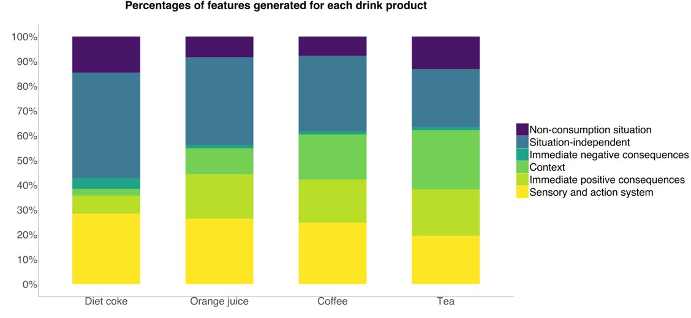

*Note*. Consumption and reward features include features related to context, immediate positive consequences, and sensory and action system.

Additional pairwise comparisons between all drinks: sensory features

Supplemental analyses were carried out to test the effect of drink item on sensory features (a subcategory from consumption and reward simulation features). The overall effect of drink item on sensory features was significant, 𝜒2 (8) = 66.4, *p* < .001, *R*2 = .121. Pairwise comparisons are shown in Table 2.

*Table S2*. Pairwise comparisons of sensory features of all drinks in Experiment 1 (Tukey adjusted).

|  |  |  |  |  |
| --- | --- | --- | --- | --- |
| **(I) Drink item** | **(J) Drink item y** | **Mean difference (I-J)** | **SE** | ***p*-value** |
| Bottled water | Coca Cola | -1.16* | 0.27 | <0.001 |
| Bottled water | Coffee | -1.00* | 0.28 | 0.010 |
| Bottled water | Diet coke | -1.20* | 0.27 | <0.001 |
| Bottled water | Orange juice | -1.09* | 0.28 | 0.002 |
| Bottled water | Orange soda | -1.73* | 0.27 | <0.001 |
| Bottled water | Squash | -0.83 | 0.28 | 0.083 |
| Bottled water | Tap water | -0.43 | 0.30 | 0.881 |
| Bottled water | Tea | -0.70 | 0.29 | 0.258 |
| Coca Cola | Coffee | 0.17 | 0.23 | 0.999 |
| Coca Cola | Diet coke | -0.03 | 0.22 | 0.100 |
| Coca Cola | Orange juice | 0.08 | 0.22 | 0.100 |
| Coca Cola | Orange soda | -0.56 | 0.21 | 0.163 |
| Coca Cola | Squash | 0.34 | 0.23 | 0.868 |
| Coca Cola | Tap water | 0.74 | 0.25 | 0.071 |
| Coca Cola | Tea | 0.47 | 0.24 | 0.559 |
| Coffee | Diet coke | -0.20 | 0.22 | 0.995 |
| Coffee | Orange juice | -0.09 | 0.23 | 0.100 |
| Coffee | Orange soda | -0.73* | 0.22 | 0.022 |
| Coffee | Squash | 0.18 | 0.24 | 0.998 |
| Coffee | Tap water | 0.57 | 0.25 | 0.357 |
| Coffee | Tea | 0.30 | 0.24 | 0.944 |
| Diet coke | Orange juice | 0.10 | 0.22 | 0.100 |
| Diet coke | Orange soda | -0.53 | 0.21 | 0.217 |
| Diet coke | Squash | 0.37 | 0.23 | 0.802 |
| Diet coke | Tap water | 0.77* | 0.25 | 0.050 |
| Diet coke | Tea | 0.50 | 0.24 | 0.469 |
| Orange juice | Orange soda | -0.64 | 0.21 | 0.070 |
| Orange juice | Squash | 0.27 | 0.23 | 0.968 |
| Orange juice | Tap water | 0.67 | 0.25 | 0.163 |
| Orange juice | Tea | 0.39 | 0.24 | 0.778 |
| Orange soda | Squash | 0.90* | 0.22 | 0.002 |
| Orange soda | Tap water | 1.30* | 0.24 | <0.001 |
| Orange soda | Tea | 1.03* | 0.23 | <0.001 |
| Squash | Tap water | 0.40 | 0.26 | 0.832 |
| Squash | Tea | 0.13 | 0.25 | 0.100 |
| Tap water | Tea | -0.27 | 0.26 | 0.982 |

*Note*. \**p* < .05, \*\**p* < .001

Hypothesis 2

Hypothesis 2 tested the association of frequency of consumption and current thirst and proportion of consumption and reward features. In addition to the analysis comparing Coca Cola with bottled water reported in the main text, we report here the same analyses for the two additional sugary drinks: orange soda and squash.

With regard to the effect of consumption frequency (**Hypothesis 2a**),there was a main effect of consumption frequency on consumption and reward features for both **orange soda** compared to bottled water, *b* = 0.72, *SE* = 0.15, *p* < .001, and for **squash** compared to bottled water, *b* = 0.54, *SE* = .14, *p* < .001 but no interaction with drink type, *p*’s > .113.

With regard to the effect of thirst **(Hypothesis 2b**), for **orange soda**, there was a main effect of frequency, *b* = 0.58, *SE* = 0.23, *p* = .011, but no main effect of thirst, *p* = .822, nor an interaction effect, *p* = .627. The same was found for **squash**: a main effect of frequency, *b* = 0.40, *SE* = 0.17, *p* = .016, but no main effect of thirst, *p* = .543, nor an interaction effect, *p* = .825. Also for **bottled water**, there was a main effect of frequency, *b* = 0.35, *SE* = 0.17, *p* = .033, but not of thirst nor their interaction, *p*’s > .771. For **tap water**, there was no main effect of either frequency or thirst, nor an interaction effect between the two (*p’s* > .430). Overall, thirst had no influence on the proportion of consumption and reward simulation features for sugary drinks or water.

Hypothesis 3 tested whether consumption and reward features predict desire for drinks. The analyses in the main paper show that a higher proportion of consumption and reward features was associated with increased desire for sugary drinks. This also applied to bottled water, τ = 0.13, p = .008, and tap water, τ = .10, p = .05.

***Controlling for thirst***: We controlled for thirst in models including thirst and consumption and reward features as predictors of desire. Both thirst, *b* = 5.91, *SE* = 1.12, *p* < .001, and consumption and reward features, *b* = 4.61, *SE* = 1.06, *p* < .001, predicted desire for drinks. There was no interaction between the two, *b* = 1.29, *p* = .226.

Hypothesis 5

Exploratory correlations revealed that experiencing more mixed feelings regarding the drinking of water was associated with lower frequency of water consumption, both for bottled water, *τ* = -0.25, *p* < .001, and tap water, *τ* = -0.40, *p* < .001. These mixed feelings were also associated with lower desire to consume water, again for both bottled water, *τ* = -0.19, *p* < .001, and tap water, *τ* = -0.30, *p* < .001.

Hypothesis 6

Proportion of positive long-term health consequences

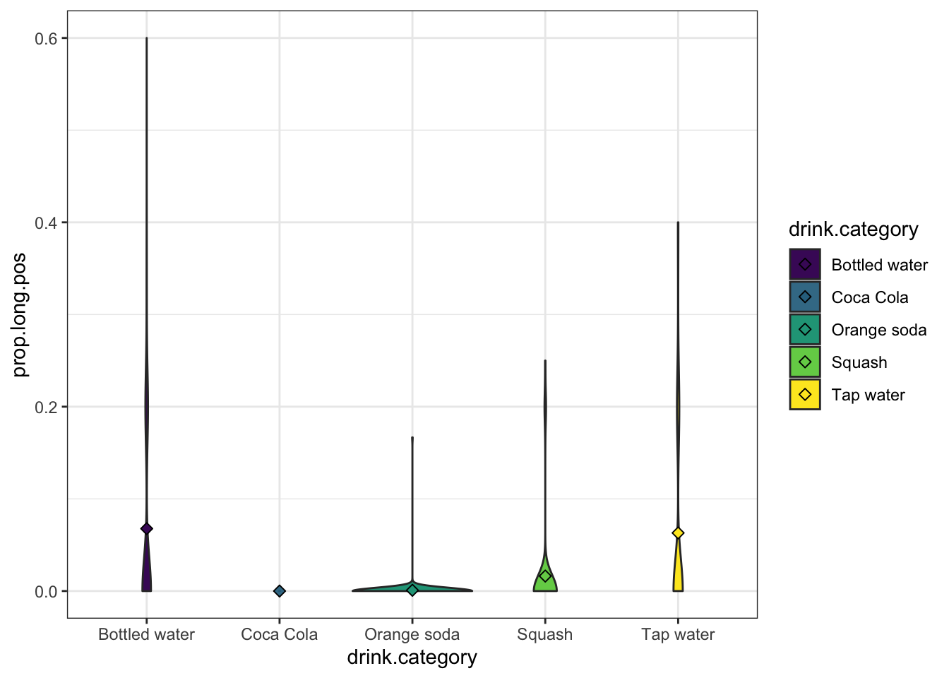

*Figure S2*. Proportions of positive long-term health consequences.

We tested whether positive long-term health consequences predict desire for water. In step 1, we added proportion of long-term positive health consequences as a predictor alongside proportion of consumption and reward features, and in step 2 we examined their interaction. The proportion of long-term positive health consequences predicted desire, *b* = 3.91, *SE* = 1.15, *p* < .001, while the proportion of consumption and reward features remained a significant predictor, *b* = 7.94, *SE* = 1.88, *p* < .001. Their interaction was not significant, *b* = 0.76, *p* = .603.

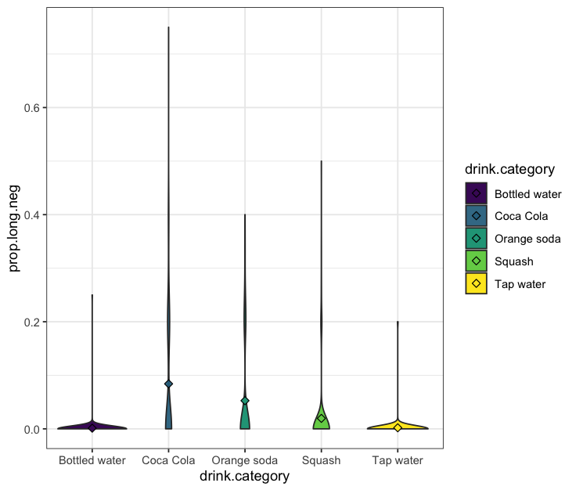

*Figure S3*. Proportions of negative long-term health consequences.

Using the same analyses as above, we also tested whether negative long-term health consequences predict desire for sugary drinks. Step 1 showed that proportion of long-term negative health consequences predicted lower desire for sugary drinks, *b* = -3.55, *SE* = 0.89, *p* < .001, and proportion of consumption and reward features remained a significant predictor, *b* = 5.09, *SE* = 1.27, *p* < .001. The interaction term was not significant, *b* = -0.11, *SE* = 1.08, *p* = .916.

Manipulation check

As expected, Coca Cola was perceived as less healthy (*M* = 5.37, *SD* = 12.6) than bottled water (*M* = 83.4, *SD* = 20.5), *t*(336) = 46, *p* < .001, and tap water (*M* = 84.7, *SD* = 22.1), *t*(322) = 45, *p* < .001. Orange soda was also perceived as less healthy (*M* = 8.47, *SD* = 13.9) than bottled water, *t*(357) = 43, *p* < .001, and tap water, *t*(342) = 42, *p* < .001. The same applied for squash (*M* = 33.5, *SD* = 24.0), which was perceived as less healthy than bottled water, *t*(397) = 23, *p* < .001, and tap water, *t*(403) = 22, *p* < .001. These findings clearly show that the sugary drinks are perceived as less healthy than bottled and tap water.

Assessing replication of pilot study:

**BMI and consumption frequency of sugary drinks.** In our (unpublished) pilot study, we had found no relationship between body mass index (BMI) and the frequency of consuming sugary drinks.Correlations in this experiment again revealed that participant’s BMI did not correlate with frequency of consumption of Coca Cola, orange soda or squash (*τ*’s < .055 , *p*’s > .235).

**Habits and consumption and reward features.** In the pilot study, using the self-report habit index scores, we had found that the proportion of consumption and reward features positively correlated with habit scores for sugary drinks. We found no such relationship for the bottled water and for the tap water. In Experiment 1, we again found a correlation between the proportion of consumption and reward features for the regular coca cola and self-report habit index scores for consumption of sugary drinks, *τ* = 0.13, *p* = .011. The same relationship emerged for bottled water, *τ* = 0.15, *p* = .003, but for tap water there was no correlation, *τ* = 0.08, *p* = .12.

**Consumption and reward features and desire for water.** In the pilot study, we had found no reliable relationship between the proportion of consumption situation and reward features and desire for the bottled water and for the tap water. However, in Experiment 1, there was a positive (but small) correlation between the proportion of consumption situation and reward features and desire to consume bottled water, *τ* = .13, *p* = .008, and the desire to consume tap water, *τ* = .10, *p* = .045.

Last, we preregistered exploratory analyses addressing questions related to socioeconomic status. These questions will be addressed in a different research communication.

Experiment 2

Hypothesis 1

Here we examine additional comparisons of consumption and reward features between drinks.

*Table S3*. Pairwise comparisons of consumption and reward features of all drinks in Experiment 2 (Tukey adjusted).

|  |  |  |  |  |
| --- | --- | --- | --- | --- |
| **(I) Drink category** | **(J) Drink category** | **Mean difference (I-J)** | **SE** | ***p*-value** |
| Bottled water | Coca Cola | -0.059 | 0.232 | 0.999 |
| Bottled water | Diet coke | -0.222 | 0.230 | 0.871 |
| Bottled water | Fanta | -0.929* | 0.232 | 0.001 |
| Bottled water | Tap water | -0.333 | 0.230 | 0.594 |
| Coca Cola | Diet coke | -0.163 | 0.229 | 0.955 |
| Coca Cola | Fanta | -0.870* | 0.231 | 0.002 |
| Coca Cola | Tap water | -0.274 | 0.229 | 0.753 |
| Diet coke | Fanta | -0.707* | 0.229 | 0.018 |
| Diet coke | Tap water | -0.111 | 0.227 | 0.989 |
| Fanta | Tap water | 0.596 | 0.229 | 0.070 |

Additional pairwise comparisons were conducted to examine differences in the proportion of sensory features listed for the drinks.

*Table S4*. Pairwise comparisons of sensory features of all drinks in Experiment 2 (Tukey adjusted).

|  |  |  |  |  |
| --- | --- | --- | --- | --- |
| **(I) Drink category** | **(J) Drink category** | **Mean difference (I-J)** | **SE** | ***p*-value** |
| Bottled water | Coca Cola | -0.798 | 0.318 | .088 |
| Bottled water | Diet coke | -1.083* | 0.310 | .004 |
| Bottled water | Fanta | -1.656* | 0.301 | <.001 |
| Bottled water | Tap water | -0.533 | 0.328 | .480 |
| Coca Cola | Diet coke | -0.284 | 0.263 | .817 |
| Coca Cola | Fanta | -0.857* | 0.253 | .006 |
| Coca Cola | Tap water | 0.265 | 0.284 | .885 |
| Diet coke | Fanta | -0.573 | 0.242 | .125 |
| Diet coke | Tap water | 0.549 | 0.275 | .268 |
| Fanta | Tap water | 1.122* | 0.265 | <.001 |

Hypothesis 2

Hypothesis 2 tested the association of frequency of consumption and current thirst with the proportion of consumption and reward features. Here, we report these analyses for specific drinks, as was done for Experiment 1.

With regard to consumption frequency (**Hypothesis 2a),** comparing Coca Cola to bottled water, there was a main effect of frequency, *b* = 0.72, *SE* = .16*, p* < .001, and of drink item, *b* = 0.52, *SE* = .15, *p* < .001, and no interaction, *b* = 0.30, *SE* = .16*, p* = .063. Comparing Fanta to bottled water revealed a significant interaction, *b* = 0.61, *SE* = 0.21, *p* = .004. Moreover, both main effects were significant: frequency predicted more consumption and reward features, *b* = 0.87, *SE* = 0.19, *p* < .001, and so did drink item, *b* = 1.15, *SE* = .17, *p* < .001.

The same analysis comparing Diet Coke and bottled water showed no significant interaction, *b* = 0.56, *p* = .067. However, there was a main effect of frequency *b* = 0.73, *SE* = 0.15, *p* < .001, and of drink item (Diet Coke vs. bottled water), *b* = 1.09, *SE* = 0.29, *p* < .001. Overall, more frequent consumers reported a higher proportion of consumption and reward features for both sugary drinks and waters.

With regard to thirst (**Hypothesis 2b)**, for **Fanta**, there was a main effect of frequency, *b* = 0.85, *SE* = 0.29, *p* = .004, but no main effect of thirst, *p* = .828, nor an interaction effect, *p* = .871. For **Diet Coke**, frequency predicted the proportion of consumption and reward features (*b* = 0.59, *SE* = 0.19, *p* = .002), but thirst and the interaction term did not (*p*’s > .314). Moreover, there was no main or interaction effect of thirst or frequency on consumption and reward features listed for either type of water (all *p* > .120).

Hypothesis 3

Kendall correlations between the proportion of consumption and reward features and desire showed that listing more features was associated with increased desire for Coca Cola, *τ* = 0.34, *p* < .001, Fanta, *τ*  = .35, *p* < .001, Diet Coke, *τ* = .39, *p* < .001, as well as bottled water, *τ* = .22, *p* < .001, and tap water, *τ* = .20, *p* < .001.

Hypothesis 4

Proportion of positive long-term health consequences

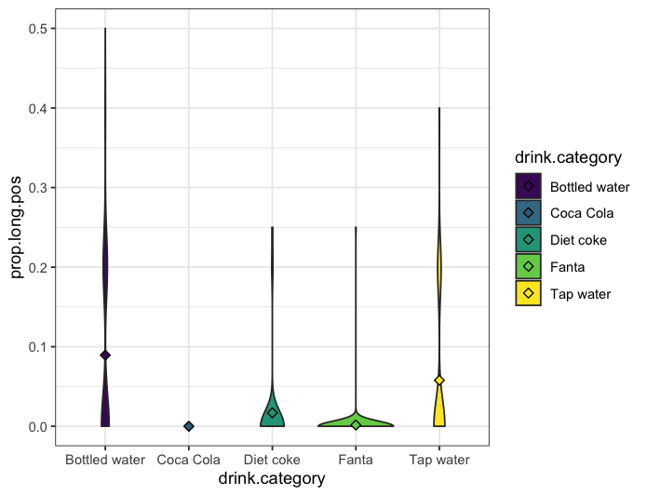

*Figure S4*. Proportions of positive long-term health consequences.

We tested whether positive long-term health consequences predict desire for water. In step 1, we added proportion of health features and proportion of consumption and reward features, and in step 2 we added their interaction. As in Experiment 1, proportion of long-term positive health consequences predicted desire, *b* = 3.46, *SE* = 1.31, *p* = .008, and proportion of consumption and reward features remained a significant predictor, *b* = 11.3, *SE* = 2.03, *p* < .001. Their interaction was not significant, *b* = 0.49, *p* = .791.

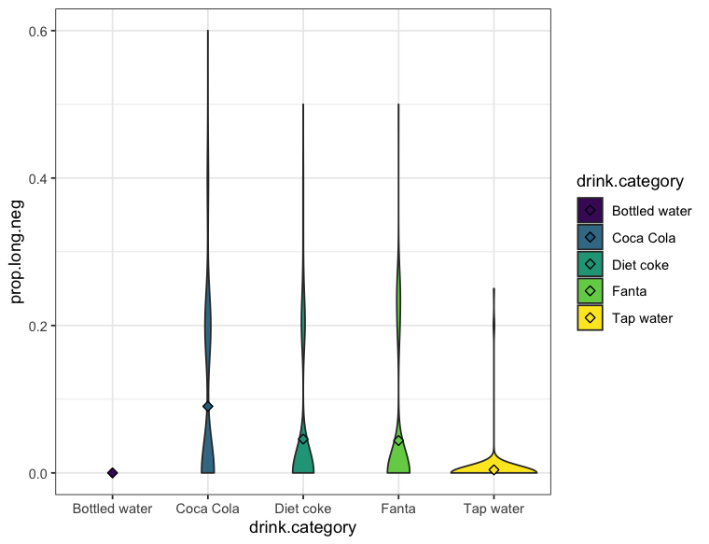

*Figure S5*. Proportions of negative long-term health consequences.

Using the same analyses as above, we also tested whether negative long-term health consequences predict desire for sugary drinks. Again as in Experiment 1, step 1 showed that proportion of long-term negative health consequences predicted lower desire for sugary drinks, *b* = -3.53, *SE* = 1.42, *p* = .014, and proportion of consumption and reward features remained a significant predictor, *b* = 10.1, *SE* = 1.63, *p* < .001. Again, the interaction was not significant, *b* = 0.24, *SE* = 1.53, *p* = .878.

Experiment 3

Bayesian sequential sampling

We had preregistered that if after having collected the minimum sample size (N = 100), the data with regard to Hypothesis 3 is at least 6 times (BF = 6) more likely under the alternative than under the null hypothesis, or vice versa at least 6 times more likely under the null than under the alternative hypothesis (BF = 1/6), we would stop data collection. Therefore, we conducted a Bayesian t-test to compare the proportion of consumption and reward features between thirsty and non-thirsty participants. The Bayes Factor of 0.1737 revealed that our findings were substantially more likely under the null hypothesis of no difference between conditions. Thus, our stopping criterion had been met, and we stopped data collection.

Hypothesis 1

Hypothesis 1tested for differences between drinks in the proportions of sensory features reported per condition. Here, we supplement this pre-registered analysis by examining the differences in the proportion of consumption and reward features between drink items**.**

**Non-thirsty participants:** Overall, sugary drinks (*M* = 54%, *SD* = 22%) were described with a higher proportion of consumption and reward features than water (*M* = 42%, *SD* = 24%), *b* = 0.42, *SE* = .15, *p* = .005. Comparing individual drinks showed that participants listed more consumption and reward features for Coca Cola (*M* = 55%, *SD* = 22%) compared to tap water (*M* = 37%, *SD* = 22%), *b* = 0.96, *SE* = .23, *p* < .001, but not compared to bottled water (*M* = 46%, *SD* = 25%), *p* = .162.

The same was the case for Fanta (*M* = 54%, *SD* = 22%), which elicited more consumption and reward features than tap water *b* = 0.64, *SE* = .23, *p* < .001 but not than bottled water, *p* = .841.

**Thirsty participants:** Overall, sugary drinks (*M* = 59%, *SD* = 23%) were described with a higher proportion of consumption and reward features than water (*M* = 41%, *SD* = 23%), *b* = 0.58, *SE* = .15, *p* < .001. Comparing individual drinks showed that participants listed more consumption and reward features for Coca Cola (*M* = 60%, *SD* = 22%) compared to tap water (*M* = 39%, *SD* = 22%), *b* = 0.67, *SE* = 0.21, *p* = .002, and compared to bottled water (*M* = 44%, *SD* = 24%), *b* = 0.53, SE = .21, *p* = .010.

Furthermore, participants reported more consumption and reward features for Fanta (*M* = 59%, *SD* = 24%) than for tap water, *b* = 0.63, *SE* = 0.21, *p* = .003 and also more than for bottled water, *b* = 0.49, *SE* = 0.21, *p* = .017 (see Figure 6).

*Figure S6***.** Consumption and reward features across drink categories for participants in the Non-thirsty and Thirsty condition.

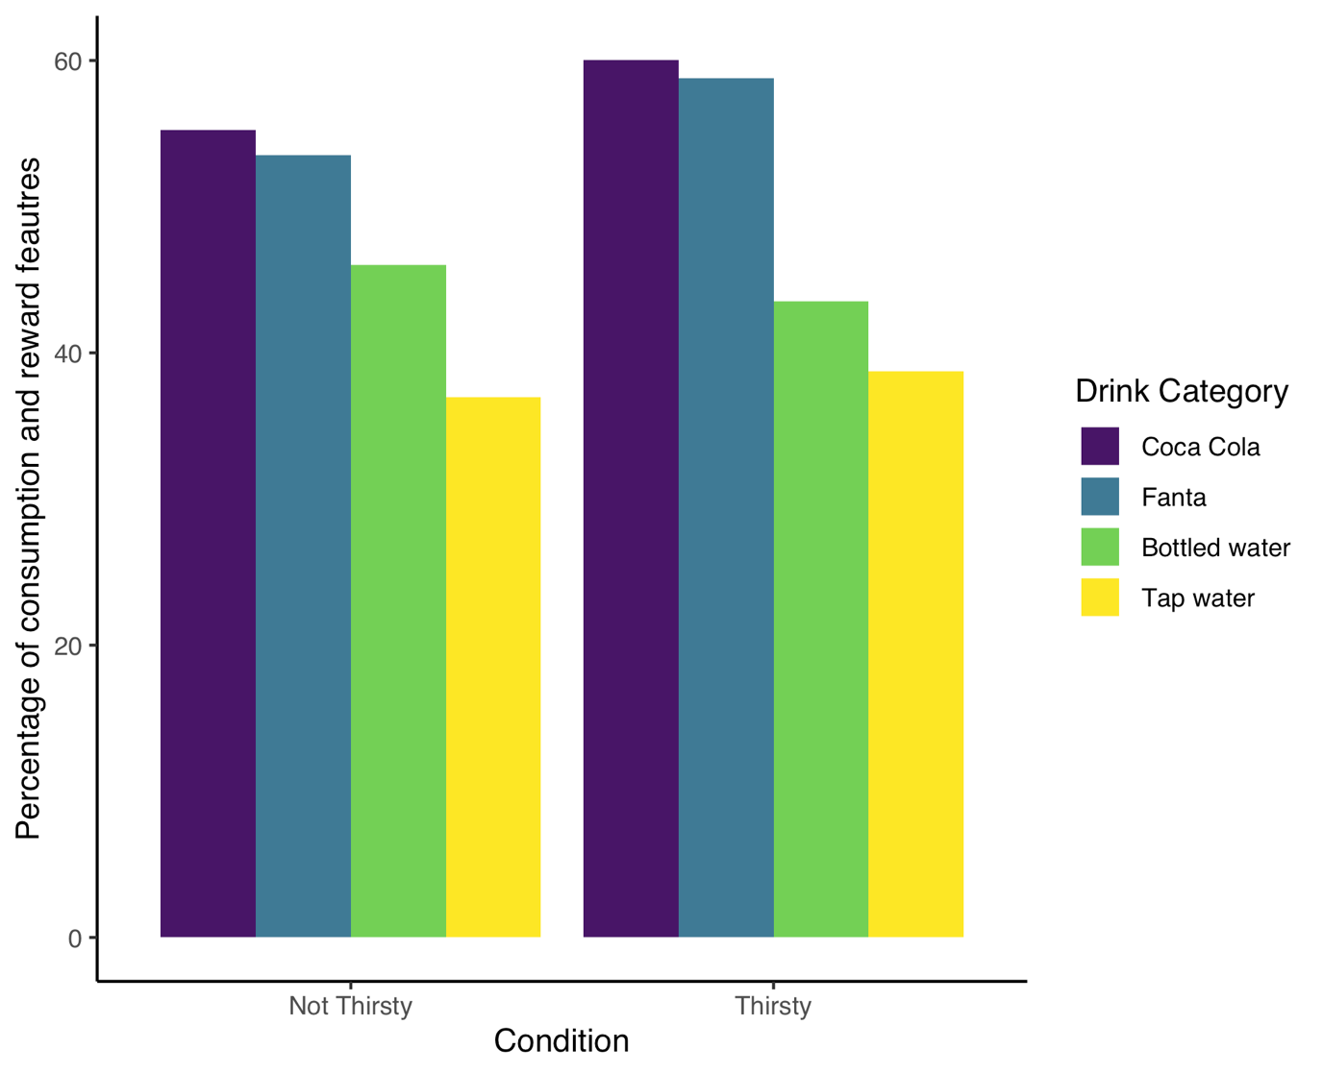

Hypothesis 2

Tests reported in the main paper showed that the thirsty participants did not drink more on average than non-thirsty participant. Additional separate *t*-tests per drink item revealed that thirsty participants drank slightly more bottled water than non-thirsty participants, *t*(97) = -2.14, *p* = .035, *d* = 0.428. They did not drink more tap water or sugary drinks (see Figure 7).

*Figure S7*. Consumption of each drink by thirst condition in Experiment 3.

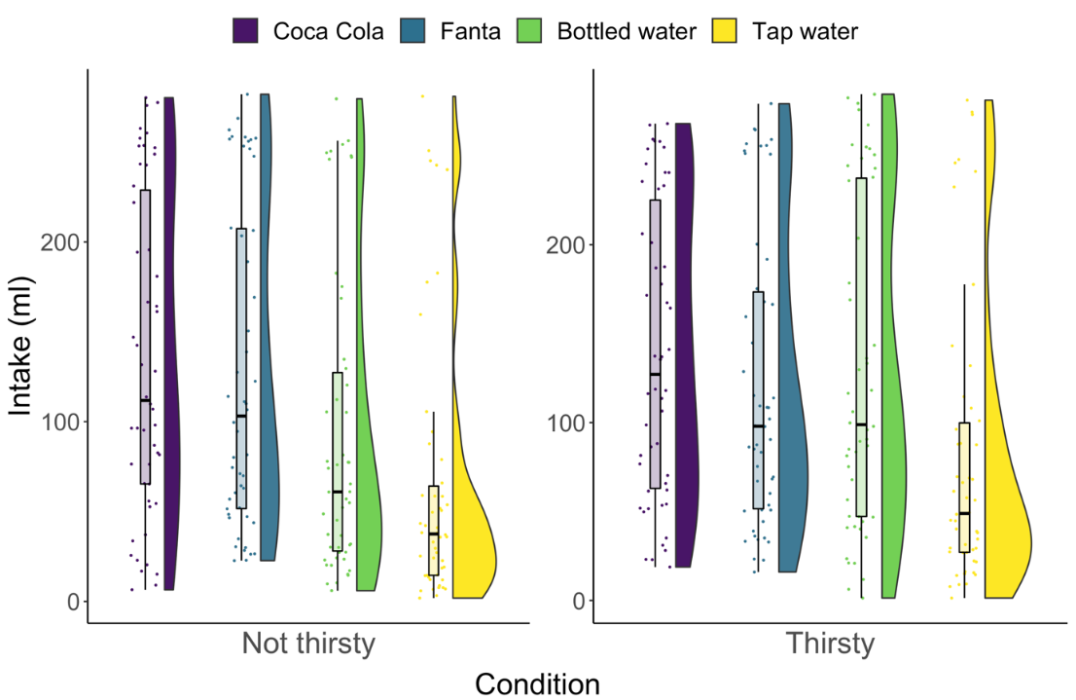

Hypothesis 3

As reported in the main paper, we found no difference in the proportion of consumption and reward features reported by thirsty and non-thirsty participants. Here, we specifically compare the proportion of sensory features between thirsty and not thirsty participants. The results show that there was also no difference in the proportion of sensory features between thirsty (*M* = 25%, *SD* = 19%) and non-thirsty (*M* = 26%, *SD* = 20%) participants, *p* = .910, *R*2 = .002.

Proportion of long-term health consequences

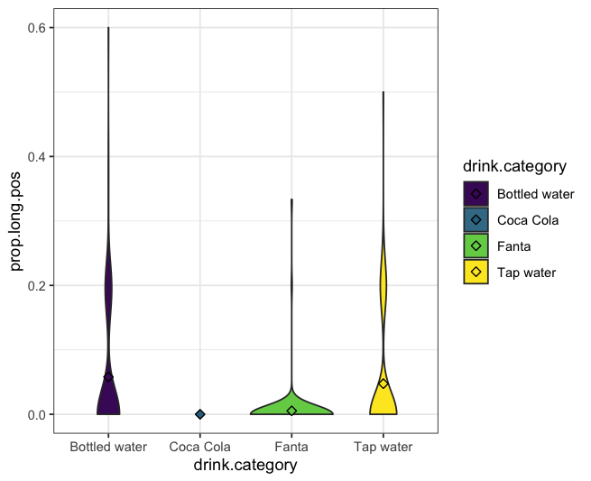

*Figure S8*. Proportions of positive long-term health consequences.

We tested whether positive long-term health consequences predict desire and intake for water. First, to predict desire, in step 1, we added proportion of health features and proportion of consumption and reward features, and in step 2 we added their interaction. The proportion of long-term positive health consequences did not predict desire, *b* = 0.10, *SE* = 0.125, *p* = .408, and proportion of consumption and reward features remained a significant predictor, *b* = 0.35, *SE* = 0.17, *p* = .038. Their interaction was not significant, *b* = 0.06, *p* = .542.

Similarly, regarding intake, listing positive long-term health consequences did not significantly predict more water intake, *b* = 8.89, *SE* = 4.50, *p* = .050, while proportion of consumption and reward features remained a significant predictor, *b* = 15.4, *SE* = 6.05, *p* = .012. Again, the interaction effect was not significant, *b* = -1.12, *p* = .783.

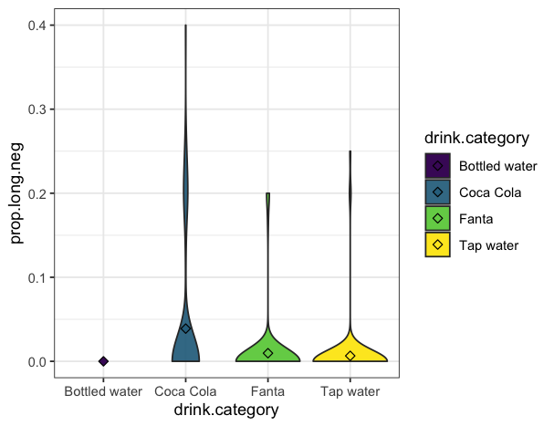

*Figure S9*. Proportions of negative long-term health consequences.

Using the same analyses as above, we also tested whether negative long-term health consequences predict desire and intake for sugary drinks. Step 1 showed that the proportion of long-term negative health consequences did not predict desire for sugary drinks, *b* = -0.18, *p* = .123, and proportion of consumption and reward features remained a significant predictor, *b* = 0.67, *SE* = 0.17, *p* < .001. There was no interaction, *b* = -0.08, *p* = .563.

Examining intake, proportion of long-term negative health consequences did not predict intake of sugary drinks, *b* = -3.98, *SE* = 4.45, *p* = .373, and proportion of consumption and reward features remained a significant predictor, *b* = 20.5, *SE* = 6.37, *p* = .002. Again, there was no interaction, *b* = -3.80, *p* = .476.

Replicating findings from Experiment 1 and 2

We tested whether findings from Experiment 1 and 2 replicate in Experiment 3, focusing on the non-thirsty condition.

We again found that desire correlated positively with the proportion of consumption and reward features across drinks. Examining correlations of each drink separately indicated that the proportion of consumption and reward features correlated with desire for Fanta (*τ* = 0.235, *p* = .031), but not for Coca Cola, bottled water and tap water (*p*’s > .163).

We found that frequency positively correlated with the proportion of consumption simulations across drinks. Examining correlations of each drink separately indicated that frequency of consumption correlated with the proportion of consumption and reward features for Fanta (*τ* = 0.292, *p* = .007), but not for Coca Cola, bottled water and tap water (*p*’s > .694).

As pre-registered, we also explored whether frequency of consumption positively correlated with desire for each drink. Correlations indicated that frequency of consumption correlated with desire for Coca Cola (*τ* = 0.459, *p* < .001) and Fanta (*τ* = 0.395, *p* < .001), but not with desire for bottled water (*p* = .398) and tap water (*p* = .057).

Effect of thirst and drink type type on consumption and reward features

Additionally, as pre-registered, we tested across the complete sample whether more consumption and reward features were reported for sugary drinks than for water, moderated by thirst. Binomial mixed effect models revealed a main effect of drink type, *b* = 0.50, *SE*  = 0.10, *p* < .001, but there was no main effect of thirst (*p* = .300) and no interaction between drink type and thirst (*p* = .440).

Desire and intake

Finally, we explored the influence of desire on intake. Linear mixed effects models showed main effects of desire, *b* = 32.2, *SE* = 3.90*, p* < .001, and drink type (sugary drinks vs. water), *b* = 15.2, *SE* = 3.25*, p* < .001, but no interaction effect (*b* = 6.63, *p* = .081). Thus, participants consumed more of a drink if they desired it more, and they consumed more sugary drinks than water.