**Supplemental Material**

**Table S1:** Self-report information and training behaviors across four experimental conditions.

|  |  |  |  |  |
| --- | --- | --- | --- | --- |
| Condition | Opaque-Realistic | Opaque-Abstract | Translucent-Realistic | Translucent-Abstract |
| SOD | 18.63 (3.57) | 19.00 (4.36) | 18.42 (4.27) | 18.38 (3.57) |
| SWM | 50.37 (12.28) | 52.50 (11.84) | 47.71 (15.08) | 51.00 (13.53) |
| Gender (male : female) | 14:11 | 15:9 | 13:11 | 12:12 |

***Notes:*** The means and standard deviations (in parenthesis) of the sense of direction (SOD), spatial working memory capacity (SWM) and gender ratio in each experimental condition. SOD and SWM did not differ significantly across conditions (*F*s < 0.46, *p*s > 0.713). Gender ratio did not differ significantly across conditions (χ2 (3, N = 96) = 0.804, *p* = 0.848)

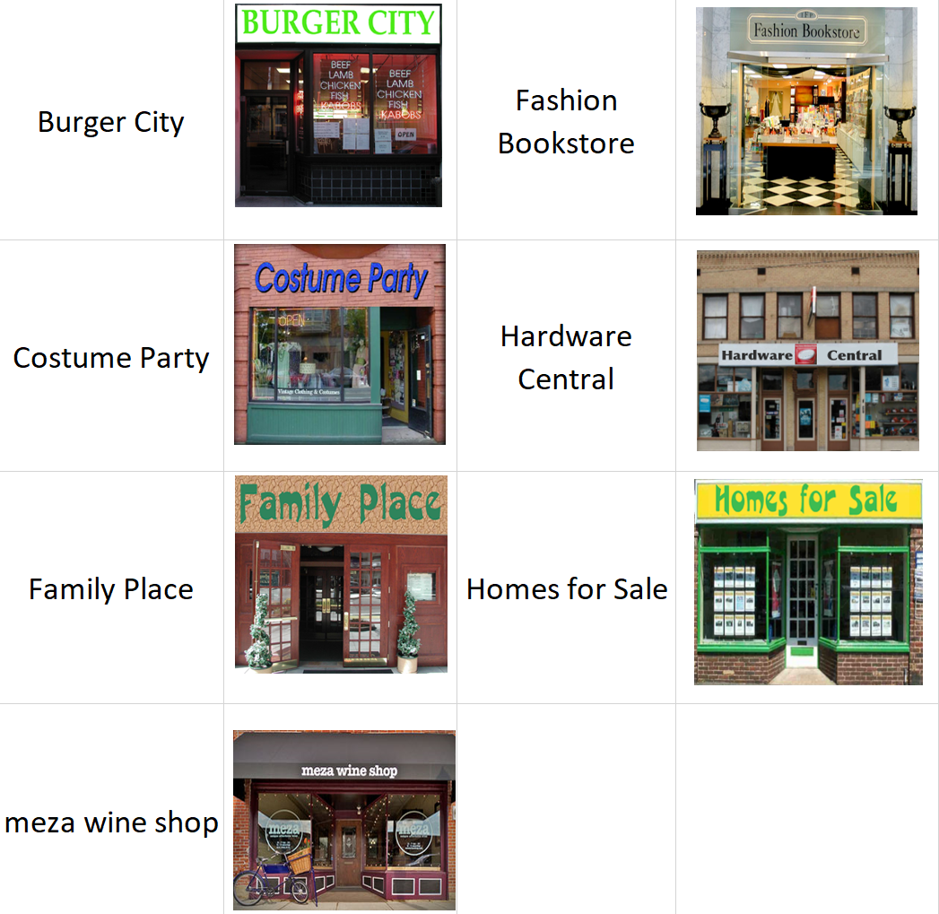 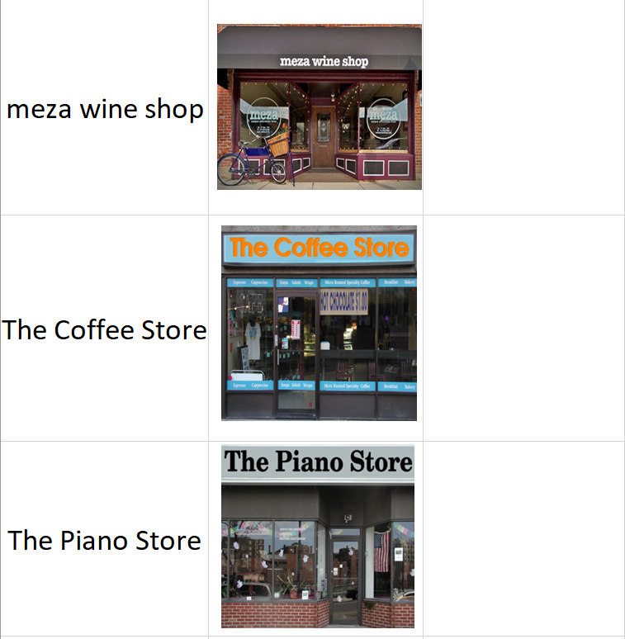

**Figure S1**: Presentation of target locations to participants. Participants received two pages of paper in the training phase, with appearance of the target buildings printed on these pages. The order of the buildings in the list was alphabetical and did not relate to the layout of these locations in the environment

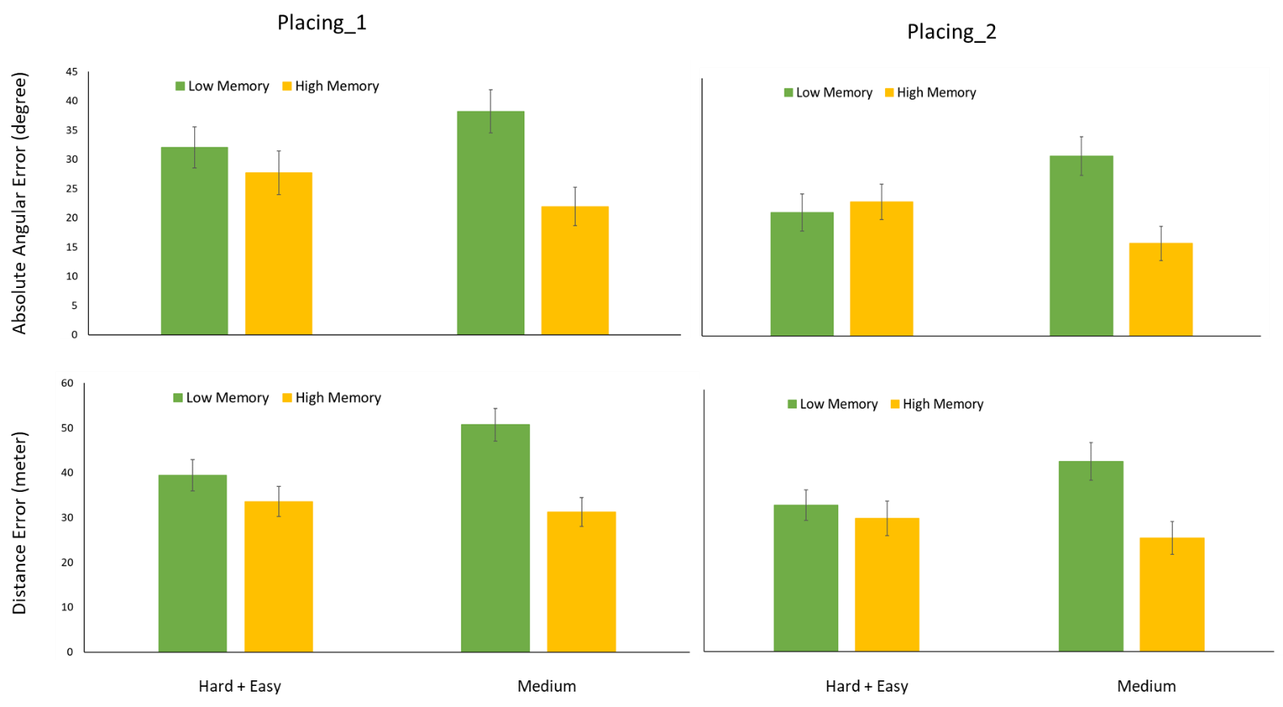

**Figure S2**: Absolute angular error (upper panels) and distance error (lower panels) in the first and second placing tasks. Note that the patterns are very similar to the ones of the position error. Error bars stand for standard error of the mean.

Data simulation Procedure (the R code and the data for this simulation are available at <https://osf.io/p2q8h>). The simulation first fills in known correlations between our SWM task and VWM, Gf, and spatial performance (measured in our study). It then iteratively simulates expected fluid intelligence (Gf) and verbal working memory (VWM) scores for each participant, with these simulated scores constrained by previous empirical findings and their known interrelationships and correlations with our collected measures. We then run multiple regressions with SWM, Gf and VWM as predictors of spatial performance on our task, separately for extreme and medium conditions. Finally, we test whether the observed correlation between SWM and spatial learning in the medium group is still significantly larger than the extreme group when a distribution of expected Gf and VWM values from the simulation are partialed out. Note that the simulation is completely agnostic to the group membership (extreme or medium) or other task properties.

1. Draw 96 random samples from each of two independent normal distributions. One of them is named Gf and the other is named VWM.
2. VWM data are transformed to ensure that the correlation between SWM (data from our study) and VWM is 0.44 exact (plane projection; Rodgers & Nicewander, 1988). This correlation is based on Đokić et al., (2018) and Redick et al., (2016) in which they used the same SWM task as in our study (symmetry span; with our gratitude to the Engle lab for sharing the code and stimuli for us to build directly on this prior work) to show that the correlation between symmetry span and operation span is on average 0.44 (N >500 in both studies). Similarly, Gf data are transformed to ensure that the correlation between SWM (data from our study) and Gf is 0.44 exact. This correlation is also based on Đokić et al. (2018) and Redick et al. (2016) using the Raven’s Progressive Test scores as a measure of Gf.
3. Derive a correlation matrix based on previous empirical findings (continued from above, and visualized see below). To define an empirically-based, non-arbitrary range for the distributions of correlations in this matrix, we use the 95% confidence intervals of the published correlations (shown in brackets in correlation matrix below) between VWM and Gf, between spatial performance and VWM, and between spatial performance and Gf. We use confidence intervals instead of exact values as in step 2, because it is mathematically impossible to generate data with more than one pre-defined exact correlations with other variables. The correlation and its 95% confidence intervals between VWM and spatial performance are estimated from Weisberg and Newcombe (2015). Weisberg and Newcombe used a pointing task which was similar to our placing task, and importantly the correlation between SWM and the angular error in Weisberg and Newcombe (2015) is -0.30, which is highly similar to ours (r = -0.37 between SWM and the angular error of our first placing task). The correlation and 95% confidence interval between VWM and Gf are estimated from Đokić et al. (2018) and Redick et al. (2016). Note that we use the SWM-VWM correlations from Đokić et al. (2018) and Redick et al. (2016) due to their larger sample size, but Weisberg and Newcombe (2015) also used the symmetry span task to measure SWM and the operation span task to measure VWM, and the relationship replicates, with 0.44 falling within Weisberg and Newcombe’s 95% CI = [0.40, 0.70] (n = 76). Finally, the correlation and 95% confidence interval between spatial performance and Gf are estimated from Silverman et al. (2000), which the authors also used Raven’s Progressive Test to reflect Gf.

|  |  |  |  |  |
| --- | --- | --- | --- | --- |
| **Derived Matrix** | | | | |
|  | SWM (from our data) | VWM (simulated) | Gf (simulated) | Spatial Performance (from our data) |
| SWM (from our data) |  |  |  |  |
| VWM (simulated) | 0.44 |  |  |  |
| Gf (simulated) | 0.44 | [0.25,0.41] |  |  |
| Spatial Performance (from our data) | -0.37 | [-0.48, -0.12] | [-0.24, 0.06] |  |

1. Compute the a simulated correlation matrix with exact values in the VWM and Gf columns from the derived matrix (above) using the observed SWM data in our study, the observed spatial performance data in our study (the angular error of our first placing task) and the simulated Gf and VWM data based on the empirical constraints detailed in 3. Assess whether the computed correlation matrix falls in the range of values in each cell of the empirically derived matrix (i.e, check if all the following conditions are satisfied: cor(SWM, VWM) = 0.44, cor(SWM, Gf) = 0.44, 0.25 >= cor(VWM, Gf) <= 0.41, -0.48 >= cor(VWM, performance) <= -0.12, and -0.24 >= cor(Gf, performance) <= 0.06).
2. When the computed correlation matrix fits the empirically-constrained values, we then run three multiple regressions separately in the medium and extreme groups (six in total). The predictors in each regression are the same, namely SWM, VWM and Gf. The dependent variables are the excessive distance of the first wayfinding task, and the position errors of the first and second placing task. We then extract the standardized estimate of SWM from each regression. Note that this standardized estimate is the correlation between SWM and performance when the simulated VWM and Gf are controlled for. When the computed correlation matrix does not fit the empirically-constrained values we repeat steps 1 and 2 until the computed matrix is statistically probable based on the literature.
3. The simulation terminates when steps 1-5 are run 1000 times successfully. As a result, we have 6 vectors, with each vector containing 1000 correlation coefficients between SWM and spatial learning when Gf and VWM are partialled out.
4. Run independent t-tests to test whether the distributions of likely residual SWM-spatial learning correlations (Fisher Z transformed) are different between extreme and medium conditions in each of the three tasks.

The resulting distributions of the SWM-performance correlation coefficients, partialing out the expected variance explained by VWM and Gf for each task (after step 6), are plotted below.

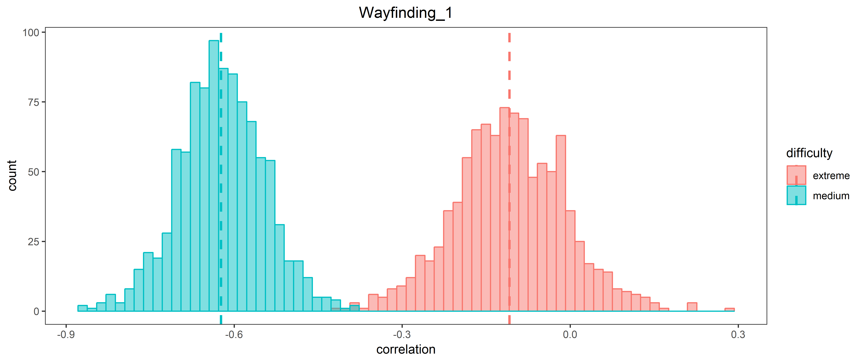

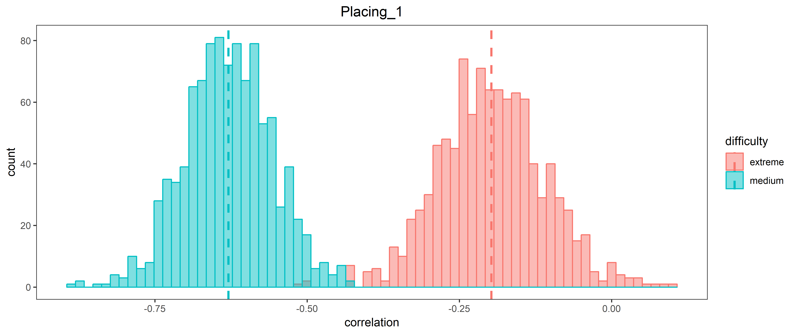

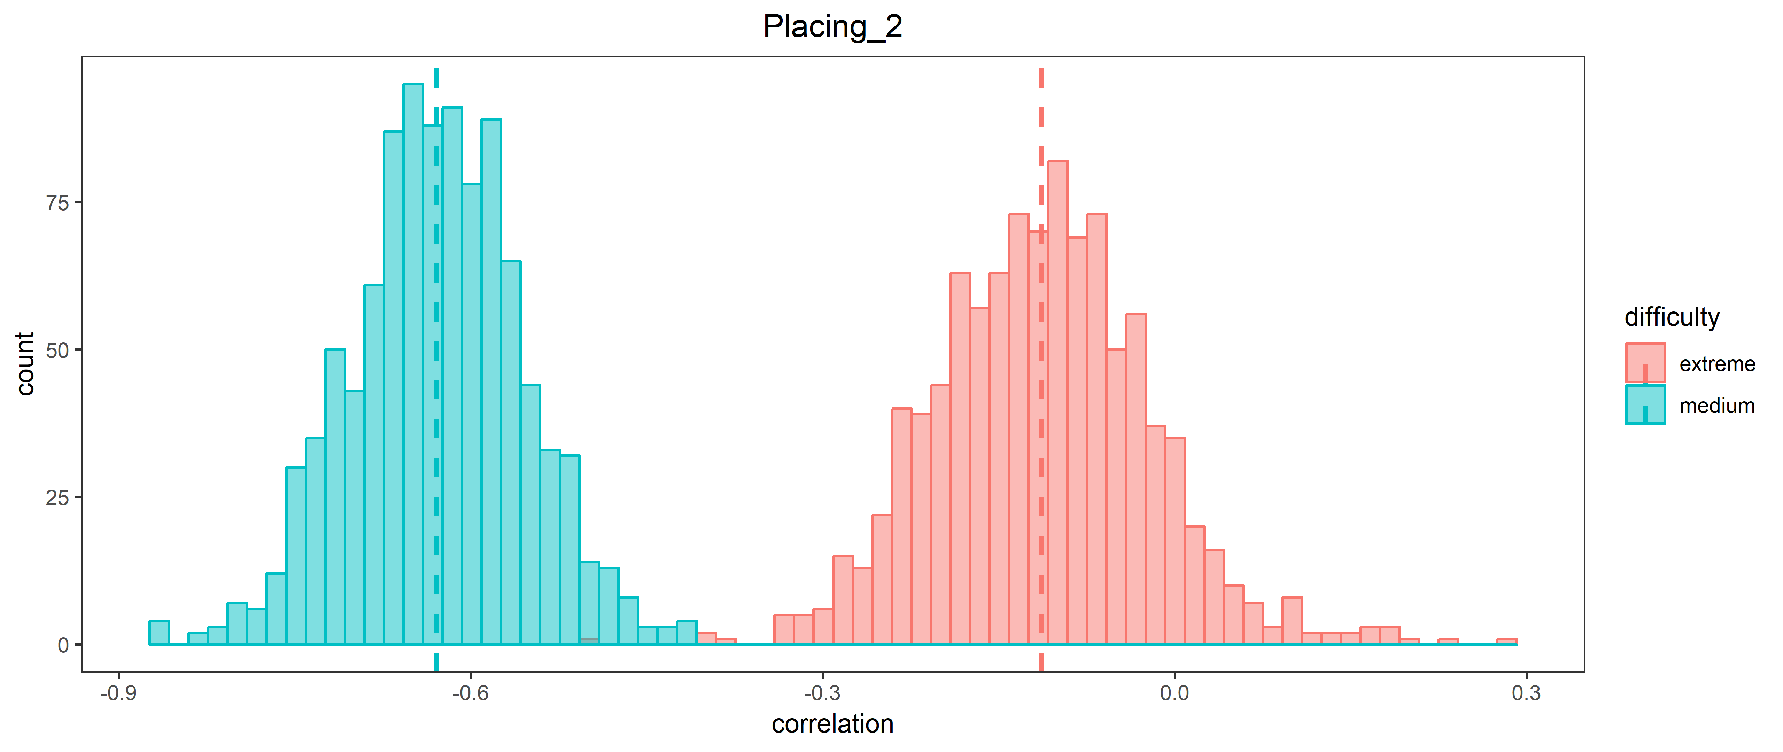

References

Đokić, R., Koso-Drljević, M., & Đapo, N. (2018). Working memory span tasks: Group administration and omitting accuracy criterion do not change metric characteristics. *PLoS ONE*, *13*(10). https://doi.org/10.1371/journal.pone.0205169

Redick, T. S., Shipstead, Z., Meier, M. E., Montroy, J. J., Hicks, K. L., Unsworth, N., Kane, M. J., Hambrick, D. Z., & Engle, R. W. (2016). Cognitive predictors of a common multitasking ability: Contributions from working memory, attention control, and fluid intelligence. *Journal of Experimental Psychology. General*, *145*(11), 1473–1492. https://doi.org/10.1037/xge0000219

Rodgers, J. L., & Nicewander, W. A. (1988). Thirteen Ways to Look at the Correlation Coefficient. *The American Statistician*, *42*(1), 59–66. https://doi.org/10.1080/00031305.1988.10475524

Silverman, I., Choi, J., Mackewn, A., Fisher, M., Moro, J., & Olshansky, E. (2000). Evolved mechanisms underlying wayfinding: Further studies on the hunter-gatherer theory of spatial sex differences. *Evolution and Human Behavior*, *21*(3), 201-213.

Weisberg, S. M., & Newcombe, N. S. (2016). How do (some) people make a cognitive map? Routes, places, and working memory. *Journal of Experimental Psychology: Learning, Memory, and Cognition*, *42*(5), 768.