**Online supplemental materials**

**Study 1 – Adjustments in creating threat categories**

To ensure full transparency, we report the considerations underlying adjustments to threat categories. Whereas “inequality” was among the most commonly mentioned threats in the U.K., “economic inequality: was among the most common in the U.S. Because social and economic equality are related terms, we felt that inequality is a broader term, that captures all forms of inequality and prevents conceptual overlap between two highly related terms. This decision, however, comes with the cost of not being able to tease apart different types of inequality. For the purpose of the present analysis, these distinctions, that may be important in other contexts, are not crucial, as the main purpose of Study 1 is to identify broad categories of threat. The same reasoning underlies the decision to combine the terms "Illegal immigration" (one of the most commonly mentioned threats in the U.S.) and "immigration" (one of the most commonly mentioned threats in the U.K.) into a single “immigration” category (again the broad immigration category is more useful for our purposes than more nuanced distinctions between types of immigration). Similarly, "Nuclear war" and "Nuclear weapons" were combined into a single "Nuclear weapons" category. "Donald Trump" was further commonly mentioned as a threat to society in both samples. His name was however excluded from further analysis, since the perception of him as a threat was clearly limited to his term as president, the nature of the threat that he poses is open to broad interpretation, and no other mentions were made of individual persons among the most commonly mentioned threats.

**Study 1 – Additional analyses**

We were interested in examining whether political preference was associated with the mention of the threats from the final scale (although this analysis was not preregistered). In order to examine this, we created dummy variables for each of the 18 threats (0 = not mentioned, 1 = mentioned) and ran binary logistic regressions for each of the threats, entering political preference as predictor, controlling for age and gender.

In both samples, right-wing/conservative political preference was associated with the mention of terrorism (U.K.: *B* = .20, *SE* = .09, *p* = .022; U.S.: *B* = .34, *SE* = .08, *p* < .001)and immigration (U.K.: *B* = .65, *SE* = .15, *p* < .001; U.S.: *B* = .69, *SE* = .16, *p* < .001), while left-wing/liberal political preference was associated with inequality (U.K.: *B* = -.41, *SE* = .21, *p* = .045; U.S.: *B* = -.50, *SE* = .13, *p* < .001). In the U.S. sample, right-wing/conservative political preference was associated with the mention of crime *B* = .44, *SE* = .19, *p* = .023 and economic collapse *B* = .46, *SE* = .20, *p* = .019, while left-wing/liberal political preferences was associated with the mention of climate change *B* = .39, *SE* = .09, *p* < .001 and racism *B* = .45, *SE* = .14, *p* = .001.

**Study 2 – comprehension checks**

We included a comprehension check item in which we asked the participants what the main criterion/criteria had been when they estimated similarity between threats and sorted the threats into different boxes. Participants could choose as many options as they liked and were given the following alternatives: a) whether the different threats could be said to belong to a common threat category; b) whether one threat might lead to another; c) whether the threats are likely to coincide d) whether the threats are directed at the same thing; e) whether the threats come from the same source; f) whether the threats have the same outcome; g) other:[free text option]. We assumed that if participants understood the instructions correctly they would be more likely to choose the first alternative ("whether the different threats could be said to belong to a common threat category") at a higher rate. The other alternatives are not incorrect, but just less central to the task.

In line with our expectation, the most common criterion indicated by the participants was whether the different threats could be said to belong to a common threat category (71%), followed by whether one threat might lead to another (38%), whether the threats are likely to coincide (31%), whether the threats come from the same source (26%), whether the threats have the same outcome (19%) and whether the threats are directed at the same thing (14%). These results indicate that participants understood the task correctly.

**Study 2 – sorting task**

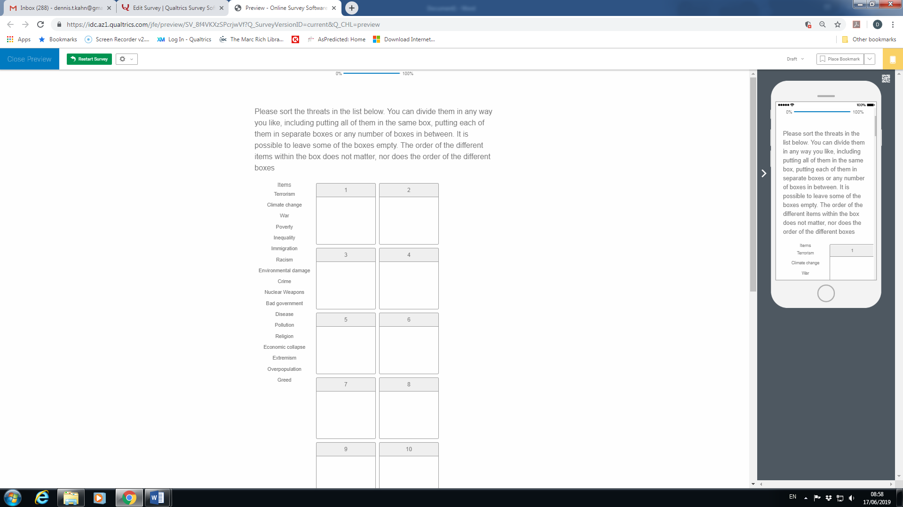

*Figure i.*

Screen shot of the sorting task as it appeared for the participants in the Qualtrics software. 18 boxes were presented to the participants altogether.

**Study 2 – advantages and limitations of similarity estimations and sorting task.**

Each of these approaches, similarity estimation and sorting task, has its advantages and drawbacks. Similarity estimation provides data on perceived similarity between each of the different objects under study and masks the purpose of the task to a greater degree than the sorting task. Further, the sorting task may suggest to the participants the existence of more than one dimension of the construct under study, a risk that is significantly reduced when judging pairs of objects in isolation. Similarity estimations, however, rely on Likert-type response scales and there is a risk that participants calibrate the rating scale in different ways. In sorting tasks, the participants are typically exposed to, and thus aware of, the full range of phenomena when making their judgment, which presumably more accurately reflects the way humans categorize objects. Finally, the sorting task is considerably less mentally taxing and time consuming, reducing the risk of fatigue influencing the results.

**Study 3 – Preliminary step**

Study 2 provided us with a map of which collective threats are perceived as similar and different from each other. The next step in the investigation of how people categorize threats was to select content criteria that could be used to interpret the 2-, 3- and 4-dimensional spaces. This is usually done by allowing participants to rate the different stimuli on content criteria, typically derived from established theories in the field (e.g., Koch et al., 2016). To stay true to our data-driven strategy, we employed a novel procedure in this preliminary step, in which participants themselves were asked to generate content criteria on which they perceived collective threats to differ. In the study, participants were shown threats associated with the poles of the different dimensions for the 2-, 3- and 4-dimension solutions and were asked to provide a free-text explanation of how these groups of threats differed from one another. The study was preregistered at aspredicted.org http://aspredicted.org/blind.php?x=cv4gj9.

**Method**

**Participants**

Participants were recruited from Prolific and, in accordance with the preregistration, the platform's prescreening was used to create quotas for gender (50/50) and political preference (1/3 left, 1/3 center, 1/3 right) among 60 U.K. participants who did not take part in Studies 1 or 2 (50% female, Mean age = 35.63).

**Measures**

Participants were presented with two groups of threat - one on the left side of the screen and one on the right side of the screen. They were told that participants in previous studies had estimated the threats in each group as being highly similar and that their task is to describe in what way the two groups of threats are different from each other. After being presented with the two groups of threat, they were posed the following free-text question: "In what way are the threats on the left different from the threats on the right in your view?" The groupings of threats were based on the results from Study 2 and the group of threats presented on the left side of the screen represented threats associated with the low pole of a certain dimension, while the group of threats presented on the right side of the screen represented threats associated with the high pole of the same dimension. The threat "religion" was in this study changed to the wording "religious fundamentalism" to provide this threat with a negative valence (religion for many people is not a threat). Participants were randomly allocated to describe groups of threats taken either from the 2-, 3- or 4-dimension solution.

Following this free text task, participants were asked how difficult the task was on a scale from 1 (*extremely easy*) to 7 (*extremely difficult*(. The measure of difficulty was included to provide an additional measure of interpretability of the dimension solution and also to indicate whether participants were able to complete the task. Political preferences were assessed on a scale from 1 (Far Left) to 7 (Far right).

**Results**

There were no significant differences in the difficulty of describing the 2-, 3- and 4-dimensional solutions. The average level of difficulty was < 4 suggesting that participants experienced a moderate level of difficulty completing the task. Descriptive statistics for perceived difficulty can be found in Table *i*.

Table *i*.

*Means and Standard Deviations for Difficulty of Describing the Dimensions in the 2-, 3- and 4-dimensional Solutions.*

|  |  |  |  |  |  |  |
| --- | --- | --- | --- | --- | --- | --- |
|  | 2-dimension solution | | 3-dimension solution | | 4-dimension solution | |
|  | M | SD | M | SD | M | SD |
| Dimension 1 | 3.33 | 1.85 | 3.70 | 2.03 | 3.63 | 1.71 |
| Dimension 2 | 4.76 | 1.67 | 5.05 | 1.70 | 4.58 | 1.46 |
| Dimension 3 |  |  | 5.20 | 1.77 | 5.21 | 1.62 |
| Dimension 4 |  |  |  |  | 3.95 | 1.08 |

We analyzed the contents of the descriptions using an inductive bottom-up thematic analysis (e.g., Braun & Clarke, 2006) in a 5-phase process. The process included the following steps: 1. Reading through the entire text; 2. Coding salient features in the text; 3. Organizing the data into potential themes; 4. Re-examining the relevance of the chosen themes to the gathered data and adjusting the theme content if needed; 5. Counting frequency of the different answers in each theme to establish the centrality and importance of each theme. After reading through the entire text (step 1), salient features of the text were coded (step 2 and 3). For example, in response to certain threats, one participant noted “Threats on the left are directly caused by people; threats on the right are indirectly caused by people”. This response was coded as “direct/indirect effect.” In another case the response: “The [threats on the] right are related to money and [the threats on the] left are not” was coded as “related to economy.” In some cases, a response was coded with more than one theme. After coding salient themes in all responses, we again went over the text and compared the contents of the text with the themes they had been assigned (step 4). We finally counted how many times a certain theme appeared in participants’ responses and sorted the themes according to how frequently they were mentioned. The resulting list contained the following themes:

1. Local/Global consequences
2. Avoidability
3. Intentional/Unintentional
4. Related to economy
5. Motivated by emotion
6. Direct/Indirect
7. Inter-human cruelty
8. Targets environment
9. Affects some/affects all
10. Motivated by ideology
11. Related to power
12. Collective-level/Individual-level consequences
13. Consequence of regular/irregular activity
14. Malicious intent
15. Physical/Symbolic
16. Clear perpetrator
17. Related to immigration
18. Long term/Short term consequences

**Discussion**

This preliminary step allowed us to generate a list of criteria that could be used to disambiguate and interpret the different dimensions. Rather than basing the rating of collective threats on theoretical assumptions, the novel procedure employed in Study 3 enabled us to generate a list of criteria that reflect what criteria people spontaneously use to categorize and describe collective threats.

**Study 3 – selecting criteria for further analysis.**

To further validate our criteria selection, we ran parallel analyses and PCAs separately in each of the political groups (among leftists, centrists and rightists), entering the 19 criteria, but not the three valence criteria. The results were highly similar in the different political groups. In each of the groups, the parallel analysis indicated the existence of 2 components explaining between 72% and 75% of the variance. Nine of the criteria (malicious intent, intentional, clear perpetrator, direct action, threats against symbolic values, ideological motivation, interhuman cruelty, related to power and emotional motivation) loaded > .4 on the first component and < .4 on the second component across all political groups. Further, seven of the criteria (affects all, global, collective-level, long-term consequences, related to the environment, threats against something physical and tangible and unrelated to immigration) loaded > .4 on component 2 and < .4 on component 1. This step provided us with 16 criteria to use in subsequent studies.

**Study 3–** **property-fitting analyses**

We carried out property-fitting analyses to compare the suitability of the two dimensions for interpreting the threats’ 1D, 2D, 3D and 4D dissimilarity space. These analyses consisted of multiple regressions, entering the two dimensions as criterions and their coordinates from the Study 2 MDS as predictors. In other words, for the 1D dimension solution, we ran two regressions, first entering the coordinates for the single dimension (from Study 2) as predictor and the component score for the commission/omission component (from Study 3) as criterion. We then ran a second regression entering the coordinates for the single dimension (from Study 2) as predictor and the component score for the local/global component (from Study 3) as criterion. For the 2D dimension solution, we entered the coordinates for both dimensions into a multiple regression, again using the component score for the commission/omission component as a criterion. The same analysis was then carried out, using the component score for the local/global component as criterion. The same strategy was used for the 3D and 4D dimension solution, with the difference that for the 3- and 4-dimension solutions, coordinates for 3 and 4 dimensions were entered as predictors. These regression analyses were all conducted twice, once for the coordinates from the similarity estimations and once for the coordinates from the threat sorting. The results showed that the local/global component was unsuitable for interpreting the 1D threat space (*R* .31 and .09, ideally the *R*2 should be > .80). The Commission/Omission component was better (*R* .57 and .73), but still not up to par, at least for the similarity estimates. Both threat components (Commission/Omission and local/global) were however suitable interpretations for the 2D, 3D and 4D threat spaces for the similarity estimates as well as for the threat sorting (*R*2s between .74 and .95). It can be noted, however, that while the explained variance increased dramatically with the inclusion of a second dimension, there was a small, if any, increase in explained variance as a result of the inclusion of a 3rd and 4th dimension (see Table *ii*).

Table ii.

*Regression coefficients predicting component score on the different dimensions (Study 3) with the coordinates from Study 2.*

|  |  |  |  |  |  |
| --- | --- | --- | --- | --- | --- |
| Threat content |  | R (1D axis) | R (2D axis) | R (3D axis) | R (4D axis) |
| Commission/Omission | Similarity | .572 | .902 | .941 | .947 |
| Sorting | .731 | .852 | .896 | .921 |
| Local/Global | Similarity | .308 | .751 | .736 | .743 |
| Sorting | .087 | .918 | .909 | .914 |

We then carried out correlational analyses between the component scores (from Study 3) and the coordinates (from Study 2). For the 1D solution, the coordinates for the single dimension were highly correlated with the Commission/Omission component, but not necessarily for the local/global component. For the 2D solution, the commission/omission component was highly correlated with the coordinates for D1, while the coordinates for D2 were relatively more weakly correlated (this pattern was more apparent for the threat sorting data than for the similarity estimations, although the pattern could be seen for the similarity estimations as well). In contrast, the local/global component had a relatively stronger correlation with the coordinates for D2 than with the coordinates for D1. The same pattern could be seen for the correlations between the two components and the coordinates for D1 and D2 in the 3- and 4-dimension solutions. The third and fourth dimensions however, were not correlated with either of these two dimensions (*r*s between .01 and .28, see Table *iii*). Taken together, these analyses indicate that the 2-factor solution was suitable for interpreting the 2D dissimilarity space, but not the 1D, 3D and 4D space.

Table *iii*.

*Correlation coefficients for component scores on the different dimensions in the different dimension solutions (Study 3) and the coordinates from the Multidimensional scaling from Study 2.*

|  |  |  |  |
| --- | --- | --- | --- |
|  |  | Commission/Omission | Severity of consequences |
| 1D - D1 | Similarity | -.757 | .555 |
| Sorting | -.855 | .295 |
| 2D - D1 | Similarity | -.746 | .555 |
| Sorting | -.837 | .397 |
| 2D - D2 | Similarity | .588 | .666 |
| Sorting | .390 | .872 |
| 3D - D1 | Similarity | -.761 | .544 |
| Sorting | .880 | -.334 |
| 3D - D2 | Similarity | .590 | .657 |
| Sorting | -.289 | -.835 |
| 3D - D3 | Similarity | .118 | .096 |
| Sorting | -.194 | -.316 |
| 4D - D1 | Similarity | .744 | -.563 |
| Sorting | .875 | -.344 |
| 4D - D2 | Similarity | .605 | .652 |
| Sorting | -.326 | -.838 |
| 4D - D3 | Similarity | .151 | .009 |
| Sorting | -.137 | -.278 |
| 4D - D4 | Similarity | -.057 | .037 |
| Sorting | -.173 | .132 |

**Study 4 – additional analyses**

As preregistered, we also carried out mixed model ANOVAs, producing the same pattern of results[1]. To visualize the main results from these analyses, we present the mean allocation of resources to threats vs. non-threat-related issues, omission vs. commission threats and local vs. global threats among liberals and conservatives in Figure *ii*.

*Figure ii.*

Mean percentage allocated to threats vs. non-threat related issues, to omission vs. commission threats and to global vs. local threats among conservatives and liberals. Error bars in the figure represent standard errors of the mean.

**Study I -- Supplemental**

The main purpose of Studies I and II was to use another method to establish that liberals and conservatives evaluate the importance of threats differently. In these two studies we used a resource allocation task to examine whether liberals and conservatives would differ in their priorities to reduce threats. As a first step we generated lists of societal issues that are perceived as collective threats and societal issues that are perceived as important, but not threatening to contrast resource allocation to threats and non-threats. A secondary purpose of Study I was to address a possible limitation in the list of threats generated in Study 1 that has guided our research thus far. In that study, we asked participants to list threats that they consider the *greatest* threats to society. It is possible that the threats people think of as the greatest threats to society are not the threats that people think about often. In that case, our study of collective threats may be limited to threats that are severe but rare and exert little effect on everyday life. To address this limitation, we used a data-driven strategy again to solicit the collective threats that people *think about often*. Generating a new list of threats also allowed us to examine whether our hypotheses on political identity and threat could be generalized beyond the list of threats produced in Study 1. Finally, Study I enabled us to conceptually replicate ideological differences in threat perception found in Study 4 using a different task and a different list of threats. This study was preregistered on aspredicted.org <http://aspredicted.org/blind.php?x=a226ju>.

**Method**

**Participants**

The sample consisted of 300 participants (49% female, Mean age 43.23), recruited from the Prolific platform and was representative of the U.S. population in the age range of 20-69 in terms of age, gender and political preferences. None of the participants were excluded.

**Measures and procedure**

Participants in the study were posed with two open-ended questions. They were first instructed to: "Please list three threats against society that you think about often". They were then given the following instruction: “Please list three societal issues that you think are important, but that you would not define as ‘threats’. The fact that you don't define these issues as threats does not imply that you perceive them as any less important. Please avoid listing issues that you perceive as unimportant or fake threats. Instead, list societal issues that you think are important, but that you would not define as ‘threats’.” Participants were then asked to provide basic demographic information.

**Results**

In accordance with the preregistration, we surveyed the list of threats and non-threat-related issued mentioned by the participants, combining threats that clearly referred to the same category. We then sorted the threats and non-threat-related issues by prevalence, identifying the threats that accounted for at least 2% of the threats mentioned in the sample. We removed reference to individuals from the final lists. Further, if the same societal issue appeared both in the list of threats and non-threat-related issues, it was removed from both lists. Finally, if any of the issues in the list of non-threat related issues was the same as an issue that had been defined as a threat in our previous study, it was removed from the list. These steps were preregistered and the purpose of the exclusions of these issues was to create manageable lists that contained issues that were unequivocally perceived as threats and non-threats. In relation to the secondary purpose of the study, it is worth mentioning that the initial list of threats accounting for at least 2% of the threats mentioned (COVID-19, Racism, Climate change, Terrorism, Violent protests, Crime and Poverty) considerably overlapped with the list of threats attained in Study 1, in which we had asked which are the *greatest* threats against society rather than societal threats that the participants think about often. After excluding threats and non-threat-related issues in accordance with the preregistered criteria mentioned above, we were left with the following list of threats and non-threat-related issues:

Threats:

1. Terrorism

2. Poverty

3. Crime

4. COVID-19 pandemic

5. Violent protests

Non-threat-related issues:

1. Education

2. Healthcare

3. LGBTQ rights

4. Family and children

**Discussion**

Study I provided us with a list of threats and non-threat-related issues. Rather than asking which threats constituted the greatest threats against society, we asked participants to list collective threats that they think about often. The list of threats had a great deal of overlap with the list generated when asking which are the greatest threats against society (Study 1). The list of threats used in Studies 1-4 thus seem to reflect the collective threats that the participants thought about in their everyday lives, and not only the threats that they consider to be the greatest threats against society. By using our preregistered criteria for exclusion of issues, we were able to ensure that the final list of threats were unequivocally perceived as threats, and that non-threats were perceived as such.

**Study II**

Studies 1-4 were restricted to two cultural settings – the U.S. and the U.K. We carried out Study 5 to examine whether the patterns we found in these two countries could also be obtained in a wide variety of cultural settings. We had access to data from the PEW Global Attitudes and Trends survey from 2017 (Pew Research Center, 2017), including data from a wide range of countries regarding political preferences and valuation of different collective threats. In order to map these threats on the Omission/Commission and Local/Global dimensions, we carried out Preliminary Study II. The main purpose of Study II was to map the threats from the Pew Research Center’s Global Trends and Attitudes Survey on the local/global and omission/commission dimensions. This was done in preparation for Study 5 in which we use the Study II ratings on the two dimensions. This study also provided an opportunity to test the two-dimensional model of collective threat and the relationship between political preferences and threat, using a different list of threats, generated by independent researchers. The study was preregistered at aspredicted.org <http://aspredicted.org/blind.php?x=5q22jk>.

**Method**

**Participants**

We relied on the power analysis from Study 3 to determine sample size for Study 5. We used the representative sample function of the Prolific platform to collect 312 U.S. participants, representative of the general population in terms of gender, age and race/ethnicity (i.e., White, Black, Asian, Mixed or Other). As in previous studies, and as per the preregistration, we excluded participants who did not recommend that we use their responses in the statistical analysis (*N* = 9), making the final sample size *N* = 303 (51% female, Mean age = 43.90).

**Measures**

The threat items appeared in PEW surveys between 2012 and 2017 with slight variations from year to year. In Study II, we opted for general phrasings of the threats that would encompass the different variations across the different surveys. For example, in some of the surveys, participants were asked about Islamic militant groups and in some surveys about the threat of the Islamic State. We chose to ask about the more general phenomenon of "Islamic militant groups". In order to clarify, we also added the phrase "The threat emanating by…", followed by the different threats. Ten threats from the PEW surveys were included in Study II:

1. Climate change
2. Islamic militant groups
3. Cyberattacks on governments, banks or corporations
4. Large-scale immigration of refugees from countries such as Iraq and Syria
5. Economic instability
6. Pollution and other environmental problems
7. Spread of nuclear weapons
8. AIDS and other infectious diseases
9. Religious and ethnic hatred
10. Growing gap between rich and poor

We further included an 11th threat – right-wing extremist groups – so that participants would not experience the survey as biased against Muslims. This threat, however, was not included in any of the PEW surveys and was, in accordance with the preregistration, excluded from further analysis.

Participants were asked to rate each of these 10 threats on the final 16 criteria associated with the two dimensions as per Study 3, with a few notable revisions. We combined emotional and ideological motivation into one item (ideological and/or emotional motivation) and removed two criteria related to specific contents ('related to the environment' and 'related to immigration'). This was done in accordance with the preregistration. The reason for these changes was to reduce the number of criteria that our participants were asked to rate the threats on and decrease the risk for fatigue. Doing so enabled us to ask the participants to assess each of the 10 threats on all 13 criteria. The order of the criteria as well as the order of the threats within each criterion were counterbalanced. All participants further assessed the threats on the three valence criteria used in Study 3 (concern, severity, and importance of threat). As in Study 3, for each threat, participants were asked to assess the threat on the relevant criterion with a slider on a scale from 0-100, anchored at both sides with short descriptions of the low and high poles of the criterion. Political preferences were assessed on a scale from 1 (*Very liberal*) to 7 (*Very conservative*).

**Results**

A parallel analysis indicated the existence of two main dimensions and a PCA confirmed the dimension structure obtained in Study 3. The two first components accounted for 86% of the variance and had eigenvalues of > 4, with subsequent components having eigenvalues of < 1. The criteria intentional, direct action, clear perpetrator, malicious intent, interhuman cruelty, ideological/emotional motivation, symbolic values, and power loaded > .40 on the Omission/Commission component, while loading < .40 on the Local/Global component. The criteria local/global, affects all, collective level, long-term consequences and physical loaded > .40 on the Local/Global component, while loading < .40 on the Omission/Commission component.

As in Study 3, we carried out linear regression analyses for political preferences and each of the threats, controlling for age and gender. We sorted the threats according to their mean rating on the omission/commission and local/global dimensions and present the regression coefficients between political preferences and the different threats (see Table *iv*). Four out of the five threats (climate change, pollution, economic instability, growing gap between rich and poor) associated with the omission pole were significantly related to left-wing political preferences, while 2 out of the 5 threats (Islamic militant groups, immigration) associated with the commission pole were significantly related to right-wing political preferences (the other three threats were unrelated to political preferences). Three of the 5 threats associated with the global pole (climate change, pollution, economic instability) were associated with left-wing political preferences. There was, however, no clear pattern with regards to the threats associated with the local pole.

Table iv.

*Regression Coefficients (Beta-values) of the Relationship Between Political Preference and Threat Valuation, Controlling for Age and Gender, organized by rating on the omission/commission and local/global dimensions. Confidence intervals for the regression coefficients are shown in parentheses.*

|  |  |  |  |  |  |  |
| --- | --- | --- | --- | --- | --- | --- |
| Threat | Omission/ Commission | Political preference X threat valuation |  | Threat | Local/ Global | Political preference X threat valuation |
| AIDS and infectious diseases | 27.81 | -.08** (-.19,-.04) |  | Immigration | 54.27 | .50** (-.39,-.60) |
| Climate change | 34.66 | -.46** (-.56,-.36) |  | AIDS | 54.32 | -.08** (-.19,-.04) |
| Pollution | 37.48 | -.39** (-.49,-.28) |  | Growing gap between rich and poor | 58.74 | -.37** (-.48,-.27) |
| Economic instability | 43.37 | -.22** (-.33,-.11) |  | Religious and ethnic hatred | 59.87 | -.10** (-.22,-.01) |
| Growing gap between rich and poor | 50.33 | -.37** (-.48,-.27) |  | Cyberattacks | 61.16 | .00** (-.11,-.12) |
| Immigration | 52.41 | .50** (-.39,-.60) |  | Islamic militant groups | 64.34 | .28** (-.17,-.39) |
| Cyber attacks | 65.9 | .00** (-.11,-.12) |  | Economic instability | 65.64 | -.22** (-.33,-.11) |
| Nuclear weapons | 69.03 | -.03** (-.15,-.08) |  | Pollution | 80.72 | -.39** (-.49,-.28) |
| Religious and ethnic hatred | 77.6 | -.10** (-.22,-.01) |  | Nuclear weapons | 81.91 | -.03** (-.15,-.08) |
| Islamic militant groups | 83.33 | .28** (-.17,-.39) |  | Climate change | 82.86 | -.46** (-.56,-.36) |

As in Study 3, we carried out multilevel modeling analyses to assess whether the relationship between political preference and threat differed depending on the intent and extent of the threat. The different threats were treated as within-subjects clusters of analysis. These analyses were not preregistered. In the first step, we entered only type of threat as a within-subjects predictor and concern for threat as an outcome variable. This analysis showed that the level of concern differed depending on the type of threat *t*(2904) = 129.26, *p* < .001. In the second step, we entered individual-level (right-wing) political preferences, as well as individual-level rating on the omission/commission and local/global dimensions. Age and gender were also included as controls. The analysis showed that left-wing political preferences *b* = -1.04, *SE* = .21, *t* = -4.90, *p* < .001, LLCI = -1.46, ULCI = -.63, rating of the threat as commission-based *b* = .24, *SE* = .01, *t* = 17.06, *p* < .001, LLCI =.21, ULCI = .27 and rating of the threat as global *b* = .78, *SE* = .02, *t* = 47.47, *p* < .001, LLCI =.74, ULCI = .81 were related to concern for threats. In the third and fourth steps, we entered interaction terms between political preference and omission/commission (third step) and political preference and local/global (fourth step). The analyses revealed significant interactions between political preferences and omission/commission *b* = .05, *SE* = .01, *t* = 7.04, *p* < .001, LLCI =.04, ULCI = .07, but not between political preferences and local/global *b* = -.01, *SE* = .01, *t* = -1.01, *p* = .312, LLCI = -.03, ULCI = .01. The more commission-based the threat, the more concern for the threat was associated with right-wing political preferences and the more omission-based the threat, the more concern for the threat was associated with left-wing political preferences.

**Discussion**

In addition to mapping the threats from the Pew global attitudes and trends survey (that we analyze separately in Study 5) on the omission/commission and local/global dimensions, the study provided an opportunity to replicate once again the dimension structure of collective threat, using a different list of threats, generated by independent researchers. The study provided further support for the 2-dimensional model of collective threat. Further, the study replicated the results from Studies 3 and 4 in terms of the relationship between political preferences and threat perception. Concern for threat was again associated overall with leftist political preferences, providing further indications that when using a broad array of collective threats, conservatism is not necessarilyrelated to greater threat sensitivity. More central for our purposes, the more a threat was commission-based, the more the threat was associated with rightist political preferences, whereas the more a threat was omission-based, the more it was associated with leftist political preferences. One result, however, was not replicated from Study 3. In Study II, the relationship between political preferences and threat did not differ depending on the threat’s rating on the local/global dimension. The replication of the two-dimensional structure of collective threat as well as the relationship between political preference and omission/commission threats in a separate sample, from a different country, using a different set of threats generated by independent researchers, speaks to the robustness of these results.

**Figures showing interaction between political preferences and omission/commission threats in separate countries – Study 5**

Argentina

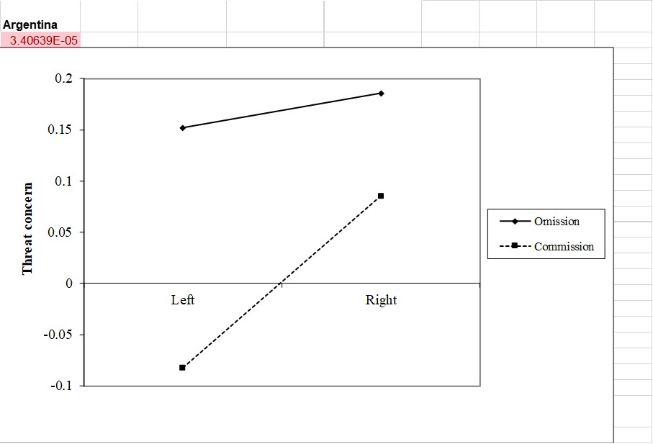

Australia



Brazil



Canada



Chile



Colombia



France



Germany



Greece



Hungary



Israel



Italy



Mexico



Netherlands



Peru



Poland



South Korea



Spain



Sweden



United Kingdom



United States



Venezuela



Figures showing interaction between political preferences and local/global threats in separate countries – Study 5

Argentina



Australia



Brazil



Canada



Chile



Colombia



France



Germany



Greece



Hungary



Israel



Italy



Mexico



Netherlands



Peru



Poland



South Korea



Spain



Sweden



United Kingdom



United States



Venezuela



1. We carried out three mixed-model ANOVAs to examine relative allocation of resources to threat-related vs. non-threat-related issues, omission vs. commission threats and local vs. global threats depending of political preferences. Non-threat related issues *F*(1, 385) = 8.61, *p* = .004, *η2* = .02, omission threats *F*(1, 385) = 130.39, *p* < .001, *η2* = .25 and global threats *F*(1, 385) = 48.66, *p* < .001, *η2* = .11 were generally allocated more resources than threat-related issues, commission threats and local threats. Central for the purposes of the study, there were significant interactions between political preference and relative percentage of resource allocation to threat-related vs. non-threat-related *F*(2, 385) = 6.97, *p* = .001, *η2* = .03, relative percentage of resources allocated to omission vs. commission threats *F*(2, 385) = 37.82, *p* < .001, *η2* = .16 and relative percentage of resources allocated to local vs. global threats *F*(2, 385) = 35.72, *p* < .001, *η2* = .16. Overall, conservatives allocated relatively more resources to threat-related issues. This was, however, heavily influenced by type of threat. Conservatives allocated relatively more resources to local threats (e.g., violent protests) and commission threats (e.g., Terrorism), while liberals allocated relatively more resources to global threats (e.g., Covid-19) and omission threats (e.g., poverty).