Supplemental Material
Contents
Comparison of the two neutral statement conditions (Experiment 1) _________________ p. 2
Response rates of sound-related beliefs ________________________________________ p. 2
Effects of sound-related beliefs on implicit evaluations ___________________________ p. 6
Additional analyses of Experiment 3 __________________________________________ p. 11
Analyses of explicit evaluations _____________________________________________ p. 15
Analysis of implicit evaluations controlling for face assignment and IAT order effects __ p. 29
Correlations across experiments _____________________________________________ p. 35
References ______________________________________________________________ p. 38

Comparison of the Two Neutral Statement Conditions (Experiment 1)
To determine whether to treat the two neutral statement conditions as equivalent in subsequent analyses and collapse across them, versus retain them as separate conditions, we first fit a mixed model to test whether a comparison of these two conditions produced a main effect or interaction with time on IAT scores within a 2 (statement: neutral-behavior vs. neutral-unrelated) X 2 (time: Time 1 vs. Time 2) design, with fixed factors for statement, time, and their interaction, and a random intercept for participants. Statement was manipulated between-participants and time was manipulated within-participants. Models were fit using the lme4 package in R (Bates, Maechler, Bolker, & Walker, 2015). Model effects were tested with Type III tests according to Satterthwaite’s method using the lmerTest package (Kuznetsova, Brockhoff, & Christensen, 2017).
There was a significant main effect of time, F(1,362) = 16.56, p < .0001, η²_{G} = .01, but no main effect of statement, F(1,362) = 0.23, p = .63, η²_{G} = .004, or interaction between statement and time, F(1,362) = .12, p = .73, η²_{G} < .0001. Thus, for our main comparison of the positive statement condition to the neutral conditions, we collapsed the two neutral conditions into a single comparison group.
Response Rates of Sound-Related Beliefs

Experiment 1. Participants were asked to select among four options the reason that seemed closest to their own beliefs regarding why the target person had been paired with the scream sounds during the aversive repeated evaluative pairings (A-REP) task. The option with the highest rate of endorsement was that the target person was causing the screams (50.61%), followed by no connection (37.42%), none/other (10.36%), and that the target was trying to stop the screams (1.62%). Due to the low frequency of belief that the target was attempting to stop the screams, for analyses in the main text, participants opting for this response were merged with those selecting either of the two non-causal options (no connection and none/other) so as to contrast participants who reported a belief that the target was causing the screams with participants who endorsed any other option.
Experiment 2. Unlike in the previous experiment, the most commonly selected relationship between the target person and the scream sounds was lack of any connection (43.67%), followed by belief that the target caused the screams (42.41%), none/other (9.49%), and finally belief that the target was trying to stop the screams (4.43%). Because in this experiment the belief question was placed after the evaluative statement (ES) manipulation and second IAT, it is possible for the statement manipulation to impact sound-belief responses, despite the phrasing of the question instructing participants to respond on the basis of what they had believed during the A-REP task and prior to the presentation of the statement. Indeed, a chi-squared test comparing the response proportions across the four choices between the two ES conditions was significant, χ²(3) = 11.79, p = .008, attributable to a higher rate of endorsement of the belief that the target was trying to stop the screams in the positive-explanation condition (7.73%) than in the positive-unrelated condition (1.24%). Notwithstanding this caveat on the relationship between statement condition and belief endorsement, for subsequent analyses, the responses to the belief questions were dichotomized in the same manner as Experiments 1-2. Frequencies across this recoded belief indicator did not differ between statement conditions, χ²(1) = 0.38, p = .54.
Experiment 3. Participant beliefs about the relationship between the target face and the scream sounds during A-REP were assessed twice: Once at the end of the first session, and once at the end of the second, to explore temporal consistency in remembered interpretations of the screams during A-REP. (Both questions asked participants to recall what they believed about the screams at the time they were presented, rather than at the time of measurement.) 71% of participants selected consistent interpretations from the first session to the second, notwithstanding some notable shifts: of participants who initially thought the target person was causing the screams, 22.6% had shifted toward recalling a belief that he had been trying to stop the screams; on the other hand, only 6.6% of participants who initially believed he was trying to stop the screams had switched during the second session to remembering a belief that he had been causing the screams. Table S-1 shows the number of participants included in the second session who had each combination of initial (Session 1) and final (Session 2) beliefs about the A-REP experience.

Table S-1.
Beliefs about the Relationship between the Target Person and Screams across Sessions
 |  |  | Final Belief
Initial Belief | Causing | None/other | Not connected | Trying to stop | Total
Causing | 122  65.6% | 3  1.6% | 19  10.2% | 42  22.6% | 186  100%
None/other | 1  2.8% | 14  38.9% | 14  38.9% | 7  19.4% | 36  100%
Not connected | 4  2.5% | 4  2.5% | 128  80.5% | 23  14.5% | 159  100%
Trying to stop | 4  6.6% | 0  0% | 5  8.2% | 52  85.2% | 61  100%
Total | 131  29.6% | 21  4.8% | 166  37.6% | 124  28.1% | 442  100%

Note. Percentages are within rows: the percent of participants of each initial belief at Session 1 who selected each final belief at Session 2.

Experiment 4. As in Experiment 1, the majority of participants indicated a belief that the target person was causing the screams (59.75%), with fewer believing the stimuli were unconnected (31.50%), indicating no belief or some other belief (8.00%), or indicating that they felt the target was trying to stop the screams (0.75%).

Effects of Sound-Related Beliefs on Implicit Evaluations
Summary. Here, we briefly summarize additional analyses of the data from Experiments 1–4 involving subjective beliefs about the nature of the scream-based A-REP task (for full details, see next section). These secondary analyses tested predictions derived from propositional theories based on the idea that it is not the stimuli per se that drive formation and updating of implicit evaluations, but the subjective inferences that participants derive about those stimuli (e.g., Hughes et al., 2018; Van Dessel et al., 2019). If this idea is correct, then subjective appraisals of the learning experience—even when ostensibly associative from the dual-process perspective, as with A-REP—may modulate learning effects. Given the inherent interpretational ambiguity of pairings, there may indeed be substantial variation in the inferences that participants draw from them (De Houwer, 2018).
Participants in all experiments were asked to select among four options the reason that seemed closest to their own beliefs regarding why the target person had been paired with the scream sounds during the A-REP task. Across experiments, implicit evaluations of the target person tended to be significantly more negative among participants who reported that they believed the target person was causing the screams during A-REP, compared to participants who endorsed any other reason. This was particularly true for the Time 1 IAT, before participants received the ES, which is consistent with the idea that inferences about the meaning of the sound conditioning will be most influential before participants learn any other information on which to base an impression of the person. In Experiment 2, for example, participants who later reported believing that the target person was the cause of the screams had more negative D-scores at Time 1 (M = -0.29, SD = 0.43) than participants who did not report this belief (M = -0.18, SD = 0.45).
In the two experiments in which sound beliefs were measured prior to the presentation of ES, the impact of sound beliefs was more general, and affected both the initial and final IATs: Participants had overall more negative IAT scores when they believed the target was the cause of the screams (Experiment 1: M = -0.19, Experiment 4: M = -0.08) than when they endorsed any alternative reason (Experiment 1: M = -0.03, Experiment 4: M = 0.04). Instead of no longer predicting implicit evaluations after more diagnostic behavioral evidence was available, A-REP beliefs continued to be impactful across statement conditions at Time 2 in these experiments. This result disconfirmed a secondary prediction in the preregistration of Experiment 1, when it was unexpected, but supported the preregistered prediction of Experiment 4, when it was expected on the basis of Experiment 1. It may be the case that when sound beliefs were assessed prior to the ES (Experiments 1 and 4), the beliefs were strengthened, or participants became more disposed to continue to rely on them during the remainder of the experiment. Regardless of the pattern, the ability of beliefs about the A-REP experience to predict implicit evaluations is consistent with the role of propositional inference in mediating REP effects (De Houwer, 2018; Van Dessel et al., 2019), corroborating empirical evidence (e.g., Hughes et al., 2018a, 2018b).
Detailed results. Here, we report analytic details to supplement the summary reported above regarding the relationship between sound-related beliefs and implicit evaluations across studies. In Experiments 1 and 4, beliefs were queried just prior to the presentation of the evaluative statement (ES), whereas in Experiments 2-3, beliefs were queried only after the presentation of the ES and completion of the post-ES IAT. Due to the low frequency of belief that the target was attempting to stop the screams, for subsequent analyses participants opting for this response were merged with those selecting either of the two non-causal options (no connection and none/other) so as to contrast participants who reported a belief that the target was causing the screams with participants who endorsed any other option. Having recoded the responses in this way, in each experiment, we tested whether causal beliefs about the nature of the connection between the target and scream would predict implicit evaluative preference for the target over the control face. To achieve this, we added sound belief as a fixed factor to the model(s) predicting IAT scores within each experiment, including its main effect and all fixed interactions.
In Experiments 1 and 4, only a main effect involving sound belief was obtained, F_{Experiment1}(1,739) = 37.05, p < .0001, η²_{G} = .03, F_{Experiment4}(1,394) = 7.78, p = .006, η²_{G} = .02, with no higher-level terms involving this factor reaching significance (all ps > .52). Overall, participants had more negative IAT scores when they believed the target was the cause of the screams (Experiment 1: M = -0.19, 95% CI: [-0.22, -0.15], Experiment 4: M = -0.08, 95% CI: [-0.14, -0.03]) than when they endorsed any alternative reason (Experiment 1: M = -0.03, 95 CI: [-0.07, 0.002], Experiment 4: M = 0.04, 95% CI: [-0.02, 0.11]).
In Experiment 2, in which the sound belief question was not posed to participants until after the final IAT, adding sound belief to the model (main effect and all interactions) revealed a significant interaction between sound belief and time, F(1,470) = 10.60, p = .001, η²_{G} = .007, which was not qualified by a three-way interaction of sound belief, time, and statement condition, F(1,470) = 0.13, p = .72, η²_{G} < .0001. Simple effects of sound belief within each time indicated that sound belief had a significant impact at Time 1, before the statement, F(1,470) = 7.23, p = .007, such that participants who later reported believing that the target person was the cause of the screams had more negative D-scores (M = -0.29, SD = 0.43) than participants who did not report having this belief (M = -0.18, SD = 0.45). However, at Time 2, sound belief did not predict D-scores, F(1,470) = 0.86, p = .35. Thus, unlike in Experiments 1 and 4, sound beliefs no longer predicted implicit evaluations of the target person on the IAT after counter-attitudinal behavioral evidence about the target had been presented, regardless of whether the behavioral statement provided an explanation for the pairings during the aversive repeated evaluative pairings (A-REP) task.
This lack of moderation by sound beliefs after the evaluative statement (ES) had been presented was similar to the pattern of results that emerged in Experiment 3, in which the sound belief question was posed to participants only after the ES (once in the first session, and a second time after the 1-day delay, following the IAT). Likely due to the absence of an IAT just after A-REP – which was the only of the two IAT administrations on which the sound belief question had an effect in Experiment 2 – there were no significant effects of the sound belief manipulation in Experiment 3. When initial sound were added as a fixed factor to the mixed model predicting Session 1 IAT scores, there was no main effect of sound belief, F(1, 461) = 0.71, p = .401, interaction between sound belief and ES, F(1, 461) = 0.45, p = .504, interaction between sound belief and time, F(1, 356.81) = 1.86, p = .173, or three-way interaction between sound belief, time, and ES condition, F(1, 356.81) = 0.43, p = .515.
Figure S-1 displays the mean IAT scores within each experiment and within each condition, broken down by sound belief.
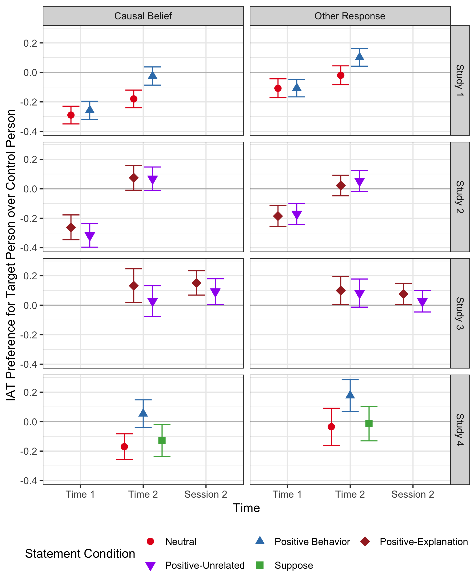
Figure S-1. IAT D-score means, by experiment, time, evaluative statement (ES) condition, and sound belief. Higher values indicate greater relative evaluative preference for the target person over the control person, with zero indicating no relative preference. In Experiment 3, in which sound beliefs were measured twice (one during Session 1 and once during Session 2), the data were partitioned according to sound beliefs measured during the first session. Means and confidence intervals were derived from linear mixed effects models fit within each experiment with a random intercept for participants in Experiments 1-3, and a fully between-subjects linear model in Experiment 4. Error bars are 95% confidence intervals of the mean.

Additional Analyses of Experiment 3
To supplement the linear mixed model analysis presented in the main text of Experiment 3, here we provide analyses of implicit evaluations within each session, and ANOVA models fit only on the subsets of the data for which complete cases exist for every cell in the analysis. The conclusions resulting from these analyses generally converge with those of the mixed model. Additionally, we report analyses of the correlations of implicit evaluations across sessions.
Initial evaluations (First Session). During the first session, overall, IAT scores were significantly above zero (M = .091, SD = .41), t(247) = 3.52, p = .0005, d = .22, BF₁₀ = 27.81, indicating that implicit evaluations were consistent with the valence of the positive behavioral statements rather than that of the scream pairings. Just as in Experiment 2 however, IAT scores did not differ between information conditions, t(246) = 0.96, p = .337, d = .12, BF₀₁ = 4.63, such that scores were significantly above zero both in the explanation condition (M = .12, SD = .45), t(118) = 2.87, p = .005, d = .26, BF₁₀ = 4.96, and in the unrelated condition (M = .07, SD = .37), t(128) = 2.06, p = .041, d = .18, BF₁₀ = 0.76, though evidence in the latter condition was only anecdotal according to the Bayes Factor, and the 95% CI derived from the mixed model included zero, [-0.013, 0.128].
Delayed evaluations (Second Session). After the 1-day delay, IAT scores during Session 2 remained highly similar to those from Session 1 overall: scores were significantly above zero, indicating that positive implicit impressions had persisted (M = .08, SD = .42), t(432) = 4.14, p < .0001, d = .20, BF₁₀ = 232. Furthermore, IAT scores at Session 2 did not differ between the two statement conditions, t(431) = 1.39, p = .17, d = 0.13, BF₁₀ = 0.27. D-scores were significantly greater than zero in the explanation condition, t(219) = 3.88, p = .0001, d = 0.26, BF₁₀ = 98, though they did not reach significance in the comparison to zero within the unrelated information condition alone, t(212) = 1.95, p = .052, d = 0.13, BF₁₀ = 0.49.
Effects of initial implicit and explicit evaluation measures on Session 2 IAT scores. IAT scores at Session 2 were analyzed within a 2 (statement: positive-unrelated, positive-explanation) x 2 (Session 1 IAT: faces, control) x 2 (Session 1 explicit: present, absent) between-subjects ANOVA to test for differences during Session 2 attributable to information condition as well as effects of practicing implicit and/or explicit evaluation immediately after learning the evaluative statement (ES). This model produced no significant effects, with the closest being a marginal interaction between the nature of the Session 1 IAT and the presence of the explicit scales during Session 1, F(1,425) = 3.77, p = .053, η²_{G} = .009. The interpretation of this trend seemed to be that implicit evaluations were neutral among participants who did not immediately have an opportunity to express an evaluation of the target person either explicitly or implicitly during Session 1 (control IAT + explicit-absent condition: M = -.01, 95% CI: [-.09, .07]), but were significantly positive in all other conditions (control IAT + explicit-present: M = .11, 95% CI: [.03, .18]; faces IAT + explicit-absent: M = .13, 95% CI: [.05, .21]; faces IAT + explicit-present: M = .10, 95% CI: [.02, .18]). The marginal nature of this effect warrants treating it with caution.
Effects of time on the IAT. We assessed the within-subjects effect of time on IAT scores within the subset of participants who received the faces IAT during Session 1. A 2 (time: Session 1, Session 2) x 2 (statement: positive-unrelated, positive-explanation) ANOVA found no main effect of statement condition, F(1,208) = 0.63, p = .429, η²_{G} = .002, no main effect of time, F(1,208) = 0.08, p = .78, η²_{G} < .001, and no interaction, F(1,208) = 0.06, p = .806, η²_{G} < .001 (Figure S-2). This is consistent with the similarities in the overall pattern of means on the IAT at both sessions, suggesting that IAT evaluations immediately following the ES were little changed by the passage of time.
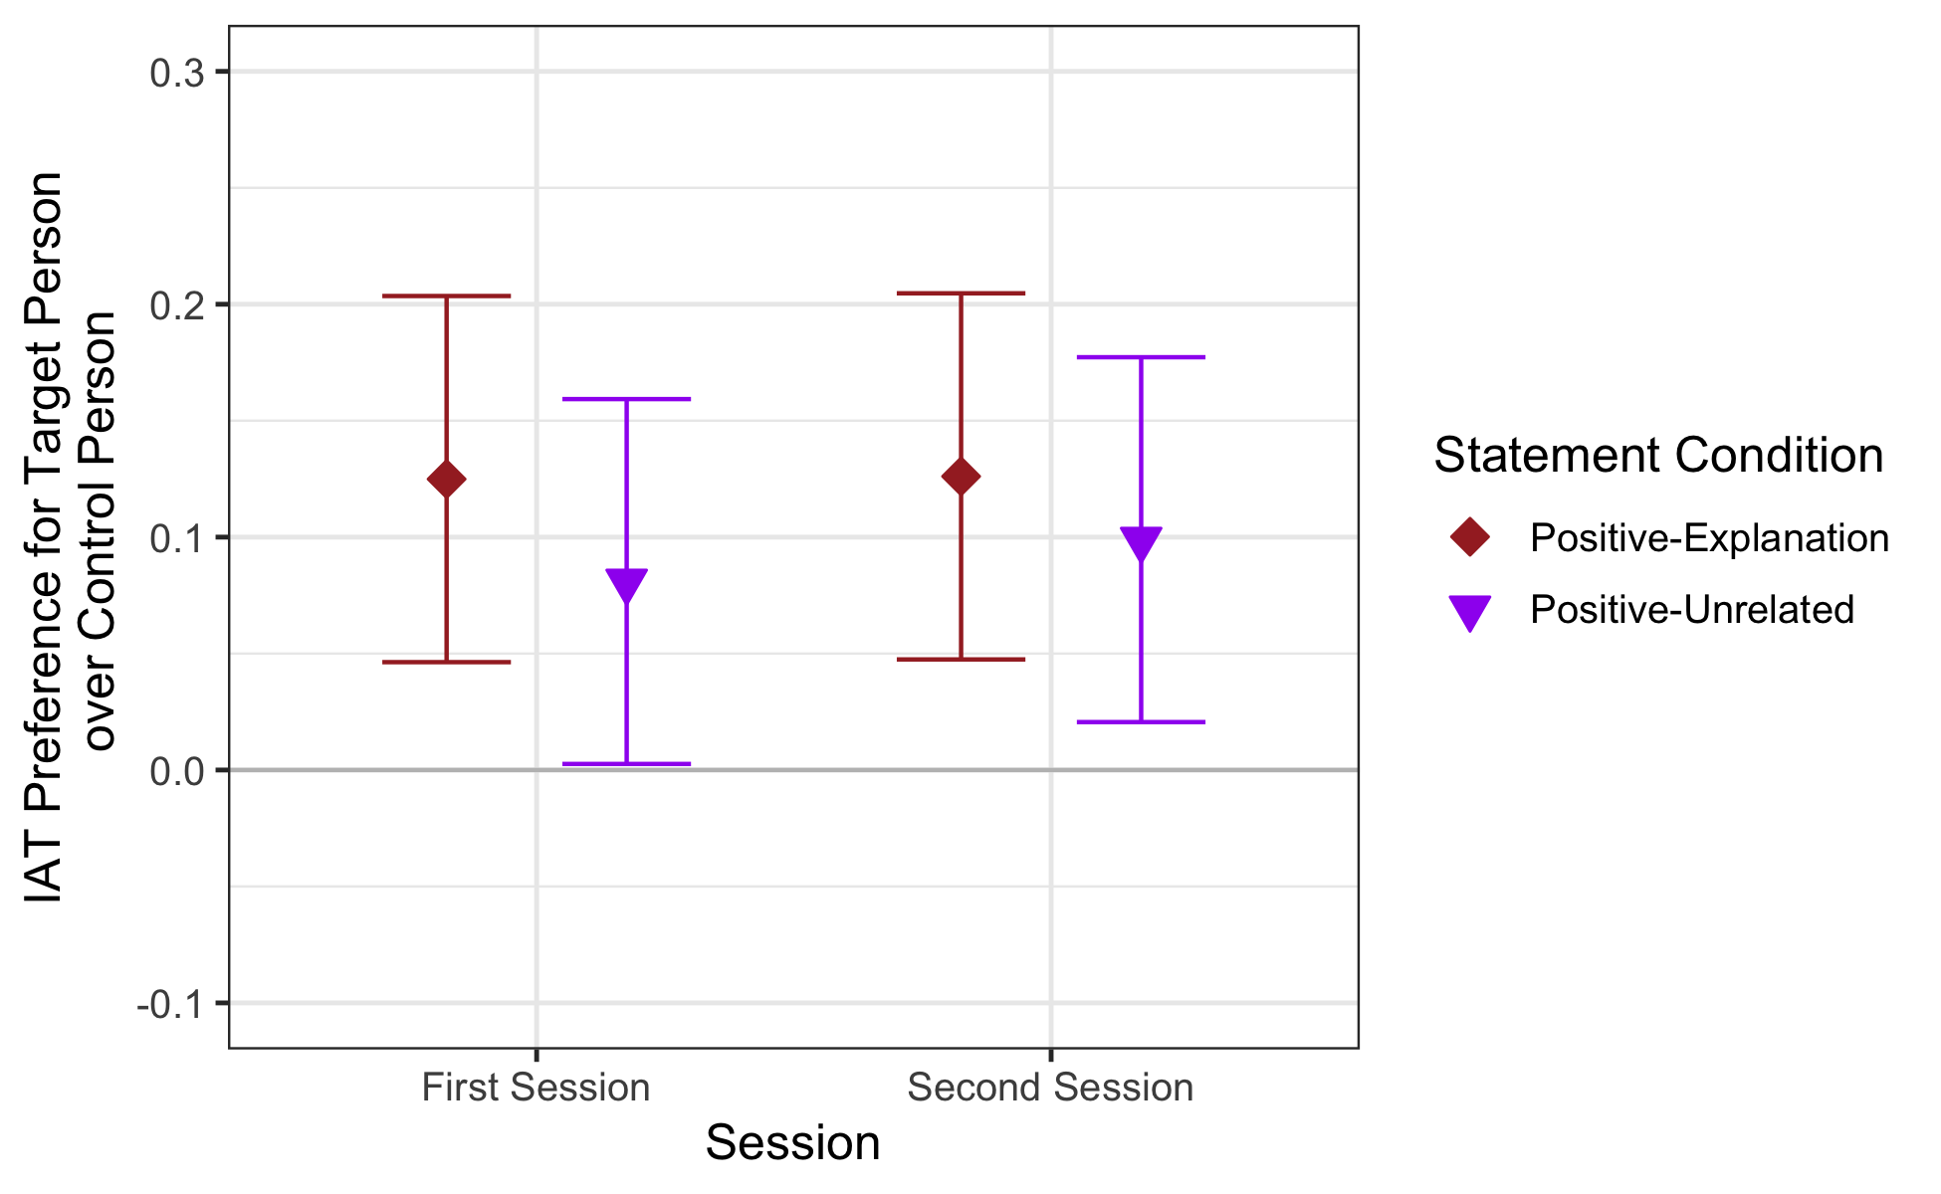
Figure S-2. IAT D-score means, by session and statement condition (Experiment 3) for participants assigned to complete the faces IAT during Session 1 whose data were included in both sessions. Higher values indicate greater relative evaluative preference for the target person over the control person, with zero indicating no relative preference. Error bars are 95% confidence intervals of the mean.

Effects of sound beliefs on the IAT. When initial sound beliefs were added as a factor to the ANOVA model predicting Session 1 IAT scores, there was no main effect of sound belief, F(1, 244) = 0.02, p = .885, η² = .0002, or interaction between sound belief and statement, F(1, 244) = 0.96, p = .328, η² = .004. Similarly, there were no effects or interactions involving causal sound beliefs on the IAT at Session 2, whether using the beliefs recorded during Session 1 or those recorded during Session 2 (all ps > .09). Finally, a temporal model of the IAT scores of participants who completed the measure during both sessions revealed no significant effects of sound causal belief, including no interaction between belief and time, F(1, 206) = 2.39, p = .12, η²_{G} = .004, and no interaction between belief, time, and statement, F(1, 206) < .01, p = .99, η²_{G} < .001.
Consistency over time. Though there were fixed effects of time on the IAT, there was a positive correlation of IAT scores between the first and second sessions, r(206) = .27, p < .0001. Interestingly, the size of this relationship between the Session 1 and Session 2 IAT was moderated by information condition, as an interaction between the Session 1 IAT and information condition in predicting Session 2 IAT scores was significant in a regression analysis, t(206) = 2.60, p = .01, R²_{p} = .032. The effect of IAT scores from Session 1 on scores from Session 2 was stronger (and only reached significance) in the unrelated information condition, B = .48, SE = .11, 95% CI: [.28, .69], compared to the explanation condition, B = .13, SE = .09, 95% CI: [-.05, .30]. At present, we can only speculate on the reason why IAT scores across time would be similar in their average levels regardless of information condition, yet more strongly correlated in the unrelated information condition. One possibility is that the explanation condition had more variable effects on participants over time, such that for some participants this ES increased in potency with delay, while for others its impact waned. This may have occurred if participants varied in the degree to which they retained the more complex information in this condition regarding the relationship between the positive information and the A-REP experience.

Analyses of Explicit Evaluations
Though our primary focus was on the formation and change of implicit evaluations, here we present results for how explicit evaluations varied by the manipulations within each of the four studies reported in the main text.
Overall summary. Across studies, explicit evaluations varied across time, moderated by statement condition and subjective beliefs about the nature of the REP task (see subsequent sections for more thorough analyses within each experiment). A few findings of particular note are described here. First, Experiments 1-2 demonstrated that explicit evaluations of the target person were negative (significantly below the midpoint of the 1-7 scale) after initial A-REP (all ps < .0001), but became positive (significantly above the midpoint of the scale) after positive behavioral information about the target person was presented, regardless of whether it did or did not offer an explanation of the earlier pairings (all ps < .0001). In the suppose condition, however (Experiment 4), explicit evaluations of the target person were neutral, showing no difference from the midpoint of the scale, t(113) = 0.25, p = .80, d = 0.02, BF₁₀ = 0.107. This contrasts with the IAT results, which showed no greater change in the suppose condition compared to neutral information, with D-scores remaining significantly below zero. Finally, sound-related beliefs had an overall more moderated effect on explicit evaluations than implicit evaluations: There was a significant three-way interaction between sound belief, time, and statement in Experiment 1, F(1, 739) = 14.76, p < .001, η²_{G} = .006, a significant interaction between sound belief and time in Experiment 2, F(1, 470) = 33.43, p < .0001, η²_{G} = .03, a significant interaction between sound belief measured during the first session and person in Experiment 3, F(1, 916.56) = 5.79, p = .016, and a significant interaction between sound belief, person, and statement in Experiment 4, F(2, 393) = 4.47, p = .012, η²_{G} = .02. Figure S-3 displays mean explicit evaluations of the target person across studies, evaluative statement conditions, and time.
The overall interpretation of these effects seems to be that sound beliefs predicted explicit evaluations in all conditions except after positive behavioral information was presented, or after the suppose instruction in Experiment 4. At Time 1 (post A-REP) and after a neutral statement at Time 2, explicit evaluations were more positive among participants who did not believe that the target person was causing the sounds (all ps < .001). Collectively, these results show that sound-related beliefs predict explicit evaluations more narrowly than implicit evaluations in Experiments 1 and 4, but show a highly similar pattern in Experiment 2, in which implicit and explicit evaluations were both more impacted by sound-related beliefs prior to the presentation of the ES. The one except to this pattern was in Experiment 3, in explicit evaluations were measured only after the ES. In that experiment, the target person was rated as more positive than the control person for participants who initially believed he caused the screams, F(1, 914.23) = 84.93, p < .0001, and for those who did not, F(1, 914.23) = 220.28, p < .0001, but with a larger difference of evaluations between the control and target person for participants who had not assumed a causal connection, F(1, 916.56) = 5.79, p = .016.

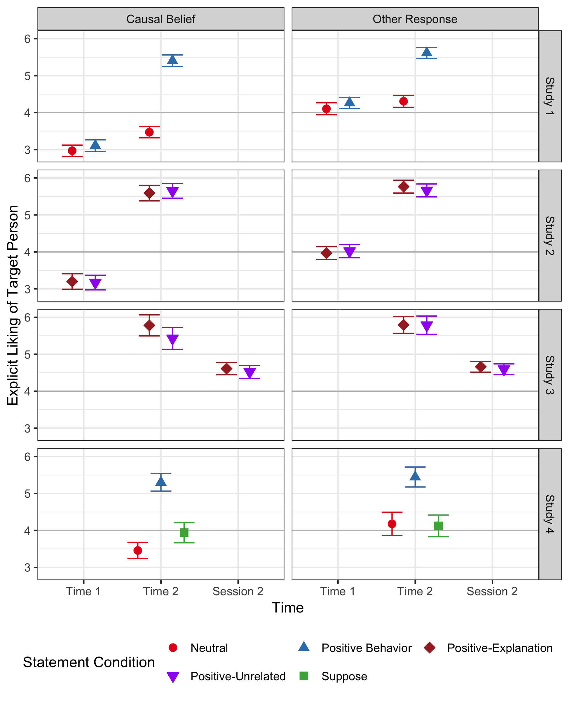
Figure S-3. Explicit evaluations of the target person, by experiment, time, statement condition, and sound belief. Higher values indicate greater liking for the target person, with a value of 4 indicating equidistance between a positive and a negative evaluation. In Experiment 3, in which sound beliefs were measured twice (one during Session 1 and once during Session 2), the data were partitioned according to the sound belief item from the first session. Means and confidence intervals were derived from linear mixed effects models fit within each experiment with a random intercept for participants in Experiments 1-3, and a fully between-subjects linear model in Experiment 4. Error bars are 95% confidence intervals of the mean.

Experiment 1. A preliminary linear mixed model testing for differences between the two neutral statement conditions in predicting explicit evaluations toward the target person revealed a significant interaction between time and statement, F(1,362) = 17.59, p < .0001, η²_{G} = .006. For this reason, the two neutral statement conditions were kept separate in the main analysis, which consisted of fitting a linear mixed model to explicit target evaluations within a 3 (statement: positive, neutral-behavior, or neutral-unrelated) x 2 (time: Time 1 and Time 2) design, with fixed factors for statement, time, and their interaction, and a random intercept for participants.
Figure S-4 displays mean explicit liking of the target person within each cell of the design. There was a significant main effect of statement, F(2,740) = 78.56, p < .0001, η²_{G} = .14, and a significant main effect of time, F(1,740) = 330.17, p < .0001, η²_{G} = .10, both of which were qualified by a significant interaction between statement and time, F(2,740) = 142.40, p < .0001, η²_{G} = .09. Though the statement factor had a slight effect at Time 1 (spurious, as the manipulation did not occur until after Time 1), F(2,740) = 3.22, p = .04, η²_{G} = .009, it had a pronounced effect at Time 2, F(2,740) = 197.66, p < .0001, η²_{G} = .35. Participants in all three statement conditions had initial explicit evaluations of the target person below the midpoint of the scale (4), all ps < .0001. At Time 2, however, participants in the positive behavior condition had positive evaluations significantly above the scale midpoint (M = 5.51, SD = 1.15), t(378) = 25.64, p < .0001, Cohen’s d = 1.32, while explicit evaluations of participants who read about a neutral behavior of the target did not differ from the midpoint (M = 3.97, SD = 1.17), t(187) = -0.33, p = 0.74, Cohen’s d = 0.02, and those of participants who read an unrelated neutral statement had persistent negative explicit evaluations below the scale midpoint (M = 3.75, SD = 1.07), t(175) = -3.12, p = .002, Cohen’s d = 0.24. Despite this qualitative difference between the two neutral statements, post hoc tests (Tukey adjusted) showed that explicit evaluations at Time 2 did not significantly differ between the two neutral conditions, M_{diff} = -.22, 95% CI: [-0.51, 0.06], but did differ between the positive behavior and neutral behavior conditions, M_{diff} = -1.77, 95% CI: [-2.02, -1.51], and between the positive behavior and neutral-unrelated conditions, M_{diff} = -1.52, 95% CI: [-1.79, -1.30].
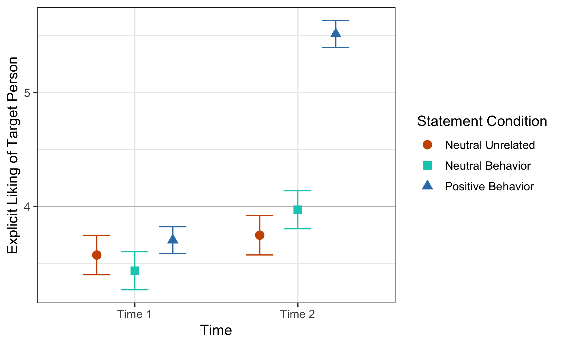
Figure S-4. Explicit liking of the target person, by time and statement condition (Experiment 1). Higher values indicate greater liking for the target person, with a value of 4 indicating equidistance between a positive and a negative evaluation. Error bars are 95% confidence intervals of the mean.

Sound-related beliefs. Similar to the analysis of the effects of sound-related beliefs on implicit evaluations, we added the same dichotomous sound belief factor to the linear mixed model predicting explicit evaluations. All fixed effects were significant, including the highest-order interaction between statement, time, and sound belief, F(2,737) = 9.63, p < .0001, η²_{G} = .007. As an inspection of Figure S-5 suggests, within each statement condition at both Time 1 and Time 2, participants reporting a belief that the target caused the screams had more negative explicit evaluations of the target than participants who endorsed another belief choice (all ps < .0001), with one exception: For participants receiving the positive behavior statement about the target person, explicit evaluations at Time 2 only marginally differed between those who held a causal belief (M = 5.40, SD = 1.25) and those who did not (M = 5.61, SD = 1.04), t(377) = 1.79, p = .07, Cohen’s d = .18.
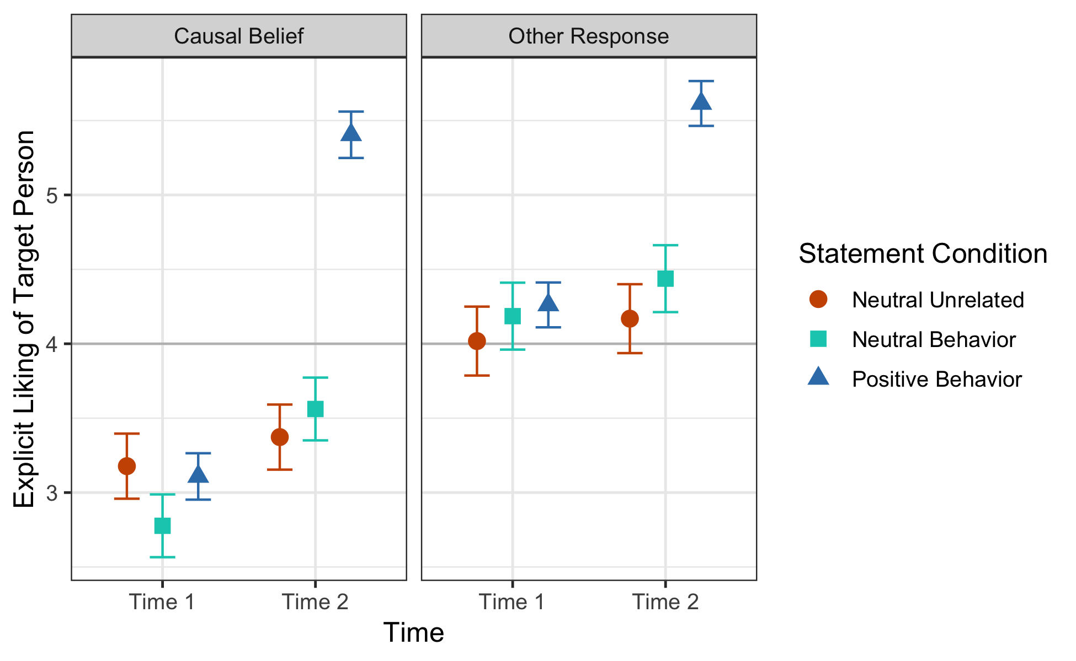
Figure S-5. Explicit liking of the target person, by time, statement condition, and sound belief (Experiment 1). Higher values indicate greater liking for the target person, with a value of 4 indicating equidistance between a positive and a negative evaluation. Error bars are 95% confidence intervals of the mean.

Experiment 2. Explicit evaluations of the target person were analyzed within a 2 (statement: positive-unrelated or positive-explanation) x 2 (time: Time 1 and Time 2) mixed ANOVA, with statement measured between-subjects and time measured within-subjects. There was a significant main effect of time, F(1,472) = 1036.14, p < .0001, η²_{G} = .47, but no main effect of statement, F(1,472) = 0.08, p = .77, η²_{G} = .0001, and no interaction between time and statement, F(1,472) = 0.06, p = .81, η²_{G} < .0001. The main effect of time was such that at Time 1, before the statement, the target person was explicitly disliked (i.e., mean ratings were below the midpoint of the scale; M = 3.65, SD = 1.10), t(473) = -6.88, p < .0001, Cohen’s d = 0.32, but at Time 2, after the statement, the target person was explicitly liked (mean ratings were above the midpoint; M = 5.68, SD = 1.04), t(473) = 35.00, p < .0001, Cohen’s d = 1.61.
Sound-related beliefs. When beliefs regarding the connection between the target person and the screams were added to the model predicting explicit evaluations, there was a significant interaction between sound beliefs and time, F(1,470) = 33.43, p < .0001, η²_{G} = .03, which was not moderated by a three-way interaction with statement condition, F(1,470) = 0.98, p = .32, η²_{G} = .0008. As illustrated in Figure S-6, the simple effect of sound belief was significant at Time 1, F(1,470) = 70.20, p < .0001, such that participants who believed that the target person caused the negative sounds had negative evaluations of him overall (M = 3.18, SD = 1.12), t(200) = -10.32, p < .0001, Cohen’s d = 0.73, while participants who indicated no such belief had evaluations that did not significantly differ from the scale midpoint (M = 3.99, SD = 0.97), t(272) = -0.13, p = .90, Cohen’s d = 0.008. The simple effect of sound belief at Time 2, on the other hand, was not significant, F(1,470) = 0.95, p = .33. Collectively, these results parallel the findings with the IAT in that beliefs about the relationship between the target person and the aversive sounds predicted initial explicit evaluations after A-REP, but ceased to predict evaluations after a positive behavioral ES about the target had been presented.

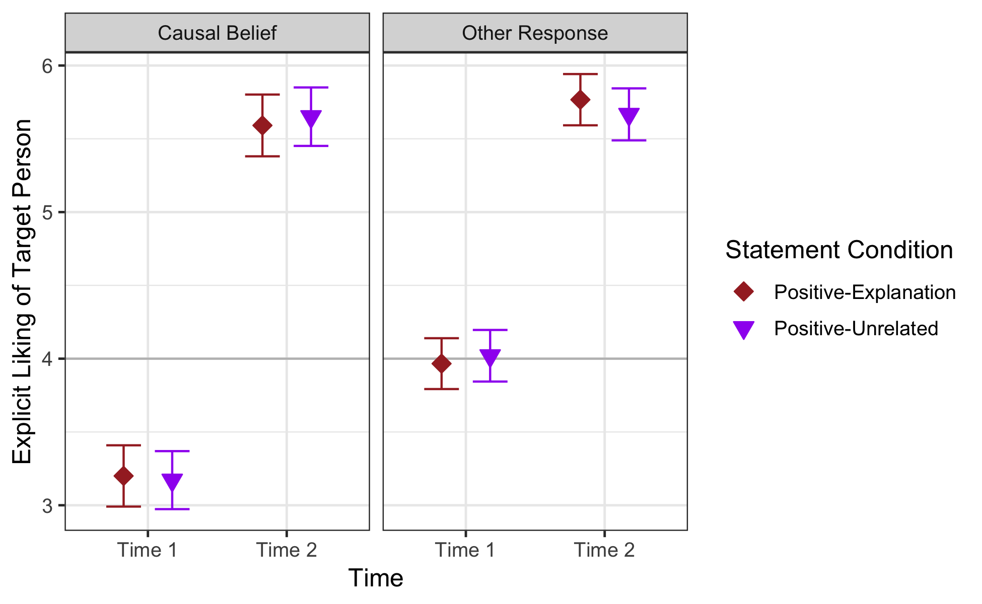
Figure S-6. Explicit liking of the target person, by statement condition, target of evaluation, and sound belief (Experiment 2). Higher values indicate greater liking, with a value of 4 indicating equidistance between a positive and a negative evaluation. Error bars are 95% confidence intervals of the mean.

Experiment 3. Half of participants were randomly assigned to complete the explicit evaluation scale during the first session of Experiment 3, and all participants completed the measure during the second session. Explicit evaluations during the second session were analyzed in a 2 (person: target person, control person) x 2 (statement: positive-unrelated, positive-explanation) x 2 (Session 1 IAT: faces, control) x 2 (Session 1 explicit: present, absent) mixed ANOVA to test for differences during Session 2 attributable to information condition as well as effects of previously practicing post-ES evaluations at the implicit and/or explicit level. This revealed a significant main effect of person, F(1, 425) = 34.94, p < .0001, η²_{G} = .04, qualified by a significant interaction between person and whether the explicit scale was presented during the first session, F(1, 425) = 4.86, p = .03, η²_{G} = .005. Overall, participants evaluated the target person (M = 4.81, SD = 1.16) as more positive than the control person (M = 4.41, SD = 0.89), t(432) = 5.99, p < .0001, d = 0.29, but this effect was larger among those who completed the explicit evaluation measure during the first session (target: M = 4.83, SD = 1.18; control: M = 4.29, SD = 0.89), t(221) = 5.83, p < .0001, d = .39, compared to those who did not (target: M = 4.78, SD = 1.14; control: M = 4.54, SD = 0.86), t(210) = 2.63, p = .009, d = .18, suggesting some benefit to durability from practicing the explicit evaluation immediately after learning the ES.
To model effects over time, explicit evaluations from the subset of participants who completed the measure during both sessions were analyzed within a 2 (time: Session 1, Session 2) x 2 (person: target person, control person) x 2 (statement: positive-unrelated, positive-explanation) mixed ANOVA, with the first two factors manipulated within-subjects. This produced significant main effects of time, F(1, 220) = 133.24, p < .0001, η²_{G} = .06, and person, F(1, 220) = 159.82, p < .0001, η²_{G} = .19, both qualified by an interaction between time and person, F(1, 220) = 71.73, p < .0001, η²_{G} = .04. No effects of statement were significant, including the three-way interaction between time, person, and statement, F(1, 220) = 2.41, p = .122, η²_{G} = .002. The person X time interaction was such that the effect of person was larger during the first session, F(1, 220) = 230.09, p < .0001, η²_{G} =.34, than during the second session, F(1, 220) = 33.98, p < .0001, η²_{G} = .06 (Figure S-7). A parallel approach using a linear mixed model, using all data included from both sessions and including fixed effects of time, person, statement, and their interactions as well as a random intercept for participant found convergent results, with the highest-level interaction being between person and time, F(1, 923.82) = 89.03, p < .0001 (Sattherthwaite).
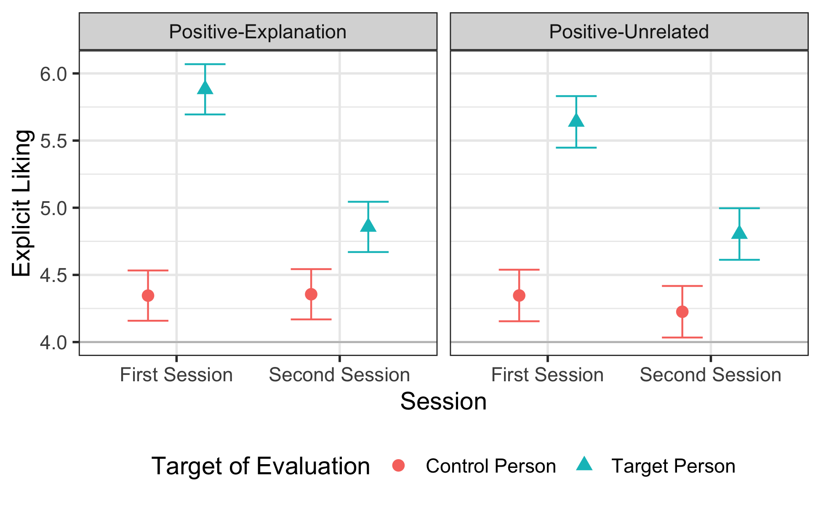
Figure S-7. Explicit liking by statement condition, target of evaluation, and session (Experiment 3). Higher values indicate greater liking, with a value of 4 indicating equidistance between a positive and a negative evaluation. Error bars are 95% confidence intervals of the mean.

Sound-related beliefs. As in previous studies, sound beliefs were dichotomously coded as causal vs. other, for the responses given to this question from each session. When such beliefs from the first session were added as a fixed factor (main effects and interactions) to the mixed effects model predicting explicit evaluations, the only effect involving sound belief was its interaction with person, F(1, 916.56) = 5.79, p = 0.016, such that the explicit preference for the target person (M = 5.15, 95% CI: [5.01, 5.28]) over the control person (M = 4.42, 95% CI: [4.28, 4.55]) was smaller (but still significant) among participants with a causal belief, F(1, 914.23) = 84.928, p < .0001, than was the explicit preference for the target person (M = 5.34, 95% CI: [5.23, 5.45]) over the control person (M = 4.36, 95% CI: [4.25, 4.47]) among participants with any other response to the belief question, F(1, 914.23) = 220.282, p < .0001.
ANOVA models within data subsets. Causal sound beliefs did not predict initial explicit evaluations during the first session, as no effects involving this factor were significant when adding to a model including effects of statement and person (all ps > .23), including the interaction between causal belief and person, F(1, 251) = 1.44, p = .23, η²_{G} = .003.
The relationship between sound beliefs and explicit evaluations during the second session can be analyzed using either the beliefs recorded in Session 1, or those recorded in Session 2. Using the beliefs registered during the first session, there is a significant interaction between sound causal beliefs and person, F(1, 429) = 4.41, p = .04, η²_{G} = .005. The interpretation appears to be that participants who initially reported a belief during the first session that the target person was causing the screams had a weaker difference in explicit evaluations between the target and control person in Session 2, F(1, 429) = 5.31, p = .022, compared to participants who endorsed a different belief from the start, F(1, 429) = 35.16, p < .0001. Interestingly, however, this effect was not significant if the retrospective beliefs reported during Session 2 are used in the model instead, F(1, 429) = 1.60, p = .21, suggesting that the beliefs measured closer in time to the A-REP experience (rather than those closer in time to the evaluation measure) are more indicative of the enduring strength of explicit preferences. Finally, in a temporal model on the participants who completed the explicit scales during Session 1, there were no significant interactions between time and causal sound belief, all ps > .16.
Experiment 4. We analyzed explicit evaluations within a 3 (statement: positive behavior, neutral behavior, or suppose) x 2 (person: target person and control person) mixed ANOVA, with statement manipulated between-subjects and person manipulated within-subjects. There was no main effect of person, F(1,396) = 1.11, p = .29, η²_{G} = .002, but there was a main effect of statement, F(2,396) = 65.72, p < .0001, η²_{G} = .10, qualified by an interaction between statement and person, F(2,396) = 43.28, p < .0001, η²_{G} = .13 (Figure S-8).
In the neutral statement condition, participants expressed greater liking for the control person (M = 4.53, SD = 0.87) than the target person (M = 3.69, SD = 1.00), t(282) = -7.57, p < .0001, Cohen’s d = 0.90, such that evaluations of the target person were significantly below the midpoint of the scale, t(141) = -3.68, p < .001, Cohen’s d = 0.31. In the positive behavior condition, on the other hand, evaluations were reversed, such that participants expressed greater liking for the target person (M = 5.36, SD = 1.23) than the control person (M = 4.24, SD = 1.10), t(284) = 8.15, p < .0001, Cohen’s d = 0.96. Lastly, in the suppose condition, participants expressed no difference in liking between the target person (M = 4.02, SD = 1.05) and control person (M = 4.03, SD = 1.23), t(227) = -0.04, p = .971, Cohen’s d = 0.005, such that explicit evaluations of the target did not significantly differ from neutrality, t(113) = 0.25, p = .80, Cohen’s d = 0.02. Post-hoc tests (Tukey adjusted) showed that explicit evaluations of the target person significantly differed between all pairwise combinations of the three ES conditions (neutral vs. positive: M_{diff} = -1.67, 95% CI: [-1.98, -1.37], t(396) = -12.81, p < .0001; neutral vs. suppose: M_{diff} = -0.33, 95% CI: [-0.66, -0.01], t(396) = -2.41, p = .04; positive vs. suppose: M_{diff} = 1.34, 95% CI: [1.01, 1.66], t(396) = 9.68, p < .0001).
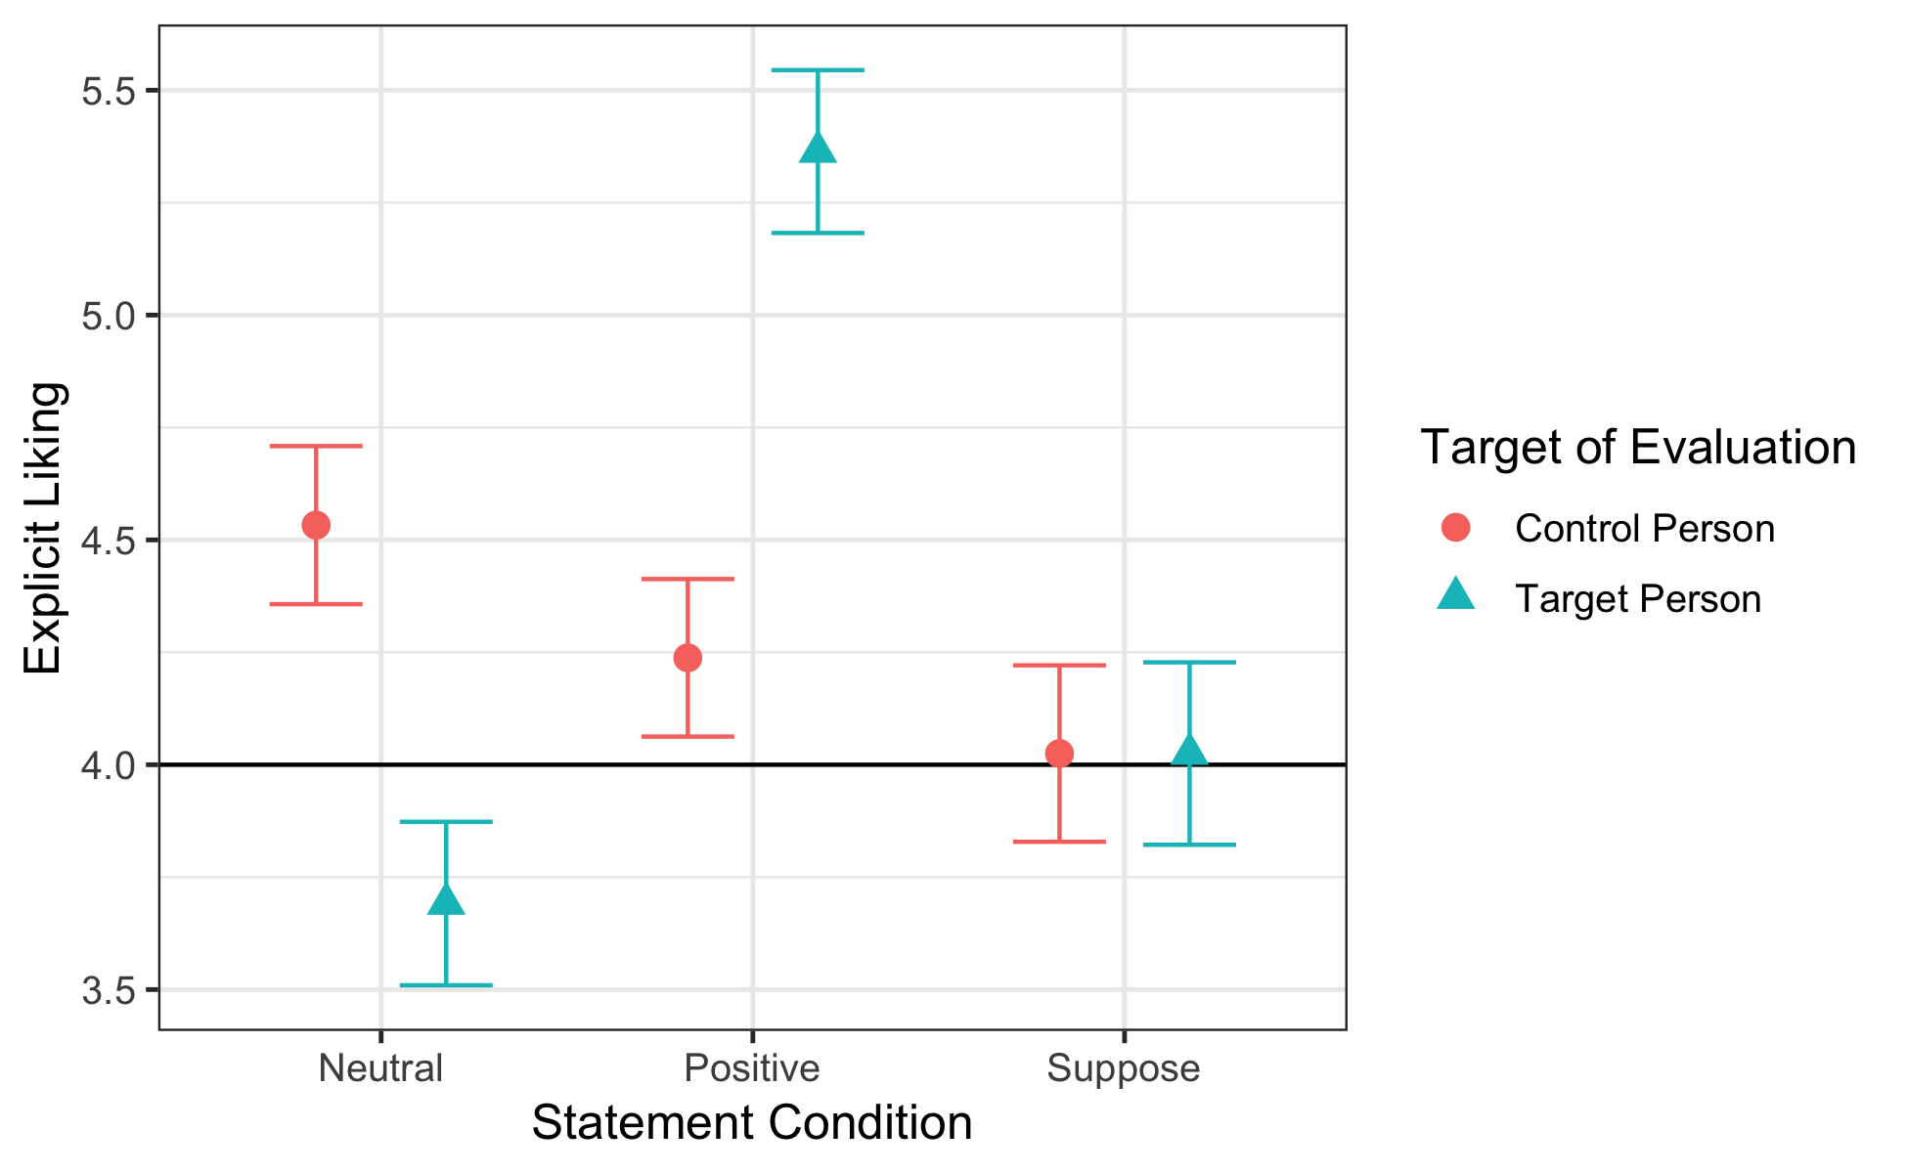
Figure S-8. Explicit liking by statement condition and target of evaluation (Experiment 4). Higher values indicate greater liking, with a value of 4 indicating equidistance between a positive and a negative evaluation. Error bars are 95% confidence intervals of the mean.

Sound-related beliefs. After adding sound belief to the ANOVA model as a dichotomous factor (including its main effect and all interactions with person and statement), the highest-level significant effect was the three-way interaction between sound belief, person, and statement, F(2,393) = 4.47, p = .01, η²_{G} = .02. As Figure S-9 illustrates, interaction contrasts revealed that sound belief moderated the effect of person in the neutral statement condition, F(1,393) = 11.08, p = .001, but not in the positive statement condition, F(1,393) = 0.53, p = .467, or suppose statement condition, F(1,393) = 0.15, p = .700. For participants who received a neutral statement about the target person, those who believed that the target had been causing the screams evaluated him significantly less positively (M = 3.46, SD = 0.99) than the control person (M = 4.64, SD = 0.91), t(190) = -8.62, p < .0001, Cohen’s d = 1.24. Those who lacked this belief, however, showed no differences overall in their explicit evaluations of the target person (M = 4.18, SD = 0.83) and the control person (M = 4.30, SD = 0.74), t(90) = -0.77, p = .44, Cohen’s d = 0.16.

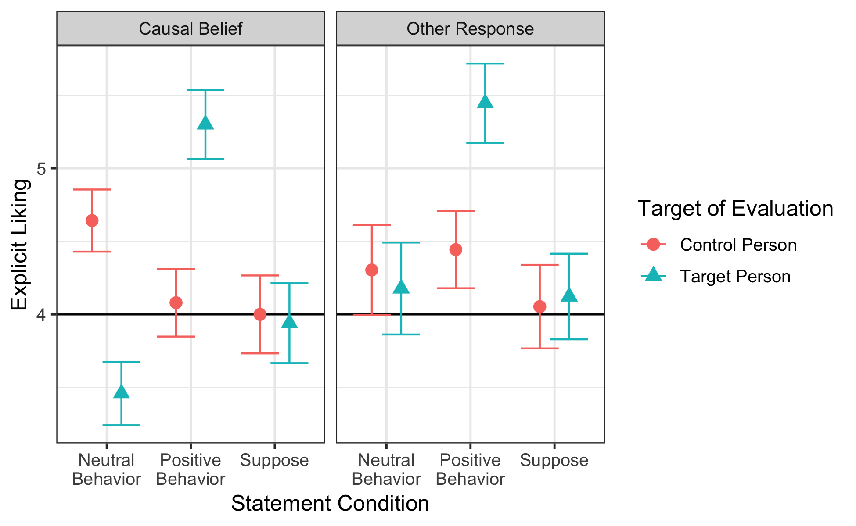
Figure S-9. Explicit liking by statement condition, target of evaluation, and sound belief (Experiment 4). Higher values indicate greater liking, with a value of 4 indicating equidistance between a positive and a negative evaluation. Error bars are 95% confidence intervals of the mean.

Analysis of Implicit Evaluations Controlling for Face Assignment and IAT Order Effects
For the sake of model simplicity and clarity, and consistent with our preregistered analysis plans (Experiments 1 & 4), analyses of IAT scores reported in the main text were conducted without controlling for effects of IAT block order (i.e., whether the target face was first paired with positive words or negative words) or face assignments (i.e., the specific faces out of the set of four that were randomly assigned as the target face and control face). Here, we present analyses of additional models that controlled for these factors. Across studies, the results revealed only main effects of face assignment (Experiments 1, 2, and 4) or no effect (Experiment 3), and simple effects of IAT block order within the level of the time factor that they reference, with no interactions involving statement condition.
Block order.
Experiment 1. Adding all fixed main effects and interactions for block order condition for the first and second IATs to the mixed effect model predicting implicit evaluations showed that the critical interaction between time and statement condition remained significant, F(1,735) = 9.25, p = .002, η²_{G} = .004. The highest order effects involving first and second IAT block order were interactions between each order manipulation and time. The effect of first IAT order condition was moderated by time, F(1,735) = 4.85, p = .03, η²_{G} = .002, such that the order effect was stronger at Time 1, F(1,735) = 24.14, p < .0001, η²_{G} = .03, than at Time 2, F(1,735) = 8.10, p = .005, η²_{G} = .01. The effect of second IAT order condition was also moderated by time, F(1,735) = 4.16, p = .04, η²_{G} = .002, such that this order effect was stronger at Time 2, F(1,735) = 9.86, p = .002, η²_{G} = .01, than at Time 1 (before it had even been assigned), F(1,735) = 0.31, p = .58, η²_{G} =.0004. Thus, each IAT order manipulation had an effect on its corresponding IAT (and the initial order manipulation had a perseverant effect on the second IAT), but these effects did not moderate the critical interaction between time and statement condition.
Experiment 2. Following a similar approach to that in Experiment 1 for examining order effects on the IATs, the addition of fixed main effects and interactions involving both IAT order manipulations revealed a significant interaction between first IAT order and time, F(1,466) = 12.52, p = .0004, η²_{G} = .009, such that the first IAT’s order effect was larger on the first IAT, F(1,466) = 13.24, p = .0003, than on the second, F(1,466) = 0.04, p = .836. Interestingly, unlike in the previous experiment, the second IAT order manipulation had no similar interaction, F(1,466) = 2.34, p = .13, η²_{G} = .002. The critical main effect of time remained significant in this model, F(1,466) = 160.43, p < .0001, η²_{G} = .10.
Experiment 3. On the Session 1 IAT, there was a significant main effect of IAT block order, F(1, 244) = 17.90, p < .001, η² = .07, but no interaction with statement condition, F(1, 244) = 2.91, p = .089, η² = .01. On the Session 2 IAT, all interactions involving statement condition, first session IAT order, and second session IAT order were examined; this produced only a main effect of Session 2 IAT order, F(1, 425) = 21.73, p < .001, η² = .05, but no other effects, all ps > .15.
Experiment 4. In Experiment 4, the IAT was administered only after the evaluative statement (ES). Adding block order as a factor to the analysis predicting IAT scores showed no main effect of block order, F(1, 394) = 0.76, p = .38, η²_{G} = .002, or interaction between block order and information condition, F(2, 394) = 0.22, p = .80, η²_{G} = .001.
Face condition assignment.
Experiment 1. When adding all fixed main effects and interactions involving the target face manipulation to the linear mixed model predicting implicit evaluations, the interaction between evaluative statement condition and time remained significant, F(1,735) = 10.97, p < .001, η²_{G} = .005, with only a main effect of face condition, F(3,735) = 26.17, p < .0001, η²_{G} = .06, suggesting baseline differences in implicit preferences among the four faces. The estimated marginal means showed that the Time 1 formation effect was independently significant (i.e., significantly below 0) for 3 of the 4 target face conditions: M_{Face1} = -0.40, 95% CI: [-0.46, -0.33], M_{Face2} = -.05, 95% CI: [-0.11, 0.01], M_{Face3} = -.18, 95% CI: [-0.24, -0.12], M_{Face4} = -.17, 95% CI: [-0.23, -0.12].
We also examined, across face assignment conditions, the implicit preference for each face stimulus when it was vs. was not the face paired with screams, for additional evidence that the initial scream-based A-REP was effective in influencing implicit evaluations. To do so, for each of the four target face conditions, we examined the subset of participants who saw that face as either the target (scream-paired) or control (unpaired) face during the A-REP task, and recoded their IAT scores such that higher scores were indicative of relative preference for that face, regardless of its role. Then, we could compare implicit preference for that face between participants who experienced it paired with screams vs. experienced the other face paired with screams. This analysis revealed that implicit preference for each of the 4 faces was significantly lower when it was the face paired with screams, compared to when it was the face not paired with screams; Face 1: t(336) = -8.15, p < .001, d = 0.89; Face 2: t(387) = -7.86, p < .001, d = 0.80; Face 3: t(357) = -7.55, p < .001, d = 0.80; Face 4: t(398) = -10.24, p < .001, d = 1.02. (It is important to note, however, that because across these 4 tests each participant’s IAT score was used once to represent preference for the scream-paired face and once to represent preference for the non-paired face, these tests are not independent.)
In addition, we assessed the similarity in the positive shifts in IAT evaluations of the target face over time in the positive statement condition across the four face subsets. The effect of time was independently significant for each of the four target faces; Face 1: t(70) = 3.53, p < .001, d = 0.42; Face 2: t(99) = 3.11, p = .002, d = .31; Face 3: t(98) = 4.96, p < .001, d = .50, Face 4: t(108) = 4.81, p < .001, d = .46. The size of these temporal shifts did not differ across the four target face conditions, F(3,375) = 0.47, p = .702.
Finally, we tested whether IAT scores were significantly negative immediately after A-REP when including only participants who received Faces 3 and 4 in some combination (with one serving as target face and one as control), as implicit evaluations of these two faces were most similar on average. In this subset of participants (N = 126, 17% of the sample), D-scores were significantly negative at Time 1, t(125) = 6.09, p < .0001, d = .54, and did not differ based on face assignment, t(124) = 1.37, p = .174, d = .24.
Collectively, these results suggest that the impact of both the evaluative pairings and evaluative statements were highly similar across the four faces from which target and control faces were randomly drawn for each participant. Though there was some baseline variation in implicit evaluative preference among the faces, these overall differences did not moderate the effect of the learning procedures presented during the experiment.
Experiment 2. When adding all fixed main effects and interactions involving the target face manipulation to the linear mixed model predicting implicit evaluations, the critical main effect of time remained significant, F(1,466) = 154.10, p < .0001, η²_{G} = .10, with only a main effect of face condition, F(3,466) = 12.46, p < .0001, η²_{G} = .05, suggesting baseline differences in implicit preferences among the four faces, consistent with Experiment 1. However, unlike in Experiment 1, the A-REP task resulted in implicit evaluations that were significantly below zero at Time 1 for each of the four target face conditions; M_{Face1} = -0.39, 95% CI: [-0.46, -0.31], M_{Face2} = -.10, 95% CI: [-0.17, -0.03], M_{Face3} = -.20, 95% CI: [-0.28, -0.13], M_{Face4} = -.22, 95% CI: [-0.29, -0.15], demonstrating successful formation of initial implicit evaluations in all face conditions despite baseline differences in preference.
Finally, when including only participants who received only the faces subsequently used in Experiment 3 (Faces 3 and 4) in some combination (with one serving as target face and one as control), IAT D-scores were significantly negative at Time 1, t(84) = 3.38, p = .001, d = .37, and did not significantly differ by face assignment, t(83) = .76, p = 451, d = .16.
Experiment 3. In Experiment 3, which restricted face stimuli to the two individuals for whom effects were most similar in the previous studies (Faces 3 and 4), there was no significant main effect of face assignment on the IAT in the first session among those participants who completed the first IAT, F(1, 244) = 2.20, p = .139, η² = .009, and no interaction with statement, F(1, 244) < .001, p = .998, η² < .001. Similarly, there was no main effect on the IAT at Session 2, F(1, 429) = 1.00, p = .318, η²_{G} = .002, and no interaction with statement condition, F(1, 429) = 1.50, p = .221, η² = .003. Finally, in a temporal model of participants who completed the IAT during both sessions, face assignment had no significant effects, including no interaction with time, F(1, 206) = 0.66, p = .416, η²_{G} = .001, and no three-way interaction with time and statement, F(1, 206) = 0.23, p = .632, η²_{G} = .0004.
Experiment 4. When adding all fixed main effects and interactions involving the target face manipulation to the ANOVA model predicting implicit evaluations, the critical main effect of statement remained significant, F(2, 388) = 10.22, p < .0001, η²_{G} = .05. There was a main effect of target face assignment, F(3, 388) = 9.18, p < .0001, η²_{G} = .07, but no interaction between statement and face assignment, F(6, 388) = 0.96, p = .45, η²_{G} = .01. When controlling for factorial effects of face assignment, the estimated marginal mean IAT score remains significantly negative in the neutral statement condition (M = -0.12, 95% CI: [-0.19, -0.05]) and significantly positive in the positive statement condition (M = 0.10, 95% CI: [0.03, 0.17]). The estimated mean in the suppose condition does not significantly differ from zero (M = -0.06, 95% CI: [-.14, .01]), but also does not significantly differ from the neutral statement condition, t(388) = 1.03, p = .304.
Correlations Across Experiments
Table S-2 displays the overall correlations between implicit and explicit evaluations within each experiment.
Table S-2
Means, Standard Deviations, and Correlations Between Implicit and Explicit Evaluations.
Dataset | M | SD | IAT 1 | IAT 2 | IAT 3 | Explicit 1 | Explicit 2 | Explicit 3
Experiment 1
IAT 1 | -.19 | .46
IAT 2 | -.03 | .41 | .35***  [.28, .41]
Explicit 1 | 3.61 | 1.20 | .29***  [.22, .36] | .17***  [.10, .24]
Explicit 2 | 4.71 | 1.40 | .13***  [.06, .20] | .23***  [.16, .30] |  | .44***  [.38, .49]
Experiment 2
IAT 1 | -.23 | .45
IAT 2 | .05 | .39 | .34***  [.26, .42]
Explicit 1 | 3.65 | 1.11 | .12**  [.03, .21] | .03  [-.06, 12]
Explicit 2 | 5.68 | 1.04 | .03  [-.06, .12] | .13**  [.04, .22] |  | .19***  [.10, .28]
Experiment 3
IAT 1
IAT 2 | .09 | .41
IAT 3 | .08 | .42 |  | .27***  [.14, .39]
Explicit 1
Explicit 2 | 5.70 | 1.14 |  | .17†  [-.02, .35] | .03  [-.16, .22]
Explicit 3 | 4.81 | 1.16 |  | .18***  [.05, .31] | .06  [-.04, .15] |  | .52***  [.37, .65]
Experiment 4
IAT 1
IAT 2 | -.03 | .45
Explicit 1
Explicit 2 | 4.39 | 1.33 |  | .26***  [.17, .35]

Note. Ranges in brackets are 95% confidence intervals of the estimate. “IAT 1”/ “Explicit 1” refers to evaluations immediately after the aversive repeated evaluative pairings (A-REP) task; “IAT 2”/ “Explicit 2” refers to evaluations immediately after the evaluative statement (ES); “IAT 3”/ “Explicit 3” refers to evaluations during the second session, after a 1-day delay. Explicit evaluations consist of the mean of the six explicit liking items regarding the target person.
***p < .001 **p < .01 *p < .05 † p < .1

References
Bates, D., Maechler, M., Bolker, B., & Walker, S. (2015). Fitting linear mixed-effects models using lme4. Journal of Statistical Software, 67(1), 1-48. doi:10.18637/jss.v067.i01
Kuznetsova A., Brockhoff, P. B., & Christensen, R. H. B. (2017). lmerTest package: Tests in linear mixed effects models. Journal of Statistical Software, 82(13), 1–26. doi: 10.18637/jss.v082.i13

There was likewise no effect of sound belief measured in the second session on delayed IAT scores.
Factorial fixed effects involving both target and control face assignments could not be fit due to missing cells (i.e. a single face could not be assigned as both target and control). Models that instead specify only fixed main effects for both face manipulations, or random intercepts for each target face + control face combination, lead to identical conclusions to the fixed-effects approach described here.

