Online Supplemental Material:
On the Road to Power:
Showing Benevolence and Integrity Fuels Power Granting

TABLE OF CONTENTS
changes from preregistration 2
PRELIMINARY Study 3
Stimuli 3
Instructions 3
Manipulations 3
Measures and Instructions 3
Supplementary Results 4
Mediator Social Responsibility 4
Study 1 5
Pretests I and II of Materials 5
Stimuli 6
Instructions 6
Manipulations 7
Measures 7
Overview of trials 8
Results from benevolence pretest 9
Supplementary Results 9
Mediator Social Engagement 9
Effects on power perception 10
Study 2 11
Stimuli 11
Instructions 11
Manipulations 11
Measures and Instructions 11
Supplementary Results 12
Mediators Social Responsibility / Social Engagement / Morality 12
Effects on power perception 13
Study 3 13
Stimuli 13
Instructions 13
Manipulations 13
Measures and Instructions 14
Supplementary Results 14
Mediators Social Responsibility / Morality 14
Effects on power perception 14
Extra Study A1: 15
Integrity as Following an Accepted Principle 15
Description, Analyses, and Results 15
Stimuli 19
Instructions 19
Manipulations 19
Checks 20
Measures and Instructions 20
Correlations Studies A1, 2, and 3 12
Overview on Results on Power Granting 13
Extra Study A2: Testing the role of benevolence and action orientation 15

changes from preregistration

Study | Label / analysis in paper vs. in preregistration
Preliminary Study | Paper: additional analysis performed for DV continuously measured variable  Preregistration: only the other two analyses reported before the above-mentioned were preregistered; additionally, a mediation analysis was preregistered testing responsibility as mediator which we report in the Supplement  See https://aspredicted.org/QVD_RCH
Study 2 | Paper: Integrity low vs. high  Preregistration: Aligned behavior no vs. yes  Paper: dependent variable is labelled power granting  Preregistration: dependent variable is labelled power affordance  See https://aspredicted.org/blind.php?x=qx39wn
Study 3 | Paper: Integrity low vs. high  Preregistration: Aligned behavior no vs. yes  Paper: dependent variable is labelled power granting  Preregistration: dependent variable is labelled power affordance  see https://aspredicted.org/blind.php?x=z478ww

Studies A1, 2, and 3 were conducted as first studies in this order; the Preliminary Study and Study 1 were conducted later as validations of our main findings across other settings and paradigms.

Study A1 was originally conducted with a different intention; accordingly, results here can be understood as exploratory. Studies 1, 2, and 3 and the Preliminary Study preregistered the hypotheses as presented here as a confirmatory test of hypotheses.

PRELIMINARY Study

Stimuli

Instructions
Instruction
In the following, we ask you to think about a person (i.e., a specific leader) in your organization.
This should be a leader who is not currently your own leader.
We then ask you to answer a few questions on how you perceive this person. There are no right or wrong answers, we are simply interested in your personal impressions.

Manipulations

For conditions:
low leader choice
Now, please think of a leader in your organization with whom you would be very reluctant to work as your own leader.
Please write down a few notes:
What makes you think you would be reluctant to work with this leader?
(Please leave out any names or identifying information)

high leader choice
Now, please think of a leader in your organization with whom you would very much like to work as your own leader.
Please write down a few notes:
What makes you think you would like to work with this leader?
(Please leave out any names or identifying information)

Measures and Instructions

Benevolence and integrity
Please answer the following questions with regard to the characteristics of this leader:

Disagree strongly |  |  |  |  |  | Agree strongly
1 | 2 | 3 | 4 | 5 | 6 | 7

- This leader is very concerned about other people’s welfare.
- Other people’s needs and desires are very important to this leader.
- This leader would not knowingly do anything to hurt others.
- This leader looks out for what is important to others.
- This leader will go out of his/her way to help others.

Filler items

Social responsibility

How do the following characteristics apply to this leader:

Not at all |  |  |  |  |  | Very much
1 | 2 | 3 | 4 | 5 | 6 | 7

- S/he takes care of others' needs.
- S/he shows concern about others‘ well-being.
- S/he takes responsibility for others' situation.
- S/he makes sure that everything goes well.

Power granting measured

How do you agree to the following:

Fully disagree |  |  |  |  |  | Fully agree
1 | 2 | 3 | 4 | 5 | 6 | 7

- I would like this person as my leader.

Controls
- I find this leader personally likable.
- attention check
- leader gender

Supplementary Results

Mediator Social Responsibility

Following our preregistration and the prediction that the ‘effect’ of benevolence x integrity on power granting (leader choice condition) is mediated via social responsibility, we also performed a mediation analysis: Specifically, we conducted as preregistered a logistic regression (via Bootstrapping with PROCESS) for moderated mediation (Model 7) to test how benevolence, integrity, and the benevolence x integrity interaction predict the mediator social responsibility, which in turn should predict power granting (leader choice condition).
Results showed that benevolent intentions (b = 0.70, SE = 0.03, p < .001, 95% CI = [0.641, 0.751]) and integrity (b = 0.32, SE = 0.04, p < .001, 95% CI = [0.250, 0.394]) both strongly predicted more perceived social responsibility; yet, the benevolent intentions x integrity interaction on perceived social responsibility was not significant (b = 0.015, SE = 0.01, p = .290, 95% CI = [–0.013, 0.044]). More perceived social responsibility was linked to more power granting (i.e., leader choice condition), b = 0.68, SE = 0.22, p = .002, 95% CI = [0.250, 1.109]. The index of moderated mediation = 0.01, SE = .01, 95% CI = [–0.013, 0.041] did not yield support for the overall model. Once again, a potential reason for this may be the strong ‘main effects’ (correlations) of both integrity and benevolence with the mediator and also on condition (see discussion in the manuscript). The remaining studies sought to overcome these by orthogonally manipulating integrity and benevolence to test their conjoint effects on (responsibility and) power granting.

Study 1

Pretests I and II of Materials

To make sure that the statements to manipulate benevolence vs. integrity in Study 1 did manipulate the respective target concept (benevolence vs. integrity), we carefully tested the statements in two pretests (Pretest 1 and Pretest 2).
In Pretest 1 (N = 100 via prolific), we presented participants with 40 statements (randomly chosen from an original set of 80 statements in total). Each statement described a target’s (leader’s) behavior and indicated either the target’s (high vs. low) benevolence with 20 items, respectively, or (high vs. low) integrity with 20 items, respectively. Statements were presented separately in random order. Participants rated the extent to which each statement suggested that this target (leader) shows benevolence and shows integrity (each on one item on a 9-point scale; 1=not at all, 9=very much). Before they did so, they received a brief definition of both concepts they rated (benevolence = is interested in and wants to contribute to others’ well-being; integrity = follows clear principles and stays true to his/her word). We then computed means for rated benevolence and rated integrity and identified those items that most clearly represented the target concept (but not the respective other concept). In statistical terms, we selected the items with the highest difference in mean rated integrity and mean rated benevolence, respectively, between integrity statements (high vs. low) and benevolence statements (high vs. low). This resulted in 12 item pairs that manipulate (high vs. low) benevolence, and 12 item pairs that manipulate (high vs. low) integrity (i.e., a total set of 48 items, as used in our main paradigm later, see Table 2).
Pretest 2 including a non-overlapping sample of N = 60 via Prolific then served to validate the statements once again when presenting two statements together (one about a target’s benevolence, one about a target’s integrity), as in the main study. That is, we here aimed at ruling out unwanted cross-over effects on the respective other concept. Participants were presented with 12 trials (one set of items randomly chosen from four potential sets of item combinations), each trial included two statements about a target (statement 1 manipulating high vs. low integrity, statement 2 manipulating high vs. low benevolence). As in Pretest 1, participants rated each target’s shown benevolence and integrity.
We tested for a main effect of (high vs. low) benevolence, (high vs. low) integrity, and a benevolence x integrity interaction on the rated benevolence and the rated integrity of the target, respectively, using ANOVAs. Supporting the validity of the (paired) statements once again, the effect sizes for the main effects for the targeted concepts were much stronger (i.e., benevolence main effect on dependent variable (DV) rated benevolence, .454 < η_{part}² < .831; integrity main effect on DV rated integrity, .432 < η_{part}² < .774), than the main effects for the non-targeted concepts (benevolence main effect on DV rated integrity, .001 <= η_{part}² < .106; integrity main effect on DV rated benevolence, .001 < η_{part}² < .096) or the very few interactions (.001 < η_{part}² < .079).

Stimuli

Instructions
Instruction
In the following, we are interested in people's spontaneous impressions of others - that is, of leaders.
Imagine you are about to work on a new project with a new leader. S/he will control important resources and evaluate you, which will impact on your bonus and promotions.
You have not met him/her yet, but colleagues have provided you with some information. In the following, you will see these pieces of information for several pairs of potential leaders.
Please read the information about each pair and then spontaneously indicate which leader you prefer, respectively.
There is no right or wrong answer, we are simply interested in spontaneous impressions.

Manipulations

Example trial
see paper
- leader choice constitutes our dependent variable here
- trials varied (within-participants) the level of high vs. low integrity and high vs. low benevolence of each target (leader) presented; each trial presented two leaders
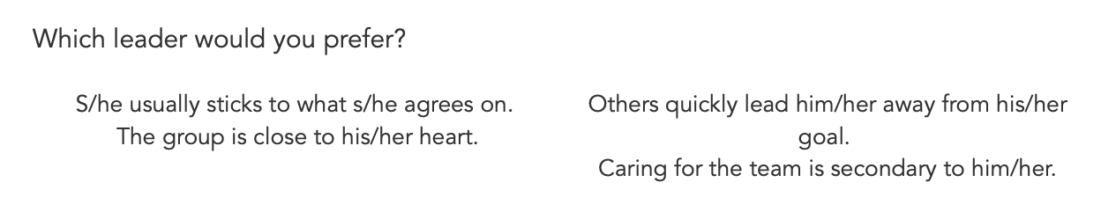

Measures
Checks
Attention check

Overview of trials

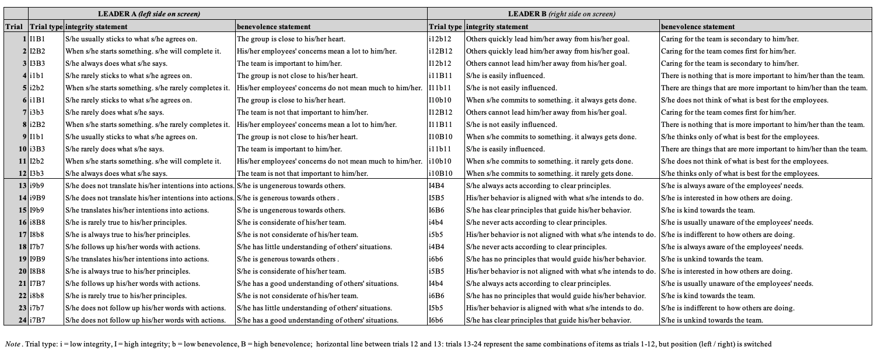

Results from benevolence pretest

In a pretest, we sought to validate the effectiveness of the benevolence manipulation from Study A1, later slightly adapted in Studies 2-3 to the specific context. To do so, participants (N=96) filled in a pretest questionnaire after completing an unrelated study on prolific. In this pretest questionnaire, they were presented with the two self-description versions from Study A1 (omitting references to integrity) in randomized order (within-factor benevolence: high-benevolence vs. low-benevolence; between-factor: order of presentation high-benevolence first vs. low-benevolence first).
For each benevolence-version (i.e., each read self-description of a speaker), participants rated (on a semantic differential from 1-7) to which extent they believed the speaker to be 1–prosocial as compared to 7–selfish, and 1–interested in others as compared to 7–interested in him-/herself (as well as 1–friendly to 7–unfriendly as filler item). The two items were highly correlated for both the low-benevolence and high-benevolence self-description, both rs(96)=.84, ps < .001. Accordingly, we combined the two respective items into a perceived selfishness score.
A mixed ANOVA with benevolence as within factor and order of presentation as between factor revealed only a main effect of benevolence, F(1, 94)=490.71, p<.001, η_{p}² = .839. There was no interaction with order of presentation, F<1. As intended, participants rated the speaker in the high-benevolence self-description as being less selfish / interested in himself (M=1.98, SD=1.16) than in the low-benevolence self-description (M=6.04, SD=1.20). This suggests that the benevolence manipulation worked as intended.

Supplementary Results

Mediator Social Engagement

We also assessed participants’ perception of the protagonist’s social engagement with 5 items (“helpful”, “sympathetic”, “social”, “friendly”, “assertive”; Van Kleef et al., 2012; 1– “not at all” to 9 – “very much”, α = .91; “assertive” was excluded across studies due to negative intercorrelations with the other items in one study and due to its potentially confounding ‘action’ component) to explore potential effects.
In additional analyses, we tested whether the main effect of benevolent intentions on power granting was mediated through social engagement, as stated by previous research (Van Kleef et al., 2012). A mediation analysis (Hayes, 2017, Model 4) revealed that, indeed, (high) benevolent intentions of the protagonist led to a higher perception of his social engagement, which in turn predicted a greater willingness to grant him power (b = 1.31, SE = 0.13, 95% CI = [1.05, 1.57]). The direct effect was different from 0 (b = .32, SE = 0.14, 95% CI = [0.06, .0.59]).

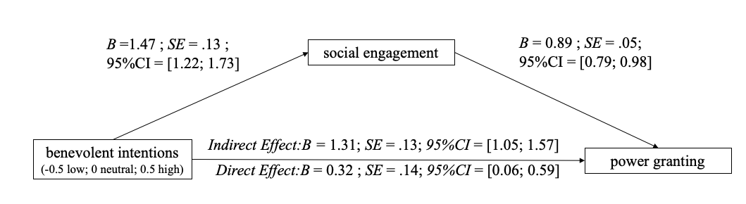

Figure S1.
Mediation model of the indirect effect of benevolence intention on power granting through perceived social engagement in Study 2. 95% confidence intervals are obtained from 5000 bootstrap resamples.

Effects on power perception

We also explored whether our experimental conditions affect the level of the protagonist’s perceived power. There was a main effect of benevolent intentions, F(1, 346) = 7.62, p = .006, η_{p}² = .022, but neither of integrity, F(1, 346) = 2.43, p = .120, η_{p}² = .007, nor an interaction, F(1, 346) = 0.16, p = .690, η_{p}² < .01. Accordingly, participants perceived the protagonist to have more power when benevolent intentions were high (M = 5.25, SD = .94) than low (M = 4.95, SD = 1.09). Again, this means that differences in power perception do not account for the interaction on power granting.

Study 2

Stimuli

Instructions

In the following, a short text is presented to you. It describes a brief situation of Mr. Smith's everyday working life. Please read the text carefully. Try to imagine the situation as vividly as possible and answer some questions afterwards.

Manipulations
For conditions:
benevolent intentions: high; integrity: high
Mr. Smith is part of a project team. The team plans to participate in a conference and to present recent results of their work. For this purpose, the administration has booked them a simple hotel in some distance from the venue. During the conversation with a colleague, it becomes clear that
usually much better accommodations are selected. Mr. Smith is very dissatisfied with the way his team is being treated in this case. It is important to him, that the whole team is given better accommodation. Upset after this conversation, Mr. Smith makes his way back to his office. Shortly thereafter, Mr. Smith happens to see the responsible contact person of the administration standing in the corridor. Spontaneously, Mr. Smith approaches him directly and speaks to him.

benevolent intentions: low; integrity: low
Smith is part of a project team. The team plans to participate in a conference and to present recent results of their work. For this purpose, the administration has booked them a simple hotel in some distance from the venue. During the conversation with a colleague, it becomes clear that usually much better accommodations are selected. Mr. Smith is very dissatisfied with the way he is being treated in this case. It is important to him, that he himself is given better accommodation even at the expense of the team budget. Upset after this conversation, Mr. Smith makes his way back to his office. Shortly thereafter, Mr. Smith happens to see the responsible contact person of the administration standing in the corridor. Mr. Smith passes the administrative employee, goes directly back to his office, without using this good opportunity to address him about a better accommodation for himself.

Measures and Instructions

Power Perception: (Studies 2,3; also Study A1, replacing “Mr Smith” with “this person”)
Now, please indicate spontaneously which impression Mr. Smith had made on you: To which extent do you think that the following may apply to Mr. Smith?
fully disagree |  |  |  |  |  | fully agree
1 | 2 | 3 | 4 | 5 | 6 | 7

- Mr. Smith can get people to listen to what he says.
- Mr. Smith's wishes don't carry much weight.
- Even if he voices them, Mr. Smith's views have little sway.
- I think Mr. Smith has a great deal of power.
- Mr. Smith's ideas and opinions are often ignored.
- Even when he tries, Mr. Smith is not able to get his way.
- Mr. Smith can get others to do what he wants.
- If he wants to, Mr. Smith gets to make decisions.

Power Granting (Studies 2,3; also Study A1, replacing “Mr Smith” with “this person”)
Again, please indicate your spontaneous impression of Mr. Smith:
fully disagree |  |  |  |  |  | fully agree
1 | 2 | 3 | 4 | 5 | 6 | 7

- I would like Mr. Smith as my boss.
- I would like Mr. Smith as my political leader.
- I would give Mr. Smith a promotion.

Perceived Social Engagement (Study 2; also Study A1, replacing “Mr Smith” with “this person”); Relevant items are displayed in bold, other items are distractors
How would you describe Mr. Smith with regard to the following job-related characteristics?
definitely not |  |  |  |  |  | definitely
1 | 2 | 3 | 4 | 5 | 6 | 7

- sophisticated
- assertive
- competent
- friendly
- experienced
- helpful
- social
- sympathetic
‘Assertive’ was excluded in all analyses due to negative correlations with the other items in the extra study A2 reported below and because it may be confounded with action.

Perceived Social Responsibility (Study 2-3)
Again, please indicate which impression Mr. Smith has spontaneously made on you.
Not at all |  |  |  |  |  | Very much
1 | 2 | 3 | 4 | 5 | 6 | 7

- Mr. Smith takes care of others' needs.
- Mr. Smith shows concern about others' well being.
- Mr. Smith takes responsibility for others' situation.
- Mr. Smith makes sure that everything goes well.

Perceived Morality (Study 2-3)
How would you describe Mr. Smith with regard to the following job-related characteristics?
Not at all |  |  |  |  |  | extremly
1 | 2 | 3 | 4 | 5 | 6 | 7

- courageous
- fair
- principled
- responsible
- just
- honest
- trustworthy
- loyal

Supplementary Results

Mediators Social Responsibility / Social Engagement / Morality
In addition to the reported analyses, we tested for moderated mediation via social responsibility, social engagement, and morality (Hayes, 2017, Model 7). Benevolent intentions served as predictor, integrity as moderator, power granting as outcome, and (1) perceived social responsibility, (2) social engagement, and (3) morality as parallel mediators. The index of moderated mediation was significant for all three mediators, but strongest for social responsibility (B = 0.77, SE = .14, 95% CI = [0.521, 1.059]) as compared to social engagement (B = 0.15, SE = .73, 95% CI = [0.027, 0.310]) and morality (B = 0.27, SE = .09, 95% CI = [0.116, 0.452]).

Effects on power perception
Again, we also checked if benevolent intentions and/or integrity affected the perceived power of the target. Results showed main effects of benevolent intentions, F(1, 434) = 6.03, p = .014, η_{p}² = .014 (M _{high-benevolence} = 4.05, SD = 1.12; M _{low-benevolence} = 3.86, SD = 1.05) and integrity, F(1, 434) = 242.21, p <.001, η_{p}² = .358 (M _{high-integrity} = 4.62, SD = 0.92; M _{low-integrity} = 3.31, SD = 0.83). As before, there was no interaction between the two, F(1, 434) = 0.02, p = .891, η_{p}² < .01. In line with the prior studies, this shows that our (interaction) results are not due to differences in power perception.

Study 3

Stimuli

Instructions

In the following, a short text is presented to you. It describes a brief situation of Mr. Smith's everyday working life. Please read the text carefully. Try to imagine the situation as vividly as possible and answer some questions afterwards.

Manipulations

For conditions:
benevolent intentions: high; integrity: high
Mr. Smith is part of a project team. The team plans to participate in a conference and to present recent results of their work. For this purpose, the administration has booked them a simple hotel in some distance from the venue. During the conversation with a colleague, it becomes clear that
usually much better accommodations are selected. Mr. Smith is very dissatisfied with the way his team is being treated in this case. It is important to him, that the whole team is given better accommodation. Upset after this conversation, Mr. Smith makes his way back to his office. Shortly thereafter, Mr. Smith happens to see the responsible contact person of the administration standing in the corridor. Spontaneously, Mr. Smith approaches him directly and speaks to him. He uses this good opportunity to negotiate better accommodation for the whole team with the administrative employee.

benevolent intentions: low; integrity: high
Mr. Smith is part of a project team. The team plans to participate in a conference and to present recent results of their work. For this purpose, the administration has booked them a simple hotel in some distance from the venue. During the conversation with a colleague, it becomes clear that usually much better accommodations are selected. Mr. Smith is very dissatisfied with the way he is being treated in this case. It is important to him, that he himself is given better accommodation even at the expense of the team budget. Upset after this conversation, Mr. Smith makes his way back to his office. Shortly thereafter, Mr. Smith happens to see the responsible contact person of the administration standing in the corridor. Spontaneously, Mr. Smith approaches him directly and speaks to him. He uses this good opportunity to negotiate better accommodation for the whole team with the administrative employee.

Measures and Instructions

Power Perception:
see Study 2

Power Granting
see Study 2

Perceived Social Responsibility
see Study 2

Perceived Morality (Study 2-3)
see Study 2

Supplementary Results

Mediators Social Responsibility / Morality
We again also tested for moderated mediation via social responsibility and morality (Hayes, 2017, Model 7). Benevolent intentions were our predictor, integrity the moderator, power granting the outcome, and (1) perceived social responsibility and (2) morality the parallel mediators. The index of moderated mediation was significant for both mediators, but strongest for social responsibility (B = 0.68, SE = .23, 95% CI = [0.276, 1.169]) as compared to morality (B = 0.47, SE = .18, 95% CI = [0.170, 0.863]).

Effects on power perception
Again, we checked for effects on perceived power of Mr. Smith. There was neither a main effect of benevolent intentions, F<1, nor of integrity, F(1, 202) = 3.12, p = .079, η_{p}² = .015. Unexpectedly, the interaction of both factors was significant, F(1, 202) = 12.57, p < .001, η_{p}² = .059. Participants perceived protagonists with high benevolent intentions as more powerful when their behaviour showed high (M = 5.08, SD = 0.66) compared to low integrity, (M = 4.45, SD = 0.88, p < .001). In contrast, when protagonists had low beneficial intentions, participants reported no differences in power perception between the high or low integrity conditions (M_{high-integrity} = 4.61, SD = 0.91; M_{low-integrity} = 4.82, SD = 0.93; p = .22).
Following up on this, we performed an additional analysis. To investigate whether the effect on power granting can be explained by power perception, we conducted an analysis of covariance (ANCOVA). It tested the effect of the two factors benevolent intentions and integrity on power granting while controlling for power perception. Importantly, even when controlling for power perception, the interaction of both factors on power granting remained, F(1, 202) = 5.87, p = .016, η_{p}² = .028. This suggests that power perception does not (fully) explain the effect on power granting. Notwithstanding, Study 3 shows that even if the two concepts are distinguishable, they may go together at least in some situations. Here, the initiative in line with declared benevolent intentions might have triggered power perception along with power granting—the observation of a target who is seemingly capable to affect his own and others’ situation may suggest that he has a relatively high level of control (social power). Still, this was only the case in Study 3.

Extra Study A1:

Integrity as Following an Accepted Principle

Description, Analyses, and Results

We here manipulated benevolence and integrity in a concrete work scenario (similar to the general design of Studies 2 and 3) by means of a self-description of a specific target person. To manipulate high (vs. low) benevolence, the target person’s intentions were oriented towards advancing the team’s (vs. personal) interests. The (high vs. low) integrity manipulation, however, here went beyond the conceptualization of integrity as intention-behavior congruency; rather, it varied the extent to which the target person did versus did not follow an accepted principle—here, the principle of deliberation. Deliberation in choosing means or making decisions (rather than acting on spontaneous impulses) reflects a principle relevant to integrity (Becker, 1998), based on the idea that deliberation helps people guide their subsequent action. A person’s deliberation can suggest to others that this target person is careful to prevent costly errors (Magee, 2009) and can be relied on to try to find best solutions (i.e., has integrity; as long as the situation does not require immediate action, such as in an emergency).
Though one could also focus on other integrity-relevant principles (e.g., being fair to others), deliberation as the integrity-relevant principle provided the advantage of being clearly conceptually distinct from benevolence (i.e., caring about others). Accordingly, the high (vs. low) integrity target person described him-/herself as being deliberative (vs. spontaneous) in following his/her goals.
Methods
Participants and Design
Participants were recruited via Prolific in 2019, ideal sample size was computed via G*power (1-β = .80, α = .05), for an ANOVA with four between-conditions and a benevolence x integrity interaction, with an expected effect size f = .15 (η_{p}² = .023) as the smallest effect of interest to detect; this resulted in an ideal N = 351. The final sample consisted of 350 participants (114 males, 235 females, 1 other; ${\text{M}}_{\text{age}}$= 37.58 ${\text{SD}}_{\text{age}}$= 12.37). We excluded two additional people due to incorrect answers on the attention check (see Study 1). The study implemented a 2 (benevolent intentions: low vs. high) x 2 (integrity: low vs. high) between-participants design with random assignment to conditions. With this sample size, the analysis had 80% power to detect an effect size of f²=.023 (η_{p}² = .023).
Procedure and Measures
Participants completed a 5-min online survey on “Social impression formation” in return for 0.40£ via Prolific. They imagined being in a coffee shop and overhearing a target person nearby. This target described their general behavior when completing work. To manipulate high vs. low benevolent intentions, the target described him-/herself as other-oriented (e.g., “Whenever I solve a task, I strive to advance the team’s situation and outcomes.”) vs. self-oriented (e.g., “Whenever I solve a task, I strive to advance my personal situation and outcomes.”). To manipulate integrity, the target said they did (not) follow the principle of deliberation. The high-integrity target described him-/herself as showing deliberation, using thought-out means to follow goals (e.g., ”I assess any major problem facing me, and I deliberate extensively how to meet a goal.”); the low-integrity target applied less predictable, more spontaneous behavioral strategies (e.g., “I promptly attack any major problem facing me, and I act decisively to meet a goal”).
Afterwards, participants completed the same measures as in Study 2 on perceived power (α = .89) and power granting (α = .93; items collapsed into one overall mean score). We also assessed the target’s perceived social engagement (van Kleef et al., 2011). Participants then read a single question prompting them not to answer as attention check. As a comprehension (perceived strategy) check of the integrity manipulation, participants reported on one item each how deliberative vs. spontaneous they perceived the protagonist to be.
Results
Checks
A mixed ANOVA with the between-subjects factor integrity and the within-subject factor perceived strategy revealed a significant interaction; F(1, 348) = 77.91, p < .001, η_{p}² = .183. As intended, participants in the high-integrity condition perceived the target as more deliberative (M = 6.10, SD = 0.99) than spontaneous (M = 5.33, SD = 1.60, p < .001). The opposite was true in the low-integrity condition; here, the target was perceived as more spontaneous (M = 6.18, SD = 1.01) than deliberative (M = 5.50, SD = 1.49, p < .001).
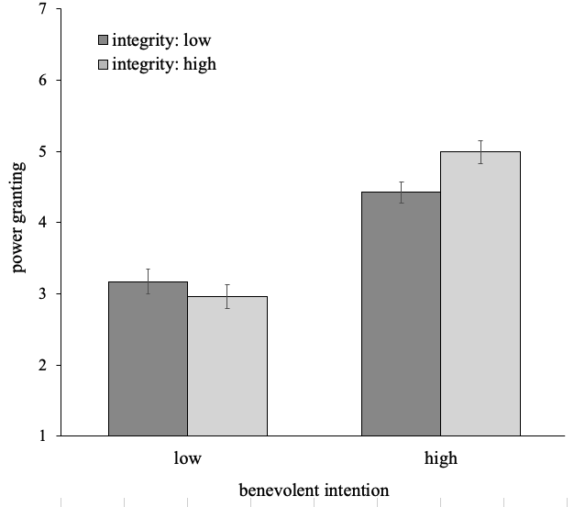
Figure A1.1. Mean power granting depending on the benevolent intention and integrity conditions. Error bars correspond to +/- 1 SE.
Primary Analyses
An ANOVA with two between-subject factors (benevolent intentions; integrity) and power granting as dependent variable revealed a main effect of benevolent intentions, F(1, 346) = 102.61, p < .001, η_{p}² = .229, 90%CI = [0.17, 0.29]. Participants reported a greater willingness to grant power to the target with high (M = 4.70, SD = 1.48) compared to low benevolent intentions (M = 3.07, SD = 1.57, p < .001). Importantly, this effect was qualified by the expected benevolent intentions x integrity interaction, F(1, 346) = 5.71, p = .017, η_{p}² = .016, 90%CI = [0.00, 0.04], see Figure 2. A target with high benevolent intentions was granted more power when showing high integrity (M = 4.99, SD = 1.51) as compared to low integrity (M = 4.42, SD = 1.41), p = .013. Conversely, for a target with low benevolent intentions, power granting did not relate to integrity (M_{high-integrity} = 2.96, SD = 1.51; M_{low-integrity =} 3.17, SD = 1.61), p = .372. No main effect of integrity emerged, F(1, 346) = 1.24, p = .266, η_{p}² = .004, 90%CI = [0.00, 0.02].
Discussion
Study A1 yielded evidence in support of our prediction in a concrete work situation. As expected, observers seemed more willing to grant power to those who have (high) benevolent intentions and who deliberate about the best way to follow through with these intentions—likely promising a benefit for observers once this person is in power. On a cautionary note, the results suggest that Study A1 was underpowered, which we addressed in the other studies. We here followed the definition of integrity as adhering to and acting in line with principles that others find acceptable (Mayer et al., 1995) and that deliberation reflects such a principle (Becker, 1998); accordingly, we used this behavioral strategy as an effective, but subtle way to give observers an impression of a target’s integrity. Going beyond, instances of more observable consistency between what one said one would do and what one actually does (i.e., “following through“) should function to manipulate a target’s integrity, which we tested in the other studies in the paper.

Stimuli

Instructions
Instruction
In the following, we are interested in people’s spontaneous perception of individuals
with regard to job-related characteristics. Please read the following text carefully and imagine yourself being in the described situation as vividly as possible. Then answer spontaneously to some questions about how you perceive the person described in the following with regard to some job-specific characteristic

Manipulations

For conditions:
benevolent intentions: high; integrity: high
You are sitting at a table in a coffee shop. Two persons are sitting at the table next to you. They seem to be engaged in a lively conversation about work. From time to time, some scraps of their conversation reach your ear.
"How I usually approach my tasks on the job when working with others? Regardless of the specific task at hand, I deliberately contemplate a lot how to finalize and then implement my plans to improve my working environment and the processes I use." "When I work with others on a task, it is crucial for me to achieve the best outcome for the team. I am convinced that everyone is responsible for the success of the team. [...]"
After a few moments, the waitress arrives with your coffee. When she leaves your table, you again catch some phrases from the table next to you. It is the same person speaking.
“In every area of my job, I take a closer look at a plan I have made before acting upon it. To be successful on a task, I assess any major problem facing me, and I deliberate extensively how to meet a goal “ "Whenever I solve a task, I strive to advance the team’s situation and outcomes. What I really focus on is what a situation will bring for the team. I usually act on behalf of the team’s goals. [...]"

benevolent intentions: low; integrity: low
You are sitting at a table in a coffee shop. Two persons are sitting at the table next to you. They seem to be engaged in a lively conversation about work. From time to time, some scraps of their conversation reach your ear.
"How I usually approach my tasks on the job when working with others? Regardless of the specific task at hand, I seek to carry forward resolutely to finalize and then implement my plans to improve my working environment and the processes I use." "When I work with others on a task, it is crucial for me to achieve the best outcome for myself. I am convinced that everyone is responsible for his or her own success. […]”
After a few moments, the waitress arrives with your coffee. When she leaves your table, you again catch some phrases from the table next to you. It is the same person speaking.
.”"In every area of my job, I push forward a plan I have made and act on it. To be successful on a task, I promptly attack any major problem facing me, and I act decisively to meet a goal." “Whenever I solve a task, I strive to advance my personal situation and outcomes. What I really focus on is what a situation will bring for me. I usually act on behalf of my personal goals. […]”

Checks

Attention Check
With this question we want to make sure that participants read all the instructions carefully. Therefore, please do not answer this question?
- Yes
- No

Manipulation check integrity – perceived behaviour dimension
Next, we are interested in your perception of the content of the short conversation. Please indicate to what extend the described person usually focuses on the following aspects while approaching a task on the job:
definitely not |  |  |  |  |  | definitely
1 | 2 | 3 | 4 | 5 | 6 | 7
- This person usually focuses on moving forward with his/her plan to be successful on the task.
- This person usually focuses on his/her plan to be successful on the task.

Measures and Instructions

The instructions and measures were identical (with very few specific exceptions in terms of wording) to Studies 2 and 3. Study A1 referred to the described target person (‘this person’; anonymous); Studies 2 and 3 referred to the target Mr. Smith.

Power Perception (Studies A1,2,3)
See Studies 2 and 3 (replacing “Mr Smith” in the items with “this person”

Power Granting (Studies A1,2,3)
See Studies 2 and 3 (replacing “Mr Smith” in the items with “this person”

Perceived Social Engagement (Studies A1,2)
See Study 2 (replacing “Mr Smith” in the items with “this person”

Correlations Studies A1, 2, and 3

Table S9: Intercorrelations among dependent and exploratory variables.

 | Study A1 |  |  | Study 2 |  |  |  | Study 3
Variable | 1 | 2 | 1 |  | 2 | 3 | 4 | 1 | 2 | 4
1. Power Granting | - | - | - |  |  |  |  | - | - | -
2. Power Perception | .44 | - | .62 |  | - |  |  | .33 | - | -
3. Social Engagement | .78 | .22 | .75 |  | .41 | - |  | - | - | -
4. Social Responsibility | - | - | .79 |  | .44 | .88 | - | .71 | .24 | -
5. Morality | - | - | .78 |  | .50 | .86 | .84 | .70 | .27 | .84

Overview on Results on Power Granting
Table S10
Results of the hypotheses tests Studies A1, 2, and 3. ANOVAs with the two factors intentions, integrity, and their interaction on power granting
 |  | Power Granting
 |  | Study A1 |  |  |  |  | Study 2 |  |  |  |  |  | Study 3
Variable |  | F | p | η_{p}² | 90%CI |  | F | p | η_{p}² | 90%CI |  |  | F | p | η_{p}² | 90%CI
constant |  | 2310.45 | < .001 | .87 |  |  | 2883.00 | < .001 | .87 |  |  |  | 2096.40 | < .001 | .91
benevolent intentions |  | 102.61 | < .001 | .23 | [0.17, 0.29] |  | 98.29 | < .001 | .19 | [0.13, 0.24] |  | 31.08 |  | < .001 | .13 | [0.07, 0.21]
integrity |  | 1.24 | .266 | <.01 | [0.00, 0.02] |  | 181.87 | < .001 | .30 | [0.24, 0.35] |  | 0.13 |  | 0.724 | < .01 | [0.00, 0.01]
benevolent intentions  x integrity |  | 5.71 | .017 | .02 | [0.00, 0.04] |  | 46.49 | < .001 | .10 | [0.06, 0.14] |  | 12.09 |  | 0.001 | .07 | [0.02, 0.11]
Notes. Sample size differs between Studies
F = F-Value with Study A1 df (1, 346), Study 2 df(1, 434), Study 3 df(1, 202); η_{p}² = Partial Eta-Square; 90%CI = 90% - Confidence interval

Extra Study A2:
Testing the role of benevolence and action orientation
This extra Study A2 (the first study we conducted on power granting; 2018) tested the relevance of benevolent intentions paired with action orientation for the willingness to grant power to a target. Note that integrity was not the focus of the present study and was identical across conditions. We report this extra study here for the interested reader and for the sake of transparency.
Method
Participants and Design. We computed the ideal sample size prior to data collection using G*power (Erdfelder et al., 2009; (1-β) = .80, α = .05, f = .15 as the smallest effect to detect of interest) for an experiment with six between-conditions and for a benevolence x action orientation interaction; ideal N = 400). Three hundred-eighty-nine German-speaking undergraduate students (257 males, 121 females, 2 other; 11 people who did not specify, ${\text{M}}_{\text{age}}$= 22.80, ${\text{SD}}_{\text{age}}$ = 3.54) participated. Participants could win one out of ten vouchers of an online store of each 10 € in return. The study comprised a 3 (benevolent intentions: low vs. neutral vs. high) x 2 (action orientation: low vs. high) between-participants design with random assignment to condition. Ten more participants retracted their data and were deleted prior to any analysis. As preregistered, we excluded 49 additional people due to an incorrect answer on an attention check. Moreover, though not preregistered, we excluded one participant who selected maximum options only (only ticking extreme scale points); this exclusion did not change the main results.
Procedure and Measures. Participants were invited via a university-wide mailing list to complete a 10-minute online study on “Social impression formation”. They read a description of a work situation. The protagonist (Mr. Smith) and his team planned to attend a conference. The administration had booked an unsatisfactory accommodation for them. Mr. Smith happened to meet the responsible person and started to negotiate a better accommodation. To manipulate benevolent intentions, Mr. Smith either selfishly tried to achieve a better accommodation for himself at the team’s cost (low benevolent intention) or he prosocially tried to achieve this better outcome for the whole team (high benevolent intention). In the neutral benevolent intention condition (control), he travelled alone, and no team was mentioned (i.e. his intentions were inconsequential for others). To manipulate action orientation, the protagonist either actively initiated this negotiation (“Spontaneously, Mr. Smith takes the initiative [...]; without hesitating, he opens the negotiations [..]”; high action orientation) or only participated in the negotiation once the other person had initiated it (“Spontaneously, the administrative employee takes the initiative [...]; without hesitating, the administrative employee opens the negotiations […]”; low action orientation).
Afterwards, participants indicated their impression of the protagonist: perceived power as a control variable (α = .83); willingness to grant power to the protagonist (α = .89); the protagonist’s social engagement (α = .86; “assertive” excluded due to negative intercorrelations with the other items here). As attention check, participants were asked to recall the protagonist’s behaviour and intention on one dichotomous item, respectively (“What was particularly important to Mr. Smith during the negotiation?” and “Who opened the negotiation?”). As a check of action orientation, we assessed how active participants perceived Mr. Smith to be during the negotiation (from 0 – “passive” to 100 – “active”). Finally, demographic data was collected, participants were thanked and debriefed.
Results
Checks. Participants perceived Mr. Smith to be as less active in the low-action (M =38.27,SD = 22.64) than in the high-action orientation condition (M = 89.61, 𝑆𝐷 = 12.49), F(1, 383) = 800.15, p < .001, η_{p}² = .676. The main effect of benevolent intentions on the action check was marginal, F(2, 383) = 2.88, p = .058, η_{p}² = .015 (neutral intentions: M = 61.39, 𝑆𝐷 = 33.22; low benevolent intentions: M = 69.11, 𝑆𝐷 = 31.93; high benevolent intentions: M = 67.61, 𝑆𝐷 = 28.48). Importantly, there was no benevolent intention x action orientation interaction on the action check, F(2, 383) = 2.52, p = .081, η_{p}² = .013. Thus, we consider this manipulation successful.
Exploring effects of benevolence x action on power granting. We conducted an analysis of variance (ANOVA) with two between-subject factors (benevolent intentions; action orientation) and power granting as dependent variable. This served to test if high (vs. low or neutral) benevolent intentions promote power granting—but here especially so when a target person exhibits high (vs. low) action orientation.

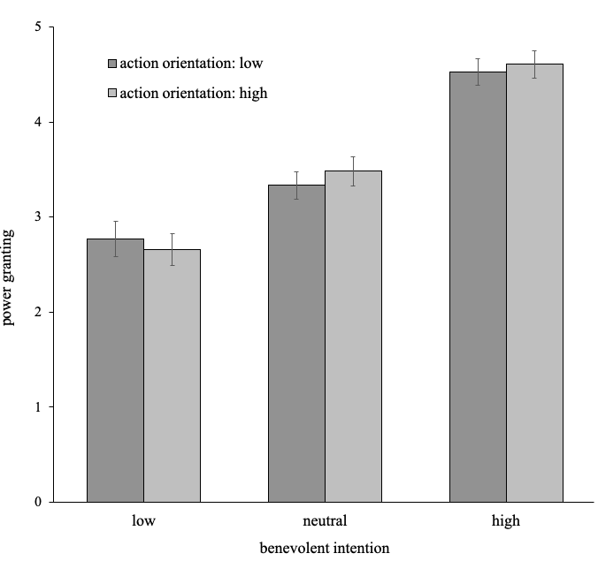
Figure S1. Mean power granting depending on benevolent intentions and action orientation conditions. High values indicate higher willingness to grant power. Error bars correspond to +/- 1SE.
Results revealed a main effect of benevolent intentions, F(2, 383) = 73.80, p < .001, η_{p}² = .278, 90%CI = [0.01, 0.08], but no interaction with action orientation F(2, 383) = 0.36, p = .698, η_{p}² =.002, 90%CI = [0.00, 0.02]. Participants were more willing to grant power to the protagonist with high benevolent intentions (M= 4.57, SD = 1.22, p < .001) and less willing to do so to the protagonist with low benevolent intentions (M = 2.71, SD = 1.29, p < .001), than to the protagonist in the control condition (M = 3.41, SD = 1.21, see Figure 1). No main effect of action orientation emerged, F(1, 383) = 0.15, p = .697, η_{p}² < .01, 90%CI = [0 .00, 0.01].
Additional Analyses for perceived power. We also tested whether our factors alter the level of the protagonist’s perceived power. There was a main effect of benevolent intentions, F(2, 383) = 8.40, p <.001, η_{p}² = .042, but neither an effect of action orientation, F(1, 383) = 0.30, p = .585, η_{p}² = .001, nor an interaction, F(2, 383) = .95, p = .387, η_{p}² = .005. Accordingly, participants perceived the protagonist as having greater power in the low (M = 4.39, SD = 0.96, p = .013) or high (M = 4.56, SD = 0.90, p < .001) benevolent intentions conditions than in the control condition (𝑀 = 4.09, SD = 1.01); the first two conditions did not differ (p = .218)
Additional analyses for social engagement. In addition to the presented additional analyses, we examined a potential mediation of intentions on power granting, which revealed that (high) benevolent intentions led to a higher perception of social engagement, which in turn predicted more power granting, b = 1.98, SE = 0.21, 95% CI = [1.58, 2.40]. The direct effect was different from 0 (b = 0.97, SE = 0.26, 95% CI = [0.45, 1.49]).
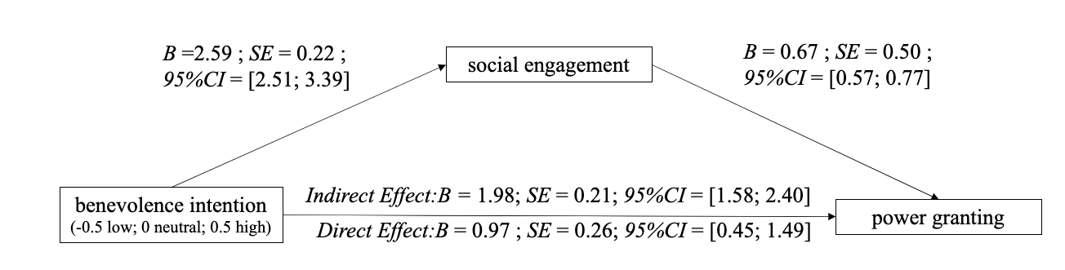
Figure S2. Mediation model of the indirect effect of benevolence intention on power granting through perceived social engagement. 95% confidence intervals are obtained from 5000 bootstrap resamples

Discussion
This extra study showed that observers do take information about a person’s benevolent intentions into account when deciding whether to grant this person power. But this effect was not qualified by the target’s action orientation (here, showing initiative in a negotiation). Of note, this result needs to be considered indeterminate, as we only applied NHST analyses. Carefully interpreted, this suggests that information’s about a target’s benevolent intentions may be crucial when evaluating whether or not to grant power to him/her, whereas information about the target’s action orientation seems less important. Further analyses revealed a main effect of benevolent intentions also on power perception; this effect, however, was driven by the neutral intentions condition. Accordingly, power perception cannot explain the pattern on power granting that we found.

Please note that Study A1 was originally conducted with a different intention; accordingly, results here can be understood as exploratory. Studies 2 and 3 then preregistered the hypothesis (H1) as presented here as a confirmatory test.
Note that the high- (vs- low-) integrity condition here also reflects a strategy implying low (vs. high) action. This relation between integrity and action was reversed in Study 3 and omitted in Study 4 to rule-out any potential confounds. High (vs. low) integrity here reflects deliberative (vs. spontaneous) strategies to vary the extent to which the target can be expected to think about how to best follow his/her intentions (versus spontaneously going for the (or any) next possible chance to act) and, thus, to follow the integrity-relevant principle of deliberation (Becker, 1998).
Name changed to English for the sake of readability and anonymity for review

