Supplemental Materials

Scientists, speak up!
Source impacts trust in health advice across five countries

Table of Contents
- Covid-19 advice text presented to participants (the UK version)
- Pilot Study supplementary information (Method & Results)
- Intentions to comply with the advice: Individual analyses
- Source effects when controlling for worldviews & demographics

Covid-19 advice text presented to participants (the UK version).
All versions are available on OSF: https://osf.io/m8zhk/
The source and certainty information are presented in bold.

The certain advice coming from the government
Now, we would like to present you with some information about measures designed to help prevent the spread of Covid-19. This information was taken from a recent briefing delivered by the UK government led by Boris Johnson. After reading the information, you will be asked some questions about its content, so please read the information carefully. These questions will appear on the next page.
The government reports indicate that the following actions will prevent the spread of the virus:
1. Washing your hands with soap and water or hand sanitiser regularly throughout the day.
2. Wearing a face covering over your nose and mouth.
3. Staying at least 2 metres apart.
4. Limiting the number of people or households that you come into contact with.
5. Working at home as much as possible.
6. Self-isolating after travelling abroad.
Specifically, the government reports show that the above actions reduce the risk of catching or passing the virus on and prevent the spread of droplets carrying the virus.

The uncertain advice coming from the government
Now, we would like to present you with some information about measures designed to help prevent the spread of Covid-19. This information was taken from a recent briefing delivered by the UK government led by Boris Johnson.
After reading the information, you will be asked some questions about its content, so please read the information carefully. These questions will appear on the next page.
The government reports indicate that the following actions may prevent the spread of the virus:
1. Washing your hands with soap and water or hand sanitiser regularly throughout the day.
2. Wearing a face covering over your nose and mouth.
3. Staying at least 2 metres apart.
4. Limiting the number of people or households that you come into contact with.
5. Working at home as much as possible.
6. Self-isolating after travelling abroad.
Specifically, the government reports show that the above actions potentially reduce the risk of catching or passing the virus on and potentially prevent the spread of droplets carrying the virus.

The certain advice coming from the scientific journal
We would like to present you with some information about measures designed to help prevent the spread of Covid-19. This information was taken from a scientific article that recently appeared in the Journal of Medicine.
After reading the information, you will be asked some questions about its content, so please read the information carefully. These questions will appear on the next page.
The scientific findings indicate that the following actions will prevent the spread of the virus:
1. Washing hands with soap and water or hand sanitiser regularly throughout the day.
2. Wearing a face covering over your nose and mouth.
3. Staying at least 2 metres apart.
4. Limiting the number of people or households that you come into contact with.
5. Working at home as much as possible.
6. Self-isolating after travelling abroad.
Specifically, the scientific data show that the above actions reduce the risk of catching or passing the virus on and prevent the spread of droplets carrying the virus.

The uncertain advice coming from the scientific journal
We would like to present you with some information about measures designed to help prevent the spread of Covid-19. This information was taken from a scientific article that recently appeared in the Journal of Medicine.
After reading the information, you will be asked some questions about its content, so please read the information carefully. These questions will appear on the next page.
The scientific findings indicate that the following actions may prevent the spread of the virus:
1. Washing your hands with soap and water or hand sanitiser regularly throughout the day.
2. Wearing a face covering over your nose and mouth.
3. Staying at least 2 metres apart.
4. Limiting the number of people or households that you come into contact with.
5. Working at home as much as possible.
6. Self-isolating after travelling abroad.
Specifically, the scientific data show that the above actions potentially reduce the risk of catching or passing the virus on and potentially prevent the spread of droplets carrying the virus.

Pilot Study

Method
We recruited 335 British participants online via Prolific recruitment platform (60% women, mean age = 37.91, age range = 18 - 79 years, mean political orientation [1 = left-wing – 10 = right-wing] = 5.26, mean religiosity [1 = not at all religious – 7 = very religious] = 2.19). We used a 2 (uncertainty) x 2 (source) between-subject design. Participants read about the Covid-19 pandemic impact estimations. We manipulated framing of the estimations such that the estimations were either presented certain or uncertain and their source was either the government or scientific findings (the same design as in the main study). We measured to what extent participants considered the estimations as trustworthy by asking three questions (α = .91) concerning the estimations reliability. Participants responded to the questions on a scale from 1 (not at all true) to 7 (very true). We also measured the extent to which participants trusted the government on a scale from 1 (not at all) to 7 (very much). We also included other variables, which were not relevant to the current investigation and hence are not reported here.

Materials
We obtained the Covid-19 impact estimations from newspaper sources in March/May 2020: https://www.bbc.co.uk/news/health-51674743, https://www.bbc.com/news/uk-52433520, https://www.bbc.com/news/uk-52495434, https://www.reuters.com/article/us-health-coronavirus-britain-jobs/uk-employment-growth-slowed-in-march-as-covid-began-to-hit-ons-idUSKBN2230NM, https://www.ft.com/content/e5061be6-2978-4c0b-aa68-f372a2526826

Stimuli presented to participants in each condition:

Condition: Scientific findings - certain
Table 1. Estimated impact of the coronavirus pandemic in the UK based on scientific findings.
Health impact
Mortality rate | 5.7%
Actual death toll in May 2020 | 36,478
Predicted death toll in August 2020 | 43,479
Predicted number of ICU beds needed next month for COVID-19 patients | 1,948

Social impact
Number of people experiencing food shortages during lockdown | 3m
Increase in domestic abuse helpline calls compared to normal | 49%

Economic impact
Projected unemployment rate | 10%

Condition: Scientific findings - uncertain
Table 1. Estimated impact of the coronavirus pandemic in the UK based on scientific findings.
Health impact
Mortality rate | 5.5% – 5.9%
Actual death toll in May 2020 | 35,923 – 38,133
Predicted death toll in August 2020 | 40,109 – 50,120
Predicted number of ICU beds needed next month for COVID-19 patients | 1,272 – 3,152

Social impact
Number of people experiencing food shortages during lockdown | 2m – 5m
Increase in domestic abuse helpline calls compared to normal | 48% – 55%

Economic impact
Projected unemployment rate | 8% – 12%

Condition: Government – certain
Table 1. Estimated impact of the coronavirus pandemic in the UK based on the British government’s sources.
Health impact
Mortality rate | 5.7%
Actual death toll in May 2020 | 36,478
Predicted death toll in August 2020 | 43,479
Predicted number of ICU beds needed next month for COVID-19 patients | 1,948

Social impact
Number of people experiencing food shortages during lockdown | 3m
Increase in domestic abuse helpline calls compared to normal | 49%

Economic impact
Projected unemployment rate | 10%

Condition: Government – uncertain
Table 1. Estimated impact of the coronavirus pandemic in the UK based on the British government’s sources.
Health impact
Mortality rate | 5.5% – 5.9%
Actual death toll in May 2020 | 35,923 – 38,133
Predicted death toll in August 2020 | 40,109 – 50,120
Predicted number of ICU beds needed next month for COVID-19 patients | 1,272 – 3,152

Social impact
Number of people experiencing food shortages during lockdown | 2m – 5m
Increase in domestic abuse helpline calls compared to normal | 48% – 55%

Economic impact
Projected unemployment rate | 8% – 12%

Results
We found that the effect of source was significant, F(1, 331) = 9.25, p = .003, such that participants found the estimations significantly more trustworthy when the source was the scientific findings, as opposed to the government, t(331) = 3.04, p = .003, d = 0.33, 95% CI [0.12, 0.55] (see Supplementary Figure 7). No other effects emerged, ps > .708.

Moderation with Political Orientation
We then explored whether participants’ political orientation moderated the detected effect of source on participants’ trust in the estimations while controlling for trust in the government and religiosity. We found that this was indeed the case, β = 0.18, 95% CI [0.03, 0.33], t(325) = 2.41, p = .016. Simple slopes analyses indicated that left-wing β = -1.04, 95% CI [-1.39, -0.68], t(325) = 5.74, p < .001, and moderate participants, β = -0.47, 95% CI [-0.72, -0.22], t(325) = 3.68, p < .001, found the estimations more trustworthy when the source, was the scientific findings as opposed to the government. However, right-wing participants found the estimations equally as trustworthy regardless of the source, β = 0.09, 95% CI [-0.26, 0.45], t(325) = .52, p = .600.

Moderation with Religiosity
We also found that religiosity marginally moderated the effect of source on trustworthiness of the estimations while controlling for trust in the government and political orientation, β = 0.21, 95% CI [-0.02, 0.44], t(325) = 1.81, p = .071. Non-religious, β = -0.65, 95% CI [-1.02, -0.29], t(325) = 3.52, p < .001, and moderately religious participants, β = -0.46, 95% CI [-0.72, -0.21], t(325) = 3.54, p < .001, trusted the estimations more when their source was the scientific findings rather than the government. No such bias was present for highly religious participants, β = -0.27, 95% CI [-0.64, 0.09], t(325) = 1.47, p = .140.

Supplementary Figure 1
Participants’ Trust in the Presented Estimations as a Function of Source; gov – government.
Intentions to Comply with the Advice: Individual Analyses
We conducted individual analyses for each intention variable (handwashing, wearing a face covering, avoiding public spaces, and social distancing). The model structure was the same as for the composite score of intentions, that is, we conducted a multilevel model with country as random intercepts, source as the main independent variable, with country as a moderator, and uncertainty as a covariate.
We found that across all the dependent variables, the effect of source was not significant, for handwashing: F(1, 4550) = 0.01, p = .962; wearing a face covering, F(1, 4550) = 0.001, p = .962; avoiding public spaces, F(1, 4550) = 0.01, p = .925; and social distancing, F(1, 4550) = 0.39, p = .530. The source by country interaction was also not significant for handwashing: F(4, 4548) = 1.39, p = .234; wearing a face covering, F(4, 4550) = 1.64, p = .161; avoiding public spaces, F(4, 4550) = 0.89, p = .471; and social distancing, F(4, 4550) = 1.32, p = .260.

Source Effects When Controlling for Worldviews & Demographics
Finally, we conducted an exploratory analysis to test whether message source contributed to participants’ trust in the advice controlling for demographics, and individual differences in worldviews as well as Covid-19 knowledge. We estimated multilevel multiple regression models with trust in the advice (model 1) and compliance intentions (model 2) as outcomes, and source, uncertainty, demographics, and individual difference variables as predictors. We did not include political orientation as a predictor, as it was measured with different questions across different countries. We allowed the intercepts to vary across the countries.
We found that controlling for participants’ worldviews, Covid-19 knowledge, and demographics, the message source (β = -.42) was among the strongest predictors of trust in the prevention advice, with the scientific journal source associated with higher trust compared to the government source. Trust in government was equally as strong as source in contributing to trust as the source (β = .43), followed by general perception of threat associated with Covid-19 (β = .23; see Supplementary Figure 2a). These findings corroborate the previous analyses demonstrating that source is an important factor that contributes and impacts on trust in health advice, even when controlling for individual differences in worldviews.
In turn, the analyses of intentions to comply suggest that trust in the advice is the strongest predictor of intentions (β = .25), followed by perceived Covid-19 general threat (β = .25). Interestingly, source had a significant effect on intentions, however, in the opposite direction to the effect of source on trust: The government source was associated with higher intentions to comply compared to the scientific source (β = .13; see Supplementary Figure 2b). Altogether, these findings show that message source is one of the key variables that contribute to trust in health advice, beyond individual difference variables, while such trust contributes strongly to intentions to comply with health measures. At the same time, while trust was increased when the source was scientific versus governmental, participants had higher intentions to comply with the advice, when the source was governmental versus scientific, suggesting that the manipulation of source has different effects on trust as opposed to behavioural intentions.

Supplementary Figure 2
Coefficients Associated with Predictors of (a) Trust in the Advice and (b) Intentions to Comply with the Advice.
(a)
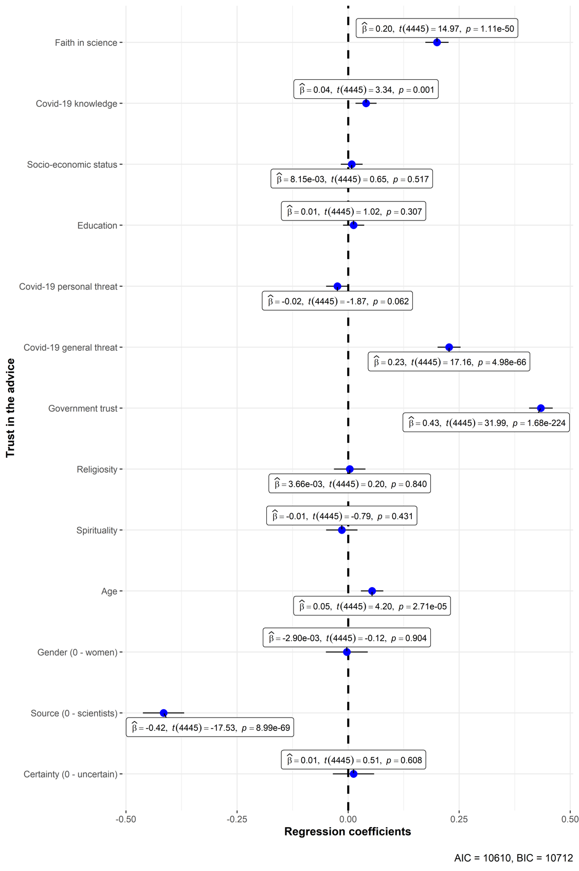

(b)
